PSPKVM (v0.4.0)

Getting Started Guide
pspkvm@gmail.com

Run from binary bundle
  - Download correct binary bundle:
- If you have a 1.50 kernel PSP and have installed pspkvm 0.3.2:
Download pspkvm-bin-x.x.x-150-upgrade.zip
- If you want to run pspkvm on 3.xx OE and have installed pspkvm 0.3.2:
Download pspkvm-bin-x.x.x-OE-upgrade.zip
- If you have a 1.50 kernel PSP and haven't installed pspkvm 0.3.2:
Download pspkvm-bin-x.x.x-150-allinone.zip
- If you want to run pspkvm on 3.xx OE and haven't installed pspkvm 0.3.2:
Download pspkvm-bin-x.x.x-OE-allinone.zip
  - Extract the zip to PSP's /PSP/GAME/ or /PSP/GAME150
  - Here we go!

Building from source code
This section is for the ones who are interested in our source code:

trunk svn: https://pspkvm.svn.sourceforge.net/svnroot/pspkvm/trunk
version X.Y.Z can be checked out from svn: https://pspkvm.svn.sourceforge.net/svnroot/pspkvm/tags/pspkvm-vX_Y_Z-yyyymmdd
Or from source bundle:
pspkvm-src-X.Y.Z-yyyymmdd.zip

- You have to prepare the building environment for phoneME at first. Please refer the document from here: https://phoneme.dev.java.net/content/mr2/buildenv_feature.html#win_setup

Now assume you have installed the building environment by following the above instruction. In Cygwin:
- Grab the source code from svn to a local directory
- cd ${your_source_dir}
- export JDK_DIR=${your_jdk_dir} (example: export JDK_DIR=c:/j2sdk1.4.2_16)
- ./build-psp-cldc.sh
- cd psp
Now you should see the success message of phoneME libs building.
- Make the executable:
- If build for 1.50 kernel:
make kxploit
You should get pspkvm and pspkvm% directories in this directory, just copy them to your PSP's /PSP/GAME or /PSP/GAME150 directory.

- If build for 3.xx OE:
make BUILD_SLIM=true
You should get EBOOT.PBP in this directory, copy it to your PSP's /PSP/GAME/pspkvm directory
- Copy "lib" and "appdb" directory from ${your_source_dir}/midp/build/javacall_psp/output/ into PSP's /PSP/GAME/pspkvm
- unzip midi_res.zip to PSP's /PSP/GAME/pspkvm (If you need MIDI support)

Requirement:
SDL_mixer
libvorbis
libogg

Running tips

Run MIDlet from memory stick:
1) Select "Find Application" item in AMS (the item on the top)
2) Select "Install from memory stick (ms0:/)"
3) Browse the file system of your memory stick now, and select jad or jar to run
4) After selected, the jad/jar will be automatically installed and run. You can choose the installed application from AMS next time you want to run.
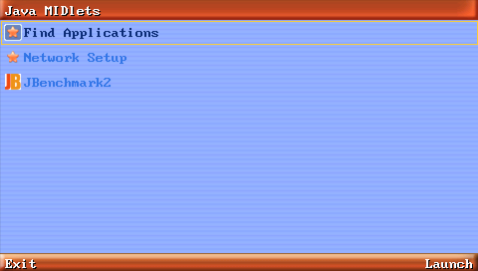

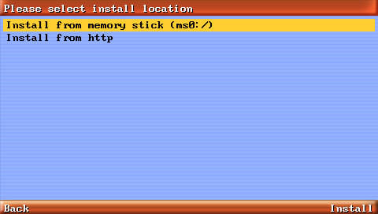

Input text:
You can't use Qwerty input method on PSP since it's lack of standard keyboard, but there's still other input methods available. In any text input sence, you can popup the menu by Right Soft-button, and change to another input method. I'd suggest to use "abc" to input alphabetics, just like you've done on your phone, input english characters by 0~9,#,* keypad.

Key map:
By default, the key assignment is blow:
NUM0: Cross
NUM1: Square
NUM2: UP
NUM3: Triangle
NUM4: LEFT
NUM5: Shift+Circle
NUM6: RIGHT
NUM7: Shift+Square
NUM8: DOWN
NUM9: Shift+Triangle
*: Shift+SELECT
#: Shift+START
CLEAR: Shift+Cross
SELECT: Circle
Left Soft: SELECT
Right Soft: START
UP/DOWN/LEFT/RIGHT: Analog joy stick
(* "Shift" = holding Left Trigger or Right Trigger)

Left Trigger + Right Trigger + Triangle: Multi-tasking key (Click to return AMS and put MIDlet to background)
Left Trigger + Right Trigger + Cross: Exit current running MIDlet

Multi tasking
In any application, press Left Trigger+Right Trigger+Triangle will put current running MIDlet to background, and AMS screen will be shown. The background running MIDlet is shown in high-lighted, and you can choose another MIDlet to run without stop the previous MIDlet. To bring a background running MIDlet to foreground, just click the MIDlet item from AMS.
Note that currently we only enable 2 MIDlets to run at same time, will allow more in future.

Connect to network
Before a Java MIDlet wants to use network, you need to connect your PSP to network at first. To setup this connection, please select "Network Setup" in AMS(the 2nd item in AMS MIDlets list), then all the wifi connections you've setup in PSP will be listed. Select one and until an alert popup to tell you if it's succeeded. Once it says "Successfully connected by profile xxx", that means your network is setup, and back to AMS and run you MIDlet which uses network.
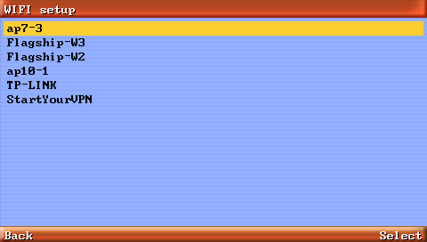
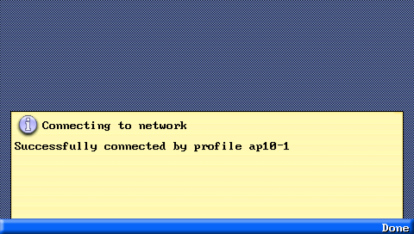

*Tips for 3.xx OE users: you don't have to setup network in "Network Setup" menu. When the first your MIDlet want to access wifi network, a PSP network setup dialog will popup and prompt you connecting. And also, you can use “L+R+Square” to call up the network setup dialog at any time.

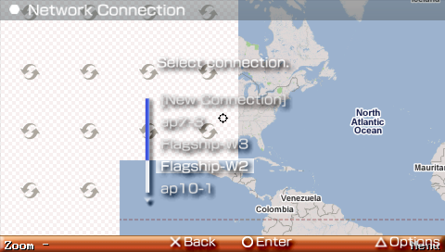

Select device to emulate
When user select a jad/jar file from memory stick to run, a "Device Select" menu will appear. Choose you preferred device size and model here, and press CIRCLE key to decide. If want to change the preferred device setting, go back to AMS and move the highlight onto the MIDlet whose setting you want to change, then select "Select Device" from menu.

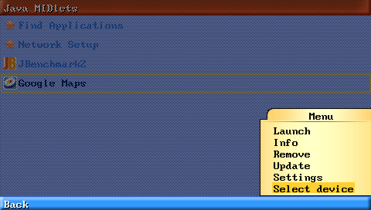

Change default key assignment for specific game
Default key assignment may not fit your game, you can go to AMS and move the highlight onto the MIDlet whose key assignment you want to change, then select "Select Device" from menu. Change the key setting as what you want.
REMEBER:"Shift" means Left Trigger or Right Trigger.
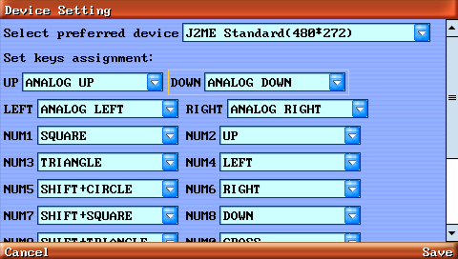

Change default root directories mapping of JSR75 Fileconnection
The default root directories mapping is as following:
/root -> ms0:/pspkvm/
/music -> ms0:/PSP/MUSIC/
/photo -> ms0:/PSP/PHOTO/
/video -> ms0:/PSP/VIDEO/
/recordings -> ms0:/pspkvm/
/tones -> ms0:/pspkvm/
/graphics -> ms0:/pspkvm/
/private -> ms0:/pspkvm_pri/
However, you can change the default mapping in pspkvm.ini. Please open pspkvm.ini in PSPKVM's install directory, change the values in [jsr75] section. If the value is left blank, default value is applied.

Virtual Keyboard and Chinese Input tips:
"#" (SHIFT+START by default) -> Open/Close Chinese Input
"*" (SHIFT+SELECT by default) -> Switch input methods
4/6 (LEFT/RIGHT by default) -> Select candidate chinese chars / Move cursor
2/8 (UP/DOWN by default) -> Prev/Next page of candidate chinese chars
5 (SHIFT+CIRCLE by default) -> Confirm selected chinese char
CLEAR (SHIFT+CROSS by default) -> Backspace

Use FreeType2 font files
You can have 3 type of fonts: System, Proportional and Monospace. Copy your .ttf files into ms0:/PSP/GAME/PSPKVM and rename them as below:
System font: sys.ttf
Proportional font: pro.ttf
Monospace font: mono.ttf
If pro.ttf or mono.ttf is not found, sys.ttf will be used automatically; If no any of three font files are found, internal built-in font will be used.

