|  |  |
| --- | --- |
| ID | B |
| 0 | B0 |

1a. 𝑅1 ∩ 𝑅2

1b. 𝑅1 × 𝑅2

|  |  |  |  |  |  |  |
| --- | --- | --- | --- | --- | --- | --- |
| ID | A | B | ID.2 | B.2 | D | E |
| 0 | A0 | B0 | 0 | B0 | D0 | E0 |
| 0 | A0 | B0 | 2 | B99 | D2 | E2 |
| 0 | A0 | B0 | 3 | B3 | D3 | E3 |
| 1 | A1 | B1 | 0 | B0 | D0 | E0 |
| 1 | A1 | B1 | 2 | B99 | D2 | E2 |
| 1 | A1 | B1 | 3 | B3 | D3 | E3 |
| 2 | A2 | B2 | 0 | B0 | D0 | E0 |
| 2 | A2 | B2 | 2 | B99 | D2 | E2 |
| 2 | A2 | B2 | 3 | B3 | D3 | E3 |

|  |  |  |  |  |
| --- | --- | --- | --- | --- |
| ID | A | B | D | E |
| 0 | A0 | B0 | D0 | E0 |

1c.

𝑅1⨝𝑅2

|  |  |  |  |  |
| --- | --- | --- | --- | --- |
| ID | A | B | D | E |
| 0 | A0 | B0 | D0 | E0 |
| 1 | A1 | B1 | null | null |
| 2 | A2 | B2 | null | null |

1d.

𝑅1⟕𝑅2

|  |  |  |  |  |
| --- | --- | --- | --- | --- |
| ID | A | B | D | E |
| 0 | A0 | B0 | D0 | E0 |
| 2 | null | B99 | D2 | E2 |
| 3 | null | B3 | D3 | E3 |

1e. 𝑅1⟖𝑅2

|  |  |  |  |  |  |  |
| --- | --- | --- | --- | --- | --- | --- |
| ID | A | B | ID | B | D | E |
| 0 | A0 | B0 | 0 | B0 | D0 | E0 |
| 1 | A1 | B1 | null | null | null | null |
| 2 | A2 | B2 | null | null | null | null |
| null | null | null | 2 | B99 | D2 | E2 |
| null | null | null | 3 | B3 | D3 | E3 |

1f. 𝑅1⟗ R2

2a.π(Pizza)(σ(Gender = female ꓥ Age>20)(Person⨝Eats)

2b. π(Name)(σ(Gender = female)(Person⨝Eats) ⨝ σ(Pizzeria = “Straw Hat”)(Serves)

2c. π(Pizzerias)(σ(price<10)(Serves) ⨝ σ(Name = “Amy” ꓦ “Fay”)(Person⨝Eats)

2d. π(Pizzerias)(σ(price<10)(Serves) ⨝ σ(Name = “Amy” ꓥ “Fay”)(Person⨝Eats)

2e. π(name)(σ(pizzeria = “dominoes” Eats⨝Serves - σ(pizzeria = “dominoes” Frequents)

2f. p(youngerAge, π(age)(σ(Pizza = “Mushrooms” Eats⨝Person) - π(youngerAge<age)(σ(Pizza = “Mushrooms” Eats⨝Person)

2g. π(Pizzerias)(σ(age>30) Frequents⨝Person)

3a. {BG}+ = B,G,A,C,D,E,F

3b. Candidate Key is {B, G}

3c. R{AB -> CD

C->EF

G->AF}

3d.

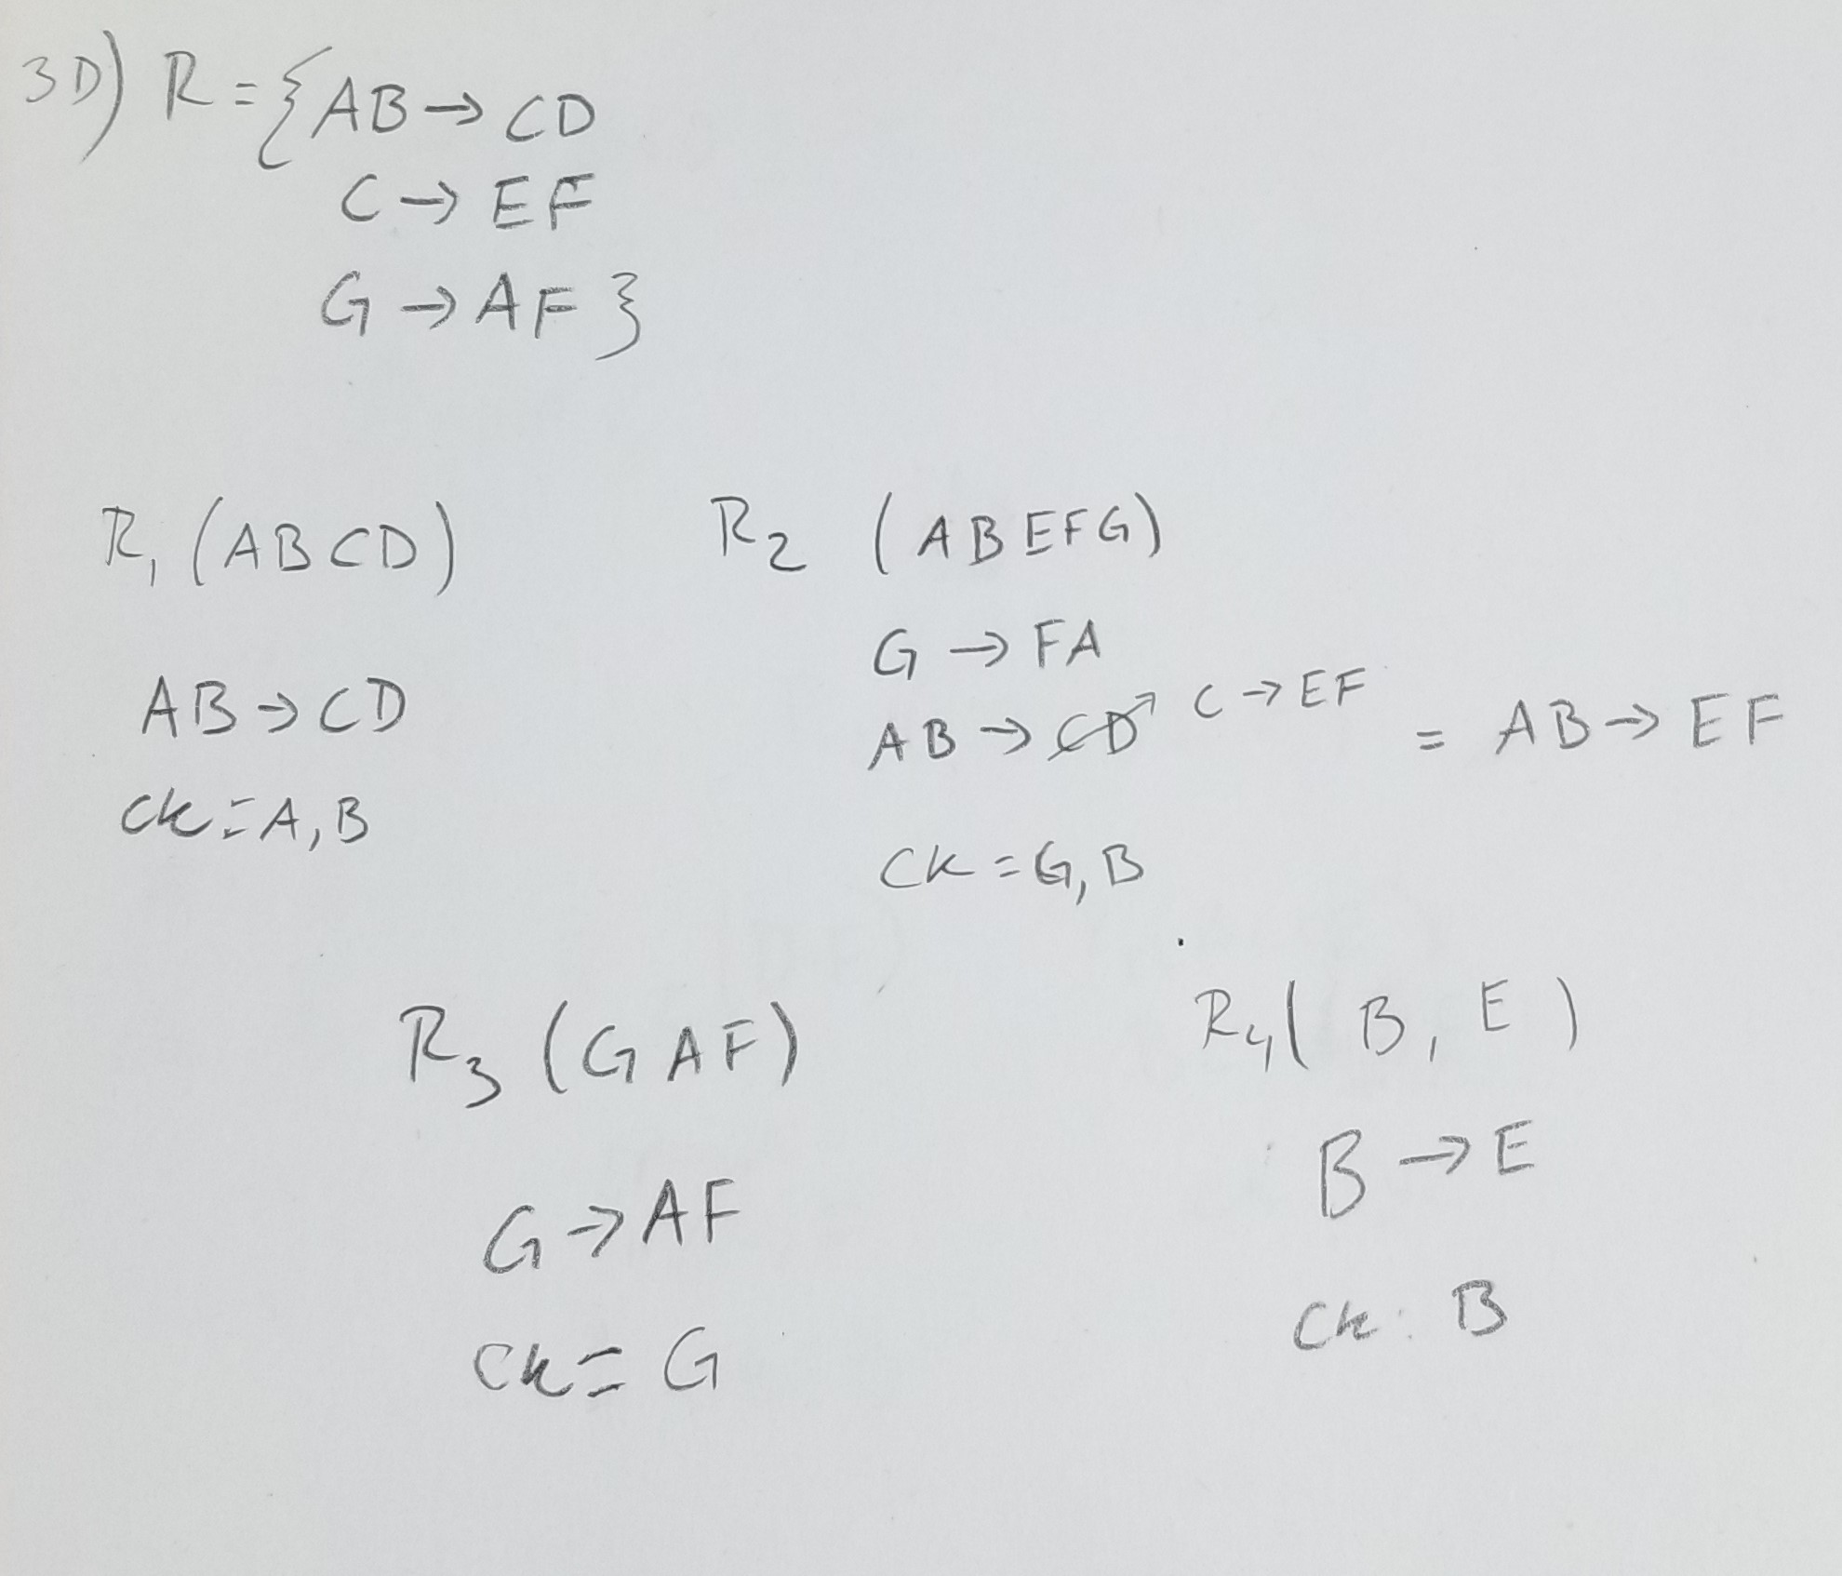

4a.{D}+ = D, A, B, C, E

4b. CK is DF,AF, BF

4c. R{A -> BCD

BC->DE

B->A}

4d.

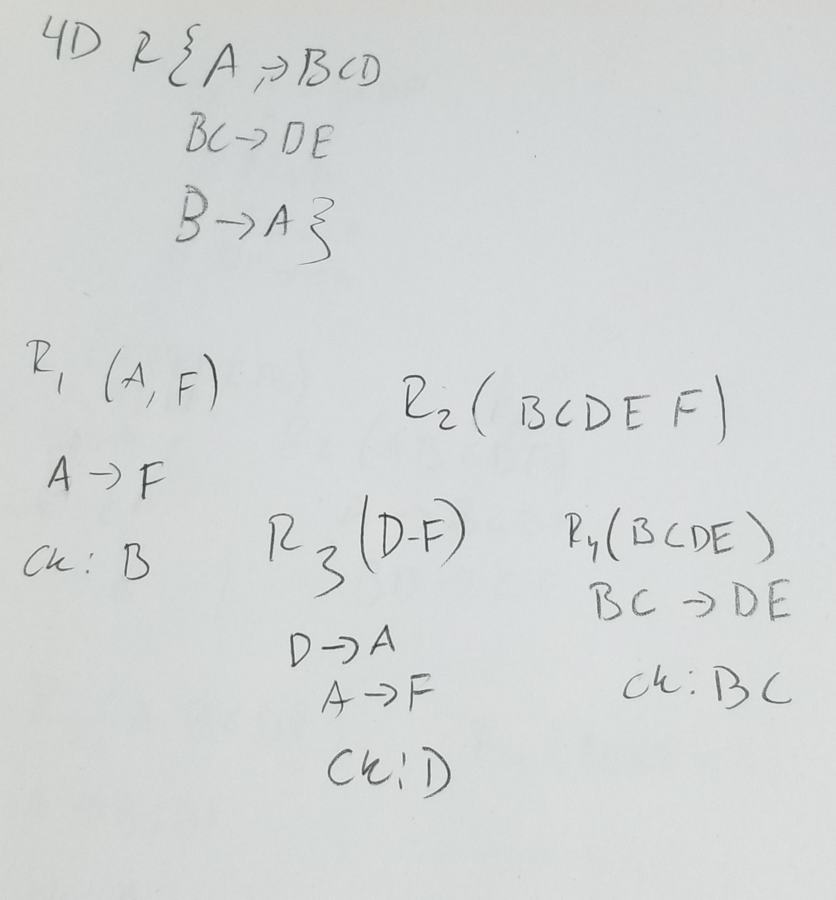

5a. {E}+

5b. A-> BCDF

E-> A

B->D

BD->CF

DF ->-> G

5c.

