**MAP290**

**MATLAB ASSIGNMENT**

**On**

### COMPUTATIONAL GAS DYNAMICS

***INTRODUCTION:***

Simple classic methods for scalar conservative laws have been dealt here. The six basic design techniques used in computational gas dynamics are:

* Flux averaging
* Flux and wave speed splitting
* Numerical integration and numerical differentiation
* Cauchy-Kowalewski
* Method of lines and
* Reconstruction-evolution.

The numerical methods we are dealing with use all of these derivational techniques, albeit in simple ways. To evaluate these numerical methods we use some specifications like Artificial viscosity, CFL condition, Conservation, Consistency, Convergence, Explicit versus implicit, Finite volume versus finite difference, Linear stability, Linear versus nonlinear, Nonlinear stability, Order of accuracy and Up-winding & stencil selection are no substitute for actual performance testing. Many numerical methods have difficulties when a wave speed equals zero. In three dimensions, wave speeds equal zero along *sonic surfaces;* in two dimensions, wave speeds equal zero along *sonic lines;* and in one dimension, wave speeds equal zero at *sonic points.* In other words, w* is a sonic point if f (w*) *= a (u*)* = 0. Sonic points usually signal a change in the wind direction. Sonic points are *expansive* if the wave direction switches from left to right and *compressive* if the wave direction switches from right to left.



Expansive sonic points typically occur inside sonic expansion fans, which contain one stationary characteristic separating left- from right-running characteristics. Compressive sonic points typically occur inside stationary or slowly moving shocks.

Many numerical methods produce significant errors near sonic points, especially expansive sonic points, which often cause spurious expansion shocks. Upwind methods are forced to give sonic points special consideration, since the upwind direction changes at sonic points. Unlike shocks, contacts, expansions, and sonic points, the formal order of accuracy is a generally reliable indicator of the size of phase, dispersive, and amplitude errors for smooth solutions, assuming only that the numerical method is reasonably stable.

***TEST CASES:***

The following five test cases involve all of the flow features identified above - shocks, contacts, expansion fans, sonic points, and smooth regions. To avoid the complicating influence of boundary conditions, all five test cases involve a periodic domain [-1, 1], In other words, w (-1, *t)* = w (l, *t)* for all *t* and, furthermore, *u(x* - 1, *t)* = *u(x* + 1, t) for all *x* and *t.*

There are 5 test cases and 5 methods to solve the PDE; we have to solve every case with every method.

***Test case 1:***

Find u(x, 30) where M=40, evenly space grid points

t = 30**,** periodic domain =[-1,1]

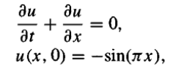



This test case has a completely smooth exact solution.

***Test case 2:***

Find u(x ,4) where M=40, evenly space grid points

t = 4**,** periodic domain = [-1, 1] and u(x, 4) = u(x, 0)

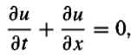





***Test case 3:***

Find u(x,4) and u(x, 40) where M=600, evenly space grid points

t = 4 and t=40,







***Test case 4:***

Find u(x,0.6) where M=40, evenly space grid points

t = 0.6**,**

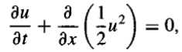





***Test case 5:***

Find u(x,0.3) where M=40, evenly space grid points

t = 0.3**,**







***Lax-Friedrichs method:***

The Lax-Friedrichs method is a basic method for the solution of hyperbolic partial differential equations (PDEs). Its use is limited because itsorder is only one, but it is easy to program, applicable to general PDEs, The Lax-Friedrichs scheme proposed for the approximation of hyperbolic conservation laws. It’s monotonic.









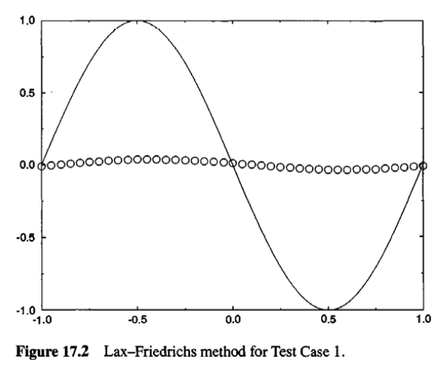

***Lax-Wendroff Method:***

It’s not a monotonic



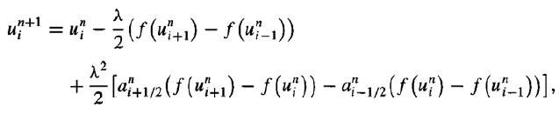



where mid-point value is calculated from the formula.





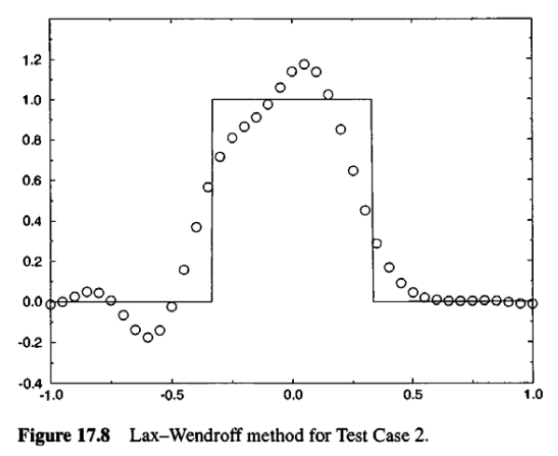

***Godunov’s first-order Upwind Method:***

It’s not a monotonic



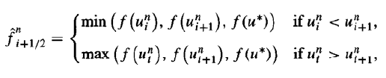

Where u* refers to any and all sonic points between $u_{i}^{n}$ and $u_{i+1}^{n}$. In artificial viscosity form, Godunov’s first-order upwind method is

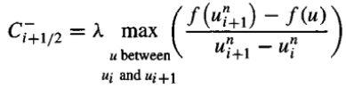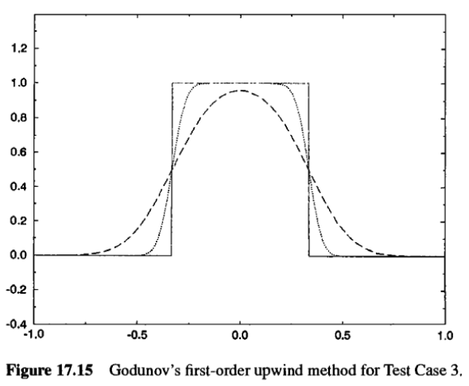

***Roe’s First-order Upwind Method:***





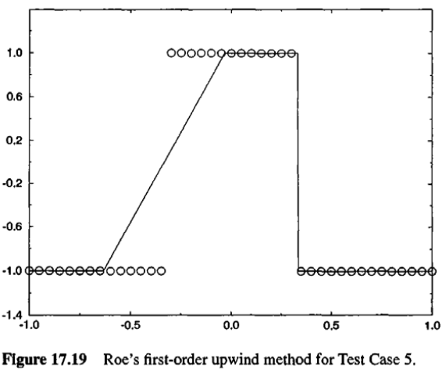

***Beam-Warming Second order Upwind Method:***



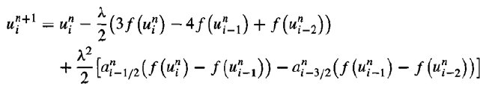



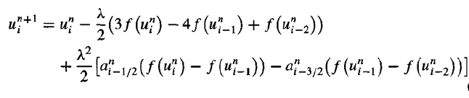



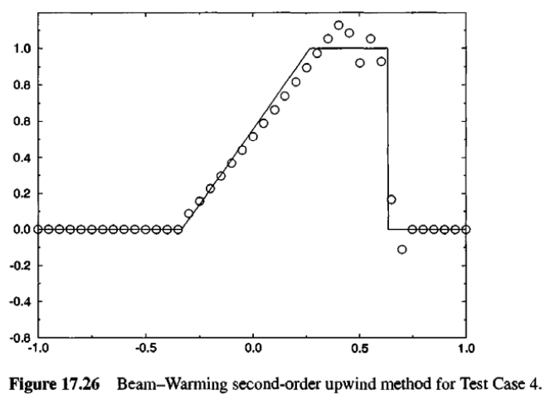

***Fromm’s Method:***

