Eye Disease Classification using Machine & Deep Learning Algorithms
Abstract
The goal of the proposed project is to use eye images analysis and machine learning techniques to identify various eye diseases. This study utilizes cutting-edge technology to fill a crucial need in the healthcare industry by offering an automated, non-invasive technique for early disease detection. The actual aim of the project is to develop a machine learning system to automatically detect eye diseases in patients by analysing images. Early detection of this disease can help patients in avoiding vision loss or impairment. This disease symptoms may appear due to environmental conditions or forefather inheritance or can say genetic disease. The project's implementation entails gathering data from paediatric patients, selecting suitable machine-learning techniques, extracting features from pupillometry data, pre-processing for noise reduction, training the model, and fine-tuning hyper parameters. The system is optimized for maximum disease detection accuracy and evaluated on Eye disease datasets which can be download from famous KAGGLE repository.
Algorithm Details
To detect disease we have experimented with multiple Machine and deep learning algorithms such as SVM, KNN, Random Forest, and in Deep Learning we have employed Convolution 2D Neural Networks (CNN2D) and Pre-trained VGG16. Each algorithm performance is evaluated in terms of accuracy, precision, recall, FSCORE and Confusion Matrix. Among all algorithms CNN2D is giving highest accuracy of 98%.
Techniques used for Data Processing
Before train algorithms we have applied various features processing techniques like Resizing, shuffling, normalizations and then splitting dataset into train and test where application using 80% dataset for training and 20% dataset for testing.
For better performance we have tuned each algorithm with multiple hyper parameters.
Dataset Description
For experiment we have utilized same dataset given by you and we have downloaded this dataset from below URL
https://www.kaggle.com/datasets/gunavenkatdoddi/eye-diseases-classification
Above dataset consists of 4 different class labels such as ['glioma_tumor', 'meningioma_tumor', 'no_tumor', 'pituitary_tumor']
We have coded this project using JUPYTER notebook and below are the code and output screens with blue colour comments
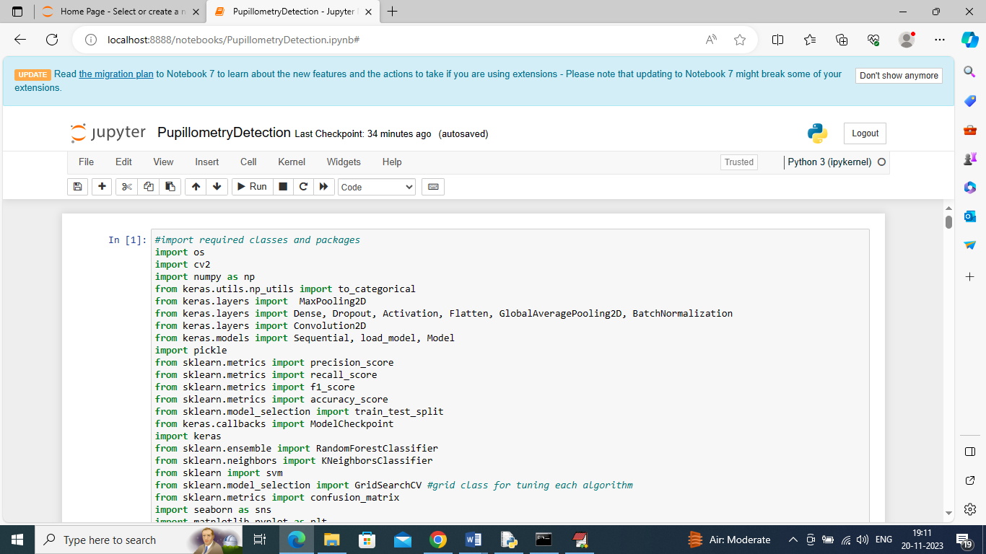
In above screen importing required python classes and packages
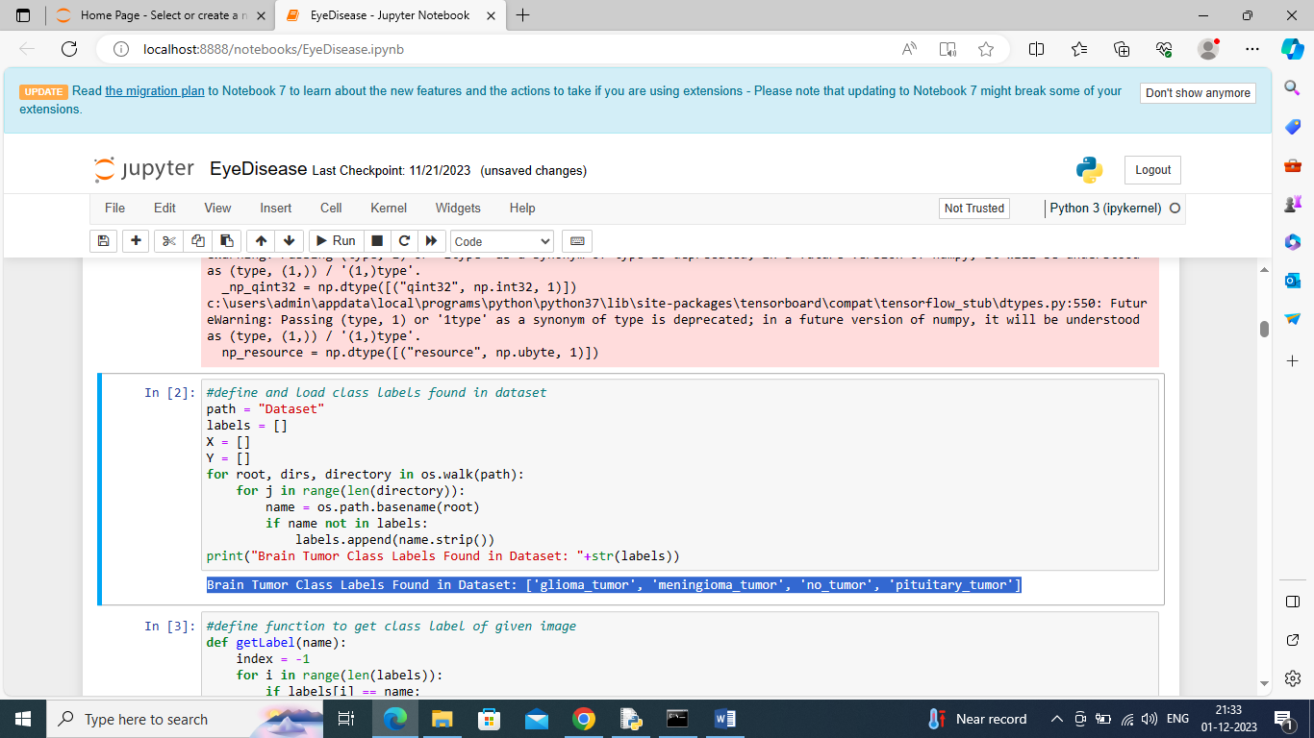
In above screen defining function to loop and display all class labels found in dataset
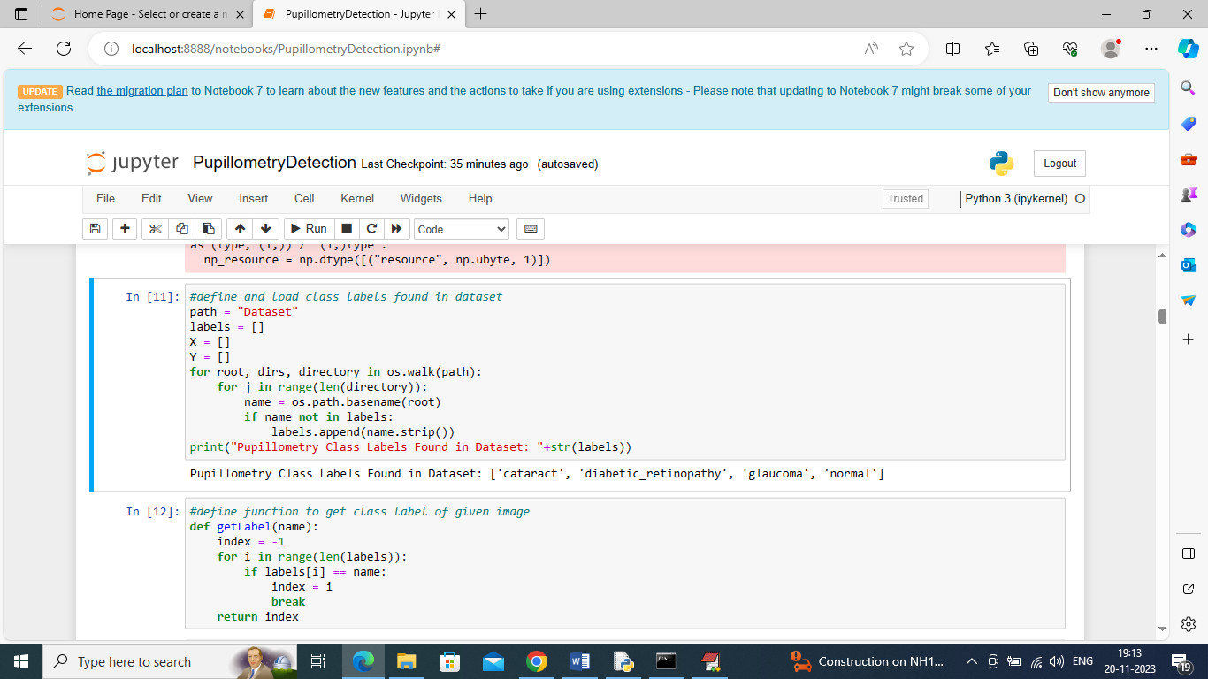
In above screen defining function to get integer class label from given image name
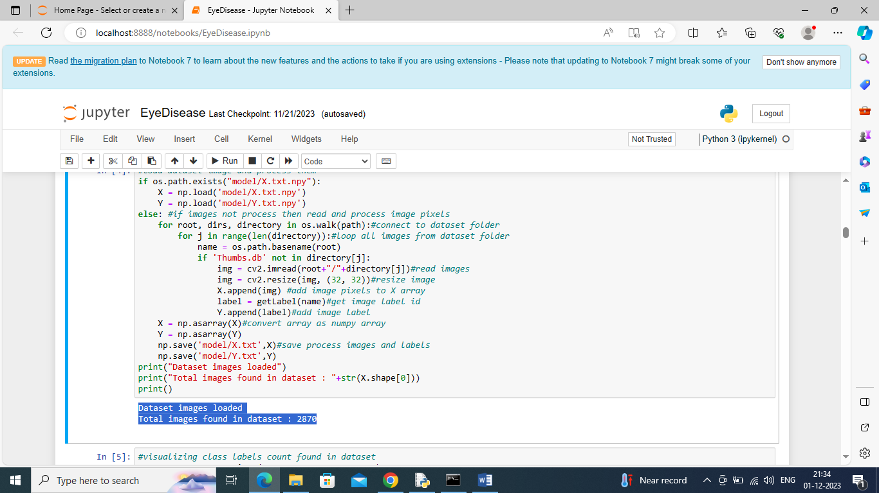
In above screen reading all images from given dataset folder and then in blue colour text displaying total images loaded
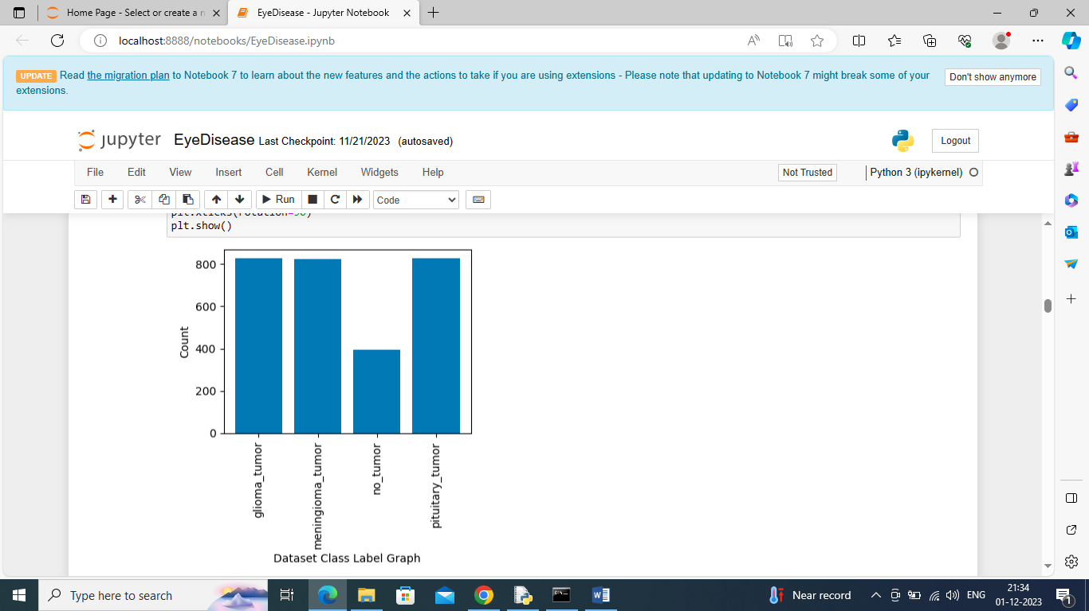
In above graph x-axis represents pupillometry disease class labels and y-axis represents of count of those class labels found in dataset
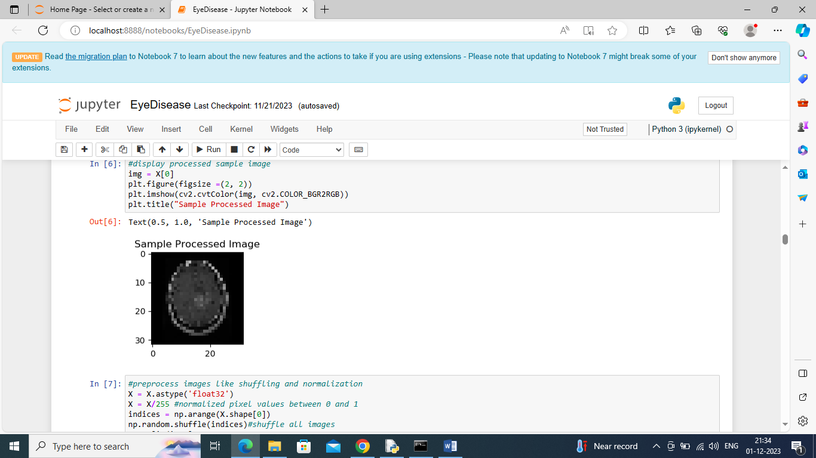
In above screen displaying processed sample image
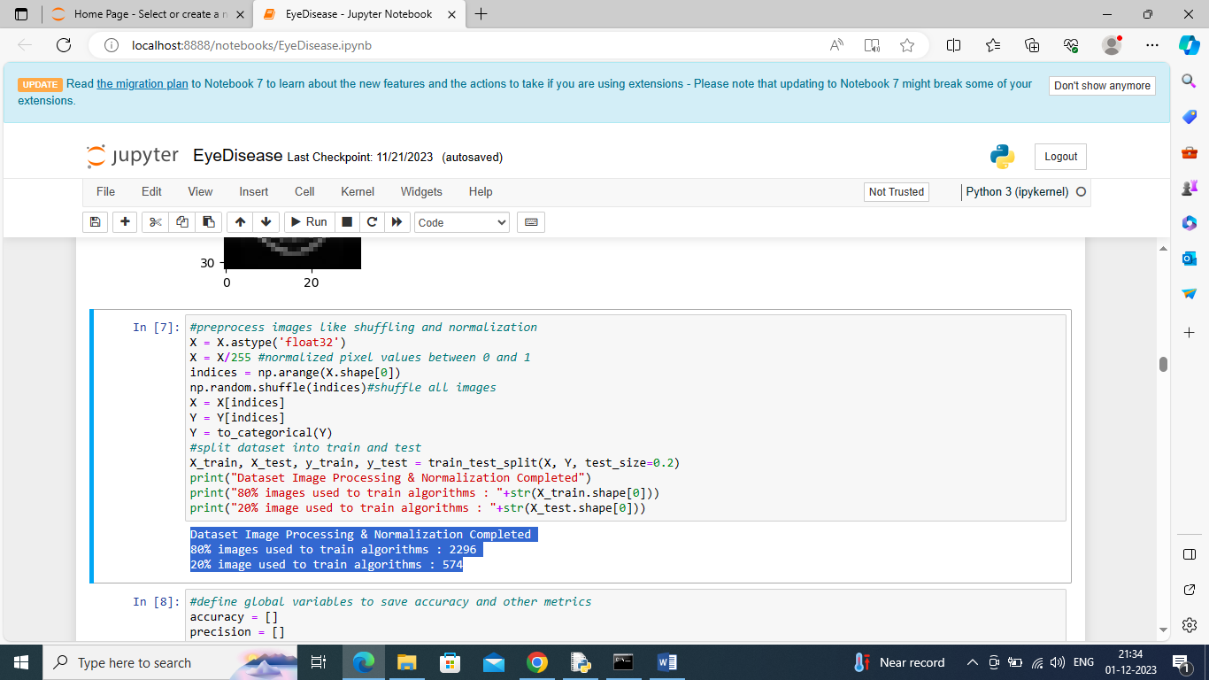
In above screen applying processing techniques such as shuffling, normalization and then splitting dataset into train and test and then in blue colour text displaying train and test data size
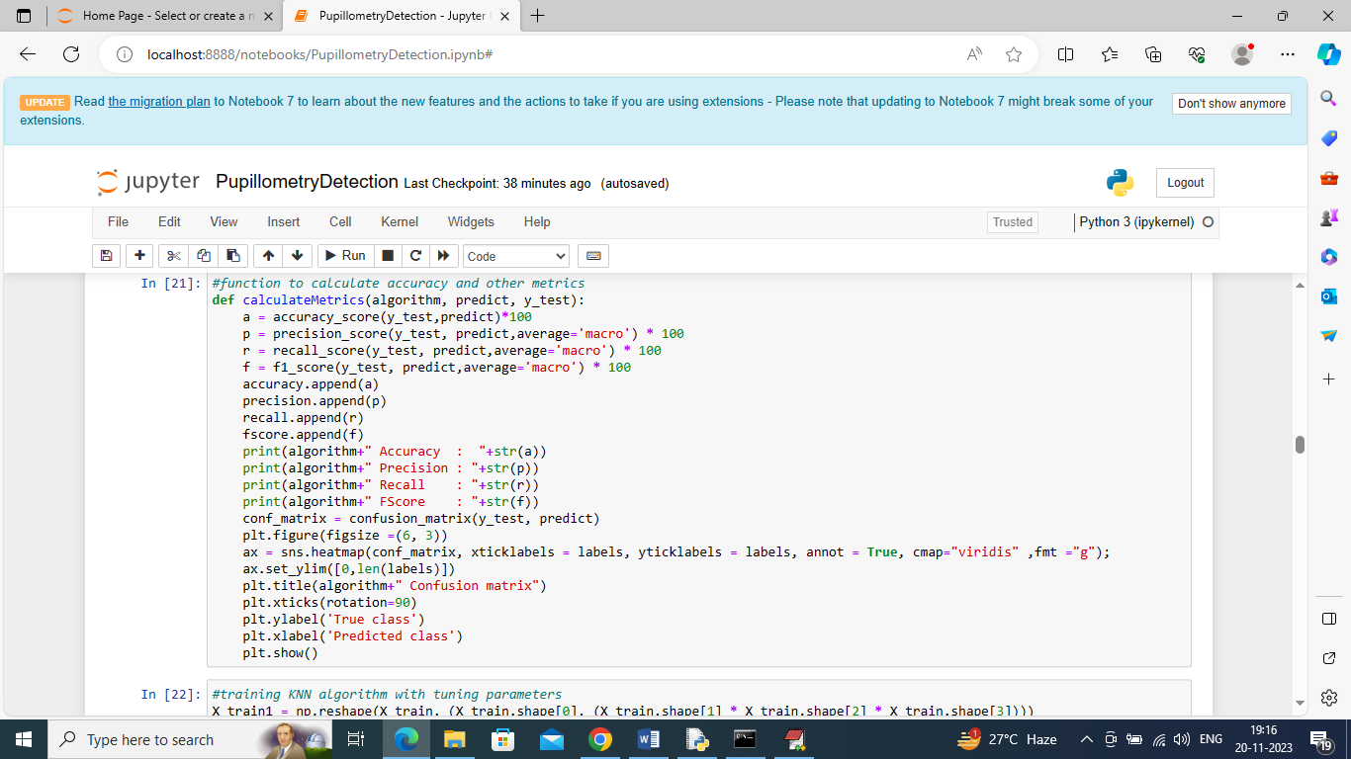
In above screen defining function to calculate accuracy and other metrics
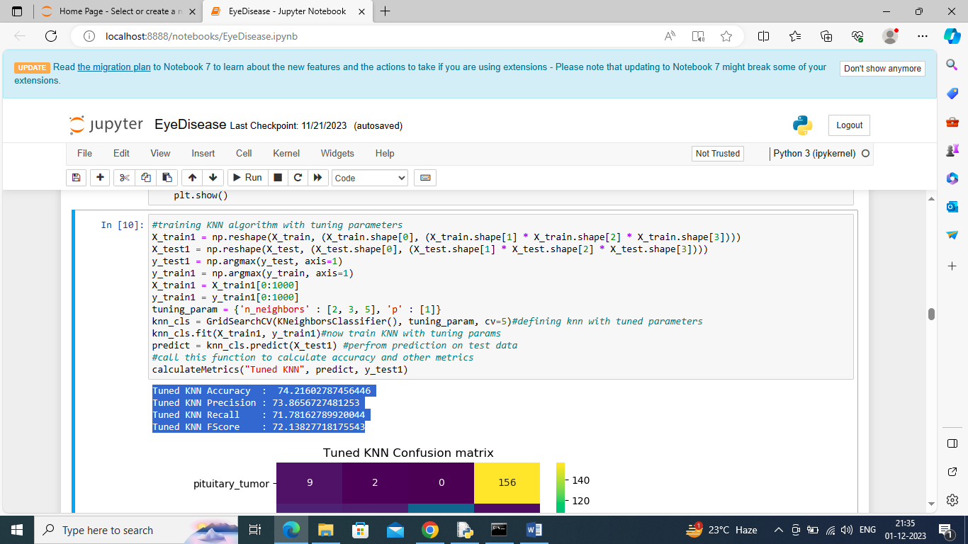
In above screen training KNN with tuned parameters and after training KNN got 74% accuracy and can see other metrics also and below is the KNN prediction confusion matrix graph
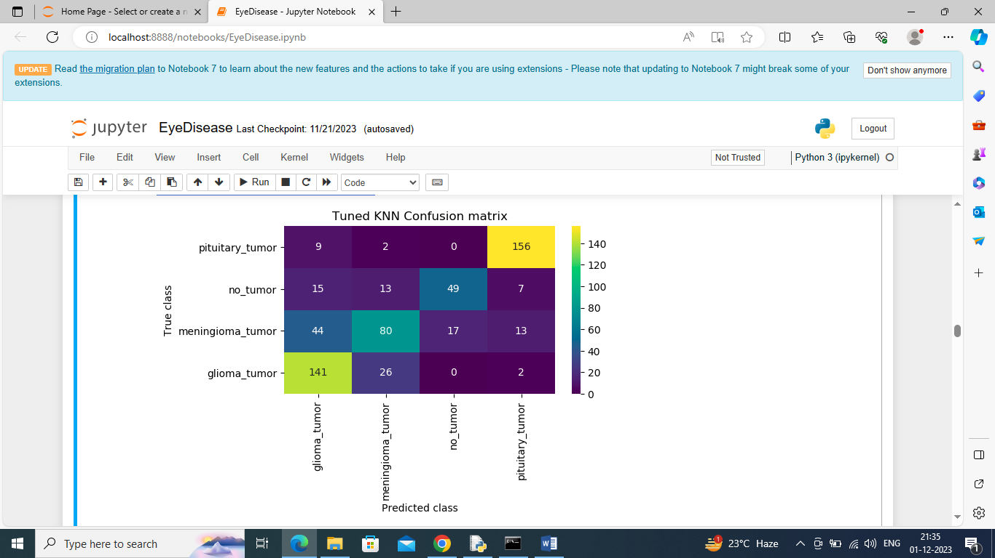
In above KNN confusion matrix graph x-axis represents Predicted Labels and y-axis represents True Labels and all boxes in diagnol represents correct prediction count and remaining boxes represents incorrect prediction count
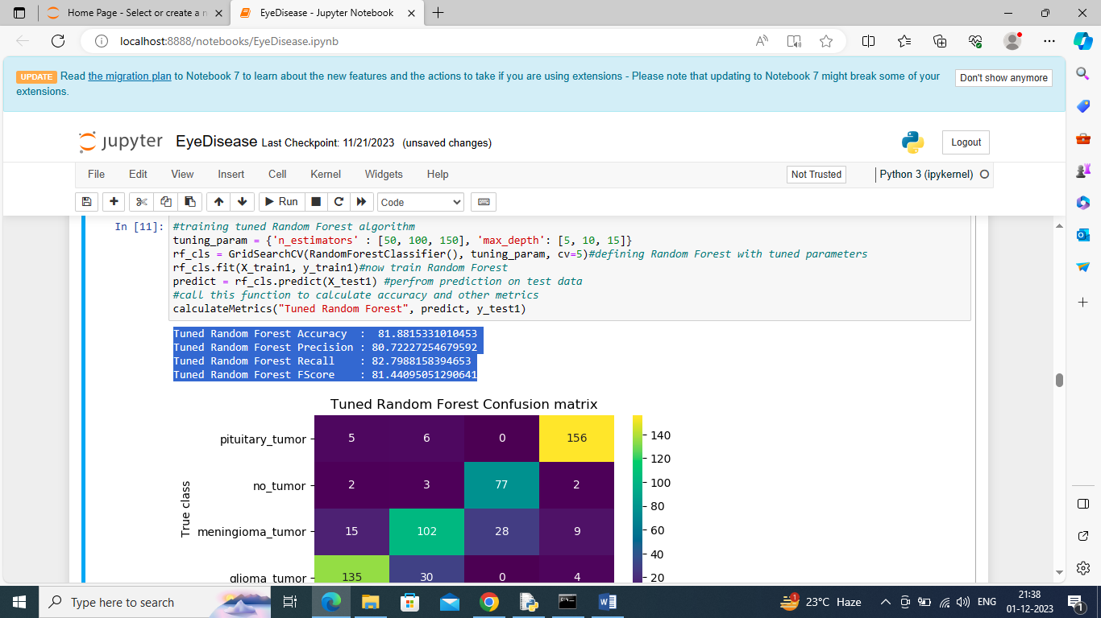
In above screen training Random Forest with tuned hyper parameters and then performing prediction on test data and then Random Forest got 81% accuracy and can see other metrics also
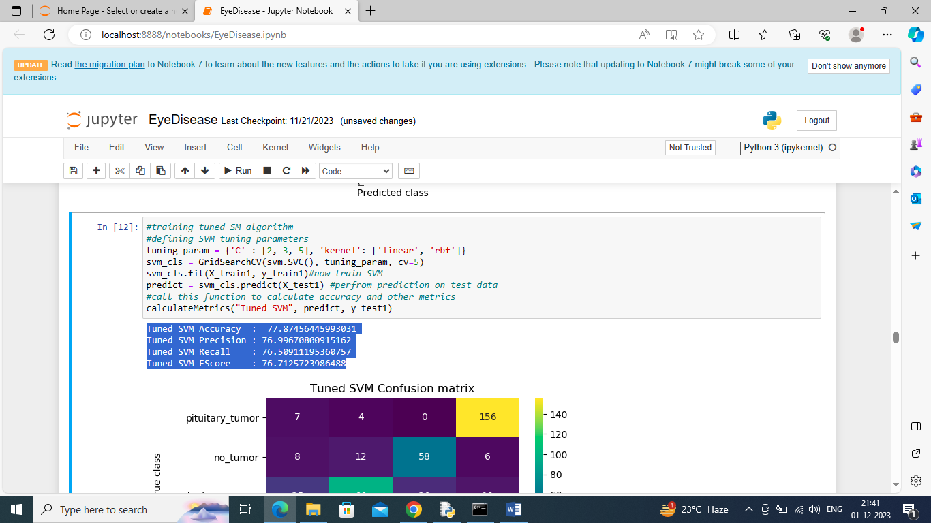
In above screen training SVM algorithm and after prediction on test data SVM got 77% accuracy
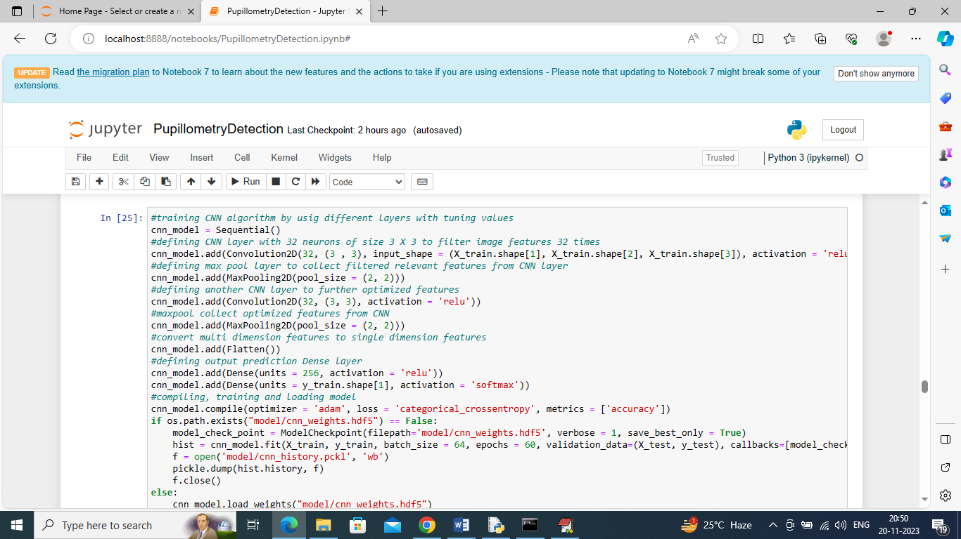
In above screen defining CNN2D neural network and after execution of this block will get below output
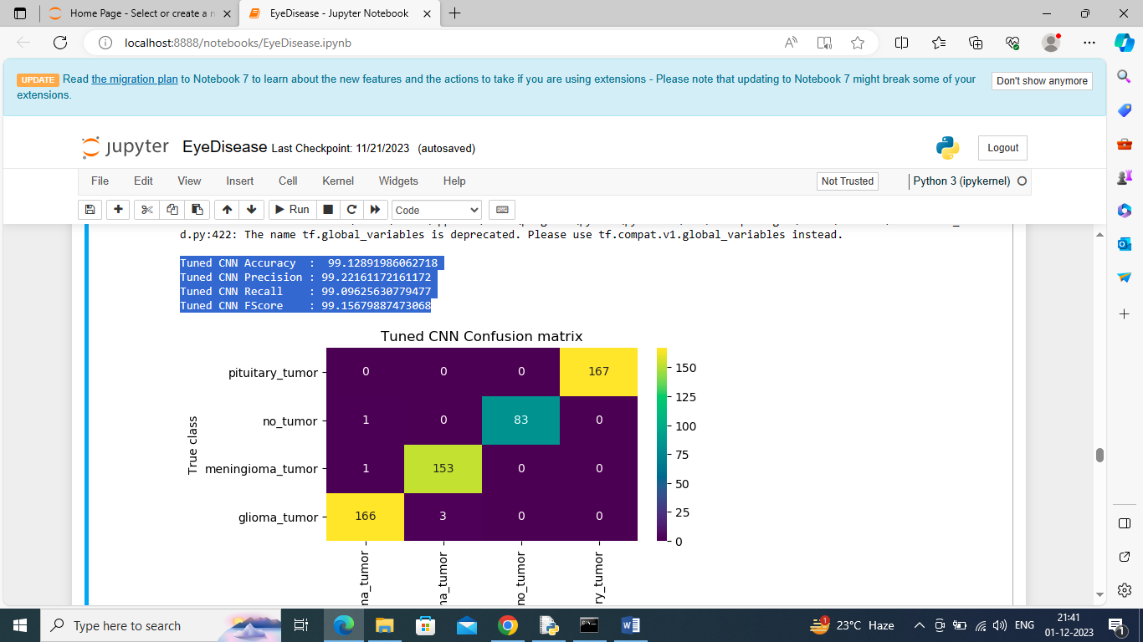
In above screen CNN got 99% accuracy and in confusion matrix graph yellow boxes contains correct prediction count and all blue boxed contains incorrect prediction count which are very few.
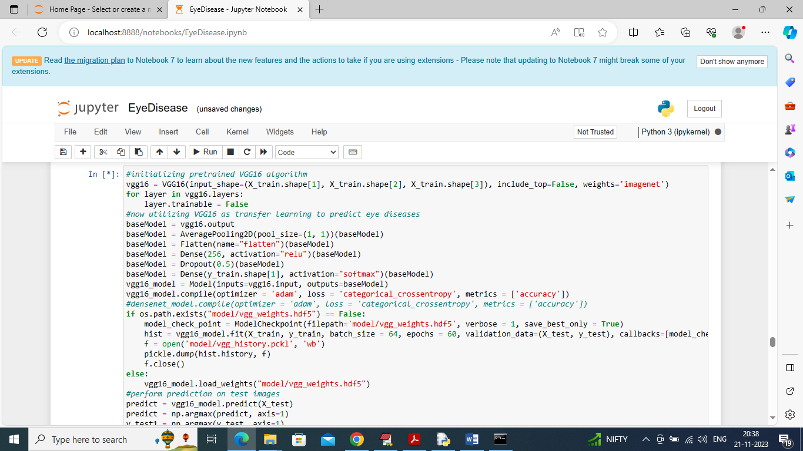
In above screen training pre-trained VGG16 model and after executing above model will get below output
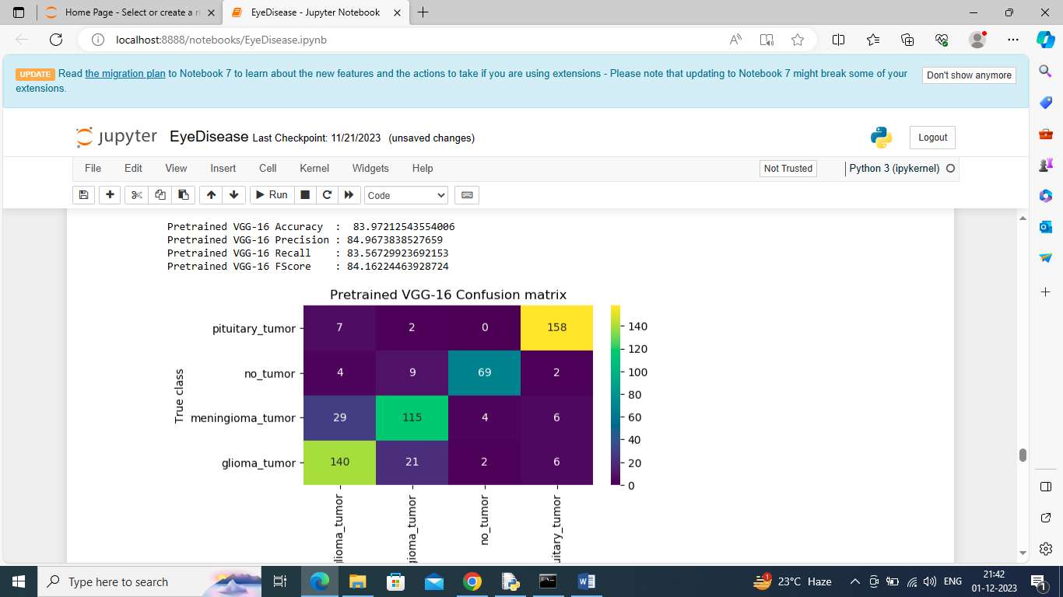
In above screen VGG16 got 83% accuracy and this model is the second highest in accuracy
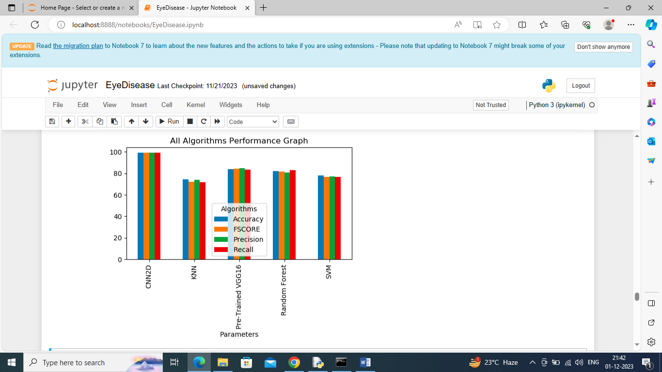
In above graph displaying performance of all algorithms where x-axis represents algorithm names and y-axis represents accuracy and other metrics and in all algorithms CNN got high accuracy
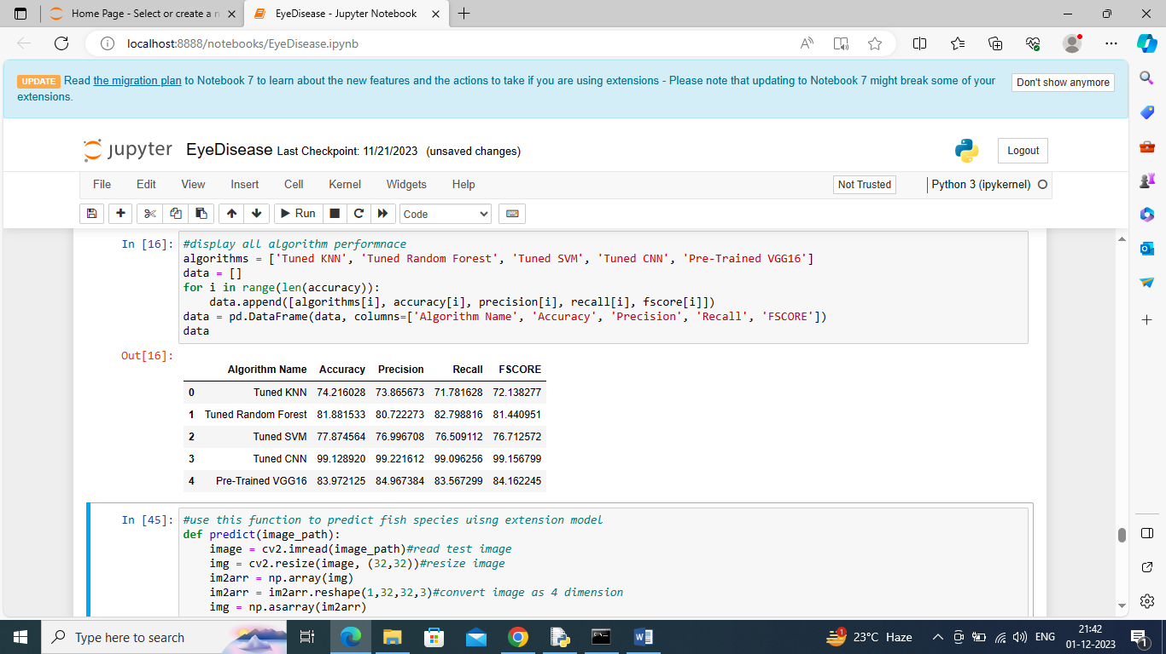
In above screen displaying all algorithm performance in tabular format
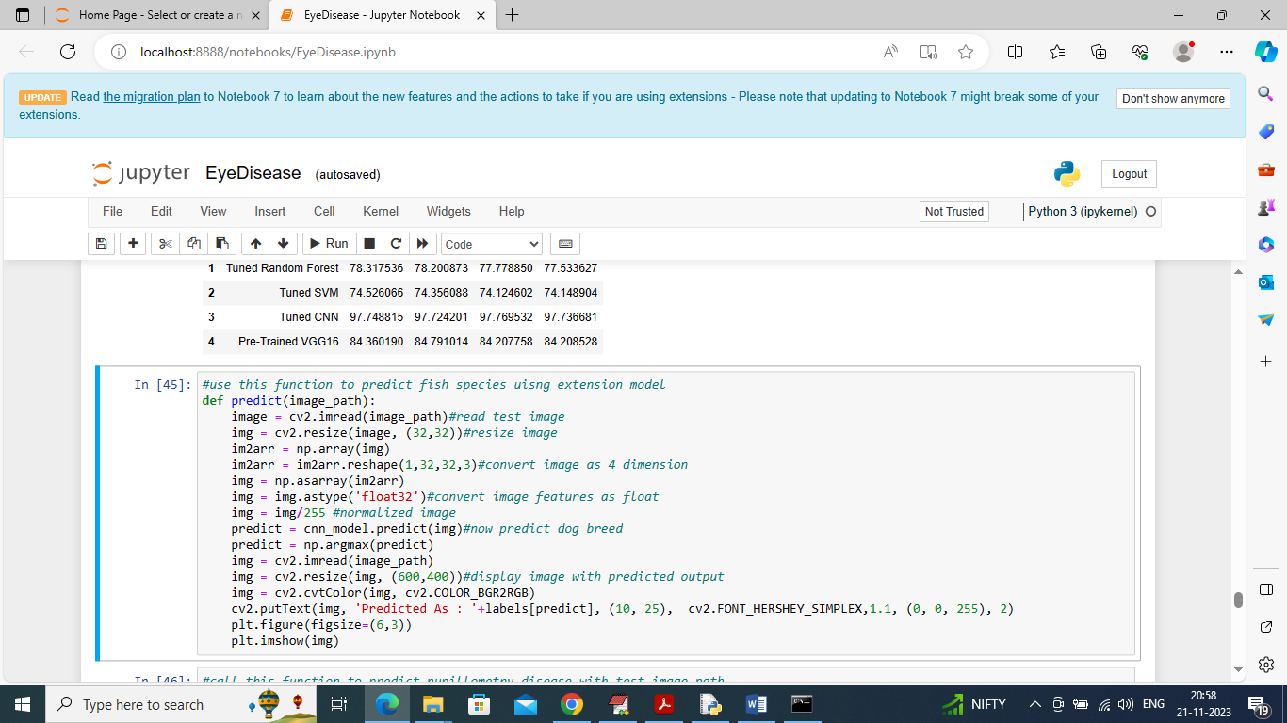
In above screen defining predict function which will take input image path and then predict disease type
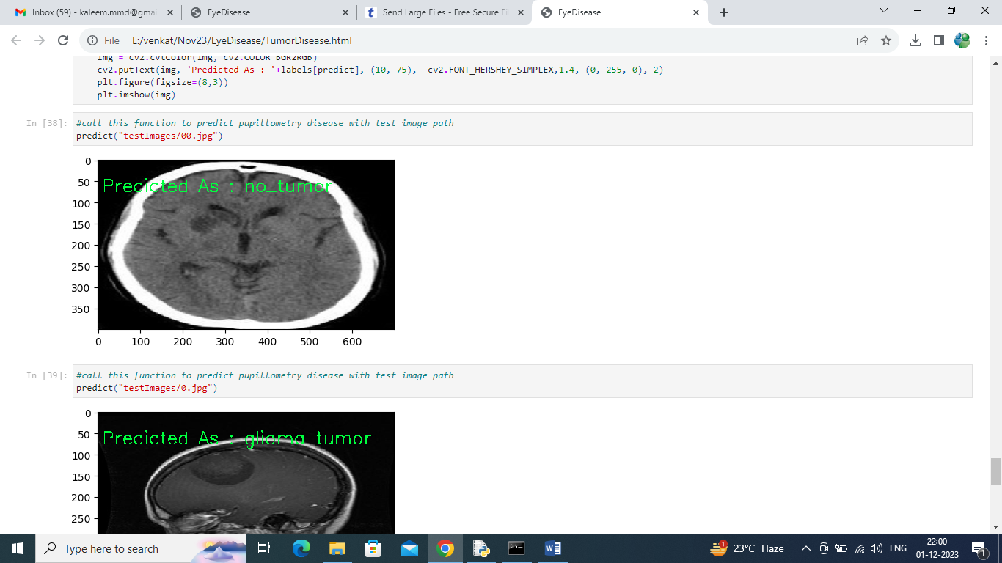
In above screen calling predict function with test image path and then in green colour text we can see predicted label
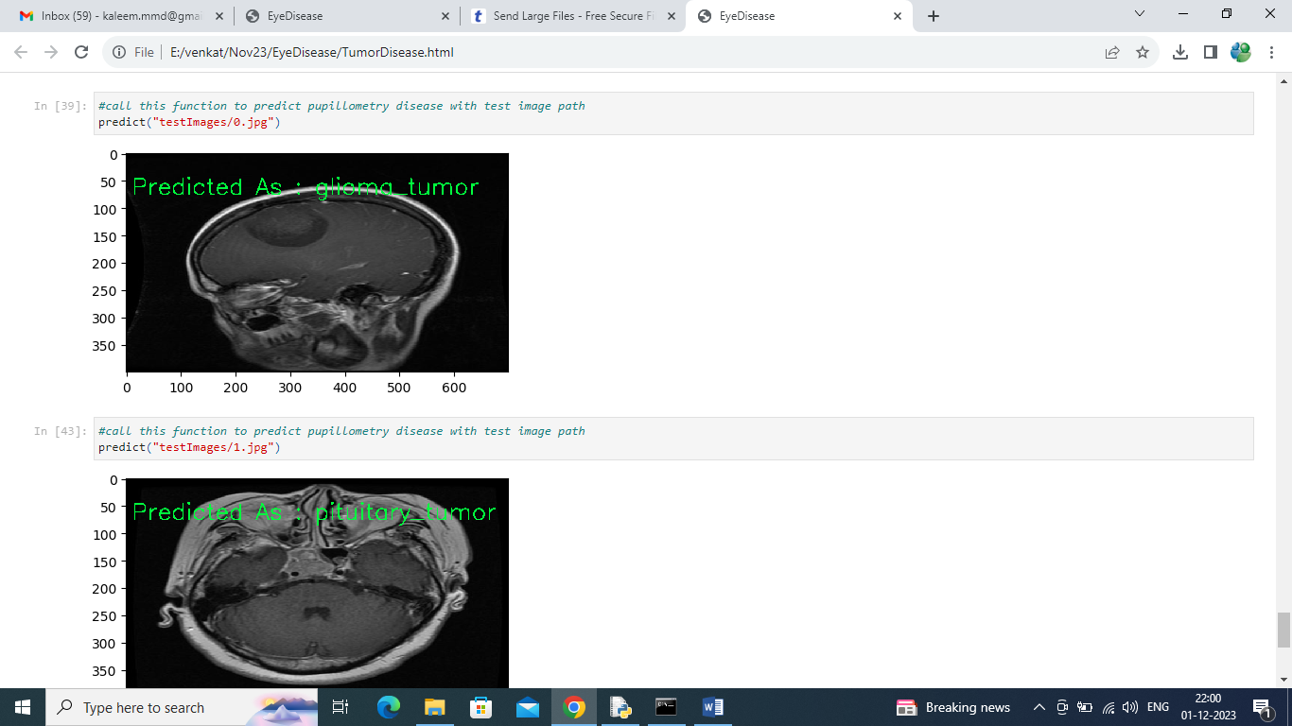
In above screen can see other image predicted disease type
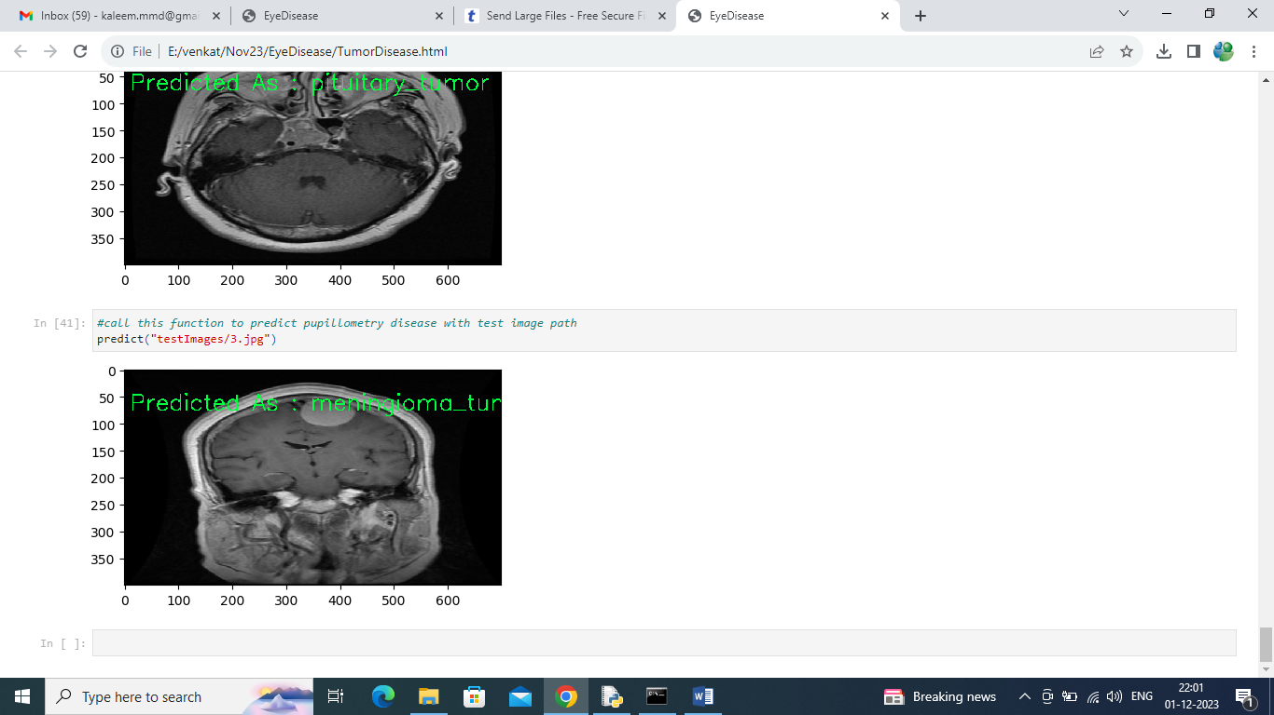
Above screen showing prediction of another image. Similarly by giving test image path we can predict pupillometry disease

