MASTER'S THESIS PROGRESS REPORT
Deep Learning-Based Real-Time Student Behavior Analysis and Attention Loss Detection
A near-real-time, leak-free, uncertainty-aware visible-cue study in a computer laboratory
Prepared by: Wael Kokach
Reporting date: 10 August 2026
Repository state: main at 5826e1cb8a48dc5adedb5f7fb9b9e941a709631d
Project status: Core experiments complete; thesis drafting and closure work in progress

Summary
The strongest positive result is the controlled Branch-A attribution experiment: replacing detector-order assignment with content-based Hungarian matching raises grounding Recall@1 from 0.3230 to 0.4954 while Recall@10 changes by only 0.014. A model trained on exact correspondences reaches test R@1 of 0.6462 on a pre-registered 27-video split. Branch B then shows that temporal architecture matters more than adding feature families: MS-TCN reaches 0.500 +/- 0.011 test macro-F1, improving on the transformer by 0.0933 in all three seed pairs.
Branch C provides disciplined negative evidence. A validated full-range pose estimator, task-relative canonicalisation, uniform multimodal fusion, and learned reliability fusion all fail the registered practical-effect gate. The branch nevertheless makes two valuable contributions: it demonstrates that pose is redundant with the existing appearance representation, and it catches label leakage in an initially impressive reliability-fusion result before that result could enter the thesis. An unregistered follow-up also finds that a different training configuration improves macro-F1 by 0.0406, a practical effect twice the registered threshold, although the responsible hyperparameter remains unidentified.

1. Project scope and defensible claim
Registered title: Deep Learning-Based Real-Time Student Behavior Analysis and Attention Loss Detection
Operational thesis claim: the system detects and temporally aggregates visible cues such as screen orientation, looking away, head-down posture, turning towards a peer, phone-use evidence, and uncertainty. It supports instructor review; it does not infer a student's internal mental state.
The corpus audit further narrows the setting. The recordings come from one computer-laboratory room and one fixed corner-mounted camera at approximately 20-30 degrees elevation, not from multiple overhead cameras. Viewpoint invariance can be proved and synthetically tested but cannot be claimed empirically from this dataset.

Research questions now supported by evidence
RQ1 - Attribution: How much does description-to-student binding quality affect open-vocabulary grounding?
RQ2 - Cue modelling: Which feature families and temporal architectures improve six-cue classification?
RQ3 - Temporal behaviour: How well do frame predictions form sustained human-referenced events?
RQ4 - Deployment: What accuracy, calibration, latency, and scaling trade-offs arise in an instructor dashboard?
RQ5 - Construct validity: How context-dependent is the relationship between visible cues and engagement labels?
RQ6 - Extension study: Do full-range pose, task-relative canonicalisation, and observability-aware fusion add measurable value beyond appearance?

2. Progress against major work packages
Table 1. Current completion and evidence status
Work package | Status | Evidence / remaining condition
Data reconstruction and audit | Complete | 128 recovered recordings; 4,660/4,660 anchors verified; deduplication and video-wise splits frozen.
Branch A grounding | Complete | Controlled assignment ablation and one permitted 27-video test evaluation.
Branch B cue modelling | Complete | Leak-free 73/27/27 rebuild; transformer, MS-TCN and ASRF; three seeds; calibration and events.
Human-reference study | Diagnostic complete | 754 accepted frame labels, 10 tracks, 16 distinct episodes; second annotator still missing.
Dashboard and runtime | Operational | Model selector, uploaded/recorded video, calibration, abstention and replay verified; near-real-time GPU mode.
Branch C extension | Selection stage complete | 180 training runs across 12 arms; four registered nulls; outer folds preserved unopened.
Reproducibility | Substantial, incomplete | Artifact lock, bootstrap, pyproject, CI design and 234-test HPC suite; public checkpoint/data hosting unresolved.
Thesis writing | In progress | Full first draft and separate thesis-ready Branch-C draft available.
Ethics and governance | Open blocker | No ethics/consent record found; identifiable annotation history requires a repository-policy decision.
Sources: FINDINGS.md Sections 1-12; THESIS_FIRST_DRAFT.md; THESIS_BRANCH_C_DRAFT.md; docs/REPRODUCIBILITY.md.

3. Dataset reconstruction and evaluation discipline
The largest improvement in scientific validity came from rebuilding the data pipeline rather than changing the neural architecture. Earlier March experiments were invalidated because the frame-wise split was temporally leaked, some checkpoints were missing or duplicated, and several evaluators produced plausible but incorrect numbers. The rebuilt pipeline recovers recording identity, removes near-duplicate crops, preserves every retained frame's student annotations, and groups all splits by video.
Table 2. Audited corpus and split
Audit item | Result | Interpretation
Raw per-student records | 283,913 | One crop, caption and structured label record per detected student.
Recovered recordings | 128 | 127 used in the main split; the remaining recording contains four frames.
Verified identity anchors | 4,660 / 4,660 | 100% of available anchors matched recovered appearance chains.
Deduplicated selections | 84,950 | Approximately 70% of near-duplicate crops removed.
Main video split | 73 / 27 / 27 | Train / validation / test; video-wise and shared across Branch A/B rebuild.
Detector frames | 36,339 / 9,352 / 9,405 | Train / validation / test.
Temporal sequences | 4,390 / 1,085 / 1,056 | 6,531 total sequences.
Temporal frames | 185,050 / 42,702 / 43,733 | Train / validation / test.
Camera setting | 1 room, 1 fixed corner camera | Audit sample indicates approximately 20-30 degree elevation.
Students per video | Median 7 (range 2-13) | Branch-C repository/data audit.
Sources: THESIS_FIRST_DRAFT.md Tables 3.1 and 5.1; FINDINGS.md Sections 2 and 11.1; docs/branch_c/REPOSITORY_AND_DATA_AUDIT.md.
SCIENTIFIC VALUE: The project does not rely on a single best score. Its evidence base includes controlled ablations, pre-registered test access, grouped splits, multiple seeds, paired video-level comparisons, human diagnostic labels, calibration, runtime profiling, and explicit invalidation of compromised results.

4. Branch A - description-to-student grounding
Branch A addresses a first-order supervision problem: a multi-student caption can describe several people, but the description units must be bound to the correct boxes before detector training. The original detector-confidence ordering has no semantic relationship to the caption order. Content-based Hungarian matching provides a clean, controlled improvement while holding images, boxes, captions, schedule, learning rate, seed, and evaluator fixed.

4.1 Content-only assignment benchmark
Table 3. Description-unit to box assignment
Binding method | Assignment accuracy | Wrong-assignment rate
Detector-confidence ordinal | 0.2607 | 0.7393
Hungarian, CLIP content only | 0.7896 | 0.2104
Sinkhorn, content only | 0.7896 | 0.2104
72,398 frames and 261,397 assignments; spatial_weight=0.0. The earlier 0.9231 result is contaminated by a ground-truth ordering shortcut and is excluded.
A logistic assignment calibrator reaches AUROC 0.760 and ECE 0.011. At probability >= 0.9 it retains 70.1% of assignments at 96.2% held-out precision. This confirms that confidence ranking is meaningful, although the later training ablation shows that aggressive filtering sacrifices too much data.

4.2 Controlled detector ablation and held-out result
Table 4. Grounding experiment
Training labels | Regions | R@1 | R@5 | R@10 | Interpretation
Ordinal binding | 165,013 | 0.3230 | 0.8978 | 0.9811 | Controlled baseline
Hungarian binding | 165,017 | 0.4954 | 0.9595 | 0.9952 | +0.1724 R@1
Hungarian + p>=0.9 | 98,526 | 0.4787 | 0.9441 | 0.9913 | Negative: below unfiltered
Exact correspondence, validation | 141,522 | 0.6343 | 0.9808 | 0.9963 | Main model
Exact correspondence, test | 141,522 | 0.6462 | 0.9891 | 0.9982 | Pre-registered; protocol closed
Sources: TEST_SPLIT_PROTOCOL.md; outputs/FINAL_RESULTS_REGISTER.*; FINDINGS.md Sections 3.2-3.5.
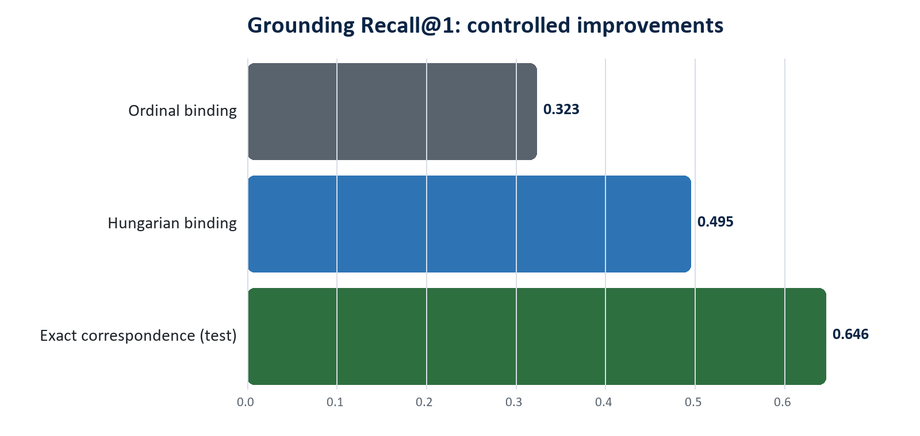
Figure 1. Cleaner attribution improves top-1 grounding; exact correspondences provide the strongest supervision.
CORE THESIS RESULT: Hungarian binding improves R@1 by 17.24 percentage points (+53% relative), while R@10 changes by only 1.41 points. Both models locate students; the gain is primarily correct attribution of the description to the student.

5. Branch B - visible-cue temporal modelling
Branch B maps each tracked student sequence to one of six observable cues. The feature base combines CLIP appearance, box geometry, colour statistics and posture proxies. Controlled column-slice ablations then add head pose, facial-expression probabilities, and handcrafted motion/gaze dynamics. All final comparisons use the shared leak-free 73/27/27 video partition and three seeds.

5.1 Feature ablation
Table 5. Isolated feature-family effects
Added block | Delta macro-F1 | Significant seed pairs | Conclusion
Head-pose block (556-552) | +0.0294 validation; +0.0296 test | 3/3 | Supported aggregate gain
Expression only | +0.0009 | 0/3 | No supported gain
Motion/gaze dynamics only | -0.0105 | 0/3 | No supported gain
Expression + dynamics | -0.0031 | 0/3 | No supported gain
Pose angles over face_found control | +0.0058 test | 0/3 | Angles not supported
Sources: THESIS_FIRST_DRAFT.md Section 5.3; FINDINGS.md Sections 11.4 and 11.10.
Decomposition changes the interpretation of the head-pose result. Approximately four fifths of the useful block-level gain is associated with face_found, while yaw, pitch and roll add only a small non-significant increment. Branch C later confirms that the legacy angles are not reliable orientation measurements and that a valid full-range estimator is redundant with appearance.

5.2 Temporal architecture comparison
Table 6. Untouched Branch-B test split, mean over three seeds
Model | Features | Accuracy | Balanced acc. | Macro-F1 | Macro-AUPRC | ECE
Transformer | 552 | 0.657 +/- 0.003 | 0.396 | 0.377 +/- 0.007 | 0.357 | 0.065
Transformer | 556 | 0.699 +/- 0.011 | 0.424 | 0.407 +/- 0.004 | 0.392 | 0.068
Transformer* | 570 | 0.660 +/- 0.011 | 0.424 | 0.390 +/- 0.005 | 0.388 | 0.075
ASRF | 556 | 0.710 +/- 0.022 | 0.513 | 0.477 +/- 0.016 | 0.473 | 0.033
ASRF | 570 | 0.735 +/- 0.023 | 0.521 | 0.492 +/- 0.019 | 0.482 | 0.031
MS-TCN | 556 | 0.759 +/- 0.002 | 0.519 | 0.500 +/- 0.011 | 0.489 | 0.032
MS-TCN* | 570 | 0.765 +/- 0.018 | 0.481 | 0.488 +/- 0.023 | 0.477 | 0.025
*The additional 570-dimensional feature block did not provide a repeatable aggregate gain. Source: BRANCH_B_TEST_PROTOCOL.md and outputs/FINAL_RESULTS_REGISTER.*.
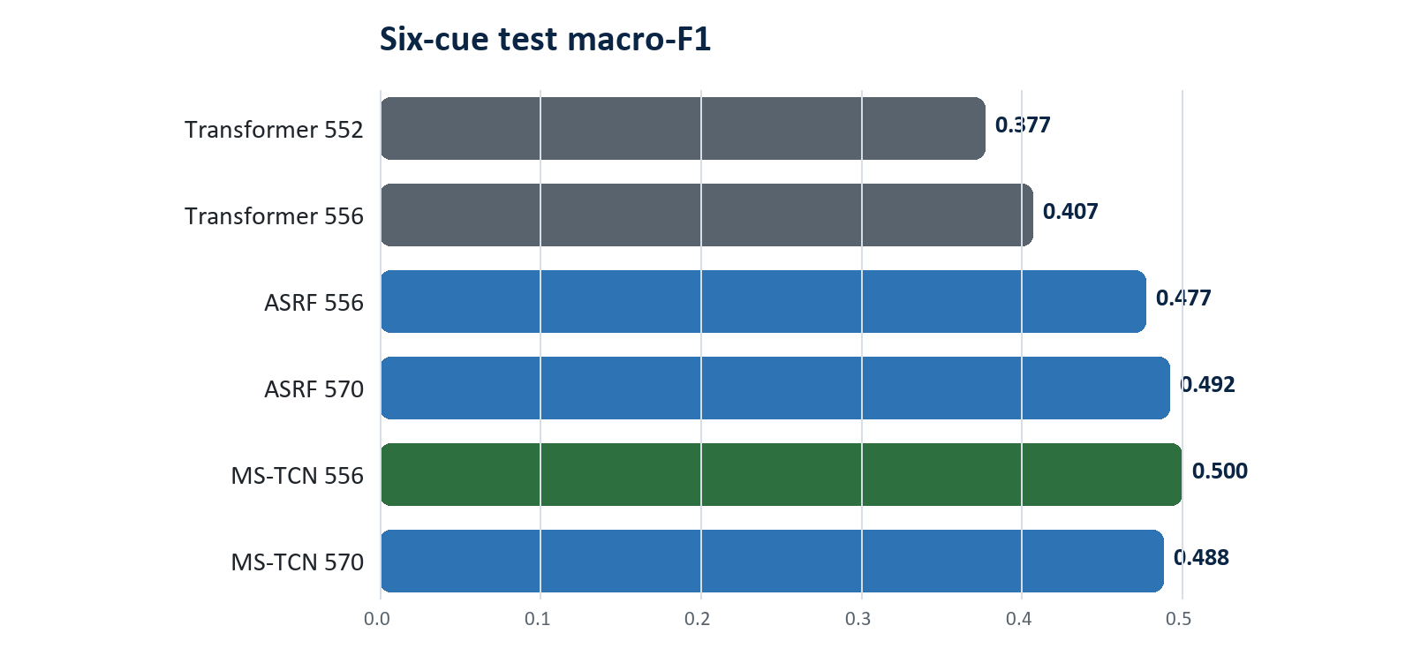
Figure 2. Temporal architecture contributes substantially more than adding expression and handcrafted dynamics.
With identical 556-dimensional inputs, MS-TCN improves test macro-F1 over the transformer by 0.0933, with all three seed-pair differences significant. The pre-registered ASRF-556 primary remains reported at 0.477 +/- 0.016; the fact that MS-TCN scores higher is retained rather than used to rewrite the selection rule.

5.3 Human-referenced temporal and event evaluation
The dense human diagnostic contains 754 accepted frame annotations across ten tracks and 16 distinct episodes after removing duplicated event aliases. It is deliberately small and excludes detector/tracker errors, so its event scores are diagnostic rather than classroom-wide estimates.
Table 7. Human-referenced segmentation and events
System | Frame acc. | F1@25 | Edit | Event P | Event R | Event F1 | FA/hour
Transformer 552 | 0.738 | 0.244 | 30.9 | 0.560 | 0.292 | 0.383 | 9.4
Transformer 556 | 0.782 | 0.265 | 38.2 | 0.622 | 0.208 | 0.312 | 5.1
MS-TCN 556 | 0.788 | 0.291 | 48.5 | 0.554 | 0.271 | 0.353 | 11.1
MS-TCN 570 | 0.771 | 0.362 | 59.9 | 0.454 | 0.312 | 0.368 | 15.3
ASRF 570 | 0.785 | 0.291 | 53.4 | 0.506 | 0.229 | 0.315 | 9.4
Pseudo-label teacher | 0.874 | 0.700 | 76.5 | 0.588 | 0.625 | 0.606 | 17.9
Majority control | 0.341 | 0.067 | 34.9 | 0.000 | 0.000 | 0.000 | 0.0
tIoU=0.30 for events. Detector and tracker excluded. Source: THESIS_FIRST_DRAFT.md Section 5.5 and outputs/FINAL_RESULTS_REGISTER.*.
MS-TCN clearly reduces fragmentation: its best edit score is 59.9 versus 28.8-38.2 for transformer configurations. Event recall remains the unresolved weakness, reaching at most 0.312 compared with 0.625 for the pseudo-label teacher. This makes temporal segmentation a demonstrated improvement while preventing an exaggerated event-detection claim.

5.4 Calibration, abstention and alert operating points
Table 8. Temperature calibration
Model | Temperature | Test ECE before -> after | Test NLL before -> after
Transformer 556 | 1.311 | 0.0739 -> 0.0191 | 0.9660 -> 0.9121
ASRF 556 | 0.759 | 0.0570 -> 0.0306 | 0.7854 -> 0.7791
MS-TCN 556 | 0.924 | 0.0287 -> 0.0155 | 0.7033 -> 0.7043
Thresholds are fit on validation and frozen. A slight NLL increase for MS-TCN is reported rather than hidden.
For the deployed path, the display threshold retains approximately 90% coverage; the alert threshold targets at least 85% selective accuracy. Raw predictions are always recorded, while low-confidence predictions are withheld from the interface or alerts. Across 13 dashboard variants, alert coverage at the same 85% precision target spans 30.5% to 78.7%, showing that operational usefulness is not ranked by macro-F1 alone.

6. Construct validity and external evidence
External experiments are used to bound the thesis claim, not to manufacture a universal engagement result. Their central lesson is that identical visible movements can mean different things in different learning settings.
Table 9. External and construct-validity experiments
Experiment | Result | Interpretation
DIPSER cue-engagement association | Spearman rho = +0.172; p<0.0001; n=1,825 | Weak and opposite to the naive disengagement hypothesis; cue meaning is context-dependent.
Basic expressions -> expert boredom | AUROC 0.544; n=1,176 | Near chance; no boredom-detection claim.
SCB zero-shot transfer | Localisation recall 0.392; R@1 confounded | Task/label mismatch prevents a valid transfer score.
Teacher vs human frame labels | 0.874 agreement on 754 accepted frames | Empirical teacher benchmark, not a theoretical ceiling.
Pseudo-label field accuracy | 0.939 over 311 held-out crops | Activity is weakest at 78.9%.
Sources: outputs/FINAL_RESULTS_REGISTER.*; FINDINGS.md Sections 5-6; DIPSER and SCB analyses.

6.1 CMOSE split-policy experiment
CMOSE is treated as a separate four-level ordinal engagement task. The released random-segment split places 101 of 103 subjects in more than one split. Rebuilding a subject-disjoint split produces a large performance drop, quantifying how split policy changes the apparent difficulty.
Table 10. CMOSE official versus subject-disjoint evaluation
Metric | Official split | Subject-disjoint | Change
Accuracy | 0.7179 +/- 0.0030 | 0.6006 +/- 0.0058 | -0.1173
Average accuracy | 0.6007 +/- 0.0086 | 0.4347 +/- 0.0084 | -0.1660
Macro-F1 | 0.5733 +/- 0.0027 | 0.4111 +/- 0.0051 | -0.1622
MAE | 0.3123 +/- 0.0029 | 0.4459 +/- 0.0123 | +0.1336
QWK | 0.5369 +/- 0.0039 | 0.3167 +/- 0.0319 | -0.2202
Spearman rho | 0.5354 +/- 0.0086 | 0.3221 +/- 0.0305 | -0.2133
Separate task; these values must not be compared directly with six-cue macro-F1 or grounding R@k.

7. Deployment, dashboard and runtime
The prototype is operational and demonstrable, but it is correctly described as near-real-time. The deployment work replaced the expensive face landmark mesh with a detector-based face-presence signal, then introduced detector and temporal striding with measured cue-agreement controls.
Table 11. Runtime trade-off on one A100, approximately six students
Detector:temporal stride | FPS | p50 | p95 | Cue agreement | Track coverage
1:1 | 3.69 | 270.7 ms | 295.9 ms | 100% reference | 100%
3:2 adopted | 5.77 | 157.6 ms | 291.7 ms | 94.7% | 100%
5:3 | 7.03 | 117.9 ms | 257.5 ms | 92.2% | 100%
10:5 | - | - | - | 88.3% | 100%
Source: FINDINGS.md Sections 11.16-11.17; LLMDet/configs/attention_runtime.yaml.
The detector backend improves like-for-like throughput from 2.84 to 3.69 FPS (+30%) with no repeatable accuracy loss. The adopted 3:2 stride raises throughput by a further 56% and preserves 94.7% cue agreement. Because the p95 tail remains approximately 292 ms and the system does not reach a 10 FPS budget, the report avoids the stronger real-time claim.

7.1 Dashboard evidence
Model selector across 13 deployable variants, each linked to measured validation metrics and its own calibration.
Uploaded/recorded video as a first-class source, plus precomputed session replay and camera/live-path support.
Eight of eight HTTP checks and all model-card consistency checks passed on the frozen dashboard verification.
Four replayed models disagree on 8.5-15.0% of shared frame-track pairs, confirming that switching changes the actual model rather than only the label shown in the interface.
On CPU, the temporal head runs at approximately 25-26 FPS for MS-TCN but 5.7-5.8 FPS for ASRF; ASRF is roughly 4.5 times slower.

DEPLOYMENT POSITION: The project demonstrates a calibrated, auditable instructor-facing prototype with measured latency and fallback behaviour. It should be presented as decision support and research infrastructure, not as an autonomous classroom surveillance or intervention system.

8. Branch C - OVERT-Cue extension study
Branch C was designed to test an overhead-specific contribution based on task-relative orientation and reliability-aware multimodal fusion. The initial premise was corrected before experimentation: the dataset contains one fixed corner camera, not multiple overhead views. The branch therefore retained only claims that could be supported in this setting and used nested grouped cross-validation because the original Branch-B test had already been spent.
The five outer folds remain unopened. All Branch-C performance values below are inner-validation selection statistics over 15 matched fold-seed pairs, not generalisation estimates and not directly comparable to the Branch-B test table.

8.1 Methodological contribution retained
A task-relative SO(3) representation with an exact coordinate-invariance proof, verified over 256 random rotations to numerical tolerance.
A validated 6DRepNet360 full-range pose instrument selected after license review; Ultralytics and DirectMHP candidates were rejected because of copyleft implications.
Pre-registered gates for canonicalisation, pose, uniform fusion, learned fusion and observability losses.
Leakage-aware quality controls that distinguish deployable pipeline signals from teacher-side annotation fields.
Independent recomputation, error analysis and proposer-reviewer sign-off.

8.2 Experimental sweep
Table 12. Branch-C inner-validation arms under the common project selection rule
Arm | Features / model | Macro-F1 | SD | Interpretation
0b | Five pipeline-measured quality signals only | 0.3208 | 0.028 | Valid shortcut baseline
0 | + three teacher-side annotation fields | 0.4602 | 0.023 | Upper bound; not deployable
1 | Appearance 552 + face_found | 0.4837 | 0.027 | Deployed-style baseline
2 | + legacy MediaPipe angles | 0.4887 | 0.033 | Pose baseline
5 | + validated 6DRepNet360 rotation | 0.4865 | 0.027 | No aggregate gain
3b | Appearance 552, Branch-C training configuration | 0.5243 | 0.032 | Same architecture; configuration change
3 | 3b + deeper stack | 0.5288 | 0.029 | Small architecture increment
8 | + head/motion experts, uniform fusion | 0.5311 | 0.025 | Fusion null
9c | + leakage-free learned reliability | 0.5326 | 0.024 | Learned weighting null
10c | + observability losses | 0.5360 | 0.023 | Small effect below gate
Source: THESIS_BRANCH_C_DRAFT.md; 12 arms x 5 folds x 3 seeds = 180 training runs. Leaky arms 9/10 are excluded from this table.

8.3 Registered contrasts and verdict
Table 13. Paired Branch-C effects
Contrast | Delta | 95% CI | Wins | Verdict
Full-range pose: arm5-arm2 | -0.0022 | [-0.0119, +0.0085] | 5/15 | Null
Full-range pose vs no angles: arm5-arm1 | +0.0028 | [-0.0072, +0.0139] | 8/15 | Null
Uniform fusion: arm8-arm3 | +0.0019 | [-0.0025, +0.0057] | 11/15 | Null
Learned vs uniform: arm9c-arm8 | +0.0015 | [-0.0007, +0.0041] | 10/15 | Null
Observability losses: arm10c-arm9c | +0.0041 | [+0.0010, +0.0070] | 11/15 | Significant; one fifth of gate
Whole fusion stack: arm10c-arm3 | +0.0072 | [+0.0026, +0.0116] | 12/15 | Below +0.02 gate
Training configuration*: arm3b-arm1 | +0.0406 | [+0.0289, +0.0521] | 14/15 | Positive; twice the gate
*Unregistered configuration-level finding; six hyperparameters differ and no individual cause is yet established.
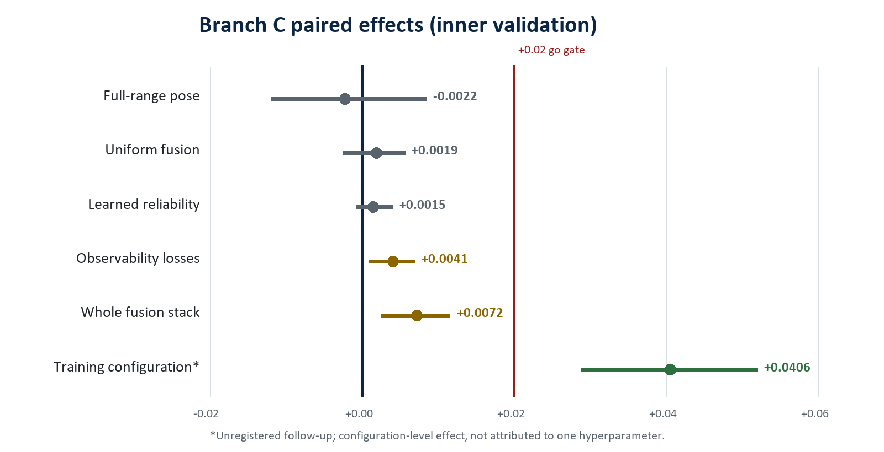
Figure 3. Every registered architectural hypothesis fails the practical-effect gate; the training configuration is the only substantial positive.

8.4 Why the negative pose result is informative
The pose instrument was validated before use. It increases coverage from approximately 63% to 100%, recovers applied in-plane rotation to about one degree, and produces a standalone scalar that separates head_down from screen_oriented at AUC 0.830. Nevertheless, replacing the legacy pose block changes predictions slightly less than changing the random seed: arm2 versus arm5 agrees on 81.9% of frames, while two seeds of the same arm agree on 82.7%.
Table 14. Appearance already encodes orientation-relevant evidence
Cue | Appearance AUROC, no pose | Standalone pose scalar
head_down | 0.915 | 0.830
uncertain | 0.930 | 0.852
turned_to_peer | 0.825 | 0.625
phone_use | 0.889 | 0.519
The standalone-pose scalar is a development pre-test and should be contextual rather than presented as a controlled held-out contrast. The arm-level pose null is the citable controlled result.
The defensible conclusion is not merely that one estimator failed. A full-range estimator was validated, given complete coverage, and shown discriminative in isolation, but the appearance representation already contained stronger orientation-related information. Pose is redundant with appearance in this task.

9. Reproducibility, software quality and independent review
The repository now contains a machine-readable artifact lock, a cross-platform bootstrap entry point, a pyproject dependency declaration, profile-specific download logic, CI checks, frozen protocols, run records, hashes, and extensive documentation. The final Branch-C commit records 234 passing tests on the reference HPC environment. Dashboard verification adds frozen replay fixtures and model-card checks.
Table 16. Reproducibility status
Area | Status | Evidence / gap
Code and protocols | Strong | Branch A/B/C protocols, split hashes, test discipline, evaluator and source are tracked.
Model provenance | Strong on HPC | Checkpoint/config hashes and artifact manifest recorded; Branch-C run records preserved.
Bootstrap and dependency declaration | Implemented | bootstrap.py, artifacts.lock.json and pyproject.toml provide demo/research/full-data/HPC profiles.
Test evidence | Reference environment pass | Latest commit reports 234 tests passing; dashboard checks 8/8 with model-card consistency.
Public demo checkpoint | Open | Fine-tuned detector/temporal weights have no public immutable download URL yet.
Restricted human/student data | Not publicly distributable | Access depends on ethics, consent and repository policy.
Container / CUDA lock | Open | No complete Docker/Apptainer image or bit-reproducible CUDA environment.
Public repository license | Open | A top-level license is still required before public release.
Cross-platform suite | Open | Reference code assumes Linux/HPC components; Windows collection requires fcntl/mmcv compatibility work.
Sources: docs/REPRODUCIBILITY.md; artifacts.lock.json; pyproject.toml; docs/branch_c/INDEPENDENT_REVIEW_LOG.md.

Independent verification and defect prevention
Multiple specialist agents were separated by file ownership and review context; the lead inspected evidence before accepting conclusions.
Unit tests caught an incorrect 6D-rotation column layout and a missing-modality NaN propagation bug before training.
A smoke test caught temporal-model collapse caused by missing deep supervision before a 60-run fusion sweep.
Independent recomputation reproduced the pose null and identified a duplicate evaluation directory, missing convenience-ledger rows and batch-dependent evaluation differences.
Batch-size-one evaluation was selected to eliminate cross-sequence contamination at temporal convolution boundaries.
License audit rejected components whose copyleft terms conflicted with the intended distribution model.

10. Thesis contribution and defensibility
The thesis is conditionally defensible now. Its strength is not a claim of state-of-the-art classroom engagement recognition. Its strength is a coherent research progression from compromised early experiments to a controlled, reproducible, human-audited and deployment-measured visible-cue system.
Table 17. Defensible contribution package
Contribution | Evidence
1. Attribution-aware grounding | Controlled evidence that description-to-box binding quality is a first-order training variable; +0.1724 R@1 with detection largely unchanged.
2. Leak-free temporal cue benchmark | Shared video-wise split, three seeds, one evaluator and paired comparisons across transformer, MS-TCN and ASRF.
3. Feature evidence | Head-pose block decomposition; null results for expression and handcrafted dynamics; pose redundancy established with a validated estimator.
4. Event and uncertainty layer | Human diagnostic events, segmentation/edit metrics, calibration, abstention and false-alert analysis.
5. Near-real-time prototype | Dashboard, model selector, video upload/replay, runtime profiling, stage timing and measured stride trade-offs.
6. Methodological audit contribution | Documented invalidation of leakage, shortcut metrics, random-model deployment and label-bearing reliability inputs.
7. Construct-validity boundary | External evidence shows visible cues are context-dependent and cannot be equated with internal engagement.

Consolidated headline results
Area | Headline result | Meaning
Data recovery | 4,660/4,660 anchors; 128 recordings | Verified reconstruction and video grouping
Deduplication | 283,913 -> 84,950 crops | Approximately 70% removed
Assignment | 0.2607 -> 0.7896 accuracy | Ordinal -> content-only Hungarian
Grounding ablation | R@1 0.3230 -> 0.4954 | +0.1724 controlled effect
Grounding held-out | R@1/5/10 = 0.6462/0.9891/0.9982 | Pre-registered 27-video test
Temporal architecture | MS-TCN-556 macro-F1 0.500 +/- 0.011 | +0.0933 over transformer-556
Feature block | Head-pose block +0.0296 test | Mostly face_found; angles not significant
Segmentation | MS-TCN-570 edit 59.9 | Transformer range 28.8-38.2
Human events | Best model event recall 0.312; teacher 0.625 | 16 distinct episodes; diagnostic
External construct | DIPSER rho +0.172; boredom AUROC 0.544 | Visible cues are context-dependent
Runtime | 5.77 FPS; p95 291.7 ms; 94.7% cue agreement | Adopted 3:2 stride, one A100
Branch C pose | -0.0022 CI [-0.0119,+0.0085] | Validated full-range pose is redundant
Branch C learned fusion | +0.0015 CI [-0.0007,+0.0041] | Null after leakage removal
Branch C training recipe | +0.0406 CI [+0.0289,+0.0521] | Unregistered; cause not isolated
Only compare values within their task and protocol; grounding R@k, cue macro-F1, event recall and ordinal engagement metrics answer different questions.

