**Zend Framework学习笔记**

**一．第一天**

1.新建一个项目，将Zend 库引入项目当中。

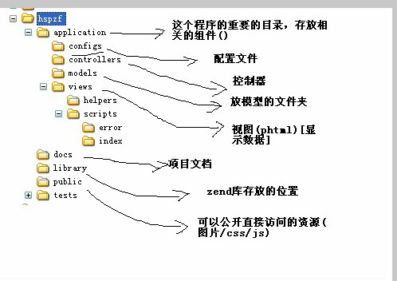

2.开启pdo和pdo数据库引擎，即php.ini中

extension=php_pdo_mysql.dll

1. 开启Apache的rewrite模块

在apache的conf文件下，httpd.conf中寻找rewrite功能

LoadModule rewrite_module modules/mod_rewrite.so

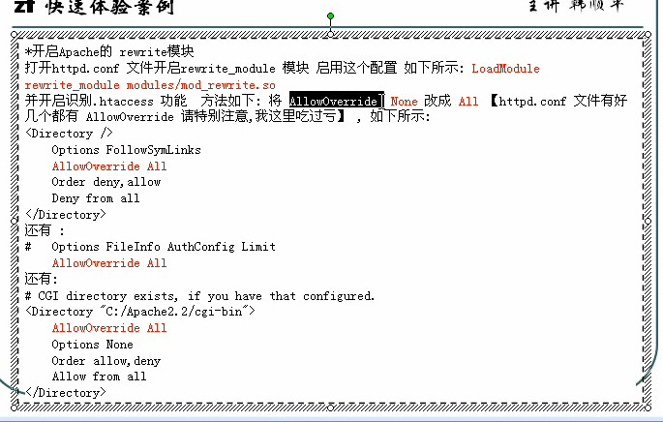

**将该文件的AllowOverride None改为ALL,有三个地方要改**

1. **配置虚拟主机**

**（1）**如果是自定义开发环境，在httpd.conf中

# Virtual hosts 虚拟主机配置

Include conf/extra/httpd-vhosts.conf

（2）在apache/conf/extra/httpd-vhosts.conf中加入下面这一段话:

#配置我们自已的虚拟主机

<VirtualHost *:8080>

ServerAdmin webmaster@dummy-host2.localhost

DocumentRoot "E:/PHP/Apache/htdocs/10-08-Zend1/public"

DirectoryIndex index.php http://dummy-host2.localhost/index.php

ServerName dummy-host2.localhost

ErrorLog "logs/dummy-host2.localhost-error.log"

CustomLog "logs/dummy-host2.localhost-access.log" common

</VirtualHost>