Assignment #2

The goal of this assignment was to connect the terminal application from the first assignment to an RFID reader, and send commands to the reader.

Our submission can put the reader into select mode, which reads all tags in the reader’s range until the user wants to stop reading tags. The tags are displayed in the terminal window.

# Design

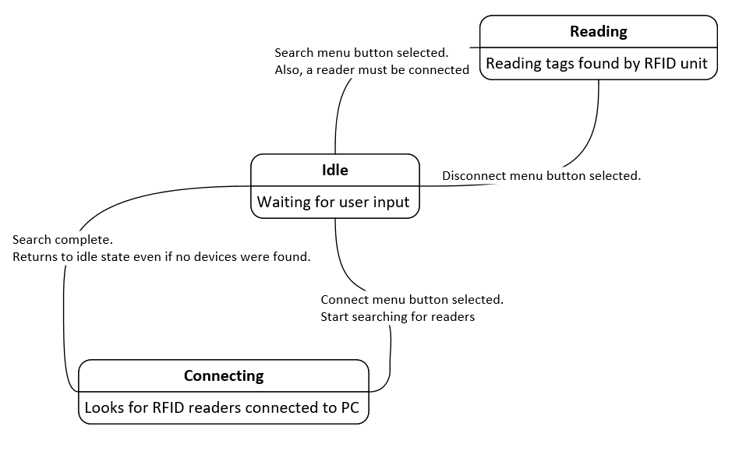

# Pseudocode