**Tagmentation-based BS-seq library preparation as performed in the Hodges Lab**

I. Buffers and Kits

5x Tris-DMF (50 mM Tris-HCl pH 7.5, 25 mM MgCl2, 50% DMF)

Tn5 Storage Buffer (50 mM Hepes pH 7.2, 100 mM NaCl, 0.1 mM EDTA, 1mM DTT,

* 1. % Triton-X 100, 50% Glycerol)

STE Buffer (10 mM Tris-HCl pH 8.0, 50 mM NaCl, 1mM EDTA, pH 8.0)

Lysis Buffer (10 mM Tris-HCl, pH 7.4, 10 mM NaCl, 3 mM MgCl2, 0.1% NP-40)

Zymo DNA Clean & Concentrate-5 (D4004), 200 use kit

Zymo EZ DNA Methylation-Lightning Kit (D5030), 50 use kit

Note: Refer to gDNA extraction protocol to obtain high quality gDNA from cultured or primary cells.

II. Annealing Oligos: (1hr)

1. Dilute oligos to 100 µM in STE buffer.
2. In a 200 µl PCR tubes, mix 10 µl each Tn5mC-Apt1 and Tn5mC1.1-A1block and 80 µl H20.
3. Set thermocycler conditions for adaptor assembly as follows:

95°C, 3 min

65°C, 3 min

Ramp to 24°C, -1ºC per cycle, 30 s

Hold at 24°C forever

1. Add 100 µl ≥99.5% Glycerol to adaptor mixture, which is now 5 µM.

III. Transposome Assembly: (1hr)

1. Mix the following:

5 µl 5µM Adaptors

15 µl Tn5 (1.8mg/mL in Tn5 storage buffer)

20 µl Total Reaction Volume

1. Let stand at room temp for 30-60min, then immediately place on ice.

IV. Tagmentation Reaction: (15 min)

1. Mix the following:

37.5-X µl H20

10 µl 5x Tris-DMF

2.5 µl Assembled Transposome

X µl DNA (25-50 ng total genomic DNA)

50 µl Total Reaction Volume

1. Mix thoroughly and incubate at 55°C for 8 min
2. Stop reaction immediately with 250µl Zymo DNA binding buffer (part of D4004) or preferably ChIP binding buffer from Zymo (D5201-1-50).

The final mixture equates to 1 part sample and 5 parts binding buffer.

1. Purify the tagmentation product with the Zymo DNA Clean & Concentrate (D4004) protocol, this protocol utilizes disposable silica-based matrix columns.
2. Elute in 15µl nuclease free H20.
3. Test a small aliquot as a control for fragmentation. This prevents unnecessary time and material loss in case of failure. Mix the following:

V. Oligo Replacement and Gap Repair: (1 hr)

1. Mix the following:

11 µl DNA Eluate (oligo replaced)

2 µl Tn5mC-Repl01 (10µM)

2 µl 10x Ampligase buffer

2 µl dNTPs (2.5 mM each)

17 µl Total Reaction Volume

1. Incubate the mixture as follows:

50°C for 1 min

45°C for 10 min

Ramp to 37°C at -0.1°C/second

Hold at 37°C

1. Add 1uL T4 DNA Polymerase and 2.5uL Ampligase to the incubated sample from step 2 without removing the tube from the thermocycler. Do not make a mastermix of these two enzymes. Their manufacturer storage buffers are likely incompatible. Add them in two separate additions. Mix well by pipetting up/down 10 times with a 20 ul micropipette or multi-channel micropipette.

The following is the final reaction mix:

11 µl DNA Eluate (oligo replaced)

2 µl Tn5mC-Repl01 (10µM)

2 µl 10x Ampligase buffer

2 µl dNTPs (2.5 mM each)

1 µl T4 DNA polymerase (NEB, 3000 Units/ml)

2.5 µl Ampligase or HiFi Taq Ligase

20.5 µl Total Reaction Volume

1. Thoroughly mix with a pipette to minimize bubbles in mixture of enzyme and sample.
2. Incubate as follows:

37°C for 30 min

Hold at 4°C or continue immediately to conversion steps

1. Reserve 2µL for a test amplification to determine library distribution pre-bisulfite conversion. Be sure to reserve this before adding EDTA. Recommend to reserve as 2µL reaction mix + 8µL nuclease free H2O. Immediately use this material to prepare a pre-amplification PCR.

Mix the following:

10 µl NEB UltraII Q5 Master Mix

6 µl H20

1 µl N505 (10 µM)

1 µl N705 (10 µM)

2 µl Gap repaired gDNA product

20 µl Total Reaction Volume

**Use Q5 protocol with 10 cycles and Tm 63C**

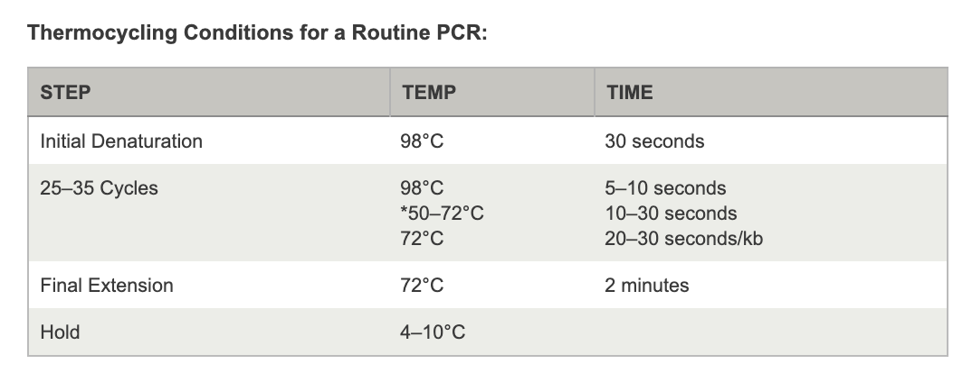

1. Add 2µL 250mM EDTA (pH=8.00) to stop the reaction. Do not heat inactivate.

VI. Bisulfite conversion:

1. Prepare two heat blocks. One at 98°C and a second at 54°C. More preferably, use a thermocycler. If using a thermocycler split the 150µL across 3 tubes, 50µL each.
2. Mix the following in a 1.5mL eppendorf and vortex briefly:

20 µl gap repaired DNA fragments

130 µl CT conversion reagent (Zymo cat #D5030)

150 µl Total Reaction Volume

1. Spin down to ensure no droplets are on the sides or lid of eppendorf tube.

**Important:** Do not spin down after denaturation, only before. Droplets on the sides of the tube are likely to be inefficiently denatured/bisulfite converted.

1. Incubate as follows:

Denature at 98°C for 8 min

Incubate at 54°C for 60 min

Transfer immediately to ice

VII. Purification/Desulphonation:

The following are the recommended steps for using the Zymo EZ DNA Methylation-Lightning Kit (D5030):

1. Add 600 µl of M-Binding Buffer to column, and then load bisulfite conversion reaction
2. Invert column 7 times to mix
3. Centrifuge at 12,500 rcf for 30 s
4. Discard flow-through
5. Add 100 µl M-Wash Buffer
6. Centrifuge at 12,500 rcf for 30 s
7. Add 200 µl L-Desulphonation Buffer, let column stand for 20 min
8. Centrifuge at 12,500 rcf for 30 s
9. Wash column with 200 µl M-Wash buffer, centrifuge at 12,500 rcf for 30 s
10. Repeat wash step
11. Transfer column to 1.5 ml tube
12. Elute with 25µl M-Elution Buffer or nuclease free water, let stand 2 min
13. Centrifuge at 12,500 rcf for 60 s

VIII. PCR Amplification and Barcoding:

1. Mix the following:

25 µl Kapa HiFi HotStart Uracil + Ready Mix

1.5 µl For Primer (10µM N7 index)

1.5 µl Rev Primer (10µM N5 index)

22 µl BS converted DNA eluate

50 µl Total Reaction Volume

Remaining DNA may be saved for diagnostic purposes.

1. Set thermocycler as follows: (27min)

98ºC, 45 sec

8-12 cycles of

98ºC, 15 sec

62ºC, 30 sec

72ºC, 30 sec

Final extension 72ºC, 2 min

1. Purify the PCR product with the Zymo DNA Clean & Concentrate (D4004) protocol, this protocol utilizes disposable silica-based matrix columns. Elute in 22 µl H2O

Analyze through quantitative methods, e.g. Bioanalyzer or Tapestation (D5000 Tape). Optimally, the majority of fragments observed in the library should be between 250-600 bp with average fragment size around 350bp.

Alternatively, PCR reactions may be analyzed on 1% agarose gel, or 5% bisacrylamide gel

5% Bisacrylamide Gel for DNA PAGE:

1 ml 10xTBE

1.7 ml 30% Bisacrylamide

7.3 ml dH20

5 µl Temed

100 µl 10% APS

(No need for stacking gel)

Bisulfite DNA library post-amplification (1% agarose)

Ladder: Invitrogen 1kb plus DNA ladder

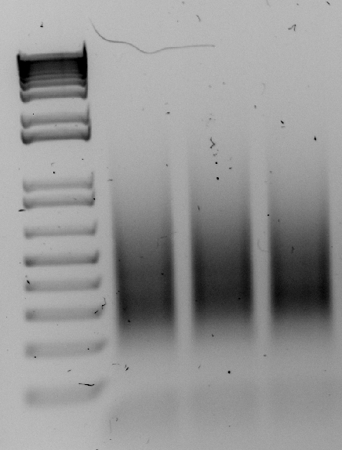

Agilent Tapestation D5000 Analysis of bisulfite DNA library post-amplification:

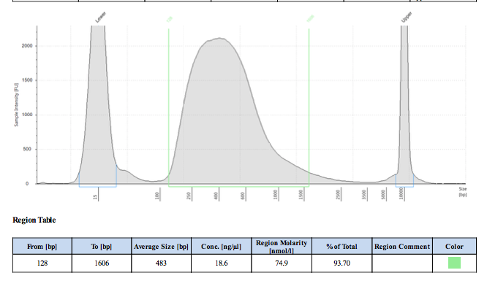

Hdoges Lab uses NovaSeq600 for sequencing.