**Instalación de Hadoop en un Ubuntu 18.04**

*(*https://tecadmin.net/setup-hadoop-single-node-cluster-on-centos-redhat/*)*

*(http://www.gsm-arabic.com/2018/02/installing-hadoop-300-single-node.html)*

**Instalación de Ubuntu 18.04**

**Instalar Java**

*sudo apt update*

*sudo apt install default-jdk*

*java –version*

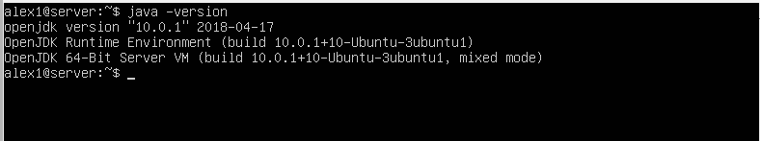

**Descargar e Instalar Hadoop**

*wget http://www-us.apache.org/dist/hadoop/common/hadoop-3.0.3/hadoop-3.0.3.tar.gz*

Recordar ~ Atl + 126

**Generación y permisos claves SSH**

$ ssh-keygen -t rsa

$ cat ~/.ssh/id_rsa.pub >> ~/.ssh/authorized_keys

$ chmod 0600 ~/.ssh/authorized_keys

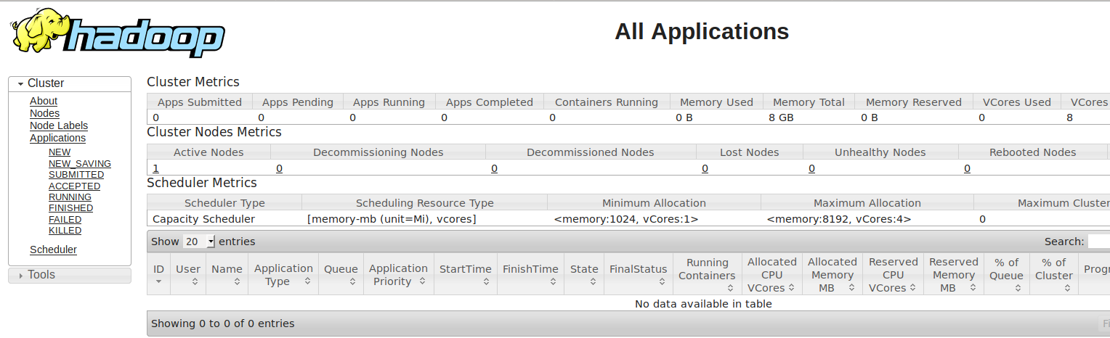

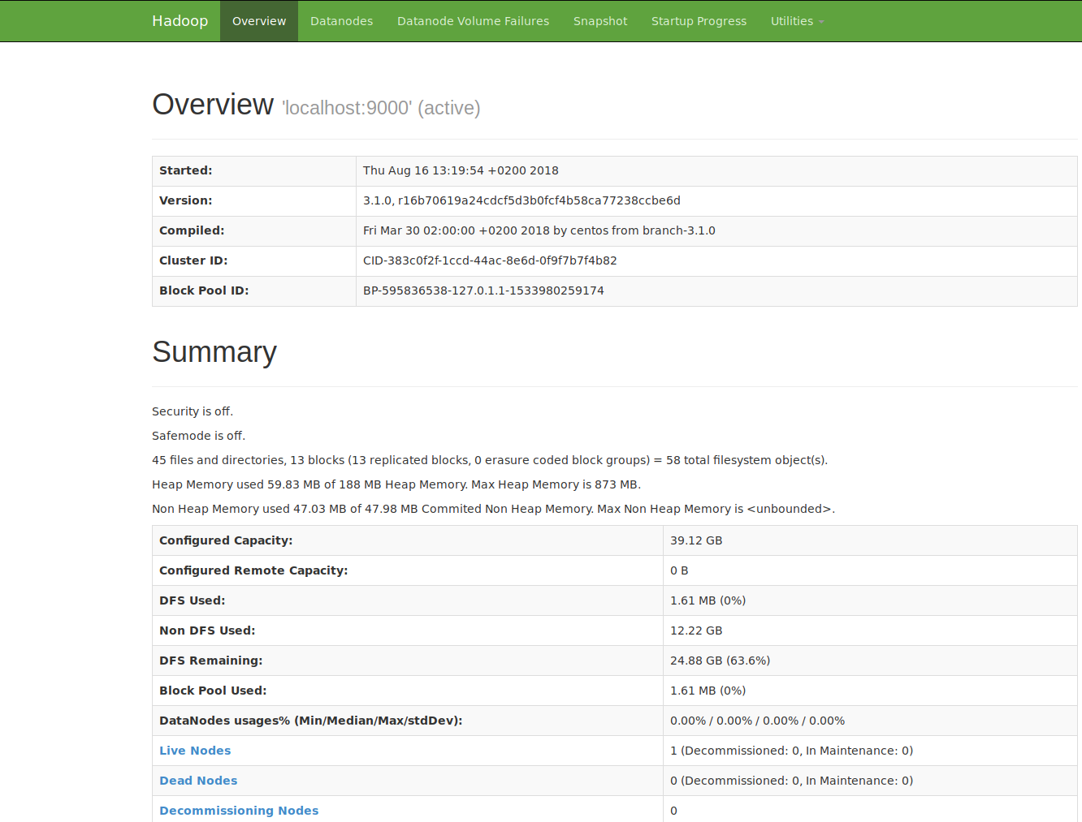

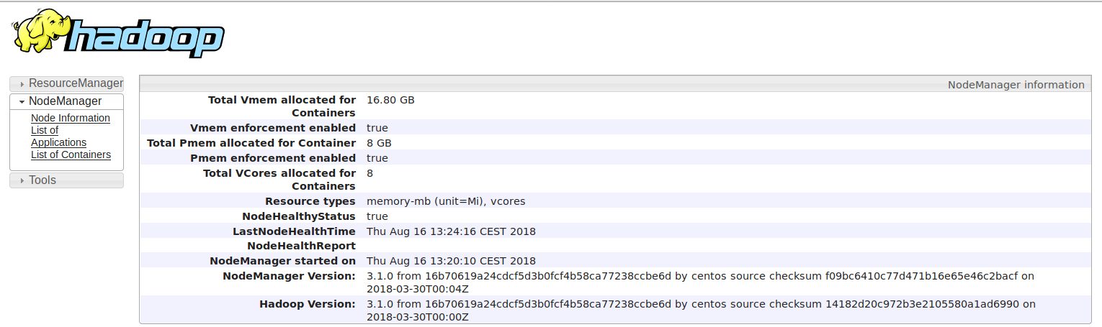

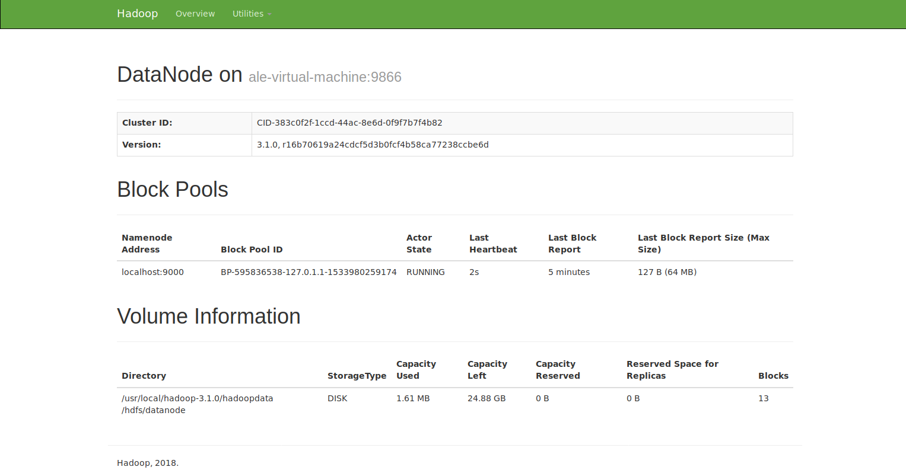

Hbase

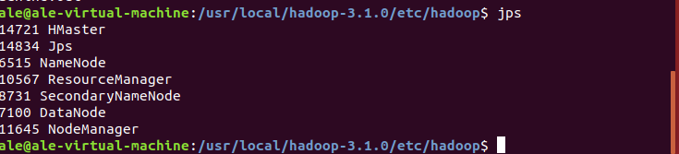

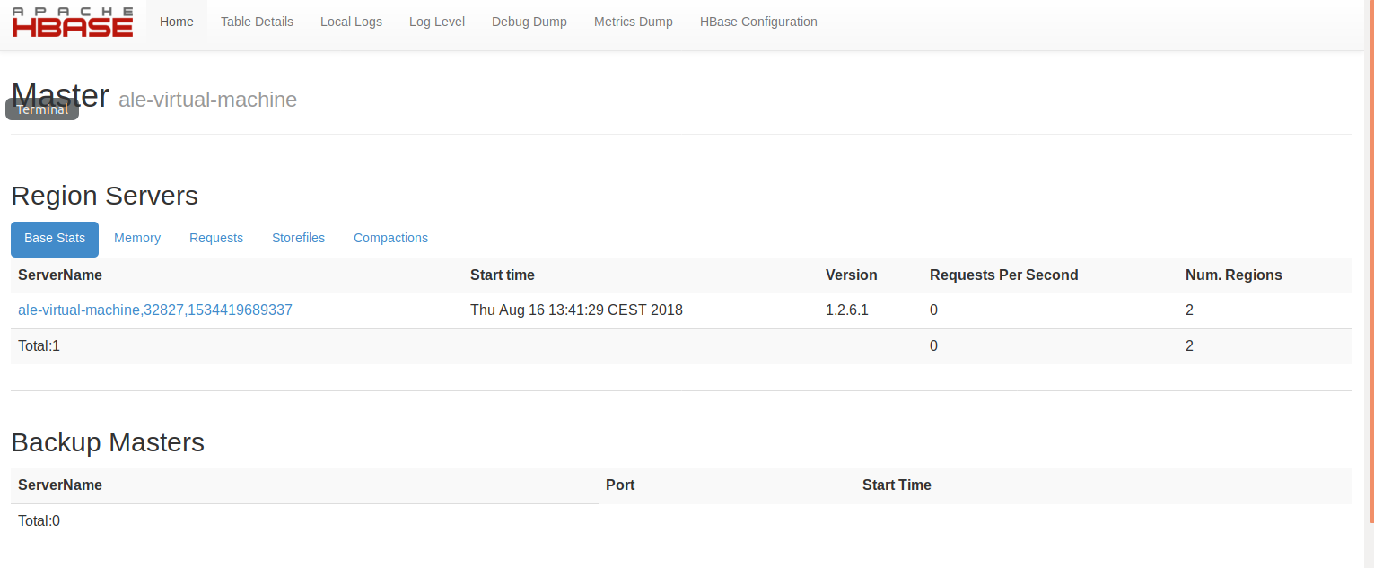

Hive

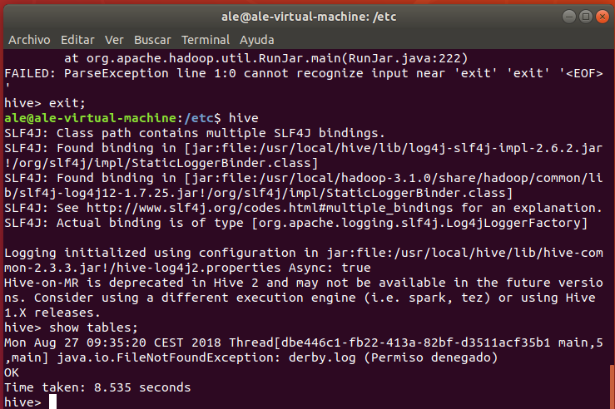

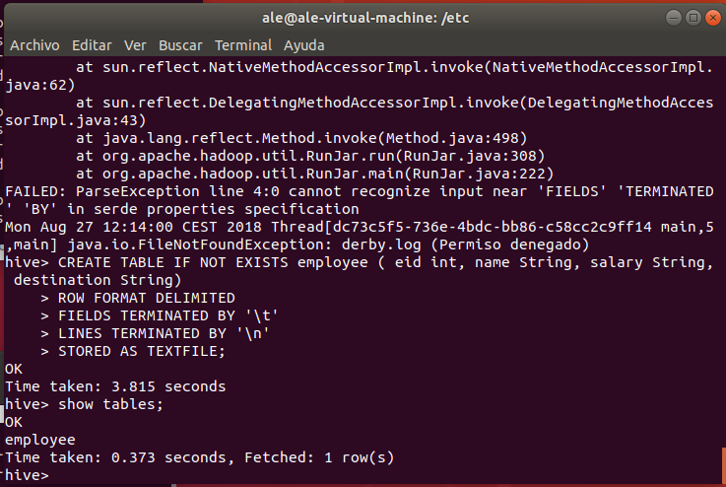

Arrancar startNetworkServer en /usr/local/derby/bin ¿por qué?

Entendiendo MapReduce

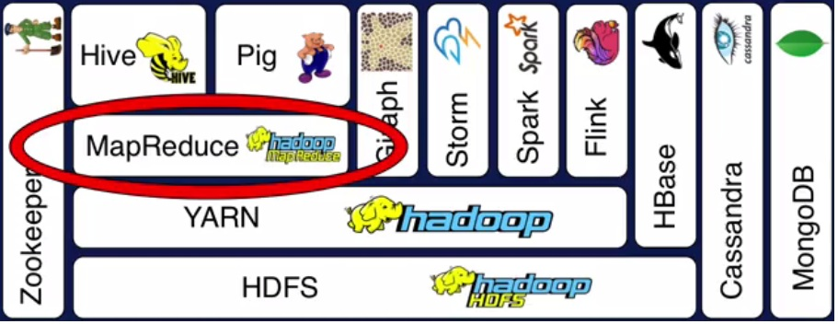

<http://spaceanalytics.blogspot.com/2016/08/hadoop-mapreduce.html?m=1>

Descarga de datos NOAA

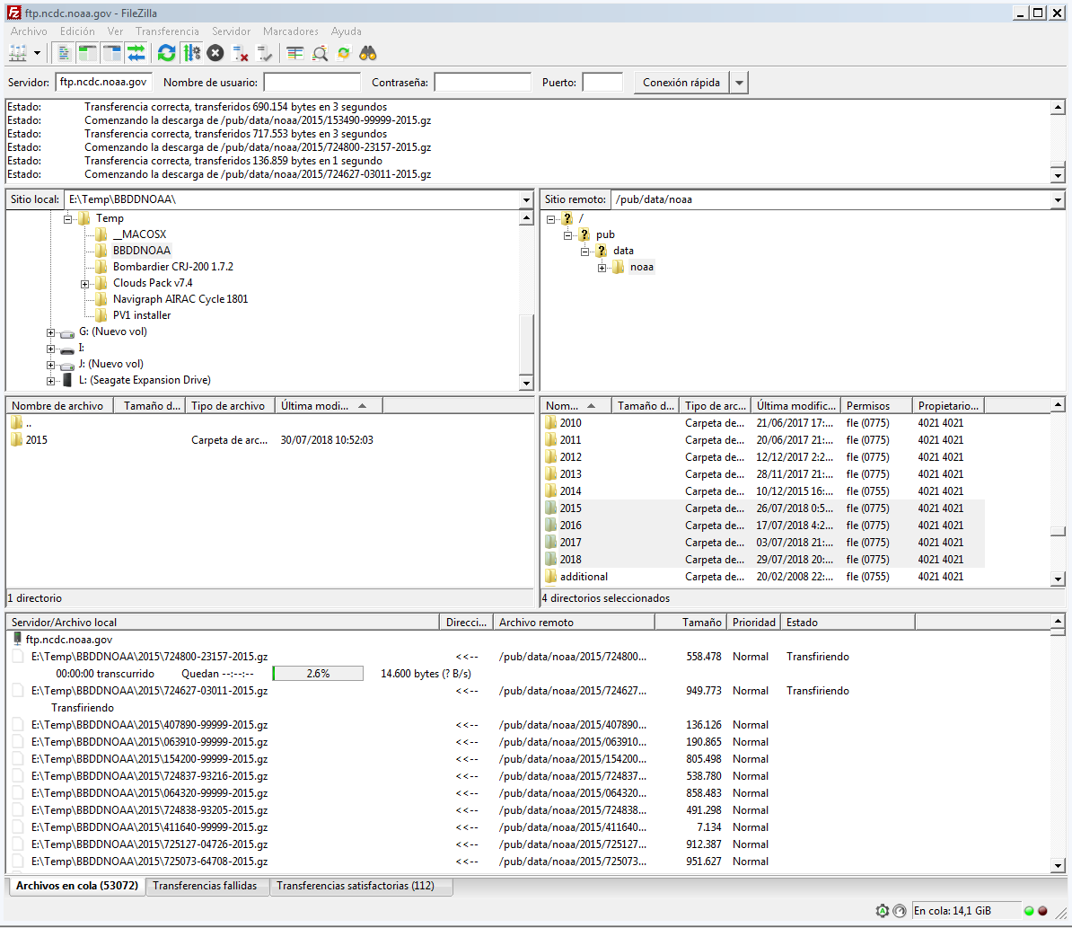

DB2 con IBM Data Studio

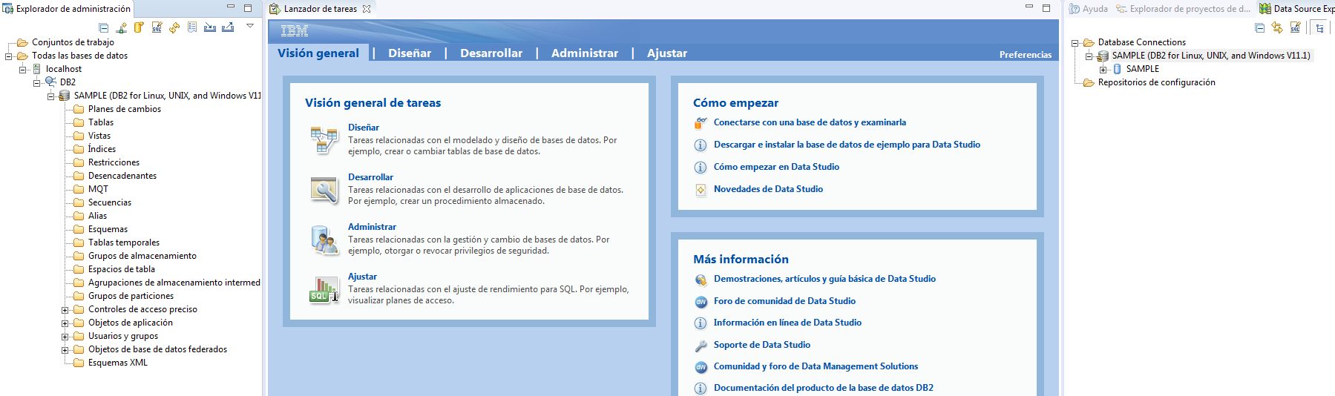

Mongodb

