**Practical-1**

**Basics of Functional Programming**

**1. (i) Ram wants to know age of his grandfather who was born on 18 th**

**December,1975. Kindly help ram to know how old is his grandfather?**

**Also, print the calendar for the month and year on which ram’s**

**Grandfather was born.**

**CODE:**

import calendar

import datetime

b=(datetime.datetime.today())

v=(datetime.datetime(1975,12,19))

a=b-c

print(a)

print(calendar.month(1975,12))

**Screenshot:**

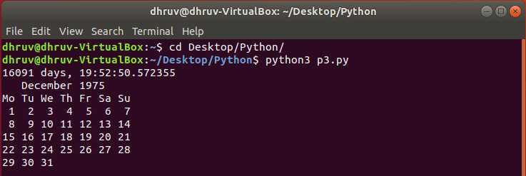

**2. In an online game competition a registration form has to be filled up by**

**user. Kindly help user to perform following operation while submitting**

**form.**

**a) User have to submit their detail and a message should be displayed**

**indicating filled details.**

**b) Also submitting time of the form should be noted indicating when the**

**form was last edited.**

**CODE:**

Import datetime

a=input(‘Enter Name:’)

b=input(‘Enter phone Number:’)

c=input(‘Enter roll Number:’)

z=str(datetime.datetime.today())

print(‘Submitted Details:’)

print(‘Name:’+a)

print(‘Phone Number:’+b)

print(‘Roll Number:’+c)

print(‘Time on which details was submitted was:’+z)

**Screenshot:**

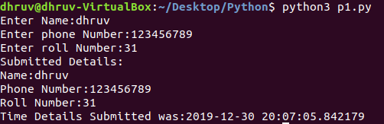

**3. Given a number game one needs to generate any random number; iterate**

**through the all digits present and print the sum of all digits.**

**Here is a sample run:**

**Enter a number between 0 and 1000:27**

1. **The sum of the digits is 9.**

**CODE:**

import random

z=random.randrange(1,1000)

print(‘Number :’ + str(z))

sum=0

while (z!=0):

w=z%10

sum=sum+w

z=z//10

print(sum)

**Screenshot:**

