Quotation Module Product Requirements Document (PRD)

Comprehensive Audit and Target-State Specification
- Document Version: 1.0
- Author: Vimal Bahuguna
- Date: 2026-04-07
- Authoring Method: Codebase Audit + Existing Technical Artifact Synthesis
- Scope: Quotation and Quote Composer ecosystem (UI, APIs, services, schema, integrations, governance)

0) Executive Summary
This PRD is built from a systematic audit of the current Quotation implementation. It documents:
- Full inventory of modules and dependencies across routes, components, services, APIs, RPCs, edge functions, and data schema.
- Section-level behavior for each primary module, including interaction models and conditional logic.
- Field-level contract documentation for key entities, including validations, defaults, formulas, and persistence mapping.
- General information requirements: role/permission hierarchy, audit trail standards, integration APIs, and compliance.
- Detailed Quotation Composer specifications (current + target), with visual and interaction requirements.
- Current-state analysis, screenshots, flowcharts, and gap matrixes.
- Future-state roadmap and architecture proposals with scalability and resilience controls.
- Persona-driven stories with explicit acceptance criteria.
- MoSCoW prioritization with estimates and staffing guidance.

1) Systematic Audit Baseline

1.1 Audited Sources (Primary Evidence)
- UI routes and pages:
  - src/pages/dashboard/QuoteNew.tsx
  - src/pages/dashboard/QuoteDetail.tsx
  - src/pages/dashboard/Quotes.tsx
  - src/pages/dashboard/QuotesImportExport.tsx
  - src/pages/dashboard/QuoteTemplates.tsx
  - src/pages/dashboard/QuoteBookingMapper.tsx
- Core composer and form modules:
  - src/components/sales/unified-composer/UnifiedQuoteComposer.tsx
  - src/components/sales/unified-composer/FormZone.tsx
  - src/components/sales/unified-composer/ResultsZone.tsx
  - src/components/sales/unified-composer/FinalizeSection.tsx
  - src/components/sales/unified-composer/schema.ts
  - src/components/sales/quote-form/*
- Services and domain logic:
  - src/services/quotation/*
  - src/services/QuoteOptionService.ts
  - src/services/pricing.service.ts
- API and integration contracts:
  - src/pages/api/v2/quotations/import.ts
  - src/pages/api/v2/quotations/export.ts
  - docs/api/quote-mapping-api.yaml
- Database contracts and migration evolution:
  - supabase/migrations/20251005170000_quotation_core.sql
  - supabase/migrations/20251108115738_69577924-736f-40dd-9d24-0a104675c62e.sql
  - supabase/migrations/20260122090000_enhance_quote_schema.sql
  - supabase/migrations/20260201170001_enterprise_quote_architecture.sql
  - supabase/migrations/20260215000000_quote_cargo_configurations.sql
  - supabase/migrations/20260227000002_enhance_quotation_module.sql
  - supabase/migrations/20260303120000_update_save_quote_atomic_locations.sql
  - supabase/migrations/20260306180000_update_quote_templates_schema.sql
- Role and access model:
  - src/config/permissions.ts
- Existing analysis and performance evidence:
  - docs/quote-data-pipeline.md
  - docs/quote-generation-workflow.md
  - docs/quick-quote-integration-spec.md
  - docs/technical_specs/quotation_engine_architecture.md
  - tests/e2e/quotation/quotation-e2e-review-and-traceability.md

1.2 Current Product Posture (As-Is)
- The platform supports end-to-end quotation lifecycle: create, enrich, compare, persist versions, generate PDFs, import/export, and map quote to booking.
- Core persistence centers around quotes, quotation_versions, quotation_version_options, quotation_version_option_legs, quote_charges, and cargo/item extensions.
- Composer already supports complex multimodal option editing and financial recalculation, but collaborative editing and true drag-and-drop layout composition are not fully realized in the quotation creation flow.
- Quote template and PDF-generation ecosystem is mature and schema-driven; visual-template designer capability is partially implemented and partially planned.

2) Quotation System Architecture Inventory

2.1 Module Inventory
Layer | Module | Responsibility | Key Dependencies | Integration Touchpoints
Route | QuoteNew | New quote orchestration, quick/smart quote conversion, option generation | QuoteFormRefactored, UnifiedQuoteComposer, QuoteOptionService patterns | Supabase tables, RPC save_quote_atomic, rate payload mapping
Route | QuoteDetail | Version management, save/restore version, detail visualization | Version panels, option cards, comparison components | Edge functions save-quotation-version, restore-quotation-version
Route | Quotes | Quote list/search/filter actions | data hooks, table/list components | CRUD endpoints and direct data reads
Route | QuotesImportExport | Batch import/export entry UI | API routes v2, permission checks | /api/v2/quotations/import, /api/v2/quotations/export
Route | QuoteTemplates | Template list/editor and quote creation from template | template components + auth context | quote_templates, quotes insert
Route | QuoteBookingMapper | Quote-to-booking conversion workflow | QuoteSelectionGrid, QuoteMappingPreview | RPC validate_quote_for_booking, convert_quote_to_booking
Component | UnifiedQuoteComposer | Main composer shell (tabs/phases), save, calculate, generate PDF | FormZone, ResultsZone, FinalizeSection, schema | RPC save_quote_atomic, Edge generate-quote-pdf
Component | QuoteFormRefactored | Structured quote editor (header/logistics/cargo/financials) | QuoteHeader, QuoteLogistics, QuoteLineItems, QuoteFinancials | useQuoteRepository, scoped DB writes
Service | QuoteOptionService | Option, leg, charge normalization and persistence | PricingService, mappers, charge matching utils | quotation_version_options, quotation_version_option_legs, quote_charges
Service | QuotationVersionService | Create/list/set active/restore logic | DB wrapper and version policies | quotation_versions, quotes.current_version_id
Service | QuotationOptionCrudService | Option-level delete/update wrappers | DB RPC abstraction | RPC delete_quote_option_safe
Service | QuotationConfigurationService | Tenant-level composer defaults and smart mode controls | tenant context | quotation_configuration
Service | QuotationRankingService | Option scoring and recommendation | scoring criteria and metadata | rank fields in quotation_version_options
Service | PricingService | margin rules, financial calculations, realtime subscriptions | margin_rules, service_pricing_tiers, services | RPC calculate_service_price, client fallback
DB Core | quotes + related | Header-level quote contract | contacts/accounts/service types/currency | CRUD and version linkage
DB Versioning | quotation_versions | immutable-ish state progression and snapshots | quote FK, template snapshot | save/restore workflows
DB Options | quotation_version_options | carrier options and ranking metadata | version FK + carrier/reference data | compare/rank/select flows
DB Legs | quotation_version_option_legs | multimodal route legs and transit detail | ports/carrier/service type FKs | per-leg charge mapping and UI route breakdown
DB Charges | quote_charges | buy/sell financial lines | bases/categories/currency/sides | final totals, reconciliation, margin
DB Cargo | quote_cargo_configurations | structured cargo setup by transport mode | package and dimensional metadata | pricing, operational planning
DB Governance | quote_approval_rules, quote_approvals, quote_pricing_logs, quote_events | approvals + auditability | user/tenant context | compliance, enterprise controls

2.2 Dependency Diagram
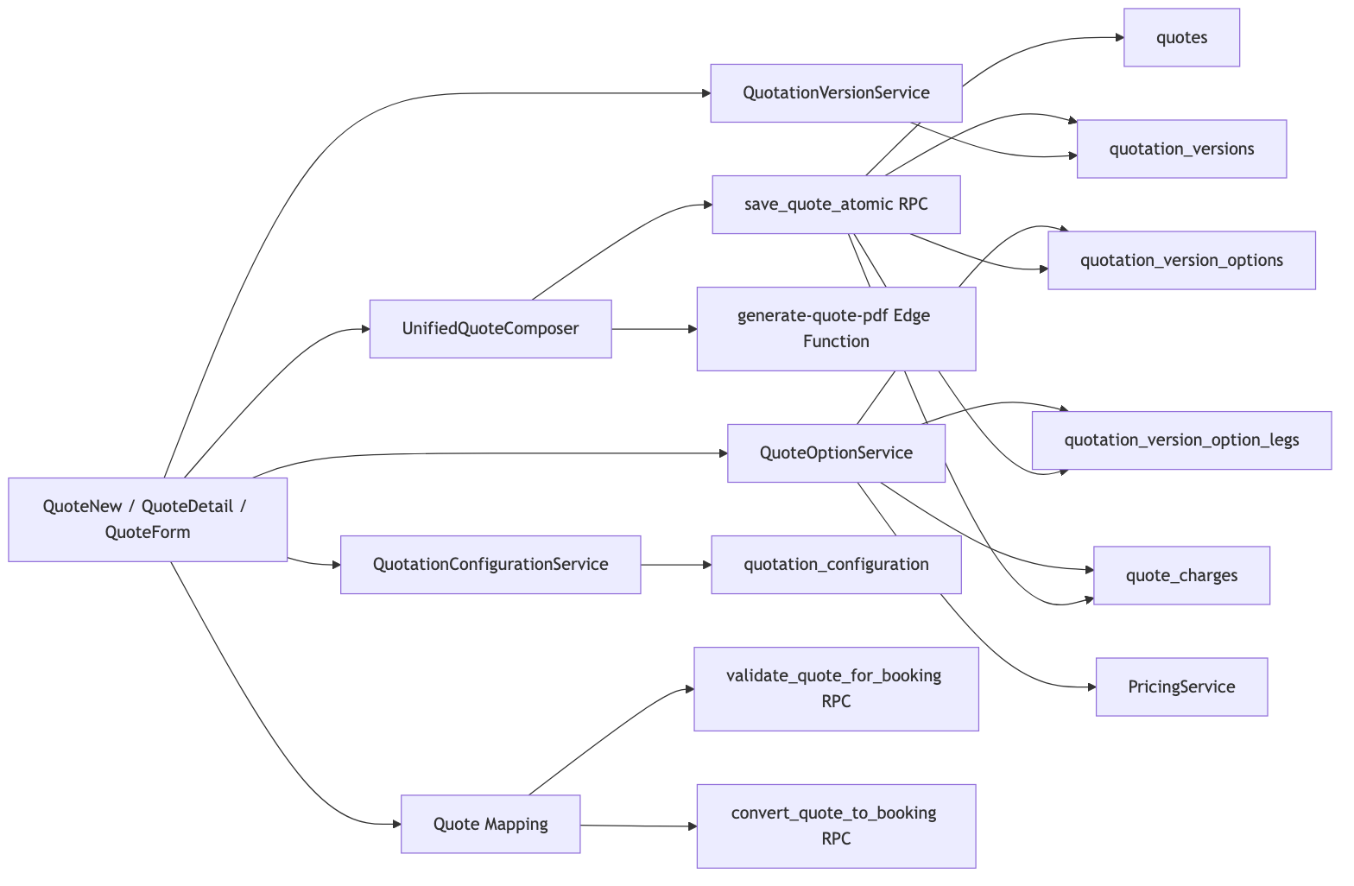
Mermaid Diagram 1

2.3 Data Flow Diagrams

A) Quick/Smart Quote to Composer
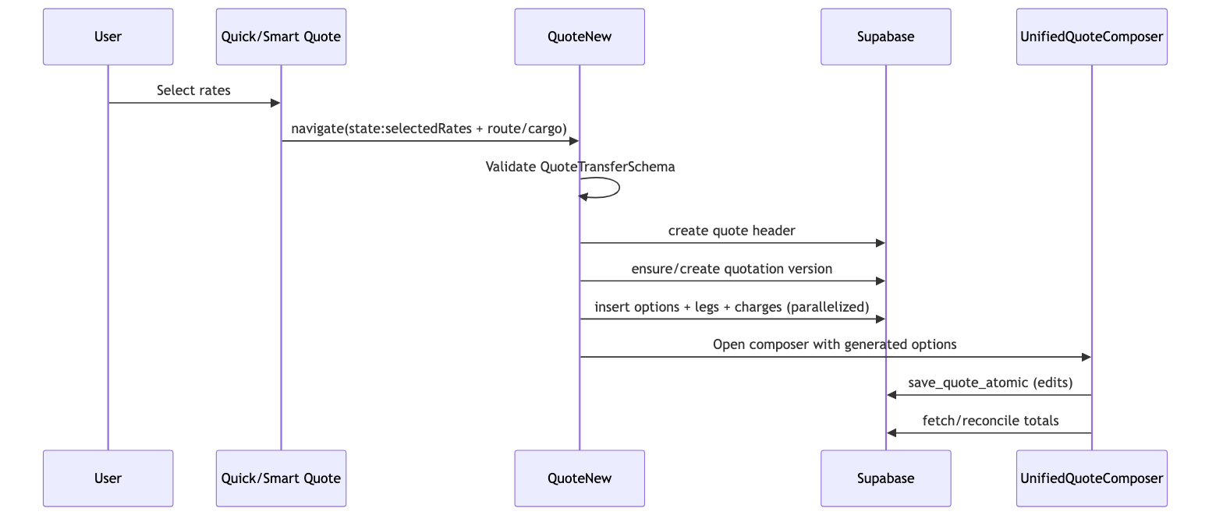
Mermaid Diagram 2

B) PDF Generation
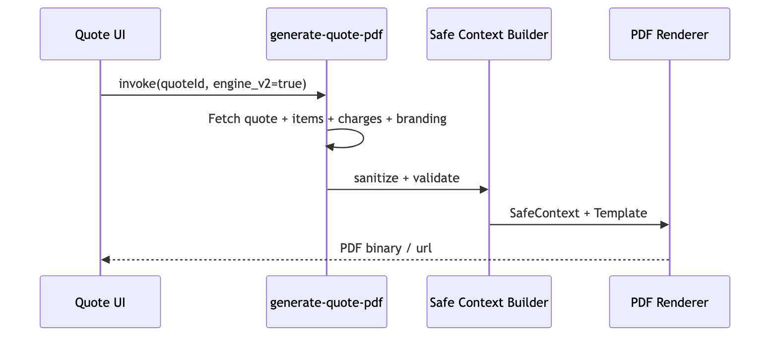
Mermaid Diagram 3

3) Section-Level Functional Decomposition

3.1 QuoteNew Primary Sections
Section | Purpose | User Interactions | Business Logic | Conditional Rendering | Performance Expectations
Initialization | Resolve navigation payload and startup data | enter page / convert flow | validates transfer payload, creates quote header/version | shows failure UI when tenant/version missing | initial load under 1s for standard form
Generation Progress | show conversion from selected rates | view progress and errors | parallel option insertion and timeout handling | visible only when selected rates exist | 4 options target ~1-3s
Composer Launch | route to detailed editing | edit options / legs / charges | binds generated data to composer state | appears once version/options exist | smooth transition without hard reload

3.2 UnifiedQuoteComposer Sections
Section | Purpose | User Interactions | Business Logic | Conditional Rendering | Performance Requirements
General Information tab | CRM/guest context and core quote header | select opp/account/contact, standalone toggle | cross-field synchronization and validation | guest fields only in standalone | under 100ms field-response
FormZone | route and cargo intake | choose mode, origin/destination, cargo, attachments | mode-specific required fields and schema validation | air/ocean/rail-specific controls | autocomplete lookup <300ms perceived
ResultsZone | option review and editing | compare options, adjust charges/margins | ranking, charge aggregation, smart suggestions | only after rates/options available | list/grid rendering should stay <16ms/frame
FinalizeSection | save/version/pdf actions | save draft/final, generate pdf | payload normalization then save_quote_atomic | enabled when form validity passes | save RPC robust retry and clear error taxonomy
Error handling surface | resilience to RPC/schema mismatches | user retries with guidance | maps backend error signatures to user-readable remediation | shown only on failure | no hard crash; recoverable fallback path

3.3 QuoteFormRefactored Sections
Section | Purpose | User Interactions | Business Logic | Conditional Rendering | Performance Requirements
QuoteHeader | quote identity + CRM linkage | set title/status/dates and link entities | auto-populate account/contact from opportunity | standalone guest block toggled | reactive updates with no full re-render
QuoteLogistics | service/carrier/route configuration | select service type/level/carrier/ports | mode normalization + leg-derived placeholders | multi-leg rows only when legs exist | lookup + select under 200ms
QuoteLineItems | cargo/commercial line management | add/remove/edit items | maps nested cargo object to flat form state | empty state card when no items | virtualization for large item lists
QuoteFinancials | pricing, taxes, terms, notes | calculate estimate, apply totals, verify server | margin-rule application + reconciliation | warning only when items exist and total is zero | calculation feedback <2s target

3.4 Versioning/Approval/Template Sections
Module | Sections | Notes
quotation-versions/* | history, comparison, actions, PDF generation, approval workflow | supports save/restore and enterprise governance controls
QuoteTemplates | list, editor, selection/create-from-template | schema-backed template content with quote instantiation
QuoteBookingMapper | selection and preview/validation | quote conversion guardrails and audit mapping

4) Comprehensive Field-Level Documentation
Note: Length semantics are inferred from schema and DB type. For text columns, practical limits are product-defined rather than DB hard caps.

4.1 Quote Header Contract (quotes + form schema)
Field | Type / Length | Required | Default | Validation / Rule | Formula / Dependency | DB Mapping
title | string, variable text | Yes | none | min length 1 | base identity field | quotes.title
description | string text | No | null | none | optional context note | quotes.description
quote_number | string <= 32 (composer path) | Optional/manual | auto generated when blank | regex [A-Za-z0-9._-]* | uniqueness in sequence policy | quotes.quote_number
status | enum-like text | Yes | draft | UI set (draft/sent/accepted/rejected) | drives available actions | quotes.status
account_id | UUID | Conditional | null | required unless standalone or opportunity used | syncs contact/opportunity filtering | quotes.account_id
contact_id | UUID | No | null | must align to account if account selected | auto-filled from opportunity/contact | quotes.contact_id
opportunity_id | UUID | Conditional | null | required in non-standalone when account absent | backfills account/contact | quotes.opportunity_id
service_type_id | UUID | No | null | selected from service types | filters service list and carrier mode | quotes.service_type_id
service_id | UUID | No | null | must belong to selected service type | dependency on service_type_id | quotes.service_id
incoterms | string | No | null | selected from allowed incoterms list | impacts pricing/compliance context | quotes.incoterms
currency_id | UUID | No | null | selected from currency master | used in charge and totals display | quotes.currency_id
origin_port_id | UUID | No | null | selected from locations | used by routing and leg derivation | quotes.origin_port_id
destination_port_id | UUID | No | null | selected from locations | used by routing and leg derivation | quotes.destination_port_id
pickup_date | date/string | No | null | date input; downstream chronology checks | paired with delivery deadline | quotes.pickup_date
delivery_deadline | date/string | No | null | optional date | should be >= pickup in ops process | quotes.delivery_deadline
vehicle_type | string | No | null | free text | used in logistics and docs | quotes.vehicle_type
special_handling | string/json | No | null | free text / structured in RPC payload | compliance and execution hints | quotes.special_handling
tax_percent | numeric-string | No | 0 | non-negative | total = shipping + tax | quotes.tax_percent
shipping_amount | numeric-string | No | 0 | non-negative | subtotal input for financials | quotes.shipping_amount
terms_conditions | text | No | null | none | shown in outbound quote docs | quotes.terms_conditions
notes | text | No | null | internal use | non-customer-facing | quotes.notes
billing_address | jsonb | No | {} | standalone mode requires key fields | used for guest quote mode | quotes.billing_address
shipping_address | jsonb | No | {} | optional | address output in docs | quotes.shipping_address
tenant_id | UUID | Yes | context-derived | must match scoped tenant | multitenant isolation | quotes.tenant_id
franchise_id | UUID | Conditional | context-derived | org hierarchy dependent | franchise partitioning | quotes.franchise_id

4.2 Cargo Item Contract (items -> quote_items_core + extension)
Field | Type | Required | Default | Validation | Formula/Dependency | DB Mapping
type | enum loose/container/unit | Yes | loose | enum constraint | drives container fields requirement | logistics.quote_items_extension.type
product_name | string | Yes | none | min length 1 | basis for commodity description | quote_items_core.product_name
description | string | No | null | none | can mirror product name | quote_items_core.description
quantity | number | Yes | 1 | min 1 | line total calc | quote_items_core.quantity
unit_price | number | Yes | 0 | min 0 | line total calc | quote_items_core.unit_price
discount_percent | number | No | 0 | min 0 max 100 | discount amount derivation | quote_items_core.discount_percent
commodity_id | UUID | No | null | optional lookup | commodity master link | quote_items_core.commodity_id
aes_hts_id | UUID | No | null | optional lookup | trade compliance linkage | quote_items_core.aes_hts_id
attributes.weight | number | No | 0 | non-negative | logistics calculations | logistics.quote_items_extension.weight_kg
attributes.volume | number | No | 0 | non-negative | logistics calculations | logistics.quote_items_extension.volume_cbm
attributes.length/width/height | number | No | 0 | non-negative | dimensional weight contexts | logistics.quote_items_extension.attributes
attributes.hs_code | string | No | null | optional | customs mapping | logistics.quote_items_extension.attributes
attributes.hazmat | object | No | null | optional structured | hazmat compliance | logistics.quote_items_extension.attributes
container_type_id | UUID | Conditional | null | required for container type | mode/type dependent | logistics.quote_items_extension.container_type_id
container_size_id | UUID | Conditional | null | required for container type | mode/type dependent | logistics.quote_items_extension.container_size_id

4.3 Cargo Configuration Contract (quote_cargo_configurations)
Field | Type | Required | Default | Validation | Dependency | DB Mapping
transport_mode | text enum-like | Yes | none | one of ocean/air/road/rail | drives downstream logic | quote_cargo_configurations.transport_mode
cargo_type | text enum-like | Yes | none | one of FCL/LCL/Breakbulk/RoRo | impacts container and pricing logic | quote_cargo_configurations.cargo_type
container_type | text | No | null | mode dependent | linked with type_id | quote_cargo_configurations.container_type
container_size | text | No | null | mode dependent | linked with size_id | quote_cargo_configurations.container_size
container_type_id | UUID | No | null | optional FK | references master | quote_cargo_configurations.container_type_id
container_size_id | UUID | No | null | optional FK | references master | quote_cargo_configurations.container_size_id
quantity | integer | Yes | 1 | min 1 | primary volume multiplier | quote_cargo_configurations.quantity
unit_weight_kg | numeric | No | null | non-negative | pricing + routing weight | quote_cargo_configurations.unit_weight_kg
unit_volume_cbm | numeric | No | null | non-negative | pricing + stowage | quote_cargo_configurations.unit_volume_cbm
length_cm/width_cm/height_cm | numeric | No | null | non-negative | used in OOG/LCL handling | corresponding columns
is_hazardous | boolean | No | false | boolean | enables hazardous fields | quote_cargo_configurations.is_hazardous
hazardous_class | text | Conditional | null | required if hazardous | hazmat rule dependency | quote_cargo_configurations.hazardous_class
un_number | text | Conditional | null | required if hazardous | hazmat rule dependency | quote_cargo_configurations.un_number
is_temperature_controlled | boolean | No | false | boolean | enables temperature fields | quote_cargo_configurations.is_temperature_controlled
temperature_min/max | numeric | Conditional | null | numeric range expectation | temp-control dependency | corresponding columns
temperature_unit | text | No | C | expected C/F | temp-control dependency | quote_cargo_configurations.temperature_unit

4.4 Option / Leg / Charge Contract
Entity.Field | Type | Required | Default | Validation | Formula/Dependency | DB Mapping
option.option_name | text | No | generated label | none | fallback uses carrier+tier | quotation_version_options.option_name
option.total_amount | numeric | Yes | 0 | non-negative expected | reconciled from sell charges | quotation_version_options.total_amount
option.total_buy | numeric | Derived | 0 | computed | sum of buy-side charges | quotation_version_options.total_buy
option.total_sell | numeric | Derived | 0 | computed | sum of sell-side charges | quotation_version_options.total_sell
option.margin_amount | numeric | Derived | 0 | computed | total_sell - total_buy | quotation_version_options.margin_amount
option.margin_percentage | numeric | Derived | 0 | computed | (margin / buy)*100 | quotation_version_options.margin_percentage
option.rank_score | numeric | No | null | optional scoring | ranking service driven | quotation_version_options.rank_score
option.is_recommended | boolean | No | false | boolean | ranking heuristic output | quotation_version_options.is_recommended
leg.sort_order | integer | Yes | sequential | >0 | ordered route sequence | quotation_version_option_legs.sort_order
leg.transport_mode | text | Yes | derived | expected mode code | affects charge matching + carriers | quotation_version_option_legs.transport_mode
leg.origin_location_id | UUID | No | null | FK optional | resolved from name/port mapping | quotation_version_option_legs.origin_location_id
leg.destination_location_id | UUID | No | null | FK optional | resolved from name/port mapping | quotation_version_option_legs.destination_location_id
leg.transit_time_days | number UI | No | 0 | non-negative | converted to hours in DB writes | mapped to transit_time_hours
charge.category_id | UUID | Yes | fallback category | must resolve category | keyword/fuzzy mapping fallback chain | quote_charges.category_id
charge.basis_id | UUID | No | per_shipment fallback | mapped via basis/unit | fallback to default basis | quote_charges.basis_id
charge.currency_id | UUID | No | USD mapping | mapped via currency code | fallback to quote currency | quote_charges.currency_id
charge.quantity | numeric | Yes | 1 | non-negative | amount = rate * quantity | quote_charges.quantity
charge.rate | numeric | Yes | computed | non-negative | pricing service output | quote_charges.rate
charge.amount | numeric | Yes | computed | non-negative | pair buy/sell insertion | quote_charges.amount
charge.charge_side_id | UUID | Yes | n/a | must resolve buy/sell side | mandatory side records check | quote_charges.charge_side_id

4.5 Quotation Configuration and Template Fields
Field | Type | Required | Default | Notes
quotation_configuration.default_module | text | Yes | composer | check: composer/legacy/smart
quotation_configuration.smart_mode_enabled | boolean | No | false | toggles smart features
quotation_configuration.smart_mode_settings | jsonb | No | {} | tenant-scoped tuning
quotation_configuration.multi_option_enabled | boolean | No | true | controls option multiplicity
quotation_configuration.auto_ranking_criteria | jsonb | No | weighted cost/time/reliability | ranking inputs
quote_templates.content | jsonb | Yes | none | template body schema-validated
quote_templates.template_name | text | No | null | named template variants
quote_templates.rate_options | jsonb array | No | [] | MGL template extension
quote_templates.transport_modes | jsonb array | No | [] | MGL template extension

5) General Information Requirements

5.1 User Roles and Permission Hierarchy (Quotation-Relevant)
Role | View | Create | Edit | Delete | Import/Export | Sensitive Export | Templates Manage | Notes
platform_admin | Yes | Yes | Yes | Yes | Yes | Yes | Yes | full platform scope
super_admin | Yes | Yes | Yes | Yes | Yes | Yes | Yes | enterprise-wide
tenant_admin | Yes | Yes | Yes | Yes | Yes | tenant export only | Yes | tenant scope
franchise_admin | Yes | Yes | Yes | No | Yes | No | No | franchise scope
user | Yes | Yes | limited | No | Yes | No | No | standard sales operations
Permission source slugs include: quotes.view, quotes.create, quotes.edit, quotes.delete, quotes.import_export, quotes.analytics, quotes.export_sensitive, quotes.templates.manage, import_quotation, export_quotation, export_quotation_sensitive.

5.2 Audit Trail Requirements
Mandatory audit points:
- Quote lifecycle events: create/update/status transitions (quote_events).
- Versioning events: save, restore, active version change (quotation_versions + route actions).
- Pricing provenance: automatic rule application and overrides (quote_pricing_logs).
- Approval traces: request/approve/reject with actor and rationale (quote_approvals).
- Mapping actions: quote-to-booking validation and conversion logs.

5.3 Integration APIs and RPC Matrix
Interface | Type | Purpose
/api/v2/quotations/import | REST API route | bulk import orchestration
/api/v2/quotations/export | REST API route | export with permission and sensitivity controls
save_quote_atomic | PostgreSQL RPC | atomic persistence of quote + items + cargo + options + legs + charges
delete_quote_option_safe | PostgreSQL RPC | safe option deletion with integrity rules
validate_quote_for_booking | PostgreSQL RPC | pre-conversion business rule validation
convert_quote_to_booking | PostgreSQL RPC | quote-to-booking conversion with audit continuity
generate-quote-pdf | Edge Function | schema-safe PDF generation
save-quotation-version / restore-quotation-version | Edge Functions | version snapshots and restore path
calculate-quote-financials | Edge Function | server-side financial verification
calculate_service_price | PostgreSQL RPC | service-tier pricing calculation

5.4 Compliance Standards (Required)
- Multitenant data isolation via tenant_id/franchise_id + RLS.
- Scoped access patterns for all quote data operations.
- Schema-first validation using Zod for form and payload contracts.
- Safe-context PDF rendering to prevent data exfiltration.
- Auditability for pricing decisions and approval workflows.
- Backward-compatible schema evolution and version-aware payload normalization.

6) Quotation Composer: Detailed Specification

6.1 UI/UX Wireframe Specification (Desktop)
+--------------------------------------------------------------------------------------+
| Header / Breadcrumb / Domain / Actions |
+--------------------------------------------------------------------------------------+
| Tabs: [General Information] [Quotation Composer] |
+--------------------------------------------------------------------------------------+
| Left/Primary (70%) | Right/Secondary (30%)|
| - FormZone | - Option summary |
| - Mode / Route / Cargo | - Ranking badges |
| - Carrier preference | - Totals |
| - Validation hints | - Save/Version actions|
| - ResultsZone (option table/cards/list) | |
| - FinalizeSection (notes/margin/pdf/send) | |
+--------------------------------------------------------------------------------------+

6.2 Responsive Requirements
- Desktop (>=1280): full two-zone composition, persistent action rail.
- Tablet (768-1279): stacked sections with sticky action bar.
- Mobile (<768): single-column wizard behavior, collapsible detail groups.
- Accessibility:
  - keyboard navigable section controls;
  - visible focus rings;
  - semantic labels for all select/input/button elements.

6.3 Drag-and-Drop Functional Requirements
Current: - Option and charge editing is primarily form-driven; no complete drag-and-drop layout composer for quote-building sections.
Required: - Drag to reorder legs, charge groups, and optional summary blocks. - Drag constraints: - non-removable mandatory sections pinned; - route continuity validator blocks invalid drops. - Interaction standards: - ghost element + insertion indicator; - keyboard-accessible reorder controls; - undo stack integration.

6.4 Real-Time Calculation Engine Requirements
Current: - Uses PricingService with cached margin rules and calculateFinancials. - Supports estimate generation and optional server verification.
Required: - deterministic calc pipeline per option: - input normalization; - category/basis/currency resolution; - buy/sell pair synthesis; - discrepancy-balancing logic; - reconciliation writeback. - SLA targets: - single option recalc <200ms client-side; - full save+reconcile <1.5s p95 for <=10 options.

6.5 Version Control and Collaborative Editing
Current: - version save/restore exists; - active/current version semantics supported.
Required: - soft-locking with collaborator presence indicator; - conflict resolution: - field-level last-writer metadata; - diff preview before overwrite; - manual merge assistant for critical financial fields. - timeline model: - draft checkpoints; - published snapshots; - immutable PDF/version pairing.

6.6 Interactive Prototype Specifications (Target)
- Prototype scope:
  - quote creation from scratch;
  - quick quote conversion;
  - option comparison/edit;
  - approval trigger path;
  - PDF generation and booking conversion.
- Prototype fidelity:
  - stateful controls for conditional fields;
  - simulated async states (loading/error/partial success);
  - keyboard-only path validation.

7) Current-State Visual Documentation and Gap Analysis

7.1 Screenshot Inventory (Current State)
- Desktop snapshot:
  - tests/e2e/quotation/quotation-comprehensive.spec.ts-snapshots/quotation-composer-visual-chromium-darwin.png
- Mobile snapshot:
  - tests/e2e/quotation/quotation-comprehensive.spec.ts-snapshots/quotation-composer-visual-ios-mobile-darwin.png
- Browser parity snapshots:
  - chromium, chrome-latest, firefox, webkit variants in same folder.

7.2 Annotated Screenshot Legend
- Header and breadcrumb indicate context and route (Create Quote).
- Top tabset separates General Information and Quotation Composer surfaces.
- CRM-linked mode toggle controls standalone vs CRM-dependent entry.
- Context selectors (opportunity/account/contact) drive auto-population logic.
- Transport mode chips change required cargo constraints and downstream pricing behavior.
- Commodity and cargo block contains container configuration + dimensions + hazmat controls.
- Attachments and draft action indicate save pipeline and document input support.

7.3 Current Workflow Diagram (As-Is)
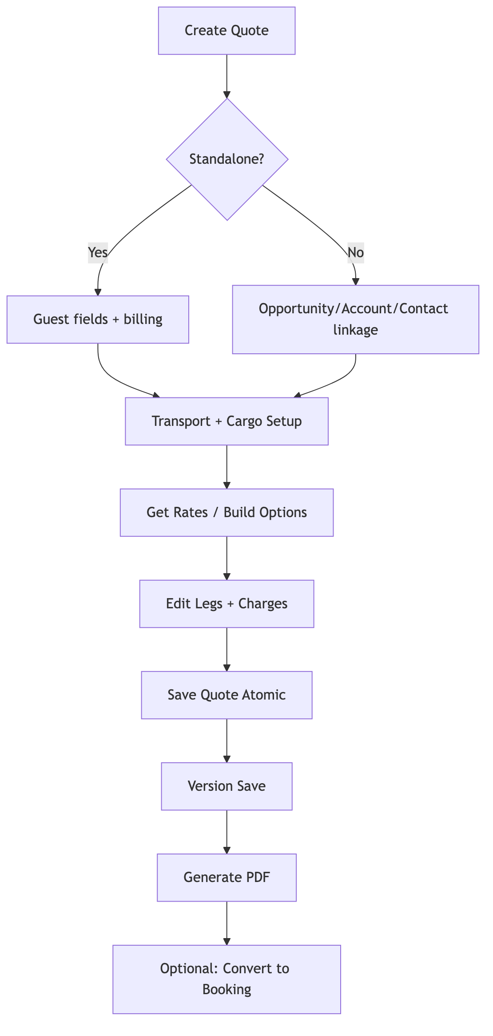
Mermaid Diagram 4

7.4 Gap Analysis Matrix (Existing vs Required)
Capability | Existing State | Required State | Gap Severity | Priority
Section-level drag-and-drop | partial/not universal | full DnD for legs/charges/layout blocks | High | Must
Collaborative editing | none/minimal | realtime presence + conflict handling | High | Must
Field governance registry | split across schemas/migrations | unified machine-readable field catalog | High | Must
Approval orchestration in composer UX | backend tables exist, UX not fully unified | inline approval trigger/escalation flows | Medium | Should
Performance SLO telemetry | partial docs and logs | p95 dashboards by tenant/workflow | Medium | Should
Accessibility automation | basic standards used | WCAG assertion suite + CI gate | Medium | Should
Visual prototype coverage | fragmented | full end-to-end prototype spec and assets | Medium | Should
Predictive ranking explainability | rank fields present | per-option explainability card + trace | Medium | Could

8) Future-State Requirements and Architecture Proposal

8.1 Target Architecture (To-Be)
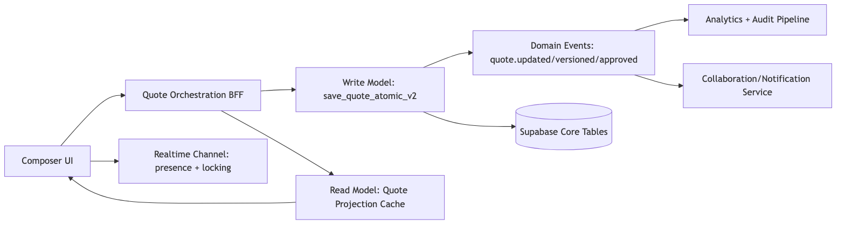
Mermaid Diagram 5

8.2 Scalability Requirements
- Multi-option save throughput:
  - support 50 options with 5 legs and 40 charges per option under controlled batching.
- Resilience:
  - idempotent save tokens;
  - dead-letter handling for failed async steps (PDF/webhook).
- Data growth:
  - partition or archive strategy for pricing/audit logs.
- Query performance:
  - indexed paths for quote-id, version-id, tenant-id, and status transitions.

8.3 Prioritized Feature Roadmap
Phase | Timeline | Outcomes
Phase 1 | 4 weeks | unified field dictionary, save flow hardening, error taxonomy, telemetry baseline
Phase 2 | 6 weeks | collaborative editing MVP, drag-and-drop leg/charge reordering, approval UX integration
Phase 3 | 5 weeks | projection cache, advanced ranking explainability, accessibility CI and performance gates
Phase 4 | 4 weeks | enterprise scaling controls, audit dashboards, rollout hardening and migration support

9) User Stories, Personas, and Acceptance Criteria

Persona A: Sales Executive (Fast Quote Creation)
- Story: As a sales executive, I want to convert selected quick quote rates into an editable quotation in one step.
- Acceptance Criteria:
  - selected rates create quote options automatically;
  - progress and failures are visible per-rate;
  - partial success preserves completed options.

Persona B: Pricing Analyst (Charge and Margin Control)
- Story: As a pricing analyst, I need to inspect and adjust buy/sell charges per leg with transparent margin math.
- Acceptance Criteria:
  - per-leg charge edit updates totals instantly;
  - reconciliation detects mismatches >0.01 and flags anomalies;
  - applied margin rules are explainable.

Persona C: Sales Manager (Governance and Approval)
- Story: As a manager, I need low-margin or high-value quotes routed for approval before sending.
- Acceptance Criteria:
  - trigger rules execute on save/finalize;
  - approval status is visible in quote header and version panels;
  - approved/rejected actions are auditable with actor and timestamp.

Persona D: Operations Planner (Route and Cargo Accuracy)
- Story: As operations, I need leg-level route and cargo details to be complete and consistent before booking conversion.
- Acceptance Criteria:
  - origin/destination continuity across legs is enforced;
  - hazardous and temperature fields are validated when applicable;
  - quote-to-booking validation blocks conversion on critical gaps.

Persona E: Tenant Admin (Template and Configuration Governance)
- Story: As tenant admin, I need control over default composer behavior and templates.
- Acceptance Criteria:
  - tenant-specific quotation configuration is editable with RBAC;
  - template versions can be managed without data leakage across tenants;
  - default module behavior (composer/legacy/smart) is applied consistently.

10) MoSCoW Priorities, Estimates, and Resource Requirements

10.1 MoSCoW Matrix
Priority | Feature | Estimate | Roles Needed
Must | unified field registry + schema governance checks | 2.5 weeks | 1 BE, 1 FE, 1 QA
Must | collaborative edit locking + conflict resolution MVP | 4 weeks | 1 FE, 1 BE, 1 QA
Must | drag-and-drop leg/charge ordering with validation | 3 weeks | 2 FE, 1 QA
Must | approval flow integration in composer and detail pages | 3 weeks | 1 FE, 1 BE, 1 QA
Should | projection cache/read optimization | 2 weeks | 1 BE
Should | accessibility CI assertions and UX hardening | 1.5 weeks | 1 FE, 1 QA
Should | performance dashboards (p95 by workflow) | 1.5 weeks | 1 BE, 1 DevOps
Could | explainable ranking cards and what-if simulation | 2 weeks | 1 FE, 1 BE
Could | advanced template marketplace workflow | 3 weeks | 1 FE, 1 BE, 1 PM
Won’t (current cycle) | full offline composer mode | deferred | backlog

10.2 Aggregate Delivery Estimate
- Total estimated effort (Must + Should): ~17.5 engineering weeks.
- Suggested squad: 2 FE, 2 BE, 1 QA, 0.5 DevOps, 0.5 PM/BA.
- Suggested rollout: feature-flagged per tenant tier, with pilot tenants before broad release.

11) Visual Documentation Package Requirements (Composer-Focused)

11.1 Annotated Screenshots of Every Interface Element
- Required captures:
  - General Information tab (desktop/mobile);
  - FormZone mode variants (air/ocean/road/rail);
  - ResultsZone in card/list/grid modes;
  - FinalizeSection save/version/pdf states;
  - error and timeout states.
- Annotation standard:
  - numeric hotspot IDs;
  - field key names;
  - interaction outcome notes.

11.2 Pixel-Perfect Mockups (Module/Section/Row/Column)
- Breakpoints:
  - Desktop 1440x900;
  - Tablet 1024x1366;
  - Mobile 390x844.
- Grid standards:
  - 12-column desktop layout;
  - 8-column tablet;
  - 4-column mobile.
- Tokenized spacing:
  - container padding 24/16/12;
  - section spacing 24;
  - control height 40 standard;
  - card radius 8.

11.3 Comprehensive Field Mapping Diagram
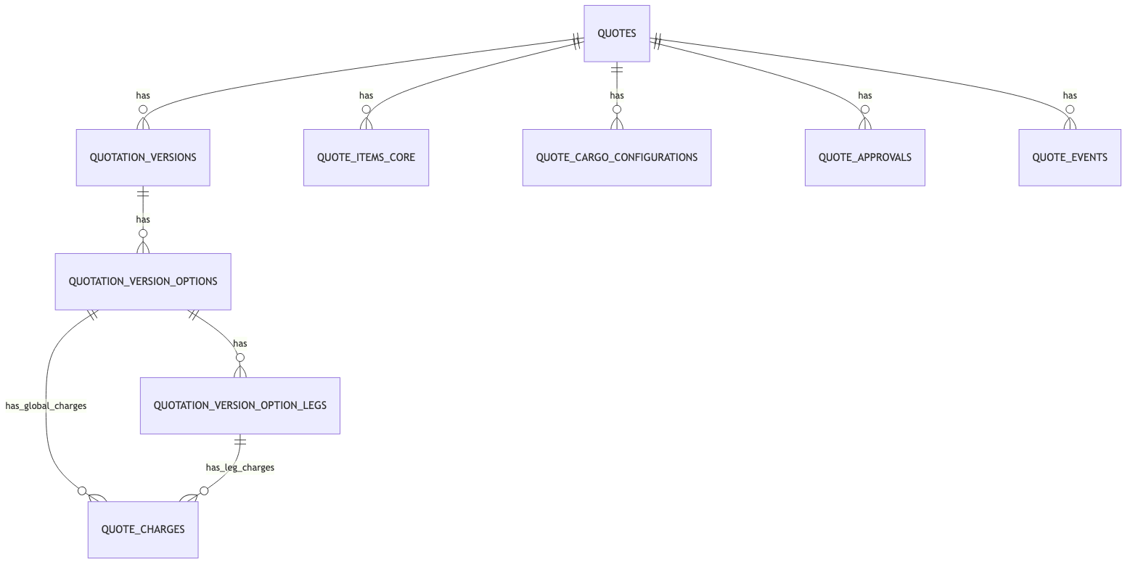
Mermaid Diagram 6

11.4 Interactive Prototype Journey Coverage
- Journey set:
  - create quote from CRM;
  - create standalone quote;
  - convert quick quote to composer;
  - edit options/charges and recalculate;
  - trigger approval and finalize;
  - generate pdf and map to booking.

11.5 Visual Workflow Diagrams
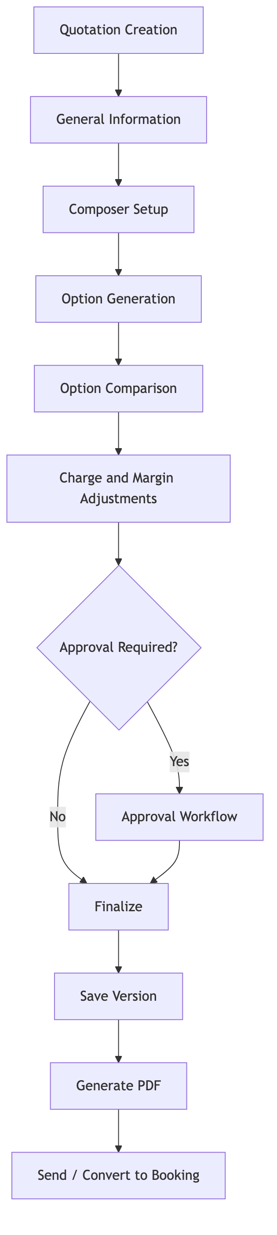
Mermaid Diagram 7

12) Non-Functional Requirements (Cross-Cutting)
- Performance:
  - quote open p95 < 1.5s;
  - save quote p95 < 1.5s for standard payload;
  - compare options render < 250ms for 20-option set.
- Reliability:
  - transactional integrity for quote+option+leg+charge save;
  - recoverable failures with user-safe retries.
- Security:
  - strict tenant/franchise isolation;
  - RBAC enforcement for template/config/export-sensitive paths.
- Observability:
  - structured logs keyed by quote_id, version_id, tenant_id;
  - error categories for schema, RPC, timeout, integration.
- Backward compatibility:
  - additive schema changes only;
  - versioned API behavior for contract changes.

13) Implementation Readiness Checklist
- Consolidate field dictionary from schema + migration deltas into machine-readable artifact.
- Define collaboration lock model and conflict policy.
- Add composer drag-and-drop interaction contract and keyboard parity.
- Finalize approval UX and integration hooks.
- Formalize performance/error SLO dashboards.
- Complete visual prototype package with all required annotated states.
- Execute regression suite (unit/integration/e2e) and attach evidence.

14) Conclusion
The Quotation module already provides a strong operational baseline with robust data structures, multimodal routing, financial logic, and version controls. The highest-value next steps are collaboration, interaction maturity (drag-and-drop), governance unification (field registry + approval UX), and scalable observability. This PRD provides the complete reference needed for execution planning, architecture review, and phased delivery.

