**1. Name of method in Thread class to pause execution?**

Thread.Sleep(millis) is used to pause current execution for a specific time in milliseconds.

**2. Role of "volatile" keyword.**

The Java volatile keyword is used to mark a Java variable as "being stored in main memory". That means, that every read of a volatile variable will be read from the computer's main memory, and not from the CPU cache, and that every write to a volatile variable will be written to main memory, and not just to the CPU cache.

**3. Write a program to create a thread using Thread class and Runnable interface each.**

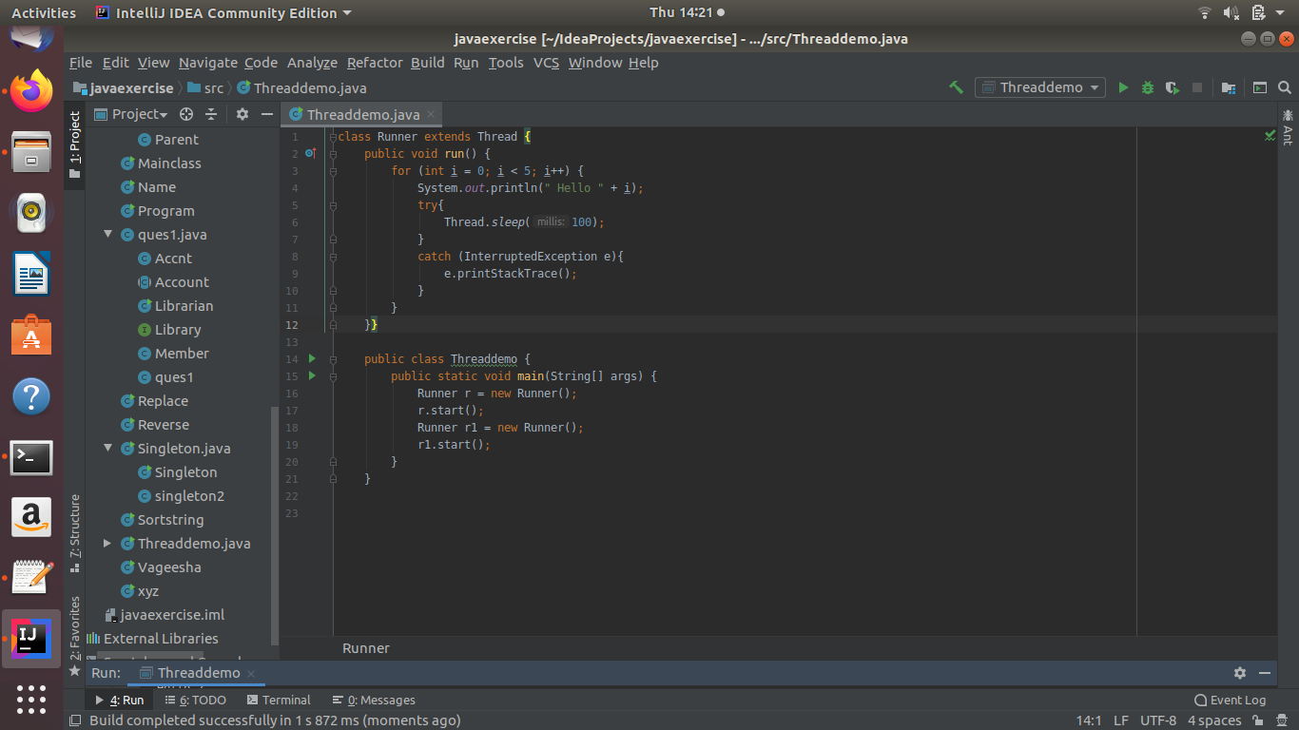

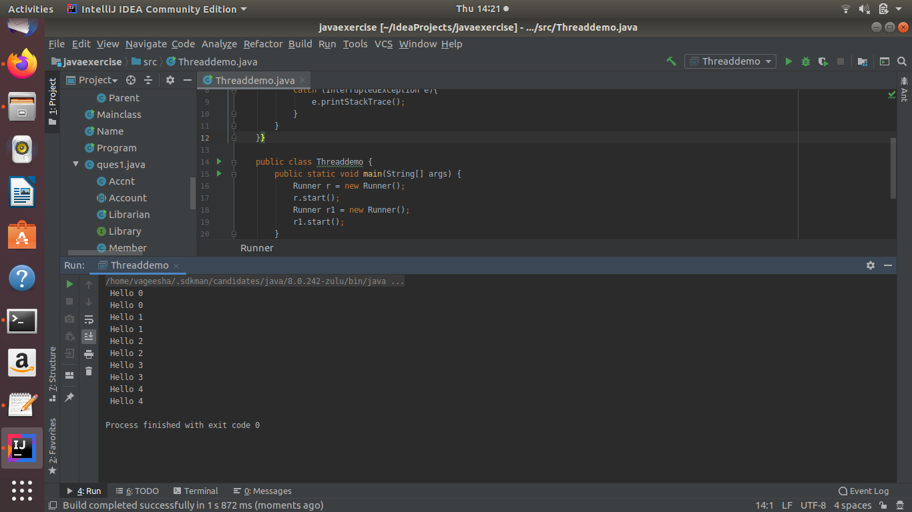

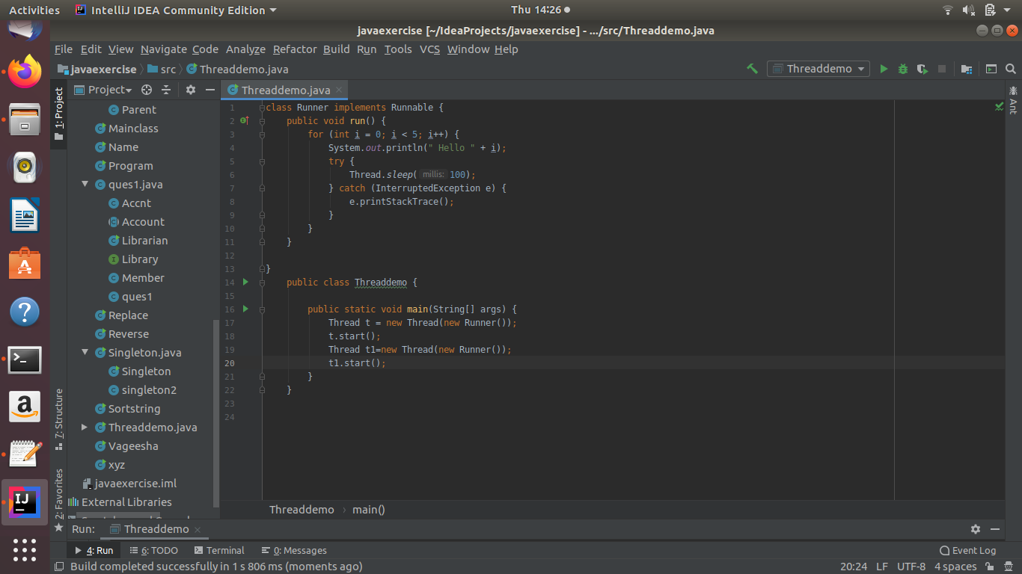

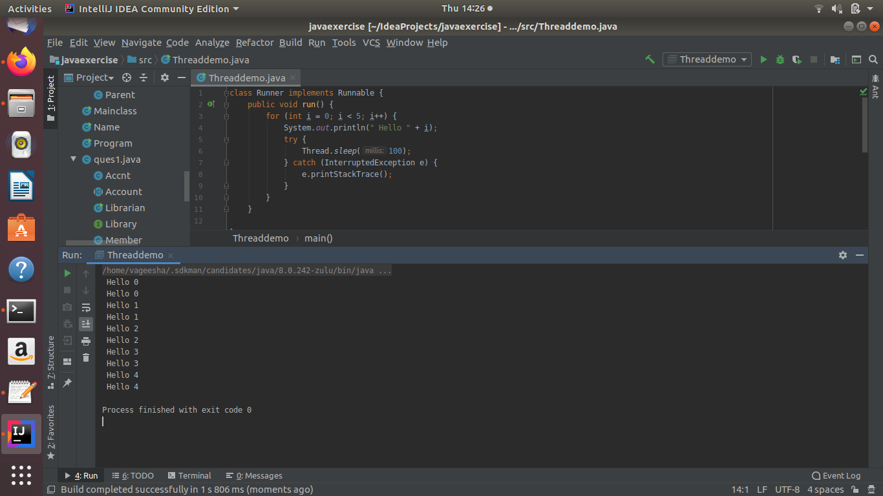

**4. Write a program using synchronization block**

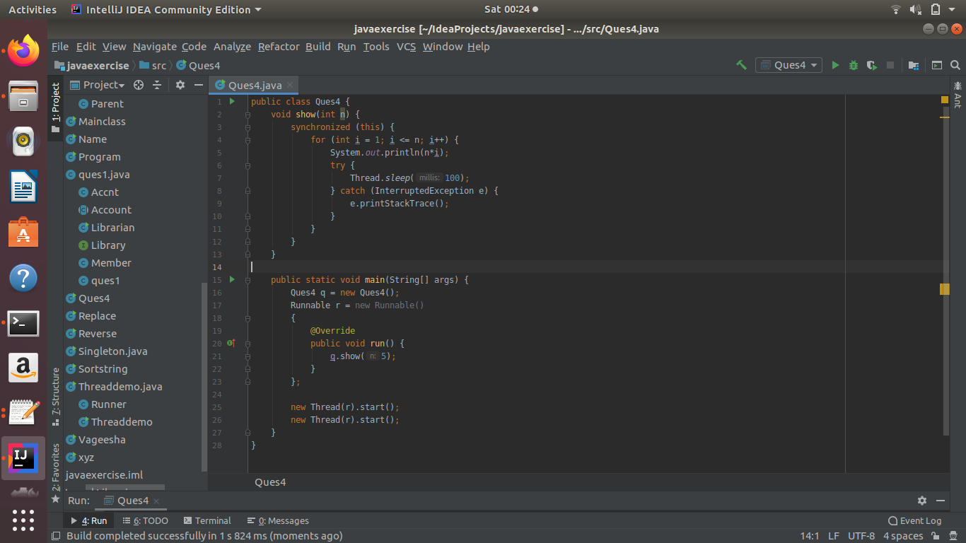

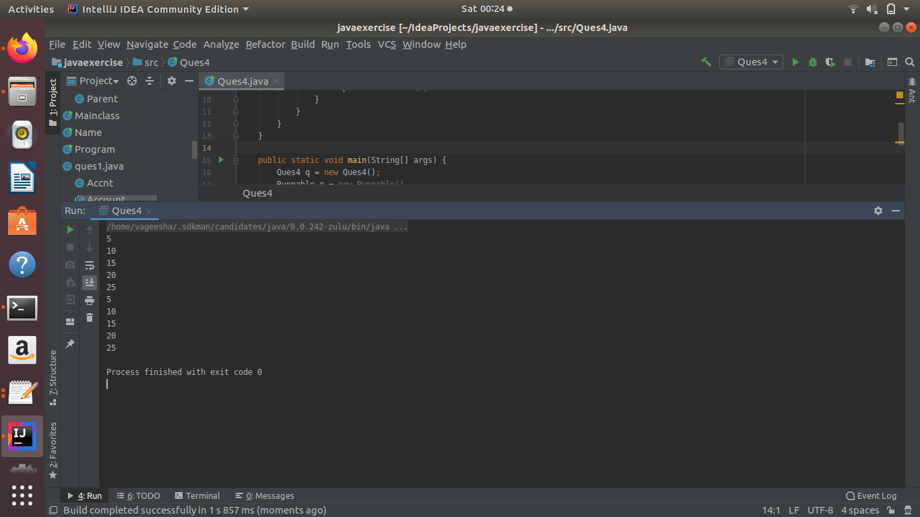

**5. Write a program using synchronization method**

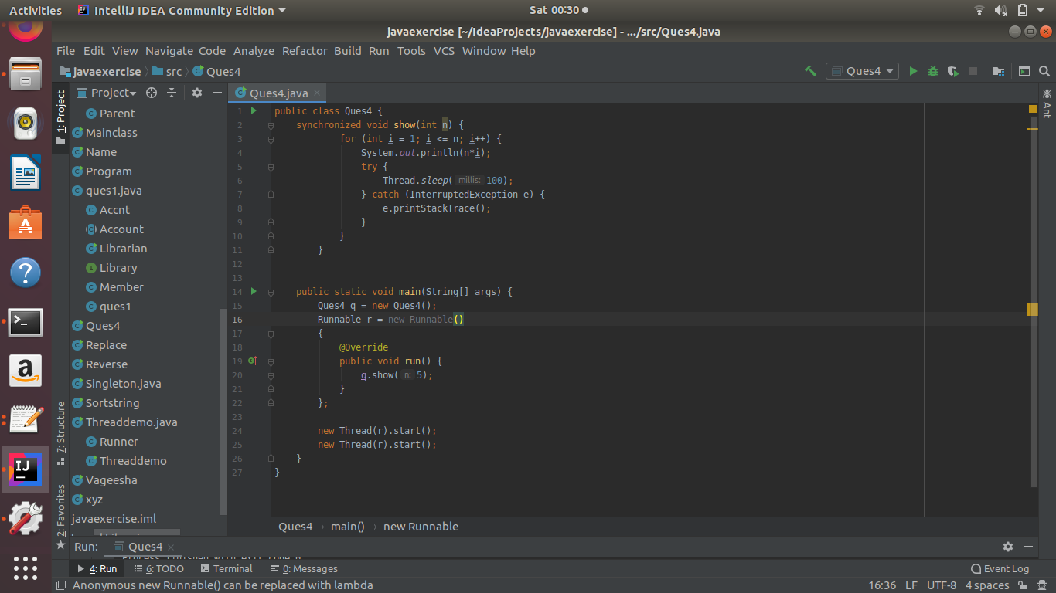

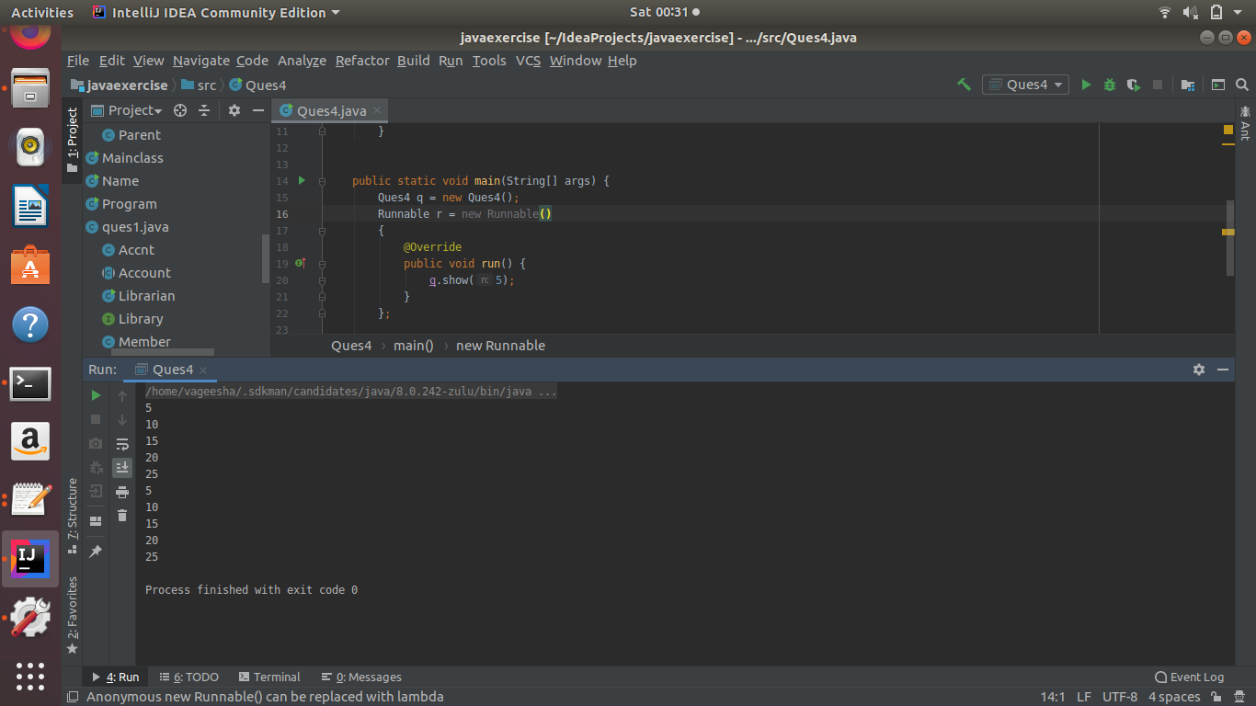

**6. Write a program to create a Thread pool of 2 threads where one Thread will print even numbers and other will print odd numbers.**

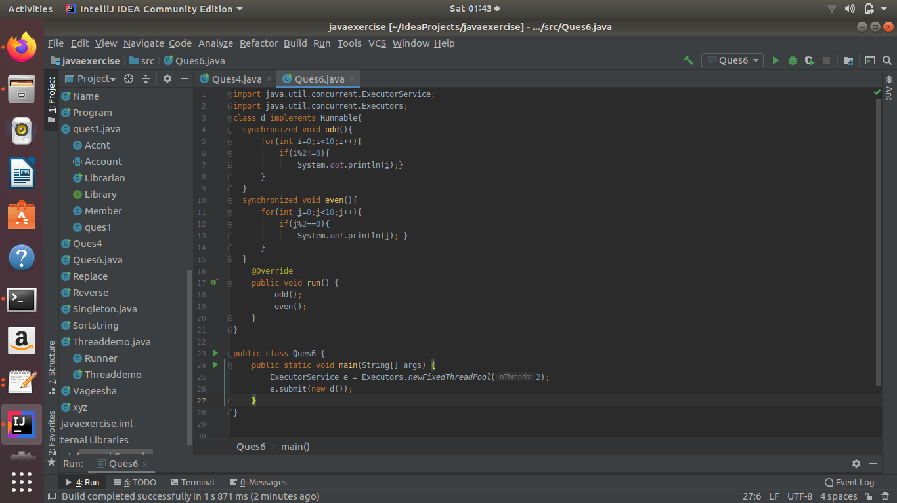

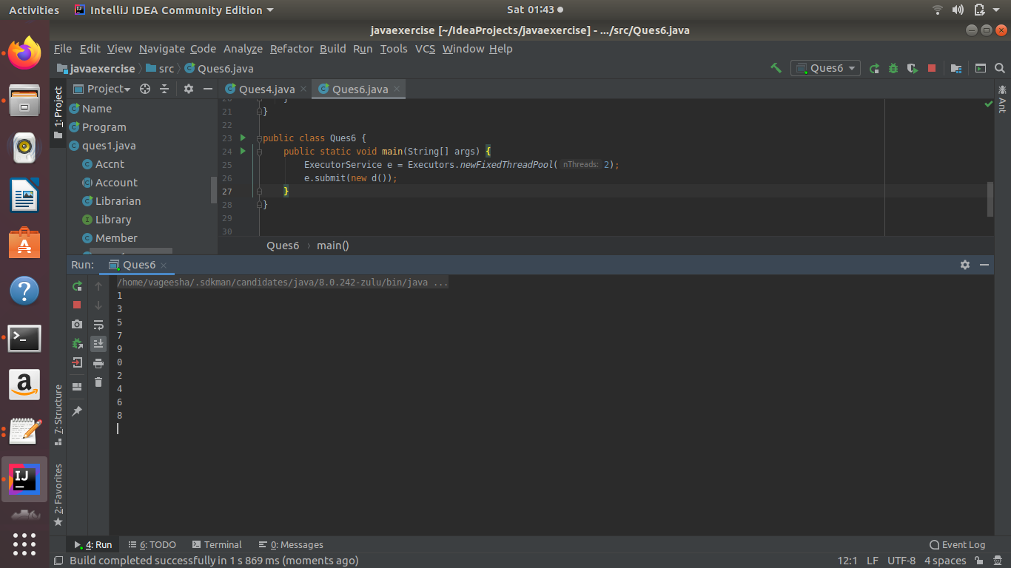

**7. Write a program to demonstrate wait and notify methods.**

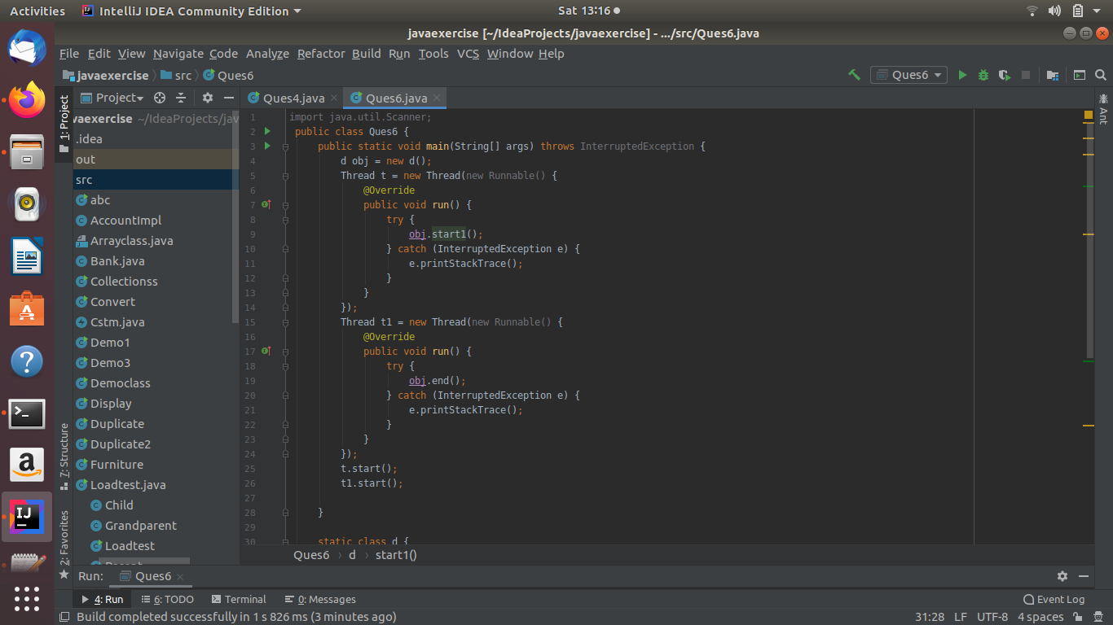

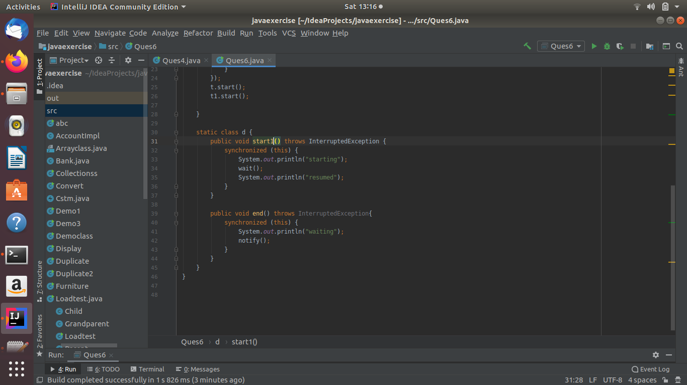

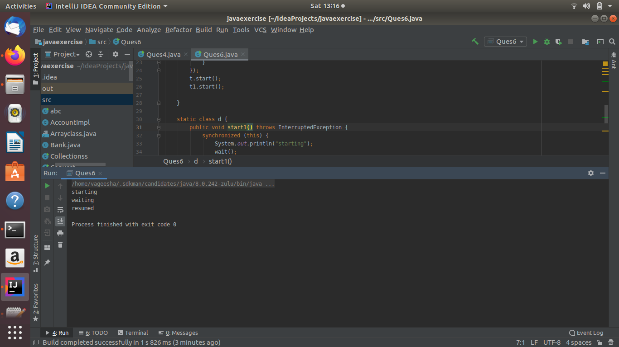

**8. Write a program to demonstrate sleep and join methods.**

