LAB EXPERIMENT – PART 2
Performance Analysis Using Type-2
Hypervisor
VMware Workstation
CPU Performance Analysis of an Ubuntu Virtual Machine using Sysbench

Name | Nupur Bagave
USN | 01FE24BCI029
Division | A
Roll No. | 125

1. Aim
To create and verify a virtual machine on the VMware Workstation Type-2 hypervisor, inspect its CPU, memory and disk configuration, monitor resource utilization, and measure CPU performance using Sysbench.

2. Experimental Configuration
Configured / Observed Value | Parameter
VMware Workstation (Type-2) | Hypervisor
Ubuntu 22.04.5 LTS | Guest OS
1 processor, 2 cores = 2 vCPU | CPU allocation
13th Gen Intel Core i5-13450HX presented to guest | CPU model
2048 MB (approximately 2 GB) | Memory allocation
20 GB virtual disk | Virtual disk
NAT | Network configuration
VMware / full virtualization | Virtualization information

3. Procedure
• Launch VMware Workstation and select Create a New Virtual Machine.
• Choose the Typical configuration and select the Ubuntu ISO image.
• Create the VM and configure a 20 GB virtual disk.
• Customize hardware to allocate 2 GB RAM and 2 vCPU; configure the network adapter using NAT.
• Power on the VM, install Ubuntu, restart, and log in.
• Verify the VM using hostnamectl, lscpu, free -h and df -h.
• Run top to observe CPU utilization, memory utilization, processes and load average.
• Install Sysbench and execute sysbench cpu --cpu-max-prime=20000 run.
• Record execution time, total events, events per second and latency statistics.
• Shut down the Ubuntu VM using sudo poweroff after completing the measurements.

4. Commands Used
hostnamectl
lscpu
free -h
df -h
top
sudo apt update
sudo apt install sysbench -y
sysbench --version
sysbench cpu --cpu-max-prime=20000 run
sudo poweroff

5. Observed Results
Observed Result | Metric
Ubuntu 22.04.5 LTS | Operating system
x86_64 | Architecture
2 CPUs / 2 cores | Virtual CPUs
13th Gen Intel Core i5-13450HX | CPU model reported by guest
VMware; full virtualization | Virtualization
Approximately 1.9 GiB total | Memory reported by free -h
20 GB virtual disk | Disk
10.0004 s | Sysbench execution time
14,410 | Sysbench total events
1,440.80 | Sysbench events per second
0.65 ms | Minimum latency
0.69 ms | Average latency
1.89 ms | Maximum latency

6. Resource Utilization Observations
• The guest reports 2 online CPUs and approximately 2 GB of allocated memory.
• The free -h output shows approximately 1.9 GiB total memory, with available memory around 865 MiB at the captured instant.
• The df -h output shows a 20 GB virtual root filesystem, with approximately 12 GB used and 6.5 GB available.
• The top display provides live CPU, memory, process and load information inside the Ubuntu guest.
• Because VMware Workstation is a Type-2 hypervisor, the guest's virtual resources are mediated through the host operating system.

7. Result and Conclusion
Part 2 was completed using VMware Workstation as a Type-2 hypervisor. The Ubuntu virtual machine was configured with 2 vCPUs, 2 GB RAM and a 20 GB virtual disk. The VM configuration was verified using standard Linux system commands, and guest resource utilization was observed using top.
For the supplied Sysbench CPU run, the VM completed the benchmark in 10.0004 seconds and processed 14,410 events at 1,440.80 events per second, with an average latency of 0.69 ms. These values form the Type-2 result set for comparison with the Type-1 Proxmox VE experiment.

8. Type-2 Hypervisor Interpretation
• Architecture: VMware Workstation operates above the host operating system, while Ubuntu runs as the guest OS.
• Host–guest interaction: CPU, memory, storage and networking are presented to Ubuntu as virtual resources and are mediated by the virtualization layer and host.
• Isolation: The guest operates on a virtual disk and virtual CPU resources rather than directly controlling the host's physical devices.
• Typical use cases: Type-2 virtualization is suitable for desktop virtualization, development/testing, laboratory work and running another operating system on a workstation.
• Performance considerations: Benchmark throughput and latency can be affected by virtualization overhead, host workload, resource contention and the configuration of the virtual machine.

9. Final Observation Record
Part 2 Result | Parameter
VMware Workstation | Hypervisor
Type-2 | Hypervisor type
Ubuntu 22.04.5 LTS | Guest OS
2 vCPU | CPU
2 GB | Memory
20 GB | Disk
10.0004 s | Total execution time
14,410 | Total events
1,440.80 | Events per second
0.69 ms | Average latency

10. Screenshots / Experimental Evidence
The supplied screenshots are included below in the same evidence-oriented format as the Type-1 reference. Each figure is placed before its caption, with the caption immediately beneath the corresponding image.
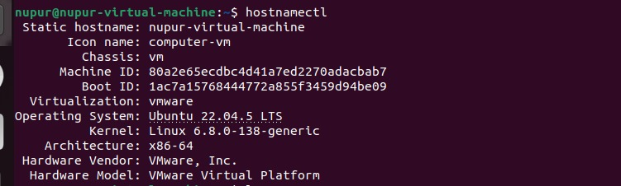
Figure 1. Ubuntu VM: hostnamectl output showing the hostname, Ubuntu operating system, kernel, architecture and VMware virtual hardware information.

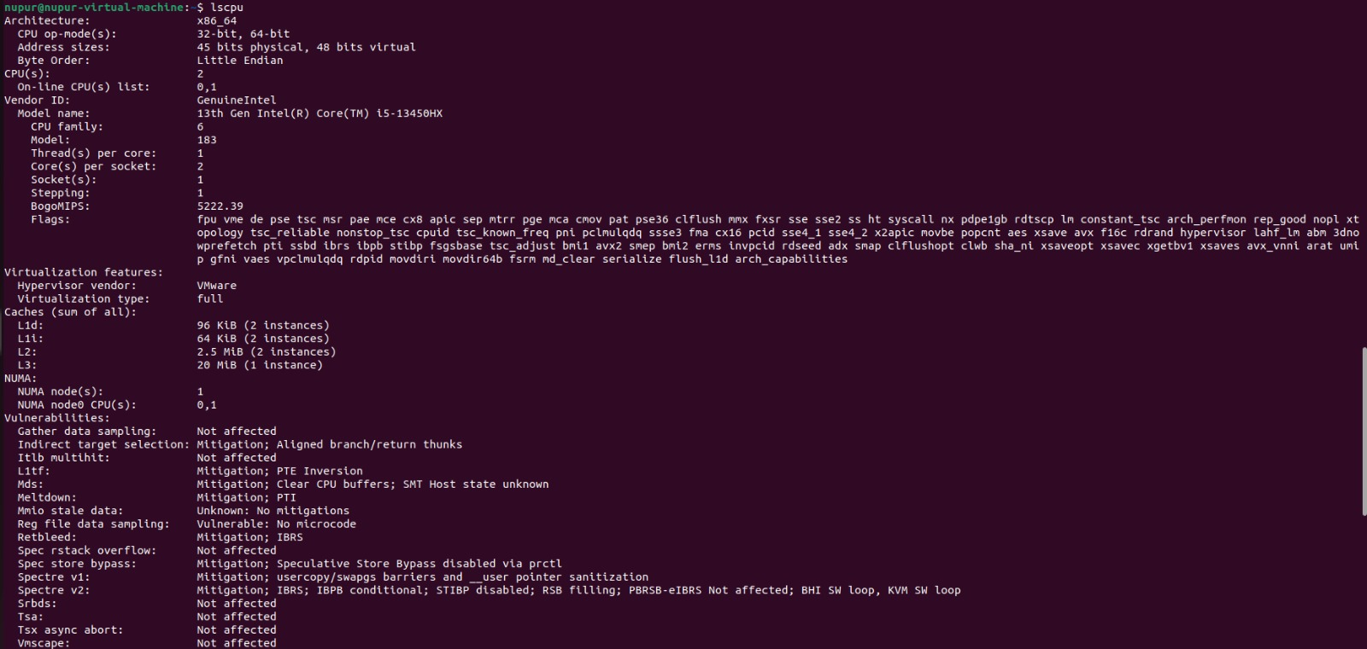
Figure 2. Ubuntu VM: lscpu output showing x86_64 architecture, 2 CPUs/cores, the presented Intel CPU model and VMware full virtualization.
Figure 3. Ubuntu VM: free -h output showing memory and swap allocation/usage.
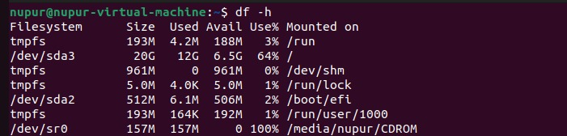
Figure 4. Ubuntu VM: df -h output showing the 20 GB virtual filesystem, used space and available space.

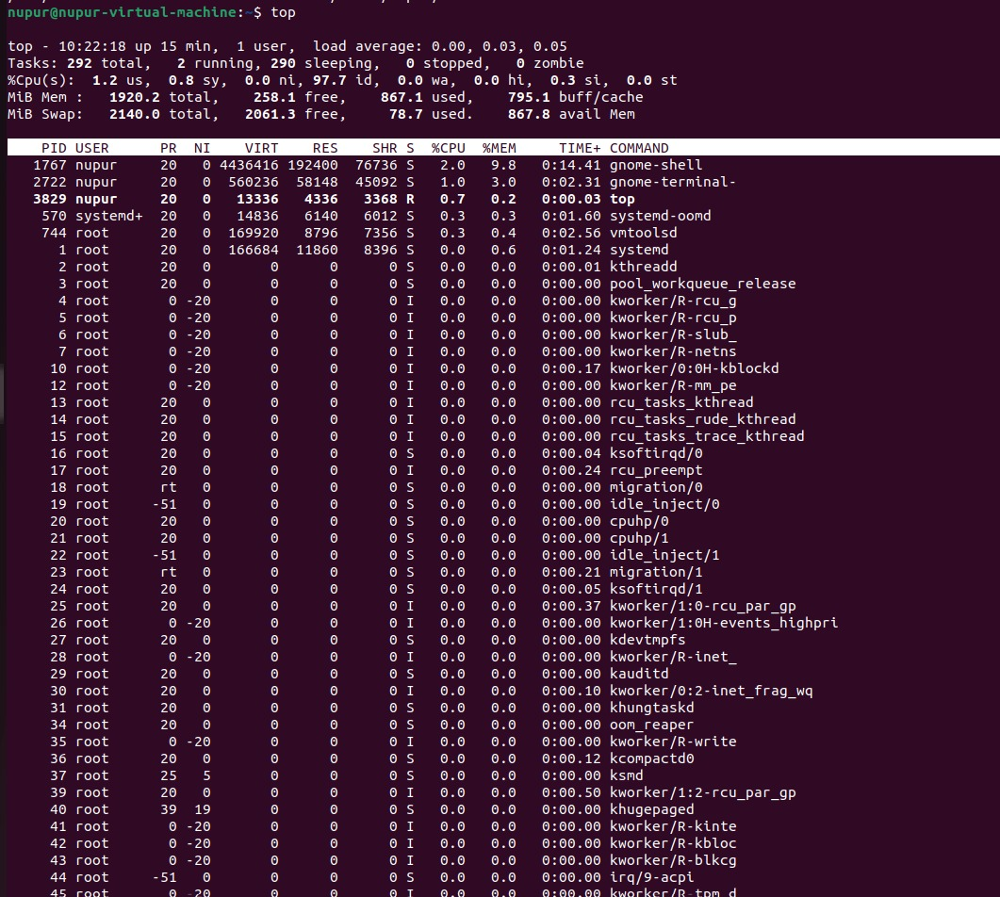
Figure 5. Ubuntu VM: top output showing CPU utilization, memory utilization, load average and active processes.
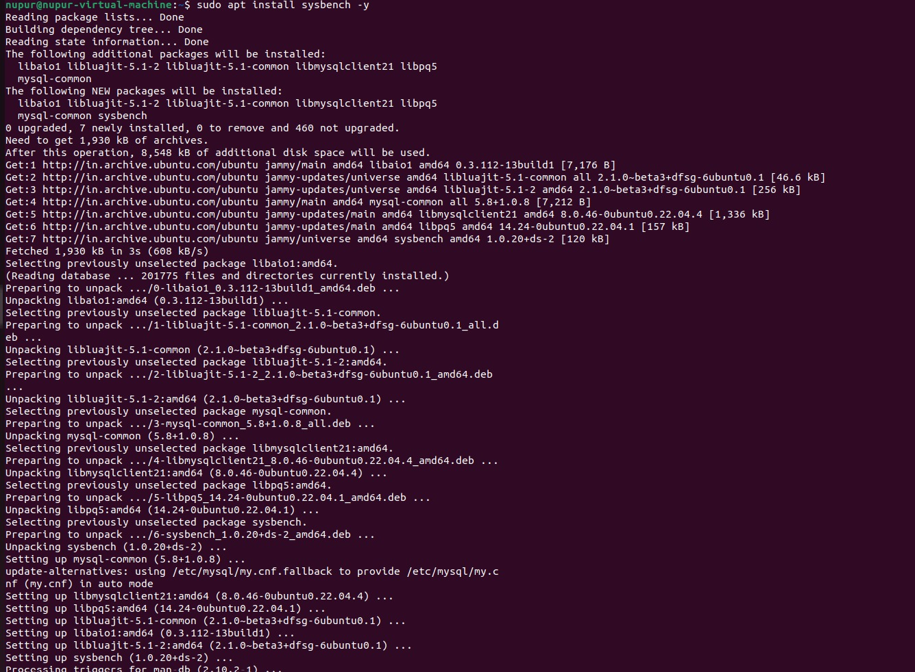
Figure 6. Ubuntu VM: Sysbench installation output showing package installation and configuration.

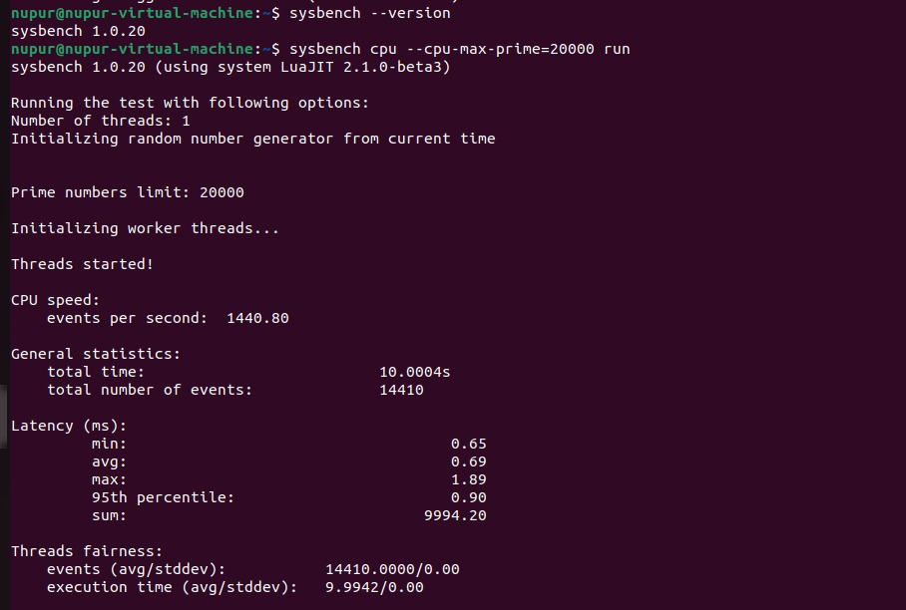
Figure 7. Ubuntu VM: Sysbench CPU benchmark output for --cpu-max-prime=20000, showing execution time, events, throughput and latency.

11. Performance Analysis Summary
The final benchmark screenshot records 1,440.80 events per second, 14,410 total events and 10.0004 seconds of execution time. Minimum, average and maximum latency are 0.65 ms, 0.69 ms and 1.89 ms respectively.

12. Key Observations
• The guest successfully recognizes VMware as its virtualization environment.
• The VM exposes 2 virtual CPUs and approximately 2 GB of memory to Ubuntu.
• The guest sees a 20 GB virtual disk through the virtual storage layer.
• The Type-2 arrangement introduces an additional software layer between the guest and physical hardware, which can influence performance.
• The Sysbench result provides a reproducible CPU-performance measurement for comparison with the Type-1 result.

