HTML ASSIGNMENT

Ques 1:

A block element always starts from a new line and take full width of the page from left to right.
A block-level element can take up one line or multiple lines.
Some of block level element -:
- <div>
- <blockqoute>
- <header>
- <footer>
- <h1>-<h6>

An inline element does not start on a new line and only takes up as much width as necessary.
Some of inline element are-:
- <span>
- <small>
- <input>
- <button>

Ques 2 :
Display:none -> it means that the tag will not appear on the page at all. There will be no space allocated for it between the other tags.

Visibility:hidden -> it means that the tag will not appear on the page at all.There will be space allocated for it between the other tags;

Ques 3:
The float property is used for positioning and formatting content e.g. let an image float left to the text in a container.
The float property can have one of the following values:
- left - The element floats to the left of its container
- right- The element floats to the right of its container
- none - The element does not float (will be displayed just where it occurs in the text). This is default
- inherit - The element inherits the float value of its parent

The clear property specifies what elements can float beside the cleared element and on which side.
The clear property can have one of the following values:
- none - Allows floating elements on both sides. This is default
- left - No floating elements allowed on the left side
- right- No floating elements allowed on the right side
- both - No floating elements allowed on either the left or the right side
- inherit - The element inherits the clear value of its parent

Ques 4 :
- Static This is the default for every single page element. Different elements don't have different default values for positioning, they all start out as static. Static doesn't mean much; it just means that the element will flow into the page as it normally would. The only reason you would ever set an element to position: static; is to forcefully remove some positioning that got applied to an element outside of your control.
- Relative This type of positioning is probably the most confusing and misused. What it really means is "relative to itself". If you set position: relative; on an element but no other positioning attributes (top, left, bottom or right), it will no effect on it's positioning at all, it will be exactly as it would be if you left it as position: static; But if you do give it some other positioning attribute, say, top: 10px;, it will shift its position 10 pixels down from where it would normally be.
- Absolute We can use the positioning attributes top, left, bottom. and right to set the location. These values will be relative to the next parent element with relative (or absolute) positioning. If there is no such parent, it will default all the way back up to the <html> element itself meaning it will be placed relatively to the page itself. The trade-off (and most important thing to remember) about absolute positioning is that these elements are removed from the flow of elements on the page. An element with this type of positioning is not affected by other elements and it doesn't affect other elements.
- Fixed A fixed position element is positioned relative to the viewport, or the browser window itself.

Ques 5:
<!DOCTYPE html>
<html>
<head>
<style>
table, th, td{
border: 1px solid red;
}
</style>
</head>
<body>
<table>
<tr>
<th>Id</th>
<th>Employee Name</th>
<th>Designation</th>
<th>Department</th>
</tr>
<tr>
<td>1</td>
<td>Vagish</td>
<td>Coder</td>
<td>IT</td>
</tr>
<tr>
<td>2</td>
<td>Varun</td>
<td>Accountant</td>
<td>Accounts</td>
</tr>
<tr>
<td>3</td>
<td>Gagan</td>
<td>Tester</td>
<td>IT</td>
</tr>
<tr>
<td>4</td>
<td>Arpit</td>
<td>HR</td>
<td>HR</td>
</tr>
</table>
</body>
</html>

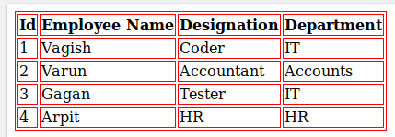

Ques 6 :
Metadata is data (information) about data.
The <meta> tag provides metadata about the HTML document. Metadata will not be displayed on the page, but will be machine parsable.
Meta elements are typically used to specify page description, keywords, author of the document, last modified, and other metadata.

Ques 7 :
All HTML elements can be considered as boxes. In CSS, the term "box model" is used when talking about design and layout.
The CSS box model is essentially a box that wraps around every HTML element. It consists of: margins, borders, padding, and the actual content. The image below illustrates the box model:
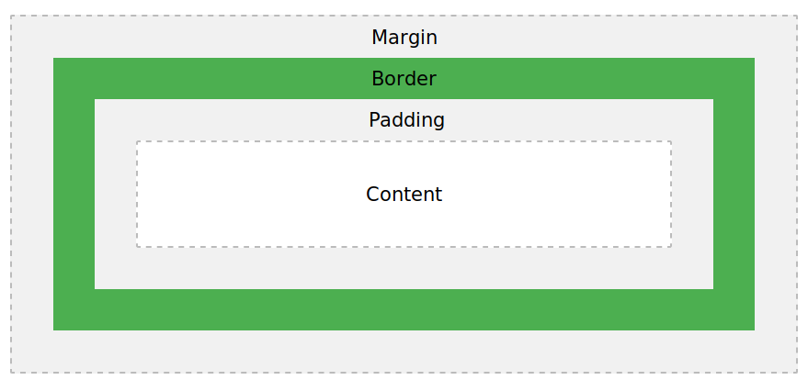
Explanation of the different parts:
- Content - The content of the box, where text and images appear
- Padding - Clears an area around the content. The padding is transparent
- Border - A border that goes around the padding and content
- Margin - Clears an area outside the border. The margin is transparent

Ques 8 :

The element Selector
The element selector selects elements based on the element name.
p {
text-align: center;
color: red;
}

The id Selector
The id selector uses the id attribute of an HTML element to select a specific element.
The id of an element should be unique within a page, so the id selector is used to select one unique element!
To select an element with a specific id, write a hash (#) character, followed by the id of the element.

#para1 {
text-align: center;
color: red;
}

The class Selector
The class selector selects elements with a specific class attribute.
To select elements with a specific class, write a period (.) character, followed by the name of the class.

.center {
text-align: center;
color: red;
}

Ques 9:
The <!DOCTYPE> declaration must be the very first thing in your HTML document, before the <html> tag.
The <!DOCTYPE> declaration is not an HTML tag; it is an instruction to the web browser about what version of HTML the page is written in.

Ques 10 :

<section>
The <section> element defines a section in a document.
According to W3C's HTML5 documentation: "A section is a thematic grouping of content, typically with a heading."
<section>
<h1>TTN Bootcamp</h1>
<p>Bootcamp for trainees</p>
</section>

<article>
The <article> element specifies independent, self-contained content.
An article should make sense on its own, and it should be possible to read it independently from the rest of the web site.
Examples of where an <article> element can be used:
- Forum post
- Blog post
- Newspaper article
<article>
<h1>TTN Bootcamp</h1>
<p>Bootcamp for trainees</p>
</article>

<header>
The <header> element specifies a header for a document or section.
The <header> element should be used as a container for introductory content.
<article>
<header>
<h1>TTN ASSIGNMENT</h1>
</header>
<p>Assignment</p>
</article>

<footer>
The <footer> element specifies a footer for a document or section.
A <footer> element should contain information about its containing element.
A footer typically contains the author of the document, copyright information, links to terms of use, contact information, etc.
<footer>
<p>Posted By:Prateek</p>
</footer>

<nav>
The <nav> element defines a set of navigation links.

<nav>
<a href=”html”/>HTML</a>
<a href=”css”/>CSS</a>
</nav>

