Contents

Assignment 1 WriteUp 1

Outcomes of the entire assignment 1

Part I Webserver 1

Part II Web Client 3

Part III UDP 6

Part IV Multi Threading Server 7

Analysis of the times required to download files over various types of connections 8

Downloading one to ten files over Non Persistent connection:- 8

Downloading ten files over persistent connection:- 8

Downloading one to ten files over UDP:- 9

Downloading one to ten files over Multithreaded server:- 10

Analysis from the above observations 11

# Assignment 1 WriteUp

## Outcomes of the entire assignment

### Part I Webserver

**Following is the screenshot of the requested webpage getting displayed correctly in the browser.**

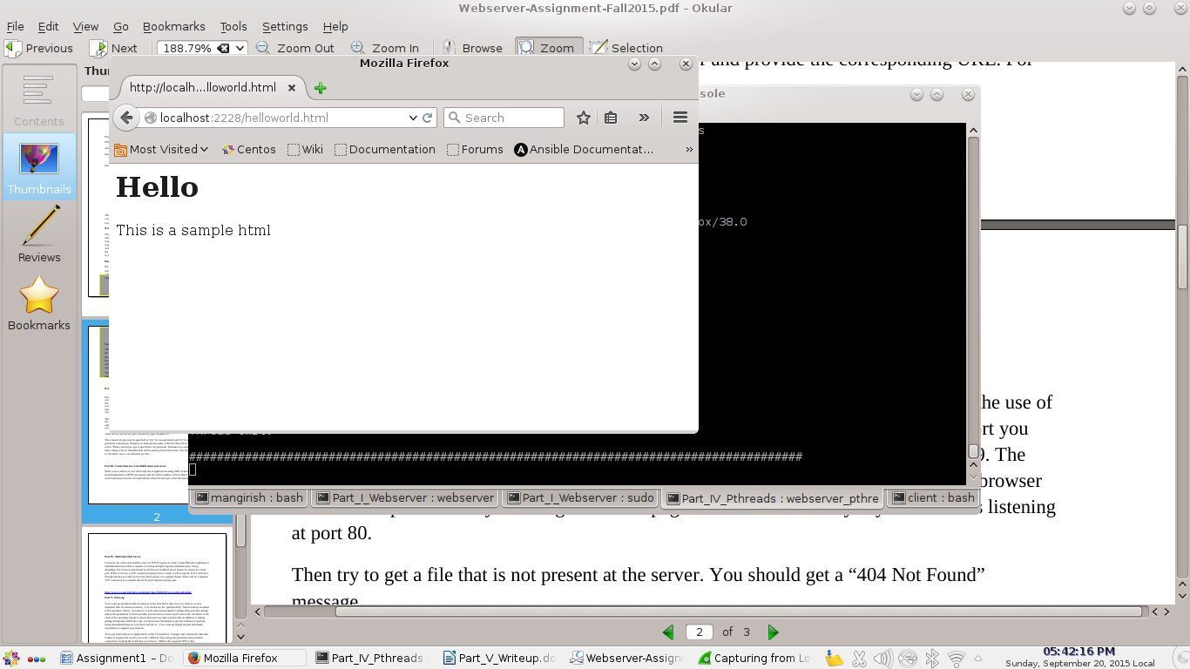

**Following is the screenshot of 404 Not Found**

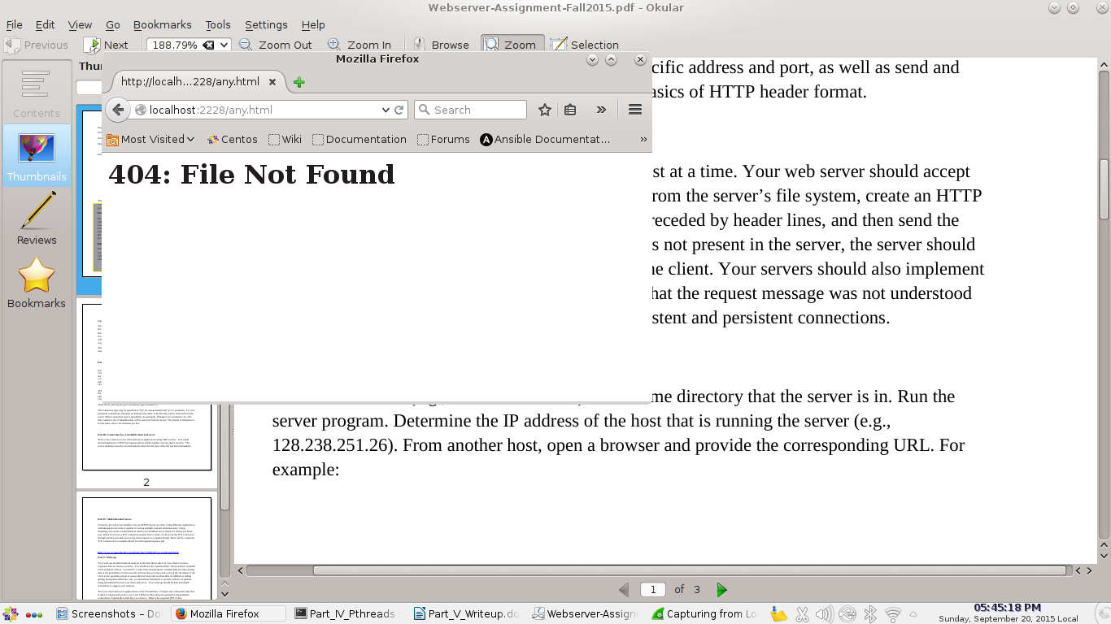

**Here is how we can test for 400 Bad Request. Provide a malformed request through telnet:-**

(ENV)[mangirish@MangoLap Part_I_Webserver]$ telnet localhost 2230

Trying ::1...

telnet: connect to address ::1: Connection refused

Trying 127.0.0.1...

Connected to localhost.

Escape character is '^]'.

GT / HTT

HTTP/1.1 400 Bad Request

Server: mangolap

### Part II Web Client

#### Non Persistent execution output:-

**Client:-**

$ ./webclient localhost 2222 np helloworld.html

Request: GET /helloworld.html HTTP/1.1

From: mango@xxx.com

Connection: close

Response:-

HTTP/1.1 200 OK

Server: mangolap

<html>

<head>

<h1>Hello</h1>

</head>

<body>

<p>This is a sample html</p>

</body>

</html>

helloworld.html file content:-

<html>

<head>

<h1>Hello</h1>

</head>

<body>

<p>This is a sample html</p>

</body>

</html>

Request sent at: 1442787494 seconds and 724876 microseconds

Last response received at: 1442787494 seconds and 732624 microseconds

**Server:-**

Client Connected...

Request:

GET /helloworld.html HTTP/1.1

From: mango@xxx.com

Connection: close

Validating Request...

Client Request received at: 1442787494 seconds and 721968 micro-seconds

Transmission started at: 1442787494 seconds and 732420 micro-seconds

Last byte was transmitted at: 1442787494 seconds and 732482 micro-seconds

Client connection closed

#### Persistent execution output:-

**NOTE:-**

The persistent connection has been implemented by using 'Connection: keep-alive' and 'Connection: close' request headers. The server would keep the connection going until it recieves a 'Connection: close' in the request header.

**Server:-**

(ENV)[mangirish@MangoLap Part_II_Webclient]$ ./webclient localhost 2222 p fnames.txt

Request: GET /helloworld.txt HTTP/1.1

From: mango@xxx.com

Connection: keep-alive

Response:-

HTTP/1.1 404 Not Found

Server: mangolap

<html><h1>404: File Not Found</h1></html>

Request: GET /mango.txt HTTP/1.1

From: mango@xxx.com

Connection: keep-alive

Response:-

HTTP/1.1 200 OK

Server: mangolap

// Note: This function returns a pointer to a substring of the original string.

// If the given string was allocated dynamically, the caller must not overwrite

// that pointer with the returned value, since the original pointer must be

// deallocated using the same allocator with which it was allocated. The return

// value must NOT be deallocated using free() etc.

mango.txt file content:-

// Note: This function returns a pointer to a substring of the original string.

// If the given string was allocated dynamically, the caller must not overwrite

// that pointer with the returned value, since the original pointer must be

// deallocated using the same allocator with which it was allocated. The return

// value must NOT be deallocated using free() etc.

Request: GET /sss.rrr HTTP/1.1

From: mango@xxx.com

Connection: keep-alive

Response:-

HTTP/1.1 404 Not Found

Server: mangolap

<html><h1>404: File Not Found</h1></html>

Requests started at: 1442787595 seconds and 792065 microseconds

Last response received at: 1442787595 seconds and 817342 microseconds

**Server:-**

***Client Connected...***

Request:

GET /helloworld.txt HTTP/1.1

From: mango@xxx.com

Connection: keep-alive

Validating Request...

helloworld.txt file does not exists

Client Request received at: 1442787595 seconds and 792061 micro-seconds

Transmission started at: 1442787595 seconds and 802820 micro-seconds

Last byte was transmitted at: 1442787595 seconds and 802885 micro-seconds

Request:

GET /mango.txt HTTP/1.1

From: mango@xxx.com

Connection: keep-alive

Validating Request...

Client Request received at: 1442787595 seconds and 792061 micro-seconds

Transmission started at: 1442787595 seconds and 808080 micro-seconds

Last byte was transmitted at: 1442787595 seconds and 808131 micro-seconds

Request:

GET /sss.rrr HTTP/1.1

From: mango@xxx.com

Connection: keep-alive

Validating Request...

sss.rrr file does not exists

Client Request received at: 1442787595 seconds and 792061 micro-seconds

Transmission started at: 1442787595 seconds and 814056 micro-seconds

Last byte was transmitted at: 1442787595 seconds and 814122 micro-seconds

Request:

GET / HTTP/1.1

From: mango@xxx.com

Connection: close

Validating Request...

file does not exists

Client Request received at: 1442787595 seconds and 792061 micro-seconds

Transmission started at: 1442787595 seconds and 815469 micro-seconds

Last byte was transmitted at: 1442787595 seconds and 815520 micro-seconds

***Client connection closed***

### Part III UDP

**Client:-**

(ENV)[mangirish@MangoLap client]$ ./webclient_udp localhost 2223 mango.txt

Request: GET /mango.txt HTTP/1.1

Number of bytes received: 406

Response:-

HTTP/1.1 200 OK

Server: mangolap

// Note: This function returns a pointer to a substring of the original string.

// If the given string was allocated dynamically, the caller must not overwrite

// that pointer with the returned value, since the original pointer must be

// deallocated using the same allocator with which it was allocated. The return

// value must NOT be deallocated using free() etc.

mango.txt file content:-

// Note: This function returns a pointer to a substring of the original string.

// If the given string was allocated dynamically, the caller must not overwrite

// that pointer with the returned value, since the original pointer must be

// deallocated using the same allocator with which it was allocated. The return

// value must NOT be deallocated using free() etc.

Request sent at: 1442787848 seconds and 290040 microseconds

Last response received at: 1442787848 seconds and 296494 microseconds

**Server:-**

$ ./webserver_udp 2223

Server started. Waiting for datagram requests...

Request:

GET /mango.txt HTTP/1.1

Validating Request...

Transmission started at: 1442787848 seconds and 296383 micro-seconds

Last byte was transmitted at: 1442787848 seconds and 296449 micro-seconds

### Part IV Multi Threading Server

**Client:-**

(ENV)[mangirish@MangoLap client]$ ./webclient_pthreads localhost 2224 hhh.ttt

Request: GET /hhh.ttt HTTP/1.1

Response:-

HTTP/1.1 404 Not Found

Server: mangolap

<html><h1>404: File Not Found</h1></html>

Request sent at: 1442788587 seconds and 904380 microseconds

Last response received at: 1442788587 seconds and 907855 microseconds

**Server:-**

Server started, listening on port 2224

Client connection received at: 1442788587 seconds and 901289 micro-seconds

Handling request in a new thread...

Request:

GET /hhh.ttt HTTP/1.1

Validating Request...

hhh.ttt file does not exists

Transmission started at: 1442788587 seconds and 907612 micro-seconds

Last byte was transmitted at: 1442788587 seconds and 907727 micro-seconds

Client connection closed

Thread exit.

## Analysis of the times required to download files over various types of connections

### Downloading one to ten files over Non Persistent connection:-

|  |  |
| --- | --- |
| Number of Files | Time required to service (micro secs) |
| 1 | 4577 |
| 2 | 12933 |
| 3 | 21202 |
| 4 | 29482 |
| 5 | 37915 |
| 6 | 46559 |
| 7 | 54819 |
| 8 | 63329 |
| 9 | 72594 |
| 10 | 84836 |

**Wireshark Screenshot:-**

Traffic sniffed for Non Persistent connection while requesting a file:-

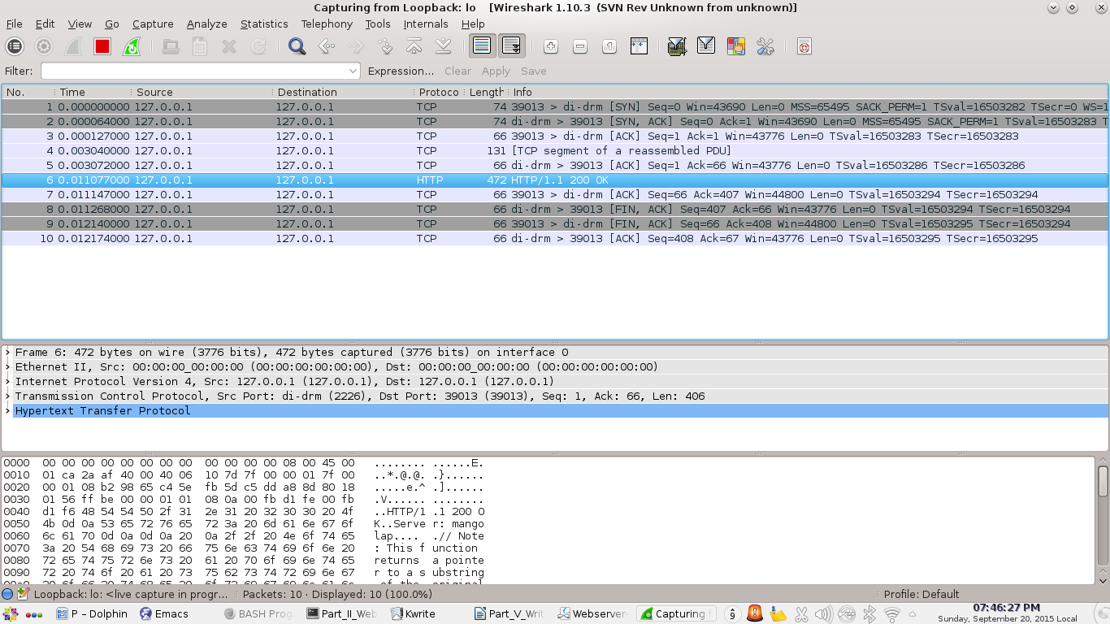

### Downloading ten files over persistent connection:-

|  |  |
| --- | --- |
| Number of Files | Time required to service (micro secs) |
| 10 | 39508 |

**Wireshark screenshot:-**

Traffic sniffed when requesting 3 files over persistent TCP connection. The multiple requests and responses within the same TCP connection is spotted.

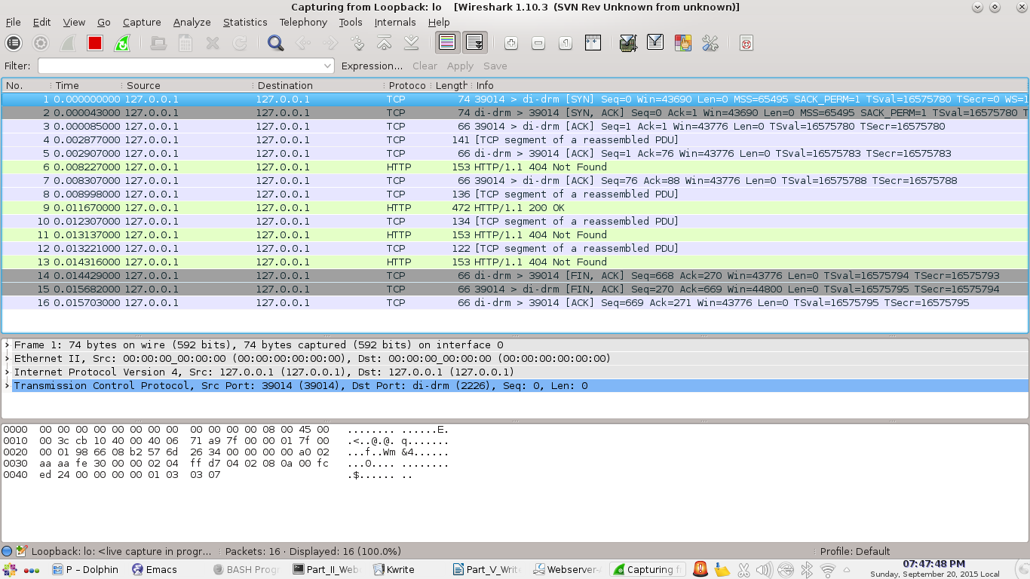

### Downloading one to ten files over UDP:-

|  |  |
| --- | --- |
| Number of Files | Time required to service (micro secs) |
| 1 | 2649 |
| 2 | 7873 |
| 3 | 13061 |
| 4 | 18122 |
| 5 | 23173 |
| 6 | 28205 |
| 7 | 33205 |
| 8 | 38256 |
| 9 | 43272 |
| 10 | 48289 |

**Wireshark Screehshot:-**

Traffic sniffed while requesting one file over UDP:-

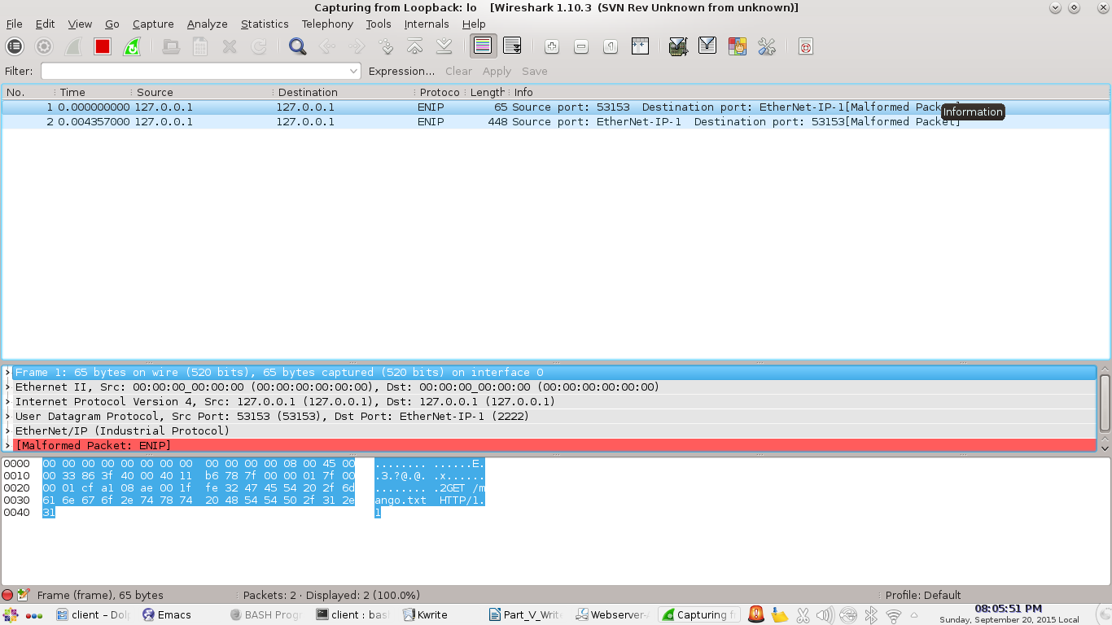

The protocol being displayed is ENIP (and not UDP), although the program is using a DGRAM socket.

### Downloading one to ten files over Multithreaded server:-

|  |  |
| --- | --- |
| Number of Files | Time required to service (micro secs) |
| 1 | 2606 |
| 2 | 8256 |
| 3 | 13820 |
| 4 | 19324 |
| 5 | 24838 |
| 6 | 30369 |
| 7 | 37018 |
| 8 | 41473 |
| 9 | 46948 |
| 10 | 52417 |

**Wireshark Screenshots:-**

Traffic sniffed when requesting a file from multithreaded server:-

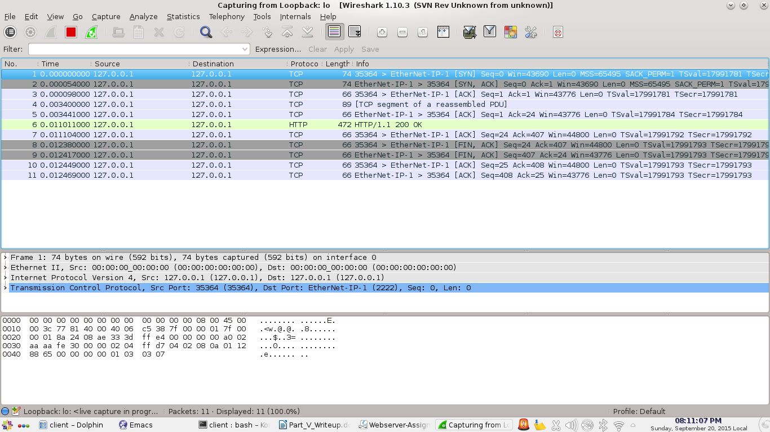

## Analysis from the above observations

* Referring to the wireshark screenshot of non- persistent connection above, the time elapsed between SYN and SYN, ACK packets can be considered as RTT in the environment. The time is: 0.000064000 secs.
* The time required to service multiple requests show a linear pattern as there is very meager congestion and packet loss if not none, and the server is handling just one connection at a time, sequentially.
* Persistent connection is faster than non-persistent connection since, the non persistent connection has an extra overhead of TCP handshake for every new request. Whereas, for persistent connections, there is one single TCP handshake for multiple request response pairs.
* According to the above data, UDP is faster than every other connection, except for TCP Persistent connection.
* There was no packet loss experienced/ reported in wireshark for any connection. Both the server and client were run on the same host machine and the traffic was routed over the loopback network interface (127.0.0.1).