
……………
Τμημα Μηχ. Η/Υ & Πληροφορικής
Πανεπιστήμιο Ιωαννίνων
Department of Computer Science & Engineering
University of Ioannina

L4 Security of Computer Systems

Project Report

“Evaluating data encryption on locally hosted open-source Amazon S3 compatible object storage platform”

Evangelos Dimoulis, AM: 421
Ioannina, Greece February 2021
1. Introduction

Object storage, also known as object-based storage, is a strategy that manages and manipulates data storage as distinct units, called objects. These objects are kept in a single storehouse and are not ingrained in files inside other folders. Instead, object storage combines the pieces of data that make up a file, adds all its relevant metadata to that file, and attaches a custom identifier. The main benefits of object storage include reduced complexity over data management and scalability by incrementing the number of storage nodes.
MinIO [1] is a popular open-source object storage server compatible with the Amazon S3 cloud storage [2]. Applications that have been configured to talk to Amazon S3 can also be configured to talk to MinIO leveraging the Amazon S3 compatible API, allowing MinIO to be a viable alternative to S3 to gain more control over the object storage server. The service stores unstructured data such as photos, videos, log files, backups, and container/VM images, and can even provide a single object storage server that pools multiple drives spread across many servers. To access the MinIO server though a client via a HTTP request, MinIO implements Server-Side Encryption (SSE) requiring TLS/HTTPS communication between the client and the server in order to ensure data confidentiality and integrity. However, another important aspect of securing the data that resides in MinIO server is in what form the data is ultimately stored on the object store and if some sort of encryption is applied to the stored objects and the object metadata. A compromised storage provider or an unauthorized third-party could possibly cause a data leak.
Our evaluation will focus on studying the security guarantees that a locally hosted MinIO instance provides, upload files via a client to the object store, and if the data is stored in raw, we will introduce an encryption scheme to secure the uploaded data against storage provider compromise, via traditional encryption algorithms (e.g., AES, AES-CTR). We will report the performance of the encryption applied on the uploaded files, and if possible re-encrypt the uploaded files online in case we want to revoke access to a user or service that could previously gain access to the data.

2. Background
In this section we briefly describe the functionality of object storage systems and the benefits gained by leveraging this kind of storage. Furthermore, we refer to Amazon S3 Object Storage and how objects are stored in Amazon S3.

2.1 Object Storage System
Object based storage system [3] is a data storage system which process data as objects when compared with other state of the art distributed storage system as blocks and files. Both files and block storage is converged to called as Objects [4]. An object is variable-length not a fixed size like blocks, and can be used to store all type of data, such as files, database records, audio/video images, medical record. A single object could even be used to store an entire file system or database. The storage application decides what gets stored in an object. Unlike block I/O, creating objects on a storage device is accomplished through a rich interface similar to a file system. Object storage manages digital data, machine data, sensor data and easily manage files, metadata, while presenting very high scalability. Moreover, keeping track of content objects using their metadata descriptors and policies makes access, discovery, replication, distribution, and retention much more practical than in traditional approaches.

2.2 Benefits of Object Storage
There are many reasons to consider an object-storage-based solution to store massive volumes of data. Object storage is used for storing/managing large volumes unstructured data such as images, video files or even archived backups which are data types that are typically static but may be required at any time. Scalability and reduced complexity are two of the main advantages of object storage. Objects or discrete units of data are stored in a structurally flat data environment within the storage cluster and by adding more servers to an storage cluster, higher throughput and additional processing capabilities can be supported given that object storage also removes the complexity that comes with a hierarchical file system with folders and directories. Furthermore, object storage goes hand in hand with cloud or hosted environments that deliver multi-tenant storage as a service allowing many companies or departments within a company to share the same storage repository. Another aspect is that, object storage services follow a pay-as-you go pricing strategies, and the pricing is usually volume-based, which means that a user or company pays less for very large volumes of data rendering this kind of storage more affordable [5].

2.3 Amazon S3
Amazon Simple Storage Service (Amazon S3) is an object storage service that offers industry-leading scalability, data availability, security, and performance. Customers of all sizes and industries can use it to store and protect any amount of data for a range of use cases, such as data lakes, websites, mobile applications, backup and restore, archive, enterprise applications, IoT devices, and big data analytics. Amazon S3 provides easy-to-use management features in order to organize data and configure finely-tuned access controls to meet specific business, organizational, and compliance requirements. In Amazon S3, objects are uploaded and stored into buckets. Amazon S3 provides REST API for creating and managing buckets which requires writing code and authenticating the requests. The requests are initiated and executed via clients [6]. Alternatively, managing buckets and objects can be achieved using high-level S3 commands provided by command line tools used to establish communication to an Amazon S3 instance.

2.4 Amazon S3 Objects
Amazon S3 is essentially an object store that uses unique key-values to store as many object as a client desires to. Objects can be handled in one or more buckets and each object can be up to 5 TB in size.
Key
Version ID
Value
Metadata
Key
Version ID
Value
Metadata
Object #1
Object #1
Key
Version ID
Value
Metadata
Object #2
Object #N

Figure 1: A collection of objects stored in a bucket

Figure 1 illustrates an example buckets which consists of a collection of total N objects. Each object is composed of the following (basic) attributes which uniquely describe the object in a bucket:

- Key: The name that you assign to an object. You use the object key to retrieve the object.
- Version ID: Within a bucket, a key and version ID uniquely identify an object.
- Value: The content that you are storing. An object value can be any sequence of bytes. Objects can range in size from zero to 5 TB.
- Metadata: A set of name-value pairs with which you can store information regarding the object.

3. MinIO
MinIO is a High Performance Object Storage released under Apache License v2.0. It is API compatible with Amazon S3 cloud storage service. MinIO is used to build high performance infrastructure for machine learning, analytics and various application data workloads.

3.1 Deployment
MinIO provides different configurations of hosts, nodes, and drives depending on the needs and infrastructure of the organization hosting the object storage service. There are three distinct types of deployment modes for MinIO: a) Standalone, b) Distributed, and c) Cloud Scale. In this work we will focus on the Standalone deployment of MinIO. To host multiple tenants on a single machine, we run one MinIO server instance per tenant with a dedicated HTTPS port, configuration, and data directory.
TENANT 1
TENANT 2
DISK 1
MINIO 1
MINIO 2
HOST
9001
9002

Figure 2: Two tenants on a single host with a single drive

In Figure 2 we illustrate a typical multi-tenant standalone deployment of MinIO on a single host with a single drive. In this example we have two tenants, each hosting a separate instance of MinIO on the same node. Each tenant has a dedicated port (port 9000 is typically used for the standard MinIO deployment) , in order to forward HTTP requests to each MinIO instance. Given that we have successfully obtained the MinIO executable by compiling the source code, in order to host two tenants we use the following commands:

minio server --address :9001 /mnt/data/tenant1
minio server --address :9002 /mnt/data/tenant2

3.2 Accessing MinIO Server with TLS
In order to securely access MinIO server all communication between a client and a MinIO instance is protected via Transport Security Layer (TLS). The primary use of TLS is for encrypting the communication between applications and servers such as web browsers loading a website [8]. TLS accomplishes to enforce three fundamental security primitives between the communication of clients and MinIO:

- Encryption: hides the data being transferred from third parties.
- Authentication: ensures that parties exchanging information are who they claim to be.
- Integrity: verifies that the data has not been forged or tampered with.

To securely establish communication, we need to provide a private key and a public certificate that have been obtained from a certificate authority (CA). Alternatively, if the server is used for development or research purposes and not for actual production release, the hosting provider can generate a self-signed certificate using the openssl library [9]. First, we generate a private RSA key, 2048 bit long modulus, and store the key as private.key. As a next step we generate an SSL configuration file named openssl.conf stating information such as the location of the provider, domain name, IP address etc. By running the command:

openssl req -new -x509 -nodes -days 730 -key private.key -out public.crt -config openssl.conf

we eventually generate the certificate file named public.crt. The private key and the certificate signed using the private key, are stored under the MinIO configuration directory.

3.3 Encryption
As described in paragraph 3.2, the communication between client and MinIO server is securely established using TLS/HTTPS. Therefore, all data transmitted through the HTTP request headers is encrypted and integrity protected. However, when we successfully put an object into a bucket the data resides in plaintext and no form of encryption is applied by default, making the data publicly accessible to any client that gains access to the MinIO server even with simple collaboration with the storage provider. In order to further protect the privacy of the sensitive data we want to securely store, MinIO supports two different types of Server-Side Encryption (SSE):

- SSE-C: The MinIO server en/decrypts objects using a secret key provided by the S3 client as part of the HTTP request headers. SSE-C requires TLS/HTTPS.
- SSE-S3: The MinIO server en/decrypts an object with a secret key managed by a Key Management System (KMS).

MinIO uses a unique, randomly generated secret key per object known as Object Encryption Key (OEK). Neither the client-provided SSE-C key nor the KMS-managed key is directly used to en/decrypt an object. Instead, the OEK is stored as part of the object metadata next to the object in an encrypted form. To en/decrypt the OEK another secret key is needed also known as, Key Encryption Key (KEK). To summarize, for any encrypted object there exists three different keys:

- OEK: A secret and unique key used to encrypt the object, stored in an encrypted form as part of the object metadata and only loaded to RAM in plaintext during en/decrypting the object.
- KEK: A secret and unique key used to en/decrypt the OEK and never stored anywhere. It is (re-)generated whenever en/decrypting an object using an external secret key and public parameters.
- EK: An external secret key, either the SSE-C client-provided key or the KMS-managed key.

For content encryption MinIO server used AES-256-GCM. Any secret key is 256 bits long. When applying SSE-C, the S3 clients need to send the secret key as part of the HTTP request. The secret key is never stored by the server however, it resides in RAM during en/decryption process. The client provided key is not required to be unique and multiple objects may be en/decrypted using the same secret key [10].

3.4 Threat Model
In our work, we focus on three kind of principals. A user is someone who wants to store data online and may selectively expose the data to a third party service or another user of the system. The user is allowed to upload and store her data on MinIO which claims the role of a cloud storage provider. Each user has one storage provider, but potentially many third-parties (or users) which request access to the users data [11]. The user can upload her data in plaintext or in an encrypted form via user provided secret keys. By default client-server communication is encrypted and integrity protected using TLS/SSL. When applying SSE-C encryption user data resides on the MinIO server in an encrypted form. However, in case the storage server is compromised, during en/decrypting an object the OEK which is loaded to RAM, a malicious user (or third-party) which has regural access to the server, may launch cold boot attacks to retain the DRAM data by freezing the memory chip [12], thus gaining access to all objects which have been encrypted with the same OEK. To prevent data leakage by the execution of such kind of hardware-based attacks, we propose a client encryption scheme where the data is formerly encrypted on the client side before uploading the data. Thus we do not leverage SSE-C encryption on the server side and never leak the secret key, since en/decrypting occurs on the client side and the keys are solely handled by the client. Using this encryption scheme, we can protect sensitive data leakage even if the communication with server is not protected with TLS since the data will be sent in an encrypted form without the HTTP header containing the secret key. However, we do not provide any security guarantees if the client machine is compromised or when applying key rotation on the server which will be described in later sections.
4. Encryption Scheme
In this section we provide an overview to the encryption scheme we employed in order to encrypt the data that is sent to the untrusted storage provider.

4.1 Client Side Encryption
MinIO server is written in Golang, thus in order to support a client side encryption scheme were the data
which is sent in an encrypted form to the storage provider we leveraged the encryption capabilities of Golang. Golang, is an open source programming language designed at Google. It’s statically typed and produces compiled machine code binaries and is syntactically similar to C, but with memory safety, garbage collection, structural typing [13]. Figure 3 depicts the code used to encrypt the data before sending in to the untrusted storage server.
- /* export encrypt */
- func encrypt(fileToEncrypt string, fileName string, pathToKey string) *C.char{

- encrypted_file := fileName + ".bin"
- plaintext, err := ioutil.ReadFile(fileToEncrypt)

- /* Read key file content and convert it to string */
- content, err := ioutil.ReadFile(pathToKey)
- keyString := string(content)

- /* Decode key in order to get the key as type byte[] */
- key, _ := hex.DecodeString(keyString)

- /* Create a new Cipher Block from the key */
- block, err := aes.NewCipher(key)

- /* Create a new GCM */
- gcm, err := cipher.NewGCM(block)

- /* Never use more than 2^32 random nonces with a given key */
- nonce := make([]byte, gcm.NonceSize())
- if _, err := io.ReadFull(rand.Reader, nonce); err != nil {
- log.Fatal(err)
- }
- /* Encrypt the data using GCM Seal function */
- ciphertext := gcm.Seal(nonce, nonce, plaintext, nil)

- /* Save back to file */
- err = ioutil.WriteFile(encrypted_file, ciphertext, 0777)

- /* Returns a pointer to the encrypted file */
- return C.CString(encrypted_file)
- }

Figure 3: AES-256 GCM Encryption in Golang.

In order to encrypt the data, we have written a function in Go which leverages AES-256 GCM encryption. AES-256 GCM is a mode of operation for symmetric-key cryptographic block ciphers similar to the standard counter mode [14]. This encryption module takes as input a file to encrypt (which can be any type of file type since its read as a byte sequence), the raw file name without the path and the file ending, and a symmetric key encoded in base64. The encrypted file is stored to the file system with all permissions granted (mode 777). Finally the functions returns a C string, which is essentially a pointer to the encrypted file. Go supports building the code and exporting C shared compiled libraries which can be distributed, installed and linked to every other application in other programming languages that can reference C shared libraries (C++, Python, Javascript, etc). In order to export the C shared library for en/decryption functionalities which reside in the source file libencrypt.go, we used the following command:

go build -buildmode=c-shared -o libencrypt.so libencrypt.go

The output of the above mentioned command is: a) libencrypt.so, the C shared library, and b) libencrypt.h, the C header file. Figure 4 presents a sample Python client code for encrypting objects using the C shared library:
- /* Loading C shared encryption library */
- lib = cdll.LoadLibrary(“libencrypt.so”)

- /* Structure that handles type convert between modules */
- class go_string(Structure):
- _fields_ = [
- ("p", c_char_p),
- ("n", c_int)]

- /* Encryption function wrapper */
- def encrypt(file_path, file_name, AES_KEY):
- lib.encrypt.restype = c_char_p
- fp = go_string(c_char_p(file_path.encode('utf-8')), len(file_path))
- key = go_string(c_char_p(AES_KEY.encode('utf-8')), len(AES_KEY))
- file_name = go_string(c_char_p(file_name.encode('utf-8')), len(file_name))
- encrypted_file_name = lib.encrypt(fp, file_name, key)

- /* Returns the name of the encrypted file */
- return encrypted_file_name

Figure 4: Python code leveraging C shared library encryption module.

4.2 Server Side Encryption
The default encryption scheme by MinIO server is Server-Side Encryption (SSE) in order to securely encrypt the uploaded objects within the object storage itself. In our work we will implement SSE-C with client provided keys managed solely by the client. In contrast to the forementioned client side encryption scheme, where the presence of TLS was not obligatory since the data was uploaded in an encrypted form, SSE-C requires a valid SSL certificate and a client provided key which is encrypted and attached to HTTP request headers.
- /* Encodes key and returns SSE configuration */
- def sse_encryption(key):

- f = open(key, "r")
- key_str = f.read()
- key_str = key_str.replace('\n', '')
- key = key_str.encode('ascii')
- SSE = SseCustomerKey(key)

- return (SSE)

- /* Custom HTTP client inquiring valid SSL certificate */
- httpClient = urllib3.PoolManager(
- timeout=urllib3.Timeout.DEFAULT_TIMEOUT,
- cert_reqs='CERT_REQUIRED',
- ca_certs=PUBLIC_CERTIFICATE,
- retries=urllib3.Retry(
- total=5,
- backoff_factor=0.2,
- status_forcelist=[500, 502, 503, 504]
- )
- )
- /* MinIO Client initialized with access information */
- client = Minio(MINIO_URL,
- access_key='minio',
- secret_key='minio123',
- secure=True,
- http_client=httpClient)

- /* SSE Customer provided key encryption */
- SSE = sse_encryption(key_path)

- /* Clients putting object to server bucket with SSE encryption */
- client.fput_object( BUCKET_NAME, file_name, file_path, sse=SSE )

Figure 5: Python client for object upload using SSE-C encryption.

Figure 5 illustrates the Python code responsible for executing a SSE client provided key encryption. Function sse_encryption( ) is responsible for encoding the input key and generating the corresponding SSE configuration. Lines 13-28 describe the initialization of the HTTP (custom) and MinIO clients provided with the server credentials and the public certificate for executing the TLS/SSL protocol.

4.3 Key Rotation
Another important aspect that we examine in this work, is how to revoke access to a third-party (or user) that gained access to the unique symmetric en/decryption key of an object that is already stored on the MinIO server. Even if the object is encrypted, a curious user who is not the owner of the file, may have access to the object and decrypt it as he was granted permission to download the object e.g., the third-party may have been formerly listed in the Access Control List (ACL) of the object. In order to revoke access to a third-party, a possible solution would be to re-encrypt the object on the storage provider. Let be the symmetric key of an uploaded object on a MinIO server instance. Re-encrypting the object would require to decrypt the object with its original key and re-encrypt the object with a new key . The secure distribution of the keys is beyond the scope of this work. To the best of our knowledge, MinIO and other related open-source object storage platforms do not provide any re-encryption capabilities on the server side. However, S3 clients can change the client-provided key of an existing object by performing a special S3 COPY operation where the coy source and destination are equal. The HTTP COPY request headers must contain the current key and the new client key . Such a special COPY request is know as S3 SSE-C key rotation.
- /* Source object customer provided key */
- SSE_SRC = sse_encryption(OLD_AES_KEY)

- /* Destination Object SSE Customer provided key encryption */
- SSE_DST = sse_encryption(NEW_AES_KEY)

- /* Copy the object to the same bucket using a different key.
- * Object does not exit the server side using this method.
- */
- result = client.copy_object(
- BUCKET_NAME,
- file_name,
- CopySource(BUCKET_NAME, file_name, ssec=SSE_SRC),
- sse=SSE_DST,
- )

Figure 6: Python code for executing S3 SSE-C key rotation.

In Figure 6, we list the Python code used to implement the S3 COPY operation which results in key rotation of the specified object. The client initialization and SSE configuration methods are not included since they are already stated in Figure 5. The client (owner of the file) generates two distinct SSE configurations (lines 1-5) using the old encryption key and the new encryption key , which she generates and handles privately. Lines 11-14 specify the contents of the HTTP request headers including the SSE configurations the selected object and the bucket in which the object resides. On the server side, the MinIO server decrypts the OEK which is part of the object metadata using the KEK derived from . The server receives the new key and derives a new KEK with it. Using the newly generated KEK the server re-encrypts the OEK with it. As a final step, the freshly encrypted OEK data key is stored as part of the object metadata.

5. Evaluation
In this section we present the experimental setup of our system and report the performance of the encryption schemes we employed in our standalone deployment of the MinIO object storage server using test files of scaling size.

5.1 Experimental Setup
In order to evaluate the scaling performance of: a) our client side encryption scheme, b) the MinIO SSE-C encryption, and c) the SSE COPY request leveraged for key rotation, we deploy a standalone version of MinIO built from source. The standalone deployment consists of one node equipped with Intel (R) Core (TM) i5-4590 at 3.30GHz with 4 cores, 7.7 GB of RAM and a 500 GB hard disk drive. The clients and the MinIO server are connected through the the loopback interface since both are located on the same node. Our system runs the latest version of MinIO built from source and we use Go version go1.15.6 linux/amd64. The operating system on the node is Debian 10 buster 64-bit Linux distribution 4.19.0-13-amd64. The private key and the public certificate reside within the MinIO configuration directory and were generated using OpenSSL version 1.1.1d. Symmetric keys for object AES-256 object encryption are 32 byte long and derived by a random generator implemented in Go leveraging module crypto/rand.
MINIO
HDD
9000
SSL/TLS
Python Client
HTTP Request
Object
Data
Go Encryption
Module
Encrypted Data
SSE-C
10.7.2.207

Figure 7: MinIO Standalone Deployment

Figure 7 illustrates the Standalone MinIO server setup on a single server with IP: 10.7.2.207. The data to encrypt resides on the file system and is encrypted using the the Go Encryption Module. The symmetric key for en/decryption is already generated by a Golang random key generator module which we do not depict here. The Encrypted Data and are propagated to the Python Client which generates an HTTP Request containing the encrypted data object and optionally . When applying SSE-C encryption we bypass the Go Encryption Module and propagate the plaintext Data to the client. The client communicates via SSL/TLS and port 9000 with the MinIO server, which provides its public certificate signed by its private key .

5.2 Performance
We tested the performance of our encryption module and the MinIO server SSE-C encryption scheme using custom size generated binary files of 1KB up to files of 500 MB for application testing and benchmarking [15]. We repeat the test for each functionality and each input binary file 100 times and plot the median of the results tin order to remove possible outliers, which consist noise to the evaluation process and may be produced during testing time due to system overheads. The client requests sent to the MinIO server are generated within the same system, thus we do not examine network utilization in this work.
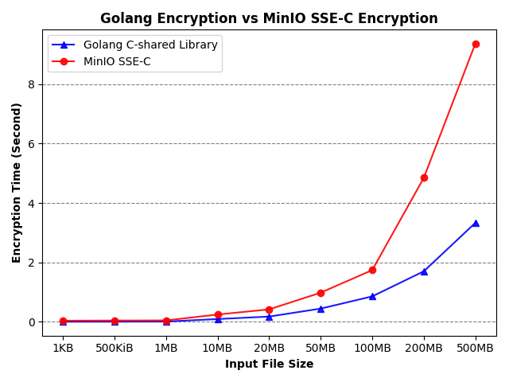

Figure 8: Client-side and SSE-C encryption time.

As shown in Figure 8, for small input files ranging from 1 KB up to 100 MB our client-side encryption scheme using the Golang C-shared library built encryption module and the built in SSE-C encryption applied at the standalone MinIO server instance comparatively perform in a similar manner, with a range of encryption time of seconds up to almost 2 seconds for SSE-C encryption. With a file size of 200 MB SSE-C encryption incurs up to 286% overhead to the total encryption time compared to the client-side encryption scheme. Furthermore with a file size of 500 MB our client-side encryption scheme far outperforms the SSE-C encryption at the server-side. SSE-C presents a median encryption time of approximately 9.36 seconds, while the C compiled Golang module needs only about 1/3 of the execution time being approximately 3.32 seconds. We assume that this performance degrade of SSE-C stems from the fact that the MinIO server handles more complex tasks such as key and metadata management of the objects uploaded to the server.
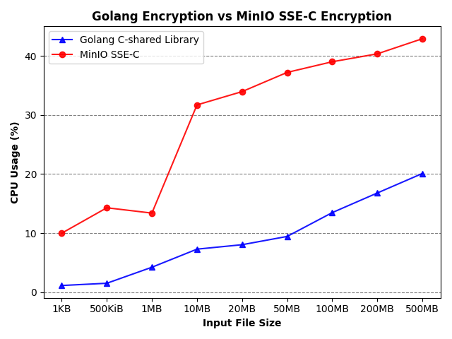
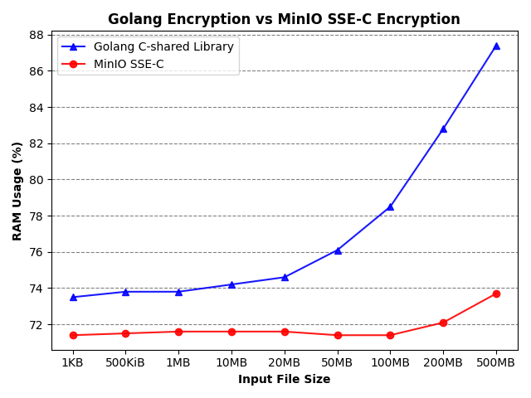

Figure 9 and 10: CPU usage (%) and RAM usage (%) during Client-side encryption and SSE-C encryption.

To retrieve information concerning system utilization, we leveraged Python’s cross-platform psutil open-source library [16]. Figure 9 and 10 present the CPU usage and RAM usage of the two encryption schemes. In compliance with the results presented in Figure 8, client-side encryption incurs less overhead to the CPU usage of the system and scales linear to the input file size. Contrariwise, for files larger than 1 MB, SSE-C encryption consumes significantly more CPU reaching up to 42% usage. Concerning memory usage, SSE-C encryption does not incur memory overheads to the system even with relatively large files, while our client-side encryption scheme exponentially increases RAM usage up to 87 % for our test file of 500 MB.

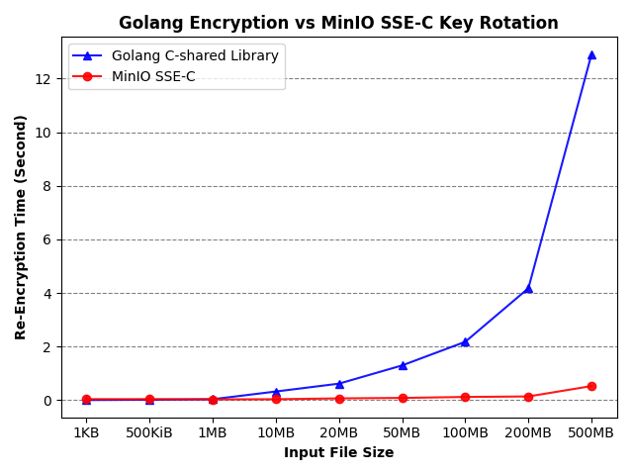

Figure 11: Re-encryption time at Client-side and SSE-C Key Rotation at Server-side.
Figure 11 reports the time spent for re-encrypting our data set. For binary files up to 20 MB our two encryption schemes perform similarly needing only up to roughly 1 second leveraging the Golang encryption module. When scaling to files of size greater than 50 MB there is an obvious performance gap between the two encryption schemes. The reason for this gap stems from the fact that our Golang module decrypts and re-encrypts with a new encryption key the whole object on the file system. SSE-C Key Rotation works in a completely different way. Given that the client and the server communicate via TLS/SSL the client sends the old encryption key and the new encryption key to the server. On the server side we perform a special copy request where the OEK of the original object is decrypted using and re-encrypted using . The object data is left intact since the object is encrypted using the same OEK. Thus, the results seem to be in compliance with what we initially expected since we do not perform the re-encryption process on the whole data object.

6 Conclusion
Object storage systems offer beneficial solutions to store massive volumes of data in a performant and secure manner. Amazon S3 is one of the most popular storage services that offers such solutions providing scalability, security and performance guarantees. Amazon S3 provides REST APIs for creating and managing buckets where objects are stored. MinIO is an open-source object storage server compatible with the Amazon S3 cloud storage API for managing and storing vast amount of unstructured data such as log files, backups, and container/VM images etc. MinIO is be a viable alternative to S3 to gain more control over the object storage server. Like most object storage services MinIO is accessed through TLS and all communication between the client and the server is encrypted and integrity protected. In our work, we set up standalone deployment of the MinIO server in order to examine the platforms security guarantees in terms of data confidentiality and integrity. By default MinIO stores the uploaded data in plaintext, thus a third-party could even with a simple collaboration with the storage provider obtain the data and/or the keys stored in the server. MinIO implements Server-Side Encryption (SSE) with client provided keys to encrypt the data stored in the object storage. However, during en/decryption the Object Encryption Key (OEK) is loaded into RAM consisting the system vulnerable to side channel attacks or to a curious provider, since once obtaining the OEK a third-party or an unauthorized user could access the encrypted object. To prevent such kind of attacks, we implemented in Google’s Golang programming language a client-side encryption scheme using a conventional symmetric key encryption AES-256 algorithm. Key generation and management are handled solely by the client and objects are encrypted on the client side. Even with non secure communication (TLS disabled) or considering a compromised storage provider, data leakage is prevented through our encryption mechanism. Furthermore, we compared our encryption scheme with the built in SSE-C encryption provided by MinIO and confirmed that client side encryption performs significantly better and utilizes less CPU resources. Additionally, we examined MinIO’s key rotation mechanism and compared its performance to our client-side re-encryption scheme and concluded that MinIO’s outperforms conventional re-encryption strategies since the only data re-encrypted on the server is the OEK and is ignorant to the actual data object size. At the end of this work we conclude that a client side encryption scheme prevents data leakage on a potentially compromised storage provider and we bestow to future work the implementation of a hybrid design in which client-side encryption and SSE-C are combined for better encryption performance, while strengthening existing data protection mechanisms.

7. References
[1] MinIO, High Performance, Kubernetes Native Object Storage https://min.io/
[2] Amazon Simple Storage Service https://aws.amazon.com/s3/
[3] Neal Ekker “File and object storage for dummies” A Willey Brand.
[4] Nagapramod Mandagere,Ramani Routray, Yang Song: “Cloud Object Storage Based Continuous data
Protection(CCDP) ”, 2015 IEEE International
[5] Object Storage https://www.ibm.com/cloud/learn/object-storage
[6] Amazon Simple Storage Service, Developer Guide https://docs.aws.amazon.com/AmazonS3/latest/dev/
[7] MinIO Multi-Tenant Deployment https://docs.min.io/docs/multi-tenant-minio-deployment-guide.html
[8] Transport Layer Security https://www.cloudflare.com/learning/ssl/transport-layer-security-tls/
[9] Securely Accessing MinIO,
https://docs.min.io/docs/how-to-secure-access-to-minio-server-with-tls#generate- a-self-signed-certificate
[10] MinIO Security Overview https://docs.min.io/docs/minio-security-overview.html
[11] Jörg Thalheim, Antonio Rodrigues, Istemi Ekin Akkus, Pramod Bhatotia, Ruichuan Chen, Bimal
Viswanath, Lei Jiao, and Christof Fetzer. 2017. Sieve: actionable insights from monitored metrics
in distributed systems. In Proceedings of the 18th ACM/IFIP/USENIX Middleware Conference,
New York, NY, USA, 14–27.
[12] Taehoon Kim, Joongun Park, Jaewook Woo, Seungheun Jeon, and Jaehyuk Huh. 2019. ShieldStore:
Shielded In-memory Key-value Storage with SGX. In Proceedings of the Fourteenth EuroSys Conference
2019 , New York, NY, USA, Article 14, 1–15.
[13] The Go Programming Language https://golang.org/doc/
[14] Golang Package Crypto https://golang.org/src/crypto/
[15] Download & Generate Test Files https://fastest.fish/test-files
[16] Python system and process utilities https://psutil.readthedocs.io/en/latest/

