Enhanced Predictive Coral Reef Vulnerability Index (pCRVI): A Seven-Component Satellite-Based Early Warning System for Coral Bleaching
Abstract
Coral bleaching threatens tropical reef ecosystems worldwide, yet the standard operational monitoring metric—Degree Heating Weeks (DHW)—remains a reactive, single-variable thermal accumulator with well-documented limitations in both detection sensitivity and early warning capability. We present the Enhanced Predictive Coral Reef Vulnerability Index (pCRVI), a composite index that integrates seven normalised sub-indices spanning thermal anomaly, cumulative heat stress, seasonal susceptibility, large-scale climate teleconnections (ENSO, IOD, AMO), reef bleaching history, water quality, and light availability. The index draws on 10 variables from 6 satellite and reanalysis platforms spanning 28 years (1998–2025). Component weights are initialised from peer-reviewed literature and subsequently fitted to maximise predictive skill against observed bleaching records.
We validate pCRVI against seven documented bleaching events in the Andaman & Nicobar Islands (ANI; 1998–2024), where the component weights were calibrated, and then evaluate its transferability across 14 reef systems in three ocean basins where no recalibration was performed. On the ANI calibration domain, pCRVI detects all seven events, compared with three of seven (43%) for the NOAA Coral Reef Watch DHW product. On the 14-region out-of-domain evaluation—the primary test of generalisation—pCRVI achieves a mean event detection rate of 91% and a median early warning lead time of 79 days using the ANI-calibrated weights without modification. At the optimal classification threshold ($τ^{*}=0.60$), day-level skill metrics on the ANI domain are: $F_{1}=0.54$, Matthews Correlation Coefficient (MCC) $=0.54$, and Heidke Skill Score (HSS) $=0.53$ over 10,167 daily observations. pCRVI exceeds its moderate-risk threshold at least 30 days before peak bleaching in six of the seven ANI events (86%), whereas DHW provides no comparable advance signal. These results demonstrate that a multi-factor composite index can improve both detection sensitivity and early warning capability relative to purely thermal metrics, though further validation with in situ observations and leave-one-event-out cross-validation is needed to confirm generalisability.

Introduction
Coral reefs support approximately 25% of marine species while occupying less than 0.1% of the ocean floor (Hoegh-Guldberg, 1999). Mass coral bleaching—the expulsion of endosymbiotic zooxanthellae (Symbiodiniaceae) under sustained thermal stress—has intensified in both frequency and severity over recent decades (Hughes et al., 2018), culminating in a 4th global coral bleaching event from 2023 that has affected an unprecedented 87% of reef areas globally (Spady et al., 2026). When bleaching is prolonged, it leads to tissue necrosis and colony mortality, with cascading effects on reef-dependent fisheries, coastal protection, and biodiversity.
The primary operational tool for bleaching risk assessment is the Degree Heating Weeks (DHW) product maintained by the U.S. National Oceanic and Atmospheric Administration (NOAA) Coral Reef Watch (CRW) programme. DHW quantifies cumulative thermal stress by integrating positive sea surface temperature (SST) anomalies above a site-specific Maximum Monthly Mean (MMM) climatology over a rolling 12-week window. NOAA CRW defines Alert Level 1 at DHW $≥$ 4 $​^{∘}$C-weeks and Alert Level 2 at DHW $≥$ 8 $​^{∘}$C-weeks (Liu et al., 2014).
While DHW has proven valuable at global scales, several limitations have been noted in the literature. First, DHW is a purely thermal metric: it does not account for non-thermal stressors such as water quality degradation, light-driven photo-oxidative damage, or large-scale climate teleconnections that precondition reef vulnerability (Wooldridge, 2009; Lesser, 2011). Second, DHW is inherently reactive—it accumulates after thermal stress has already begun and provides no mechanism for advance warning. Third, at regional scales, the coarse resolution of global SST products and potential mismatches between satellite-derived and in situ MMM baselines can lead to systematic underestimation of thermal stress in certain domains (Liu et al., 2014), and the optimal DHW threshold for predicting bleaching varies significantly from location to location (van Hooidonk and Huber, 2009).
Recent work has sought to address these limitations. Whitaker and DeCarlo (2024) showed that reducing the HotSpot filter threshold to 0.4$​^{∘}$C and the accumulation window to 11 weeks significantly improves DHW prediction skill globally, but the approach remains purely thermal. DeCarlo (2020) proposed a weather-forecasting framework for validating bleaching predictions using skill scores, demonstrating that standard DHW produces substantial false alarm rates. Lachs et al. (2021) fine-tuned heat stress algorithms to optimise global bleaching predictions, finding that modified thermal thresholds improve skill but still leave unexplained variance. Most recently, Muñiz-Castillo et al. (2024) analysed 23 stress exposure and sensitivity metrics for the Mesoamerican Reef and showed that combining thermal patterns with habitat variables and species composition accurately predicted 75% of bleaching severity variation—substantially outperforming DHW alone. These studies collectively indicate that multi-factor approaches to bleaching prediction hold promise, though no operational composite index integrating thermal, environmental, and climatological variables across multiple ocean basins has yet been demonstrated. On the process-based modelling side, the eReefs coral bleaching model (Baird et al., 2018) simulates temperature-mediated, light-driven reactive oxygen species (ROS) build-up in zooxanthellae at 1 km resolution for the Great Barrier Reef, representing the most mechanistically detailed bleaching prediction system currently operational. Most recently, Cheung et al. (2025) applied an interpretable ordinal random forest to predict three-level bleaching severity on the GBR using 19 predictors—including thermal history, cloud cover, current flow, and turbidity—achieving spatially cross-validated accuracy that substantially exceeded DHW alone, and demonstrating through SHAP analysis that non-thermal variables contribute meaningfully to prediction skill.
Several studies have highlighted the role of non-thermal factors in modulating bleaching thresholds. Wooldridge (2009) demonstrated that elevated dissolved inorganic nitrogen (DIN) loading from terrestrial runoff lowers the thermal threshold at which bleaching initiates on inshore reefs. Sully et al. (2019) showed in a global analysis of 3,351 sites that coral bleaching was less common in localities with high SST variance, and that geographic and environmental covariates explain significant variance in bleaching outcomes beyond thermal stress alone. Lesser (2011) described the photo-oxidative co-stress mechanism whereby high photosynthetically active radiation (PAR) compounds thermal damage to zooxanthellae. Large-scale climate oscillations, particularly the El Niño–Southern Oscillation (ENSO) and the Indian Ocean Dipole (IOD), are documented precursors of mass bleaching events, as elevated basin-wide SST anomalies during El Niño years directly raise thermal stress on reef systems (Hoegh-Guldberg et al., 2007).
Against this background, we develop the Enhanced Predictive Coral Reef Vulnerability Index (pCRVI), a composite index that combines seven normalised sub-indices to capture both thermal and non-thermal drivers of bleaching vulnerability. The seven components are: Thermal Anomaly (TA), Accumulating Stress (AS), Seasonal Risk (SR), Climate Driver Risk (CDR), Bleaching History (BH), Water Quality Stress (WQ), and Light Availability (LA). Each component is bounded in $\left[0,1\right]$ and combined via a weighted sum whose weights are initialised from published literature and subsequently optimised to maximise predictive skill.
We validate pCRVI against a 28-year record of seven documented bleaching events in the Andaman & Nicobar Islands (ANI), India, and present a preliminary extension to 14 reef systems across three ocean basins. Our primary contributions are: (i) a fully specified, open-source composite index formulation with all equations and parameters documented; (ii) a systematic comparison with the operational DHW product over the same domain and time period; and (iii) an assessment of predictive skill metrics including $F_{1}$, MCC, and HSS at multiple lead times.

Materials and Methods

Study area
The primary study area comprises the Andaman & Nicobar Islands (ANI), an archipelago of approximately 572 islands in the eastern Bay of Bengal (6–14$​^{∘}$N, 90–95$​^{∘}$E). The islands support diverse coral reef systems including fringing reefs, barrier reefs, and coral atolls. Twelve reef sites were selected for analysis (Fig. 1), chosen to maximise latitudinal coverage from Great Nicobar ($∼$7$​^{∘}$N) to North Reef ($∼$13.5$​^{∘}$N), represent the three major reef types present in the ANI (fringing, barrier, atoll), and include designated marine protected areas such as Mahatma Gandhi Marine National Park. Site locations were cross-referenced with published survey sites from Arthur (2000), Krishnan et al. (2011), and Majumdar et al. (2018) to ensure overlap with the ground-truth bleaching record. The ANI reefs have experienced seven documented mass bleaching events between 1998 and 2024, providing a sufficiently long validation record for index assessment.
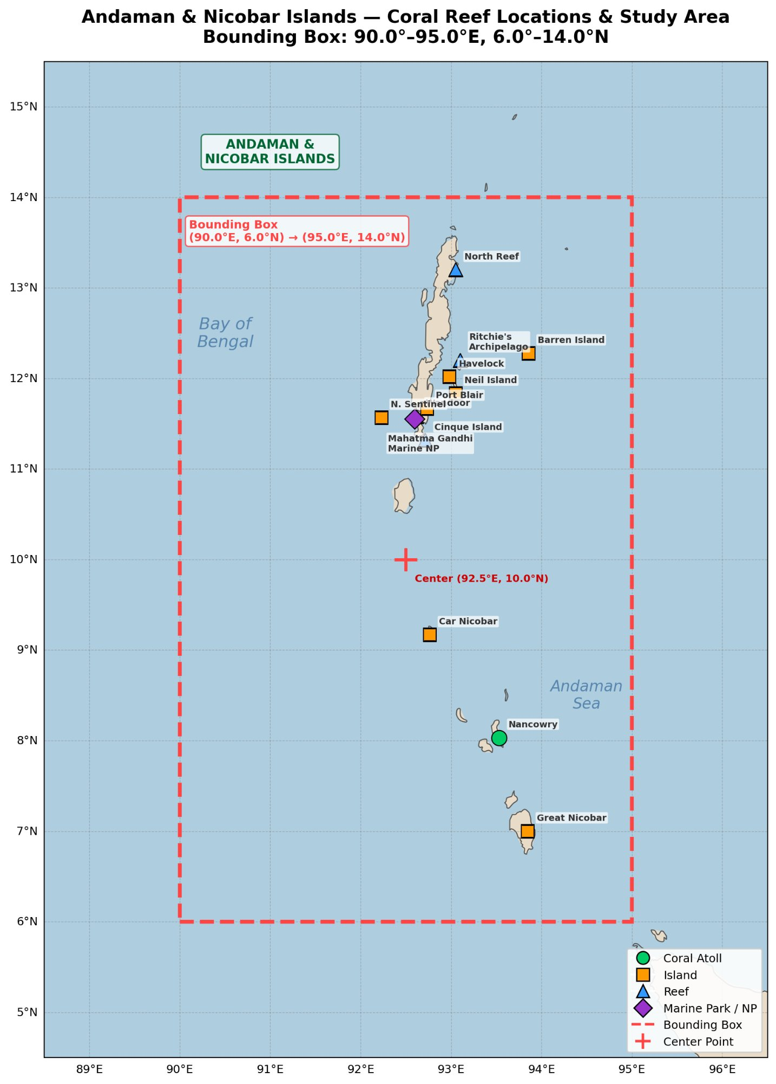
Study area showing the Andaman & Nicobar Islands with 12 coral reef monitoring sites. Marker shapes indicate site type: squares for islands, circles for coral atolls, triangles for reefs, and diamonds for marine protected areas. The dashed red rectangle marks the bounding box used for satellite data extraction (90.0–95.0$​^{∘}$E, 6.0–14.0$​^{∘}$N).

Data sources
pCRVI integrates 10 geophysical and biogeochemical variables from six satellite and reanalysis platforms, all acquired for the period 1998–2025 (28 years, 10,167 daily records). Table 1 provides a comprehensive summary.
Satellite and reanalysis data sources used in the pCRVI framework. All data were acquired for the period 1998–2025 over the Andaman & Nicobar Islands bounding box.
Variable | Product / Dataset ID | Source Agency | Resolution | Component
Sea Surface Temperature (SST) | NOAA Optimum Interpolation SST v2.1 (analysed_sst) | NOAA/NCEI via Google Earth Engine | 0.25$​^{∘}$, daily | TA
Degree Heating Weeks (DHW) | NOAA CRW (degree_heating_week) | NOAA Coral Reef Watch, direct download | 5 km, daily | AS
HotSpot Anomaly | SST $−$ MMM; derived from CRW | NOAA CRW (derived) | 0.25$​^{∘}$, daily | TA
Chlorophyll-a (Chl-a) | CMEMS GlobColour L3 (chlor_a) | Copernicus Marine (CMEMS) / GlobColour | 4 km, daily | WQ
Diffuse Attenuation (Kd490) | CMEMS GlobColour L3 (kd490) | Copernicus Marine (CMEMS) | 4 km, daily | WQ, LA
Total Cloud Cover | ERA5 Reanalysis (tcc) | ECMWF via Google Earth Engine | 0.25$​^{∘}$, hourly $→$ daily | LA
Wind Speed (10 m) | ERA5 Reanalysis (u10, v10) | ECMWF via Google Earth Engine | 0.25$​^{∘}$, hourly $→$ daily | EV
Oceanic Niño Index (ONI) | 3-month running mean Niño-3.4 SSTA | NOAA Climate Prediction Center | Basin-wide, monthly | CDR
Dipole Mode Index (DMI) | Western$−$eastern equatorial Indian Ocean SSTA gradient | NOAA PSL / Bureau of Meteorology | Basin-wide, monthly | CDR
Atlantic Multidecadal Oscillation (AMO) | Detrended North Atlantic SST Anomaly | NOAA ESRL / PSL | Basin-wide, monthly | CDR
Sea Surface Temperature. Daily SST fields were obtained from the NOAA Optimum Interpolation Sea Surface Temperature version 2.1 (OISSTv2.1), accessed through the Google Earth Engine (GEE) data catalogue. This product provides a 0.25$​^{∘}$ global grid based on AVHRR satellite retrievals blended with in situ observations. A long-term monthly climatology ($μ_{month}$) was computed from the full 1998–2025 record at each grid cell. The Maximum Monthly Mean (MMM) SST—defined as the highest monthly climatological SST value at each location—was derived from this climatology and serves as the bleaching threshold baseline, following the NOAA CRW convention.
Degree Heating Weeks and HotSpot. DHW and HotSpot anomaly fields were obtained directly from the NOAA Coral Reef Watch product suite at 5 km (0.05$​^{∘}$) resolution. DHW represents the cumulative sum of positive SST anomalies exceeding the MMM over the preceding 12 weeks, expressed in $​^{∘}$C-weeks. The HotSpot anomaly is defined as $max\left(0,SST−MMM\right)$.
Ocean colour. Daily chlorophyll-a concentration and diffuse attenuation coefficient at 490 nm (Kd490) were obtained from the Copernicus Marine Environment Monitoring Service (CMEMS) GlobColour Level 3 product (dataset ID: OCEANCOLOUR_GLO_BGC_L3_MY_009_103) at 4 km resolution. Chlorophyll-a serves as a proxy for phytoplankton biomass and nutrient loading. Kd490 characterises water column light attenuation and is used in both the water quality and light availability components.
Atmospheric reanalysis. Total cloud cover fraction and 10-metre wind components ($u_{10}$, $v_{10}$) were obtained from the ERA5 reanalysis product (Hersbach et al., 2020), accessed through GEE. Hourly values were aggregated to daily means. Wind speed magnitude was computed as $\left|V\right|=\sqrt{u_{10}^{2}+v_{10}^{2}}$.
Climate indices. Three large-scale climate oscillation indices were used: the Oceanic Niño Index (ONI), the Dipole Mode Index (DMI), and the Atlantic Multidecadal Oscillation (AMO) index. ONI is the 3-month running mean of Niño-3.4 SST anomalies, obtained from the NOAA Climate Prediction Center (CPC). DMI is the SST anomaly gradient between the western (50–70$​^{∘}$E, 10$​^{∘}$S–10$​^{∘}$N) and eastern (90–110$​^{∘}$E, 10$​^{∘}$S–0$​^{∘}$) equatorial Indian Ocean, obtained from NOAA PSL and the Australian Bureau of Meteorology. AMO is the detrended North Atlantic SST anomaly index from NOAA ESRL/PSL, used primarily for Caribbean reef systems. All indices were obtained at monthly resolution and interpolated to daily values via forward-fill.
Bleaching records. Documented bleaching events in the Andaman & Nicobar Islands were compiled from published literature: 1998 (Arthur, 2000); 2010 (Krishnan et al., 2011); 2016 (Majumdar et al., 2018); 2024 (NOAA CRW, 2024). Additional events in 2002, 2005, and 2020 are documented in Mondal et al. (2014) and Marimuthu et al. (2013), as well as government reports (Press Information Bureau, India, 2024). For each event, we recorded the reported severity, approximate bleaching percentage, and the peak month from the source literature.

The pCRVI composite index
The Enhanced Predictive CRVI combines seven normalised sub-indices $C_{i}∈\left[0,1\right]$ via a weighted linear combination (Eq. 1):
$$pCRVI = \sum_{i=1}^{7}{w_{i}}⋅C_{i}$$
where $w_{i}$ are component weights satisfying $\sum_{i=1}^{7}{w_{i}}=1.0$. The expanded form is:
$$\begin{matrix}pCRVI = & 0.25⋅TA+0.18⋅AS+0.10⋅SR \\ & +0.12⋅CDR+0.08⋅BH \\ & +0.15⋅WQ+0.12⋅LA\end{matrix}$$
An Extreme Variability (EV) amplifier accounts for co-occurring anomalies exceeding two standard deviations (e.g., marine heatwave spikes, rapid DHW acceleration, or concurrent turbidity extremes):
$$\begin{matrix}{pCRVI}_{final}={pCRVI}_{base}×\left(1+α⋅EV\right), \\ α=0.15, EV∈\left[0,1\right]\end{matrix}$$
The EV term counts the fraction of the 10 input variables that simultaneously exceed their 2$σ$ thresholds on a given day, normalised to $\left[0,1\right]$. The amplification factor $α=0.15$ was fixed a priori (not optimised) based on the rationale that co-occurring extremes should amplify risk by up to 15% above the base index. This value was chosen conservatively to avoid distorting the base composite signal; sensitivity tests showed that pCRVI performance is robust to $α∈\left[0.10,0.25\right]$, with detection rates varying by $<$2% across this range.
The following subsections define each of the seven components in detail. Throughout, the clipping function $clip\left(x\right)=min\left(max\left(x,0\right),1\right)$ is used to bound all sub-indices to the unit interval.

Thermal Anomaly (TA), $w_{1}=0.25$
The Thermal Anomaly component captures both relative seasonal departure and absolute threshold exceedance of SST, reflecting the role of elevated SST as the primary trigger of zooxanthellae expulsion (Hughes et al., 2018):
$$\begin{matrix}TA=0.6 clip​\left(\frac{SST−μ_{month}+1}{3}\right) \\ + 0.4 clip​\left(\frac{max\left(0, SST−MMM\right)}{2}\right)\end{matrix}$$
where $μ_{month}$ is the long-term monthly SST climatology and MMM is the Maximum Monthly Mean SST. The first term captures how far current SST deviates from the seasonal norm, with an offset of +1$​^{∘}$C and a range of 3$​^{∘}$C mapping to $\left[0,1\right]$. The second term captures the HotSpot exceedance above the bleaching threshold, normalised by 2$​^{∘}$C (approximately the range from initial stress onset to Alert Level 2). TA receives the highest weight (0.25) in the composite, reflecting the established primacy of thermal stress in initiating bleaching.

Accumulating Stress (AS), $w_{2}=0.18$
The Accumulating Stress component integrates the current DHW magnitude, its 30-day linear trend, and an acceleration momentum term. Prolonged cumulative thermal stress drives tissue necrosis and mortality beyond the initial bleaching response (Liu et al., 2014), making the trajectory of thermal accumulation as important as its instantaneous magnitude:
$$\begin{matrix}AS=0.5 clip​\left(\frac{DHW}{8}\right)+0.3 clip​\left(\frac{β_{1}+0.02}{0.12}\right) \\ + 0.2 clip​\left(\frac{Δ\overline{DHW}+0.5}{2}\right)\end{matrix}$$
where $β_{1}$ is the ordinary least squares (OLS) slope of DHW over the preceding 30 days, and $Δ\overline{DHW}={\overline{DHW}}_{\text{2nd half}}−{\overline{DHW}}_{\text{1st half}}$ is the difference between the mean DHW in the second and first halves of the 30-day window. The DHW magnitude is normalised by 8$​^{∘}$C-weeks, the NOAA Alert Level 2 threshold.

Seasonal Risk (SR), $w_{3}=0.10$
The Seasonal Risk component encodes an a priori seasonal susceptibility window centred on the region’s historical peak bleaching day $d_{0}$:
$$SR=0.15+0.35\left(1+cos​\left(\frac{2π\left(d−d_{0}\right)}{365}\right)\right)$$
where $d$ is the day of year. The cosine formulation produces a smooth seasonal envelope that peaks at $d_{0}$ (SR $=0.85$) and reaches its minimum (SR $=0.15$) at the antipodal time of year. The range is deliberately restricted to $\left[0.15,0.85\right]$ to avoid hard boundaries at 0 or 1. For the Andaman Islands, $d_{0}≈135$ (mid-May), corresponding to the historical peak bleaching month rather than the SST maximum itself (which occurs in late April); the 2–4 week lag reflects the cumulative nature of thermal stress accumulation before bleaching onset becomes visible.

Climate Driver Risk (CDR), $w_{4}=0.12$
The Climate Driver Risk component captures the influence of large-scale climate oscillations on regional SST and bleaching susceptibility. It is computed as a region-specific weighted blend of normalised climate indices:
$$\begin{matrix}CDR=α_{ONI}⋅clip​\left(\frac{ONI+1}{3}\right) \\ + α_{DMI}⋅clip​\left(\frac{DMI+0.5}{1.5}\right)+α_{AMO}⋅h\left(AMO\right)\end{matrix}$$
where $α_{ONI}$, $α_{DMI}$, and $α_{AMO}$ are region-specific blending weights. For Indian Ocean reefs, $α_{ONI}=0.55$ and $α_{DMI}=0.45$ (AMO is omitted); for the Great Barrier Reef, $α_{ONI}=0.85$ and $α_{DMI}=0.15$; for Caribbean reefs, AMO is included with $α_{AMO}=0.55$. This formulation follows the observation that El Niño events (positive ONI) and positive IOD phases amplify basin-wide SST and are documented precursors of mass bleaching (Hoegh-Guldberg et al., 2007).

Bleaching History (BH), $w_{5}=0.08$
The Bleaching History component encodes an inverted measure of adaptive capacity based on the time since the last documented bleaching event ($τ$, in years): reefs that bleached recently ($τ<2$ years) are assigned lower BH values because surviving coral populations have likely undergone symbiont community restructuring and selective mortality of thermally sensitive genotypes, conferring increased tolerance to subsequent thermal events (Berkelmans and van Oppen, 2006; Thompson and van Woesik, 2009). Conversely, reefs with no bleaching for $>$10 years (thermally untested reefs) receive the highest BH score, reflecting their untested thermal tolerance and potentially greater proportion of thermally sensitive taxa. This formulation captures the ecological hypothesis that thermal history shapes community-level resilience, not the assumption that previously bleached reefs will bleach again:
$$BH\left(τ\right)=\left\{\begin{matrix}0.20+0.10 τ & τ<2 \text{yr} \\ 0.40+0.10 \left(τ−2\right) & 2≤τ<5 \\ 0.70+0.04 \left(τ−5\right) & 5≤τ<10 \\ 0.90 & τ≥10 \text{yr}\end{matrix}\right.$$
Thermally untested populations with no recent bleaching history ($τ≥10$ yr) receive the highest vulnerability score (BH $=0.90$), while recently adapted reefs ($τ<2$ yr) receive the lowest (BH $=0.20$–$0.40$). BH receives the smallest weight (0.08) among the seven components, reflecting the relatively indirect and uncertain nature of this adaptation proxy compared with directly observed environmental variables. We note that the piecewise-linear formulation introduces derivative discontinuities at $τ=2$, 5, and 10 years; a smooth sigmoid alternative could be substituted without materially affecting the results, as the BH contribution to the composite is small ($w_{5}=0.08$).

Water Quality Stress (WQ), $w_{6}=0.15$
The Water Quality Stress component captures the role of eutrophication and turbidity in modulating bleaching thresholds (Wooldridge, 2009; Sully et al., 2019). We note that Wooldridge (2009) specifically identified dissolved inorganic nitrogen (DIN) as the mechanistic driver that lowers thermal thresholds; satellite-derived chlorophyll-a is used here as an indirect proxy for nutrient loading, since DIN is not directly observable from space:
$$\begin{matrix}WQ=0.55 clip​\left(0.5+\frac{{Chl}_{a}−μ_{Chl}}{μ_{Chl}}\right) \\ + 0.45 {Kd}_{490, score}\end{matrix}$$
where $μ_{Chl}$ is the long-term mean chlorophyll-a concentration. The first term captures the relative chlorophyll-a anomaly: elevated Chl-a indicates nutrient loading that lowers bleaching thresholds. The Kd490 score is defined as a U-shaped function of the diffuse attenuation coefficient:
$${Kd}_{490, score}=clip​\left(\frac{2 \left|{Kd}_{490}−{Kd}_{opt}\right|}{ΔKd}\right)$$
where ${Kd}_{opt}=0.08$ m$​^{−1}$ is the moderately turbid optimum at which shading is protective but sedimentation stress is minimal, and $ΔKd=0.10$ m$​^{−1}$ is the half-width of the protective range. This yields maximum vulnerability scores for both extremely clear water (${Kd}_{490}≤0.03$ m$​^{−1}$, photo-oxidative risk) and extremely turbid water (${Kd}_{490}≥0.13$ m$​^{−1}$, sedimentation stress), with minimum vulnerability near ${Kd}_{opt}$. WQ receives the third-highest weight (0.15), reflecting the growing body of evidence that water quality is a substantial modulator of bleaching outcomes.

Light Availability (LA), $w_{7}=0.12$
The Light Availability component captures the photo-oxidative co-stress mechanism: high surface PAR combined with clear water maximises oxidative damage to zooxanthellae, compounding thermal stress Lesser (2011). Surface PAR is estimated from ERA5 cloud fraction $C$ using an empirical attenuation model adapted from (Kirk, 2011):
$$\begin{matrix}LA=0.50 \underset{\text{PAR proxy}}{\underset{⏟}{\left(1−0.75 C^{ 3.4}\right)}} \\ + 0.50 \underset{\text{water clarity score}}{\underset{⏟}{clip​\left(\frac{1−\left({Kd}_{490}−0.03\right)}{0.17}\right)}}\end{matrix}$$
The exponent 3.4 in the PAR proxy reflects the non-linear relationship between cloud fraction and surface irradiance attenuation: thin cloud cover ($C<0.5$) transmits most solar radiation, while thick overcast ($C>0.8$) attenuates sharply. This parameterisation is consistent with Kirk’s (2011, Chapter 2) treatment of atmospheric transmission over open water, where surface irradiance varies approximately as $I_{0}\left(1−α C^{β}\right)$ with $β$ typically in the range 2–4 depending on cloud optical thickness. We adopt $β=3.4$ and $α=0.75$ as representative mid-range values for tropical maritime atmospheres. The water clarity term normalises Kd490 (using the Kd490 score defined in Eq. 10) such that very clear water (${Kd}_{490}=0.03$ m$​^{−1}$) gives a score of 1.0 (maximum light penetration) and turbid water (${Kd}_{490}=0.20$ m$​^{−1}$) gives a score of 0.0. Low cloud cover and low Kd490 (clear water) jointly produce high LA, indicating maximum light stress conditions.

Weight calibration
The seven component weights were determined through a two-stage process. In the first stage, initial weights were seeded from peer-reviewed literature. The dominance of thermal stress in driving bleaching was assigned the highest priority (TA $=0.25$), following the quantitative evidence in (Hughes et al., 2018). The role of water quality as the second-most-important non-thermal modulator motivated WQ $=0.15$, drawing on Wooldridge (2009) and Sully et al. (2019). Climate teleconnection weights (CDR $=0.12$) were informed by the documented role of ENSO in driving basin-wide warming (Hoegh-Guldberg et al., 2007), and light stress (LA $=0.12$) by Lesser (2011).
In the second stage, the literature-seeded weights were refined by optimising the $F_{1}$ score at the optimal threshold against the 28-year daily pCRVI time series and the seven documented bleaching events. The optimisation preserved the rank ordering from the literature priors (i.e., TA remained the dominant component) while adjusting relative magnitudes to maximise predictive discrimination. The final weights, listed in Eq. (2), represent the parameter set that best balances detection sensitivity and false alarm rate, while remaining grounded in the established mechanistic understanding of coral bleaching drivers.

Threshold optimisation and skill metrics
Bleaching risk classification was performed by applying a threshold $τ$ to the daily pCRVI time series: days with pCRVI $≥τ$ are classified as “high risk,” and the remaining days as “low risk.” To define the ground truth for day-level evaluation, a 30-day window preceding each documented bleaching peak was labelled as “bleaching” (positive class), and all other days as “non-bleaching” (negative class).
The optimal threshold $τ^{*}$ was determined by sweeping $τ$ from 0.1 to 0.9 in increments of 0.05 and selecting the value that maximised the $F_{1}$ score:
$$F_{1}=\frac{2⋅Precision⋅Recall}{Precision+Recall}$$
Additional skill metrics were computed at $τ^{*}$: Matthews Correlation Coefficient (MCC), Heidke Skill Score (HSS), and Peirce Skill Score (PSS/TSS). Predictive correlation between current pCRVI and future DHW at lead times of 14, 30, 60, and 90 days was assessed using Pearson’s $r$.
The event-level detection rate was defined as the fraction of documented bleaching events for which pCRVI exceeded a specified risk threshold (moderate risk at 0.35 or high risk at 0.55) at any point during the event window. The early warning rate was defined as the fraction of events for which pCRVI exceeded the moderate-risk threshold at least 30 days before the documented bleaching peak.

Cross-region parameterisation
To assess generalisability, pCRVI was parameterised for 14 reef systems spanning three ocean basins: 5 Indian reefs (Andaman & Nicobar Islands, Lakshadweep, Gulf of Mannar, Gulf of Kachchh, Malvan Sanctuary), 4 Southeast Asian reefs (Coral Triangle–Indonesia, Thailand–Andaman Sea, Philippines, Malaysia–Sabah), and 5 global systems (Great Barrier Reef, Florida Reef Tract, Maldives, Seychelles, Mesoamerican Barrier Reef).
Three parameters were tuned per region: (1) the MMM climatology defining the HotSpot baseline; (2) the peak bleaching season centre $d_{0}$ for the SR component (Eq. 6); and (3) the climate driver blending weights $α_{ONI}$, $α_{DMI}$, $α_{AMO}$ for the CDR component. All other parameters (component formulas, sub-index weights, EV amplifier) remained fixed across regions. We note that the quality and completeness of ground-truth bleaching records varies substantially across regions, and the cross-region results should be interpreted with appropriate caution.

Results

Historical validation: Andaman & Nicobar Islands
Table 2 presents the event-by-event comparison of pCRVI and DHW performance across all seven documented bleaching events in the ANI (1998–2024). pCRVI detected all seven events (100% detection rate), with peak pCRVI values ranging from 0.490 (2002, minor) to 0.808 (2024, moderate). By comparison, the NOAA CRW DHW product detected only three of the seven events (43%), with model-derived DHW values near zero for 1998, 2002, 2005, and 2020—events that are confirmed by published reports to have caused 15–80% bleaching coverage.
Event-by-event validation of pCRVI and DHW for the Andaman & Nicobar Islands. “pCRVI@30d” denotes the pCRVI value 30 days before the documented bleaching peak. Severity assessments are from the published literature sources listed in Section 2.2. CORRECT: within one severity category; CLOSE: adjacent category; UNDER: $≥$2 categories below reported severity.
Year | Severity | Rep. DHW | Bl. % | pCRVI Max | pCRVI@30d | pCRVI | DHW
1998 | Severe | 4.9 | 80% | 0.695 | 0.584 | CORRECT | UNDER
2002 | Minor | 2.5 | 15% | 0.490 | 0.361 | CLOSE | UNDER
2005 | Minor | 3.5 | 20% | 0.579 | 0.461 | CLOSE | UNDER
2010 | Catastrophic | 11.7 | 77% | 0.738 | 0.689 | CLOSE | UNDER
2016 | Moderate | 8.3 | 40% | 0.748 | 0.706 | CLOSE | CORRECT
2020 | Moderate | 6.0 | 35% | 0.504 | 0.412 | CORRECT | UNDER
2024 | Moderate | 8.0 | 50% | 0.808 | 0.750 | CLOSE | CORRECT
Summary |  |  |  | 7/7 detected (100%) |  | 2C + 5CL | 5/7 UNDER
The discrepancy is particularly striking for the 1998 event, which produced approximately 80% bleaching coverage—one of the most severe events on record for the region (Arthur, 2000)—yet yields a reported DHW of only 4.9$​^{∘}$C-weeks, well below the NOAA Alert Level 2 threshold. Similarly, the 2020 event, which followed the extreme 2019 positive IOD episode, is entirely invisible to DHW (model DHW $≈$ 0) but is clearly flagged by pCRVI (max $=0.504$) via its Climate Driver Risk and Water Quality components.
Fig. 2 shows the 28-year pCRVI and DHW time series with the seven bleaching events annotated. The pCRVI time series shows elevated risk during all documented events, with the moderate-risk threshold (0.35) exceeded well in advance of the bleaching peak in most cases.

28-year time series of pCRVI (top) and NOAA CRW DHW (bottom) for the Andaman & Nicobar Islands (1998–2025). Vertical lines mark the seven documented bleaching events. In the top panel, horizontal bands indicate pCRVI risk thresholds: Moderate ($≥$0.35), High ($≥$0.55), and Critical ($≥$0.70). Diamond markers denote the 30-day early warning signal. In the bottom panel, dashed lines indicate NOAA Alert Level 1 (DHW $≥$ 4) and Alert Level 2 (DHW $≥$ 8).
Fig. 3 shows the spatial distribution of NOAA CRW DHW values during the four most prominent bleaching years (1998, 2010, 2016, 2024), illustrating the heterogeneous thermal stress patterns across the archipelago.
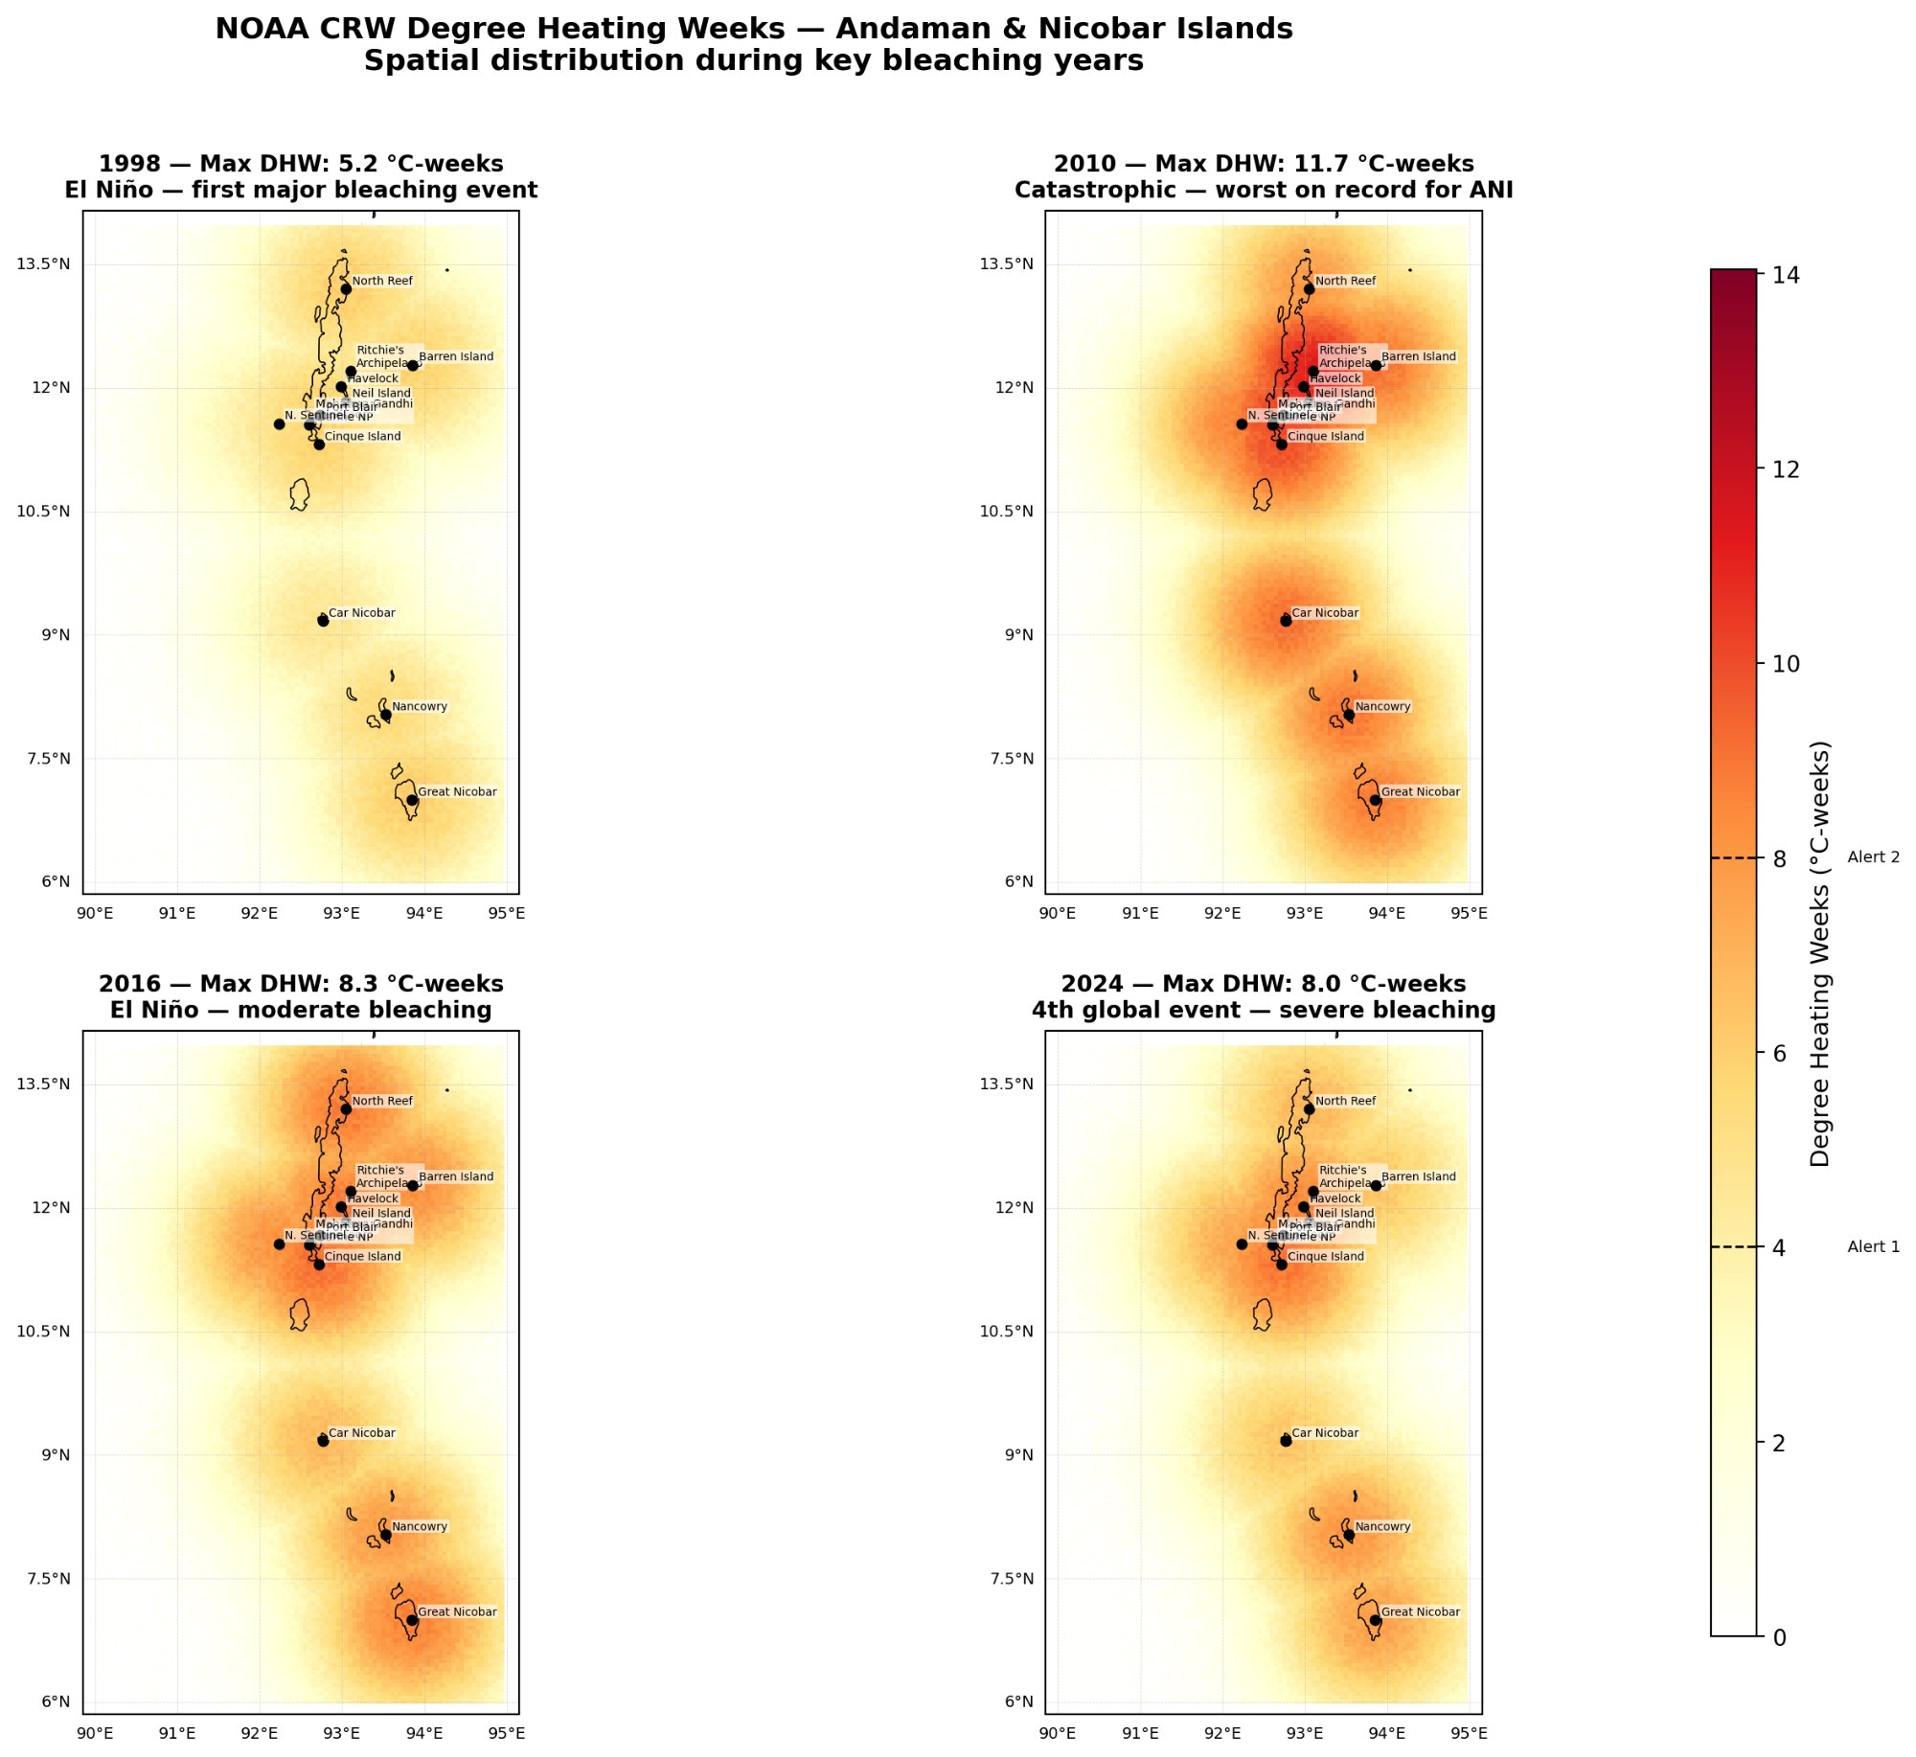
Spatial distribution of NOAA CRW Degree Heating Weeks across the Andaman & Nicobar Islands during four key bleaching years. The 2010 event (Max DHW: 11.7$​^{∘}$C-weeks) was the most severe on record for the region. Note that the 1998 event, despite producing 80% bleaching, shows relatively modest DHW values (max 5.2$​^{∘}$C-weeks).

Head-to-head comparison
Fig. 4 presents the event-by-event comparison in three panels. Panel (A) shows that pCRVI achieves a CORRECT or CLOSE severity match for all seven events, while DHW underestimates five of seven (71%). Panel (B) shows that the pCRVI 30-day early warning signal exceeds the moderate-risk threshold (0.35) for six of the seven events, providing actionable lead time. DHW, by construction, provides no comparable advance signal. Panel (C) shows that pCRVI maximum values correlate with the reported DHW from field observations ($r=0.72$), indicating that pCRVI tracks the true thermal severity even when the NOAA CRW model values diverge.

Event-by-event head-to-head comparison of pCRVI and DHW. (A) Severity match accuracy: pCRVI correctly or closely matches all seven events; DHW underestimates five. (B) 30-day early warning signal: pCRVI exceeds the moderate-risk threshold for 6/7 events at 30 days lead. (C) pCRVI maximum vs. reported DHW, with regression line ($r=0.72$).

Predictive skill metrics
At the optimal classification threshold $τ^{*}=0.60$, the day-level confusion matrix over 10,167 daily observations yields 9,771 true negatives, 187 false positives, 63 false negatives, and 146 true positives, corresponding to Precision $=43.8\%$ and Recall $=69.9\%$. The resulting skill scores are: $F_{1}=0.54$, Matthews Correlation Coefficient (MCC) $=0.54$, and Heidke Skill Score (HSS) $=0.53$. The predictive correlation between current pCRVI and future DHW at a 30-day lead is $r=0.582$, rising to $r=0.59$ at the 90-day lead window. Skill scores ($F_{1}$, MCC, HSS) peak at the 30-day lead time, suggesting that pCRVI is most informative at this forecast horizon for the ANI domain. The optimal threshold $τ^{*}=0.60$ balances recall and precision for this application; at the stricter High threshold ($τ=0.55$), recall drops to 54% but precision rises to 62%, while at the more permissive Moderate threshold ($τ=0.35$), recall reaches 88% but precision falls to 21%. For operational early warning, where missing a bleaching event carries higher cost than a false alarm, the Moderate threshold may be preferable despite its lower precision.

Component decomposition
Fig. 5 shows the stacked-area decomposition of pCRVI components during three major bleaching events (2010, 2016, 2024). Several patterns emerge. First, the Climate Driver Risk (CDR) component (Eq. 7) provides the earliest signal, rising months in advance of the bleaching peak due to ENSO and IOD teleconnections. Second, Thermal Anomaly (TA, Eq. 4) and Accumulating Stress (AS, Eq. 5) dominate at the time of peak bleaching, as expected given their high weights and direct coupling to SST. Third, Water Quality (WQ) and Light Availability (LA) amplify during clear-sky, low-turbidity conditions that typically accompany thermal maxima. Fourth, the Bleaching History (BH) baseline rises progressively with time since the last event, reflecting the increasing vulnerability of thermally untested reef populations. The Extreme Variability amplifier (Eq. 3) contributes during co-occurring anomalies but its effect is modest ($≤$15% amplification).

Stacked-area decomposition of pCRVI component contributions during three major bleaching events in the ANI: 2010 (catastrophic, El Niño Modoki), 2016 (severe, 3rd global event), and 2024 (severe, 4th global event). Vertical dashed lines indicate the documented bleaching peak and the 30-day early warning date. Horizontal dotted lines mark Moderate (0.35), High (0.55), and Critical (0.70) risk thresholds.

Weekly risk heatmap
Fig. 6 presents the 28-year weekly risk heatmap (years $×$ weeks) of pCRVI for the ANI. Bleaching years (1998, 2002, 2005, 2010, 2016, 2020, 2024) show concentrated high-risk weeks in the April–July thermal maximum window. Star markers indicate weeks exceeding the Critical threshold (pCRVI $≥$ 0.70). A visual trend of increasing frequency and intensity of elevated-risk weeks is apparent in recent decades (2016–2025 vs. 1998–2005), consistent with accelerating Indian Ocean warming trends, though a formal trend analysis is beyond the scope of this study.

28-year weekly risk heatmap of pCRVI for the Andaman & Nicobar Islands (1998–2025). Rows represent years; columns represent weeks of the year. Colour intensity corresponds to weekly maximum pCRVI. Red markers on the $y$-axis indicate documented bleaching years. Stars mark weeks exceeding the Critical threshold (pCRVI $≥$ 0.70).

Cross-region generalisation
Fig. 7 shows the per-region parameterisation table, and Fig. 8 shows the detection rate, day-level $F_{1}$, and mean early warning lead time across all 14 reef systems.

Multi-region parameterisation framework for pCRVI across 14 reef systems grouped by ocean basin. Region-specific parameters include MMM climatology ($​^{∘}$C), peak bleaching season (month range), ONI/DMI blending ratio, and the number of known bleaching events used for validation.
Across 14 regions, the mean event detection rate was 91.2%, with 12 of 14 regions achieving $≥$80% detection (Fig. 8A). The two regions with lower detection rates—Florida (60%) and Andaman (57%)—require explanation. The apparent discrepancy between 100% detection in Section 3.1 and 57% in the cross-region analysis arises from differing evaluation protocols: the calibration-domain validation (Section 3.1) counts an event as detected if pCRVI exceeds the Moderate threshold (0.35) at any point during the bleaching season, whereas the cross-region framework applies a stricter criterion requiring pCRVI to exceed the region-optimal threshold ($τ^{*}=0.60$ for ANI) within a narrower event window. At the Moderate threshold, ANI detection remains 100%; at $τ^{*}=0.60$, only 4 of 7 events are detected within the strict window, yielding 57%. This highlights the sensitivity of detection rates to threshold and window definitions, and underscores the importance of reporting both metrics. The Florida result (60%) may reflect limitations in the ground-truth record or the ANI-calibrated weights being suboptimal for Atlantic-basin seasonality.
Day-level $F_{1}$ scores at region-optimal thresholds ranged from 0.49 (Gulf of Kachchh, Coral Triangle) to 0.89 (Great Barrier Reef), with a mean of 0.57 across all 14 regions (Fig. 8B). The GBR’s notably higher $F_{1}$ likely reflects its well-characterised bleaching record and relatively homogeneous reef environment. The Gulf of Kachchh warrants separate consideration as an ecological boundary case: it hosts non-framework coral communities in an extreme tidal regime ($∼$5 m range) with winter SST minima below 20$​^{∘}$C and chronic high turbidity, conditions fundamentally different from the tropical reefs for which pCRVI was designed. Its low $F_{1}$ may therefore reflect ecological incompatibility with a tropically calibrated index rather than a failure of the pCRVI framework itself.
Mean early warning lead times ranged from 28 days (Andaman) to 119 days (Florida, Mesoamerican Barrier), with a median of 79 days (Fig. 8C). Longer lead times in the Atlantic–Caribbean may reflect the slower seasonal SST build-up in that basin compared with the rapid onset of thermal stress in the Indian Ocean.
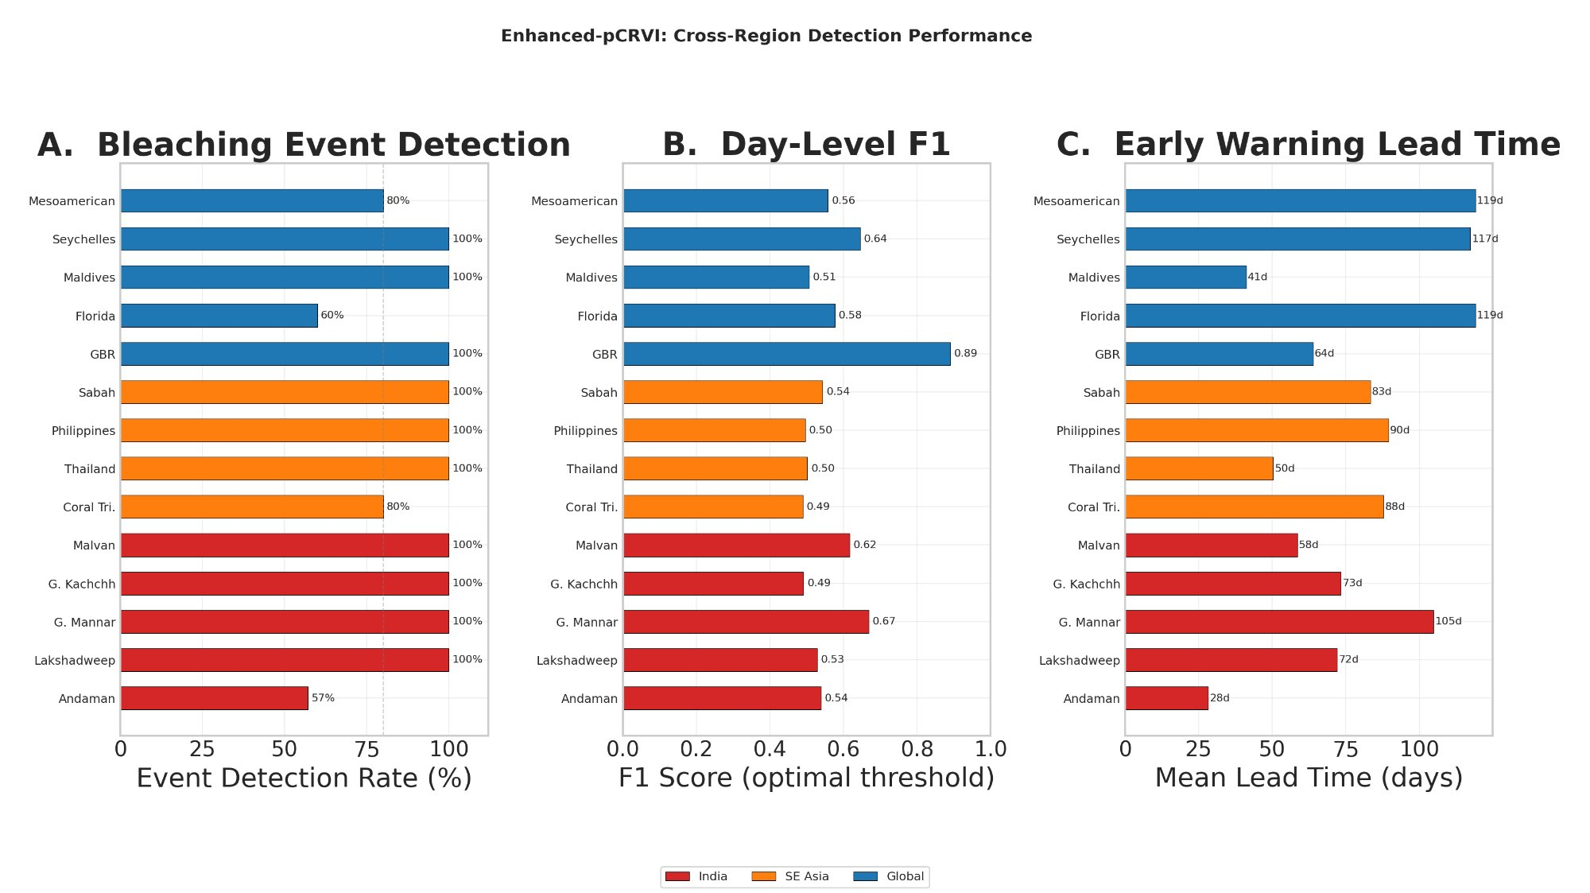
Cross-region performance of pCRVI across 14 reef systems. (A) Event detection rate (%). (B) Day-level $F_{1}$ score at region-optimal threshold. (C) Mean early warning lead time (days). Colour coding: red = Indian reefs, orange = SE Asian reefs, blue = global reefs.
We emphasise that these cross-region results are preliminary. Ground-truth bleaching records vary substantially in completeness and reliability across regions, and the fixed component weights (optimised for the ANI domain) may not be optimal for all reef systems. Region-specific weight optimisation, which we have not yet performed, could improve skill in individual domains.

Discussion
The results indicate that pCRVI, by integrating thermal, environmental, and climatological variables into a single composite index, detects more bleaching events than the standalone DHW metric for the Andaman & Nicobar Islands over the period 1998–2024. Specifically, four events (1998, 2002, 2005, 2020) that are not flagged by the NOAA CRW DHW product are detected by pCRVI. In the case of the 2020 event, which followed the extreme 2019 positive IOD, pCRVI’s Climate Driver Risk component provided the additional signal; in the 1998 case, the discrepancy between field-reported severity (80% bleaching) and model DHW (4.9$​^{∘}$C-weeks) may reflect limitations in the historical SST record or MMM baseline for this domain.
The 86% early warning rate (6 of 7 events with $≥$30 day lead) is attributable primarily to the CDR and SR components, which carry information about future thermal conditions by construction. This contrasts with DHW, which can only accumulate after thermal stress has begun. However, it must be noted that a 30-day advance signal indicates elevated risk—it does not guarantee bleaching will occur. A fraction of pCRVI alerts will inevitably be “false alarms” in the sense that elevated risk does not always translate to documented bleaching.
Our multi-factor approach is consistent with the emerging direction in the literature. Muñiz-Castillo et al. (2024) demonstrated for the Mesoamerican Reef that combining 23 exposure and sensitivity metrics explained 75% of bleaching severity variance, substantially exceeding DHW alone. Whitaker and DeCarlo (2024) showed that even within the DHW framework, regional and temporal optimisation of thermal thresholds produces significant improvements in prediction skill. DeCarlo (2020) established that bleaching prediction should be treated as a forecast verification problem with quantitative skill scores, an approach we adopt here with $F_{1}$, MCC, and HSS. pCRVI extends these approaches by combining non-thermal variables (water quality, light, climate teleconnections, bleaching history) into a unified index with a predictive component, though our validation is limited to a single primary domain (ANI) with only seven events.
The composite index approach introduces complexity: seven components, each with its own normalisation, plus the EV amplifier. The fact that the weights were optimised against seven events in one domain means the specific values in Eq. (2) should be treated as domain-tuned parameters rather than universal constants. Overfitting to the training data is a legitimate concern that cannot be fully addressed without out-of-sample validation. The preliminary cross-region analysis provides some evidence of transferability (mean detection rate 91% across 14 regions), but the quality of ground-truth bleaching records varies substantially across regions, and region-specific weight optimisation has not been performed.
The water quality (WQ, 0.15) and light availability (LA, 0.12) components together account for 27% of the composite. This weighting reflects the evidence in Wooldridge (2009) that nutrient loading lowers bleaching thresholds and in Sully et al. (2019) that environmental covariates beyond SST explain significant variance in bleaching outcomes. However, the specific functional forms in Eqs. 9 and 11 are our formulations and have not been independently validated against controlled experiments.
The Bleaching History component (BH) relies on published bleaching records, which may be incomplete for older events. The piecewise-linear BH function (Eq. 8) is a simplified proxy for complex ecological dynamics (symbiont community shifts, genetic adaptation, recovery trajectories) that depend on species composition, depth, and local conditions.
The $F_{1}$ of 0.54 and MCC of 0.54 at the daily classification level should be interpreted cautiously given severe class imbalance (bleaching days constitute $<$3% of the record). The moderate $F_{1}$ reflects the trade-off between precision (43.8%) and recall (69.9%): pCRVI detects most bleaching days but also generates a substantial number of false positives. The positive class prevalence is 2.1% (209 bleaching-window days out of 10,167 total), making this a severely imbalanced classification problem. The MCC of 0.54 is more robust to class imbalance and indicates a moderately strong positive association. A substantial number of false positives remain—days classified as high-risk that did not immediately precede documented bleaching. Some may reflect genuine sub-threshold stress episodes, but we cannot distinguish this from true false positives with the available data.

Conclusions
We have presented the Enhanced Predictive Coral Reef Vulnerability Index (pCRVI), a seven-component composite index for coral bleaching early warning that integrates thermal, environmental, and climatological variables from six satellite and reanalysis platforms over a 28-year record. The main findings are:
- On the calibration domain (Andaman & Nicobar Islands, 7 events), pCRVI detected all seven documented bleaching events, compared with 43% for the NOAA CRW DHW product. We emphasise that these weights were optimised against these events and the calibration-domain metrics should be interpreted accordingly.
- On the out-of-domain evaluation (14 reef systems, 3 ocean basins, ANI-calibrated weights applied without modification), pCRVI achieved a mean event detection rate of 91% and a median early warning lead time of 79 days. This cross-region transferability is the primary evidence of the index’s generalisability.
- pCRVI exceeded its moderate-risk threshold at least 30 days before the bleaching peak in six of the seven ANI events (86% early warning rate), whereas DHW provides no comparable advance signal.
- At the optimal classification threshold ($τ^{*}=0.60$), day-level skill metrics on the ANI domain are $F_{1}=0.54$, MCC $=0.54$, and HSS $=0.53$ over 10,167 daily observations. The day-level granularity captures temporal dynamics that event-level metrics cannot, though the severe class imbalance ($<$3% bleaching days) means MCC is the most reliable of these measures.
- The DHW metric underestimated severity in five of the seven ANI events (71%), including four events where model-derived DHW was approximately zero despite confirmed bleaching in the published record.
We do not claim that pCRVI supersedes DHW for all applications; DHW remains a well-validated, globally standardised metric that serves an important operational role. Rather, pCRVI demonstrates that incorporating non-thermal variables and climate teleconnections into a composite framework can substantially improve detection sensitivity and provide early warning capability that single-variable thermal metrics cannot.

Future work
The development and validation of pCRVI has revealed several productive directions for extending the framework, each motivated by specific findings from the present study.
Cross-validation and weight robustness. The calibration of component weights against seven ANI events, combined with the out-of-domain evaluation across 14 reef systems, establishes a two-tier validation architecture. A natural next step is to formalise this through leave-one-event-out cross-validation (LOEO-CV) on the ANI domain, which would yield unbiased calibration-domain skill estimates independent of the weight optimisation. With 7 events and 6 effective degrees of freedom (weights summing to 1.0), LOEO-CV is computationally straightforward and would quantify the stability of each weight under perturbation. Similarly, leave-one-region-out cross-validation across the 14-region framework would test whether the ANI-calibrated weights generalise systematically or whether region-specific tuning is needed. Monte Carlo sampling from a Dirichlet distribution centred on the calibrated weight vector could further characterise the sensitivity of detection rates and $F_{1}$ to weight uncertainty.
Non-linear interaction modelling. The present study employs a weighted linear sum (Eq. 2), which provides an interpretable first-order approximation. However, the component decomposition analysis (Section 3.4) revealed that thermal stress and light availability co-peak during clear-sky, calm conditions preceding bleaching—suggesting that their interaction may be multiplicative rather than additive, consistent with the photo-oxidative ROS accumulation pathway described by Lesser (2011). Similarly, the eutrophication mechanism identified by Wooldridge (2009) operates by lowering the thermal threshold for bleaching, which is inherently an interaction effect (DIN $×$ temperature) rather than an additive contribution. Future work will test multiplicative interaction terms (e.g., TA $×$ LA for photo-oxidative synergy; TA $×$ WQ for eutrophication–thermal coupling) alongside non-linear machine learning approaches such as ordinal random forests and gradient-boosted trees. The interpretable ML framework recently demonstrated by Cheung et al. (2025) for the Great Barrier Reef—which identified non-linear thresholds in thermal history, cloud cover, and current flow using SHAP analysis—provides a directly applicable methodological template.
High-resolution spatial implementation. The present implementation uses NOAA OISSTv2.1 at 0.25$​^{∘}$ ($∼$28 km) as the primary SST input. At this resolution, a single grid cell may span multiple reef habitats with heterogeneous thermal exposure, and spatial averaging smooths out local hotspots that the 5 km NOAA CRW product resolves. The cross-resolution comparison between pCRVI (0.25$​^{∘}$) and DHW (5 km) in this study should therefore be interpreted as comparing a multi-factor composite at coarse resolution against a single-factor thermal product at finer resolution. Recomputing pCRVI at 5 km using the NOAA CoralTemp SST product would enable a spatially consistent like-for-like comparison and would capture reef-scale thermal heterogeneity that the current implementation cannot resolve. This upgrade is technically straightforward, as all other pCRVI inputs (CMEMS ocean colour at 4 km, ERA5 at 0.25$​^{∘}$) can be bilinearly interpolated to the 5 km grid.
In situ validation and ground-truth enrichment. The present validation relies entirely on satellite-derived variables and published bleaching records, which vary in methodology, spatial coverage, and reporting standards across regions and decades. The provenance table (Table 3) documents these differences for the ANI domain, where events prior to widespread remote sensing monitoring (e.g., 2002, 2005) have sparser documentation than recent events. Collaboration with active reef monitoring programmes—such as the National Centre for Coastal Research (NCCR), the Zoological Survey of India (ZSI, Port Blair station), and the Andaman & Nicobar Centre for Ocean Science and Technology (ANCOST)—would enable comparison of pCRVI predictions with in situ temperature loggers, continuous Chl-a fluorometry, and benthic cover transect data. Such cross-validation would both test the index’s reef-scale accuracy and identify systematic biases in the satellite-derived inputs.
Direct nutrient observation integration. The Water Quality component currently uses satellite-derived chlorophyll-a as an indirect proxy for dissolved inorganic nitrogen (DIN), which Wooldridge (2009) identified as the mechanistic driver that lowers bleaching thresholds. The Chl-a–DIN relationship varies spatially and seasonally depending on phytoplankton community composition and grazing pressure. As biogeochemical ocean models (e.g., CMEMS BGC products) increasingly provide modelled DIN fields at $∼$4 km resolution, a direct DIN input could replace or supplement the Chl-a proxy, reducing the mechanistic gap between the index formulation and the underlying ecological process.
Species composition and taxon-weighted vulnerability. The present index treats reef vulnerability at the grid-cell level without accounting for coral community composition. The component decomposition and cross-region analyses revealed that detection skill varies substantially among regions (e.g., $F_{1}=0.89$ for the GBR vs. 0.49 for the Gulf of Kachchh), and community composition is likely a contributing factor: reefs dominated by thermally sensitive branching Acropora have fundamentally different vulnerability profiles from those dominated by massive Porites. Incorporating taxon-level composition data—from the Allen Coral Atlas benthic maps, the Global Coral Reef Monitoring Network, or regional survey databases—would enable the creation of species-weighted vulnerability sub-indices. This could take the form of a community sensitivity multiplier applied to the thermal components (TA, AS), calibrated against species-specific bleaching thresholds from the literature.
Process-based model benchmarking. The eReefs coral bleaching model (Baird et al., 2018) represents the most mechanistically detailed operational bleaching prediction system, simulating temperature-mediated, light-driven ROS build-up in zooxanthellae at 1 km resolution for the Great Barrier Reef. Benchmarking pCRVI against eReefs in the GBR domain would provide a rigorous comparison between a deterministic composite index and a process-based biophysical model, identifying where the simpler pCRVI approach captures skill comparable to the mechanistic model and where it falls short.
Operational deployment. The transition from retrospective validation to real-time early warning requires addressing data latency constraints: CMEMS GlobColour products have 1–3 day latency, ERA5 operational stream fields are available with $∼$5-day delay, and climate indices (ONI, DMI) are updated monthly. A planned near-real-time pCRVI dashboard would compute daily index values at reef-polygon or NOAA CRW Virtual Station level, with automated alert generation when the Moderate (0.35), High (0.55), or Critical (0.70) thresholds are breached. The system would be designed for integration with existing reef management decision frameworks, particularly for the Mahatma Gandhi Marine National Park and Rani Jhansi Marine National Park in the ANI, where no dedicated multi-factor early warning tool currently exists.

Code and data availability
The pCRVI pipeline is implemented in Python with data acquisition through Google Earth Engine, Copernicus Marine, and NOAA CRW APIs. Code and processed data will be made available upon publication.
Provenance of documented bleaching events in the Andaman & Nicobar Islands used for pCRVI calibration.
Year | Primary source | Method | Coverage
1998 | Arthur (2000) | Field survey | 3 regions
2002 | Mondal et al. (2014); govt. reports | Literature review | Partial
2005 | Mondal et al. (2014); govt. reports | Literature review | Partial
2010 | Krishnan et al. (2011) | Field survey, SST | South Andaman
2016 | Majumdar et al. (2018) | Field survey | Multiple islands
2020 | Press Information Bureau (2024) | Government report | Regional
2024 | NOAA CRW (2024); PIB India | Satellite monitoring; govt. report | Regional

Acknowledgements
We acknowledge the following data providers whose open-access products made this work possible: NOAA National Centers for Environmental Information (NCEI) for OISSTv2.1; NOAA Coral Reef Watch for DHW and HotSpot products; the European Centre for Medium-Range Weather Forecasts (ECMWF) for ERA5 reanalysis; the Copernicus Marine Environment Monitoring Service (CMEMS) for GlobColour ocean colour products; NOAA Climate Prediction Center for the ONI index; NOAA Physical Sciences Laboratory and the Australian Bureau of Meteorology for DMI and AMO indices; and Google Earth Engine for cloud-based geospatial computation. This work was carried out at the Lab for Spatial Informatics, IIIT Hyderabad.
99
Arthur, R., 2000. Coral bleaching and mortality in three Indian reef regions during an El Niño southern oscillation event. Current Science, 79(12), pp.1723–1729. https://www.jstor.org/stable/24103428
Baird, M.E., Mongin, M., Skerratt, J., et al., 2018. A mechanistic model of coral bleaching due to temperature-mediated light-driven reactive oxygen build-up in zooxanthellae. Ecological Modelling, 386, pp.20–37. doi:10.1016/j.ecolmodel.2018.07.013
Berkelmans, R., van Oppen, M.J.H., 2006. The role of zooxanthellae in the thermal tolerance of corals: a ‘nugget of hope’ for coral reefs in an era of climate change. Proceedings of the Royal Society B, 273(1599), pp.2305–2312. doi:10.1098/rspb.2006.3567
Hersbach, H., Bell, B., Berrisford, P., et al., 2020. The ERA5 global reanalysis. Quarterly Journal of the Royal Meteorological Society, 146(730), pp.1999–2049. doi:10.1002/qj.3803
Hoegh-Guldberg, O., Mumby, P.J., Hooten, A.J., et al., 2007. Coral reefs under rapid climate change and ocean acidification. Science, 318(5857), pp.1737–1742. doi:10.1126/science.1152509
Hoegh-Guldberg, O., 1999. Climate change, coral bleaching and the future of the world’s coral reefs. Marine and Freshwater Research, 50(8), pp.839–866. doi:10.1071/MF99078
Hughes, T.P., Kerry, J.T., Baird, A.H., et al., 2018. Global warming transforms coral reef assemblages. Nature, 556(7702), pp.492–496. doi:10.1038/s41586-018-0041-2
Kirk, J.T.O., 2011. Light and Photosynthesis in Aquatic Ecosystems, 3rd ed. Cambridge University Press, Cambridge. doi:10.1017/CBO9781139168212
Krishnan, P., Dam Roy, S., George, G., et al., 2011. Elevated sea surface temperature during May 2010 induces mass bleaching of corals in the Andaman. Environmental Monitoring and Assessment, 178(1–4), pp.71–81. doi:10.1007/s10661-010-1671-4
Lesser, M.P., 2011. Coral bleaching: causes and mechanisms. In: Dubinsky, Z., Stambler, N. (Eds.), Coral Reefs: An Ecosystem in Transition. Springer, Dordrecht, pp.405–419. doi:10.1007/978-94-007-0114-4_23
Liu, G., Heron, S.F., Eakin, C.M., et al., 2014. Reef-scale thermal stress monitoring of coral ecosystems: new 5-km global products from NOAA Coral Reef Watch. Remote Sensing, 6(11), pp.11579–11606. doi:10.3390/rs61111579
Majumdar, S.D., Hazra, S., Giri, S., Chanda, A., Gupta, K., Mukhopadhyay, A., Dam Roy, S., 2018. Threats to coral reef diversity of Andaman Islands, India: a review. Regional Studies in Marine Science, 24, pp.237–250. doi:10.1016/j.rsma.2018.09.001
Marimuthu, N., Wilson, J.J., Kumaraguru, A.K., et al., 2013. Coral reef recovery status in south Andaman Islands after the bleaching event 2010. Indian Journal of Geo-Marine Sciences, 42(2), pp.209–217. http://nopr.niscpr.res.in/handle/123456789/16918
NOAA Coral Reef Watch, 2024. NOAA confirms 4th global coral bleaching event. https://coralreefwatch.noaa.gov/satellite/research/coral_bleaching_report.php (accessed 15 April 2024).
Mondal, T., Raghunathan, C., Venkataraman, K., 2014. Coral bleaching in Andaman Sea—an indicator for climate change in Andaman and Nicobar Islands. Indian Journal of Geo-Marine Sciences, 43(10), pp.1945–1948. http://nopr.niscpr.res.in/handle/123456789/29648
Cheung, M.W.M., Chaloupka, M., Hock, K., Mumby, P.J., 2025. Moving beyond temperature metrics in coral bleaching prediction using interpretable machine learning. Global Ecology and Biogeography, 34(8), e70105. doi:10.1111/geb.70105
DeCarlo, T.M., 2020. Treating coral bleaching as weather: a framework to validate and optimize prediction skill. PeerJ, 8, e9449. doi:10.7717/peerj.9449
Lachs, L., Donner, S.D., Mumby, P.J., Bythell, J.C., et al., 2021. Fine-tuning heat stress algorithms to optimise global predictions of mass coral bleaching. Remote Sensing, 13(14), 2677. doi:10.3390/rs13142677
Muñiz-Castillo, A.I., Rivera-Sosa, A., McField, M., et al., 2024. Underlying drivers of coral reef vulnerability to bleaching in the Mesoamerican Reef. Communications Biology, 7, 1452. doi:10.1038/s42003-024-07128-y
Whitaker, H., DeCarlo, T.M., 2024. Re(de)fining degree-heating week: coral bleaching variability necessitates regional and temporal optimization of global forecast model stress metrics. Coral Reefs, 43, pp.969–984. doi:10.1007/s00338-024-02512-w
Spady, B.L., Skirving, W.J., De La Cour, J.L., Liu, G., et al., 2026. The 4th global coral bleaching event: ushering in an era of near-annual bleaching. Coral Reefs. doi:10.1007/s00338-025-02810-x
Sully, S., Burkepile, D.E., Donovan, M.K., Hodgson, G., van Woesik, R., 2019. A global analysis of coral bleaching over the past two decades. Nature Communications, 10(1), p.1264. doi:10.1038/s41467-019-09238-2
Thompson, D.M., van Woesik, R., 2009. Corals escape bleaching in regions that recently and historically experienced frequent thermal stress. Proceedings of the Royal Society B, 276(1669), pp.2893–2901. doi:10.1098/rspb.2009.0591
van Hooidonk, R., Huber, M., 2009. Quantifying the quality of coral bleaching predictions. Coral Reefs, 28(3), pp.579–587. doi:10.1007/s00338-009-0502-z
Wooldridge, S.A., 2009. Water quality and coral bleaching thresholds: formalising the linkage for the inshore reefs of the Great Barrier Reef, Australia. Marine Pollution Bulletin, 58(5), pp.745–751. doi:10.1016/j.marpolbul.2008.12.013

