**Name: Vaibhav Agrawal**

**Prog. : MBA(tech.)**

**Stream: I.T.**

**Year/Sem : 3rd/ VI**

**Sap-ID : 70411017003**

UX/UI

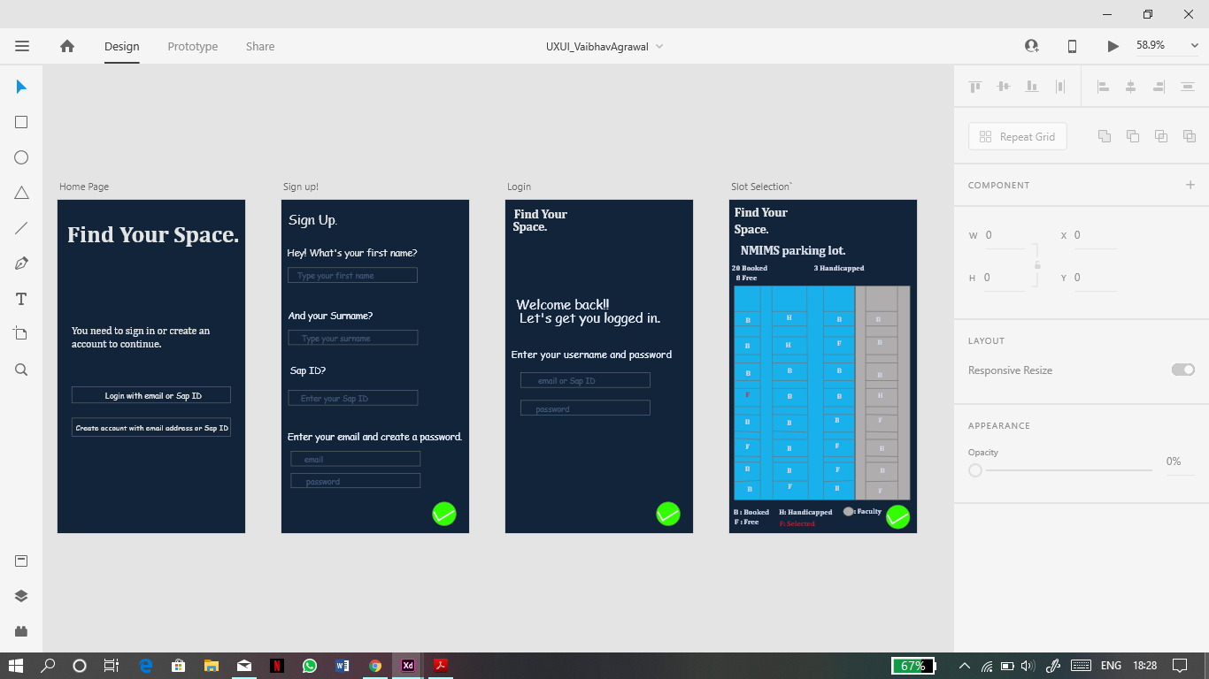

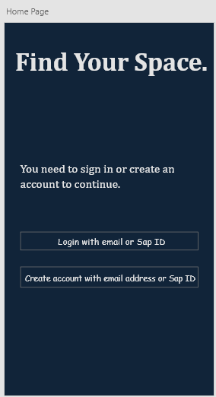**Homepage:**

This is the homepage of the android app “Find Your Space”. The homepage gives the new user the option to create an account and a login option for the existing user.

Condition: The user has to be a student of NMIMS.

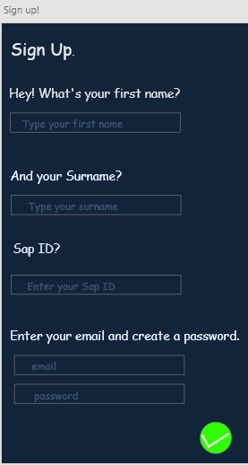**Sign Up:**

The sign up page allows the new user to create an account and access the application.

Compulsory fields:

* First name
* Sap ID
* Email
* Password

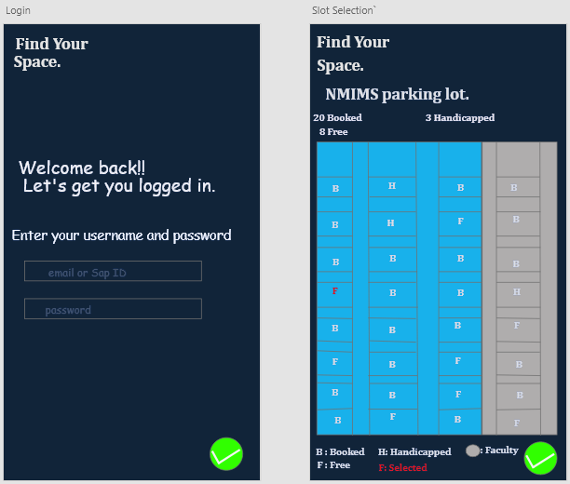**Login:**

The login page allows the existing user to login the application using the email or Sap ID and password.

**Slot Selection:**

This page gives the user the information regarding the parking lot.

The page gives information the parking slots that are for student, faculty and handicapped as well as the slots that are free and booked. With this information the user can access the nearest parking spot.