BÁO CÁO THỰC HÀNH LAB 01 LẬP TRÌNH HƯỚNG ĐỐI TƯỢNG

Mục lục

Làm việc với Github 2

Java Setup 2

The Very First Java Programs 3

*2.2.1* Write, compile the first Java application: 3

*2.2.2* Write, compile the first Java application: 4

4

*2.2.3* Write, compile the first input dialog Java application 4

*2.2.4* Write, compile, and run the following example: 5

*2.2.5* Write a program to calculate sum, difference, product, and quotient of 2 double numbers which are entered by users. 6

*2.2.6* Write a program to solve: For simplicity, we only consider the real roots of the equation in this task. 7

IntelliJ 13

Excercises 14

*6.1* Write and run the the ChoosingOption program: 14

*6.2* Write a program for input/output from keyboard 15

*6.3* Write a program to display a triangle with a height of n stars(*), n is entered by users. 16

*6.4* Write a program to display the number of days of a month, which is entered by users (both month and year). If it is an invalid month/year, ask the user to enter again. 17

*6.5* Write a Java program to sort a numeric array, and calculate the sum and average value of array elements. 19

*6.6* Write a Java program to add two matrices of the same size. 20

Làm việc với Github

Link: <https://github.com/vah102/IT3103.732872.2023.1.20214988.PhamVanAnh>

Java Setup

# The Very First Java Programs

* + 1. Write, compile the first Java application:

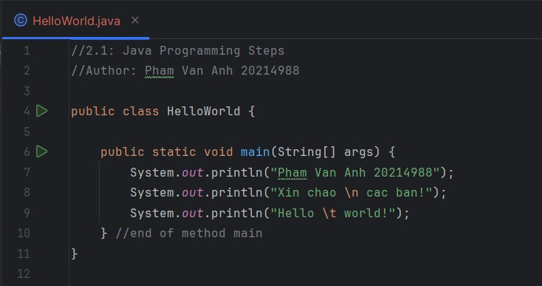

*Kết quả:*

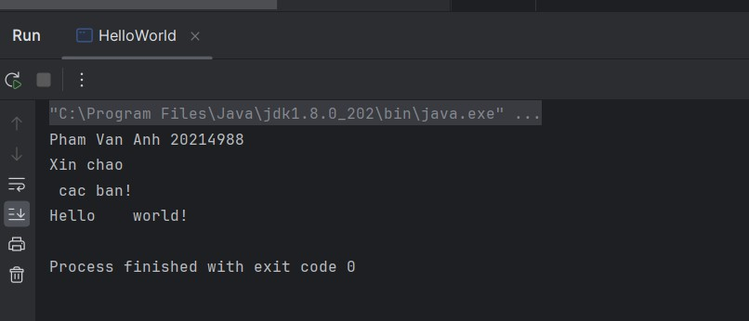

* + 1. Write, compile the first Java application:

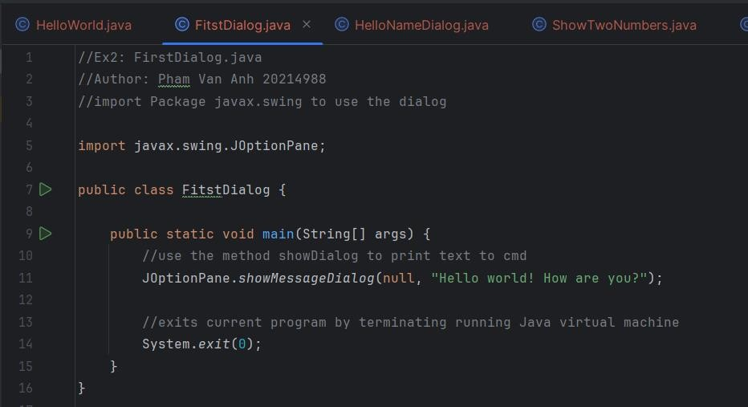

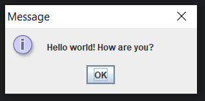

* + 1. Write, compile the first input dialog Java application

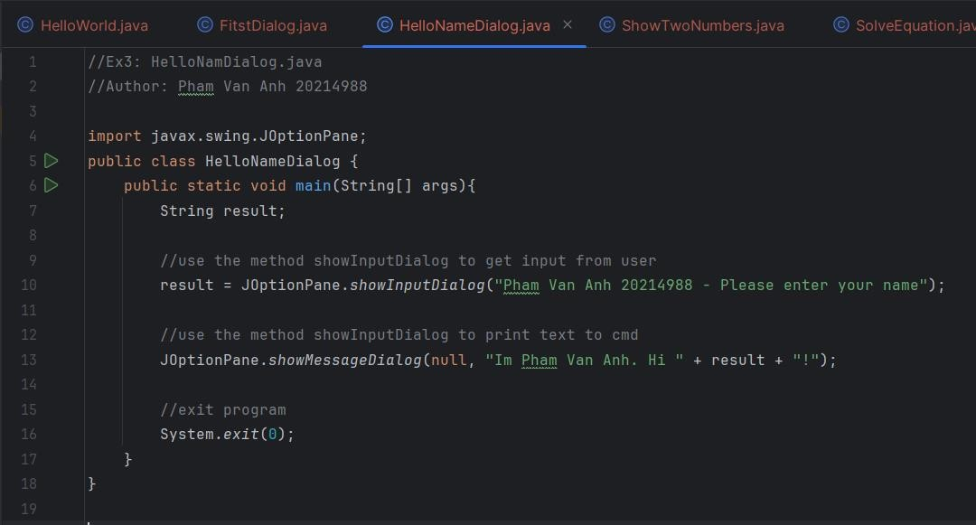

|  |  |
| --- | --- |
|  |  |

* + 1. Write, compile, and run the following example:

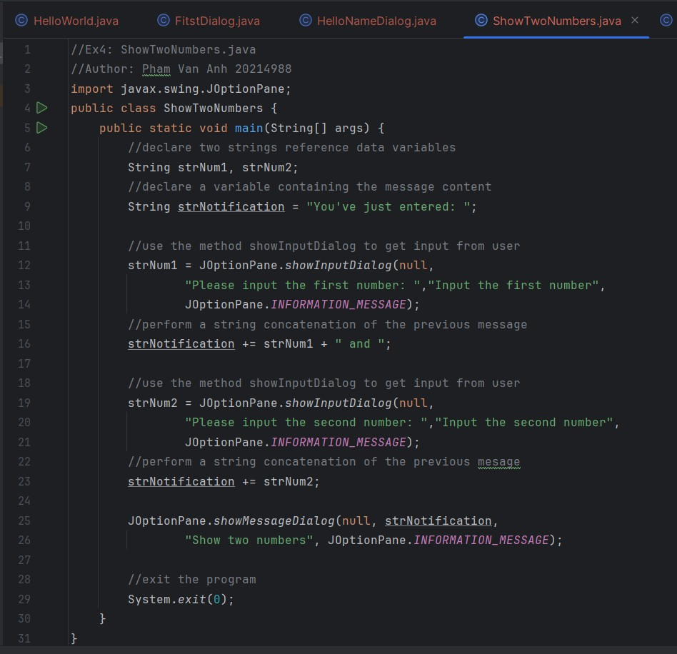

|  |  |
| --- | --- |
|  |  |

*Kết quả:*

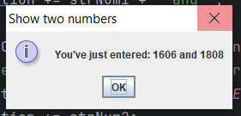

* + 1. Write a program to calculate sum, difference, product, and quotient of 2 double numbers which are entered by users.

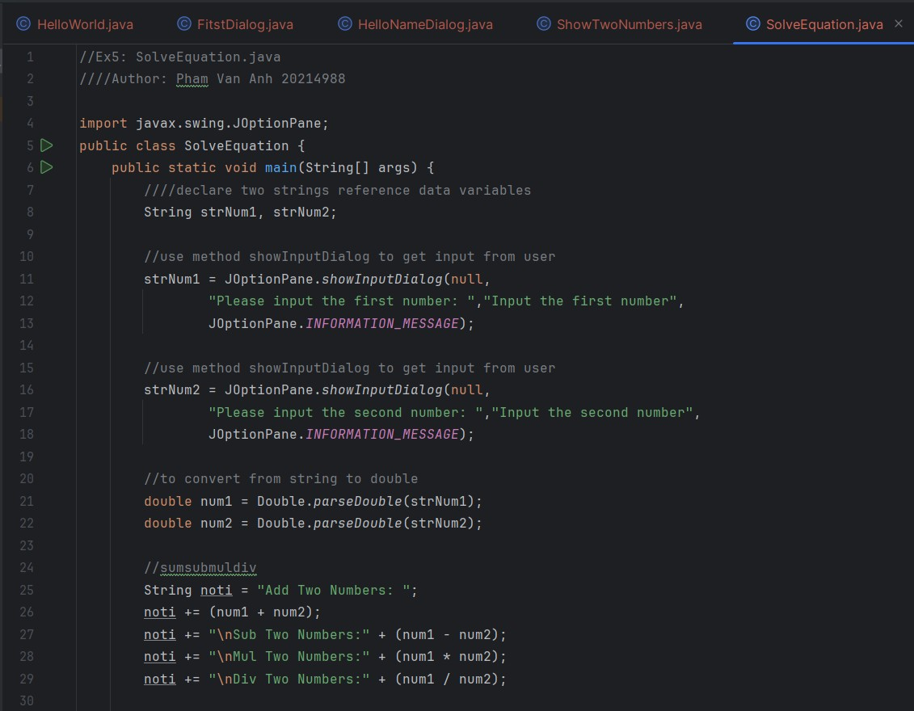

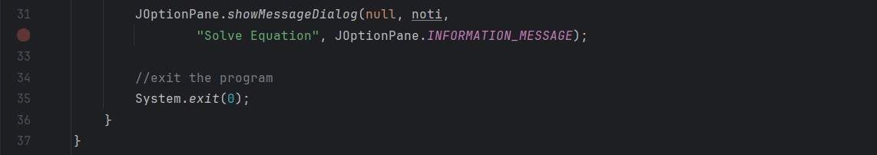

|  |  |
| --- | --- |
|  |  |
| *Kết quả:* |  |

* + 1. Write a program to solve: For simplicity, we only consider the real roots of the equation in this task.

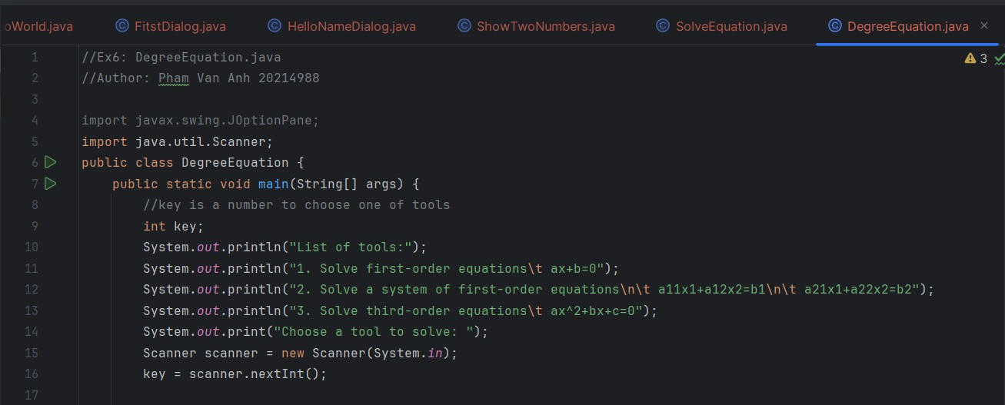

key = 1

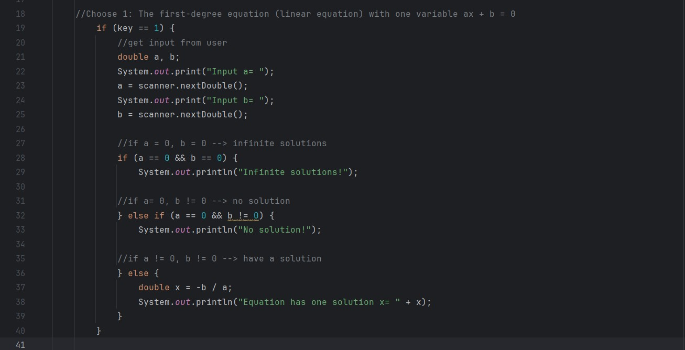

key = 2

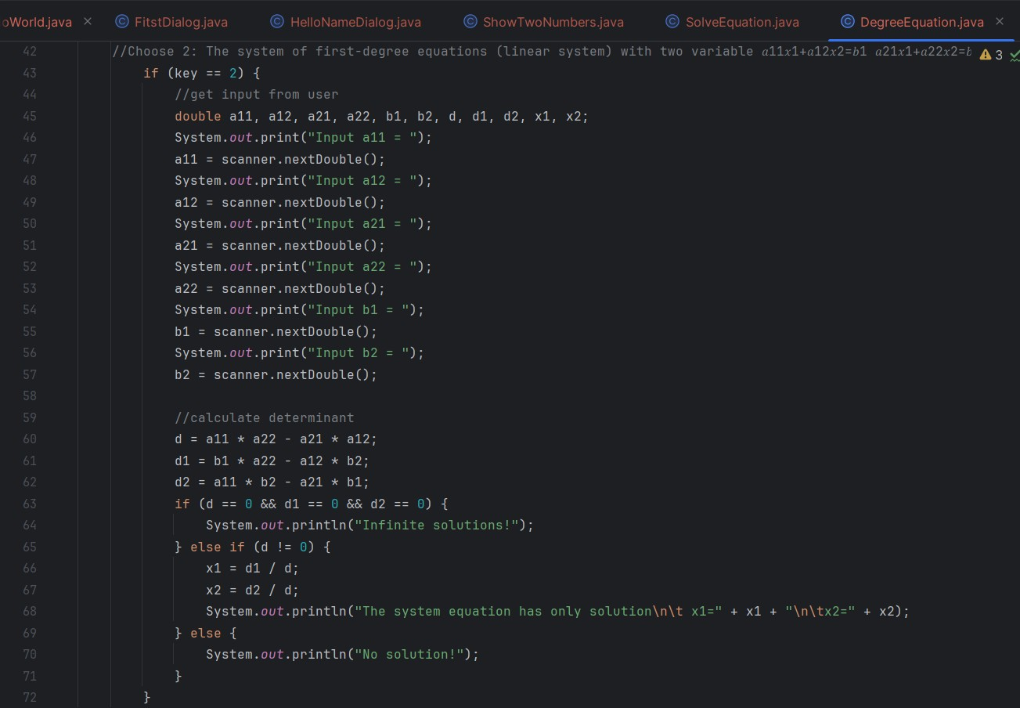

key = 3

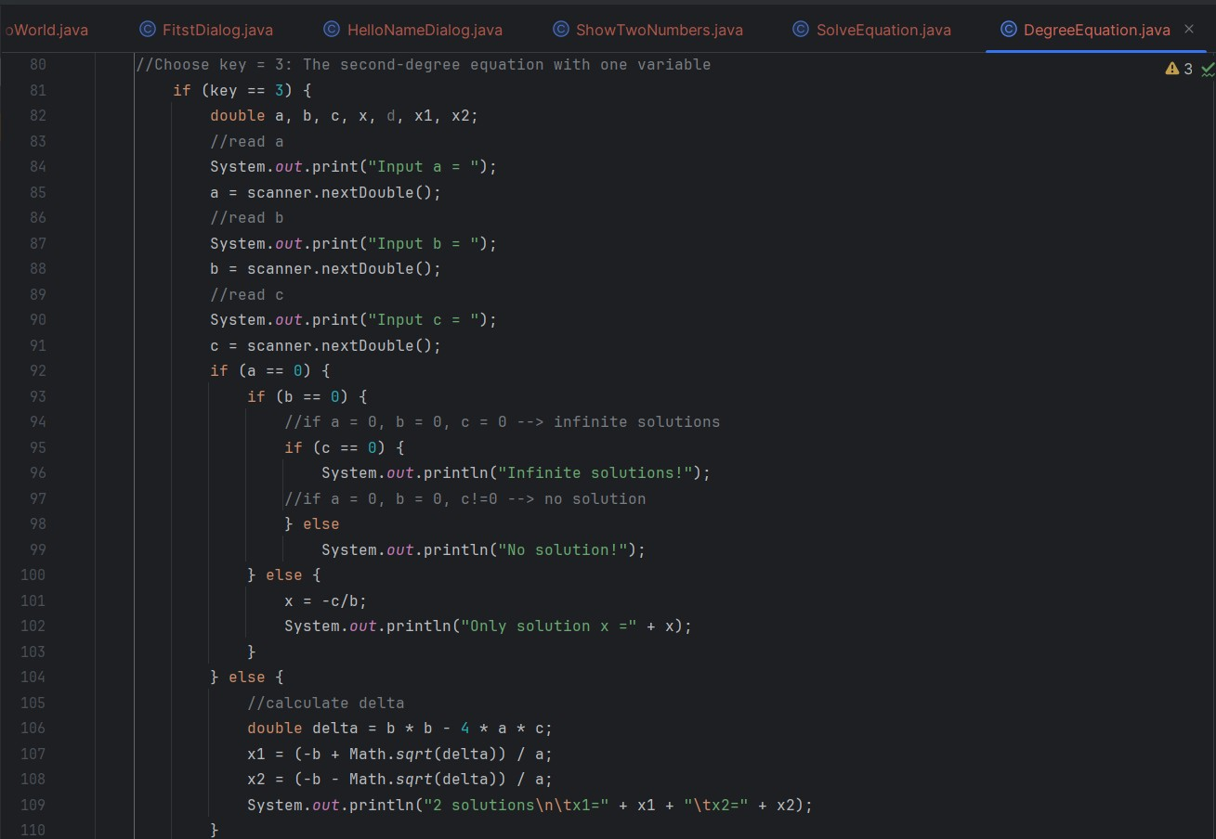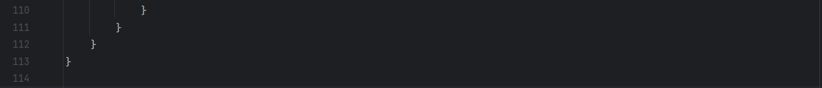

*Kết quả:*

* key = 1 🡪 first degree

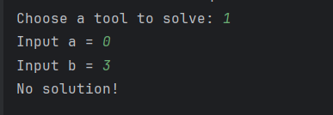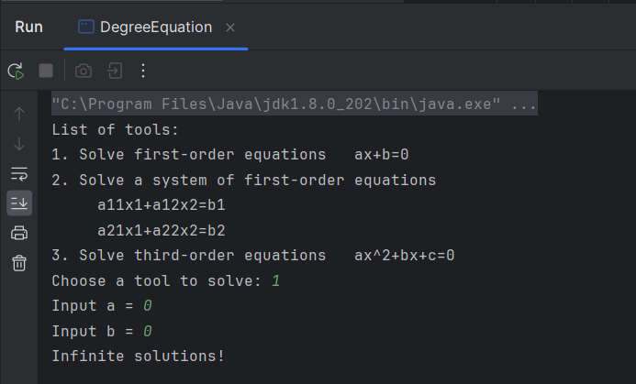

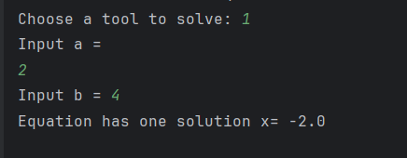

* key = 2 🡪 The system of first - degree equations (linear system) with two variables

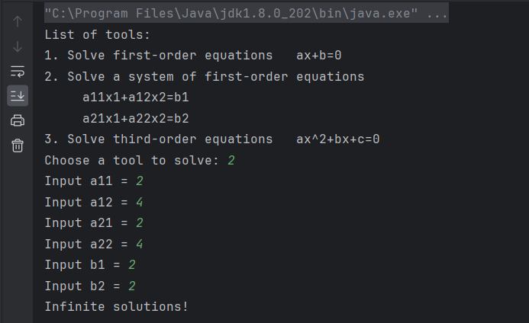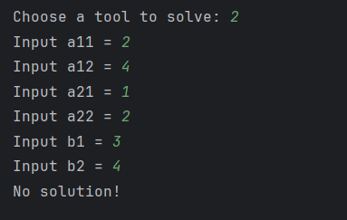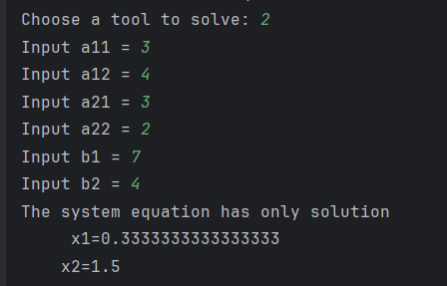

* key = 3 🡪 The second-degree equation with one variable

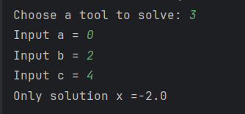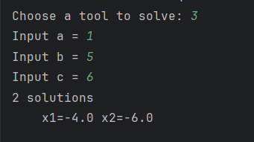

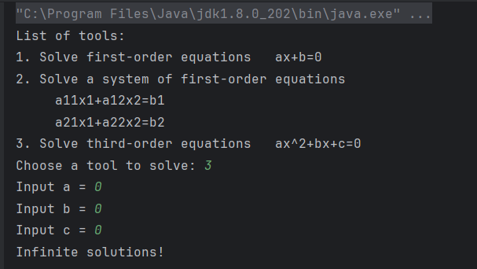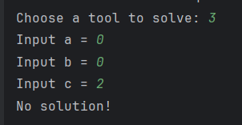

# IntelliJ

# Excercises

* 1. Write and run the the Choosing Option program:

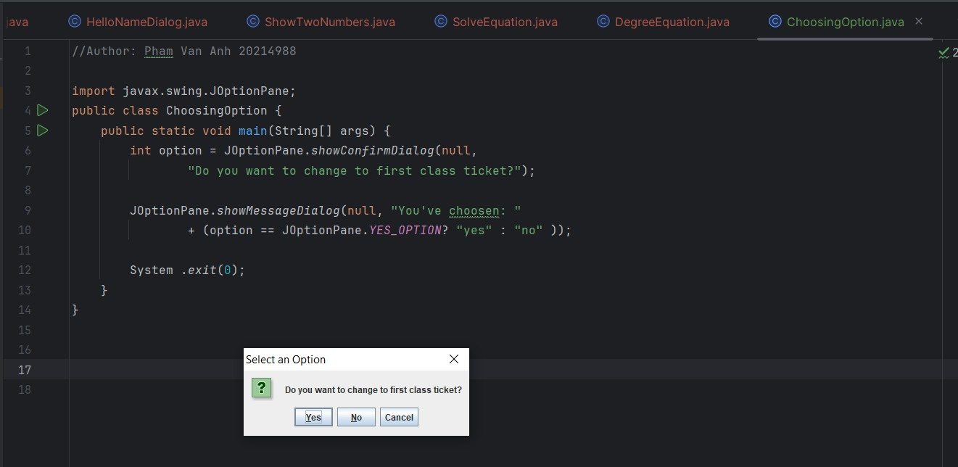

|  |  |
| --- | --- |
|  |  |

* + - Trong Eclipse IDE cho Java, nếu người dùng chọn "Cancel" khi được nhắc lưu tài nguyên trước khi khởi chạy, điều đó có nghĩa là những thay đổi được thực hiện đối với dự án hoặc tệp sẽ không được lưu và thao tác khởi chạy sẽ bị hủy. Về cơ bản, nó ngăn quá trình xây dựng hoặc chạy diễn ra mà không lưu bất kỳ thay đổi nào chưa được lưu vào dự án hoặc tệp của bạn.
    - Để customize như yêu cầu cần sử dụng nhiều tham số đầu vào của method showOptionDialog hơn, các text lựa chọn sẽ được lưu vào mảng xâu, về bản chất vẫn là câu hỏi yes/no, cụ thể như sau:

import javax.swing.JOptionPane;

public class ChoosingOption {

public static void main(String[] args) {

String[] options = {"I do", "I don't"};

int option = JOptionPane.showOptionDialog(null,

"Do you want to change to the first class ticket?",

"Confirmation", // Dialog title

JOptionPane.YES_NO_OPTION, // Option type

JOptionPane.QUESTION_MESSAGE, // Message type

null, // Icon (null for default)

options, // Custom button text

options[0]); // Default selected option

if (option == JOptionPane.YES_OPTION) {

JOptionPane.showMessageDialog(null, "You've chosen: I do");

} else if (option == JOptionPane.NO_OPTION) {

JOptionPane.showMessageDialog(null, "You've chosen: I don't");

}

System.exit(0);

}

}

* 1. Write a program for input/output from keyboard

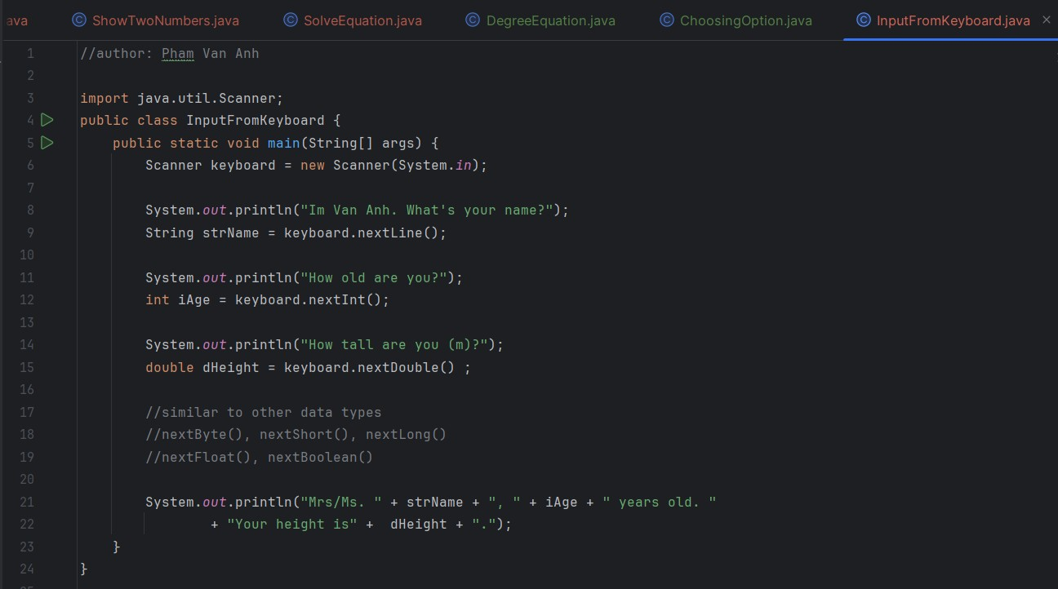 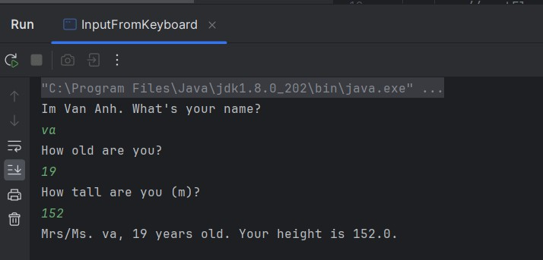

* 1. Write a program to display a triangle with a height of n stars(*), n is entered by users.

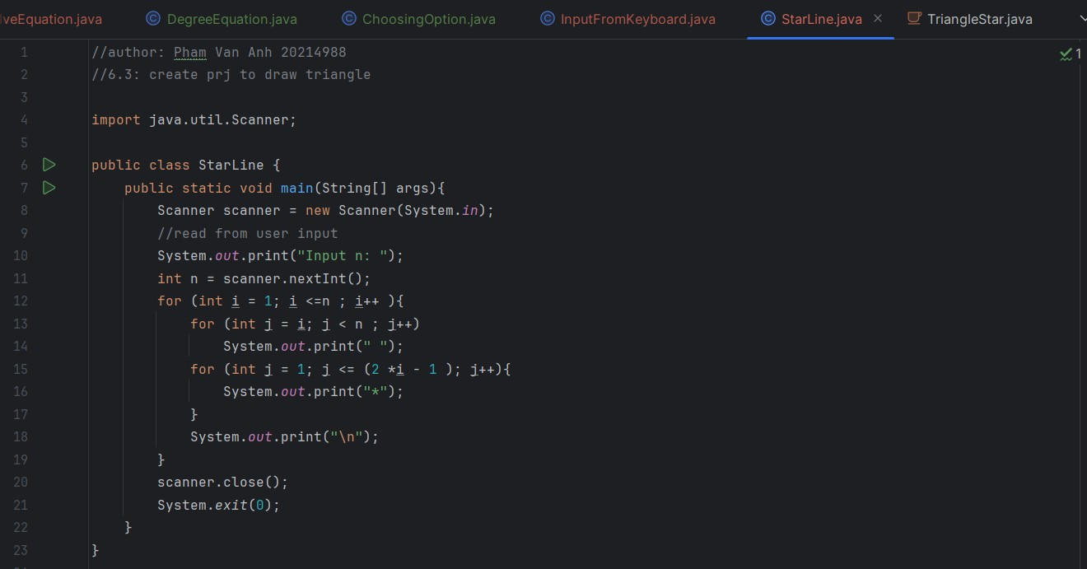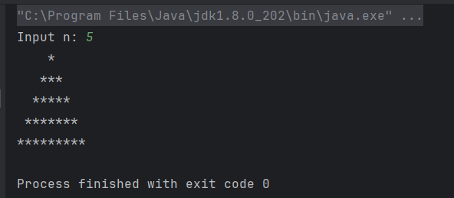

* 1. Write a program to display the number of days of a month, which is entered by users (both month and year). If it is an invalid month/year, ask the user to enter again.

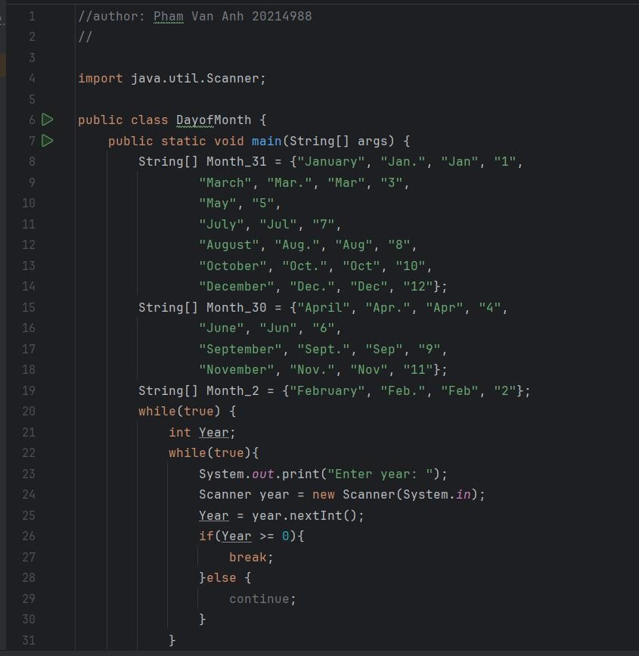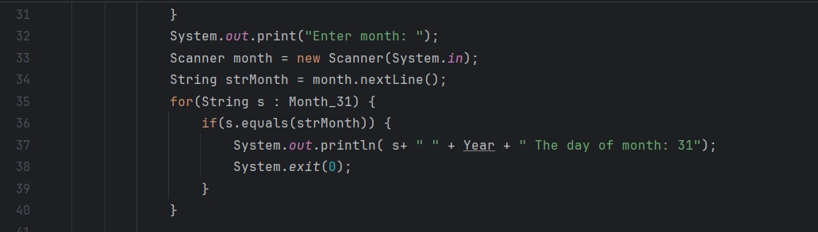

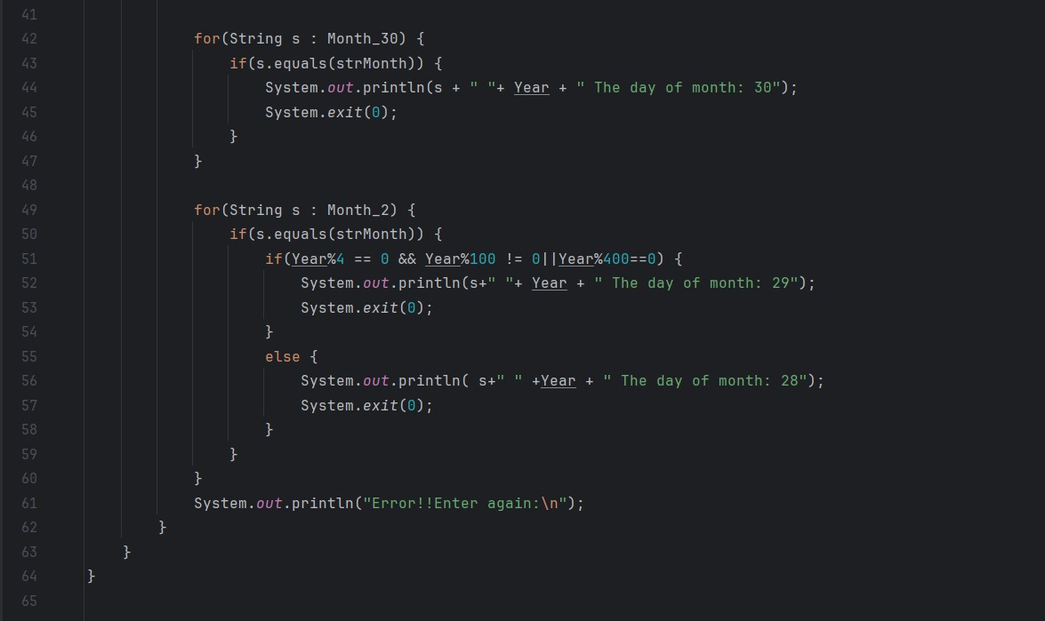

* + - Kết quả:

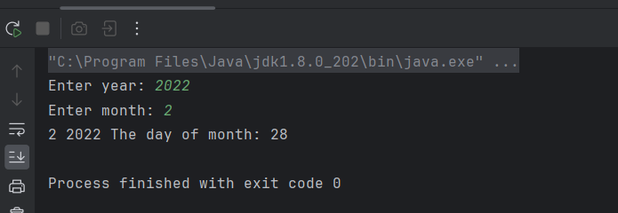

* 1. Write a Java program to sort a numeric array, and calculate the sum and average value of array elements.

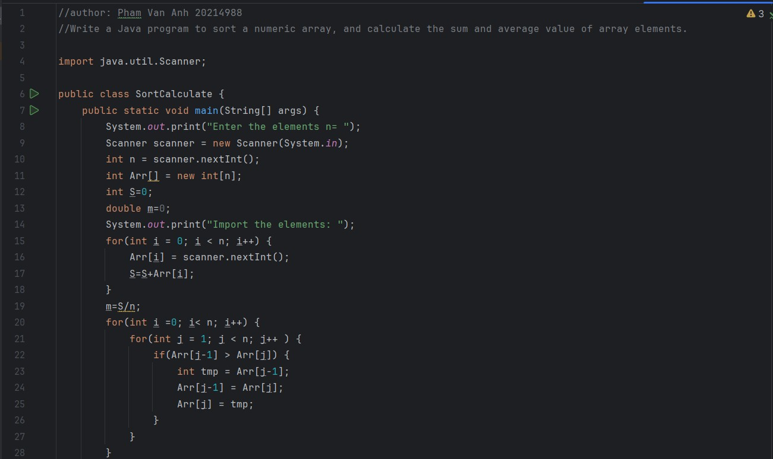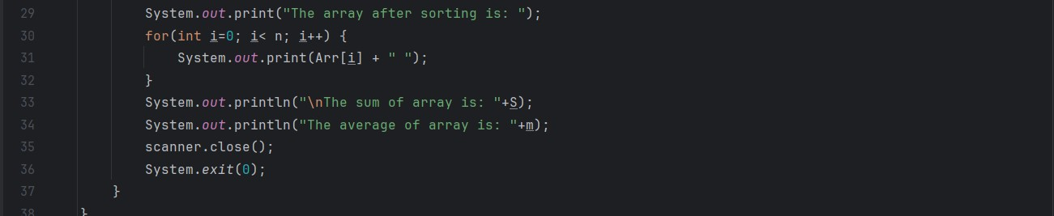

* + - Kết quả:

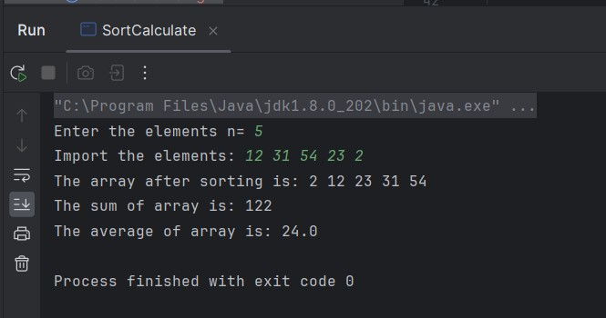

* 1. Write a Java program to add two matrices of the same size.

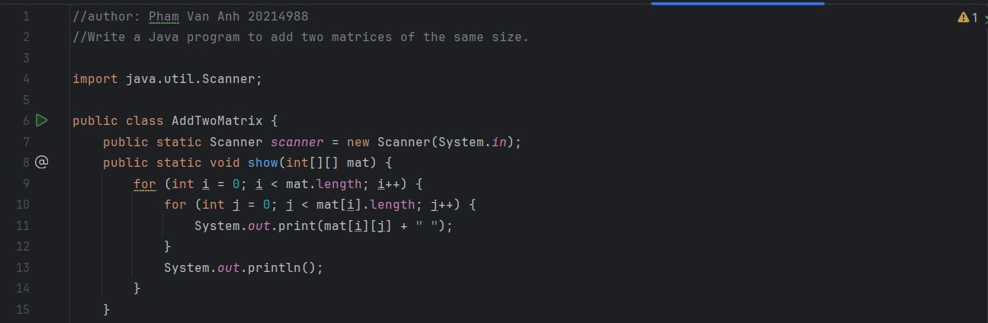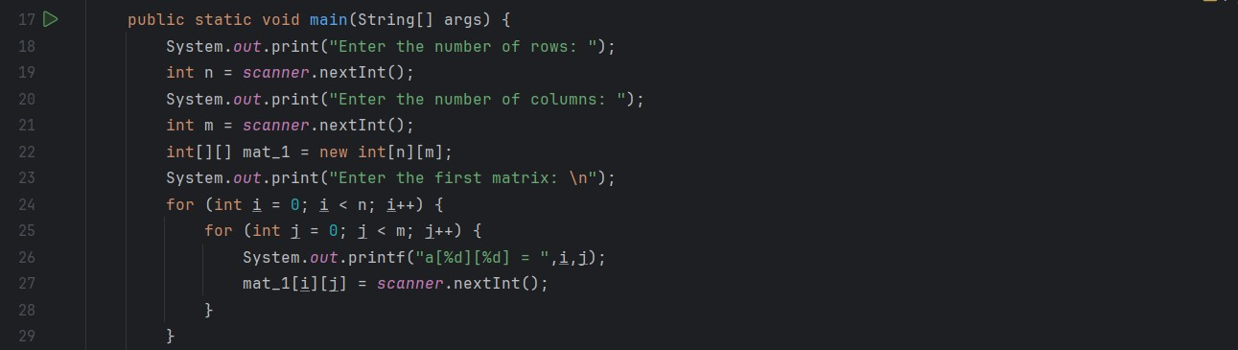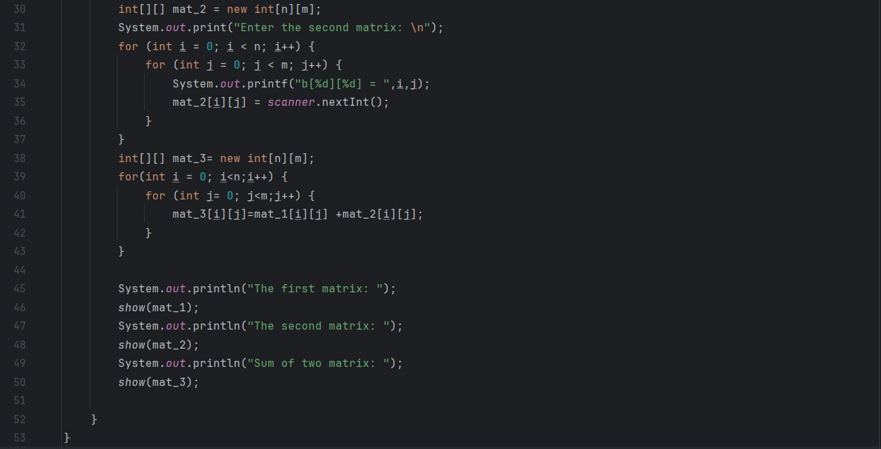

* + - Kết quả:

