BÁO CÁO THỰC HÀNH
CHƯƠNG TRÌNH DỊCH
LAB01

Phạm Vân Anh
MSSV: 20214988

- Hoàn thiện Scanner.c
State 2~3
case 2: {
readChar();
state = 0;
return getToken();
}

case 3:
{
int count = 0;
while (charCodes[currentChar] == CHAR_LETTER || charCodes[currentChar] == CHAR_DIGIT)
{
if(count < MAX_IDENT_LEN) {
str[count] = currentChar;
count++;
}

readChar();
}

str[count] = '\0';
token = makeToken(TK_IDENT, ln, cn);
strcpy(token->string, str);
state = 4;

return getToken();
}

State 5~7
case 5:
state = 0;
return token;
case 6:
state = 0;
return token;
case 7:
{
int count = 0;
char str[MAX_IDENT_LEN];
token = makeToken(TK_NUMBER, lineNo, colNo);

while (charCodes[currentChar] == CHAR_DIGIT)
{
if(count > 9) {
error(ERR_NUMBERTOOLONG, token->lineNo, token->colNo);
} else {
str[count] = currentChar;
count++;
readChar();
}
}

str[count] = '\0';
strcpy(token->string, str);
token->value = atoi(token->string);
state = 8;

return getToken();
}

State 10~12
case 10:
readChar();
state = 0;
return makeToken(SB_MINUS, lineNo, colNo - 1);
case 11:
readChar();
state = 0;
return makeToken(SB_TIMES, lineNo, colNo - 1);
case 12:
readChar();
state = 0;
return makeToken(SB_SLASH, lineNo, colNo - 1);

State 16~20
case 16:
readChar();
if (charCodes[currentChar] == CHAR_EQ)
state = 17;
else
state = 18;
return getToken();
case 17:
ln = lineNo;
cn = colNo;
readChar();
state = 0;
return makeToken(SB_GE, ln, cn-1);
case 18:
state = 0;
return makeToken(SB_GT, lineNo, colNo);
case 19:
ln = lineNo;
cn = colNo;
readChar();
state = 0;
return makeToken(SB_EQ, ln, cn);
case 20:
readChar();
if (charCodes[currentChar] == CHAR_EQ)
state = 21;
else
state = 22;
return getToken();

State 23~30
case 23:
ln = lineNo;
cn = colNo;
readChar();
state = 0;
return makeToken(SB_COMMA, ln, cn);
case 24:
readChar();
ln = lineNo;
cn = colNo;
if (charCodes[currentChar] == CHAR_RPAR)
state = 25;
else
state = 26;
return getToken();
case 25:
readChar();
state = 0;
return makeToken(SB_RSEL, ln, cn-1);
case 26:
state = 0;
return makeToken(SB_PERIOD, ln, cn-1);
case 27:
ln = lineNo;
cn = colNo;
readChar();
state = 0;
return makeToken(SB_SEMICOLON, ln, cn);
case 28:
readChar();
if (charCodes[currentChar] == CHAR_EQ)
state = 29;
else
state = 30;
return getToken();
case 29:
readChar();
state = 0;
return makeToken(SB_ASSIGN, lineNo, colNo - 2);
case 30:
state = 0;
return makeToken(SB_COLON, lineNo, colNo - 1);

State 36~39
case 36:
readChar();
state = 0;
return makeToken(SB_LSEL, lineNo, colNo - 2);
case 37:
readChar();
while (currentChar != EOF) {
if (charCodes[currentChar] == CHAR_TIMES) {
readChar();
if (charCodes[currentChar] == CHAR_RPAR) { // Phát hiện đóng chú thích *)
state = 39;
break;
}
} else {
readChar();
}
}
if (currentChar == EOF) {
error(ERR_ENDOFCOMMENT, lineNo, colNo); // Báo lỗi nếu EOF trước khi kết thúc chú thích
}
return getToken();

case 38:
readChar();
if(charCodes[currentChar] == CHAR_RPAR) {
state = 39;
}
return getToken();
case 39:
readChar();
state = 0;
return getToken();

- KẾT QUẢ
- Biên dịch example1.kpl
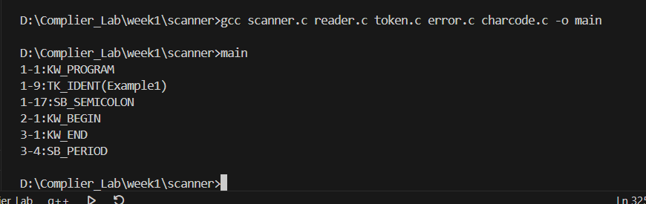

- Biên dịch example2.kpl
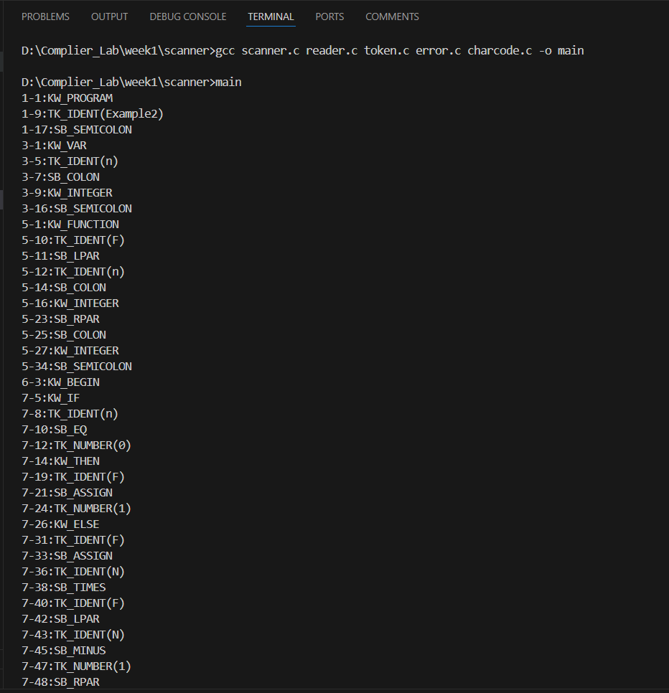
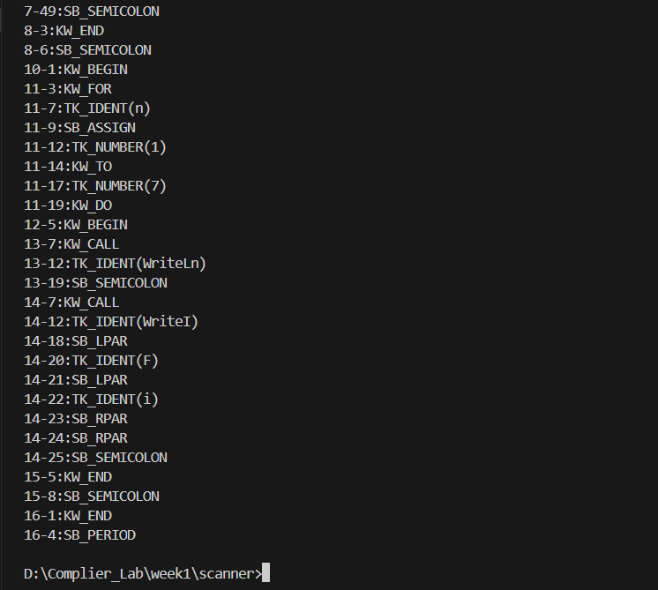

- Biên dịch exampleA1.kpl, xử lí số nguyên lớn
