-- install samba on ubuntu

sudo apt-get install samba

-- register password for compiling, all next steps, change 'tai' to your username

sudo smbpasswd -La tai

-- create shared folder between window and ubuntu

mkdir **/home/tai/work**

-- edit samba config file

sudo vi /etc/samba/smb.conf

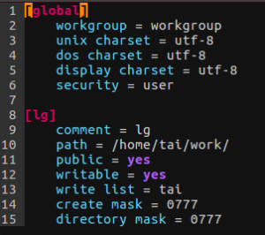

-- restart samba

sudo service smbd restart

-- test samba

connect from window to ubuntu via ubuntu's IP.

i.e \\192.168.56.2, locate to shared folder

https://techblog.vn/alarmmanager-trong-androidpart-1