**Aim:** Write a program to demonstrate working with tuples in python.

**IDE:**

Python Tuple

A tuple is a collection similar to a Python list. The primary difference is that we cannot modify a tuple once it is created.

A tuple represents a sequence of any objects separated by commas and enclosed in parentheses. A tuple is an immutable object, which means it cannot be changed, and we use it to represent fixed collections of items.

Create a Python Tuple

numbers = (1, 2, -5)

print(numbers)

Output:

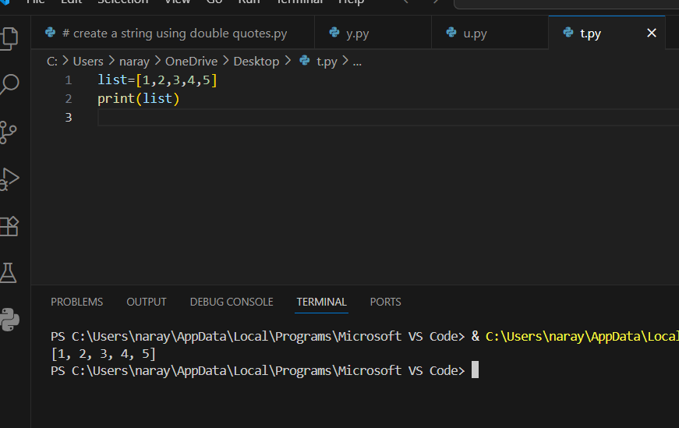

Let's take a look at some examples of Python tuples:

() — an empty tuple

(1.0, 9.9, 10) — a tuple containing three numeric objects

('Casey', 'Darin', 'Bella', 'Mehdi') — a tuple containing four string objects

('10', 101, True) — a tuple containing a string, an integer, and a Boolean object

Also, other objects like lists and tuples can comprise a tuple, like this:

a_tuple = (0, [1, 2, 3], (4, 5, 6), 7.0)

print(a_tuple)

output:

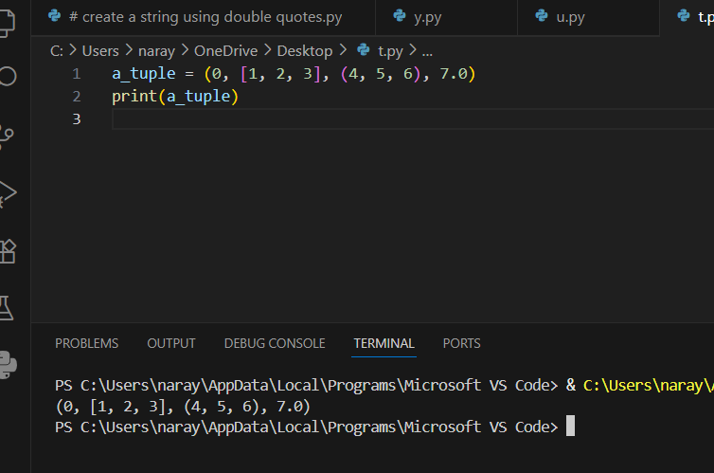

Access Tuple Items

Each item in a tuple is associated with a number, known as a index.

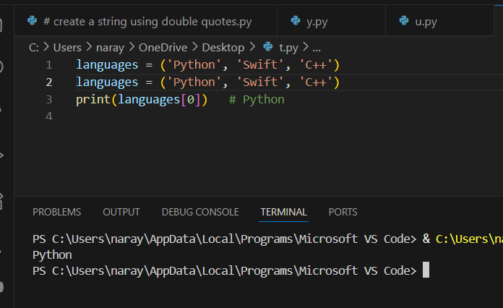Output:

Python Tuple Length

cars = ('BMW', 'Tesla', 'Ford', 'Toyota')

print('Total Items:', len(cars))

output

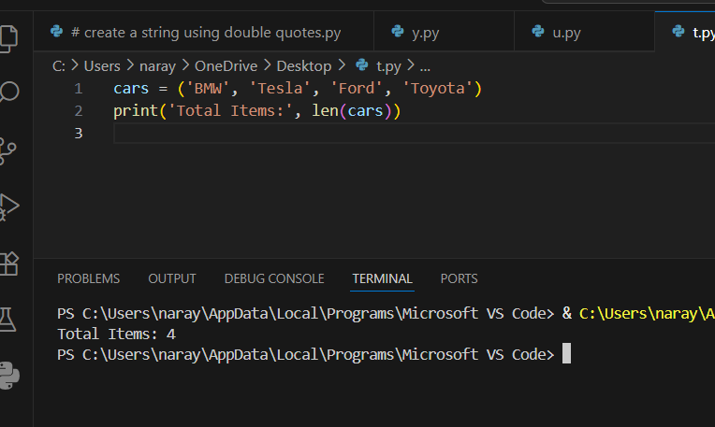

Task

a = tuple(range(5))

print(a)

output

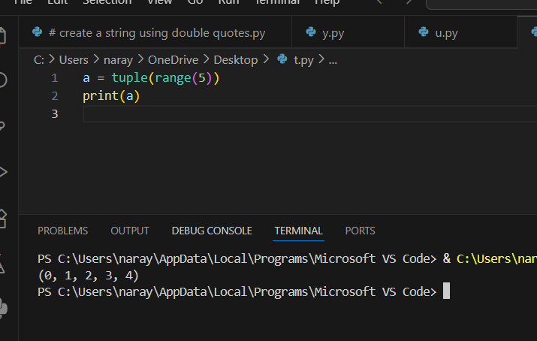

b = tuple(range(5,10))

print(b)

Output:

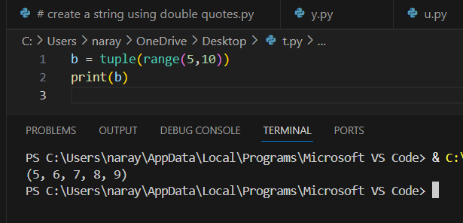

c = tuple(range(0,10,2))

print(c)

output:

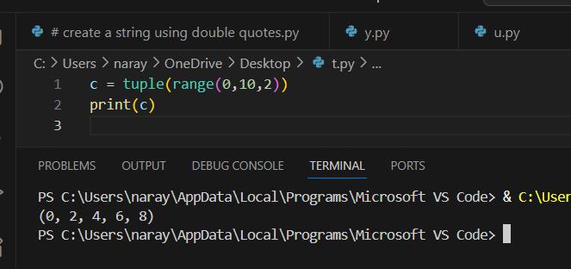

d = tuple(range(10,0,-2))

print(d)

output:

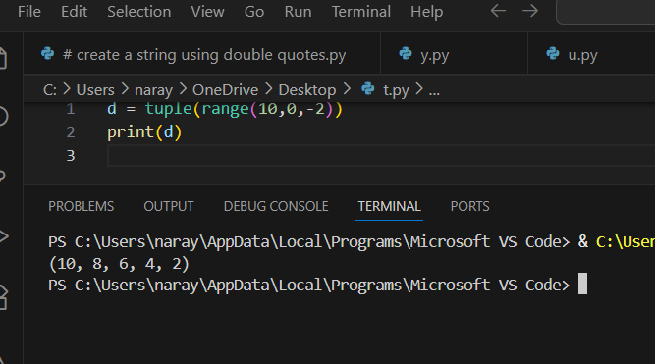

Task:

d = (3,[5,6,7],(4,5,6),[5,6,7,(6,7,8)],9,10)

Extract **6**

**Syntax:**

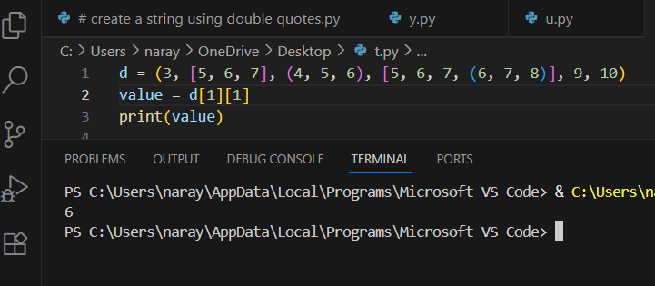

Important Functions of the Python Tuple

t1 = (2,3,4,5)

print(sum(t1))

output

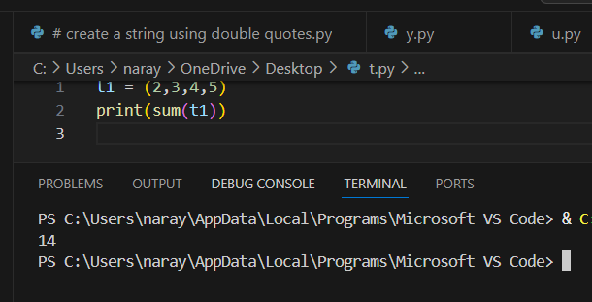

t3 = (3,4,4,2,2,3,6,7,4,4)

print(t3.count(4))

output

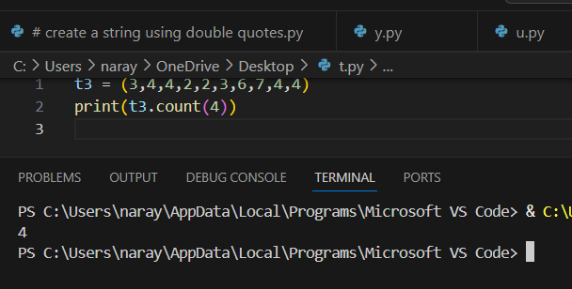

4. Python index() Method

t3 = (3,4,4,2,2,3,6,7,4,4)

print(t3.index(2))

print(t3.index(4,3,9))

Output:

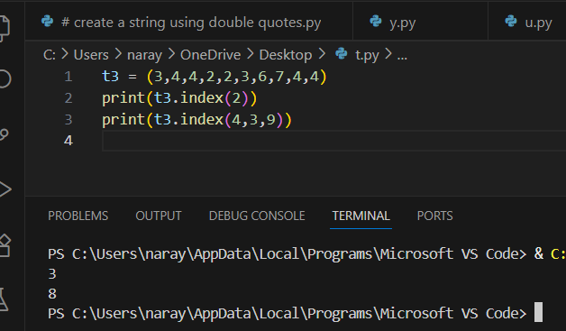

5. Python min() Method

t3 = (3,4,4,2,2,3,6,7,4,4)

print(min(t3))

output

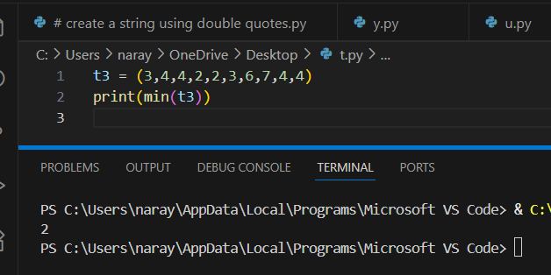

6. Python max() Method

Calculates the maximum of all the elements of the tuple.

numbers = (7, 2, 8, 5, 9)

print(max(numbers))

output

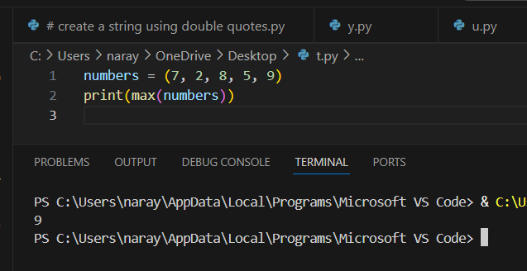

# removing duplicates from a tuple using dictionaries

a = (5,6,7,5,5,9,7)

b = ("a","b","v","b")

my_tu_1 = tuple(dict.fromkeys(a))

print(my_tu_1)

my_tu_2 = tuple(dict.fromkeys(b))

print(my_tu_2)

Output:

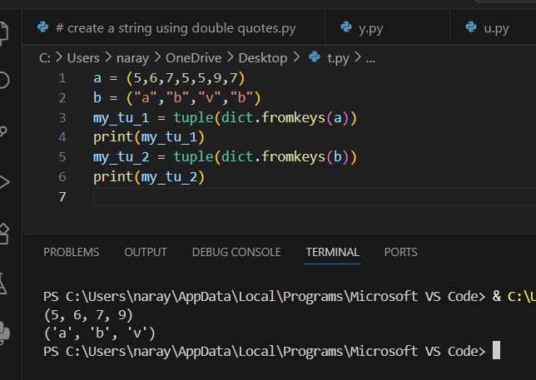

Combining tuples

first_names = ('Simon', 'Sarah', 'Mehdi', 'Fatime')

last_names = ('Sinek', 'Smith', 'Lotfinejad', 'Lopes')

ages = (49, 55, 39, 33)

zipped = tuple(zip(first_names, last_names,ages))

print(zipped)

output

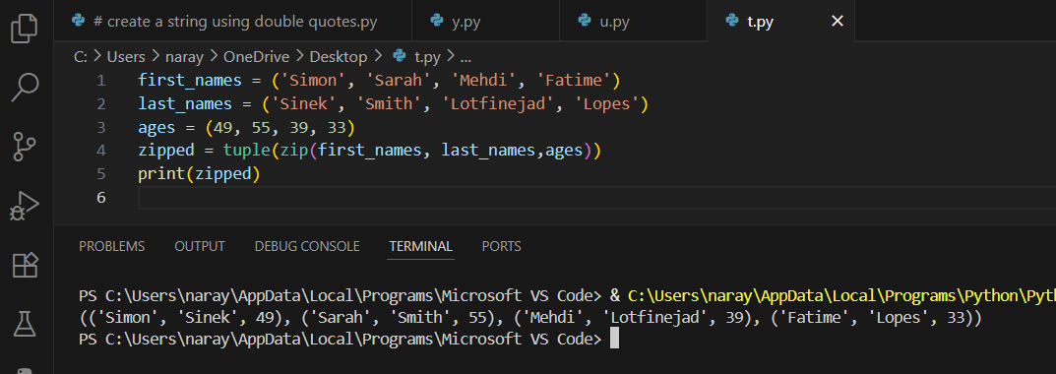

Flatten a tuple of tuples

b = ((1,2),(3,4),(5,6))

my = tuple(item for l in b for item in l)

print(my)

output

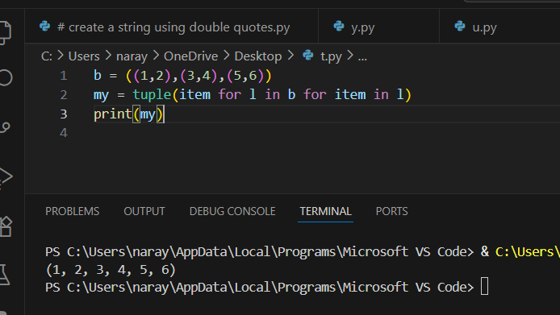

**Post Lab Exercise:**

1. Write a Python program to Count the occurrences of an element in a tuple.

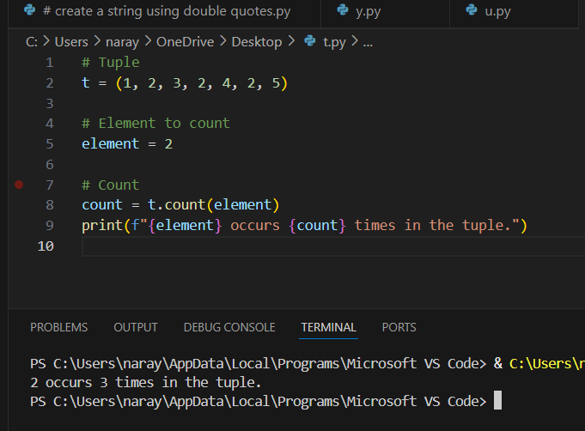

1. Write a Python program to Check if an element exists in a tuple.

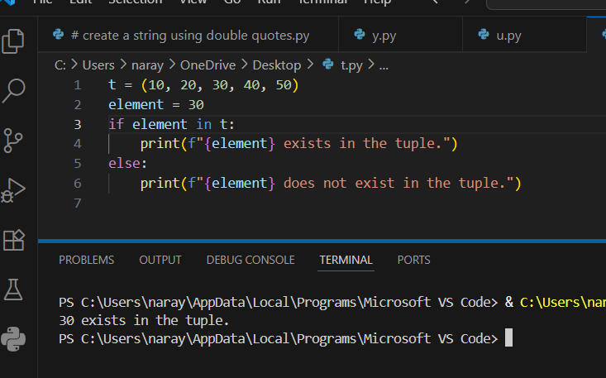

1. Write a Python program to Convert a tuple to a string.

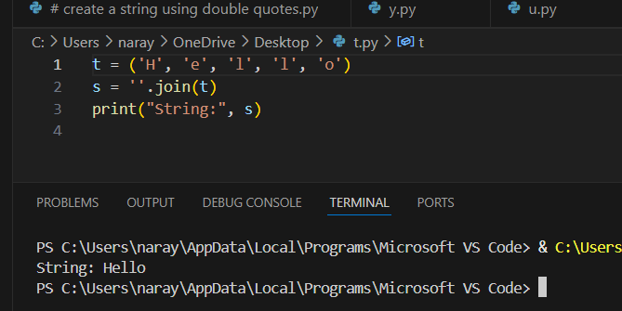

1. Write a Python program to Find the maximum and minimum elements in a tuple.

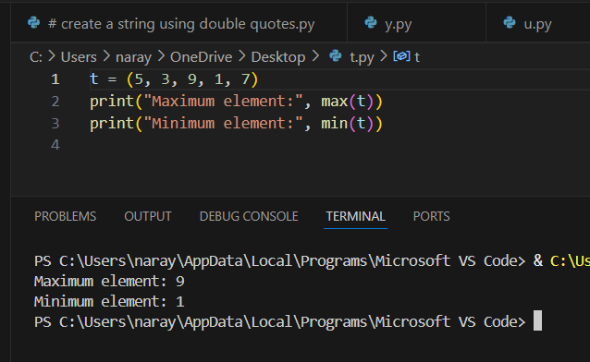

1. Write a Python program to convert a tuple of strings to a single string.

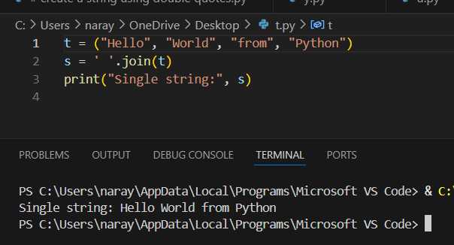

1. Write a Python program to sort a tuple of integers.

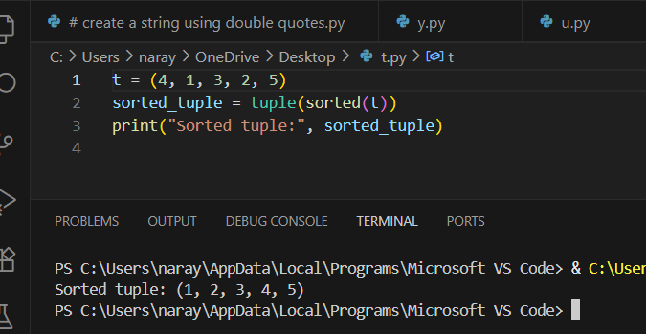

1. Write a python program to find the first and last elements of a tuple.

