**Aim:** Practical based on matplotlib

**IDE:**

What is Matplotlib?

Matplotlib is a popular plotting library in Python used for creating high-quality visualizations and graphs. It offers various tools to generate diverse plots, facilitating data analysis, exploration, and presentation. Matplotlib is flexible, supporting multiple plot types and customization options, making it valuable for scientific research, data analysis, and visual communication. It can create different types of visualization reports like line plots, scatter plots, histograms, bar charts, pie charts, box plots, and many more different plots. This library also supports 3-dimensional plotting.Installation of Matplotlib

pip install matplotlib

To verify the installation, you would have to write the following code chunk:

import matplotlib as plt

print(plt.__version__)

Line Plots

Line graphs are commonly used to visualize trends over time or relationships between variables.

Example

import matplotlib.pyplot as plt

# data to display on plots

x = [3, 1, 3]

y = [3, 2, 1]

plt.plot(x, y)

plt.title("Line Chart")

# Adding the legends

plt.legend(["Line"])

plt.show()

Output

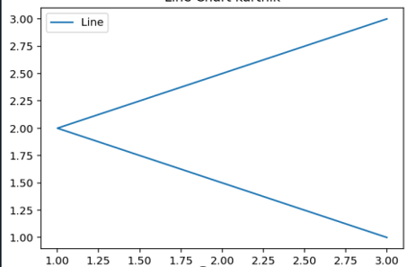

Note: xlabel, ylabel, title, plt.xlabel("X-axis")  # add X-axis label, plt.ylabel("Y-axis")  # add Y-axis label

plt.title("Any suitable title")  # add title, plt.show(), plt.grid(), plt.axhline(y=0, color='k'), plt.axvline(x=0, color='k')

Stem Plots

A stem plot, also known as a stem-and-leaf plot, is a type of plot used to display data along a number line. Stem plots are particularly useful for visualizing discrete data sets, where the values are represented as “stems” extending from a baseline, with data points indicated as “leaves” along the stems.

Example

**import** **matplotlib.pyplot** **as** **plt**

**import** **numpy** **as** **np**

x = np.linspace(0.1, 2 * np.pi, 41)

y = np.exp(np.sin(x))

plt.stem(x, y, use_line_collection = **True**)

plt.show()

Output

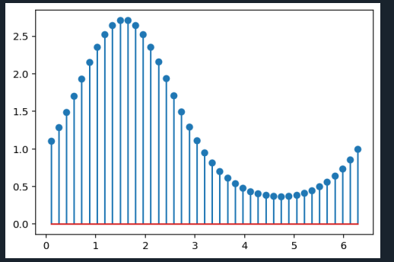

Bar Charts

A **bar plot** or bar chart is a graph that represents the category of data with rectangular bars with lengths and heights that is proportional to the values which they represent. The bar plots can be plotted horizontally or vertically. A bar chart describes the comparisons between the discrete categories. It can be created using the **bar()** method.

Example

**import** **matplotlib.pyplot** **as** **plt**

*# data to display on plots*

x = [3, 1, 3, 12, 2, 4, 4]

y = [3, 2, 1, 4, 5, 6, 7]

*# This will plot a simple bar chart*

plt.bar(x, y)

*# Title to the plot*

plt.title("Bar Chart")

*# Adding the legends*

plt.legend(["bar"])

plt.show()

Output

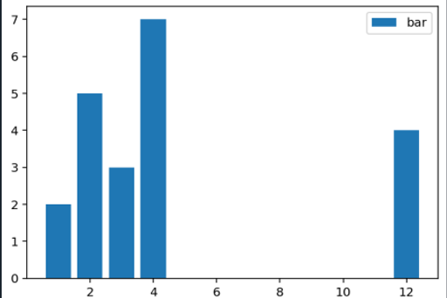

Histogram Plot

A histogram is basically used to represent data in the form of some groups. It is a type of bar plot where the X-axis represents the bin ranges while the Y-axis gives information about frequency. To create a histogram the first step is to create a bin of the ranges, then distribute the whole range of the values into a series of intervals, and count the values which fall into each of the intervals. Bins are clearly identified as consecutive, non-overlapping intervals of variables.

**import** **matplotlib.pyplot** **as** **plt**

*# data to display on plots*

x = [1, 2, 3, 4, 5, 6, 7, 4]

*# This will plot a simple histogram*

plt.hist(x, bins = [1, 2, 3, 4, 5, 6, 7])

*# Title to the plot*

plt.title("Histogram")

*# Adding the legends*

plt.legend(["bar"])

plt.show()

Output

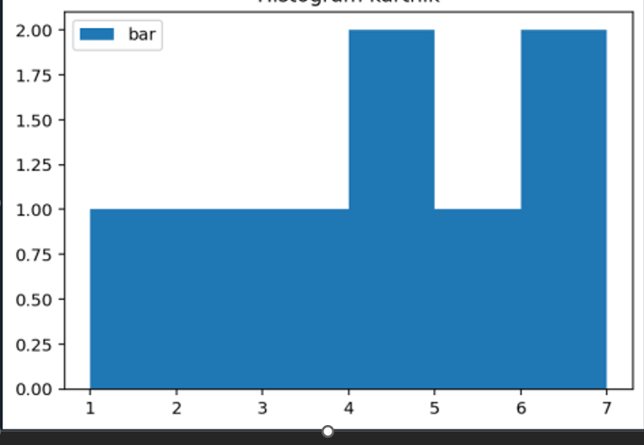

Scatter Plot

Scatter plots are ideal for visualizing the relationship between two continuous variables.

**Example**

**import** **matplotlib.pyplot** **as** **plt**

*# data to display on plots*

x = [3, 1, 3, 12, 2, 4, 4]

y = [3, 2, 1, 4, 5, 6, 7]

*# This will plot a simple scatter chart*

plt.scatter(x, y)

*# Adding legend to the plot*

plt.legend("A")

*# Title to the plot*

plt.title("Scatter chart")

plt.show()

Output

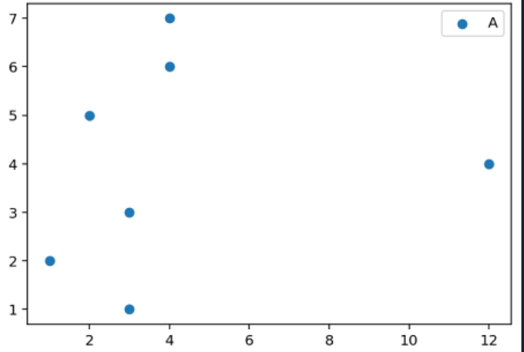

Box Plot

A box plot, also known as a box-and-whisker plot, provides a visual summary of the distribution of a dataset. It represents key statistical measures such as the median, quartiles, and potential outliers in a concise and intuitive manner. Box plots are particularly useful for comparing distributions across different groups or identifying anomalies in the data.

Example

**import** **matplotlib.pyplot** **as** **plt**

**import** **numpy** **as** **np**

*# Creating dataset*

np.random.seed(10)

data = np.random.normal(100, 20, 200)

fig = plt.figure(figsize =(10, 7))

*# Creating plot*

plt.boxplot(data)

*# show plot*

plt.show()

Output

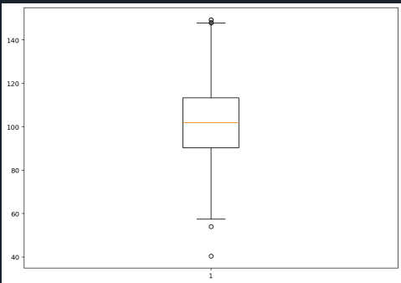

Pie chart

A Pie Chart is a circular statistical plot that can display only one series of data. The area of the chart is the total percentage of the given data. The area of slices of the pie represents the percentage of the parts of the data. The slices of pie are called wedges. The area of the wedge is determined by the length of the arc of the wedge.

Example

**import** **matplotlib.pyplot** **as** **plt**

*# data to display on plots*

x = [1, 2, 3, 4]

*# this will explode the 1st wedge*

*# i.e. will separate the 1st wedge*

*# from the chart*

e =(0.1, 0, 0, 0)

*# This will plot a simple pie chart*

plt.pie(x, explode = e)

*# Title to the plot*

plt.title("Pie chart")

plt.show()

Output

PIE CHART HEMANTH

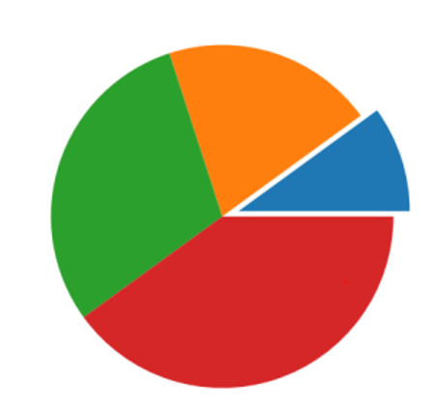

Error Plot

Error plots display the variability or uncertainty associated with each data point in a dataset. They are commonly used in scientific research, engineering, and statistical analysis to visualize measurement errors, confidence intervals, standard deviations, or other statistical properties of the data. By incorporating error bars into plots, we can convey not only the central tendency of the data but also the range of possible values around each point.

Example

*# importing matplotlib*

**import** **matplotlib.pyplot** **as** **plt**

*# making a simple plot*

x =[1, 2, 3, 4, 5, 6, 7]

y =[1, 2, 1, 2, 1, 2, 1]

*# creating error*

y_error = 0.2

*# plotting graph*

plt.plot(x, y)

plt.errorbar(x, y,yerr = y_error,fmt ='o')

Output

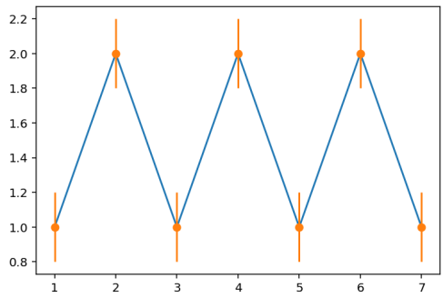

Note:

lets the creation of a 3D plot in Matplotlib. We can create different types of 3D plots like scatter plots, contour plots, surface plots, etc. Let’s create a simple 3D line plot.

Example

**import** **matplotlib.pyplot** **as** **plt**

x = [1, 2, 3, 4, 5]

y = [1, 4, 9, 16, 25]

z = [1, 8, 27, 64, 125]

*# Creating the figure object*

fig = plt.figure()

*# keeping the projection = 3d*

*# creates the 3d plot*

ax = plt.axes(projection = '3d')

ax.plot3D(z, y, x)

Output

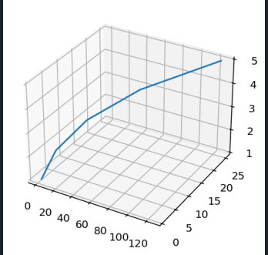

**Post Lab Exercise:**

1. Write a Python program to draw a line with suitable label in the x axis, y axis and a title.

Code:

import matplotlib.pyplot as plt

import numpy as np

# Generate x values from 0 to 10

x = np.linspace(0, 10, 100)

# Define y as a function of x (say y = 2x + 1)

y = 2 * x + 1

# Plot the line

plt.plot(x, y, label="y = 2x + 1", color='blue')

# Add labels and title

plt.xlabel("X Axis")

plt.ylabel("Y Axis")

plt.title("Line Plot Example vachalya")

# Show legend

plt.legend()

# Display the plot

plt.show()

output:

LINE PLOT EXAMPLE VAHCHALYA

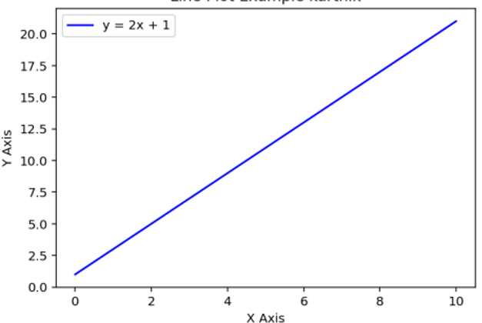

1. Write a Python program to plot two or more lines on same plot with suitable legends of each line.

Code:

import matplotlib.pyplot as plt

import numpy as np

x = np.linspace(0, 10, 100)

y1 = x # Line 1: y = x

y2 = x**2 # Line 2: y = x^2

y3 = np.sqrt(x) # Line 3: y = √x

plt.plot(x, y1, label="y = x", color='blue')

plt.plot(x, y2, label="y = x²", color='red')

plt.plot(x, y3, label="y = √x", color='green')

plt.xlabel("X Axis")

plt.ylabel("Y Axis")

plt.title("Multiple Lines on Same Plot vahchalya")

plt.legend()

plt.show()

code:

MULTIPLE LINES ON SAME PLOT VAHCHALYA

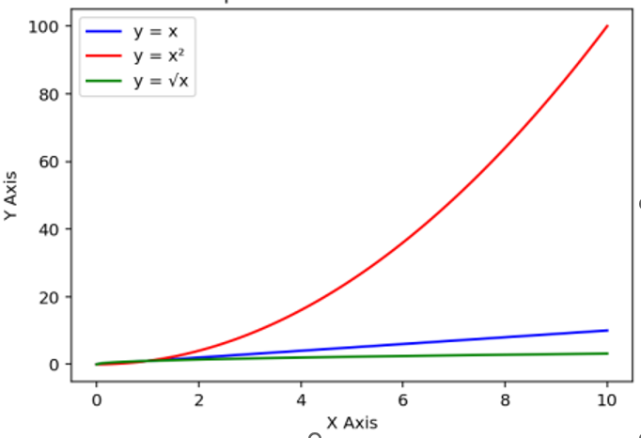

1. Write a Python programming to display a bar chart of the popularity of programming Languages.

Sample data:

Programming languages: Java, Python, PHP, JavaScript, C#, C++

Popularity: 22.2, 17.6, 8.8, 8, 7.7, 6.7

Code:

import matplotlib.pyplot as plt

languages = ['Java', 'Python', 'PHP', 'JavaScript', 'C#', 'C++']

popularity = [22.2, 17.6, 8.8, 8, 7.7, 6.7]

plt.bar(languages, popularity, color=['blue', 'green', 'red', 'purple', 'orange', 'cyan'])

plt.xlabel("Programming Languages")

plt.ylabel("Popularity (%)")

plt.title("Popularity of Programming Languages vahchalya")

plt.show()

output:

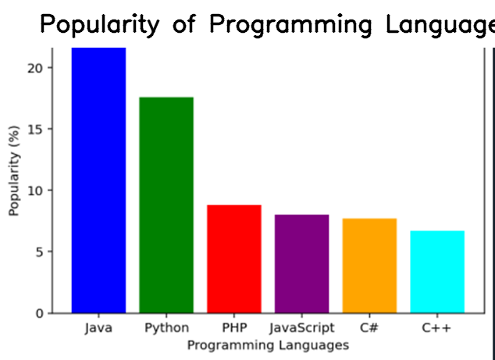

Github link:

https://github.com/vahchalya-bodas/pwp.git

More Practice

Reference : <https://medium.com/@DebaprasannBhoi/python-matplotlib-exercises-cc46c994563c>