
COMSATS UNIVERISTY ISLAMABAD, LAHORE

Reg. #: FA23-BCS-200
Name: Vaheebah Fatima
Course Title: Advance Database Systems
Section: B
Assignment #: 3

ASSIGNMENT NO 1

Question #1
Module | Best NoSQL Model | Recommended DB & Justification
1. Student Profiles | Document Store | MongoDB: Student profiles vary significantly (some have extra activities, different grading schemes).  Justification: Schema Flexibility allows handling semi-structured data (JSON/BSON) without costly migrations when profile requirements change.
2. Real-time Attendance | Key-Value / Document | Firestore (or DynamoDB):  Justification: Real-time Updates. Firestore has built-in listeners (onSnapshot) that can instantly push attendance status changes to a teacher’s dashboard without them refreshing the page.
3. Course Materials | Document Store | MongoDB: Course content is hierarchical.  Justification: Indexing Capabilities. MongoDB allows complex indexing on nested fields (e.g., finding a specific chapter within a module) and handles metadata for large files efficiently.
4. Chat (Teachers/Students) | Document Store | Firestore: Chat requires syncing messages across devices instantly.  Justification: Global Replication & Real-time Sync. Firestore automatically syncs data to all connected clients. It also handles offline support (caching messages locally if the internet drops) better than raw DynamoDB.

Question 2: Food Delivery App Indexing
a. Which fields to index?
- Rider Location: coordinates (Lat/Long).
- Customer Orders: customer_id and order_date.
- Restaurant Menus: item_name and description.
- Delivery Route History: delivery_status or timestamp.
Data Requirement | Index Type | Why?
Rider Live Location | Geospatial Index (2dsphere) | Essential for "Find riders near me" queries based on radius.
Customer Orders | Compound Index | Indexing (customer_id, order_date) allows fetching a specific user's orders sorted by time efficiently.
Restaurant Menus | Text Index | Allows keyword search (e.g., "Spicy Burger") across descriptions rather than exact matches.
Payment Logs | TTL (Time-To-Live) Index | Payment logs (for debugging) or session tokens might need to auto-delete after 30 days to save space.
Query by ID | Single-Field / Primary Key | Standard fast lookups for order_id or restaurant_id.

c. What goes wrong with "Over-indexing"?
- Write Latency: Every time you Insert, Update, or Delete a document, the database must update every corresponding index. Too many indexes slow down write operations significantly.
- Storage Costs: Indexes take up disk space (and RAM). An index can sometimes become larger than the data itself.
- RAM Usage: For indexes to be fast, they need to fit in RAM (Working Set). Over-indexing pushes useful data out of RAM, causing "Page Faults" (reading from slow disk).
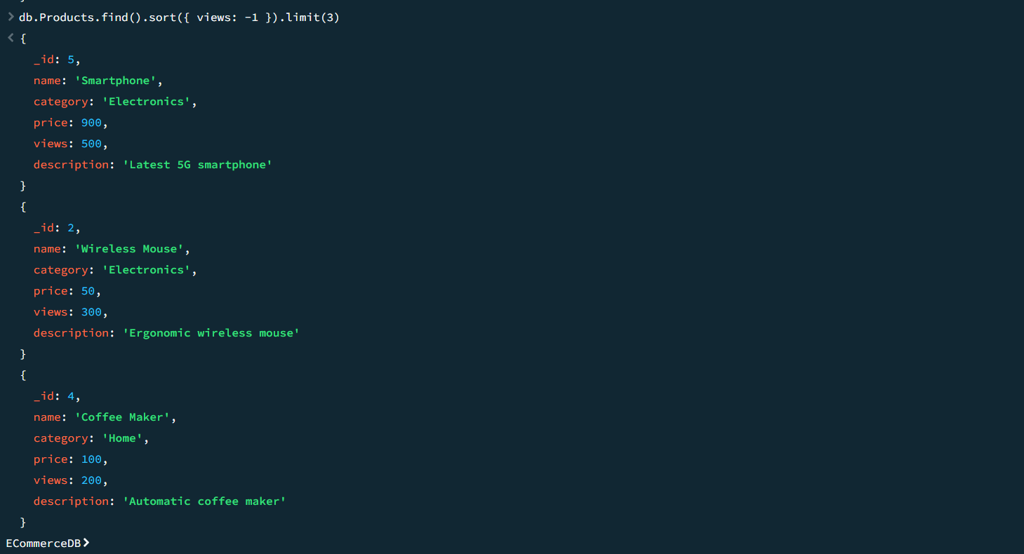
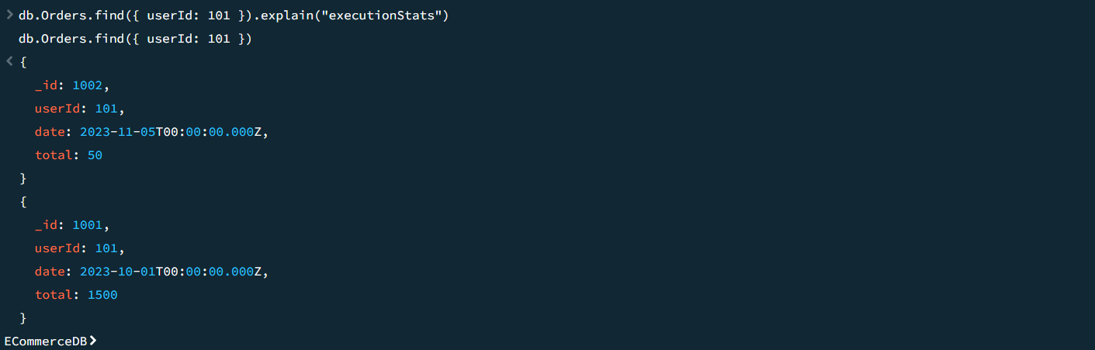
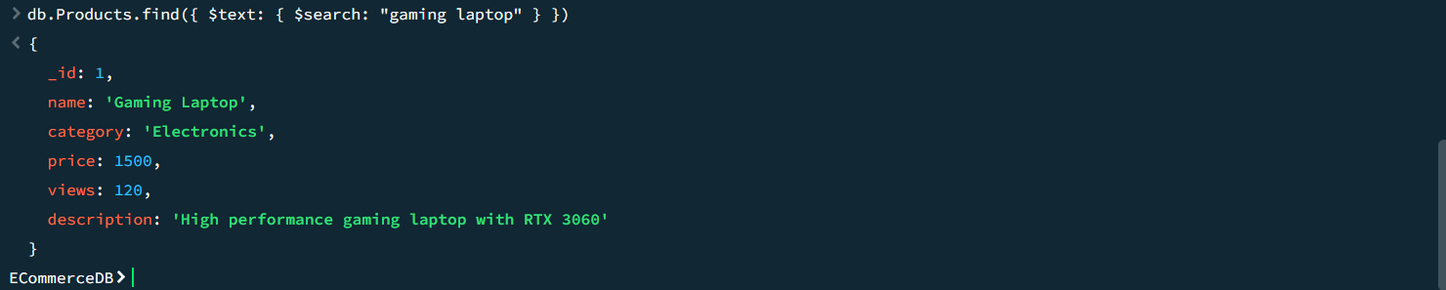
Feature | Firestore Real-time Sync | DynamoDB Streams
Target Audience | Frontend Client (Mobile/Web) | Backend Services / Lambda
Mechanism | Uses WebSockets / Long-polling. The client maintains an open connection to the server. | Uses a Log-based approach. Changes are written to a stream log (like Kafka/Kinesis) which triggers backend functions.
Data Flow | Server pushes update directly to the User's UI (e.g., chat message appears instantly). | Change triggers an event (e.g., Lambda function) to process data, update analytics, or send an email. It does not go directly to the UI.
Use Case | Chat apps, Live scoreboards, Uber driver maps. | Replicating data to other DBs, Triggering welcome emails on signup, Audit logging.

Why are they not the same? Firestore Sync is designed for the View Layer (instant visual updates for the user). DynamoDB Streams is designed for the Logic Layer (asynchronous backend processing).
uestion 5: MongoDB Sharding (Router & Config Server)
How Routing Works (The Flow)
- Application Request: The client application sends a query (e.g., find({student_id: 500})) to the Mongos Query Router. The app does not know which shard holds the data.
- Metadata Lookup: The Mongos router consults the Config Server. The Config Server holds the "Map" (Metadata) of the cluster.
  - Metadata Example: "IDs 1-1000 are on Shard A", "IDs 1001-2000 are on Shard B".
- Routing: The Config Server tells Mongos that student_id: 500 falls into the range for Shard A.
- Fetch & Return: Mongos forwards the query only to Shard A. Shard A returns the data to Mongos, which aggregates it (if needed) and returns it to the client.

