Spotify Songs
Analysis
Using Python & Power BI

Exploratory Data Analysis · Business Intelligence · Dashboard
Dataset: 32,833 Tracks · 11K+ Artists · 6 Genres
June 2026

Abstract

The music streaming industry generates vast amounts of user and content data daily. Analysing this data provides valuable insights into listener preferences, content performance, and genre trends. This project explores a Spotify songs dataset containing 32,833 tracks and performs comprehensive Exploratory Data Analysis (EDA) using Python. The study investigates genre distribution, artist representation, popularity trends, and relationships between audio features such as danceability, energy, acousticness, and valence. Interactive visualisations and a Power BI dashboard were developed to transform raw data into actionable business intelligence. The findings demonstrate how data analytics can directly support content optimisation, playlist curation, and recommendation systems within music streaming platforms.

Keywords
Spotify · Python · Power BI · EDA · Music Analytics · Danceability · Genre Analysis · Dashboard

32,833  Total Tracks | 11,000+  Unique Artists | 6  Genres Covered

Table of Contents

Abstract 2
1. Introduction 4
2. Project Objectives 4
3. Dataset Description 4
3.1 Key Variables 4
4. Methodology 5
4.1 Tools & Technologies 5
4.2 Data Preprocessing 5
5. Power BI Dashboard 6
5.1 KPI Summary 6
6. Exploratory Data Analysis 7
6.1 Genre Distribution 7
6.2 Top 10 Artists by Playlist Appearances 8
6.3 Track Popularity Distribution 9
6.4 Danceability vs Track Popularity 10
6.5 Energy Distribution by Genre 11
7. Results & Discussion 12
8. Business Recommendations 13
9. Skills Demonstrated 14
10. Conclusion 14
References 15

1. Introduction
Music streaming services such as Spotify have fundamentally transformed how audiences discover and consume music. With millions of songs available and thousands of new tracks added every day, understanding listener preferences has become a strategic imperative for platform operators, labels, and artists alike.
This report presents a comprehensive exploratory data analysis (EDA) of Spotify song data using Python and Power BI. Through structured data cleaning, statistical exploration, visualisation design, and dashboard development, the project transforms raw music metadata into meaningful business intelligence.
The report covers genre distribution, artist representation, popularity dynamics, audio-feature relationships, and concludes with a Power BI executive dashboard and actionable business recommendations.

2. Project Objectives
This project pursued seven primary objectives:
- Clean and prepare Spotify song data to ensure analytical reliability.
- Explore the distribution of songs across genres and identify dominant categories.
- Identify the artists with the highest playlist representation.
- Analyse the distribution and skewness of track popularity scores.
- Investigate relationships among audio characteristics (danceability, energy, acousticness, valence, etc.).
- Examine the relationship between danceability and track popularity.
- Develop an interactive Power BI dashboard for executive-level reporting.

3. Dataset Description
The dataset comprises 32,833 Spotify songs sourced from Kaggle. Each record includes track metadata, playlist attribution, and eleven continuous audio-feature scores derived from the Spotify Web API. After de-duplication, the working dataset contained 28,356 unique records.

3.1 Key Variables
Variable | Description | Type
track_name | Name of the song | String
track_artist | Artist name | String
playlist_genre | Music genre category | Categorical
track_popularity | Popularity score (0–100) | Numeric
danceability | Suitability for dancing (0–1) | Numeric
energy | Intensity and activity level (0–1) | Numeric
speechiness | Spoken-word content (0–1) | Numeric
acousticness | Acoustic quality (0–1) | Numeric
instrumentalness | Instrumental content (0–1) | Numeric
liveness | Audience presence (0–1) | Numeric
valence | Musical positivity (0–1) | Numeric

4. Methodology

4.1 Tools & Technologies
The project employed a modern, open-source analytics stack:
- Python (Pandas, NumPy) – data ingestion, cleaning, and manipulation.
- Matplotlib & Seaborn – statistical visualisation and chart generation.
- Power BI Desktop – interactive dashboard and KPI reporting.
- Jupyter Notebook – iterative development environment.

4.2 Data Preprocessing
Raw data quality was validated before any analysis. The preprocessing pipeline performed:
- Loaded the CSV and audited column types, value ranges, and completeness.
- Identified and counted missing values per column (df.isnull().sum()).
- Detected 4,477 duplicate records (df.duplicated().sum()) and removed them.
- Validated numerical ranges: popularity scores 0–100; audio features 0–1.
These steps ensured analytical integrity across all subsequent computations.

5. Power BI Dashboard
An interactive Power BI dashboard was built to surface key metrics and support ad-hoc exploration by non-technical stakeholders. It includes KPI cards, genre and popularity charts, and interactive genre/artist slicers.

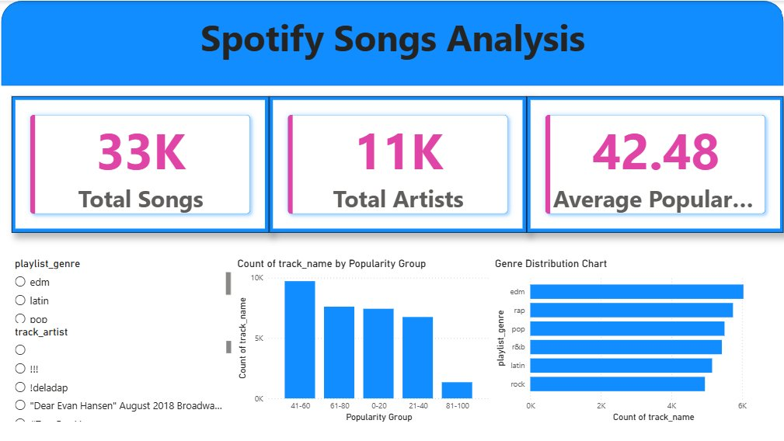
Figure 1 – Power BI Dashboard: KPI Cards, Popularity Distribution & Genre Chart

5.1 KPI Summary
33,000+  Total Songs Analysed | 11,000+  Unique Artists | 42.48  Average Popularity Score

The three headline KPIs confirm substantial scale: over 33,000 songs, 11,000 unique artists, and an average popularity score of 42.48 out of 100 — indicating that while the platform is vast, a majority of content sits in the mid-range popularity band rather than at viral extremes.

6. Exploratory Data Analysis

6.1 Genre Distribution
Genre analysis was conducted to understand how songs are distributed across the six major Spotify playlist categories. Track counts per genre were calculated and visualised as a horizontal bar chart.

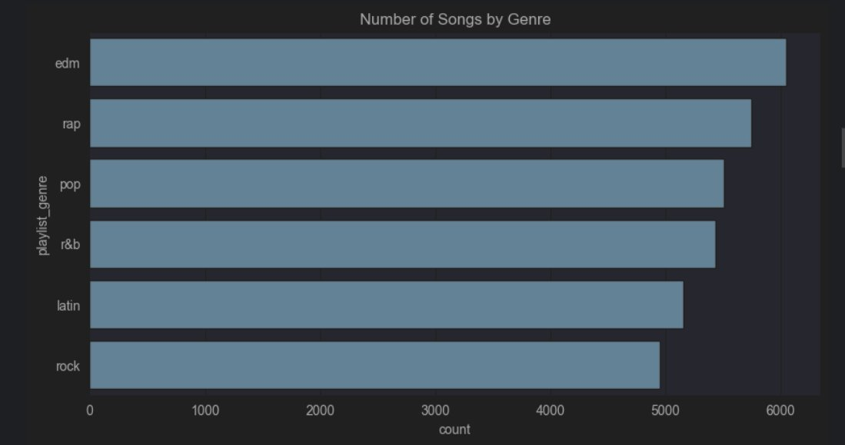
Figure 2 – Number of Songs by Genre

Key Findings
- EDM had the highest representation (~6,000 songs), suggesting it is the most heavily curated genre on the platform.
- Rap and Pop followed closely with approximately 5,500–5,800 songs each.
- R&B and Latin occupied the middle range, reflecting their growing global listener bases.
- Rock had the fewest songs (~4,900), indicating comparatively lighter playlist inclusion in this dataset.
- Genre counts are relatively balanced overall, spanning a range of only ~1,100 songs from lowest to highest.

6.2 Top 10 Artists by Playlist Appearances
Artist frequency analysis identified which performers appear most prominently across Spotify playlists. The top 10 artists by song count were extracted and plotted as a vertical bar chart.

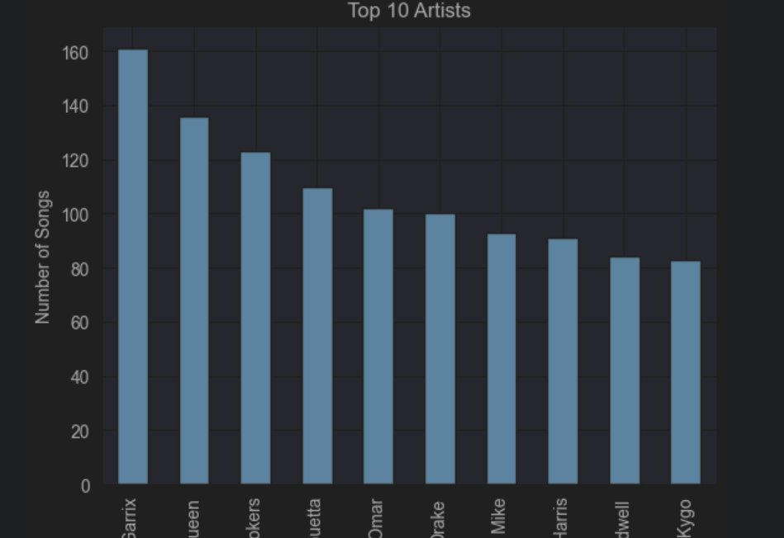
Figure 3 – Top 10 Artists by Number of Songs in Dataset

Key Findings
- Martin Garrix leads the ranking with ~160 playlist appearances, underlining his dominance in the EDM genre.
- Queen ranks second (~135), demonstrating sustained catalogue longevity across decades.
- The Chainsmokers and Julieta Venegas round out the top four with roughly 110–123 appearances each.
- Despite 11,000+ unique artists in the dataset, playlist placement is heavily concentrated among a small elite cohort.
- The gap between first (160) and tenth (~83) illustrates a classic long-tail distribution pattern.

6.3 Track Popularity Distribution
Popularity scores (0–100) were analysed to understand the overall performance landscape. A histogram with 30 bins was generated to reveal the frequency distribution across the full score range.

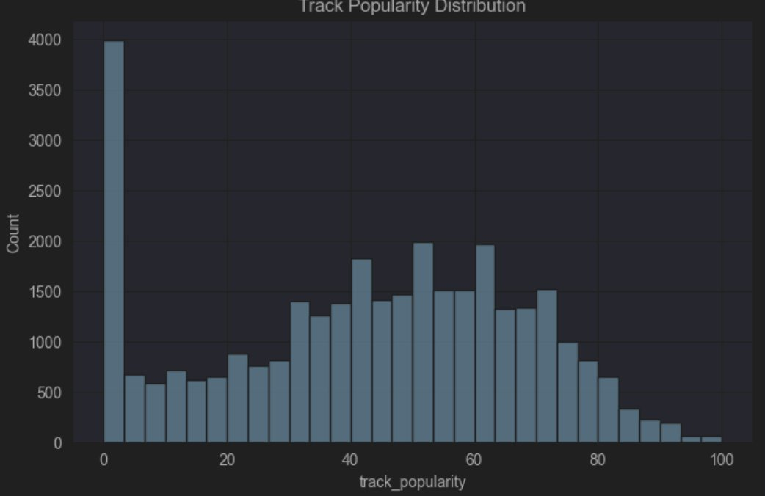
Figure 4 – Track Popularity Distribution Histogram

Key Findings
- A pronounced spike at score 0 (~4,000 tracks) represents tracks with no listener engagement or recently added content.
- Excluding the zero-score cluster, popularity follows a roughly normal distribution centred around 45–65.
- Peak frequency occurs in the 55–65 band, confirming that mid-tier content forms the backbone of the platform.
- Extremely high-popularity tracks (85–100) are rare, confirming that viral hits represent a small minority.
- The right tail drops steeply above 80, indicating only a handful of blockbuster tracks achieve top-tier scores.

6.4 Danceability vs Track Popularity
A scatter plot was constructed to examine whether audio danceability (0–1 scale) has a meaningful relationship with the popularity of a track. Each data point represents one song in the dataset.

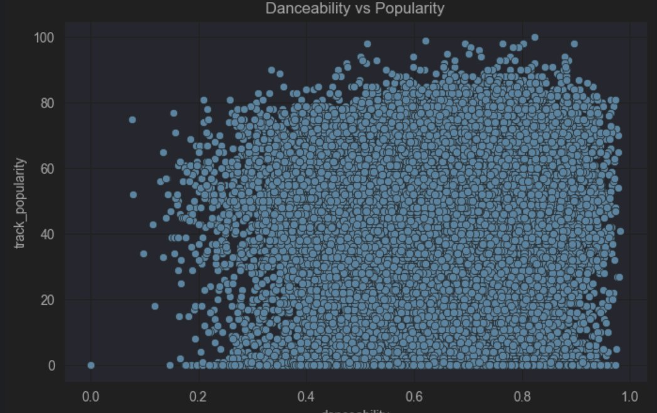
Figure 5 – Danceability vs Track Popularity Scatter Plot

Key Findings
- At very low danceability (<0.2), data is sparse and popularity scores vary widely, suggesting niche or specialised content.
- From danceability ≥ 0.3 onwards, data density increases and high-popularity tracks (>80) become far more common.
- The upper boundary of attainable popularity rises with danceability, indicating a positive association.
- Moderate to high danceability (0.5–0.9) produces the densest cluster, concentrated in the 40–80 popularity range.
- The scatter remains wide throughout, confirming danceability is a contributing factor but not the sole determinant of popularity.

6.5 Energy Distribution by Genre
Box plots were produced to compare the distribution of energy scores across all six genres. Energy measures the intensity and activity level of a track on a 0–1 scale.

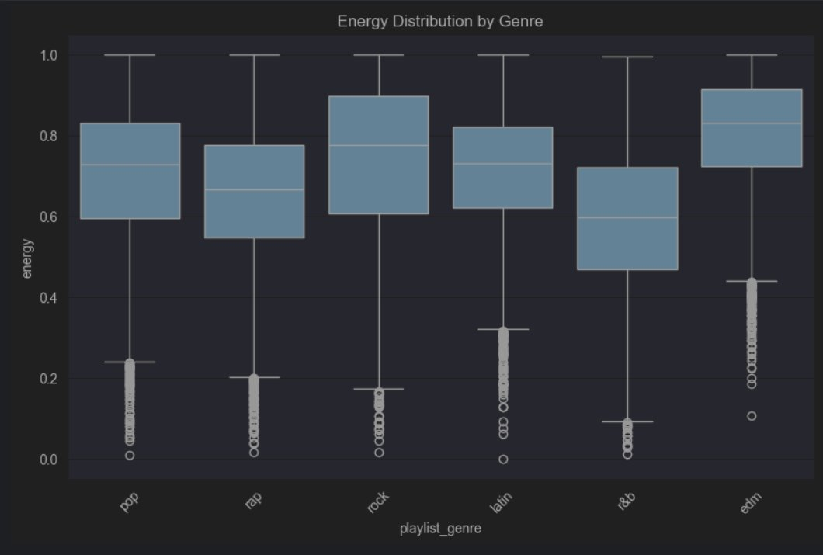
Figure 6 – Energy Distribution by Genre (Box Plot)

Key Findings
- EDM exhibits the highest median energy (~0.82) with a narrow IQR, reflecting its consistently driving, high-intensity sound.
- Rock shows a high median (~0.77) but the widest interquartile range, accommodating everything from hard rock to ballads.
- Pop and Latin sit in a mid-high energy band (~0.72–0.73 median), confirming their upbeat, radio-friendly characteristics.
- Rap's median energy (~0.67) is lower than expected, reflecting the genre's greater dynamic range.
- R&B has the lowest median (~0.59) and a wide spread, consistent with its melodic and slower-tempo sub-genres.
- All genres exhibit outlier tracks at extremely low energy (<0.1), representing acoustic or ambient entries.

7. Results & Discussion
Taken together, the analyses reveal a coherent picture of how genre, artist concentration, audio characteristics, and popularity interact on the Spotify platform.

Genre Landscape
EDM's dominance in raw song count does not necessarily translate into the highest average popularity. This suggests that sheer volume of content and listener engagement are distinct dynamics deserving separate strategic consideration.

Artist Concentration
Despite over 11,000 unique artists in the dataset, playlist placement is disproportionately concentrated among a small elite. This long-tail pattern has significant implications for emerging artist discoverability and algorithmic promotion strategies.

Popularity Dynamics
The large cluster of zero-popularity tracks warrants deeper investigation — these may represent tracks that have not yet accumulated streams or have been recently added. Separating this cluster before modelling would improve predictive accuracy significantly.

Audio Feature Relationships
Higher danceability is associated with a greater likelihood of achieving high popularity. Similarly, EDM's consistently high energy profile correlates with its strong playlist representation, reinforcing the value of energetic audio characteristics for playlist curators and recommendation engines.

8. Business Recommendations
Based on the analytical findings, four strategic recommendations are proposed for Spotify's content and product teams:

Content Curation | Prioritise tracks with danceability > 0.6 and energy > 0.7 when building algorithmically curated playlists, as these characteristics correlate with higher listener engagement.
Recommendation Engine | Incorporate audio-feature vectors (danceability, energy, valence) into collaborative filtering models to improve personalised recommendation accuracy beyond genre and artist signals alone.
Emerging Artists | Develop targeted promotion programmes for under-represented artists in high-performing genres (EDM, Pop) who exhibit strong audio-feature profiles but have not yet achieved significant playlist placement.
Playlist Strategy | Build genre-specific editorial playlists targeting the optimal energy and danceability ranges identified for each genre to maximise average stream counts per playlist session.

9. Skills Demonstrated
This project showcased a broad range of technical and professional competencies:

Data Analytics | Data cleaning, exploratory data analysis, descriptive statistics, and pattern identification across 32,000+ records.
Python | Pandas data wrangling, NumPy computations, and Matplotlib/Seaborn visualisation pipelines.
Power BI | KPI card design, bar chart and histogram construction, interactive slicer configuration, and dashboard layout.
Data Storytelling | Translating statistical outputs into business narratives with clear, actionable conclusions for non-technical audiences.
Problem Solving | Designing a multi-step analytical workflow from raw CSV to polished executive dashboard.

10. Conclusion
This project successfully analysed 32,833 Spotify songs using Python (Pandas, Seaborn, Matplotlib) and Power BI, uncovering actionable insights across genre distribution, artist representation, popularity dynamics, and audio-feature relationships.
The analysis confirms that danceability and energy are meaningfully associated with listener engagement, that playlist representation is concentrated among a small artist elite, and that EDM dominates the dataset in both song volume and energy levels.
The accompanying Power BI dashboard translates these statistical findings into an accessible, interactive format suitable for non-technical stakeholders, supporting data-driven decision-making in content strategy, recommendation systems, and artist promotion.

"Data analytics transforms raw streaming numbers into the strategic intelligence that powers the next generation of music discovery."

References
- McKinney, W. (2022). Python for Data Analysis (3rd ed.). O'Reilly Media.
- Hunter, J. D. (2007). Matplotlib: A 2D graphics environment. Computing in Science & Engineering, 9(3), 90–95.
- Waskom, M. (2021). Seaborn: Statistical data visualisation. Journal of Open Source Software, 6(60), 3021.
- Microsoft Corporation. (2024). Power BI Documentation. https://docs.microsoft.com/en-us/power-bi/
- Pandas Development Team. (2024). pandas: Powerful Python Data Analysis Toolkit. https://pandas.pydata.org/docs/
- NumPy Developers. (2024). NumPy Documentation. https://numpy.org/doc/
- Spotify Tracks Dataset. (2023). Kaggle. https://www.kaggle.com/datasets/maharshipandya/-spotify-tracks-dataset

