EndStops
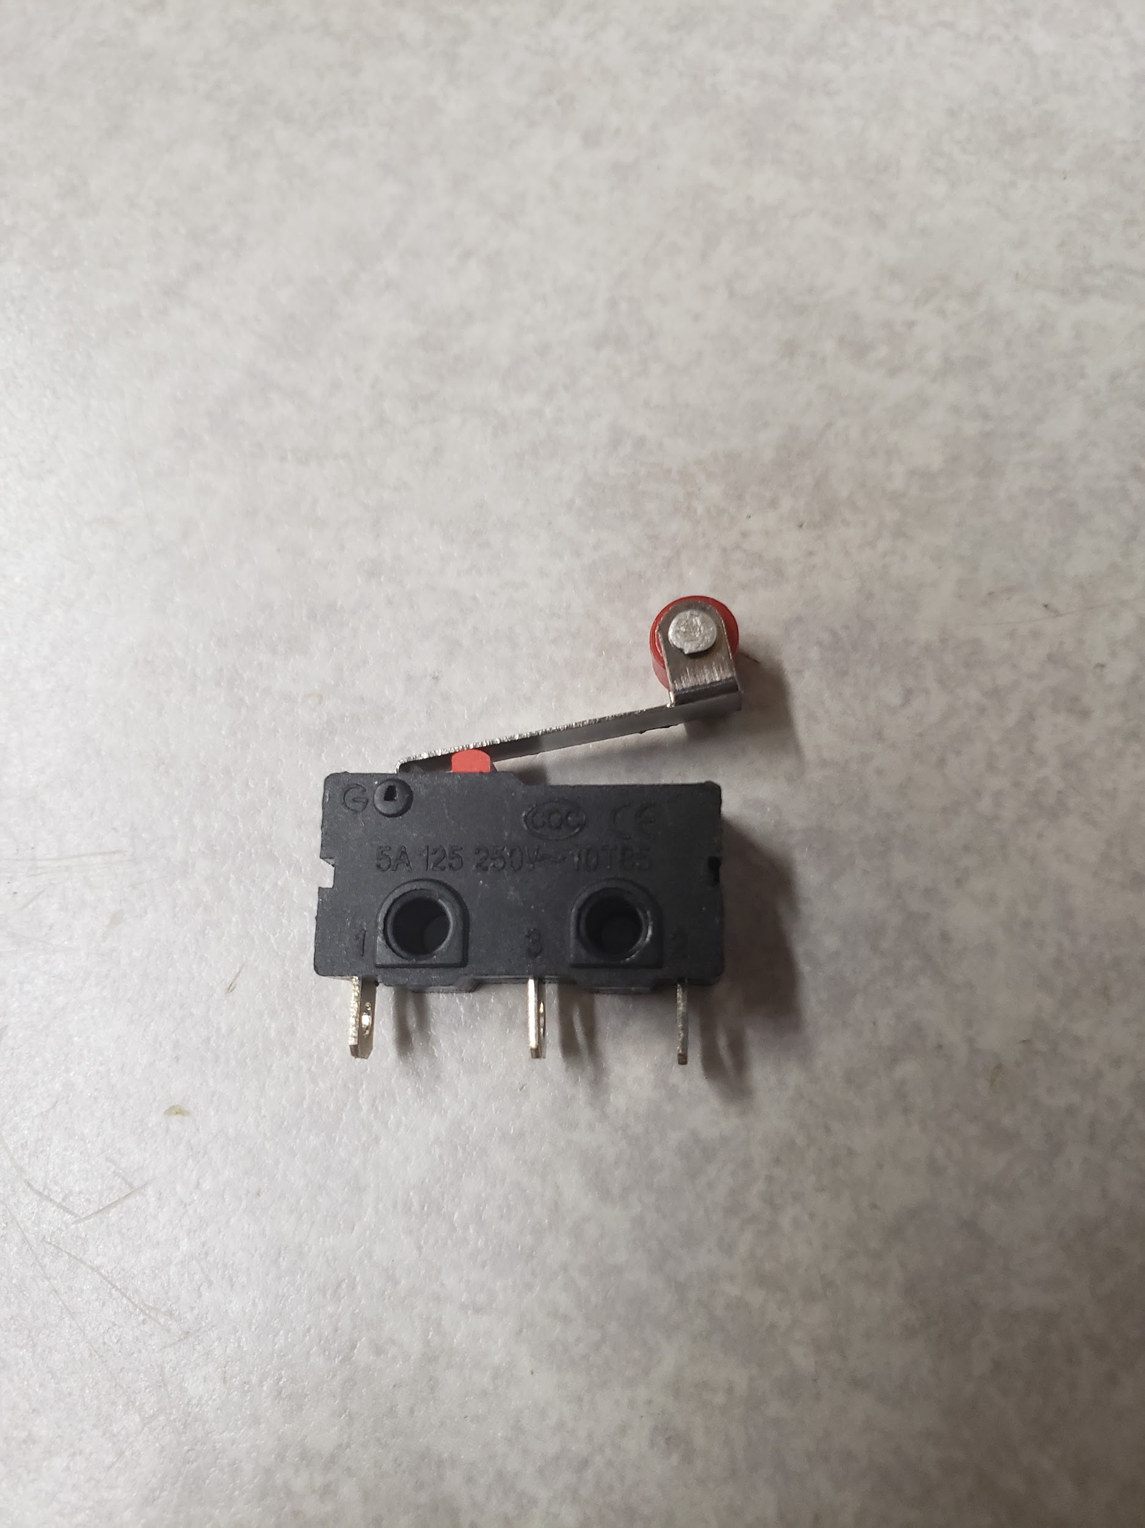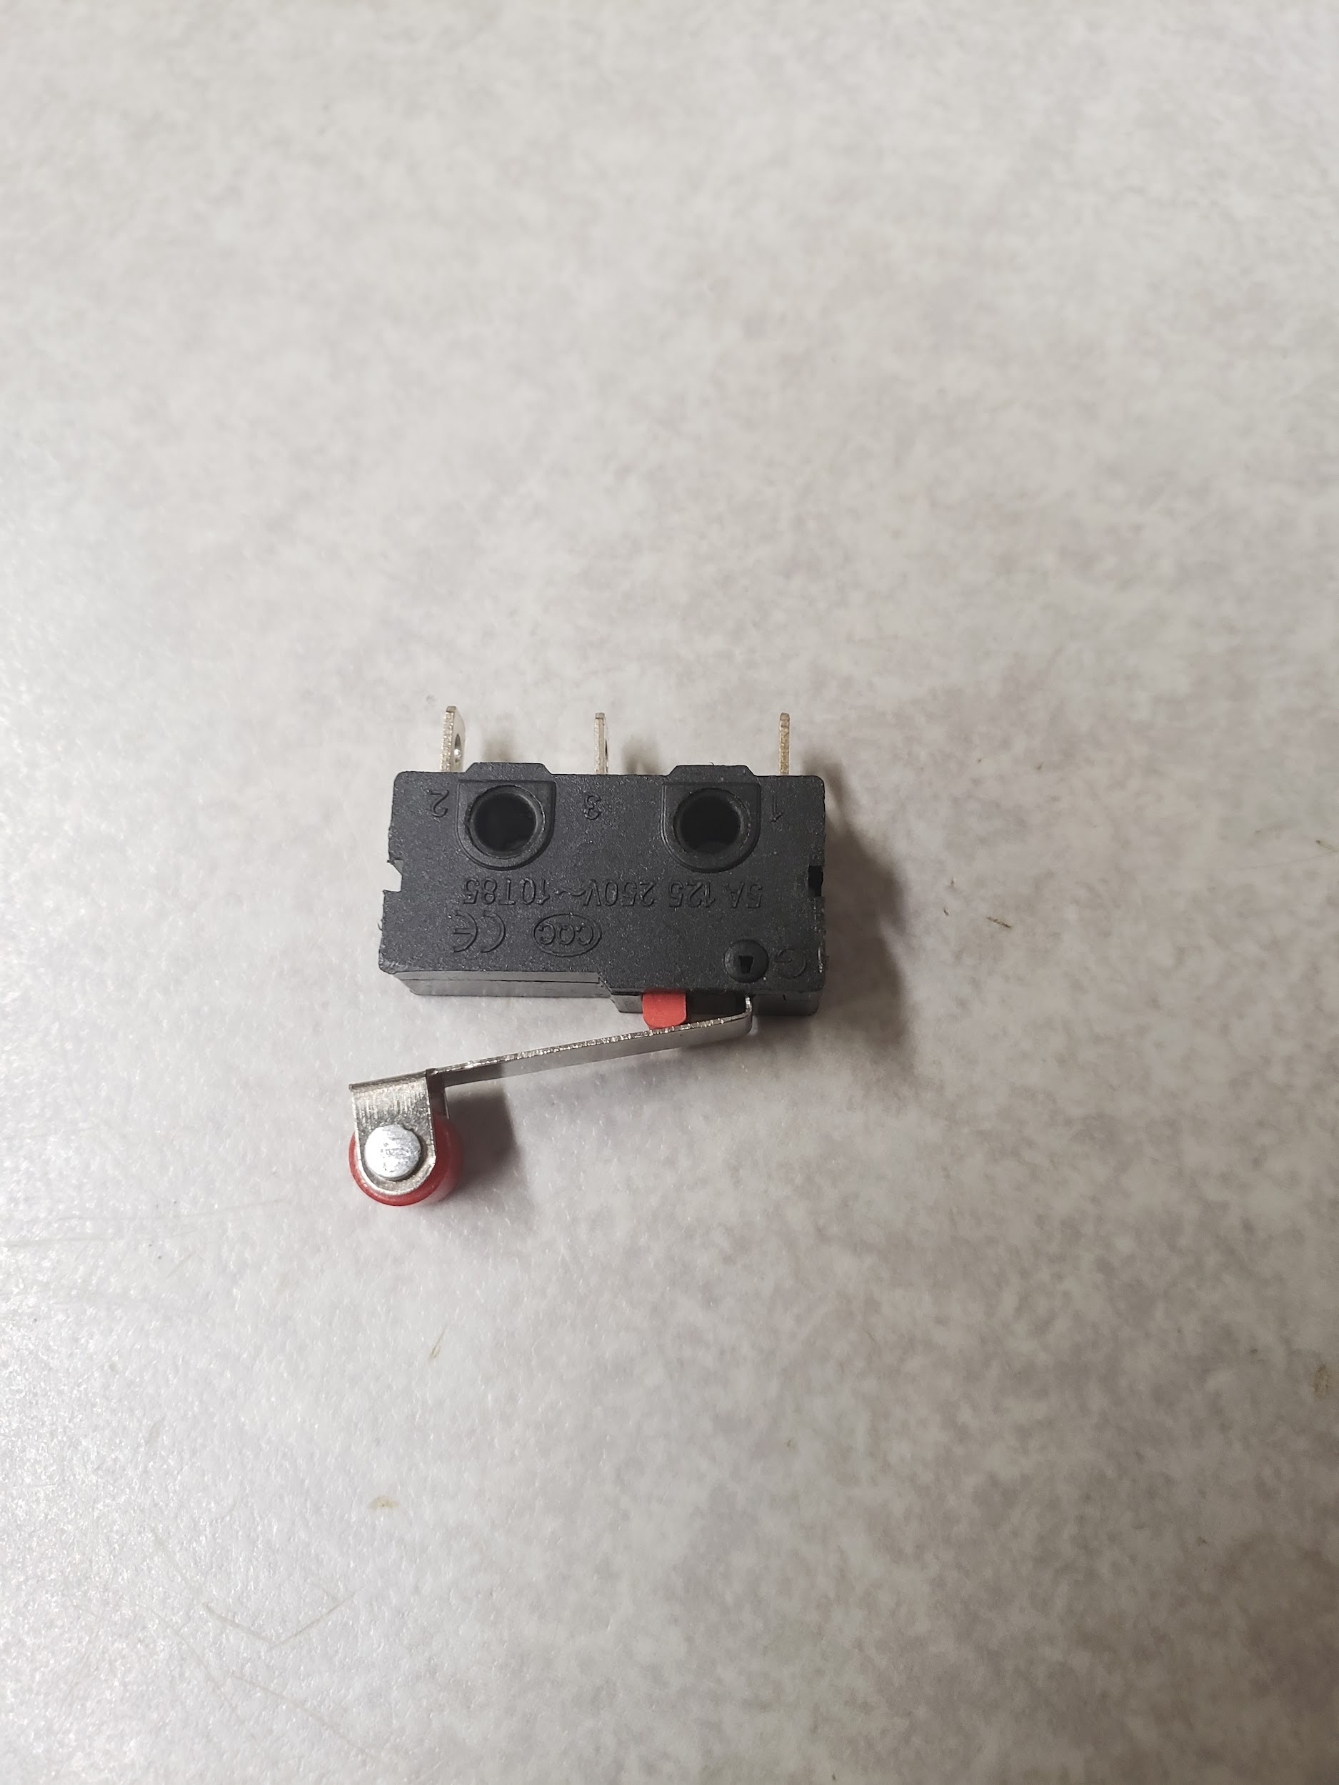

Hinge Roller Lever Micro Switches
- 3 Pins
- 250v
- 5a

Related Content

WorkHorse 3D Printer

Duet3D

Electronics

Stepper Motor Holding Torque

Electronics

Duet 3

Duet 3 Wiring Guide

Duet Wifi

RepRap Firmware

Docs

Stepper Motors

How To Calculate Stepper Motor RPM?

Stepper Motor Holding Torque

Unipolar vs Bipolar Stepper Motors

EndStops

0.9 vs 1.8 degrees Stepper Motors

WorkHorse-3D Printer Wiring

WorkHorse-3D Printer Wiring

Set Macro Explained

Dual X-Axis / Dual Z

Contact Details:

3D Distributed

12601 Bowles Rd.

Conroe, TX 77304

Phone: (936) 689-3522

GoogleSite: https://sites.google.com/view/3d-distributed/

Google Folder: https://drive.google.com/drive/folders/1Z_93K5Q_JtBvKC2-QC_a9ZEusXI1YnX6?usp=sharing Duet 3 Endstop Wiring

endstop

endstops

3d printer endstop

3d printer endstop wiring

3d printer limit switch

3d printer optical endstop

endstop switch

mechanical endstop

optical endstop wiring

inductive endstop 3d printer

3d printer limit switch wiring

endstop not working

endstop configuration

3d printer endstop types

types of endstops

endstop test

3d printer endstop test

endstop bracket

endstop mount

3d printer endstop bracket

endstop holder

endstop holders

3d printed endstop

3d printer without endstops

Reprap endstop configuration

reprap endstop config

endstop config

What is an Endstop in a 3D printer?

What is an Endstop?

How does an Endstop work?

Where should the Z Endstop be?

How does an optical limit switch work?

What is a BL touch?

What should the Z offset be?

What is the difference between a micro switch and limit switch?

Which is better: CR-Touch or BLTouch?

How accurate is BLTouch?

Is Z offset positive or negative?

How do you calibrate the Z offset?

Is a limit switch analog or digital?

How do you wire a limit switch?

How much can BLTouch compensate?

Are limit switches normally open?

What is NC and no limit switch?

What is no NC switch?

What is G29 G code?

What are the 4 types of switches?

What are the two main types of limit switches?

Types of limit switches

Whisker

Roller

Lever

Plunger

Types of endstops

Does the limit switch have polarity?

What is the difference between NO and NC?

What are the 3 types of switches?

Types of Switches

types of mechanical switches

How do I choose a limit switch?

How do you know if a switch is NO or NC?

What color is the earth wire?

Plug wiring colours

Are limit switches normally open?

What is the difference between NO and NC?

Reprap endstop configuration

How does an Endstop work?

What does RepRap stand for?

replicating rapid prototyper

The RepRap project

When was RepRap invented?

reprap endstop config

NC

NO

What is a limit switch for a 3D printer?

How do you test end stops?

What is a limit switch?

How do I choose a limit switch?

Marlin endstop configuration

Reprap endstop configuration

What is a mechanical Endstop?

What is end stop electronics?

3D printer limit switch wiring

