WorkHorse X-Carriage

X-Carriage Assembly

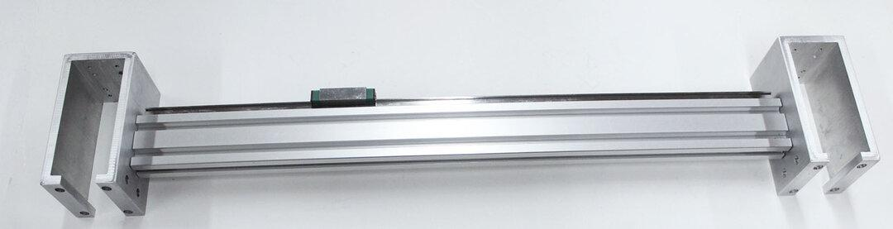

X-Carriage Dimensions
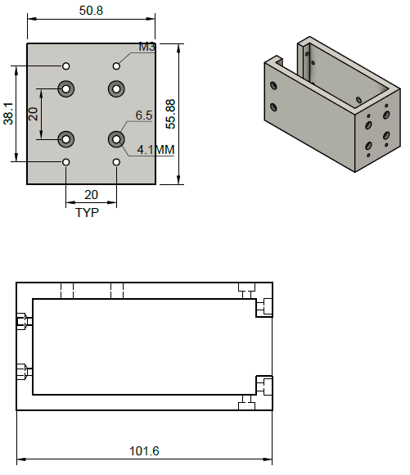

X-Carriage Assembly CAD
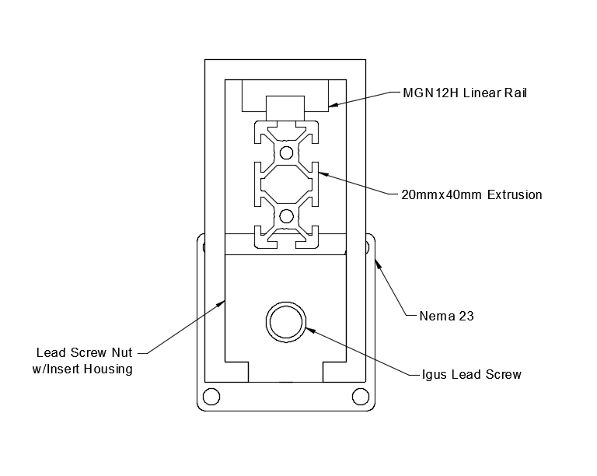

X-Carriage Screws BOM

M3x8mm Long | Mounts to Carriage | 12pcs
M3x6mm Long | Carriage to Linear Rail | 12pcs
M3x35mm Long | C-Carriage Insert | 8pcs
M5x20mm Long | C-Carriage to Extrusion | 6pcs

Related Content
WorkHorse BOM
Igus Lead Screw
Linear Rails
WorkHorse Frame
WorkHorse Motors
WorkHorse Printer: Users Guide
Duet Wifi Setup
Duet 2 vs Duet 3
WorkHorse 3D Printer
Recommended Print Settings
3D Distributed

Firmware Files
config.g
Homeall.g
homex.g
Homey.g
Homez.g

Duet 3 Mainboard Setup
Duet3D YAT Commands
Reverse Motor Direction

Duet Wifi
Duet Wifi Setup

