**Call Oracle 10g Report Form Oracle Apex Application..**

Purpose : I would like to show an 10g oracle report using Oracle Application Express.  
  
Action :  
1. Create a table for contain Report URL Information.  
2. Create a procedure for return Return Report URL.  
3. Create an Oracle Apex Form With 3 Item (Named P12_FROM_DATE, P12_TO_DATE, P12_URL).  
4. Create an process Before Header (Name url_assigne)  
5. Create an Branch After Processing (Name SHOW_REPORT)  
6. Create an Button (SHOW)  
  
  
1. Create a table for contain Report URL Information.  
=========================================================   
CREATE TABLE SY_REPORT_CONFIGURATION  
(REPORT_SERVER VARCHAR2(30),  
 MODULE_NAME    VARCHAR2(30),  
 REPORT_EXTENSTION VARCHAR2(10),  
 REPORT_FORMAT      VARCHAR2(10),  
 REPORT_KEY_NAME    VARCHAR2(30),  
 REPORT_FILE_PATH   VARCHAR2(200),  
 REPORT_URL             VARCHAR2(300)  
)  
  
SET DEFINE OFF;  
Insert into IMS.SY_REPORT_CONFIGURATION  
   (REPORT_SERVER, MODULE_NAME, REPORT_EXTENSTION, REPORT_FORMAT, REPORT_KEY_NAME, REPORT_FILE_PATH, REPORT_URL)  
 Values  
   ('IMS', 'IMS', 'RDF', 'PDF', 'IMS',   
    'G:\', 'http://10.11.201.200:7778/reports/rwservlet?');  
COMMIT;  
  
  
2. Create a procedure for return Return Report URL.  
==========================================================   
  
CREATE OR REPLACE PROCEDURE DPR_REPORT_RUN  
(P_MODULE_NAME IN VARCHAR2,  
 P_REPORT_FILE_NAME VARCHAR2,  
 P_OUTPUE    OUT VARCHAR2)  
IS  
V_DATA1 VARCHAR2(300);  
V_REPORT_SERVER  VARCHAR2(300);  
V_MODULE_NAME    VARCHAR2(30);  
V_REPORT_EXTENSTION  VARCHAR2(300);  
V_REPORT_FORMAT  VARCHAR2(300);  
V_REPORT_KEY_NAME  VARCHAR2(300);  
V_REPORT_FILE_PATH  VARCHAR2(300);  
V_REPORT_URL  VARCHAR2(300);  
BEGIN  
  
SELECT LOWER(REPORT_SERVER), LOWER(MODULE_NAME), LOWER(REPORT_EXTENSTION), LOWER(REPORT_FORMAT), LOWER(REPORT_KEY_NAME), LOWER(REPORT_FILE_PATH), LOWER(REPORT_URL)  
INTO V_REPORT_SERVER,V_MODULE_NAME , V_REPORT_EXTENSTION, V_REPORT_FORMAT, V_REPORT_KEY_NAME, V_REPORT_FILE_PATH, V_REPORT_URL  
FROM SY_REPORT_CONFIGURATION  
WHERE LOWER(MODULE_NAME)=LOWER(P_MODULE_NAME);  
  
V_DATA1 := V_REPORT_URL||V_REPORT_KEY_NAME||'&desformat=pdf&destype=cache&paramform=NO&report='||V_REPORT_FILE_PATH||P_REPORT_FILE_NAME;  
  
  
EXCEPTION  
       WHEN NO_DATA_FOUND THEN  
                V_DATA1:='URL NOT FOUND '||LOWER(P_MODULE_NAME);  
       WHEN TOO_MANY_ROWS THEN  
                V_DATA1:='TOO MANY URL FOUND '||LOWER(P_MODULE_NAME);  
P_OUTPUE :=V_DATA1;  
  
END;  
/  
  
4. Create an process Before Header (Name url_assigne)  
==================================================  
 Process Code  
  
BEGIN  
DPR_REPORT_RUN  
(P_MODULE_NAME         =>'IMS',  
 P_REPORT_FILE_NAME =>'COMPAY_INFO',  
 P_OUTPUE                        =>:P12_URL);  
END;

[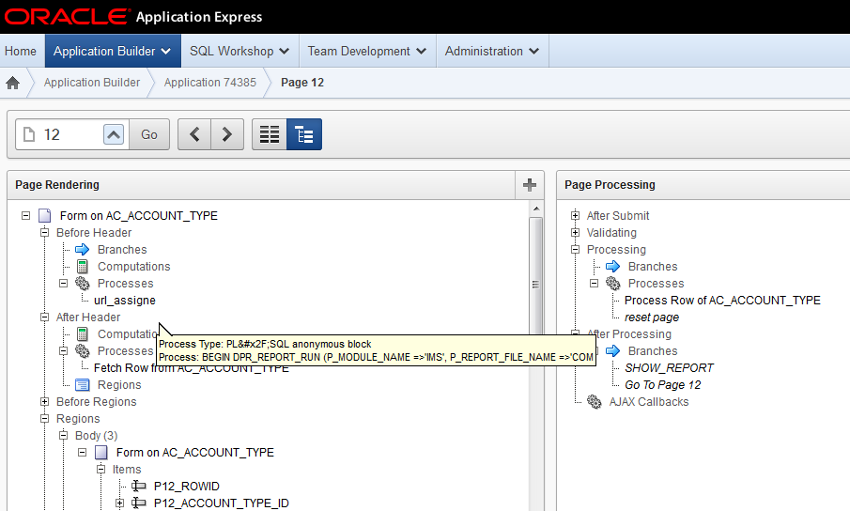](http://4.bp.blogspot.com/-g7A7Kb3Ydd4/U2nEcSH5BAI/AAAAAAAAAKA/IhKp1b17Yzo/s1600/aa.png)

5. Create an Branch After Processing (Name SHOW_REPORT)  
==================================================  
Target Type : URL  
  
URL Target: &P12_URL.&P_FROM_DATE=&P12_FROM_DATE.&P_TO_DATE=&P12_TO_DATE.

[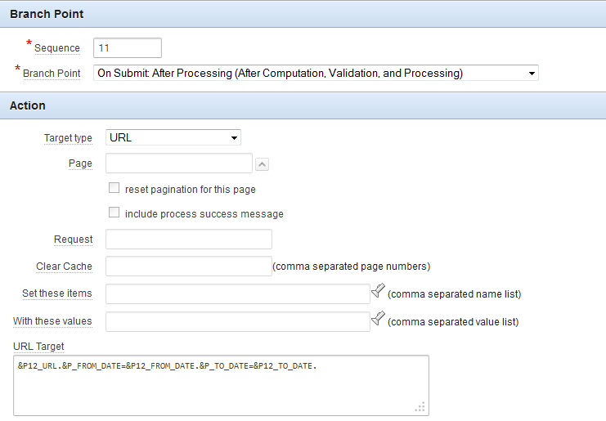](http://2.bp.blogspot.com/-b-gsOkI1ZtI/U2nE4CUQRoI/AAAAAAAAAKI/IRRwWVHmP4Y/s1600/aaa.png)

6. Create an Button (SHOW)  
  
Change Button Action : Submit Page

[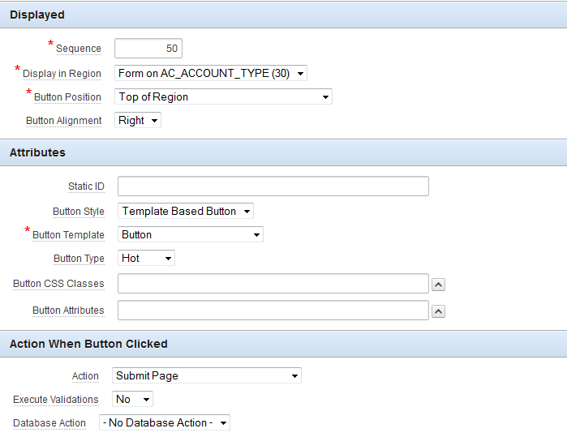](http://3.bp.blogspot.com/-vOV0yVU1jPE/U2nFMdE4FyI/AAAAAAAAAKQ/v6lojO2OYXc/s1600/aaaa.png)

Now Click Show button and see your report ........

[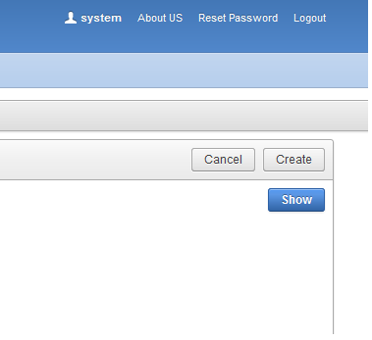](http://2.bp.blogspot.com/-Am2oUGDXeBU/U2nFmwYKWoI/AAAAAAAAAKY/9QLrrETpvnI/s1600/aaaaa.png)

Posted by [Rajib Pradhan](https://plus.google.com/116768868541830687890" \o "author profile)at [10:45 PM](http://rajiboracle.blogspot.com/2014/01/call-oracle-10g-report-form-oracle-apex.html) [[https://resources.blogblog.com/img/icon18_email.gif](https://www.blogger.com/email-post.g?blogID=2737456520417739265&postID=6149875805028422137)](https://www.blogger.com/email-post.g?blogID=2737456520417739265&postID=6149875805028422137)

[Email This](https://www.blogger.com/share-post.g?blogID=2737456520417739265&postID=6149875805028422137&target=email)[BlogThis!](https://www.blogger.com/share-post.g?blogID=2737456520417739265&postID=6149875805028422137&target=blog)[Share to Twitter](https://www.blogger.com/share-post.g?blogID=2737456520417739265&postID=6149875805028422137&target=twitter)[Share to Facebook](https://www.blogger.com/share-post.g?blogID=2737456520417739265&postID=6149875805028422137&target=facebook)[Share to Pinterest](https://www.blogger.com/share-post.g?blogID=2737456520417739265&postID=6149875805028422137&target=pinterest)

Labels: [Others](http://rajiboracle.blogspot.com/search/label/Others), [SQL](http://rajiboracle.blogspot.com/search/label/SQL)

**15 comments:**

1. http://lh3.googleusercontent.com/zFdxGE77vvD2w5xHy6jkVuElKv-U9_9qLkRYK8OnbDeJPtjSZ82UPq5w6hJ-SA=s35

[**mfitinfo.blogger.com**](https://www.blogger.com/profile/10466173379444476501)[August 8, 2015 at 4:42 AM](http://rajiboracle.blogspot.com/2014/01/call-oracle-10g-report-form-oracle-apex.html?showComment=1439034134859#c3478984397666292759)

video tutorial করে youtube a দিলে ভালো হতো। কোন rdf report run হবে এটা set করবো কিভাবে?

[Reply](javascript:;)

1. http://lh5.googleusercontent.com/-pw85kSzrqG0/AAAAAAAAAAI/AAAAAAAAAEE/IqpIk_Rxtd8/s35-c/photo.jpg

[**Rajib Pradhan**](https://www.blogger.com/profile/17015005305661925354)[August 8, 2015 at 9:52 AM](http://rajiboracle.blogspot.com/2014/01/call-oracle-10g-report-form-oracle-apex.html?showComment=1439052768467#c2733653262681557154)

Ok. I will prepare an video tutorial for this article.

[Reply](javascript:;)

[Replies](javascript:;)

* 1. http://lh3.googleusercontent.com/zFdxGE77vvD2w5xHy6jkVuElKv-U9_9qLkRYK8OnbDeJPtjSZ82UPq5w6hJ-SA=s35

[**mfitinfo.blogger.com**](https://www.blogger.com/profile/10466173379444476501)[August 30, 2015 at 11:38 PM](http://rajiboracle.blogspot.com/2014/01/call-oracle-10g-report-form-oracle-apex.html?showComment=1441003097179#c3570140370397455723)

WHAT IS REPORT_KEY_NAME

* 1. http://lh4.googleusercontent.com/-_jO1OrpuBgo/AAAAAAAAAAI/AAAAAAAAAW0/9Youfj28Pk8/s35-c/photo.jpg

[**Firoz Mahmud**](https://www.blogger.com/profile/05456155009972727234)[March 13, 2016 at 3:12 AM](http://rajiboracle.blogspot.com/2014/01/call-oracle-10g-report-form-oracle-apex.html?showComment=1457863936408#c1018930111353703240)

Can i get video tuto form youtube?

[**Reply**](javascript:;)

1. http://img1.blogblog.com/img/blank.gif

**Anonymous**[August 23, 2015 at 1:01 AM](http://rajiboracle.blogspot.com/2014/01/call-oracle-10g-report-form-oracle-apex.html?showComment=1440316894847#c2259909188822732979)

nice post, thanx for sharring.

[Reply](javascript:;)

1. http://lh4.googleusercontent.com/-RgFJFeciKyY/AAAAAAAAAAI/AAAAAAAAAEE/tZ-BVGoIqq4/s35-c/photo.jpg

[**Md. Alomgir Hosain Shekh**](https://www.blogger.com/profile/05346982397060142304)[March 28, 2016 at 6:00 AM](http://rajiboracle.blogspot.com/2014/01/call-oracle-10g-report-form-oracle-apex.html?showComment=1459170006850#c840224685699546957)

nice post, thanx for blog

[Reply](javascript:;)

1. http://lh3.googleusercontent.com/-TgXUUr89LJ8/AAAAAAAAAAI/AAAAAAAACXg/MdZbusiAw9Y/s35-c/photo.jpg

[**Aminul Islam**](https://www.blogger.com/profile/16874728159005111428)[November 20, 2016 at 2:46 AM](http://rajiboracle.blogspot.com/2014/01/call-oracle-10g-report-form-oracle-apex.html?showComment=1479638775777#c7875420982158144239)

How to run 10g Form in apex 5.0.3 without convert XML. Please give me a suggestion. also give us a video tutorial

[Reply](javascript:;)

1. http://lh3.googleusercontent.com/zFdxGE77vvD2w5xHy6jkVuElKv-U9_9qLkRYK8OnbDeJPtjSZ82UPq5w6hJ-SA=s35

[**Unknown**](https://www.blogger.com/profile/09978920284242015521)[March 26, 2017 at 9:00 AM](http://rajiboracle.blogspot.com/2014/01/call-oracle-10g-report-form-oracle-apex.html?showComment=1490544037678#c9086873966836341130)

Where The Step Number 3

[Reply](javascript:;)

[Replies](javascript:;)

* 1. http://lh5.googleusercontent.com/-pw85kSzrqG0/AAAAAAAAAAI/AAAAAAAAAEE/IqpIk_Rxtd8/s35-c/photo.jpg

[**Rajib Pradhan**](https://www.blogger.com/profile/17015005305661925354)[March 26, 2017 at 10:48 AM](http://rajiboracle.blogspot.com/2014/01/call-oracle-10g-report-form-oracle-apex.html?showComment=1490550501366#c2486260476568371805)

In this steps you have to Create an Oracle Apex Form With 3 Item (Named P12_FROM_DATE, P12_TO_DATE, P12_URL).

[**Reply**](javascript:;)

1. http://lh6.googleusercontent.com/-V3YPpEkVAPU/AAAAAAAAAAI/AAAAAAAAAK4/Kng3xhXC9wQ/s35-c/photo.jpg

[**DJzz Khawer**](https://www.blogger.com/profile/17411590197624664683)[March 26, 2017 at 2:54 PM](http://rajiboracle.blogspot.com/2014/01/call-oracle-10g-report-form-oracle-apex.html?showComment=1490565277295#c2593508121238837103)

for opening report in new tab.  
javascript:var x=window.open('&P201_URL.&P_FROM_DATE=&P201_FROM_DATE.&P_TO_DATE=&P201_TO_DATE.','_blank');

[Reply](javascript:;)

[Replies](javascript:;)

* 1. http://lh6.googleusercontent.com/-WWA1QREjA6U/AAAAAAAAAAI/AAAAAAAAC7I/2TezPo7_eC4/s35-c/photo.jpg

[**Marzan Al Koes**](https://www.blogger.com/profile/10246170971518968763)[May 20, 2017 at 4:52 AM](http://rajiboracle.blogspot.com/2014/01/call-oracle-10g-report-form-oracle-apex.html?showComment=1495281139590#c3247851918795697848)

javascript:var x=window.open('http://10.10.10.25:9002/reports/rwservlet?keemp+report=Company-wise_11G.jsp+desformat=pdf+destype=cache+paramform=no'&eid=&p2_emr_ref.','_blank') please help me.. parameter not passed

[**Reply**](javascript:;)

1. http://lh6.googleusercontent.com/-V3YPpEkVAPU/AAAAAAAAAAI/AAAAAAAAAK4/Kng3xhXC9wQ/s35-c/photo.jpg

[**DJzz Khawer**](https://www.blogger.com/profile/17411590197624664683)[March 26, 2017 at 2:55 PM](http://rajiboracle.blogspot.com/2014/01/call-oracle-10g-report-form-oracle-apex.html?showComment=1490565358851#c6181962447708847395)

Thanks for the post Rajib, it is really helpful.

[Reply](javascript:;)

1. http://lh6.googleusercontent.com/-V3YPpEkVAPU/AAAAAAAAAAI/AAAAAAAAAK4/Kng3xhXC9wQ/s35-c/photo.jpg

[**DJzz Khawer**](https://www.blogger.com/profile/17411590197624664683)[March 26, 2017 at 3:25 PM](http://rajiboracle.blogspot.com/2014/01/call-oracle-10g-report-form-oracle-apex.html?showComment=1490567107667#c2403581326566230162)

P_OUTPUE :=V_DATA1;  
This line should be written before Exception, if i am not wrong.

[Reply](javascript:;)

1. http://lh5.googleusercontent.com/-pw85kSzrqG0/AAAAAAAAAAI/AAAAAAAAAEE/IqpIk_Rxtd8/s35-c/photo.jpg

[**Rajib Pradhan**](https://www.blogger.com/profile/17015005305661925354)[March 27, 2017 at 2:39 AM](http://rajiboracle.blogspot.com/2014/01/call-oracle-10g-report-form-oracle-apex.html?showComment=1490607558740#c4508705761090136450)

No. If any exception occur out parameter P_OUTPUE of procedure return the URL by using this message you can find the cause of exception. So it is right.   
  
Thank you for your opinion.

[Reply](javascript:;)

1. http://img1.blogblog.com/img/blank.gif

**Anonymous**[June 7, 2017 at 9:37 PM](http://rajiboracle.blogspot.com/2014/01/call-oracle-10g-report-form-oracle-apex.html?showComment=1496896674439#c7130630022747032779)

how can we call oracle forms from apex?

[Reply](javascript:;)