ADF – Groovy for Total Sum of a Column in a Table

ADF – Groovy for Total Sum of a Column in a Table

We will be looking in this article as how we can add Total of a column in a table. Very often we require to have total of a column in a table. For example , we might need total sum of Salary column in the table.

We will be leveraging power of Groovy in accomplishing this task.

So lets see how we can do this.

Use Case :- Add a Total Salary Attribute below Salary column in Employees Table.

Model Project

Considering that we have EmployeesView VO object which is based on Employees EO, go to attributes of VO and click add new attribute. Select “Add new Attribute”. It will by default be transient. Give this attribute  name as TotalSal.

[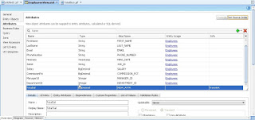](http://1.bp.blogspot.com/-NLqwb6x3f0Y/UJI9jTioJOI/AAAAAAAAAl0/u65zwzNJky8/s1600/ScreenHunter_16+Nov.+01+14.44.jpg)

Now go to View Accessors tab and click on green + sign to create new View Accessor.

Select EmployeesView from the first window and shuttle it so that you can see like below.

[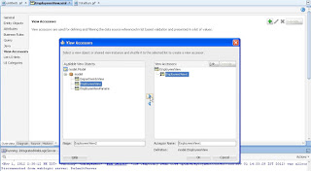](http://3.bp.blogspot.com/-4aadD7Q3dsY/UJI-LgiibyI/AAAAAAAAAl8/dwuHr8qxBfI/s1600/ScreenHunter_17+Nov.+01+14.47.jpg)

Do ok and it should be like below screenshot.

[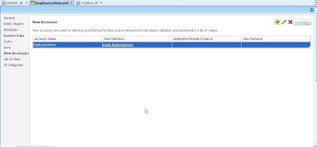](http://4.bp.blogspot.com/-Zwc4VDtvdkk/UJI-YHsAX1I/AAAAAAAAAmE/GNaoAqxORao/s1600/ScreenHunter_18+Nov.+01+14.48.jpg)

Now go to attributes tab and select the new transient attribute (TotalSal).

Give its Default value as Expression and give Groovy expression as EmployeesView1.sum(“Salary”) .

[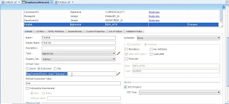](http://2.bp.blogspot.com/-tZ7UDhy3LVk/UJI_nol24bI/AAAAAAAAAmM/YtiN_oir74I/s1600/ScreenHunter_19+Nov.+01+14.53.jpg)

View Project

Create a new page. Drag and Drop EmployeesVO from data control and create a new read only table “without” TotalSal Attribute.

Now go to Salary Column in Structure and do a right click and select footer from facet as shown below.

[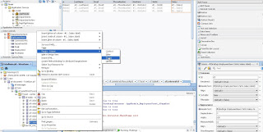](http://1.bp.blogspot.com/-Peny9GZ_ULk/UJJBBhG-JCI/AAAAAAAAAmU/hkEj22JqKrA/s1600/ScreenHunter_20+Nov.+01+14.58.jpg)

Now from EmployeesView1 in DataControl, drag and drop TotalSal column in this new footer facet.

[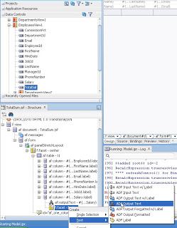](http://2.bp.blogspot.com/-nnSSmaamWS0/UJJCT33thCI/AAAAAAAAAmk/KBVMRO8VvJA/s1600/ScreenHunter_22+Nov.+01+15.04.jpg)

Now go to bindings and create a new binding for this variable.

[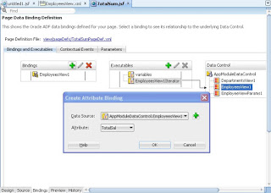](http://2.bp.blogspot.com/-wrncn_jHEPo/UJJDWJcARqI/AAAAAAAAAm0/k-sx19Dh43A/s1600/ScreenHunter_24+Nov.+01+15.07.jpg)

 And change the value of footer output text with this binding.

[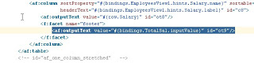](http://4.bp.blogspot.com/-plzKUTv4JoU/UJJDPVMxiaI/AAAAAAAAAms/HJoforOKaLQ/s1600/ScreenHunter_25+Nov.+01+15.08.jpg)

Save all and run this page.

[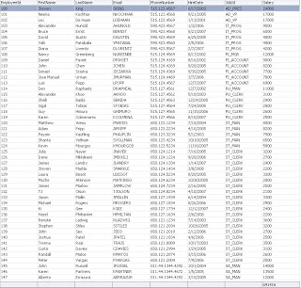](http://2.bp.blogspot.com/-0L3tQ2JQldc/UJJD7e6ZyrI/AAAAAAAAAm8/nQdJub6irtw/s1600/ScreenHunter_26+Nov.+01+15.11.jpg)

Hope this was useful.

Happy Learning !!

Rohan Walia

[**Oracle Analytic Functions for Total and Average Calculation in ADF BC**](http://andrejusb.blogspot.com/2013/02/oracle-analytic-functions-for-total-and.html)

What is great about ADF BC - this framework is very close to the DB and makes data management and analysis operations implementation really easy. There are different ways to implement total and average value calculation. The best way probably is to use [Oracle DB Analytic Functions](http://docs.oracle.com/cd/E11882_01/server.112/e26088/functions004.htm). Using analytic functions minimizes custom Java code, simplifies handling search from Query criteria of from table filter. There is no need to specify GROUP BY in SQL when using analytic functions, this makes easier ADF BC VO implementation.  
  
You are welcome to download sample ADF 11g R2 application - [ADFAnalyticFuncApp.zip](http://jdevsamples.googlecode.com/files/ADFAnalyticFuncApp.zip). Two calculated attributes are added to the Employees VO, both of them are initialized from SQL statement calling analytic function. Here is example for total calculation - check SQL statement for calculated attribute:

[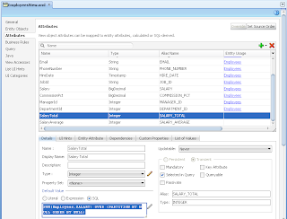](http://1.bp.blogspot.com/-XYgiH16Hrh0/UQwnzxOzbFI/AAAAAAAAI30/hiNjBNikuV0/s1600/1.png)

Here is for the average:

[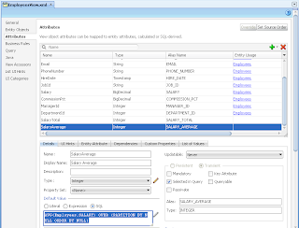](http://3.bp.blogspot.com/--SBPCvu6XyA/UQwn_re6HzI/AAAAAAAAI38/nFRS2Q6eOEQ/s1600/2.png)

This is how resulting SQL statement looks for ADF VO with two calculated attributes based on analytic function:

[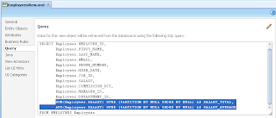](http://3.bp.blogspot.com/-0LarFfVLgO0/UQwoKjVI_iI/AAAAAAAAI4E/o7ITs2eEGQk/s1600/3.png)

This is all about ADF BC. On ADF UI you need to define in page definition two attributes for calculated fields:

[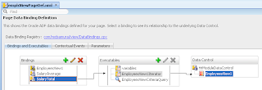](http://1.bp.blogspot.com/-HO0Tf_HXcT4/UQwoXWE7L7I/AAAAAAAAI4M/HNhrJx8BT7s/s1600/4.png)

Reference these attributes from table column footer for example:

[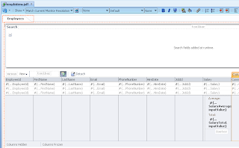](http://2.bp.blogspot.com/--LTwLaY59iI/UQwof5ajZzI/AAAAAAAAI4U/S_MA8gnaEx4/s1600/5.png)

It works smooth on runtime - search is executed from ADF query, total and average reflect salary data:

[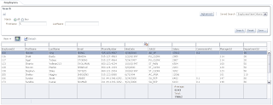](http://2.bp.blogspot.com/-blb-8tollyo/UQwo3BIJ2AI/AAAAAAAAI4c/jVdyHvLXFTI/s1600/6.png)

If you want, type search criteria into table filter and execute additional filtering - total and average values will be automatically recalculated based on filtered table data:

[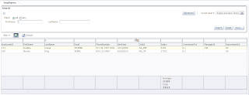](http://4.bp.blogspot.com/-FV_is2pTBwM/UQwpHh0MDkI/AAAAAAAAI4k/0OYCWDo5OJ8/s1600/7.png)

Posted by Andrejus Baranovskis at [9:44 PM](http://andrejusb.blogspot.com/2013/02/oracle-analytic-functions-for-total-and.html)