Relationship Bridge (RB)
Company Intelligence Layer
Profile schema, momentum & vulnerability scoring, and ecosystem positioning
Version 1.0 • May 2026

Abstract
The Company Intelligence Layer turns the firehose of signals about a company into a living strategic profile. For each watched company it computes a Momentum score M_c(t) ∈ [−1, +1], a Vulnerability score V_c(t) ∈ [0, 1], an Operational Complexity score, an AI Posture classification, and an ecosystem position vector. These scores feed the action engine, the DRR uplift function, and the gap-detection layer.
This document specifies the profile schema, the scoring formulas with derivations, the rules for selecting the watched set, the peer-set definition, and the update model. It assumes the signal pipeline and DRR specifications and refers back to them where relevant.

1. Design Principles
- Profile state is derived, not entered. Every field has a provenance trail to the signals that produced it.
- Direction over absolute level. Investors and operators care about which direction a company is moving more than the snapshot value.
- Momentum and vulnerability are orthogonal. A company can be rising AND fragile, or fading AND resilient.
- Confidence travels through. Profile fields display the confidence of their evidence; aggregate scores are confidence-weighted.
- Watched-set is finite. Profiles are not maintained for the entire universe — only for companies meaningful to the user's graph or focus.
- Comparative is first-class. Companies are scored both absolutely and relative to their peer set.
- AI is one signal among many. AI posture is tracked but does not dominate the profile; it's a column, not a religion.

2. Profile Schema
A CompanyProfile is the canonical view of a watched company. It is rebuilt on signal arrival and materialized for query.
CompanyProfile {
company_id: uuid,
canonical_name: string,
aliases: [string],
segment_tags: [string], // e.g., ['qsr_coffee','multi_unit_franchise']
ecosystem_tags: [string], // e.g., ['enterprise_pos','multi_unit_payments']
scores: {
momentum: { value: float[-1,1], trend, confidence, last_updated, contributing_signals[] },
vulnerability: { value: float[0,1], trend, confidence, last_updated, contributing_signals[] },
operational_complexity: { value: float[0,1], confidence, last_updated, factor_breakdown },
ai_posture: { label: enum, score: float[0,1], evidence_signals[], last_updated }
},
state: { // discrete derived states
scaling_pressure: bool,
leadership_instability: bool,
modernization_opportunity: bool,
ecosystem_weakness: bool,
consolidation_signal: bool
},
history: { // 12-week rolling buffers
momentum_series: [(t, value)],
vulnerability_series: [(t, value)],
notable_events: [signal_id] // human-readable timeline anchors
},
ecosystem_position: {
peer_set: [company_id],
peer_set_basis: 'segment+size+geo',
rank_within_peer_set: { momentum: int, vulnerability: int },
adjacent: { vendors:[], customers:[], partners:[], competitors:[] }
},
graph_links: { // user-graph integration
people_in_user_graph: [person_id],
user_drr_at_company_max: float,
user_focus_alignment: float[-1,1]
},
watched_reason: enum, // why this co. is in the watched set
watch_priority: int, // 1 (high) – 3 (low); affects update cadence
last_full_recompute_at: ISO8601
}

3. Momentum — M_c(t)
A signed, bounded measure of which direction a company is moving. Symmetric: M = +1 is unambiguously rising; M = −1 is unambiguously falling; M ≈ 0 is steady or mixed.

3.1 Definition
M_c(t) = tanh( λ · Σ_s ∈ S_c(t) sign(s) · α_M(s.type) · w_conf(s.tag) · 2^(-Δt/τ_M(s.type)) )
Where:
- S_c(t) — recent signals (last 12 weeks) affecting company c.
- sign(s) ∈ {+1, −1} — directional indicator from the signal-type table below.
- α_M(s.type) — per-signal magnitude coefficient (positive).
- w_conf(s.tag) — confidence weight (same as elsewhere).
- τ_M(s.type) — momentum half-life per signal type (typically longer than DRR uplift half-lives — momentum is a slower-moving aggregate).
- λ — global temperature; default 0.8. Lower λ flattens the curve.

3.2 Signal direction & coefficients
Signal type | sign | α_M | τ_M (weeks)
customer_win | +1 | 0.60 | 8
funding | +1 | 0.50 | 6
expansion | +1 | 0.55 | 12
scaling | +1 | 0.50 | 12
leadership_growth (top hires, board adds) | +1 | 0.35 | 10
m&a (acquirer) | +1 | 0.65 | 10
customer_loss | -1 | 0.55 | 8
layoffs | -1 | 0.55 | 8
leadership_departure (CEO/CFO/CRO) | -1 | 0.55 | 10
exec_churn (3+ exits in 90d) | -1 | 0.60 | 12
operational_strain (derived) | -1 | 0.35 | 10
m&a (acquired) | 0 (neutral; ambiguous) | — | —
Asymmetry note: Negative signals tend to have higher α than their positive twins because contraction signals are usually more decisive than equivalent expansion signals (a layoff is more definitive than a hire).

3.3 Confidence weighting and corroboration
- Standard confidence weights apply (CONFIRMED 1.0 … RUMOR 0.3).
- MULTI_SOURCE corroborated signals contribute once per cluster; the cluster's combined uplift uses the higher confidence weight.
- Conflicting signals (signal.conflicts[]) cancel only partially: opposing contributions multiply by 0.5 inside the same window.

3.4 Properties
- M ∈ (−1, +1); tanh saturates so no single signal can dominate.
- Decays naturally toward 0 in the absence of new signals.
- Linear in the small-signal regime; soft-bounded in the strong-signal regime.
- Confidence-weighted — a single CONFIRMED win outweighs three RUMORs of contraction.

4. Vulnerability — V_c(t)
Vulnerability is exposure, not contraction. A company can be rising (M high) and vulnerable (V high) at the same time — this is the most strategically interesting state, the 'opportunity window' quadrant.

4.1 Definition
V_c(t) = σ( w_op · op_strain_score(c, t)
+ w_ldr · leadership_instability(c, t)
+ w_cust · customer_concentration_risk(c)
+ w_reg · regulatory_exposure(c)
+ w_comp · competitive_pressure(c, t)
+ w_vnd · vendor_dissatisfaction(c, t)
- w_res · resilience_factors(c) )
σ is the logistic, producing V ∈ (0, 1). Each input is bounded in [0, 1]; weights sum to 1 for the positive terms and resilience is a separate counterweight.

4.2 Component definitions
Component | Computed from
op_strain_score | Density of operational_strain signals, scaling-pressure derivation, infrastructure-strain text patterns.
leadership_instability | Exec departure rate over 12 months relative to peer set; board churn; CEO tenure z-score.
customer_concentration_risk | If known (10-K disclosures, trade reporting): top-3 customer revenue %.
regulatory_exposure | Active investigations, pending rulings, jurisdiction-specific risks; default 0 when no signal.
competitive_pressure | Density of customer_loss + market-share movement at peers + vendor displacement events.
vendor_dissatisfaction | Operator-side commentary + vendor switching signals across the company's operating footprint.
resilience_factors | Cash position (when known), revenue diversification, board strength signal, recent capital raise.

4.3 Default weights
Weight | Default | Range
w_op | 0.25 | [0.15, 0.35]
w_ldr | 0.20 | [0.10, 0.30]
w_cust | 0.15 | [0.05, 0.25]
w_reg | 0.10 | [0, 0.25]
w_comp | 0.20 | [0.10, 0.30]
w_vnd | 0.10 | [0, 0.20]
w_res (counterweight) | 0.20 | [0.10, 0.30]

4.4 Properties
- V is slow-moving by design — vulnerability builds and dissipates over weeks.
- Bounded; never hits 0 or 1 due to logistic.
- Resilience is subtractive: a vulnerable company that just raised a war chest will have its V meaningfully reduced.

5. Momentum × Vulnerability — Strategic Quadrants
The two scores combine to produce four operating regions with distinct strategic implications.
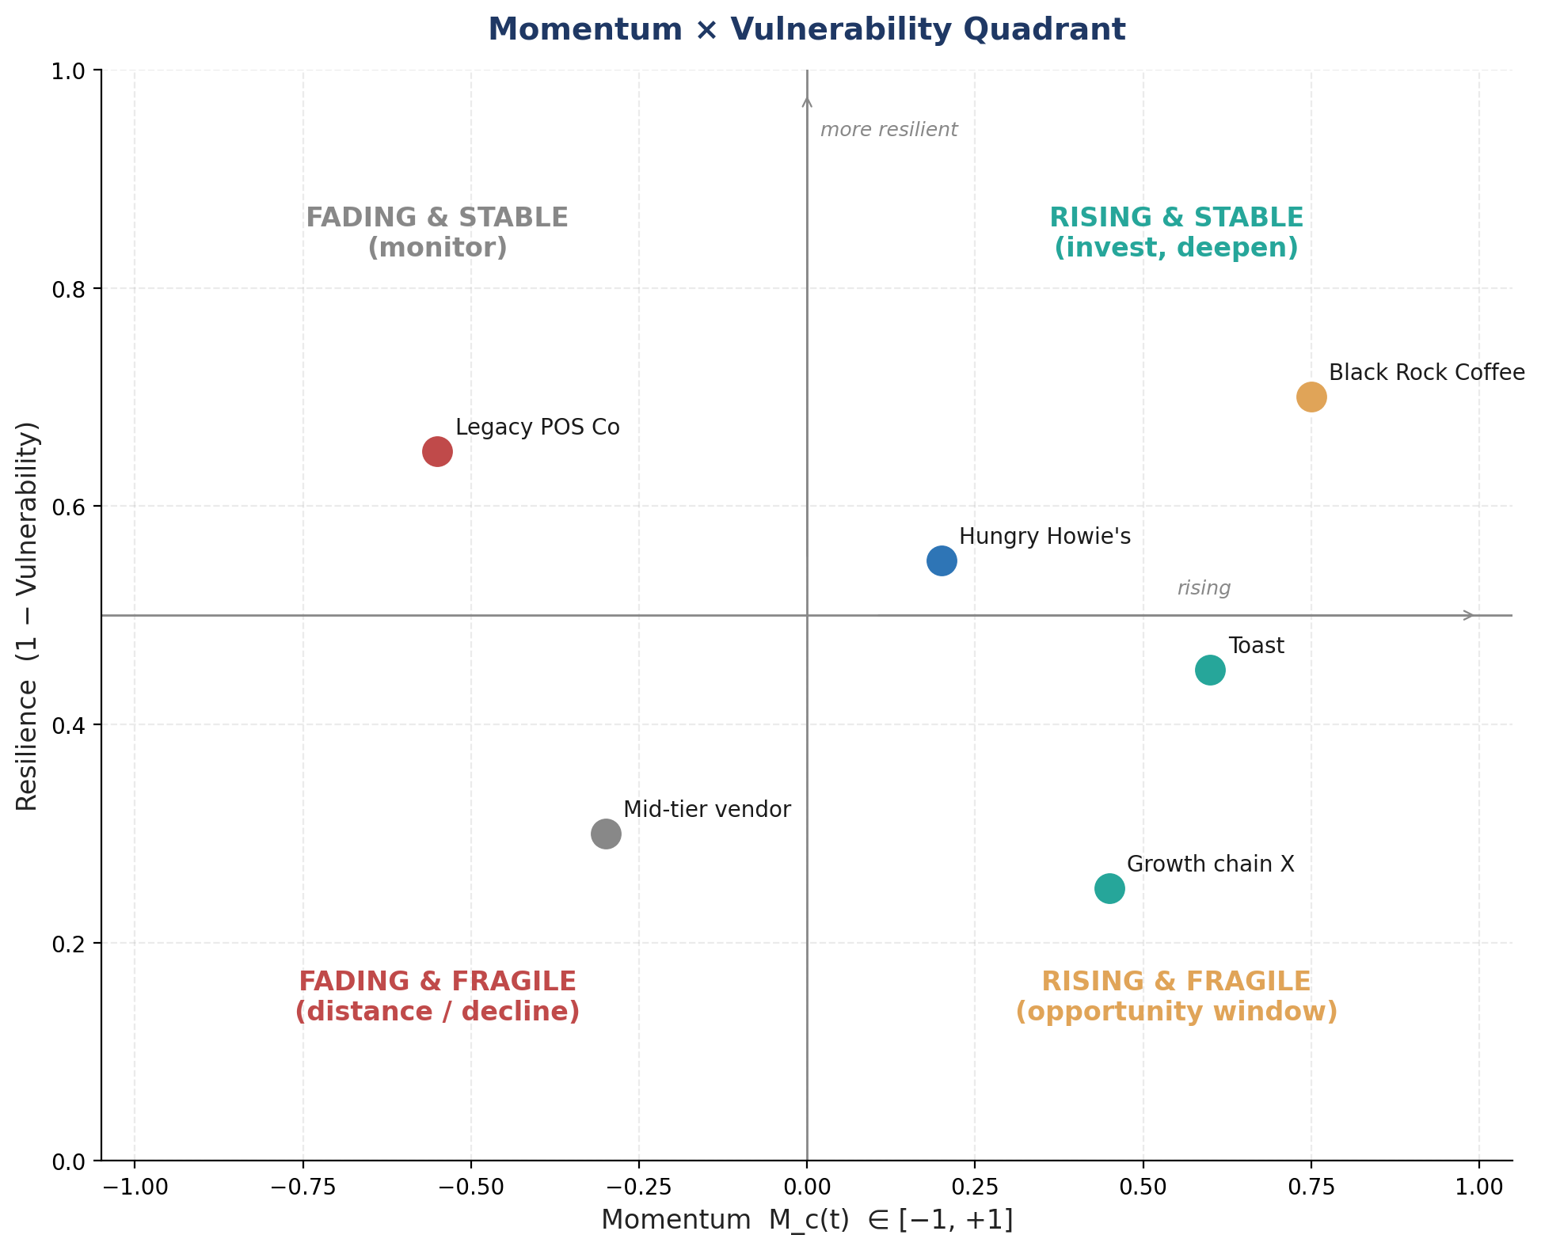
Quadrant | M_c | V_c | Strategic meaning
Rising & Stable | > 0 | < 0.5 | Invest, deepen — strong durable position.
Rising & Fragile | > 0 | ≥ 0.5 | Opportunity window — momentum exists but vulnerability creates entry points for vendors, partners, talent.
Fading & Stable | < 0 | < 0.5 | Monitor — slowly declining but still resilient; no urgency.
Fading & Fragile | < 0 | ≥ 0.5 | Distance — vendor risk, talent risk; decline + exposure.
Why this matters: The action engine treats Rising & Fragile signals very differently from Rising & Stable signals — the former gets investigate / strengthen verbs aimed at the moment; the latter gets monitor / share_article aimed at relationship maintenance.

6. Operational Complexity — OC_c
A static structural feature of the business, updated quarterly. Higher OC means more surface area for technology change and more leverage for relationships.
OC_c = σ( w_loc · log(1 + locations)
+ w_brd · log(1 + brands)
+ w_geo · log(1 + geographies)
+ w_int · log(1 + integration_count)
+ w_seg · segment_combinations
+ w_chn · channel_diversity )
- Locations: total operating units (stores, sites, plants).
- Brands: distinct brand identities operated.
- Geographies: countries / regulatory zones.
- Integration_count: known technology integrations (POS, payments, labor, supply chain).
- Segment_combinations: cross-segment operating (e.g., QSR + delivery + catering).
- Channel_diversity: direct + franchise + licensee + JV combinations.
Use: OC modulates several scoring layers: high-OC companies have higher modernization opportunity if scaling-pressure signals are present, and their vendor relationships carry higher DRR uplift.

7. AI Posture
Classifies how a company relates to AI in operations and product. Four-state label plus a continuous score; both are updated on AI-relevant signals (hiring, integrations, public posture, customer commentary).

7.1 Label and score
Label | Description | Score range
laggard | No public AI activity; manual operations; no AI-related hiring. | 0.00–0.20
aware | Discussion of AI in earnings/press; no concrete deployment. | 0.20–0.40
experimenting | Pilots in production; AI-related roles being filled. | 0.40–0.65
building | Multiple AI deployments shipping value; AI in product roadmap. | 0.65–0.85
native | AI is core to the product/operating model; deep AI org. | 0.85–1.00

7.2 Inputs
- Hiring signals — count and seniority of AI/ML roles posted and filled (LinkedIn data).
- Earnings calls / public commentary — frequency and substance of AI mentions, filtered for puffery.
- Integrations — adoption of AI-enabled vendors, partnerships with AI-native companies.
- Operator commentary — customer or operator references to AI usage at the company.
- Patents and publications — for technical companies.
Caveat: AI posture is noisy and prone to puffery. The system explicitly weights demonstrated deployment more than stated intent.

8. Ecosystem Positioning
Companies don't exist in isolation. Each profile maintains a peer set and an adjacency map that drive comparative scoring and the gap-detection layer.

8.1 Peer set definition
Peers are defined by an intersection of segment, size band, business model, and primary geography. Default peer-set size: 5–15 companies.
peer_set(c) = top_k by similarity in {
segment_tags (exact overlap),
size_band (within ±1 tier on log-scale headcount or revenue),
business_model (franchise|owned|licensed|hybrid),
geography (overlap of primary regions)
}

8.2 Adjacency map
- Vendors — known technology, payments, supply-chain vendors.
- Customers — public customer references.
- Partners — strategic partnerships, JVs, channel partners.
- Competitors — direct and adjacent competitors.
Adjacency edges have their own confidence (CONFIRMED if public, INDUSTRY_SIGNAL if inferred from trade press, RUMOR if from a single source).

8.3 Comparative scoring
- Within-peer rank for momentum, vulnerability, OC, AI posture.
- Quadrant frequency: how often is this company in 'Rising & Fragile' over the last 12 weeks?
- Outlier detection: companies whose momentum or vulnerability is > 2 standard deviations from peer mean are flagged.

9. Watched Set Membership
RB does not maintain profiles for the entire universe. The watched set is per-user (with significant overlap across users) and is sized to keep update cost predictable.

9.1 Inclusion rules
- Any company with ≥ 1 person in the user's graph at warm or dormant relationship strength.
- Any company explicitly added by the user (focus list).
- Any company in the user's stated focus ecosystems that appears in the peer set of an already-watched company.
- Up to N adjacency expansion: vendors/competitors/customers of already-watched companies, with diminishing-priority weighting.
- Companies that have appeared in ≥ 3 of the user's last 30 days of briefings — graduated to watched if not already.

9.2 Watch priority tiers
Tier | Membership | Update cadence | Profile depth
P1 — Direct graph | User has warm contacts there. | Real-time on signal arrival. | Full.
P2 — Focus / adjacency | User-focus or peer of P1. | Hourly batch + signal-arrival. | Full.
P3 — Background watch | Ecosystem peers, 2-hop adjacency. | Daily batch. | Reduced (momentum + vulnerability only).

9.3 Eviction
- P3 companies inactive (no relevant signals) for 60 days are demoted to dormant and excluded from update batches.
- Dormant companies retain their last-computed profile for 1 year; full reconstruction on re-entry.
- Users may pin a company to prevent eviction.

10. Update Model
Profiles update on three cadences:
- Signal-driven (real-time): every signal touching a watched company invalidates affected score components; relevant scores recompute within seconds.
- Hourly batch: P2 companies; cross-checks and peer rank updates.
- Daily batch: P3 companies; resilience-factor refreshes; ecosystem rank deltas; quadrant moves.

10.1 Incremental updates
- Momentum: O(k) where k is number of new signals; existing series tail-extended.
- Vulnerability: O(1) for component refresh; rerun logistic.
- Operational Complexity: only on explicit structural-change signals (M&A, new geo entry, brand divestiture).
- AI Posture: only on AI-tagged signals.

10.2 Materialization
- Profiles materialized to fast-read view (Postgres JSONB with covering indexes).
- History series capped at 12 weeks rolling; older points downsampled to weekly for the year-long trend view.
- Audit log retains all signal_id → score-delta links.

11. UI Surface (Company Profile Page)
Specification of what the user sees, derived from the profile.

11.1 Header
- Company name, primary segment, watched-tier badge.
- Momentum gauge (−1 to +1) with 12-week trend arrow.
- Vulnerability gauge (0 to 1) with 12-week trend arrow.
- Quadrant chip (e.g., 'Rising & Fragile').
- Watched-reason and graph-link summary ('3 warm contacts; max DRR 0.84').

11.2 Body sections
- Signal timeline — chronological signals filtered to this company; confidence tags visible.
- Relationships panel — user's contacts at this company, ranked by DRR; last-touch indicator.
- Comparables — peer set with side-by-side momentum and vulnerability bars.
- Adjacencies — vendor/customer/partner/competitor lists with their own momentum chips.
- Recommended actions — handoff to action engine, scoped to this company.
- Derived state callouts — 'Scaling pressure detected,' 'Modernization opportunity,' etc.

12. Edge Cases
Case | Behavior
Subsidiaries & parents | Maintained as separate profiles with parent_company_id linkage; signals propagate upward at 0.4 weight by default.
M&A in flight (announced, not closed) | Both entities retain profiles; signals to either tag both with provenance; on close, merge per user-acknowledged event.
Name change / rebrand | Aliases table updated; old name retained for historical signal matching.
Company split / divestiture | New profiles created; portion of history attributed by rule (HQ keeps history; divested unit starts fresh).
Stealth / very young company | Profile created with low confidence on all scores; OC computed from limited data; resilience flag = 'unknown'.
Public company quiet period | Vulnerability not penalized for signal silence during quiet periods; flag in audit log.
Multi-region operations under different brand names | Merged via aliases when relationship is confirmed; otherwise kept distinct.
Holding company / private equity portfolio | Holding profile aggregates portfolio scores; portfolio members keep individual profiles.

13. Worked Examples

13.1 Example — Black Rock Coffee
Inputs over 8 weeks:
- scaling/expansion signal (INDUSTRY_SIGNAL): pursuing 1,000 locations — α 0.55, w_conf 0.80, age 1w → contribution +0.43.
- leadership_growth (CONFIRMED): new CFO — α 0.35, w_conf 1.0, age 4w → +0.32 · 2^(-4/10) ≈ +0.24.
- operational_strain (INDUSTRY_SIGNAL): training-infrastructure investment — α 0.35, w_conf 0.80, age 2w → +0.27 (also feeds vulnerability).
- No negative signals.
M = tanh(0.8 · (0.43 + 0.24 + small adj.)) ≈ tanh(0.55) ≈ +0.50
V components (illustrative):
op_strain_score = 0.55 (training-infra + scale)
leadership_instability = 0.10
customer_concentration_risk = 0.20
regulatory_exposure = 0.05
competitive_pressure = 0.30
vendor_dissatisfaction = 0.10
resilience_factors = 0.40 (recent raise, board strength)
V = σ(0.25·0.55 + 0.20·0.10 + 0.15·0.20 + 0.10·0.05 + 0.20·0.30 + 0.10·0.10 - 0.20·0.40)
= σ(0.138 + 0.020 + 0.030 + 0.005 + 0.060 + 0.010 - 0.080)
= σ(0.183) ≈ 0.55
Interpretation: Rising & Fragile — momentum is positive but vulnerability is elevated. This is the canonical opportunity-window state: high modernization-opportunity flag, ecosystem-weakness false, scaling-pressure true. Action engine will favor investigate / strengthen / share_article verbs for relationships at this company.

13.2 Example — Hypothetical fading legacy POS
Inputs over 12 weeks: customer_loss (CONFIRMED) × 2, exec_churn (CONFIRMED), op_strain (INDUSTRY_SIGNAL), no positive signals.
M ≈ tanh(0.8 · (-0.55·1.0·decay - 0.55·1.0·decay - 0.60·1.0·decay)) ≈ -0.55
V ≈ σ(0.25·0.6 + 0.20·0.55 + 0.15·0.30 + 0 + 0.20·0.40 + 0.10·0.30 - 0.20·0.10) ≈ 0.65
Interpretation: Fading & Fragile — distance / decline quadrant. Action engine downgrades all outreach verbs at this company except internal investigate / monitor.

Appendix A — Score Reference Card
M_c(t) = tanh( λ · Σ_s sign(s)·α_M(type)·w_conf(tag)·2^(-Δt/τ_M(type)) )
V_c(t) = σ( Σ_i w_i · component_i - w_res · resilience )
OC_c = σ( Σ_j w_j · log(1 + count_j) )
AI(c) = classify( hiring, commentary, integrations, deployments )
Quadrants:
M > 0, V < 0.5 → Rising & Stable
M > 0, V ≥ 0.5 → Rising & Fragile (opportunity window)
M < 0, V < 0.5 → Fading & Stable
M < 0, V ≥ 0.5 → Fading & Fragile (distance)

Appendix B — Glossary
Term | Definition
Watched set | Per-user finite set of companies with maintained profiles.
Peer set | Closest 5–15 companies by segment, size, model, geography.
Adjacency | Vendor / customer / partner / competitor relationship; first-class typed edge.
Quadrant | (M, V) regime label describing the company's strategic state.
Operational Complexity | Structural surface area for technology and partnerships.
AI Posture | Five-label classification with continuous score.

