Relationship Bridge (RB)
Dynamic Relationship Relevance
Rigorous Specification & Evaluation Framework
Version 1.0 • May 2026

Abstract
Dynamic Relationship Relevance (DRR) is the per-edge score that decides which of a user's relationships are strategically important right now. DRR is the foundational primitive of the Relationship Bridge platform: the action recommendation engine, the daily briefing, the company intelligence layer, and the gap analysis all read from DRR. This document specifies DRR formally — closed-form components, parameter defaults with rationale, edge cases, and worked examples — and pairs it with the evaluation framework required to tune DRR responsibly.
Part I (sections 1–9) is the DRR specification. Part II (sections 10–16) is the evaluation framework. Section 17 is the iteration playbook. The appendix carries the parameter reference card and a one-page formula summary.

Part I — DRR Specification
How RB computes whether a given relationship matters right now.

1. Design Goals & Constraints

1.1 What DRR must do
- Produce a per-edge score in a bounded, interpretable range so scores are comparable across edges and across users.
- Reflect both static relationship strength and live environmental movement.
- Decay sensibly without further input (no signal storm required to keep scores honest).
- Spike on genuine signals and decay back to baseline on its own.
- Penalize over-eager outreach via a cooldown without permanently suppressing the edge.
- Be explainable — every component of a score must be inspectable in the UI.
- Be tunable — parameters live in code, not in prompts, and are versioned.

1.2 What DRR must not do
- Compress all relationship value into one number; DRR is one of several inputs to the action engine.
- Make outreach decisions; outreach is a downstream policy that consumes DRR with additional gates.
- Score people on personal attributes; DRR scores edges (context-specific connections), not individuals in the abstract.
- Use rumors or LOW_CONFIDENCE signals at full weight; confidence weighting is mandatory.

2. Master Formula
For every edge e in the user's relationship graph and time t, DRR is defined as:
DRR(e, t) = clip[ S(e, t) · M(e) + D(e, t) ; 0, 1 ]
With three top-level components:
- S(e, t) — Static relevance: the resting strategic value of the edge in the absence of any environmental movement. Range: [0, 1].
- M(e) — User focus modifier: a multiplicative adjustment that lifts or attenuates edges based on the user's stated focus. Range: [0.7, 1.3].
- D(e, t) — Dynamic delta: the net effect of recent signals minus the cooldown penalty. Range: [−1, 1] (clipped at the outer DRR boundary).

Expanding each:
S(e, t) = B(e) · R(e, t)
M(e) = 1 + γ · align(e, user.focus) where align ∈ [-1, 1], γ ≤ 0.3
D(e, t) = U(e, t) − C(e, t)
Each term is defined in the next sections.
Why this shape: The static component models the relationship's resting energy and decays continuously; the dynamic component models the environment's movement and decays back to zero on its own. Cooldown is subtractive so it cannot make a strong relationship invisible — only quiet it briefly. The clip prevents pathological outputs while keeping the inner math interpretable.

3. Static Relevance — S(e, t)

3.1 Base strength — B(e)
B(e) summarizes the durable strength of a relationship from observed history. It is invariant in time (only updated when new interactions are recorded).
B(e) = σ( w_freq · log(1 + freq(e))
+ w_div · diversity(e)
+ w_qual · quality(e) )
where σ is the standard logistic function σ(x) = 1 / (1 + e^-x)
Components:
- freq(e) — count of recorded interactions over the lifetime of the edge (emails, meetings, intros, mentions).
- diversity(e) ∈ [0, 1] — log-normalized count of distinct interaction source types (e.g., personal email + calendar + intro chain scores higher than personal email alone).
- quality(e) ∈ [0, 1] — weighted by interaction type: 1:1 meeting (1.0), intro author (0.9), 1:1 email (0.7), group meeting (0.5), group email/cc (0.3), public mention (0.15).

Default weights
Weight | Default | Rationale
w_freq | 0.55 | Frequency dominates because consistent contact is the strongest signal of durable strength.
w_div | 0.25 | Cross-channel presence indicates a real relationship, not just a mailing list.
w_qual | 0.20 | Quality matters but is noisier than frequency for early relationships.

3.2 Recency decay — R(e, t)
Recency decay is a per-edge-type exponential function of the time since the last meaningful touch:
R(e, t) = 2^(-(t − t_last_touch(e)) / τ_R(edge_type))
Where τ_R is the half-life (in months) for the edge's type. This is the cleanest decay model: a half-life is interpretable, tunable, and matches how relationships actually fade — slowly at first, then more quickly as people move and forget.

Per-edge-type half-lives
Edge type | Half-life (months) | Rationale
introduced-by | 24 | A specific intro is durable for years; it remains true even if the relationship is dormant.
knows (1:1 personal) | 18 | Personal relationships fade slowly; 18 months reflects the natural half-life of meaningful contact.
professional acquaintance | 12 | Standard professional ties weaken on a yearly cadence.
works-at (colleague-by-virtue-of-employer) | 6 | Colleague-only ties decay quickly once people leave jobs.
transactional only | 4 | Single-purpose ties fade fastest; weighted toward zero by default.

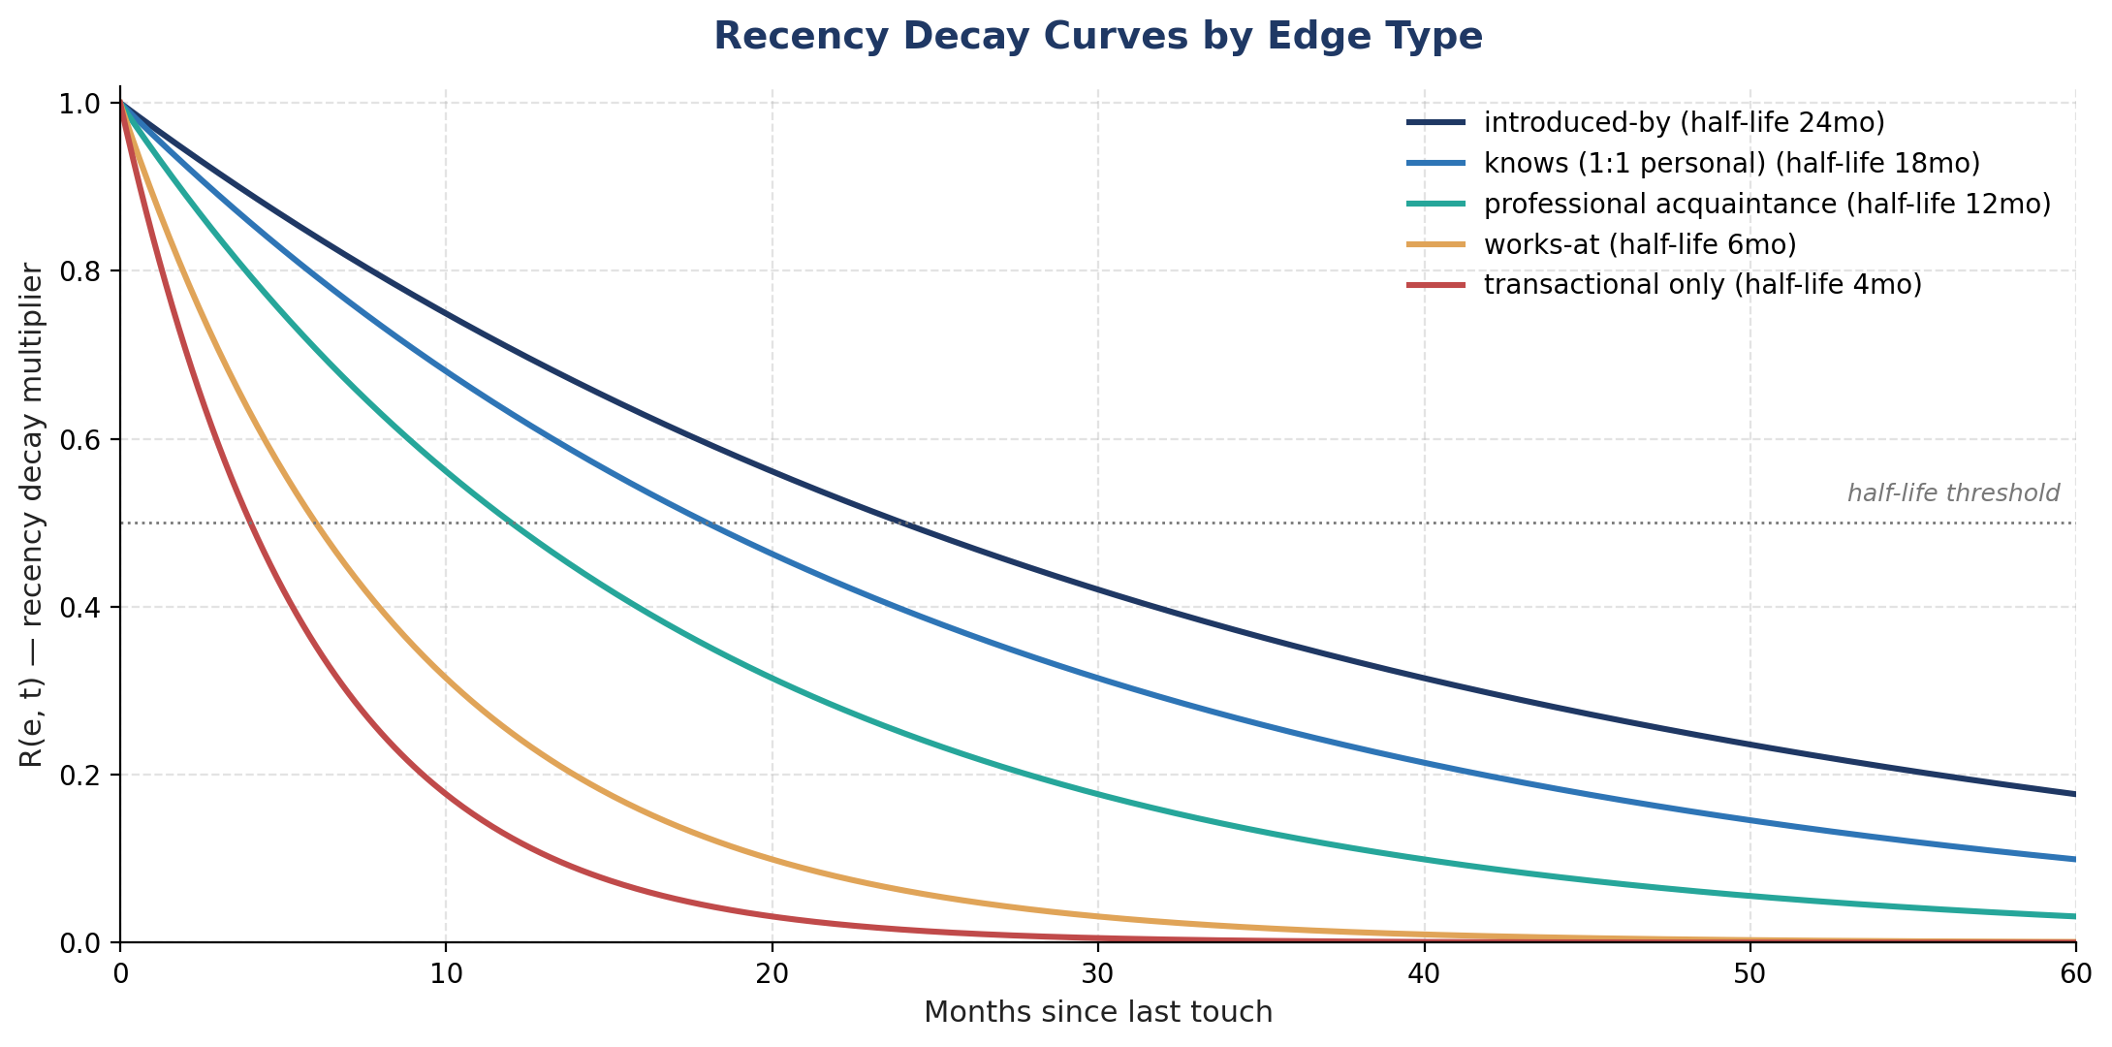
Figure 1 — Recency decay R(e, t) by edge type. Note that even a dormant introduced-by edge retains ~60% of its base strength after a year, while a transactional-only edge has decayed to roughly 18%.

4. User Focus Modifier — M(e)
Two users with identical graphs should see different DRR rankings if their strategic focus differs. The focus modifier captures this without overpowering the underlying strength.
M(e) = 1 + γ · align(e, user.focus)
- align(e, user.focus) ∈ [−1, 1] — cosine similarity between an edge-context embedding (built from the edge's company, ecosystem, role, and recent interaction topics) and the user's stated focus areas.
- γ — focus pressure parameter; default 0.3. With γ = 0.3, M(e) is bounded in [0.7, 1.3] — a 30% lift for highly aligned edges, a 30% attenuation for highly off-focus edges.
- Edges with no embedding available default to align = 0 → M(e) = 1.0 (neutral).

Why bounded: If γ is too large, focus collapses the graph onto the user's stated priorities and surprising opportunities disappear. 0.3 is conservative and explicitly tunable; treat it as a calibration parameter, not a fixed constant.

4.1 Focus alignment input
- User-stated focus areas: free-text statements captured in onboarding and editable in settings.
- Inferred focus: a low-weight contribution from observed user activity (e.g., which company profiles they open repeatedly).
- Inferred-focus weight ≤ 25% of stated-focus weight by default — stated focus is the canonical signal.

5. Dynamic Delta — D(e, t)
D captures everything the environment is doing to this edge right now. It rises with signals and decays back to zero on its own.

5.1 Signal uplift — U(e, t)
Uplift is the sum of contributions from all recent signals that touch the edge:
U(e, t) = min( 1 , Σ_s ∈ S_recent α(type(s)) · w_conf(tag(s))
· h(hops(s, e))
· 2^(-(t − emitted_at(s)) / τ_U(type(s))) )
With:
- α(type) — per-signal-type coefficient; how much this kind of event moves DRR at full confidence on a direct edge.
- w_conf(tag) — confidence weight (CONFIRMED=1.00, MULTI_SOURCE=0.95, INDUSTRY_SIGNAL=0.80, ECOSYSTEM_CHATTER=0.55, LOW_CONFIDENCE=0.40, RUMOR=0.30, UNVERIFIED=0).
- h(hops) — hop decay: h(0)=1.0, h(1)=0.5, h(2)=0.2, h(≥3)=0.
- τ_U(type) — signal half-life in days; per-signal-type.
- The outer min ensures the dynamic component cannot dominate; the static component still anchors the score.

5.2 Signal type parameters
Signal type | α | τ_U (days) | Rationale
customer_win | 0.60 | 21 | Strong, time-bounded relevance window.
customer_loss | 0.50 | 21 | Symmetric magnitude, slightly less actionable.
leadership_change | 0.55 | 30 | Long lead time; relevant for ~a month.
funding | 0.45 | 14 | Newsworthy spike, decays quickly.
m&a (CONFIRMED) | 0.65 | 30 | Largest single mover; long relevance window.
m&a (RUMOR) | 0.30 | 10 | Heavily attenuated by confidence; short window.
layoffs | 0.40 | 14 | Relevant for empathy and intel; never triggers outreach.
expansion / scaling | 0.40 | 45 | Slower-moving, longer half-life.
operational_strain | 0.35 | 30 | Subtle signal; surfaces opportunity over weeks.
sentiment_shift | 0.25 | 14 | Diffuse signal; conservative.
ai_posture | 0.30 | 60 | Strategic-direction signal; persists.

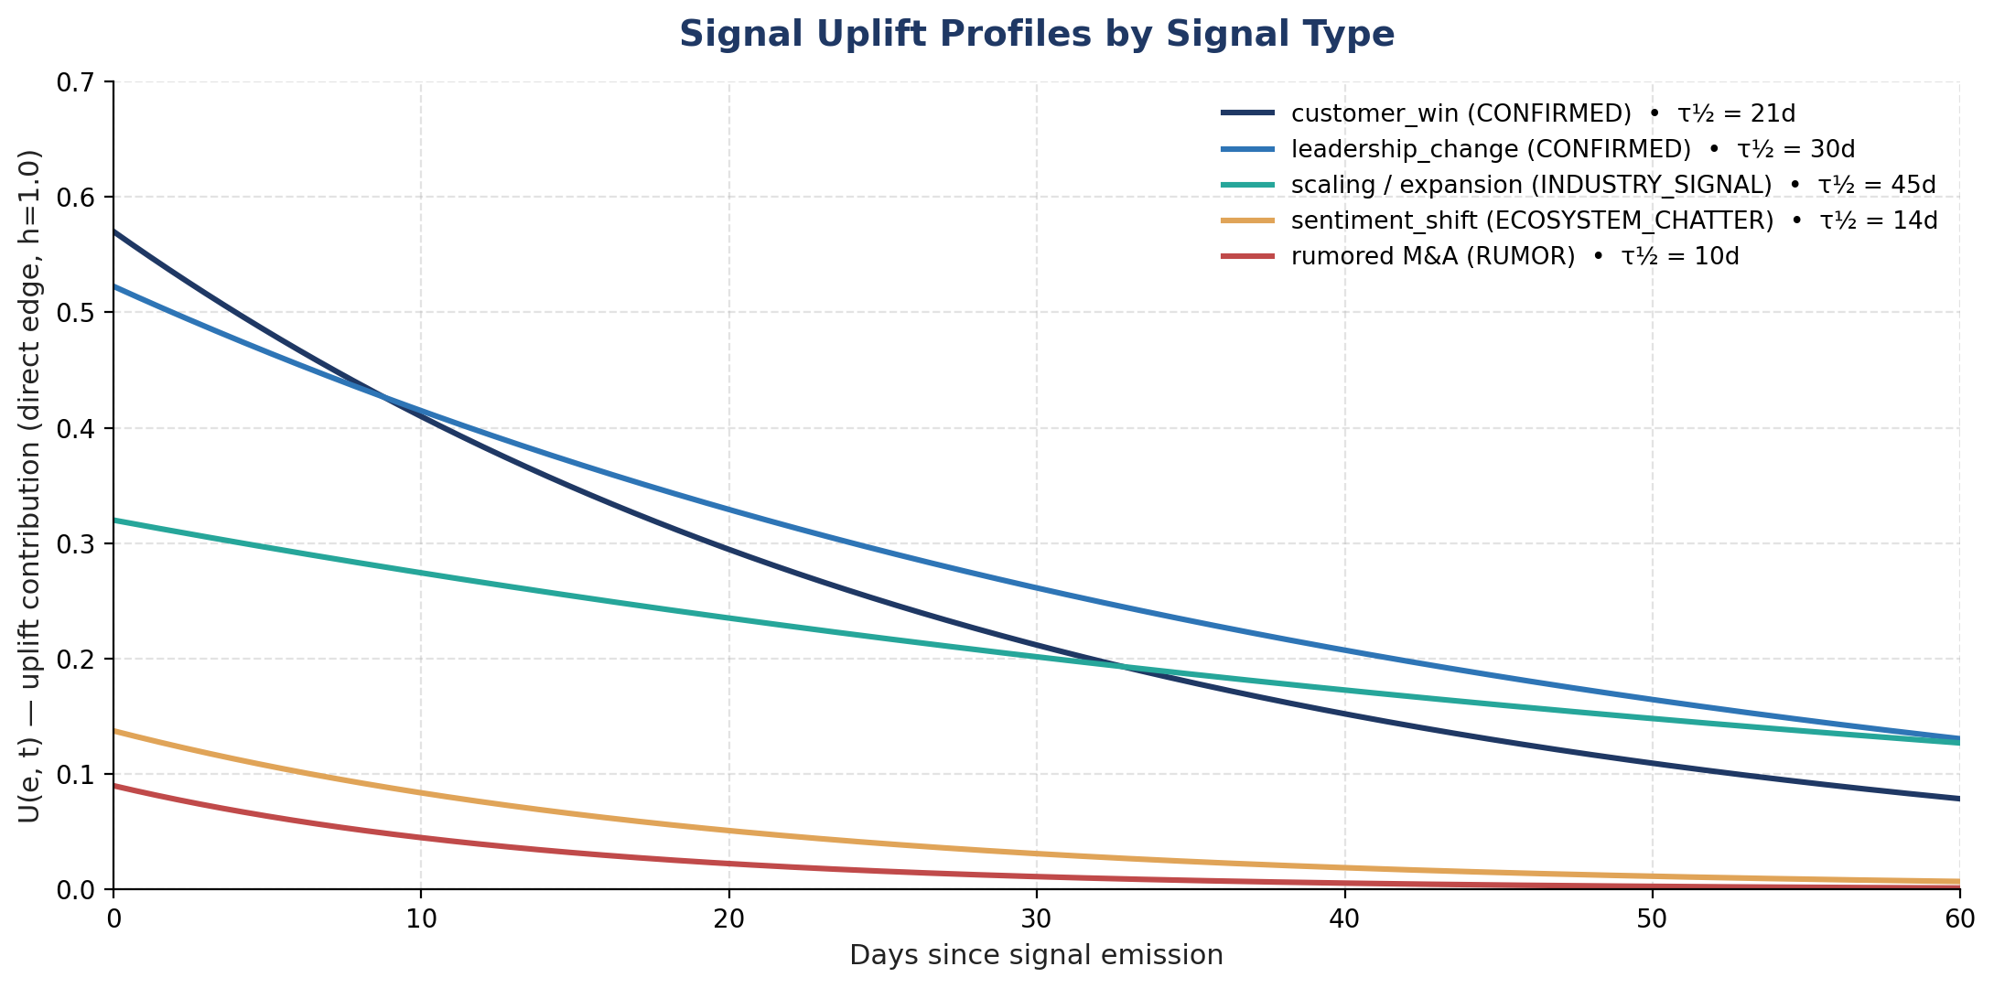
Figure 2 — Uplift contribution U(e, t) for a direct edge across signal types. RUMOR sits low even at emission; CONFIRMED customer-win signals peak near 0.57 and decay to half within three weeks.

5.3 Cooldown penalty — C(e, t)
After meaningful outreach, the edge enters a cooldown window during which DRR is temporarily reduced — preventing rapid re-outreach without permanently suppressing the edge:
C(e, t) = c_max · exp(−(t − t_last_outreach(e)) / τ_C) · 𝟙{outreach occurred}
Defaults:
- c_max = 0.40 — outreach can drop DRR by up to 40 points (out of 100).
- τ_C = 14 days — penalty half-life of two weeks; configurable per user.
- The penalty applies only when a recorded outreach occurred (email sent, meeting accepted, message delivered). DRR scoring itself does not create the penalty.
Property: Because the penalty is subtractive and bounded, a strong baseline relationship (S·M ≈ 0.85) will still surface (DRR ≈ 0.45) even at peak cooldown — but only with a strong signal. This is intentional: cooldown moderates, it doesn't censor.

6. Parameter Reference
All parameters appear here in one place. Each is versioned in code; changes require evaluation set passes (Part II).

6.1 Top-level parameters
Parameter | Default | Range | Where used
γ (focus pressure) | 0.30 | [0, 0.5] | M(e)
c_max (max cooldown depth) | 0.40 | [0, 0.6] | C(e, t)
τ_C (cooldown half-life, days) | 14 | [7, 28] | C(e, t)
hop decay h(0), h(1), h(2) | 1.0, 0.5, 0.2 | monotone decreasing | U(e, t)
uplift cap | 1.0 | [0.8, 1.5] | U(e, t) outer min

6.2 Base-strength weights
Weight | Default | Sums to
w_freq | 0.55 | 0.55
w_div | 0.25 | 0.80
w_qual | 0.20 | 1.00

6.3 Confidence weights
Tag | Weight
CONFIRMED | 1.00
MULTI_SOURCE | 0.95
INDUSTRY_SIGNAL | 0.80
ECOSYSTEM_CHATTER | 0.55
LOW_CONFIDENCE | 0.40
RUMOR | 0.30
UNVERIFIED | 0.00 (excluded)

7. Update Model
DRR is computed lazily for display and incrementally on signal arrival; full recomputation runs nightly as a sanity pass.

7.1 Triggering events
- Signal arrival touching entities within k=2 hops of any edge — recompute DRR for affected edges within 30 seconds (p95).
- User interaction (meeting, email, message) — recompute B(e), R(e, t), and C(e, t) on the affected edge.
- Focus area change — recompute M(e) for all edges (cheap; cached embedding similarity).
- Nightly job — full recompute across all edges per user.

7.2 Computational complexity
Worst-case per-user nightly recompute is O(E + S·k_avg) where E is edge count and S is recent signal count. For a typical user (E ≈ 1,500, S ≈ 200/day), the nightly job is well under a minute on commodity hardware. Incremental updates are O(edges within k hops of signal entities) — typically O(10–100).

7.3 Caching
- B(e) cached and only invalidated on new interactions; updates are cheap.
- Embedding for align() cached per edge; invalidated when context changes meaningfully.
- DRR itself is recomputed cheaply on display; no global cache needed.

8. Edge Cases
Case | Behavior | Why
Brand-new edge, no signals | B(e) low; R(e, t) ≈ 1; DRR low. | Insufficient evidence; system should not promote unknown contacts.
Brand-new edge, immediate strong signal | U(e, t) lifts DRR despite low B(e); capped by uplift cap. | Allows hot opportunities to surface even on new relationships, without false promotion.
Very old edge (5+ years dormant) | R(e, t) → ~0; static near zero; only signals can resurface. | Correct: a dormant edge has no resting relevance, but a strong signal can re-activate it.
Conflicting signals | Each signal contributes independently; conflict_set surfaces in UI; if a contradicting CONFIRMED arrives, the RUMOR uplift is discounted by 50%. | Avoids double-counting and prevents narrative collapse.
Edge where person changed companies | works-at edge replaced with new edge; old company adjacency edge retained with attenuated weight (0.5). | Captures that the relationship survives the move.
User signals 'less of this' | Per-category prior shifts; affects signal coefficient α via per-user multiplier. | Adapts without destroying the global model.
Multiple outreach events in cooldown window | Most recent t_last_outreach used; cooldown does not double up. | Avoids permanent suppression from a flurry of automated touches.
No focus areas set | M(e) = 1.0 for all edges. | Neutral until the user gives the system something to align against.

9. Worked Examples
Concrete numbers, end-to-end. All figures rounded to two decimals.

9.1 Example A — Steady warm relationship, quiet week
Profile: A senior operator who meets the user 1:1 roughly every month for two years. Last meeting three weeks ago. No recent signals. No recent outreach. Edge type: knows (τ_R = 18 mo).
freq(e) = 24 meetings, log(1+24) ≈ 3.22
diversity = 0.6 (1:1 + calendar + intro chain)
quality = 0.92 (mostly 1:1 meetings)
B(e) = σ(0.55·3.22 + 0.25·0.6 + 0.20·0.92)
= σ(1.77 + 0.15 + 0.18) = σ(2.10) ≈ 0.89
R(e, t) = 2^(-0.75 / 18) ≈ 0.97
S(e, t) = 0.89 · 0.97 ≈ 0.86
M(e) = 1.0 (no specific alignment)
U(e, t) = 0, C(e, t) = 0 ⇒ D = 0
DRR ≈ 0.86
Interpretation: a strong resting relationship surfaces high without any environmental movement — as it should.

9.2 Example B — Dormant contact, hot signal
Profile: Worked together five years ago; no contact since. Their company just won a marquee customer (customer_win, MULTI_SOURCE). Edge type: knows.
freq(e) = 18, log(1+18) ≈ 2.94
diversity = 0.4, quality = 0.7
B(e) = σ(0.55·2.94 + 0.25·0.4 + 0.20·0.7) = σ(1.86) ≈ 0.87
R(e, t) = 2^(-60 / 18) ≈ 0.099
S(e, t) = 0.87 · 0.099 ≈ 0.086
U(e, t) = α·w_conf·h(0)·decay = 0.60 · 0.95 · 1.0 · 1.0 ≈ 0.57
C = 0, D = 0.57
DRR = clip[0.086 · 1.0 + 0.57] ≈ 0.66
This is the case the system exists for. A dormant edge that, on its own, would not surface — a hot, confirmed signal moves it into the top of the action queue. As the signal decays, DRR returns to ≈0.09 within ~6 weeks.

9.3 Example C — Strong relationship, recent outreach, mild signal
Profile: Strong contact (B = 0.90), last touch one week ago, outreach five days ago. Mild ECOSYSTEM_CHATTER about their industry.
S(e, t) = 0.90 · 2^(-0.25/18) ≈ 0.90 · 0.99 ≈ 0.89
U(e, t) = 0.25 · 0.55 · 1.0 · 2^(-2/14) ≈ 0.13
C(e, t) = 0.40 · exp(-5/14) ≈ 0.40 · 0.70 ≈ 0.28
D = 0.13 - 0.28 = -0.15
DRR = clip[0.89 · 1.0 + (-0.15)] ≈ 0.74
Interpretation: DRR is still high — the relationship matters — but cooldown moderates it. The action engine sees a high score but its restraint policy will still block outreach within the cooldown window. DRR is correctly reflecting strategic importance without overriding the policy layer.

9.4 Example D — Adjacency-only signal
Profile: User has a warm contact at vendor V's competitor. Signal: vendor V publicly loses a major customer (customer_loss, CONFIRMED). The user's edge is two hops away (warm contact → competitor → V).
h(2) = 0.20
U(e, t) = 0.50 · 1.00 · 0.20 · 1.0 ≈ 0.10
S(e, t) = 0.70 (assumed strong warm contact)
DRR = 0.70 + 0.10 ≈ 0.80
Interpretation: adjacency reasoning correctly surfaces the contact — but at a lower lift than a direct-edge signal would produce. The action engine's rule table (vendor-loss adjacency × competitor relationship) determines whether the recommendation is reconnect, monitor, or investigate.

Part II — Evaluation Framework
How to tell whether DRR is producing the right answers — and how to safely tune it.

10. The Evaluation Problem
There is no objective ground truth for what a person's relationship-relevance score should be. Three users with identical graphs may rank the same relationships differently and all three may be correct. What we can evaluate is whether DRR's rankings agree with revealed strategic intent — what users actually act on, take meetings about, hire from, sell to, or congratulate.
The evaluation strategy is therefore proxy-based and multi-method. Each proxy is noisy; together they triangulate.

10.1 Evaluation principles
- No single metric. DRR is tuned against a basket of proxies; over-fitting to one corrupts the others.
- Offline before online. Every weight change passes a labeled fixture set before any user sees it.
- Online only behind A/B. Production changes ship behind feature flags with explicit guardrails.
- User-centered. Acceptance and restraint correctness sit above any internal metric.
- Versioned weights. DRR parameter sets are versioned alongside code; rollbacks are first-class.

11. Ground Truth Strategies
RB uses five overlapping sources of evaluation signal. Each has bias; together they cover.
Source | How collected | Strengths | Biases
User-confirmed labels | Periodic in-app prompt: 'rank these 10 contacts by current strategic importance.' | Direct user intent; gold standard. | Sparse; fatigue effects; self-presentation bias.
Behavior-derived labels | Track which DRR-ranked contacts the user actually messages, meets, references. | Dense; low burden; honest revealed preference. | Confounded by RB's own surfacing (visibility bias).
Outcome-derived labels | Tag relationships that produced measurable outcomes (deals, hires, intros, advisor engagements) within 90 days of being surfaced. | Reflects strategic value rather than activity. | Slow; small N; attribution is messy.
Expert annotations | Internal team or power users annotate fixture scenarios with expected rankings. | Catches reasoning errors and edge cases. | Doesn't scale; reflects annotator priors.
Synthetic scenarios | Hand-crafted edge profiles with expected DRR orderings (e.g., 'dormant edge + hot signal must outrank steady mid-strength edge with no signal'). | Pinpoint specific properties; deterministic. | Doesn't reflect distributional reality.

11.1 Combining proxies
- Behavior + outcome labels are the primary online metric.
- User-confirmed labels are the offline gold standard for top-of-ranking precision.
- Synthetic scenarios are the regression set — they must always pass before release.
- Expert annotations are the smoke test for new edge types or signal classes.

12. Offline Metrics

12.1 Ranking quality
Metric | Definition | Use
Precision@k | Fraction of RB's top-k that the user acted on (accepted/messaged/met) within window W. | Primary top-of-list metric. Default k = 10, W = 14 days.
NDCG@k | Normalized discounted cumulative gain against user-confirmed ranks. | Rewards correct ordering, not just inclusion.
Spearman ρ | Rank correlation between DRR ordering and behavior-derived ordering. | Whole-list shape; catches inversions deep in the list.
Mean reciprocal rank (MRR) | Reciprocal rank of the first acted-on item. | Catches 'right answer too low.'

12.2 Calibration
Calibration asks: when DRR predicts 0.8, does the user act on the edge ~80% of the time? This matters because DRR is consumed by downstream policy thresholds; uncalibrated DRR produces unstable behavior.
- Brier score and reliability diagrams over outcome-derived labels.
- Bin DRR into deciles; plot empirical action rate against bin midpoint; target diagonal alignment.
- Acceptable: Brier score < 0.10 on rolling 90-day window; reliability MAE < 0.05.

12.3 Stability
- Bootstrap robustness — resample interactions and verify top-k stability.
- Parameter sensitivity — measure how top-10 changes when a single parameter is perturbed by ±10%.
- If small perturbations flip many edges in top-10, weights are too sharp; smooth via regularization.

12.4 Fairness across edge types
- Per-edge-type precision@k — no one edge type should dominate the top by an unjustified margin.
- Recall by edge type — are introduced-by edges systematically under-surfaced?
- Long-tail check — % of users whose top-10 is dominated by a single ecosystem.

13. Online Experimentation (A/B)

13.1 Framework
- Per-user randomization with stable assignment; bucket switches blocked during active experiments.
- CUPED variance reduction using pre-period acceptance rates.
- Sequential testing with α-spending to allow early stopping.
- Minimum detectable effect declared upfront for each metric.
- Pre-registration of primary and secondary metrics before rollout.

13.2 Metrics hierarchy
Tier | Metric | Direction
Primary | Acceptance rate of recommendations driven by top-DRR edges. | Up.
Primary | Restraint correctness — % of no_action recommendations the user agrees with. | Up.
Guardrail | Outreach engagement rate (replies, meeting acceptance). | Up or flat.
Guardrail | 'Less of this' rate. | Down.
Guardrail | Briefing dismiss-without-read rate. | Down or flat.
Counter-metric | Recommendation volume per user. | Should not balloon.
Secondary | Time-to-decision per recommendation. | Down.

13.3 Rollout discipline
- Stage 1 — internal dogfooding (≤ 30 users) for 1 week.
- Stage 2 — 5% holdout vs. 5% treatment for 2 weeks.
- Stage 3 — 50/50 for 1 week if guardrails clean.
- Stage 4 — full ramp; keep 1% holdout for ongoing calibration.
- Any guardrail breach → automated rollback.

14. Drift Monitoring
Production DRR can drift away from user reality even when nothing changes in the code — because the world changes, user focus changes, and source mixes change.

14.1 Daily monitors
- Acceptance rate trend (rolling 7-day) per user and aggregate.
- Restraint correctness trend.
- Distribution of DRR values — KS-test against last week's distribution.
- Top-of-briefing replacement rate — how much yesterday's top-5 overlaps today's.

14.2 Weekly monitors
- Per-edge-type acceptance rate — flag if any type drops > 20% week-over-week.
- Signal-class contribution drift — does any single signal type now drive a disproportionate share of uplift?
- Calibration drift — re-fit reliability diagram on last 30 days.

14.3 Monthly audits
- Comparison against expert-annotated fixture set.
- Spot-check on synthetic scenarios; any regressions become release blockers.
- User research review: qualitative read on whether the top-of-briefing 'feels right' to a panel of power users.

15. Failure Modes the Evaluation Must Catch
Failure | Symptom | Detection
Stale relationship inflation | Dormant edges remain in the top of briefings. | Recall@k by edge age decile; alert on age-skewed top-k.
Signal storm sensitivity | DRR rankings reshuffle wildly on news-heavy days. | Top-of-briefing day-over-day overlap drops below threshold.
Cold-start bias | New edges never surface. | Per-edge-age cohort acceptance rate.
Cooldown over-suppression | High-value contacts go silent for weeks after a single touch. | Track contacts whose DRR remains below the recommendation threshold > τ_C × 2.
Focus collapse | User with narrow focus sees same handful of contacts repeatedly. | Daily uniqueness of top-of-briefing edges; alert on low diversity.
Hop decay miscalibration | Adjacency signals over- or under-contribute. | Per-hop precision@k disaggregation.
Confidence-weight regression | RUMORs influencing top-of-briefing. | Top-k composition by confidence tag; alert on RUMOR > threshold.
Outreach engagement decline despite acceptance rate stability | Acceptance is up but replies down — superficial signal. | Guardrail tracking; investigate when correlation breaks.

16. Quality Dashboard
A single internal dashboard surfaces everything above. Anything not shown here can hide; everything shown gets reviewed weekly.
- Top-of-briefing precision@10 (rolling 14 days).
- Restraint correctness (rolling 14 days).
- NDCG@10 against user-confirmed labels (rolling 30 days).
- Calibration reliability diagram (rolling 30 days).
- Per-edge-type top-k composition (today, last week, last month).
- Per-signal-type uplift share (today, last week).
- Drift alerts: any guardrail outside SLO.
- Synthetic scenario regression status: green / yellow / red.
- Active experiments with current status.

17. Iteration Playbook
How a tuning change actually flows from hypothesis to production.
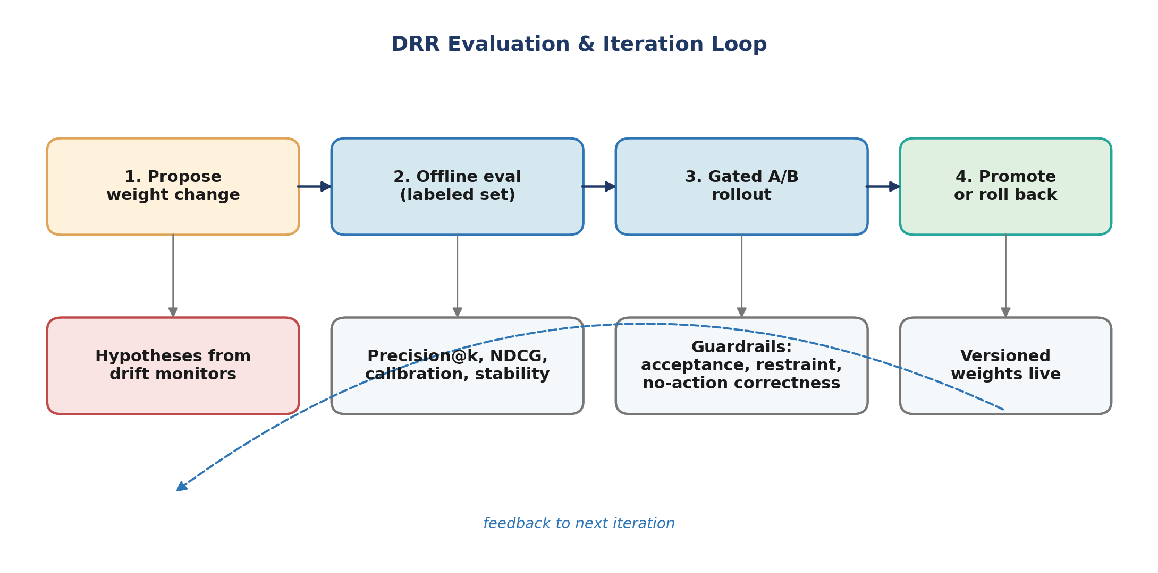

17.1 Steps
- Hypothesis. State the change and the expected metric movement. Example: 'Raising τ_R for knows from 18 to 24 months will improve recall on dormant-edge cases (per drift monitor 14.1) without hurting top-10 precision.'
- Offline eval. Run the proposed weights against the fixture set + synthetic regression set. Must beat current weights on the primary offline metric and tie-or-better on guardrails.
- Gated A/B. Ship behind a flag; 5% treatment vs 5% holdout for ≥ 2 weeks. Monitor primary, guardrail, and counter-metrics.
- Decision. Promote (with versioned commit), roll back (with logged rationale), or extend (if signal is weak).
- Post-decision. Weights live in a versioned config; rollback path is a single feature-flag flip.
- Document. Every promoted change writes to a tuning log with hypothesis, observed effect, and version stamp.

17.2 What never ships
- A change that improves the primary metric while degrading restraint correctness.
- A change that improves aggregate metrics while regressing for a specific cohort (edge type, persona).
- A change without a written hypothesis.
- A change that fails any synthetic scenario in the regression set.

Appendix A — Formula Reference Card
DRR(e, t) = clip[ S(e, t) · M(e) + D(e, t) ; 0, 1 ]
S(e, t) = B(e) · R(e, t)
M(e) = 1 + γ · align(e, user.focus)
D(e, t) = U(e, t) − C(e, t)
B(e) = σ( w_freq·log(1+freq) + w_div·diversity + w_qual·quality )
R(e, t) = 2^(-(t − t_last_touch) / τ_R(edge_type))
U(e, t) = min(1, Σ_s α(type)·w_conf(tag)·h(hops)·2^(-(t-emitted)/τ_U(type)))
C(e, t) = c_max · exp(-(t - t_last_outreach) / τ_C) · 𝟙{outreach}
Defaults:
γ = 0.3, c_max = 0.4, τ_C = 14d
w_freq = 0.55, w_div = 0.25, w_qual = 0.20
h(0)=1.0, h(1)=0.5, h(2)=0.2
Confidence: CONFIRMED 1.00, MULTI_SOURCE 0.95, INDUSTRY_SIGNAL 0.80,
ECOSYSTEM_CHATTER 0.55, LOW_CONFIDENCE 0.40, RUMOR 0.30

Appendix B — Eval Metrics Quick Reference
Metric | What it answers
Precision@10 | Are the top 10 actionable?
NDCG@10 | Is the ordering inside top 10 right?
Spearman ρ | Is the whole list shape right?
MRR | Is the right answer near the top?
Brier / reliability | Are DRR values calibrated as probabilities of action?
Top-k overlap day-over-day | Is the system stable across news cycles?
Per-edge-type precision | Is any edge type unfairly dominating or absent?
Restraint correctness | When the system stays silent, is it right to?

Appendix C — Glossary
Term | Definition
DRR | Dynamic Relationship Relevance — per-edge, time-dependent score in [0, 1].
Edge | A directed or undirected connection between two graph nodes (person↔person, person→company).
B(e) | Base strength — durable history-based component.
R(e, t) | Recency decay — exponential function of time since last touch.
U(e, t) | Signal uplift — confidence-weighted, hop-decayed, time-decayed sum of recent signals.
C(e, t) | Cooldown penalty — bounded subtractive after recorded outreach.
α(type) | Per-signal-type uplift coefficient.
τ_R, τ_U, τ_C | Half-lives for recency, uplift, and cooldown respectively.
align(e, focus) | Cosine similarity between edge context embedding and user focus embedding.
Fixture set | Curated examples (real or synthetic) with expected DRR behavior; used as the regression test set.

