Relationship Bridge (RB)
Network Gap Detection
Ecosystem penetration, opportunity density, power-shift, and entry vectors
Version 1.0 • May 2026

Abstract
Most relationship platforms operate on the assumption that the user's network is the unit of analysis. RB treats absence as a first-class signal: where the user is not is as important as where they are. The Network Gap layer continuously scores ecosystems by opportunity density and the user's penetration, identifies gaps where opportunity is high but coverage is thin, detects power-shifts that change the structure of the graph, and recommends concrete entry vectors.
This document specifies the ecosystem taxonomy, the penetration and opportunity-density metrics, the gap-score formula, the power-shift detection algorithm, the entry-vector logic, the multi-dimensional gap mapping, and how coverage trends evolve over time.

1. Design Principles
- Absence is signal. The user not being somewhere is information, not a blank space.
- Ecosystems are the unit of analysis, not companies. People and value travel across ecosystem peers; a gap is about a region, not a single company.
- Opportunity is observable from outside. Even without graph evidence, signals in an ecosystem tell us whether it's worth being present.
- Penetration is graph-weighted. Coverage is not contact count — it is influence, DRR, and strategic position.
- Power-shifts are events. People moving between companies restructure the graph and must be detected.
- Entry has cost. Every recommended gap closure includes a concrete entry vector and an effort estimate.
- Gaps are persistent. They are not one-off recommendations; gaps are tracked over time so progress (or its absence) is visible.

2. Ecosystem Taxonomy
An ecosystem is a coherent market neighborhood — a segment + business-model + technology-context bundle. Ecosystems are the segmentation unit for gap analysis.

2.1 Properties of a good ecosystem
- Coherent — people and value flow within it more than across its boundary.
- Operator-recognized — practitioners describe themselves as being 'in' this ecosystem.
- Tractable — has identifiable companies, events, publications, vocabulary.
- Not too granular — 'multi-unit QSR coffee POS' is too narrow; 'enterprise QSR POS' is right-sized.
- Not too broad — 'restaurant technology' is too vague to gap-detect against.

2.2 Maintaining the taxonomy
- Seeded with a curated list per vertical at launch.
- Refined via clustering on company segment_tags, peer-set overlap, and conference co-attendance.
- Editorial review monthly; new ecosystems require justification (operator vocabulary, distinct peer set, distinct event circuit).
- Ecosystems carry tags that map to the company-profile ecosystem_tags field.

3. Penetration — P(u, E, t)
How present the user is in ecosystem E right now. Combines breadth (how many relationships), depth (how strong), and influence (positional value).

3.1 Definition
P(u, E, t) = Σ_v ∈ companies(E) ∩ user_graph contrib(v, u, t)
contrib(v, u, t) = max_p ∈ people_at(v) ∩ graph(u) DRR(edge(u, p), t)
· influence(p, v, t)
· company_weight(v, E)
P_norm(u, E, t) = P(u, E, t) / ecosystem_capacity(E)

3.2 Components
Term | Meaning
max_p DRR | Strongest relationship at this company; one relationship per company counts.
influence(p, v, t) | Positional value of person p at company v: seniority, decision-making role, public influence. Range [0, 1].
company_weight(v, E) | How central is company v to ecosystem E? Centroids count more; edge-cases count less. Range [0.3, 1].
ecosystem_capacity(E) | Normalization. Sum of company_weights across all companies in E. Stable; updates monthly.
Why max over people, not sum: Two warm contacts at the same company do not double the user's penetration there; the strongest relationship anchors the position. Sum-of-relationships overstates coverage and creates pathological cases.

3.3 Influence inputs
- Role seniority (C-suite, VP, Director, IC) — primary input.
- Decision-making role for the ecosystem (CTO for technology ecosystems, COO for operations ecosystems).
- Public profile (speaking, publishing, board memberships).
- Length of tenure at the company (newcomers have lower influence; long-tenured higher).

4. Opportunity Density — O(E, t)
How much strategic activity is happening in ecosystem E right now, irrespective of the user. High O means the ecosystem is in motion; low O means it is quiet.

4.1 Definition
O(E, t) = σ( z_M · momentum_density(E, t)
+ z_S · signal_density(E, t)
+ z_F · funding_density(E, t)
+ z_H · hiring_density(E, t)
+ z_C · capital_flow(E, t)
+ z_P · power_shift_rate(E, t) )

4.2 Components
Component | Definition
momentum_density | Average M_c(t) across watched companies in E. Positive average = ecosystem rising.
signal_density | Count of high-confidence signals per company in E over last 12 weeks. Normalized.
funding_density | Capital raised by companies in E over rolling 90 days, log-scaled and normalized.
hiring_density | Job openings + filled roles per company in E. Strong leading indicator.
capital_flow | Net flow of investor attention into E (fund announcements, conference attention, analyst coverage).
power_shift_rate | Senior leaders moving into the ecosystem (positive) or out of it (negative).

4.3 Default weights
Weight | Default | Range
z_M (momentum density) | 0.25 | [0.15, 0.30]
z_S (signal density) | 0.20 | [0.15, 0.30]
z_F (funding density) | 0.15 | [0.10, 0.25]
z_H (hiring density) | 0.20 | [0.10, 0.30]
z_C (capital flow) | 0.10 | [0.05, 0.20]
z_P (power-shift rate) | 0.10 | [0.05, 0.20]

5. Gap Score — G(u, E, t)
The gap score combines opportunity density with the inverse of penetration:
G(u, E, t) = O(E, t) · (1 - P_norm(u, E, t))^β where β ≥ 1
β = 1 → linear penalty for coverage
β = 2 → quadratic — emphasizes truly absent ecosystems
Default β = 1.5.

5.1 Properties
- G is bounded in [0, 1].
- G is zero when either opportunity is zero or coverage is complete.
- β > 1 makes the score favor low-penetration ecosystems more aggressively — by default the user wants to find blind spots, not strongholds that need slightly more work.
- Per-user weighting via focus alignment: ecosystems in the user's focus get a small multiplicative boost (≤ 1.3); ecosystems explicitly out-of-scope get attenuation (≥ 0.6).

5.2 The gap quadrant
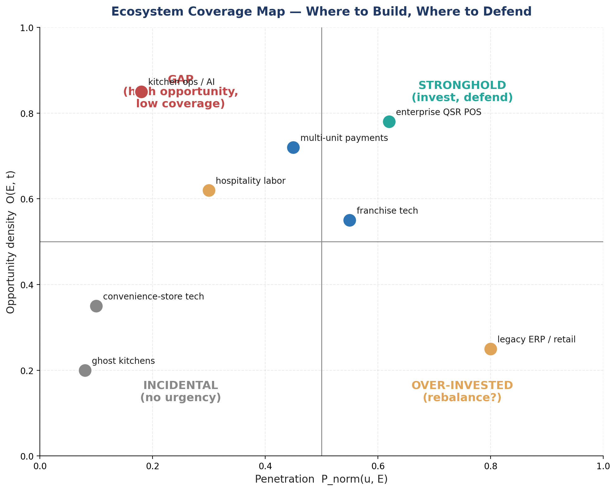
Quadrant | P_norm | O | Meaning
Gap | < 0.5 | ≥ 0.5 | High opportunity, low coverage — primary target for entry.
Stronghold | ≥ 0.5 | ≥ 0.5 | Invest and defend — keep momentum in user-strong, opportunity-rich ecosystems.
Incidental | < 0.5 | < 0.5 | Low coverage but no urgency to enter — quiet ecosystems.
Over-invested | ≥ 0.5 | < 0.5 | Coverage exceeds current opportunity — candidates for rebalancing time.

6. Power-Shift Detection
People moving between companies and ecosystems are structural events. RB detects them, classifies their impact, and emits power-shift events that update both the relationship graph and the gap layer.

6.1 Event detection
Inputs: leadership_change signals, employment-history updates (LinkedIn), user annotations. A power-shift event is a (person, from_company, to_company, t) tuple.

6.2 Classification matrix
From-company in user graph? | To-company in user graph? | Event type
yes | yes | Internal shift — DRR rebalances; new role potentially changes influence.
yes | no | Bridge formation — user gains a foothold in a new company; DRR uplift on existing edge.
no | yes | Bridge loss — user's contact at receiving company is now warm-by-import; previously unknown power moves into reach.
no | no | Ecosystem shift — no direct graph impact, but contributes to power_shift_rate(E, t) and may produce a gap-recommendation if the move is into a low-penetration focus ecosystem.

6.3 Magnitude weighting
- Influence-weighted — moves of senior decision-makers (C-suite, exec VPs) count more than IC moves.
- Ecosystem-cross-boundary moves weigh higher when the destination ecosystem is in the user's focus.
- Inferred-only moves (no public announcement, single-source detection) tagged INDUSTRY_SIGNAL or lower.
- Magnitude attenuates the recommendation it produces — a senior cross-ecosystem move into a high-G gap is the highest-priority event.

7. Entry Vectors
Every gap recommendation includes a concrete way to enter. RB ranks candidate entry vectors by realism and proximity to the user's existing graph.

7.1 Vector taxonomy
Vector | Use when | Effort
Warm intro from adjacent contact | User has a high-DRR contact one hop from the target ecosystem. | Low — ask one person.
Conference / event presence | Ecosystem has a recognized event circuit and user is willing to attend. | Medium — calendar + travel.
Thought-leadership / content | User has a credible point of view to publish and ecosystem reads it. | Medium-high — produces standing recognition.
Vendor / partner channel | User can enter via an existing vendor or partner relationship that already covers the ecosystem. | Medium — leverages existing trust.
Targeted reconnect with dormant contact | User has a dormant contact who has since moved into the ecosystem. | Low — re-activate one specific edge.
Strategic hire / advisor add | Ecosystem entry requires a credible insider; user can recruit or advise. | High — months.
Acquisition / investment | Position requires a structural commitment. | Very high.

7.2 Vector ranking
For each gap, candidate vectors are ranked by:
- Realism = function of effort + user history (vectors the user has used successfully are weighted up).
- Proximity = inverse of hops from user's existing graph to vector's required contact.
- Momentum match = does the vector align with where the ecosystem is heading (e.g., conferences for high-event ecosystems, content for analyst-driven ones)?
- Top-3 vectors are surfaced per gap; the user sees them ordered by realism.

8. Multi-Dimensional Gap Mapping
Ecosystem is the primary dimension. Two secondary dimensions add resolution: seniority and geography.

8.1 Seniority dimension
Within an ecosystem the user can be well-connected at the IC/manager level but absent at the C-suite. Penetration is computed at three seniority tiers and reported separately:
- Tier 1 — C-suite, board, founders.
- Tier 2 — VP-level operators, directors of major functions.
- Tier 3 — managers, ICs, individual operators.
A high-Tier-3 / low-Tier-1 pattern is a specific kind of gap: the user has ground-truth visibility but no decision-maker reach.

8.2 Geography dimension
- North America / EU / APAC / LATAM defaults; per-vertical refinement.
- Geographic gaps emerge when an ecosystem is internationalizing and user coverage is single-region.
- Power-shift rate by region is a leading indicator for emerging regional gaps.

9. Coverage Trends Over Time
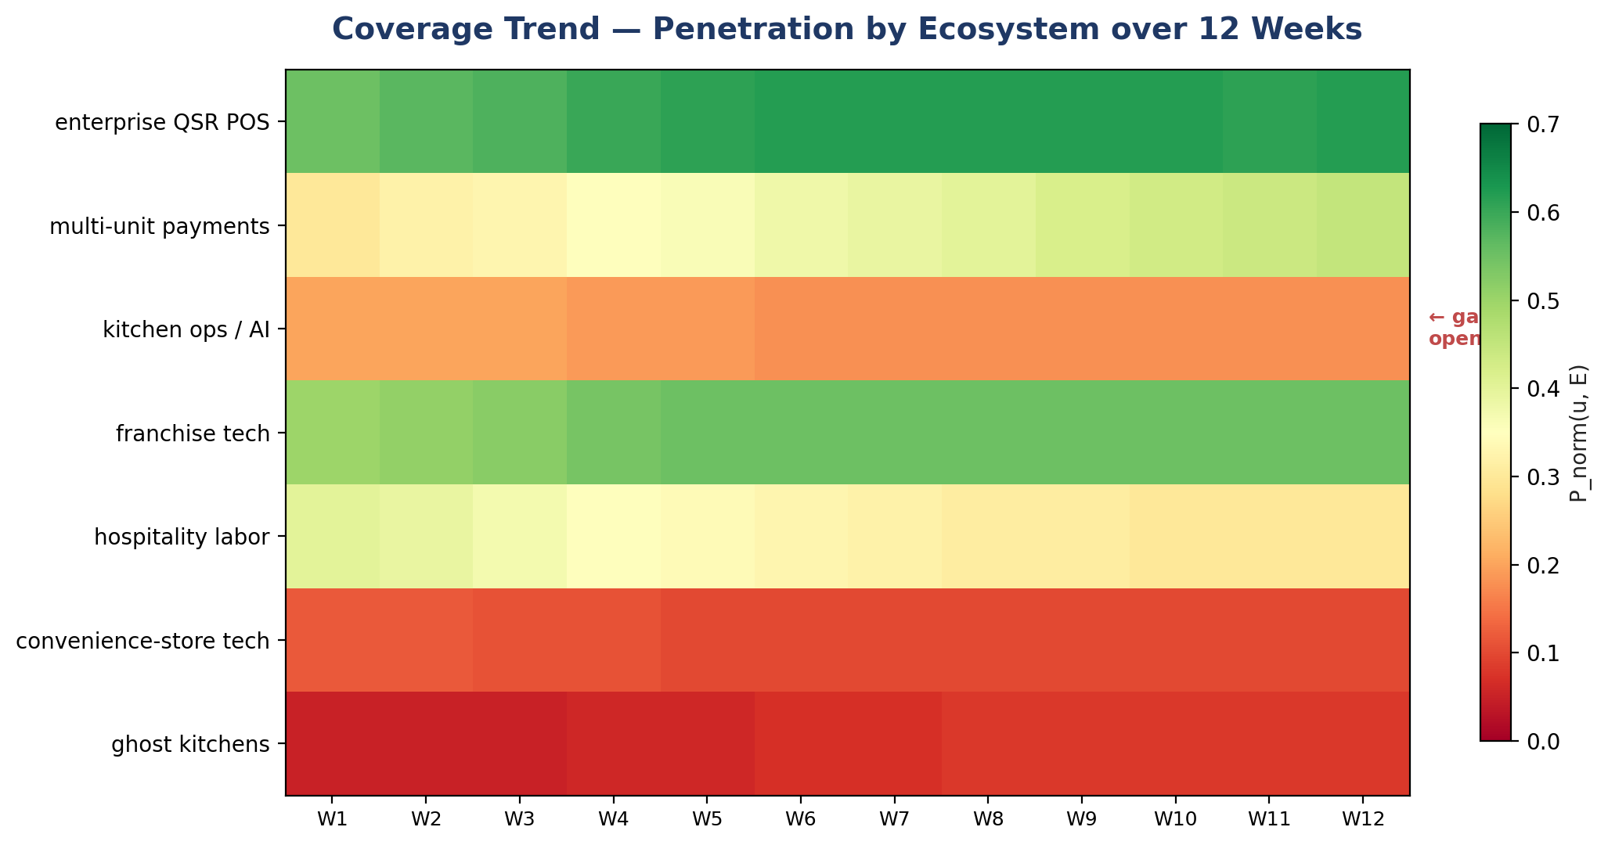
Penetration P_norm(u, E, t) is recorded weekly and rendered as a heatmap. Trends matter at three time scales:
- 12-week (operational) — the visible trend the user can act on.
- 12-month (strategic) — meaningful directional shifts; cohort comparisons against peer users (anonymized).
- Year-over-year (annual review) — long-range narrative; surfaces in periodic reflections.

9.1 Trend signals worth surfacing
- Sustained decline in a focus ecosystem (> 4 weeks of falling penetration) — alert.
- Sustained rise in a non-focus ecosystem — possible drift; user check-in.
- Sudden drop attributable to a single relationship event (e.g., a key contact left an ecosystem) — surface the cause.
- Crossing thresholds: penetration crossing from > 0.5 to < 0.5 (or vice versa) generates a gap-state change event.

10. UI Surfaces

10.1 Network Map
- Visual graph with nodes grouped by ecosystem.
- Node size = DRR-max at company; color = ecosystem; ring = warm/dormant/cold.
- Strength shading per ecosystem segment shows where the user is densely vs. thinly present.
- Hover to see specific people and their roles.

10.2 Gap Report
- Ranked list of gaps by G(u, E, t).
- Each card shows: ecosystem name, O, P_norm, top-3 entry vectors, time-to-entry estimate, current dormant contacts who could become bridges.
- Power-shift feed at the top — recent senior movement relevant to the user's focus.

10.3 Coverage Trend chart
- Heatmap of P_norm by ecosystem × week.
- Annotated with power-shift events and notable signals.
- User can click a cell to drill into the week's events.

11. Edge Cases
Case | Behavior
New ecosystem (no peer set yet) | Bootstrap with editorial taxonomy entry; P_norm low, O computed from minimal signal — caveat the score with low_confidence flag.
Ecosystem boundary shifts (segment merges) | Versioned taxonomy; old gap scores retained for trend continuity; UI shows boundary change.
User with very narrow focus | Reduce surfaced gap count to focus areas + their immediate adjacency; do not flood with off-focus gaps.
User with very broad focus | Cap surfaced gaps at 7 per cycle; rank by G.
Power-shift announced but not closed | Pending state; G contribution discounted by 50% until close confirmed.
Contact at multiple companies (board, advisor) | Per-company contribution; influence_weight reduced (split attention).
User's network heavily overlapping with one company | Single-company stronghold; ecosystem score does not over-count (max-over-people anchors).
Pure ecosystem-shift events (no graph impact) | Contributes to O(E, t) for context but does not produce a per-event recommendation; aggregated into the next coverage report.

12. Worked Examples

12.1 Example — Kitchen ops / AI gap
Inputs:
- Ecosystem: kitchen ops + AI; capacity 22 companies.
- User has 1 dormant Tier-3 contact at one company in E; max DRR ≈ 0.15.
- P(u, E) = 0.15 · 0.45 (influence) · 0.7 (company weight) ≈ 0.047; ecosystem_capacity ≈ 18.5; P_norm ≈ 0.003.
- Opportunity inputs: average M = +0.35; signal density 1.4 signals/co/12wk; funding density high (recent $200M+ rounds); hiring density very high. O ≈ 0.85.
- User focus: 'restaurant operations technology' overlaps strongly with E.
G = O · (1 - P_norm)^1.5 = 0.85 · (0.997)^1.5 ≈ 0.846
Top entry vectors:
1. Reconnect dormant Tier-3 contact (low effort) — could re-activate to bridge.
2. Conference presence at MURTEC + FSTEC (medium effort).
3. Thought-leadership piece on kitchen-ops AI integration (medium effort).
Output: top-of-gap-report card with three ranked vectors and a recommendation to begin with the dormant reconnect (lowest effort, highest realism).

12.2 Example — Power-shift bridge formation
Event: warm contact (Director-level) at Co A moves to Co B, where the user previously had no contacts. Co B is in the ent-QSR-POS ecosystem (currently a stronghold for the user).
Effects:
- New edge created at Co B (carries inherited warmth from the moving contact).
- P(u, ent-QSR-POS) increases via new company_weight contribution.
- Power-shift event surfaces in the feed; magnitude weighted by influence and ecosystem focus match.
- If Co B is itself a watched company, profile shows the new graph_link.

Appendix A — Formula Reference
P(u, E, t) = Σ_v ∈ E ∩ user.graph max_p DRR · influence · company_weight
P_norm = P / ecosystem_capacity(E)
O(E, t) = σ( Σ z_i · component_i )
G(u, E, t) = O · (1 - P_norm)^β default β = 1.5
Quadrants (P_norm, O):
( < 0.5, ≥ 0.5 ) → GAP
( ≥ 0.5, ≥ 0.5 ) → STRONGHOLD
( < 0.5, < 0.5 ) → INCIDENTAL
( ≥ 0.5, < 0.5 ) → OVER-INVESTED

Appendix B — Glossary
Term | Definition
Ecosystem | Coherent market neighborhood (segment + business model + technology context).
Penetration P(u, E, t) | User's weighted presence in ecosystem E at time t.
Opportunity density O(E, t) | Strategic activity in E, independent of the user.
Gap score G(u, E, t) | Composite favoring high-opportunity, low-coverage ecosystems.
Power-shift | (person, from_company, to_company, t) event; restructures the graph.
Entry vector | Concrete tactic to begin filling a gap; ranked by realism and proximity.

