PRODUCT PORTFOLIO MAP
Genius restaurant
technology
McDonald’s capability overview
One connected restaurant technology portfolio
Genius brings enterprise commerce, kitchen operations, digital experience, drive-thru, self-service, purpose-built hardware, payments and back-office capabilities together within a flexible platform.

Prepared for | Jeff Coffland
As of | August 12, 2026
Company | Global Payments

Portfolio at a glance
- Genius POS, Kitchen, Digital Menu Board, Drive Thru, Kiosk, Hardware, Payments and Back Office.
- Each entry summarizes product heritage, capabilities, relevance to McDonald’s and selected experience.
- CosMc’s is presented first where it provides the most directly relevant experience.

PRODUCT MAP 1 OF 5

Commerce and kitchen operations
Genius POS
Heritage | Xenial enterprise POS and Xenial Ordering, now part of the Genius Cloud portfolio.
Capabilities | Cloud enterprise POS with centralized management, real-time synchronization, device and operating-system flexibility, rapid terminal failover and offline operation for up to 30 days.
McDonald’s relevance | A flexible restaurant-commerce and integration platform that can connect front-of-house channels with enterprise services.
Selected experience | CosMc’s selected Genius Cloud POS as part of its integrated restaurant technology platform. Additional enterprise experience includes A&W Canada across 1,032 restaurants and 7 Brew across more than 530 locations.
Genius Kitchen
Heritage | Xenial Kitchen Management (XKM), Kitchen Management and Order Management System (OMS), now within the Genius portfolio.
Capabilities | Kitchen displays route items to configured production stations, support drive-thru and other destination-specific views, provide order-ready status and support configurable touchscreen or bump-bar workflows.
McDonald’s relevance | Connects order channels with production workflows to support throughput, order accuracy and operational visibility.
Selected experience | Genius Kitchen is supported by active product documentation and a continuing Xenial Kitchen release history.

PRODUCT MAP 2 OF 5

Digital menu boards and drive-thru
Genius Digital Menu Board
Heritage | SICOM DMB, first developed in 2009, was replaced by the next-generation Genius digital menu platform following Global Payments’ acquisition of SICOM.
Capabilities | Centralized content management, scheduled dayparts, local and corporate control, indoor/outdoor menus and order-confirmation boards. System-on-chip displays can retain scheduled content during an internet outage.
McDonald’s relevance | Offers a flexible digital-menu architecture for targeted indoor, drive-thru and order-confirmation requirements.
Selected experience | CosMc’s selected Genius indoor and drive-thru digital menu boards as part of its integrated restaurant technology platform. Yoshinoya deployed digital menu boards at 106 locations.
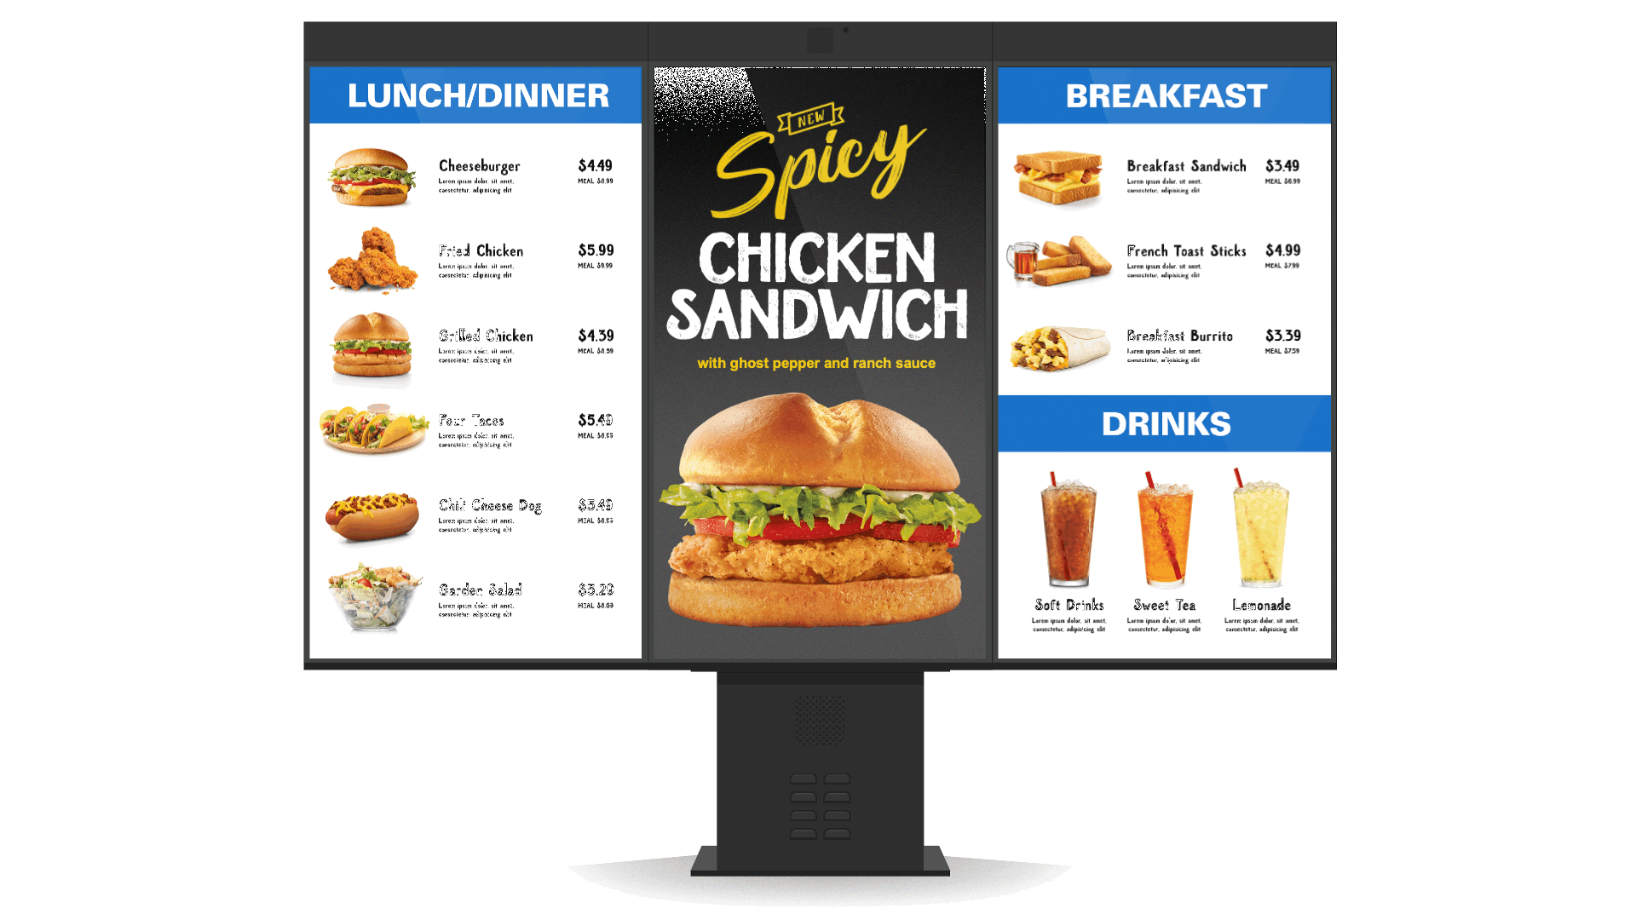
Representative Genius system-on-chip digital menu board configuration
Genius Drive Thru
Heritage | SICOM Timer → Drive-Thru Director → Vision, the Genius next-generation drive-thru timer platform.
Capabilities | Lane events from detectors, cameras and order-confirmation units; real-time vehicle visualization; single/dual-lane workflows; reporting and APIs; zone configuration for queue, pickup and pull-forward activity.
McDonald’s relevance | Supports speed-of-service visibility and a more complete operational view of the drive-thru journey.
Selected experience | CosMc’s selected Genius drive-thru timer technology as part of its integrated platform. At Yoshinoya, 34 drive-thru locations paired menu boards with a timer and reported a 35% improvement in service time.

PRODUCT MAP 3 OF 5

Self-service ordering
Genius Kiosk
Heritage | Xenial Kiosk hardware and software and Xenial Ordering Kiosk, now within the Genius portfolio.
Capabilities | Indoor/outdoor self-service ordering with multiple mounting options, favorites and repeat orders, multilingual and accessibility features, dynamic splash screens and pickup workflows.
McDonald’s relevance | Provides modular self-service and integration options for restaurant environments, subject to McDonald’s store and accessibility standards.
Selected experience | CosMc’s selected Genius indoor and outdoor kiosks as part of its integrated platform. Genius brings more than 20 years of kiosk development and 15,000+ self-service installations worldwide.
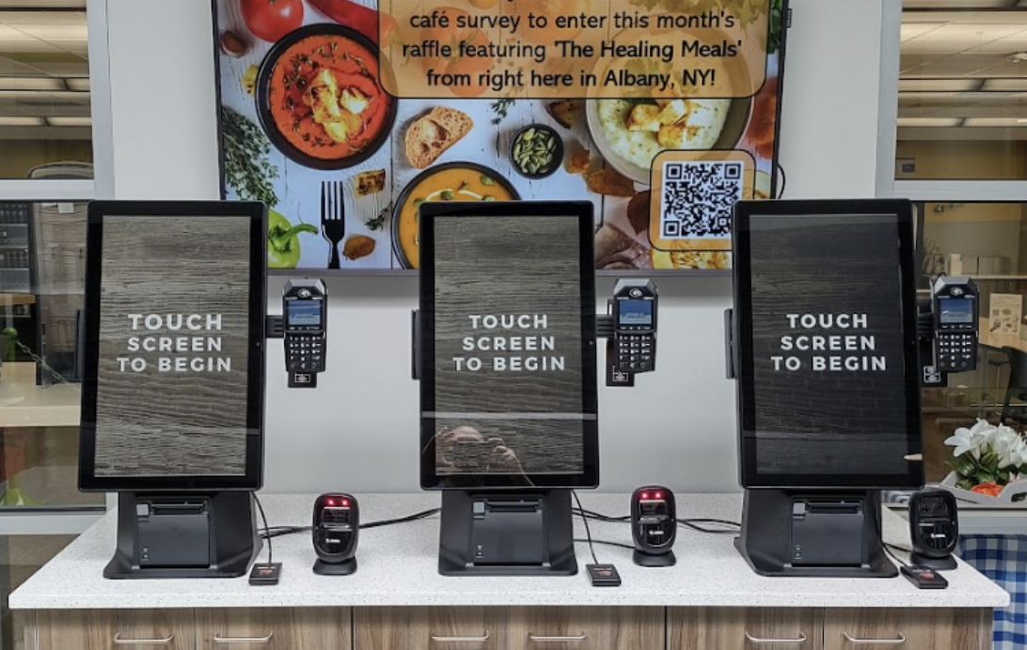
Freestanding Genius self-service kiosks in a restaurant environment

PRODUCT MAP 4 OF 5

Genius hardware
Genius Hardware
Heritage | Xenial and SICOM POS hardware, portable tablets and rugged terminals, unified under the Genius hardware identity.
Capabilities | Global Payments designs and owns the core Genius hardware specification, with Flytech as manufacturing partner. The portfolio supports modular countertop, handheld, kiosk and tethered configurations.
McDonald’s relevance | Provides a consistent device experience across counter, line-busting and self-service workflows, subject to McDonald’s hardware, certification and service requirements.
Selected experience | CosMc’s selected Genius hardware across its cloud POS and indoor/outdoor self-service environment.
Countertop  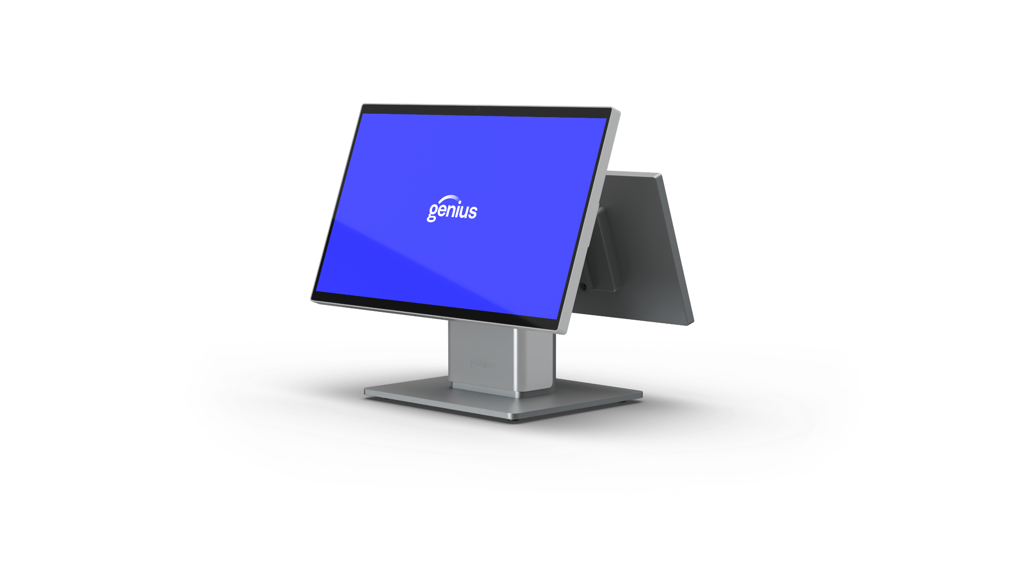  Modular merchant and customer-facing displays. | Handheld  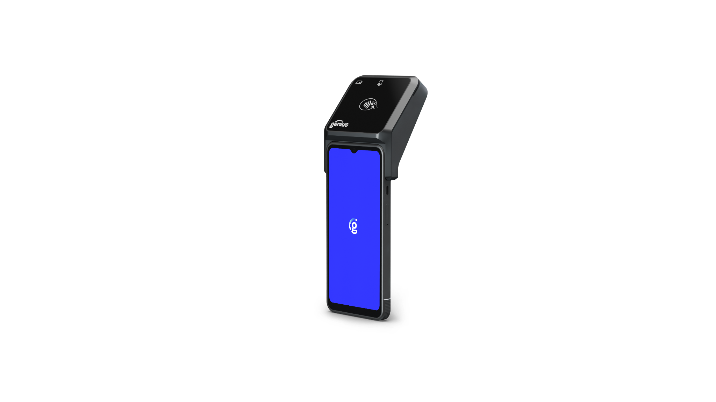  Portable POS with integrated payment. | Counter and kiosk  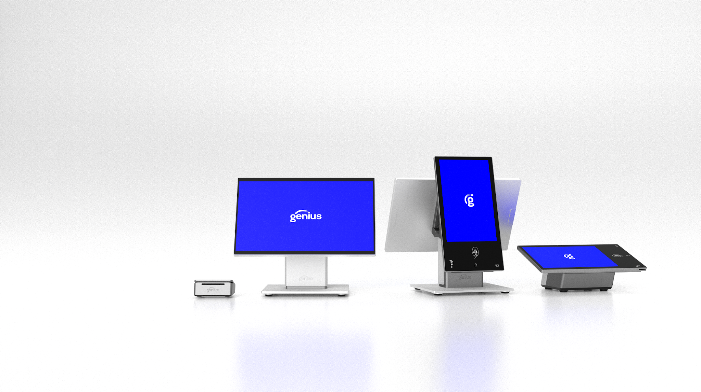  Multiple configurations within one hardware family.

PRODUCT MAP 5 OF 5

Payments and back office
Genius Payments
Heritage | Global Payments Integrated and Portico capabilities, with Merchantware/Cayan heritage and Global Payments + Worldpay processing reach.
Capabilities | Integrated acceptance across counter, drive-thru, kiosk and digital commerce; EMV/contactless and wallets; card-present and online acceptance; P2PE/tokenization; terminal management and store-and-forward.
McDonald’s relevance | Supports cross-channel orchestration, processor flexibility, centralized device control, offline resilience and token continuity.
Selected experience | CosMc’s used Global Payments for payment processing; FreedomPay supplied the gateway for its unattended-payment requirement.
Genius Back Office
Heritage | The Portal RTI, RTI Financial Accounting, Back Office and enterprise reporting heritage.
Capabilities | Back-office and enterprise reporting capabilities spanning restaurant operations, inventory, labor, financial information and enterprise-level visibility.
McDonald’s relevance | Connects restaurant activity with operational and enterprise reporting to support more consistent decision-making across the system.
Selected experience | Global Payments continues to support customers across The Portal RTI, RTI Financial Accounting and Back Office product families.

