PRODUCT PORTFOLIO MAP
Genius restaurant
technology
McDonald’s routing reference
VALIDATION COPY — NOT YET FOR EXTERNAL DISTRIBUTION
A concise view of the Genius restaurant portfolio, its product heritage and its relevance to McDonald’s. Ryan Hildebrand or Michael Schwartz should validate the highlighted confirmation items before it is shared with Jeff Coffland.

Prepared for | Jeff Coffland — McDonald’s capability overview
Validation | Ryan Hildebrand or Michael Schwartz
As of | August 12, 2026
Basis | Official Global Payments/Xenial materials + internal product and payments inputs

How to read this map
- Each entry identifies the current product, its former Xenial/SICOM/RTI heritage, supported capabilities and relevance to McDonald’s.
- Customer examples show demonstrated fit; they do not imply McDonald’s approval or a production entitlement.
- Items marked “Confirm before sharing” are reviewer checks, not part of the final external narrative.

PRODUCT MAP 1 OF 4

Core commerce and self-service
Genius Enterprise POS PUBLICLY GROUNDED
Current label | Genius Enterprise POS
Lineage | Working lineage: Xenial enterprise POS / Xenial Ordering. Confirm the exact product-to-product mapping.
What is supported | Cloud enterprise POS with centralized management, real-time synchronization, device/OS flexibility and offline operation. The internal pitch deck describes serverless in-store architecture, rapid terminal failover and offline capability for up to 30 days; validate those specifics before external use.
McDonald’s relevance | Relevant as an integration and restaurant-commerce platform reference. Do not position it as a proposed NEWPOS replacement without an explicit McDonald’s request.
Proof point | A&W Canada: 1,032 restaurants in under three years. Internal deck: 7 Brew deployed 530+ locations in nine weeks and supports millions of transactions weekly.
Confirm before sharing | Current sellable edition/SKU; exact Xenial lineage; offline/failover claims; supported markets and service model; permission to use 7 Brew metrics; what POS version CosMc’s used.
Genius Kiosk PUBLICLY GROUNDED
Current label | Genius Kiosk / enterprise self-service ordering
Lineage | Former public label: Xenial Kiosk hardware and software / Xenial Ordering Kiosk.
What is supported | Self-service ordering with indoor/outdoor and multiple mounting options. The internal deck adds 20+ years of kiosk development, 15,000+ self-service installations, favorites/repeat orders, multilingual and accessibility options, dynamic splash screens and pickup workflows.
McDonald’s relevance | Relevant where McDonald’s wants modular self-service or integration options, subject to global store standards and accessibility requirements.
Proof point | Xenial materials describe hardware/software plus an SDK path; the internal deck states 15,000+ self-service solutions installed worldwide.
Confirm before sharing | Current external name/configurations; validation and external-use permission for the 20+ year and 15,000+ claims; vendors; accessibility/security; payments; CosMc’s use; service coverage.

PRODUCT MAP 2 OF 4

Kitchen, back office and payments
Genius Kitchen PUBLICLY GROUNDED
Current label | Genius Kitchen / Kitchen Display System (KDS)
Lineage | Former/current documentation labels include Xenial Kitchen Management (XKM), Kitchen Management and Order Management System (OMS). Confirm portfolio boundaries.
What is supported | Kitchen displays route items to configured production stations, support destination-specific views such as drive-thru, and can provide order-ready status. Public documentation describes touchscreen and bump-bar interaction plus configurable ticket views.
McDonald’s relevance | Relevant to end-to-end order flow, throughput and integration conversations—not as an assumed replacement for McDonald’s kitchen production systems.
Proof point | Current Xenial documentation shows active Genius Kitchen product documentation and Xenial Kitchen release notes.
Confirm before sharing | Which KDS/OMS components are current, their external names, integration interfaces, hardware requirements, enterprise deployments and any CosMc’s footprint.
Genius Back Office CONFIRM BEFORE EXTERNAL USE
Current label | Working label: Genius Back Office / enterprise reporting
Lineage | Historical labels visible in Xenial support materials: The Portal RTI, RTI Financial Accounting, Back Office and enterprise reporting.
What is supported | Public Xenial portfolio materials establish back-office and enterprise-reporting capabilities, while support materials show continuing RTI-related product families. Detailed current scope is not sufficiently clear for an external claim in this draft.
McDonald’s relevance | Potentially relevant to store operations, inventory, labor, financial and enterprise reporting discussions once the current module map is confirmed.
Proof point | Xenial’s current support directory still routes customers for The Portal RTI, RTI Financial Accounting and Back Office.
Confirm before sharing | Current product names and module boundaries; RTI lineage; supported functions and integrations; customer references; roadmap/status; owner and delivery coverage.
Integrated payments and gateway CONFIRM BEFORE EXTERNAL USE
Current label | Global Payments Integrated (GPI) and Portico Gateway; processor connections include Global Payments and Worldpay/Vantiv
Lineage | Working lineage: Merchantware → Cayan; the current payments deck identifies GPI and Portico. Confirm the precise brand-to-platform transition before using the lineage externally.
What is supported | One semi-integrated/API layer for counter, drive-thru, kiosk and digital commerce: EMV/contactless and wallets, card-present and online acceptance, P2PE/tokenization, hosted payment components, remote terminal management and device-based store-and-forward. Listed processor connections include Global Payments, Worldpay/Vantiv, Fiserv, Elavon and Chase.
McDonald’s relevance | The McDonald’s story is cross-channel orchestration, processor flexibility, centralized device control, offline resilience and token continuity—not the full feature catalog.
Proof point | CosMc’s used Global Payments processing, but FreedomPay supplied the gateway because the required unattended certification was unavailable in time. This is not proof of a full GPI gateway deployment.
Confirm before sharing | Arjun/Payments: confirm names and lineage; GP versus Worldpay roles; processor/device certifications by market; unattended status; current Verifone/iMin availability; and what may be shared with Jeff.
PRODUCT MAP 3 OF 3
PRODUCT MAP 3 OF 4

Digital experience and drive-thru
Genius Digital Displays PUBLICLY GROUNDED
Current label | Working current label: Genius digital menu technology / digital menu screens
Lineage | SICOM DMB was first developed in 2009. After Global Payments acquired SICOM in 2018, the next-generation Genius DMB was developed as a complete replacement—not an extension of the former SICOM software.
What is supported | Centralized content management, scheduled dayparts, local/corporate control, indoor/outdoor menus and order-confirmation boards. The internal pitch deck identifies LG system-on-chip displays and scheduled content that remains current during an internet outage; architecture can vary by deployment.
McDonald’s relevance | A credible alternative architecture to evaluate for targeted needs. Do not characterize McDonald’s as replacing an incumbent or running a formal second-source process.
Proof point | Xenial reports deployment at 106 Yoshinoya locations; 34 drive-thrus combined digital menu boards and a timer, with a reported 35% service-time reduction.
Confirm before sharing | Current name; CMS/monitoring model; LG system-on-chip and offline-content claims; supported playerless versus controller configurations; partners; service coverage; CosMc’s footprint; reference permission.
Genius Drive Thru PUBLICLY GROUNDED
Current label | Genius Drive Thru; current documentation includes Drive Thru Director and Vision
Lineage | SICOM Timer (1989) → rewrite (2001) → new monitor/UI solution (2014) → Drive-Thru Director with continued Genius enhancements. Vision, developed around 2022, is the 100% Genius next-generation timer.
What is supported | Lane events from detectors, cameras and intelligent order-confirmation units; real-time vehicle visualization; single/dual-lane workflows; gamification; reporting/API. The pitch deck shows Vision zone configuration for stack size, pickup parking and pull-forward tracking across the customer journey.
McDonald’s relevance | Strongest near-term proof area if Product confirms what is commercially available, what was used at CosMc’s and which integration/service commitments are supportable.
Proof point | Yoshinoya is the public proof point. The JPR discussion also identified CosMc’s as an important internal reference, but exact scope and disclosure permission remain unverified.
Confirm before sharing | Current sellable components versus roadmap; supported sensor/camera/OCU architecture; reporting/API; AI claims; CosMc’s requirements and deployed scope; customer references; install/field-service ownership.
Hold from the external version unless Ryan confirms
Claims that the system reuses existing security-camera feeds; Wi-Fi camera deployment; employee movement tracking; player-free DMB as a universal architecture; or a camera timer developed specifically for CosMc’s. These may be valuable hypotheses, but they are not treated as verified capabilities here.

REFERENCE

Source notes and claim boundaries
Evidence standard
Publicly grounded does not mean customer-approved for reuse. Ryan should still confirm current availability, product naming, reference permissions and the operational delivery model before external circulation.

Source | URL | Used for
Genius overview | https://www.globalpayments.com/genius | Suite categories, restaurant workflow and general hardware language.
Genius Enterprise POS | https://www.globalpayments.com/point-of-sale/enterprise/enterprise-pos | Enterprise architecture, operating systems, hardware flexibility, order channels and A&W Canada reference.
Genius QSR | https://www.globalpayments.com/en-gb/point-of-sale/restaurant/quick-service | Countertop and handheld category descriptions.
Genius launch announcement | https://investors.globalpayments.com/news-events/press-releases/detail/473/global-payments-launches-new-genius-pos-platform | Unified Genius positioning and enterprise launch context.
Xenial product portfolio | https://www.xenial.com/products/ | Legacy/current portfolio taxonomy across POS, kiosk, kitchen, displays, back office and drive-thru.
Genius Kitchen documentation | https://www.xenial.com/product-documentation/en/genius-kitchen/kitchen-management-interface/kitchen-displays.html | Kitchen routing, ticket views, notifications and order-ready display.
Xenial kiosk | https://www.xenial.com/products/kiosk-hardware-software/ | Kiosk hardware/software options, peripherals and SDK positioning.
Genius Drive Thru documentation | https://www.xenial.com/developer-resources/en/genius-drive-thru.html | Drive Thru Director, Vision, lane inputs, visualization and reporting/API.
Yoshinoya case study | https://www.xenial.com/case-studies/yoshinoya-menu-board/ | Public DMB/timer deployment and reported outcome.
Xenial Digital Displays | https://www.xenial.com/pdfs/Xenial-Restaurant-Digital-Displays.pdf | Indoor/outdoor display use cases, control and operations support.
Xenial support directory | https://www.xenial.com/support/ | Visible legacy support families including RTI and Back Office.

Internal inputs requiring confirmation
- August 11 JPR discussion with Jeff Coffland, including the requested product-lineage map and CosMc’s context.
- Internal account intelligence: CosMc’s footprint, hardware ownership/manufacturing, roadmap concepts, references and owners.
- Michael Schwartz product confirmation, August 11, 2026: DMB and timer lineage, Flytech manufacturing relationship, hardware ownership, Merchantware/Cayan direction and CosMc’s processing/gateway architecture.
- Global Payments Integrated — Payments Overview (internal 2025 deck, received August 12, 2026): GPI/Portico architecture, channels, processor connections, terminal management, offline operation and devices. Roadmap labels and certifications require confirmation.
- Genius N Pitch Deck (internal 2025 deck, received August 12, 2026): product taxonomy, hardware imagery/specifications, architecture and APIs, offline resilience, integration categories, 7 Brew/A&W/CosMc’s proof points, kiosk scale, DMB system-on-chip and Vision workflow. All non-public claims require Product approval.

PRODUCT MAP 4 OF 4 — HARDWARE REFERENCE

Genius hardware
A modular in-store hardware family CONFIRM BEFORE EXTERNAL USE
Current label | Genius countertop, handheld, kiosk, tethered and GP One hardware families
Lineage | Heritage: Xenial and SICOM POS hardware, portable tablets and rugged terminals. Configuration and naming may vary by Genius edition and geography.
What is supported | Global Payments designs and owns the core Genius hardware specification, with Flytech as manufacturing partner. The portfolio supports modular countertop, handheld, kiosk and tethered configurations. Payment terminals and the iMin-based Genius All In One are separate device families.
McDonald’s relevance | Provides a consistent Genius device experience across counter, line-busting and self-service workflows, subject to McDonald’s hardware standards, certifications and support requirements.
Proof point | The current Genius pitch deck presents one hardware identity across customer segments and restaurant workflows.
Confirm before sharing | Ryan or Michael: current model names/SKUs; which devices are Flytech-, Verifone- or iMin-based; OS/payment certifications; availability by market; lifecycle/service model; CosMc’s configuration; and permission to share images and manufacturer names.
Modular countertop  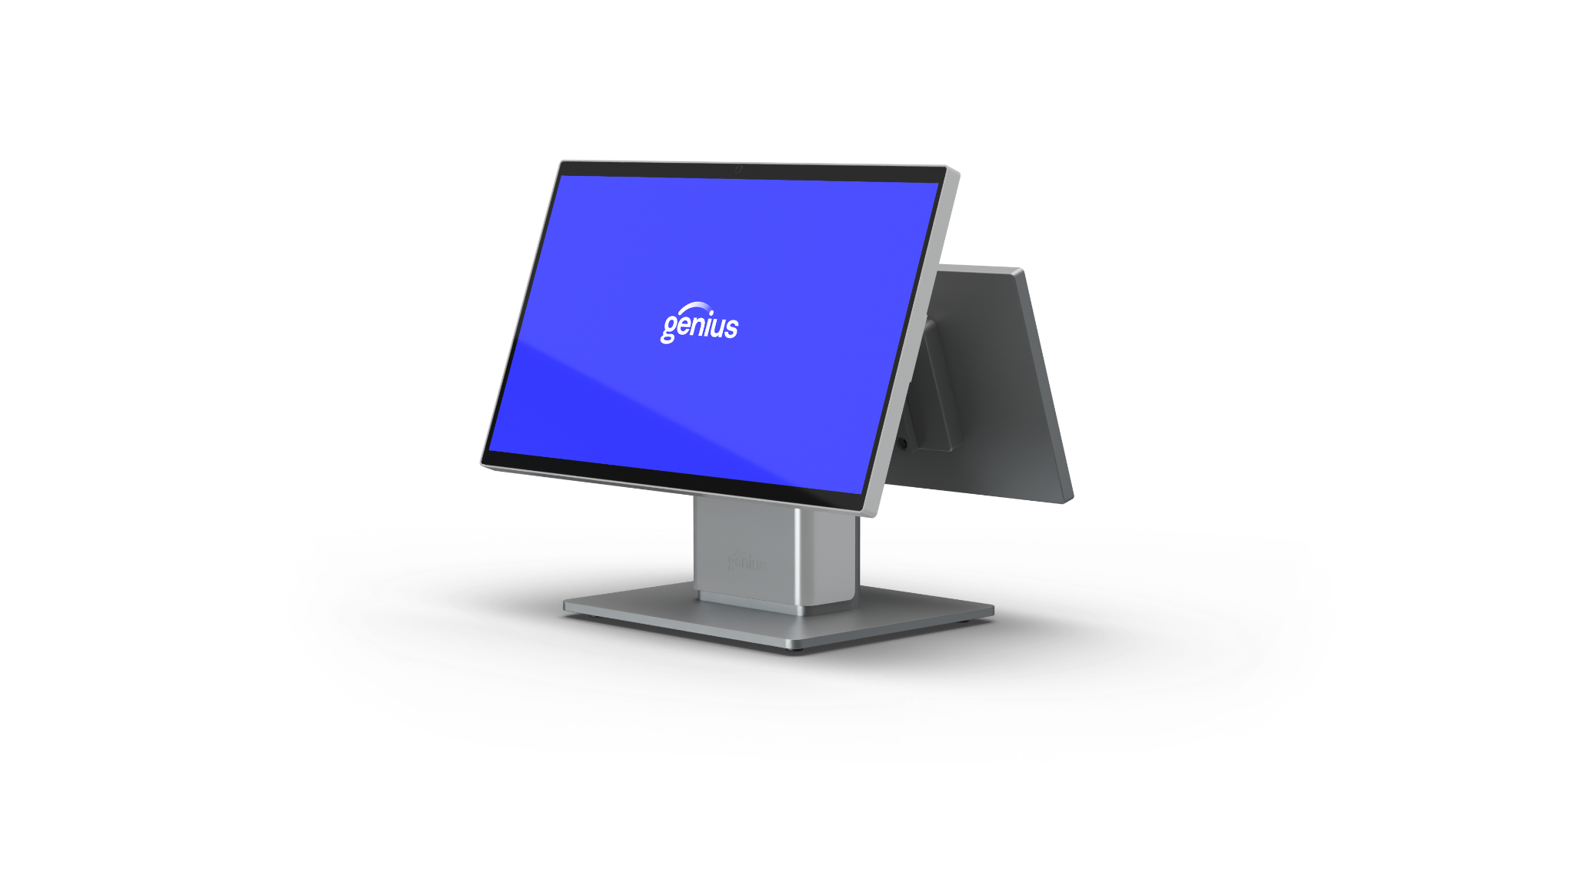  Modular merchant and customer-facing displays with countertop, low-profile, wall and self-service configurations. | Enterprise handheld  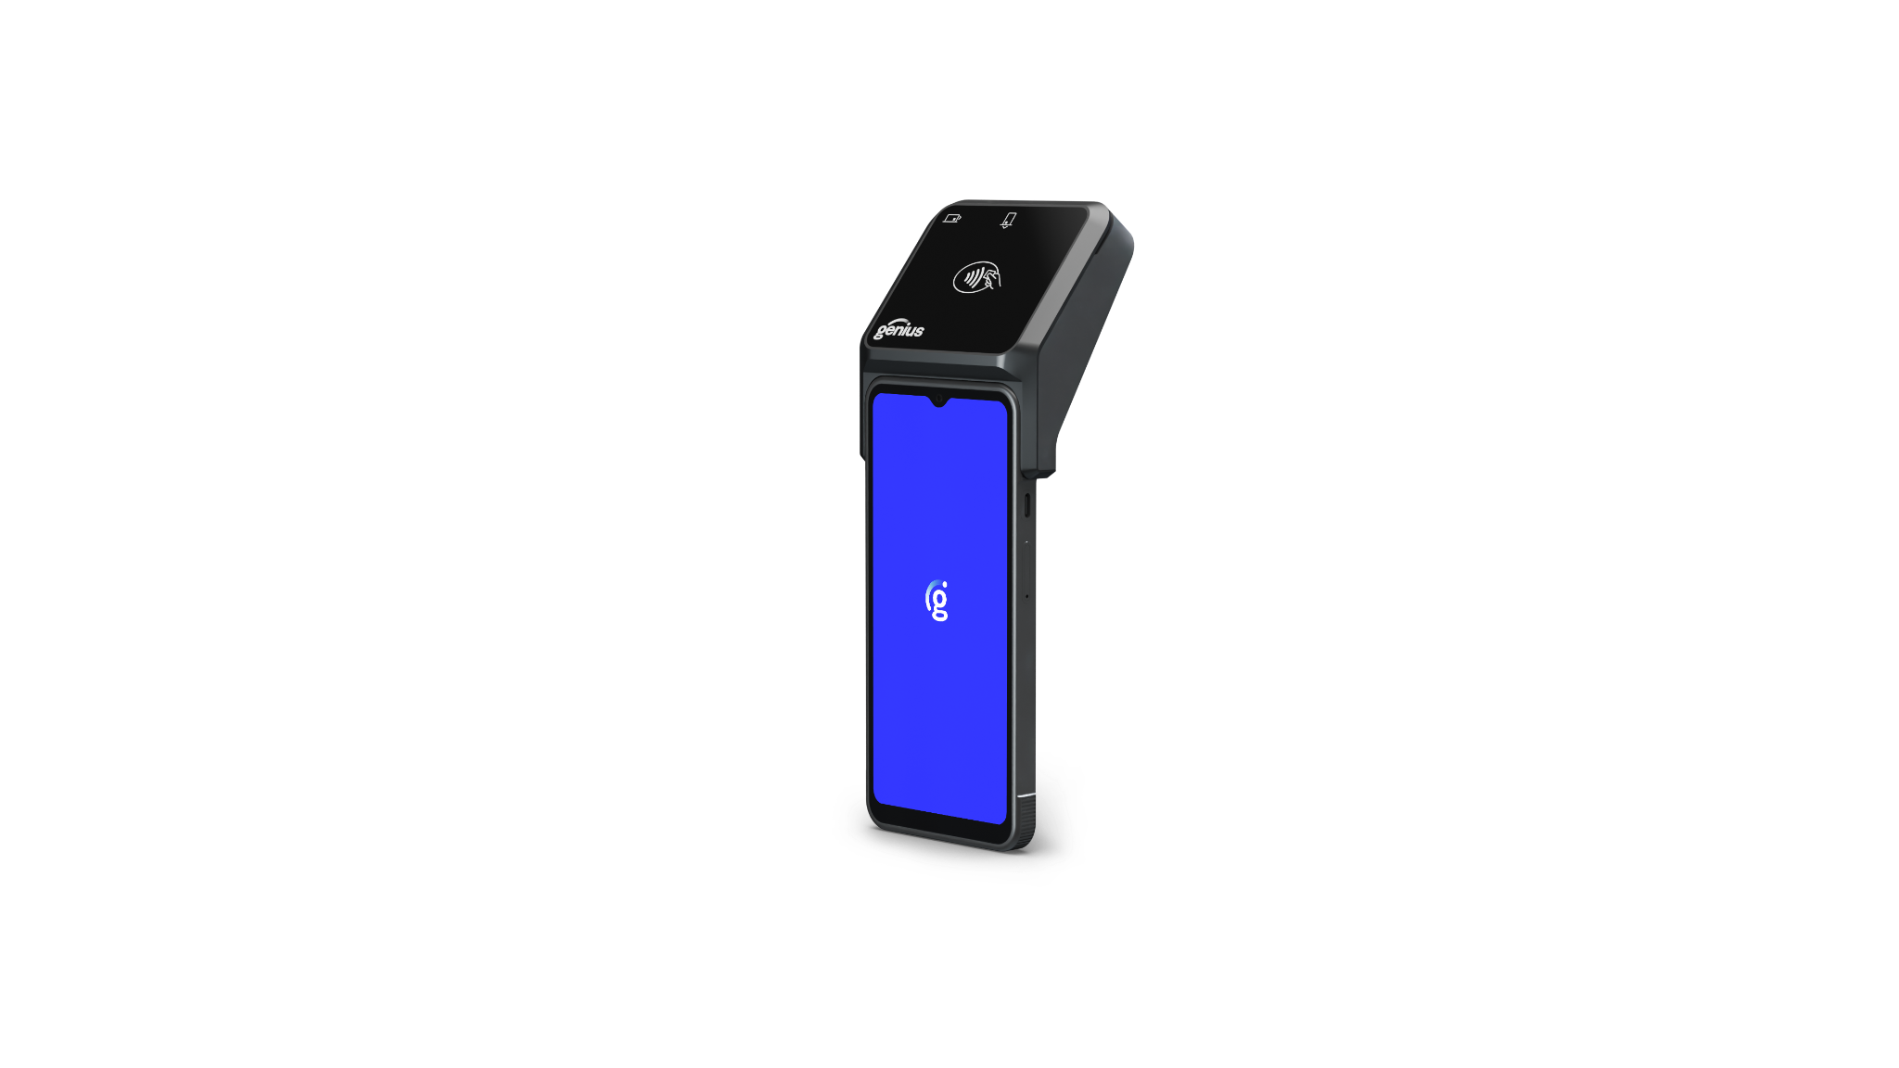  Portable enterprise POS for line-busting and mobile service, shown with integrated payment. | Self-service portfolio  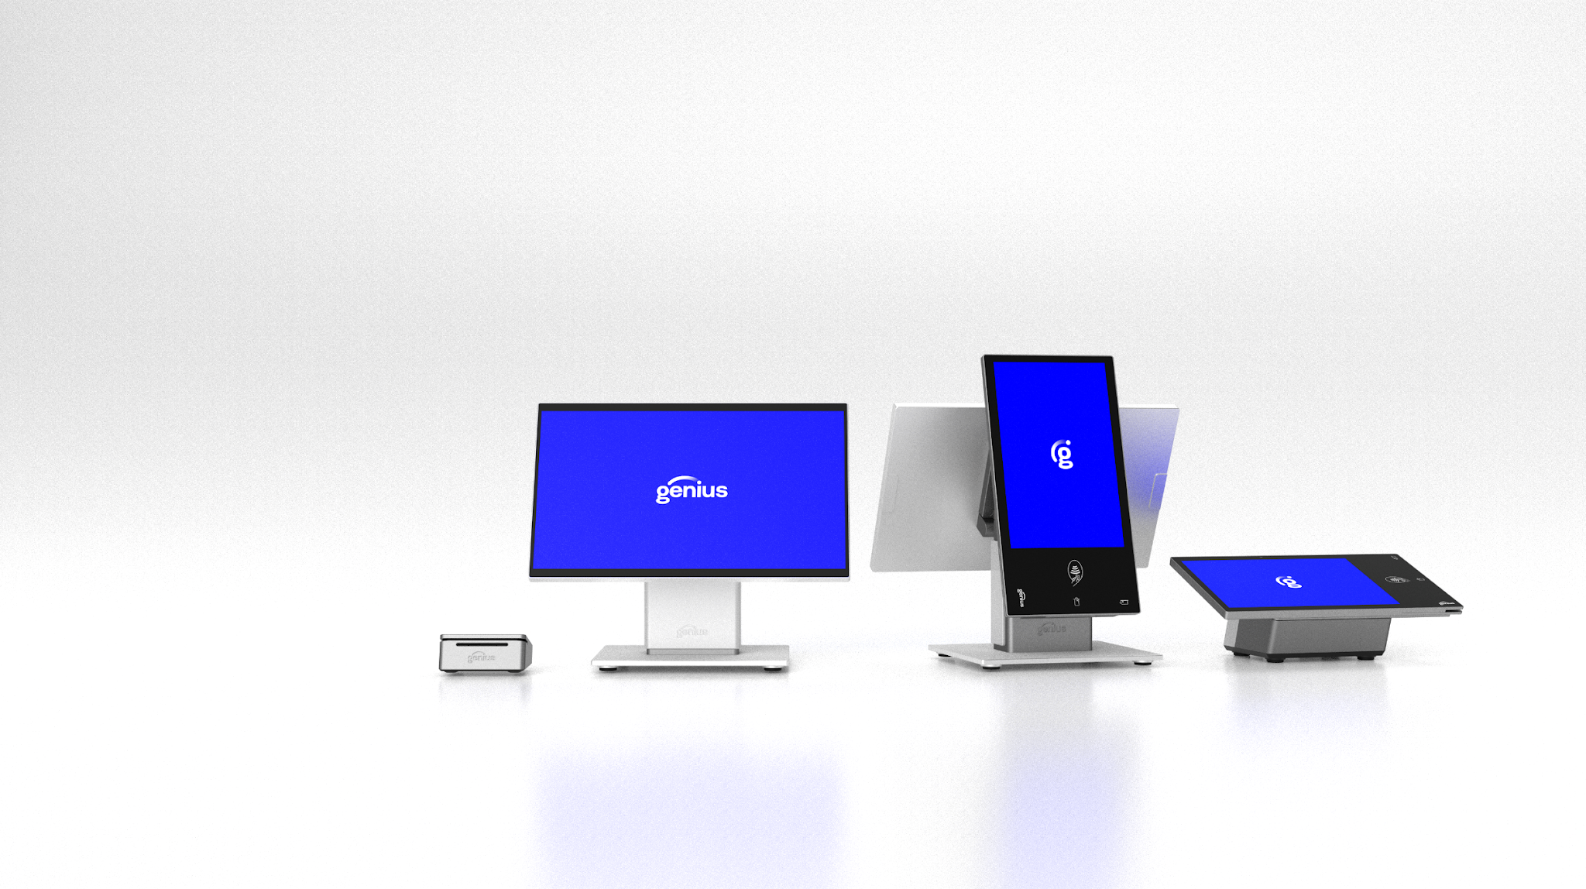  Countertop, portrait self-service and tethered configurations within one Genius visual identity.
Reviewer sign-off
Ryan Hildebrand or Michael Schwartz should confirm the hardware naming, manufacturers, specifications, certifications, availability and image-sharing rights before this page is provided to Jeff.

