PRODUCT PORTFOLIO MAP
Genius restaurant
technology
McDonald’s capability overview
One connected restaurant technology portfolio
Genius brings enterprise commerce, kitchen operations, digital experience, drive-thru, self-service, purpose-built hardware, payments and back-office capabilities together within a flexible platform.

Prepared for | Jeff Coffland
As of | August 12, 2026
Company | Global Payments

Portfolio at a glance
- Genius POS, Kitchen, Digital Menu Board, Drive Thru, Kiosk, Hardware, Payments and Back Office.
- Each entry summarizes product heritage, capabilities, relevance to McDonald’s and selected experience.
- CosMc’s is presented first where it provides the most directly relevant experience.

PRODUCT MAP 1 OF 5

Commerce and kitchen operations
Genius POS
Heritage | Xenial enterprise POS and Xenial Ordering, now part of the Genius Cloud portfolio.
Capabilities | API first, Cloud enterprise POS with centralized management, real-time synchronization, device and operating-system flexibility, rapid terminal failover and offline operation for up to 30 days. Works with existing hardware or Genius Hardware solutions. Supports Windows, Android, IOS and Unix operating systems. Supports multi-lingual and international locations.
McDonald’s relevance | A flexible restaurant-commerce and integration platform that can connect front-of-house channels with enterprise services.
Selected experience | CosMc’s selected Genius Cloud POS as part of its integrated restaurant technology platform. Additional enterprise experience includes A&W Canada across 1,032 restaurants and 7 Brew across more than 530 locations.
Genius Kitchen
Heritage | Xenial Kitchen Management (XKM), Kitchen Management and Order Management System (OMS), now within the Genius portfolio.
Capabilities | Kitchen displays route items to configured production stations, support drive-thru and other destination-specific views, provide order-ready status and support configurable touchscreen or bump-bar workflows.
McDonald’s relevance | Connects order channels with production workflows to support throughput, order accuracy and operational visibility.
Selected experience

PRODUCT MAP 2 OF 5

Drive-thru and digital menu boards
Genius Drive Thru Timer
Heritage | SICOM Timer (1989) → rewrite (2001) → new monitor/UI solution (2014) → Drive-Thru Director with continued Genius enhancements. Vision, developed around 2022, is the 100% Genius next-generation timer.
Capabilities | Lane events from detectors, cameras and intelligent order-confirmation units; real-time vehicle visualization; single/dual-lane workflows; gamification; reporting/API. Zone configuration for stack size, pickup parking and pull-forward tracking across the customer journey.
McDonald’s relevance | Supports speed-of-service visibility and a more complete view of the drive-thru journey, including queue, pull-forward and pickup activity.
Selected experience | CosMc’s selected Genius drive-thru timer technology as part of its integrated platform.
Genius Digital Menu Board
Heritage | SICOM DMB, first developed in 2009, was replaced by the next-generation Genius digital menu platform following Global Payments’ acquisition of SICOM.
Capabilities | Centralized content management, scheduled dayparts, local and corporate control, indoor/outdoor menus and order-confirmation boards. System-on-chip displays can retain scheduled content during an internet outage.
McDonald’s relevance | Offers a flexible digital-menu architecture for targeted indoor, drive-thru and order-confirmation requirements.
Selected experience | CosMc’s selected Genius indoor and drive-thru digital menu boards as part of its integrated restaurant technology platform. Yoshinoya deployed digital menu boards at 106 locations.
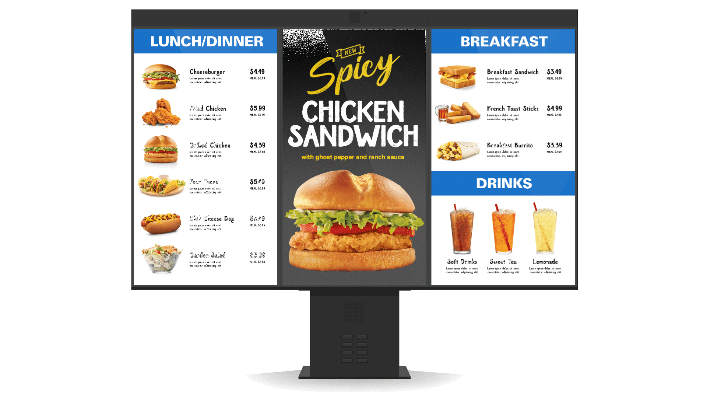
Representative Genius system-on-chip digital menu board configuration

PRODUCT MAP 3 OF 5

Self-service ordering
Genius Kiosk
Heritage | Xenial Kiosk hardware and software and Xenial Ordering Kiosk, now within the Genius portfolio.
Capabilities | Indoor/outdoor self-service ordering with multiple mounting options, favorites and repeat orders, multilingual and accessibility features, dynamic splash screens and pickup workflows.
McDonald’s relevance | Provides modular self-service and integration options for restaurant environments, subject to McDonald’s store and accessibility standards.
Selected experience | CosMc’s selected Genius indoor and outdoor kiosks as part of its integrated platform. Genius brings more than 20 years of kiosk development and 15,000+ self-service installations worldwide.
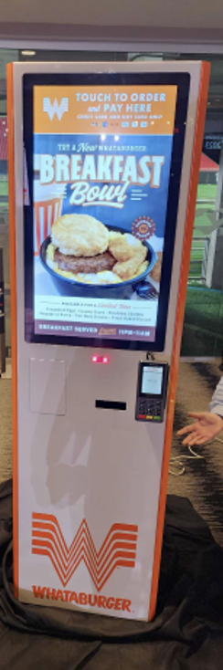
Freestanding Genius self-service kiosk in a restaurant environment

PRODUCT MAP 4 OF 5

Genius hardware
Genius Hardware
Heritage | Xenial and SICOM POS hardware, portable tablets and rugged terminals, unified under the Genius hardware identity.
Capabilities | Global Payments designs and owns the core Genius hardware specification, with Flytech as manufacturing partner. The portfolio supports modular countertop, handheld, kiosk and tethered configurations.
McDonald’s relevance | Provides a consistent device experience across counter, line-busting and self-service workflows, subject to McDonald’s hardware, certification and service requirements.
Selected experience | CosMc’s selected Genius hardware across its cloud POS and indoor/outdoor self-service environment.
Countertop  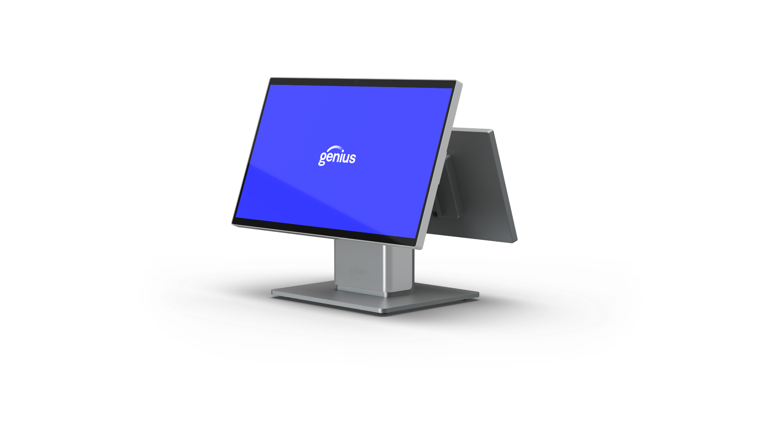  Modular merchant and customer-facing displays. |  | Handheld  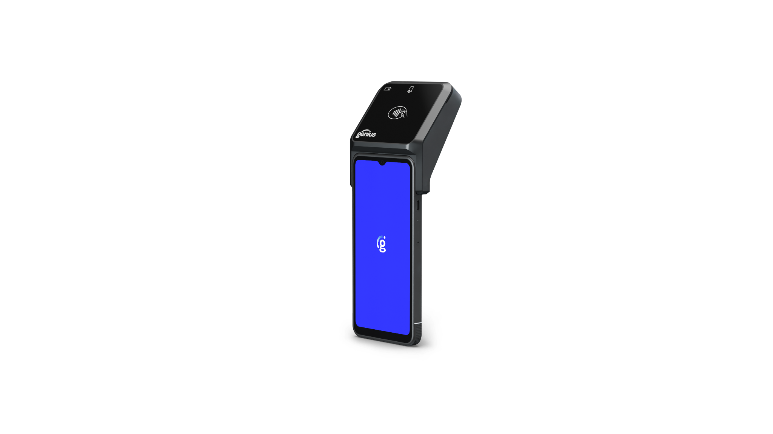  Portable POS with integrated payment. | Counter and kiosk  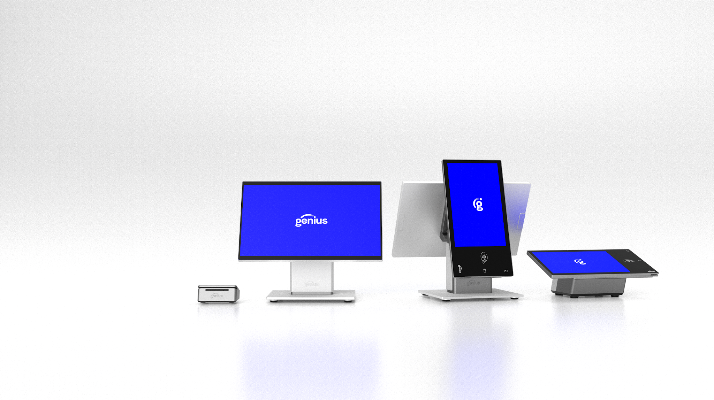  Multiple configurations within one hardware family.
PRODUCT MAP 5 OF 5

Payments and back office
Genius Payments
Heritage | Global Payments Integrated and Portico capabilities, with Merchantware/Cayan heritage and Global Payments + Worldpay processing reach.
Capabilities | Integrated acceptance across counter, drive-thru, kiosk and digital commerce; EMV/contactless and wallets; card-present and online acceptance; P2PE/tokenization; terminal management and store-and-forward.
McDonald’s relevance | Supports cross-channel orchestration, processor flexibility, centralized device control, offline resilience and token continuity.
Selected experience | CosMc’s used Global Payments for payment processing. 6m+ Merchant Locations, 94b Transavtions annually, $3.7t Payment volume, Operating in 175+ countries
Genius Back Office
Heritage | The Portal RTI, RTI Financial Accounting, Back Office and enterprise reporting heritage.
Capabilities | Back-office and enterprise reporting capabilities spanning restaurant operations, inventory, labor, financial information and enterprise-level visibility.
McDonald’s relevance | Connects restaurant activity with operational and enterprise reporting to support more consistent decision-making across the system.
Selected experience

