Explainable machine learning to predict outcomes in advanced non-small-cell lung cancer
Vinayak Ahluwalia, BS^{1,2}; Ravi B. Parikh, MD, MPP¹⁻⁵
¹Perelman School of Medicine, University of Pennsylvania, Philadelphia, PA, 19104, USA
²Leonard Davis Institute of Health Economics, University of Pennsylvania, Philadelphia, PA, 19104, USA
³Department of Medical Ethics and Health Policy, University of Pennsylvania, Philadelphia, PA, 19104, USA
⁴Department of Medicine, University of Pennsylvania, Philadelphia, PA, 19104, USA
⁵Abramson Cancer Center, University of Pennsylvania, Philadelphia, PA, 19104, USA

Introduction:
Immune checkpoint inhibitor (ICI) therapies have shown promise in treating various cancers, particularly in patients with advanced non-small-cell lung cancer (NSCLC). Between 24% and 60% of patients with NSCLC are positive for the programmed death ligand-1 (PD-L1) biomarker¹, which may qualify them for treatment with first-line immune-oncology monotherapy (IO monotherapy) such as pembrolizumab, as opposed to platinum-based chemotherapy, a treatment which is rife with toxic side effects².

In 2016, The U.S. Food and Drug Administration (FDA) approved pembrolizumab alone as a first-line therapy for patients with ALK- and EGFR-negative NSCLC with PD-L1 expression greater than 50%. The current standard of care is to treat patients with IO monotherapy whose tumor cells or tumor-infiltrating cells have a staining intensity of at least 50% for PD-L1^{3–7}. While pembrolizumab monotherapy is technically approved for patients with PD-L1 expression under 50%, combination therapy with pembrolizumab and chemotherapy is preferred when feasible^{8–10}. A two-drug immunotherapy regimen, nivolumab plus ipilimumab, is also approved for this patient population if PD-L1 expression is at least 1%. While nivolumab plus ipilimumab was shown to increase median overall survival relative to chemotherapy, treatment discontinuation secondary to side effects was more common in the immunotherapy group, demonstrating that immunotherapy is not benign^{11,12}.

Garon et al. prospectively validated the PD-L1 cutoff of 50% for patients receiving pembrolizumab monotherapy, demonstrating a response rate of 45.2% in that subgroup, as opposed to 19.4% in the entire cohort⁴. Similarly, patients with PD-L1 over 50% had a response rate of 44.8% to pembrolizumab monotherapy as opposed to chemotherapy⁶. One meta-analysis has shown that PD-L1 status has an AUC of 0.63 (95% CI [0.61-0.63]) for predicting patient response to IO monotherapy¹³. These findings imply that while the PD-L1 threshold has utility, approximately half of patients who meet the PD-L1 threshold will still experience disease progression on IO monotherapy, indicating a need for improvement. Exploring different definitions for biomarker positivity and developing better predictors of treatment response will better allocate immunotherapy to the patients who would benefit the most while sparing patients who would not benefit from its side effects.

Given the promise that artificial intelligence (AI) and machine learning (ML) demonstrate in the treatment and prognostication of cancer^{14–17}, it is likely that data-driven statistical models that incorporate temporal data can better inform clinical decision-making related to immunotherapy allocation than an individual biomarker alone such as PD-L1¹⁸. One study used machine learning to predict response to IO monotherapy in patients with advanced NSCLC using tumor-infiltrating lymphocyte scoring, although the cohort was small (n=685)¹⁹. Flatiron Health is a healthcare technology company that contains large repositories of retrospective health data, including patient demographics, vital signs, serum laboratory values, for patients with various cancers, making it a useful source for the development of large statistical models²⁰.

This study aims to leverage Flatiron-sourced retrospective data from patients who were diagnosed with advanced NSCLC between 2011 and 2021 to develop an ML model that can predict treatment response. We will train an ML model to predict the likelihood of 12-month cancer progression in advanced NSCLC patients and compare that model’s prognostic ability against standard threshold-based risk scores that utilize PD-L1.

Methods:

We acquired data from Flatiron Health. Patients were queried if they met the following inclusion criteria:
- Diagnosed with advanced NSCLC on or after 1/1/2011 and were at least 18 years old
  - Stage IIIB, IIIC, or IV at initial diagnosis
  - Earlier stage with recurrence or progression after 1/2011
- At least 2 documented clinical visits after index metastatic diagnosis

In ML model training and statistical analysis, only patients who received first-line therapy within 365 days of advanced diagnosis were included. If a date of death was available, we calculated the number of days from advanced diagnosis to death. If there was recorded evidence of cancer progression as defined as radiologic, pathologic, or clinical progression, we similarly calculated the number of days from advanced diagnosis to the first evidence of progression. Progression was recorded as early as February 2011 and as late as October 2021. A designation of “mixed response” or “pseudo-progression” was not considered as progression in this model. Patients were excluded if the time between the date of advanced diagnosis and the date of their last available clinic note was under 365 days.

We extracted basic demographic information for each patient including birth year, gender, race, ethnicity, U.S. state where treatment was provided, and age (in years) at the date of advanced diagnosis. Other relevant information about a patient included insurance status, cancer histology, cancer staging, smoking status (never-smoker, current-smoker, previous-smoker), Eastern Cooperative Oncology Group (ECOG)²¹ status, and the results of other biomarker testing, if available, including ALK, EGFR, KRAS, ROS1, BRAF, and PD-L1 when the advanced diagnosis was made. If a PD-L1 status was available, it was recorded as a value corresponding to its percent staining as seen in Table 1. If a percent staining was not available, an interpretation of “PD-L1 low expression” was represented as a 0.01 and “PD-L1 high expression” was a 0.5.

An indicator variable representing insurance status was recorded as “1” for each insurance type (commercial health plan, Medicaid, Medicare, other government program, patient assistance program, self-pay, workers’ compensation) that a patient had during their treatment and “0” otherwise.

Treatment with IO monotherapy was defined as first-line treatment with nivolumab, pembrolizumab, cemiplimab, atezolizumab, durvalumab, or nivolumab/ipilimumab without concurrent chemotherapy (CT) or another cancer-related immunotherapy. Treatment with chemotherapy was defined as receiving first-line cisplatin or carboplatin with concurrent vinorelbine, docetaxel, gemcitabine, pemetrexed, or paclitaxel. Combination therapy was defined as first-line immunotherapy as defined above with concurrent cisplatin or carboplatin. Other treatment categories in this data are in Table ***.

PD-L1 Percent Staining | Representation
<1% | 0.0
1% or “PD-L1 low expression” | 0.01
2-4% | 0.03
5-9% | 0.05
10-19% | 0.10
20-29% | 0.20
30-39% | 0.30
40-49% | 0.40
50-59% or “PD-L1 high expression” | 0.50
60-69% | 0.60
70-79% | 0.70
80-89% | 0.80
90-99% | 0.90
100% | 1.00
Not Reported/Indeterminate | 0.0
Table 1: Interpretation of PD-L1 staining values

Therapy Type | Description
IO Monotherapy | Nivolumab, pembrolizumab, atezolizumab, durvalumab, cemiplimab or ipilimumab/nivolumab alone
Chemotherapy | Cisplatin or carboplatin with concurrent vinorelbine, docetaxel, gemcitabine, pemetrexed, or paclitaxel
Combination Therapy | IO monotherapy with concurrent cisplatin or carboplatin
Anti-ALK Drug | Alectinib, ceritinib, or brigatinib
Anti-EGFR Drug | Osimertinib, erlotinib, gefitinib, or afatinib
Anti-ROS1 Drug | Crizotinib, entrectinib, or repotrectinib
Anti-BRAF Drug | Dabrafenib/trametinib, binimetinib/encorafenib, dabrafenib, tramatenib, binimetinib, or encorafenib
Anti-RAS Drug | Sotorasib or adagrasib
Other Chemotherapy | Vinorelbine, docetaxel, gemcitabine, pemetrexed, or paclitaxel without concurrent IO therapy
Carboplatin Monotherapy | Carboplatin alone
Cisplatin Monotherapy | Cisplatin alone
TRK Inhibitor | Imatinib, dasatinib, nilotinib, bosutinib
MET Inhibitor | Capmatinib or tepotinib
Other Therapy | Does not fit into the above categories
Table ***: Categorization of first-line therapies based on drug combinations used

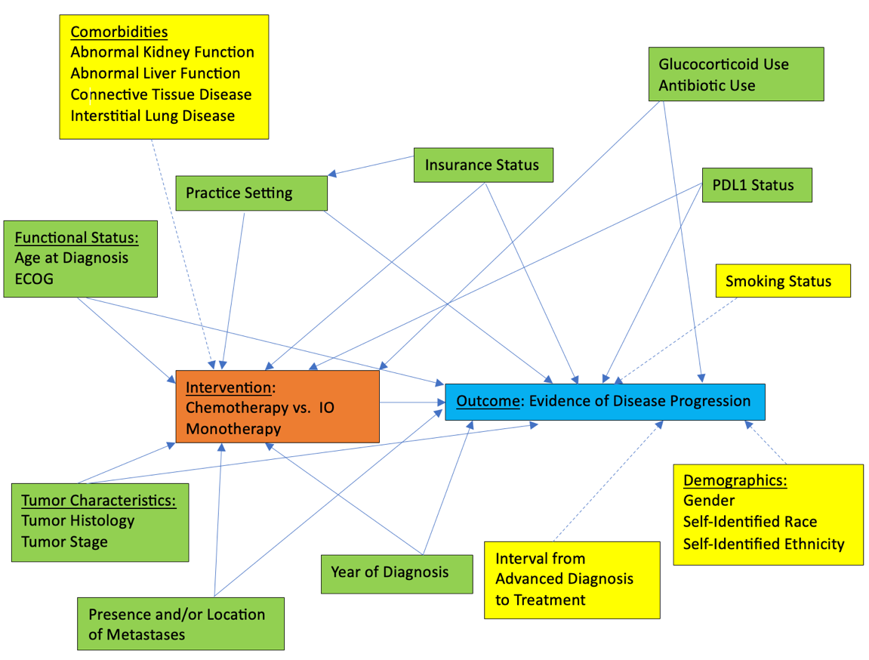
Figure ***: Directed acyclic graph demonstrating the confounding relationships between the choice of intervention and the outcome of interest

Machine Learning Model Creation

We created two machine learning models, one to predict 12-month progression-free survival (PFS) and one to predict 12-month overall survival (OS). ML models were created using the XGBoost binary classifier using the sklearn library in Python 3.11. The cohort was divided into training (80%) and test (20%). Each model was trained using five-fold cross-validation and hyperparameter tuning was completed using a grid-search methodology.

Statistical analysis post-ML model development and training was done using Stata. We calculated the area under the receiver operating curve (AUROC) using the predictions from the ML algorithm, represented as continuous values between [0, 1] and a binary indicator representing whether there was disease progression within 12 months. Confidence intervals reported for AUROC are derived from 1000 bootstraps. The threshold we selected for classifying predictions as positive progression or negative progression used the Youden index, which selects the prediction threshold that “optimizes the biomarker’s differentiating ability when equal weight is given to sensitivity and specificity”^{22,23}.

Results

78354 patients were available in the entire dataset. Once exclusion criteria were applied, the sample decreased to 34173 patients. 22785 (66.7%) experienced disease progression and 12060 (35.3%) died within 12 months of first-line therapy initiation. 17379 (50.9%) received doublet chemotherapy, 3838 (11.2%) received IO monotherapy, 4283 (12.5%) received combination therapy, and 8673 (25.4%) received another form of first-line therapy. PD-L1 testing was reported for 13227 (38.7%) patients in the cohort. Of the patients for whom PD-L1 status was available, 4308 (32.6%) had PD-L1 expression >= 50%, 4076 (30.8%) had 1% <= PD-L1 < 50%, and 4843 (36.6%) were confirmed to be negative.
The demographic makeup of our cohort can be seen in Table 1.
Characteristic | Entire Cohort (n=34173) | Test Set (n=6835)
Age at Diagnosis (y) | 67.3 +/- 9.6 | 67.1 +/- 9.6
Progression after 12 months
No evidence of disease progression | 11388 (33.3%) | 2250 (32.9%)
Evidence of disease progression | 22785 (66.7%) | 4585 (67.1%)
Mortality after 12 months
Alive after 12 months | 22113 (64.7%) | 4499 (65.8%)
Died within 12 months | 12060 (35.3%) | 2336 (34.2%)
Gender
Male | 17546 (51.3%) | 3490 (51.1%)
Female | 16626 (48.7%) | 3345 (48.9%)
Unknown | 1 (<0.1%) | 0 (0.0%)
Race
White | 23854 (69.8%) | 4743 (69.4%)
Black | 3036 (8.9%) | 610 (8.9%)
Asian | 966 (2.8%) | 212 (3.1%)
Other Race | 3432 (10.0%) | 674 (9.9%)
Unknown |  | 596 (8.7%)
Ethnicity
Hispanic/Latino | 1138 (3.3%) | 220 (3.2%)
Non-Hispanic/Latino | 33035 (96.7%) | 6615 (96.8%)
Tumor Stage at Initial Diagnosis
Stage 0 | 2 (<0.1%) | 1 (<0.1%)
Stage I | 2763 (8.1%) | 534 (7.8%)
Stage II | 1742 (5.1%) | 328 (4.8%)
Stage III | 7649 (22.4%) | 1544 (22.6%)
Stage IV | 21254 (62.2%) | 4270 (62.5%)
Occult | 4 (<0.1%) | 0 (0.0%)
Unknown | 759 (2.2%) | 158 (2.3%)
ECOG Status
0 | 5046 (14.8%) | 1073 (15.7%)
1 | 10214 (29.9%) | 2037 (29.8%)
2 | 7175 (21.0%) | 1362 (19.9%)
3 | 4272 (12.5%) | 869 (12.7%)
4 | 571 (1.7%) | 102 (1.5%)
Unknown | 6895 (20.2%) | 1392 (20.4%)
Practice Type
Academic Medical Center | 3418 (10.0%) | 694 (10.1%)
Community Medical Center | 30755 (90.0%) | 6141 (89.9%)
Smoking Status
History of Smoking | 29124 (85.2%) | 5825 (85.2%)
Never-Smoker | 4857 (14.2%) | 973 (14.2%)
Unknown | 192 (0.6%) | 37 (0.5%)
Tumor Histology
Squamous Cell Carcinoma | 8352 (24.4%) | 1658 (24.3%)
Non-squamous Cell Carcinoma | 24322 (71.2%) | 4877 (71.4%)
Unknown | 149 (4.4%) | 300 (4.4%)
PD-L1
>=50% | 4308 (12.6%) | 876 (12.8%)
1% <= PD-L1 <50% | 4076 (11.9%) | 798 (11.7%)
Confirmed PD-L1 Negative | 4843 (14.2%) | 964 (14.1%)
Unknown | 20946 (61.3%) | 4197 (61.4%)
Insurance Coverage During Treatment
Medicare | 13817 (40.4%) | 2822 (41.3%)
Medicaid | 2075 (6.1%) | 519 (7.6%)
Commercial Insurance | 14934 (43.7%) | 2953 (43.2%)
Self-Pay | 1200 (3.6%) | 235 (3.4%)
No Insurance Reported | 11378 (33.3%) | 2303 (33.7%)
First-Line Oncologic Therapy Prescribed
Platinum-Based Doublet Chemotherapy | 17379 (50.9%) | 3499 (51.2%)
IO Monotherapy | 3838 (11.2%) | 793 (11.6%)
Combination Therapy | 4283 (12.5%) | 852 (12.5%)
Other | 8673 (25.4%) | 1691 (24.7%)
Other Mutation Presence
ALK+ | 862 (2.5%) | 201 (2.9%)
EGFR+ | 4279 (12.5%) | 875 (12.8%)
ROS1+ | 192 (0.6%) | 28 (0.4%)
EGFR+ | 4279 (12.5%) | 875 (12.8%)
KRAS+ | 4219 (12.4%) | 817 (12.0%)
Anti-Infective Use Prior to Treatment
No | 33671 (98.5%) | 6732 (98.5%)
Yes | 502 (1.5%) | 103 (1.5%)
Glucocorticoid Use Prior to Treatment
No | 12640 (37.0%) | 2594 (38.0%)
Yes | 21533 (63.0%) | 4241 (62.0%)
Reported Metastases Prior to Treatment
Brain | 788 (2.3%) | 147 (2.2%)
Bone | 1397 (4.1%) | 298 (4.4%)
Other CNS Location | 27 (0.1%) | 9 (0.1%)
Digestive System | 288 (0.8%) | 52 (0.8%)
Adrenal Glands | 183 (0.5%) | 41 (0.6%)
Other Location/Unspecified | 843 (2.5%) | 170 (2.5%)
Comorbidities Prior to Treatment
Diabetes | 1588 (4.7%) | 328 (4.8%)
Connective Tissue Disease | 281 (0.8%) | 45 (0.7%)
Interstitial Lung Disease | 3 (<0.1%) | 1 (<0.1%)
Abnormal Renal Function | 4570 (13.4%) | 918 (13.4%)
Abnormal Liver Function | 717 (2.1%) | 159 (2.3%)
Table 1: Demographic make-up of the entire cohort and the test set.

The test set had 6835 patients with similar covariate balance as the original cohort. Within the test set, patients in the IO monotherapy group with PD-L1 >= 50% had improved 12-month PFS (HR 0.59 [0.45, 0.79], p < 0.0001) compared to those with 1% <= PD-L1 < 50%. There was no difference in 12-month PFS for patients with PD-L1 >= 50% receiving chemotherapy (HR 0.89 [0.70, 1.13], p = 0.34)
combination therapy (HR 0.85 [0.64, 1.13], p = 0.26) compared to those with PD-L1 < 50%. There was no difference in overall survival for these three treatment groups when stratifying by PD-L1 status. Figures *** and *** demonstrate Kaplan-Meier survival curves for 12-month PFS and 12-month OS for these groups. Complete information regarding hazard ratios can be seen in Table ***.

The ML models achieved an AUROC of 0.70 (95% CI [0.69, 0.71]) and 0.74 (95% CI: [0.73, 0.75]) for predicting 12-month PFS and 12-month OS, respectively.

Machine Learning Model Analysis
Outcome | AUROC (95% CI) on Test Set
12-month PFS | 0.70 ([0.69, 0.71])
12-month OS | 0.74 ([0.73, 0.75])
Table ***: AUROC for each ML model on the independent test set. AUROC was calculated using 1000 bootstraps. PFS = progression-free survival and OS = overall survival.

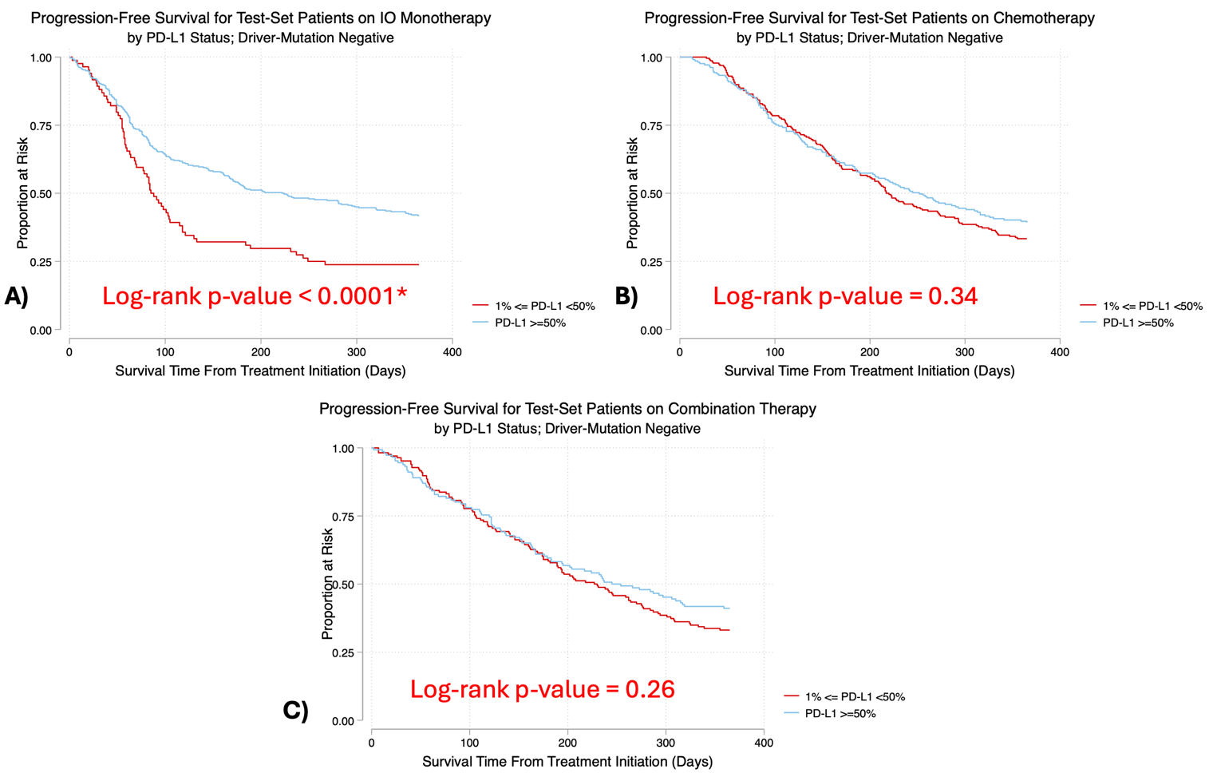
Figure ***: Kaplan-Meier curves demonstrating 12-month PFS for PD-L1 positive test-set patients on (A) IO monotherapy, (B) doublet chemotherapy, and (C) combination therapy stratified by PD-L1 status. All patients included are driver-mutation negative.
* = significant at the 0.05 level. **=significant at the 0.01 level.
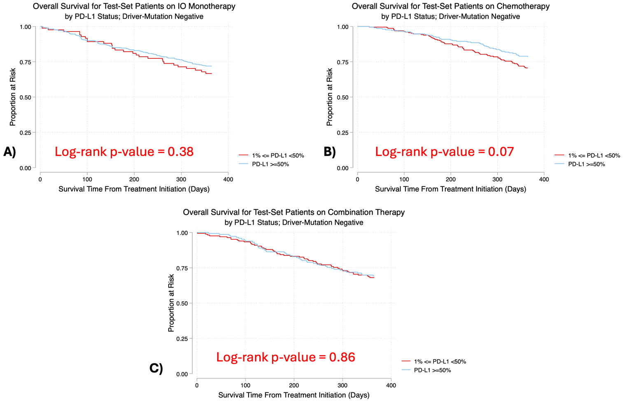
Figure ***: Kaplan-Meier curves demonstrating 12-month OS for PD-L1 positive test-set patients on (A) IO monotherapy, (B) doublet chemotherapy, and (C) combination therapy stratified by PD-L1 status. All patients included are driver-mutation negative.
* = significant at the 0.05 level. **=significant at the 0.01 level.

Outcome | n_{L} | n_{H} | Hazard Ratio (95% CI) | p-value
12-month PFS
IO Monotherapy | 84 | 339 | 0.59 [0.45, 0.79] | <0.001**
Doublet Chemotherapy | 228 | 209 | 0.89 [0.70, 1.13] | 0.34
Combination Therapy | 166 | 146 | 0.85 [0.64, 1.13] | 0.26
12-month OS
IO Monotherapy | 84 | 339 | 0.83 [0.55, 1.26] | 0.38
Doublet Chemotherapy | 228 | 209 | 0.70 [0.48, 1.03] | 0.07
Combination Therapy | 166 | 146 | 0.96 [0.65, 1.44] | 0.86
Table ***: Hazard ratios relating likelihood of 12-month disease progression for PD-L1 positive test-set patients stratified by PD-L1 status. L: 1% <= PD-L1 < 50% and H: PD-L1 >=50%. All patients in this analysis are driver-mutation negative.
* = significant at the 0.05 level. **=significant at the 0.01 level.

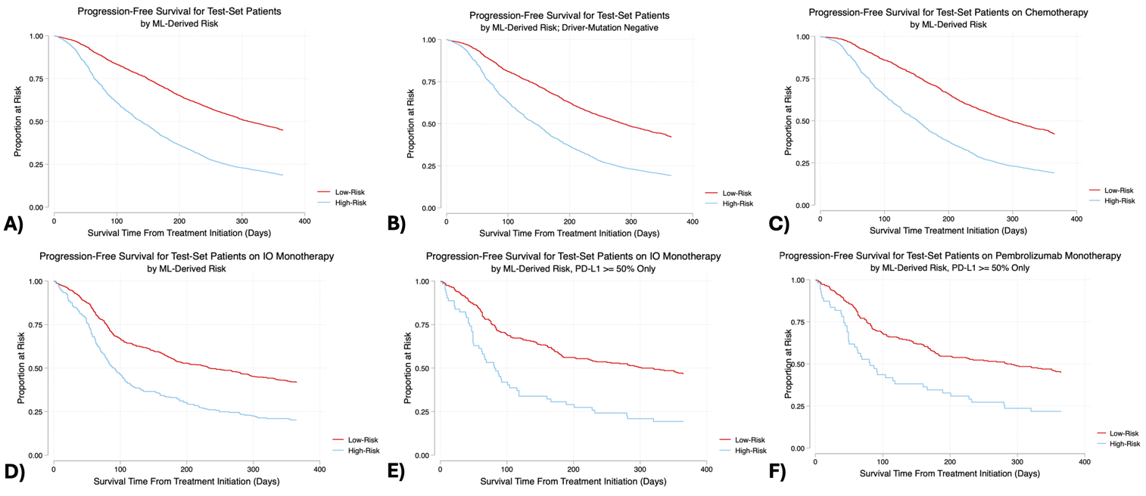
Figure ***: Kaplan-Meier curves demonstrating 12-month PFS for test-set patients classified as low-risk via the ML algorithm versus those classified as high-risk. A threshold of 0.70 was set for classifying patients as high-risk. All patients included are driver-mutation negative.

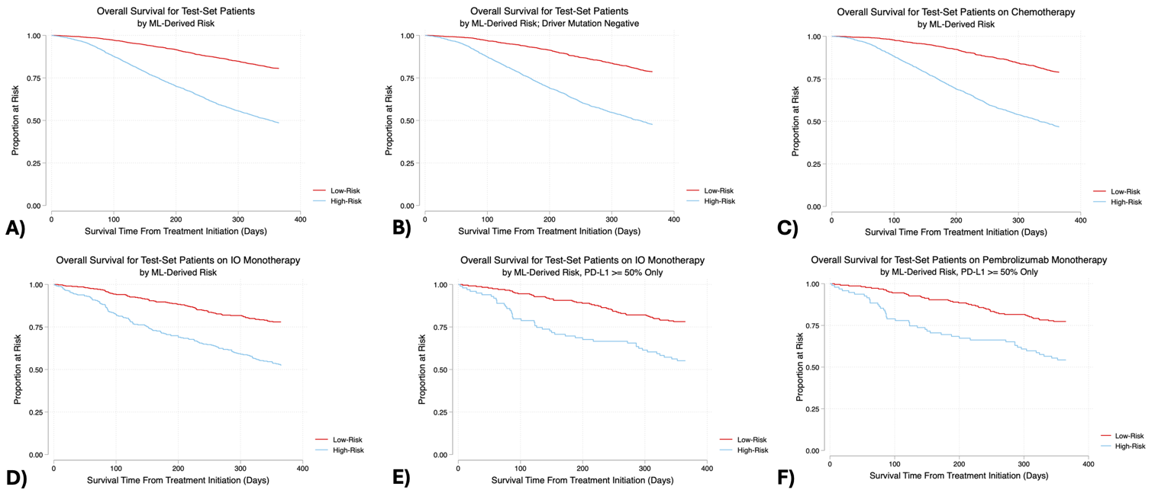

Figure ***: Kaplan-Meier curves demonstrating 12-month OS for test-set patients classified as low-risk via the ML algorithm versus those classified as high-risk. A threshold of 0.47 was set for classifying patients as high-risk. All patients included are driver-mutation negative.
A)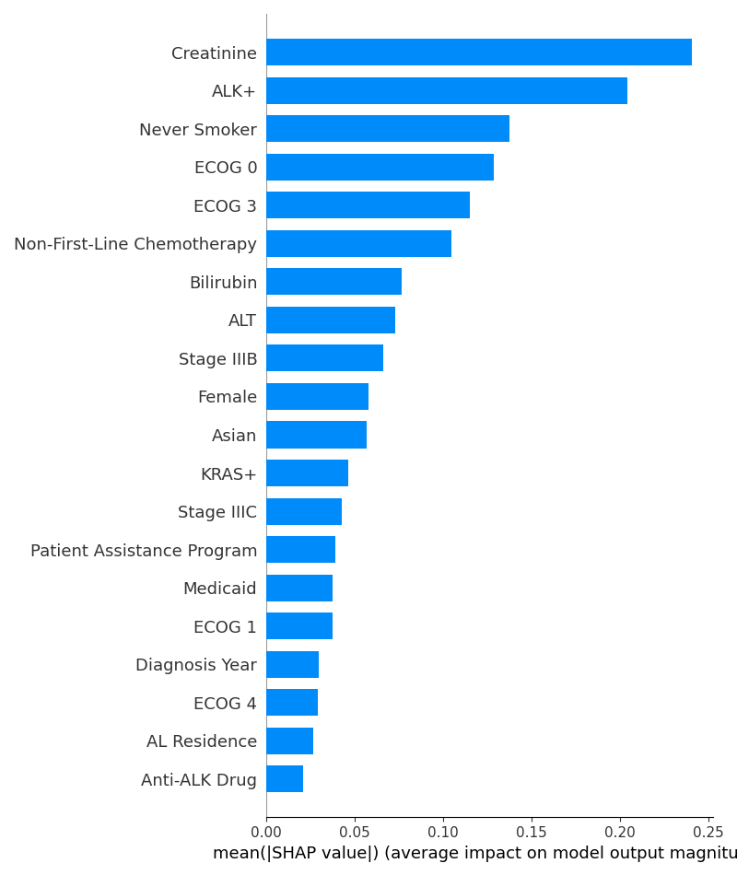B)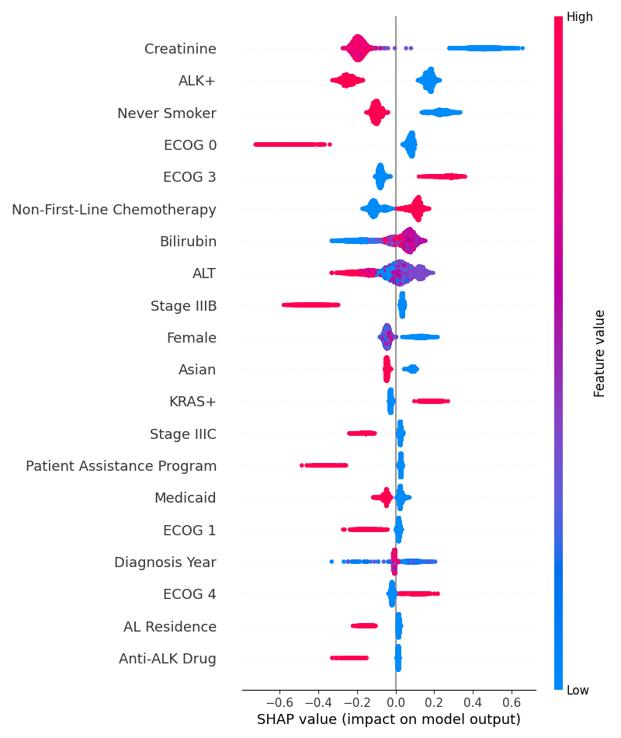

Figure ***: Shapley figures for the PFS XGBoost model. A) Most important features for the model in terms of absolute effect on model prediction. B) Most important features for the model in terms of favoring “progression” or “no progression” predictions. Warmer colors indicate higher values for the features and cooler colors indicate lower values.
A)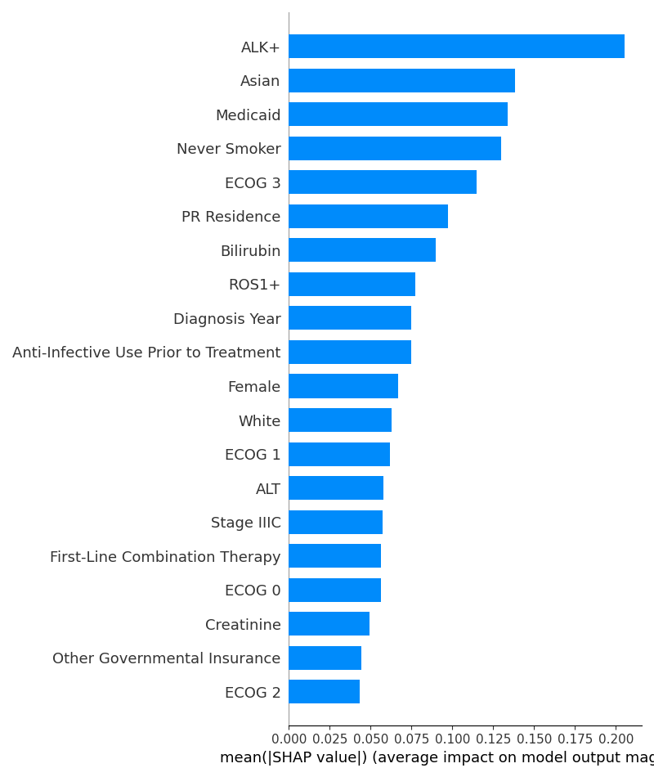B)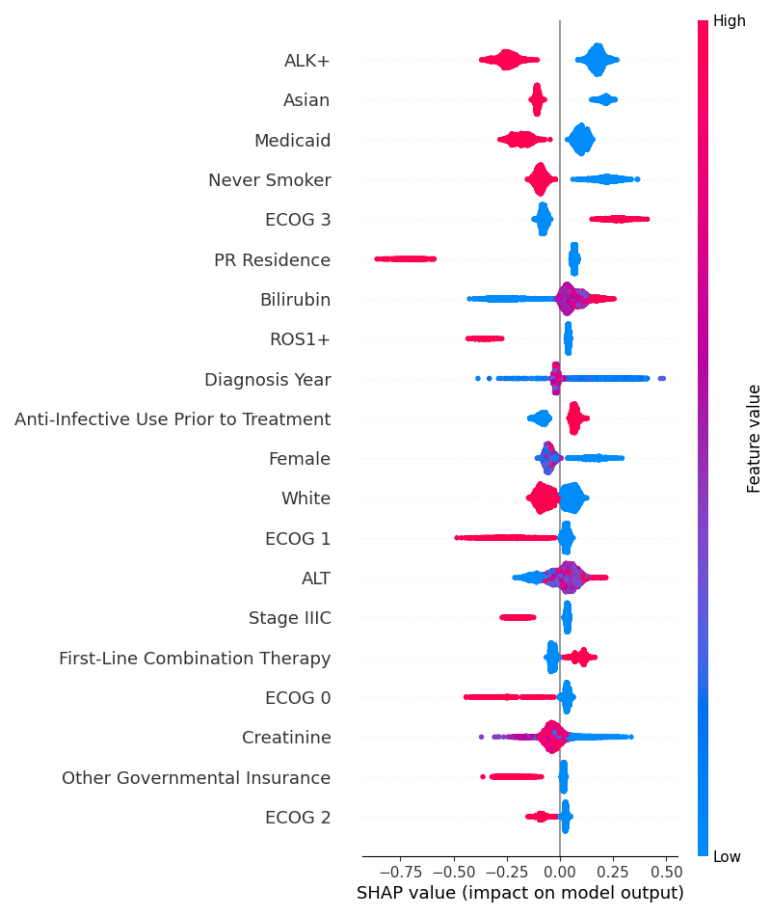
Figure ***: Shapley figures for the OS XGBoost model. A) Most important features for the model in terms of absolute effect on model prediction. B) Most important features for the model in terms of favoring “progression” or “no progression” predictions. Warmer colors indicate higher values for the features and cooler colors indicate lower values.

Outcome | n_{LR} | n_{HR} | Hazard Ratio (95% CI) | p-value
12-month PFS
All Patients | 3719 | 3116 | 0.45 [0.42, 0.48] | <0.001**
All Driver Mutation-Negative Patients (Chemotherapy or IO Monotherapy only) | 1991 | 2053 | 0.50 [0.46, 0.54] | <0.001**
Chemotherapy | 1478 | 1796 | 0.48 [0.44, 0.52] | <0.001**
IO Monotherapy | 513 | 257 | 0.53 [0.44, 0.63] | <0.001**
IO Monotherapy and PD-L1 >= 50% | 278 | 62 | 0.44 [0.32, 0.61] | <0.001**
Pembrolizumab Monotherapy and PD-L1 >= 50% | 262 | 55 | 0.58 [0.48, 0.74] | <0.001**
12-month OS
All Patients | 3474 | 3346 | 0.29 [0.27, 0.32] | <0.001**
All Driver Mutation-Negative Patients (Chemotherapy or IO Monotherapy only) | 1948 | 2082 | 0.31 [0.28, 0.35] | <0.001**
Chemotherapy | 1484 | 1779 | 0.30 [0.26, 0.34] | <0.001**
IO Monotherapy | 464 | 303 | 0.38 [0.29, 0.49] | <0.001**
IO Monotherapy and PD-L1 >= 50% | 252 | 87 | 0.40 [0.27, 0.60] | <0.001**
Pembrolizumab Monotherapy and PD-L1 >= 50% | 233 | 83 | 0.41 [0.27, 0.61] | <0.001**
Table ***: Hazard ratios relating likelihood of 12-month disease progression and 12-month mortality for patients labeled as low-risk relative to those labeled as high-risk. LR = low-risk and HR = high-risk. All patients in this analysis are driver-mutation negative.
* = significant at the 0.05 level. **=significant at the 0.01 level.

Discussion

Conclusion

We present a novel machine learning algorithm that can accurately predict the risk of disease progression in patients with advanced non-small cell lung cancer. This algorithm is more predictive for determining the efficacy of IO monotherapy compared to the PD-L1 biomarker, which has previously been used to allocate first-line IO monotherapy over first-line This study provides evidence that ML algorithms are better predictors of disease course and treatment efficacy in oncology than current threshold-based criteria such as PD-L1 status.

Acknowledgements
***

Data Availability
Data used during this study was supplied from Flatiron Health. ***

Code Availability
Development of the ML model was done in Python v3.8.10 and required the following packages: ***. Statistical analysis was done in Stata. Code is available on GitHub at https://github.com/vahluw/NSCLC_PDL1_Immunotherapy. For any further inquiries please contact ravi.parikh@pennmedicine.upenn.edu.

Competing Interests
VA reports no disclosures. RBP ***.

References:

1. Yu H, Boyle TA, Zhou C, Rimm DL, Hirsch FR. PD-L1 Expression in Lung Cancer. J Thorac Oncol Off Publ Int Assoc Study Lung Cancer. 2016;11(7):964-975. doi:10.1016/j.jtho.2016.04.014
2. Oun R, Moussa YE, Wheate NJ. The side effects of platinum-based chemotherapy drugs: a review for chemists. Dalton Trans Camb Engl 2003. 2018;47(19):6645-6653. doi:10.1039/c8dt00838h
3. Lahiri A, Maji A, Potdar PD, et al. Lung cancer immunotherapy: progress, pitfalls, and promises. Mol Cancer. 2023;22:40. doi:10.1186/s12943-023-01740-y
4. Garon EB, Rizvi NA, Hui R, et al. Pembrolizumab for the treatment of non-small-cell lung cancer. N Engl J Med. 2015;372(21):2018-2028. doi:10.1056/NEJMoa1501824
5. Brahmer JR, Drake CG, Wollner I, et al. Phase I study of single-agent anti-programmed death-1 (MDX-1106) in refractory solid tumors: safety, clinical activity, pharmacodynamics, and immunologic correlates. J Clin Oncol Off J Am Soc Clin Oncol. 2010;28(19):3167-3175. doi:10.1200/JCO.2009.26.7609
6. Reck M, Rodríguez-Abreu D, Robinson AG, et al. Pembrolizumab versus Chemotherapy for PD-L1–Positive Non–Small-Cell Lung Cancer. N Engl J Med. 2016;375(19):1823-1833. doi:10.1056/NEJMoa1606774
7. Mok TSK, Wu YL, Kudaba I, et al. Pembrolizumab versus chemotherapy for previously untreated, PD-L1-expressing, locally advanced or metastatic non-small-cell lung cancer (KEYNOTE-042): a randomised, open-label, controlled, phase 3 trial. Lancet Lond Engl. 2019;393(10183):1819-1830. doi:10.1016/S0140-6736(18)32409-7
8. Di Federico A, De Giglio A, Parisi C, Gelsomino F, Ardizzoni A. PD-1/PD-L1 inhibitor monotherapy or in combination with chemotherapy as upfront treatment for advanced NSCLC with PD-L1 expression ≥ 50%: Selecting the best strategy. Crit Rev Oncol Hematol. 2021;160:103302. doi:10.1016/j.critrevonc.2021.103302
9. Gandhi L, Rodríguez-Abreu D, Gadgeel S, et al. Pembrolizumab plus Chemotherapy in Metastatic Non–Small-Cell Lung Cancer. N Engl J Med. 2018;378(22):2078-2092. doi:10.1056/NEJMoa1801005
10. Paz-Ares L, Luft A, Vicente D, et al. Pembrolizumab plus Chemotherapy for Squamous Non–Small-Cell Lung Cancer. N Engl J Med. 2018;379(21):2040-2051. doi:10.1056/NEJMoa1810865
11. Hellmann MD, Paz-Ares L, Bernabe Caro R, et al. Nivolumab plus Ipilimumab in Advanced Non-Small-Cell Lung Cancer. N Engl J Med. 2019;381(21):2020-2031. doi:10.1056/NEJMoa1910231
12. Brahmer J, Reckamp KL, Baas P, et al. Nivolumab versus Docetaxel in Advanced Squamous-Cell Non-Small-Cell Lung Cancer. N Engl J Med. 2015;373(2):123-135. doi:10.1056/NEJMoa1504627
13. Seymour L, Bogaerts J, Perrone A, et al. iRECIST: guidelines for response criteria for use in trials testing immunotherapeutics. Lancet Oncol. 2017;18(3):e143-e152. doi:10.1016/S1470-2045(17)30074-8
14. Gould MK, Huang BZ, Tammemagi MC, Kinar Y, Shiff R. Machine Learning for Early Lung Cancer Identification Using Routine Clinical and Laboratory Data. Am J Respir Crit Care Med. 2021;204(4):445-453. doi:10.1164/rccm.202007-2791OC
15. Liu D, Wang X, Li L, et al. Machine Learning-Based Model for the Prognosis of Postoperative Gastric Cancer. Cancer Manag Res. 2022;14:135-155. doi:10.2147/CMAR.S342352
16. Nartowt BJ, Hart GR, Muhammad W, Liang Y, Stark GF, Deng J. Robust Machine Learning for Colorectal Cancer Risk Prediction and Stratification. Front Big Data. 2020;3:6. doi:10.3389/fdata.2020.00006
17. Stark GF, Hart GR, Nartowt BJ, Deng J. Predicting breast cancer risk using personal health data and machine learning models. PloS One. 2019;14(12):e0226765. doi:10.1371/journal.pone.0226765
18. Xie J, Luo X, Deng X, et al. Advances in artificial intelligence to predict cancer immunotherapy efficacy. Front Immunol. 2022;13:1076883. doi:10.3389/fimmu.2022.1076883
19. Rakaee M, Adib E, Ricciuti B, et al. Association of Machine Learning-Based Assessment of Tumor-Infiltrating Lymphocytes on Standard Histologic Images With Outcomes of Immunotherapy in Patients With NSCLC. JAMA Oncol. 2023;9(1):51-60. doi:10.1001/jamaoncol.2022.4933
20. Real-World Evidence Solutions | RWE Company | Flatiron Health. Accessed March 22, 2024. https://flatiron.com/real-world-evidence
21. Oken MM, Creech RH, Tormey DC, et al. Toxicity and response criteria of the Eastern Cooperative Oncology Group. Am J Clin Oncol. 1982;5(6):649-655.
22. Youden WJ. Index for rating diagnostic tests. Cancer. 1950;3(1):32-35. doi:10.1002/1097-0142(1950)3:1<32::aid-cncr2820030106>3.0.co;2-3
23. Ruopp MD, Perkins NJ, Whitcomb BW, Schisterman EF. Youden Index and Optimal Cut-Point Estimated from Observations Affected by a Lower Limit of Detection. Biom J Biom Z. 2008;50(3):419-430. doi:10.1002/bimj.200710415

Supplement

Parameter (Progression Outcome) | Odds Ratio | 95% CI | p-value
IO Monotherapy | 1.95 | [1.14, 3.35] | 0.016*
First-Line Chemotherapy | 1.42 | [0.84, 2.39] | 0.19
Non-First Line Chemotherapy | 2.05 | [1.08, 3.92] | 0.029*
Other First Line Therapy | 1.29 | [0.78, 2.12] | 0.32
Combination Therapy | 1.31 | [0.77, 2.21] | 0.314
Anti-BRAF Drug | 1.63 | [0.57, 4.67] | 0.361
TRK Inhibitor | N/A | N/A | N/A
MET Inhibitor | 0.40 | [0.05, 3.15] | 0.385
Carboplatin Monotherapy | 1.74 | [0.56, 5.45] | 0.342
Cisplatin Monotherapy | 0.64 | [0.08, 5.11] | 0.672
IO Monotherapy * PDL1 Interaction | 0.68 | [0.42, 1.11] | 0.123
Non-First Line Chemotherapy * PDL1 Interaction | 6.05 | [1.21, 30.25] | 0.028*
Combination Therapy * PDL1 Interaction | 0.83 | [0.51, 1.34] | 0.445
First Line Chemotherapy * PDL1 Interaction | 1.52 | [0.95, 2.41] | 0.079
Anti-ALK Drug* PDL1 Interaction | 1.85 | [0.68, 5.06] | 0.231
Anti-EGFR Drug * PDL1 Interaction | 3.67 | [2.06, 6.53] | <0.001**
Anti-ROS1 Drug * PDL1 Interaction | 2.28 | [0.79, 6.62] | 0.129
Anti-BRAF Drug * PDL1 Interaction | 1.31 | [0.20, 8.60] | 0.781
TRK Inhibitor* PDL1 Interaction | N/A | N/A | N/A
MET Inhibitor * PDL1 Interaction | 15.37 | [0.55, 426.67] | 0.107
Carboplatin Monotherapy * PDL1 Interaction | 0.37 | [0.04, 3.23] | 0.366
Cisplatin Monotherapy * PDL1 Interaction | 0.34 | [0.00, 687.16] | 0.779
Anti-ALK Drug * ALK Interaction
No anti-ALK Drug; ALK Positive | 0.54 | [0.38, 0.78] | 0.001**
Anti-ALK Drug; ALK Negative | 2.80 | [0.27, 28.99] | 0.389
Anti-ALK Drug; ALK Positive | 0.39 | [0.20, 0.76] | 0.006**
Anti-EGFR Drug * EGFR Interaction
No anti-EGFR Drug; EGFR Positive | 0.92 | [0.76, 1.11] | 0.383
Anti-EGFR Drug; EGFR Negative | 2.38 | [1.07, 5.31] | 0.034*
Anti-EGFR Drug; EGFR Positive | 0.54 | [0.32, 0.90] | 0.019*
Anti-ROS1 Drug * ROS1 Interaction
No anti-ROS1 Drug; ROS1 Positive | 0.99 | [0.57, 1.72] | 0.981
Anti-ROS1 Drug; ROS1 Negative | 1.84 | [0.84, 4.05] | 0.126
Anti-ROS1 Drug; ROS1 Positive | 0.85 | [0.35, 2.07] | 0.727
BRAF Positivity | 0.93 | [0.77, 1.13] | 0.46
KRAS Positivity | 1.12 | [1.01, 1.24] | 0.033*
ECOG Status
0 | 0.55 | [0.48, 0.64] | <0.001**
1 | 0.83 | [0.73, 0.94] | 0.004**
2 | 1.24 | [1.08, 1.43] | 0.003**
3 | 1.77 | [1.50, 2.08] | <0.001**
4 | 2.01 | [1.40, 2.89] | <0.001**
Squamous Cell Histology | 0.92 | [0.74, 1.16] | 0.493
Non-squamous Cell Histology | 0.74 | [0.60, 0.92] | 0.006**
PD-L1 | 0.46 | [0.30, 0.71] | <0.001**
Hispanic/Latino Ethnicity | 0.87 | [0.70, 1.07] | 0.19
Interval Between Diagnosis Year and 2022 | 0.87 | [0.85, 0.89] | <0.001**
Log(Age at Diagnosis) | 0.52 | [0.40, 0.69] | <0.001**
Self-Identified White | 0.83 | [0.73, 0.96] | 0.009**
Self-Identified Asian | 0.79 | [0.62, 1.01] | 0.061
Self-Identified Black | 0.74 | [0.62, 0.89] | 0.001**
Self-Identified Other Race | 0.97 | [0.81, 1.16] | 0.754
Self-Identified Hispanic Race | 0.93 | [0.30, 2.89] | 0.897
Male Gender | 1.09 | [1.01, 1.18] | 0.022*
Log(Days From Advanced Diagnosis to Treatment) | 0.95 | [0.90, 1.00] | 0.057
Insurance During Treatment
Payment Assistance Program | 0.81 | [0.72, 0.90] | <0.001**
Other Governmental Insurance | 0.93 | [0.79, 1.09] | 0.362
Medicare | 0.90 | [0.83, 0.97] | 0.01*
Self-Pay | 0.88 | [0.73, 1.07] | 0.198
Medicaid | 0.86 | [0.74, 1.01] | 0.058
Private Health Insurance | 0.96 | [0.88, 1.03] | 0.267
No Insurance Reported | 0.87 | [0.80, 0.94] | 0.001**
Stage at Initial Diagnosis
Stage 0 | N/A | N/A | N/A
Stage I | 0.71 | [0.51, 0.99] | 0.042*
Stage II | 0.90 | [0.63, 1.28] | 0.559
Stage III | 0.72 | [0.52, 0.99] | 0.046*
Stage IV | 1.13 | [0.82, 1.55] | 0.453
Occult | N/A | N/A | N/A
No Smoking History | 0.96 | [0.85, 1.08] | 0.455
Academic Medical Center | 1.02 | [0.88, 1.19] | 0.783
Kidney Disease | 0.91 | [0.81, 1.02] | 0.099
Liver Disease | 1.42 | [1.07, 1.88] | 0.014*
Connective Tissue Disease | 1.53 | [1.01, 2.32] | 0.045*
Interstitial Lung Disease | 0.37 | [0.02, 7.66] | 0.524
Diabetes | 1.00 | [0.84, 1.18] | 0.989
Bone Metastases | 1.21 | [0.99, 1.47] | 0.062
Brain Metastases | 1.28 | [0.99, 1.66] | 0.056
Other CNS Metastases | 0.49 | [0.13, 1.80] | 0.28
Digestive System Metastases | 1.68 | [1.16, 2.43] | 0.007**
Adrenal Metastases | 0.95 | [0.56, 1.60] | 0.837
Unspecific Metastases | 0.95 | [0.75, 1.20] | 0.648
Anti-Infective Prior to Treatment | 1.09 | [0.78, 1.51] | 0.616
Glucocorticoid Prior to Treatment | 0.96 | [0.86, 1.08] | 0.528
Clinical Study Drug Used | 1.51 | [1.10, 2.06] | 0.01*
Bevacizumab Used | 1.11 | [0.95, 1.30] | 0.205
Three or More Chemotherapy Drugs Used | 1.43 | [0.86, 2.39] | 0.169
Table ***: Odds ratios derived from logistic regression relating covariates to risk of disease progression within 12 months from treatment initiation. N/A indicates that covariate was excluded from model due to collinearity or because covariate was perfect predictor of outcome. Only patients with reported PD-L1 were included in the model.
* = significant at the 0.05 level. **=significant at the 0.01 level.

Parameter (Progression Outcome) | Odds Ratio | 95% CI | p-value
IO Monotherapy | 1.28 | [0.66, 2.52] | 0.465
First-Line Chemotherapy | 0.88 | [0.45, 1.69] | 0.694
Non-First Line Chemotherapy | 1.55 | [0.73, 3.27] | 0.253
Other First Line Therapy | 0.85 | [0.45, 1.61] | 0.617
Combination Therapy | 0.91 | [0.47, 1.75] | 0.77
Anti-BRAF Drug | 0.80 | [0.26, 2.46] | 0.694
TRK Inhibitor | N/A | N/A | N/A
MET Inhibitor | N/A | N/A | N/A
Carboplatin Monotherapy | 0.60 | [0.14, 2.47] | 0.476
Cisplatin Monotherapy | 2.21 | [0.27, 18.15] | 0.461
IO Monotherapy * PDL1 Interaction | 0.74 | [0.43, 1.27] | 0.275
Non-First Line Chemotherapy * PDL1 Interaction | 0.73 | [0.21, 2.58] | 0.629
Combination Therapy * PDL1 Interaction | 0.85 | [0.50, 1.46] | 0.565
First Line Chemotherapy * PDL1 Interaction | 0.95 | [0.56, 1.62] | 0.861
Anti-ALK Drug* PDL1 Interaction | 4.75 | [1.00, 22.51] | 0.05
Anti-EGFR Drug * PDL1 Interaction | 3.92 | [1.94, 7.90] | <0.001**
Anti-ROS1 Drug * PDL1 Interaction | 2.55 | [0.70, 9.27] | 0.155
Anti-BRAF Drug * PDL1 Interaction | 2.19 | [0.32, 14.74] | 0.421
TRK Inhibitor* PDL1 Interaction | N/A | N/A | N/A
MET Inhibitor * PDL1 Interaction | N/A | N/A | N/A
Carboplatin Monotherapy * PDL1 Interaction | N/A | N/A | N/A
Cisplatin Monotherapy * PDL1 Interaction | 0.19 | [0.00, 439.93] | 0.672
Anti-ALK Drug * ALK Interaction
No anti-ALK Drug; ALK Positive | 0.55 | [0.34, 0.89] | 0.014*
Anti-ALK Drug; ALK Negative | N/A | N/A | N/A
Anti-ALK Drug; ALK Positive | 0.13 | [0.05, 0.38] | <0.001**
Anti-EGFR Drug * EGFR Interaction
No anti-EGFR Drug; EGFR Positive | 0.66 | [0.53, 0.82] | <0.001**
Anti-EGFR Drug; EGFR Negative | 1.60 | [0.68, 3.76] | 0.28
Anti-EGFR Drug; EGFR Positive | 0.25 | [0.13, 0.49] | <0.001**
Anti-ROS1 Drug * ROS1 Interaction
No anti-ROS1 Drug; ROS1 Positive | 0.61 | [0.29, 1.29] | 0.197
Anti-ROS1 Drug; ROS1 Negative | 0.79 | [0.29, 2.16] | 0.644
Anti-ROS1 Drug; ROS1 Positive | 0.33 | [0.1, 1.07] | 0.065
BRAF Positivity | 0.68 | [0.55, 0.86] | 0.001**
KRAS Positivity | 1.00 | [0.89, 1.12] | 0.984
ECOG Status
0 | 0.42 | [0.35, 0.49] | <0.001**
1 | 0.67 | [0.59, 0.77] | <0.001**
2 | 1.18 | [1.02, 1.36] | 0.026*
3 | 1.66 | [1.42, 1.94] | <0.001**
4 | 1.97 | [1.44, 2.72] | <0.001**
Squamous Cell Histology | 0.78 | [0.63, 0.97] | 0.028*
Non-squamous Cell Histology | 0.64 | [0.52, 0.79] | <0.001**
PD-L1 | 0.59 | [0.36, 0.95] | 0.03*
Hispanic/Latino Ethnicity | 0.86 | [0.67, 1.09] | 0.215
Interval Between Diagnosis Year and 2022 | 0.89 | [0.87, 0.92] | <0.001**
Log(Age at Diagnosis) | 0.91 | [0.68, 1.24] | 0.557
Self-Identified White | 0.86 | [0.75, 0.99] | 0.035*
Self-Identified Asian | 0.59 | [0.43, 0.81] | 0.001**
Self-Identified Black | 0.75 | [0.62, 0.91] | 0.003**
Self-Identified Other Race | 0.83 | [0.69, 1.00] | 0.045*
Self-Identified Hispanic Race | 1.09 | [0.28, 4.33] | 0.899
Male Gender | 1.24 | [1.14, 1.35] | <0.001**
Log(Days From Advanced Diagnosis to Treatment) | 0.87 | [0.82, 0.92] | <0.001**
Insurance During Treatment
Payment Assistance Program | 0.75 | [0.66, 0.84] | <0.001**
Other Governmental Insurance | 0.95 | [0.80, 1.12] | 0.549
Medicare | 0.73 | [0.66, 0.80] | <0.001**
Self-Pay | 1.04 | [0.85, 1.27] | 0.698
Medicaid | 0.83 | [0.7, 0.98] | 0.032*
Private Health Insurance | 1.00 | [0.92, 1.08] | 0.927
No Insurance Reported | 0.82 | [0.75, 0.9] | <0.001**
Stage at Initial Diagnosis
Stage 0 | N/A | N/A | N/A
Stage I | 0.63 | [0.44, 0.91] | 0.013*
Stage II | 0.91 | [0.63, 1.33] | 0.642
Stage III | 0.81 | [0.57, 1.14] | 0.222
Stage IV | 1.42 | [1.01, 1.98] | 0.043*
Occult | N/A | N/A | N/A
No Smoking History | 0.79 | [0.68, 0.91] | 0.001**
Academic Medical Center | 0.81 | [0.69, 0.96] | 0.016*
Kidney Disease | 1.07 | [0.95, 1.21] | 0.27
Liver Disease | 1.48 | [1.14, 1.92] | 0.003**
Connective Tissue Disease | 1.20 | [0.80, 1.81] | 0.369
Interstitial Lung Disease | 1.94 | [0.1, 38.81] | 0.664
Diabetes | 1.14 | [0.95, 1.36] | 0.155
Bone Metastases | 1.28 | [1.05, 1.55] | 0.014*
Brain Metastases | 0.75 | [0.57, 0.98] | 0.038*
Other CNS Metastases | 0.30 | [0.04, 2.56] | 0.272
Digestive System Metastases | 1.49 | [1.07, 2.07] | 0.018*
Adrenal Metastases | 0.74 | [0.41, 1.31] | 0.296
Unspecific Metastases | 0.64 | [0.48, 0.84] | 0.001**
Anti-Infective Prior to Treatment | 1.31 | [0.93, 1.84] | 0.124
Glucocorticoid Prior to Treatment | 1.02 | [0.90, 1.15] | 0.754
Clinical Study Drug Used | 1.12 | [0.80, 1.55] | 0.516
Bevacizumab Used | 0.98 | [0.82, 1.16] | 0.783
Three or More Chemotherapy Drugs Used | 1.42 | [0.88, 2.31] | 0.152
Table ***: Odds ratios derived from logistic regression relating covariates to risk of mortality within 12 months from treatment initiation. N/A indicates that covariate was excluded from model due to collinearity or because covariate was perfect predictor of outcome. Only patients with reported PD-L1 were included in the model.
* = significant at the 0.05 level. **=significant at the 0.01 level.
Covariate (n=5858) | Odds Ratio | 95% CI | p-value
ECOG
0 | 0.98 | [0.67, 1.45] | 0.928
1 | 0.89 | [0.63, 1.24] | 0.485
2 | 1.3 | [0.9, 1.86] | 0.162
3 | 1.2 | [0.8, 1.81] | 0.378
4 | 1.05 | [0.42, 2.64] | 0.918
Squamous Cell Histology | 1.01 | [0.58, 1.76] | 0.964
Nonsquamous Cell Histology | 1 | [0.59, 1.71] | 0.995
PD-L1 Absolute Percent Staining | 2.32 | [1.11, 4.88] | 0.026*
PD-L1 >=50% | 4.02 | [2.29, 7.06] | <0.001**
Ethnicity | 0.9 | [0.48, 1.67] | 0.727
Log (years between diagnosis year and 2022) | 0.71 | [0.66, 0.76] | <0.001**
Log (Age at Diagnosis) | 8.68 | [4.05, 18.57] | <0.001**
Self-Identified Race
White | 1.28 | [0.9, 1.83] | 0.167
Asian | 0.97 | [0.43, 2.21] | 0.951
Black | 0.58 | [0.37, 0.92] | 0.022*
Other Race | 1.11 | [0.69, 1.79] | 0.653
Hispanic Race | 1.61 | [0.12, 22.07] | 0.722
Male | 1.05 | [0.85, 1.28] | 0.654
Log (days from advanced diagnosis to treatment) | 1.37 | [1.21, 1.54] | <0.001**
Insurance During Treatment
Patient assistance program | 1.44 | [1.05, 1.96] | 0.022*
Other Governmental Insurance | 1.56 | [1.06, 2.32] | 0.025*
Medicare | 1.19 | [0.96, 1.48] | 0.116
Self-pay | 0.84 | [0.53, 1.33] | 0.466
Medicaid | 1.28 | [0.88, 1.87] | 0.189
Private Health Insurance | 1.22 | [0.99, 1.51] | 0.06
No Insurance Reported | 0.87 | [0.7, 1.08] | 0.215
Stage
0 | N/A | N/A | N/A
I | 0.23 | [0.1, 0.53] | <0.001**
II | 0.46 | [0.2, 1.05] | 0.065
III | 0.13 | [0.06, 0.29] | <0.001**
IV | 0.15 | [0.07, 0.33] | <0.001**
Occult | N/A | N/A | N/A
Never Smoker | 1.6 | [1.03, 2.5] | 0.038*
Academic Medical Center | 0.8 | [0.54, 1.19] | 0.267
Abnormal Kidney Function | 1.34 | [1.01, 1.79] | 0.044
Abnormal Liver Function | 1.02 | [0.49, 2.12] | 0.964
Connective Tissue Disease | 0.72 | [0.29, 1.77] | 0.474
Interstitial Lung Disease | N/A | N/A | N/A
Diabetes | 0.94 | [0.62, 1.4] | 0.751
Bone Metastases | 1.23 | [0.69, 2.17] | 0.48
Brain Metastases | 2 | [1.02, 3.94] | 0.044*
Other CNS Metastases | 0.57 | [0.05, 7.09] | 0.666
Digestive System Metastases | 1.72 | [0.65, 4.55] | 0.276
Adrenal Metastases | 6.51 | [1.29, 32.73] | 0.023*
Unspecified Metastases | 1.39 | [0.73, 2.62] | 0.316
Anti-Infective Use Prior to Treatment | 9.14 | [4.22, 19.76] | <0.001**
Glucocorticoid Use Prior to Treatment | 0.01 | [0.01, 0.01] | <0.001**
BRAF Positivity | 1.03 | [0.61, 1.74] | 0.912
KRAS Positivity | 1.07 | [0.82, 1.4] | 0.596
Table ***: Odds ratios derived from logistic regression relating covariates to propensity to receive IO monotherapy over chemotherapy in patients for whom PD-L1 status was reported. Pseudo R2 = 0.6567.

