**Guide to physiological noise suppression in 3DEPI fMRI data using anatomical CompCor (aCompCor)**

1. Data preparation prior to the pre-processing step: Convert fMRI data into 4D NIFTI format and check if it has the correct volume-TR value.
2. FSL (or SPM) pre-processing:

- Motion correction

- High-pass filtering (100 second)

- Smoothing (optional, preferably smoothing with a small kernel size or no smoothing)

(The pre-processing design file (design.fsf) is attached for the FSL)

1. Register 3DEPI fMRI to enhanced-contrast whole-brain MT weighted 3DEPI (MT-3DEPI) using flirt with 6 DOF and create inverse transformation matrix. See Fig 1 for the 3DEPI and MT-3DEPI sample data.
2. Extract brain (BET) fMRI data to obtain brain mask.
3. Segment the MT-3DEPI to extract CSF and WM tissue probability maps using SPM 12 and threshold them by 0.99.
4. Transform CSF and WM masks to fMRI space using inverse transformation and multiplied to the fMRI brain mask (See Fig. 2).
5. Select the number of regressors for the CSF (N=5 is commonly used). Number of WM regressors are computed automatically using “fmri_compcor_wm”. This function extracts the sufficient number of WM regressors to the same level of variance, explained by CSF regressors. Note that “fmri_compcor_wm” is modified version of “fmri_compcor”[1] that can be found in the following link (https://github.com/dmascali/fmri_denoising)
6. Extract the CSF and WM regressors using “fmri_compcor” function (<https://github.com/dmascali/fmri_denoising>). See Fig. 3 & 4 for the exemplar regressors, extracted from CSF and WM ROIs.
7. Concatenate CSF and WM regressors and exclude highly-correlated regressors (threshold=0.5) from the regressor set.
8. Regress out the remaining regressors from the pre-processed data using “fmri_cleaning” function (https://github.com/dmascali/fmri_denoising).
9. Evaluate the effect of physiological correction by calculating the effective tSNR[2] before and after the correction (Fig. 5).

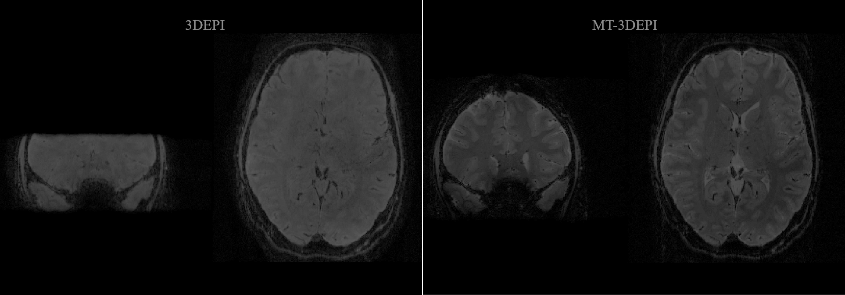

Fig1. 3DEPI and MT-3DEPI sample data

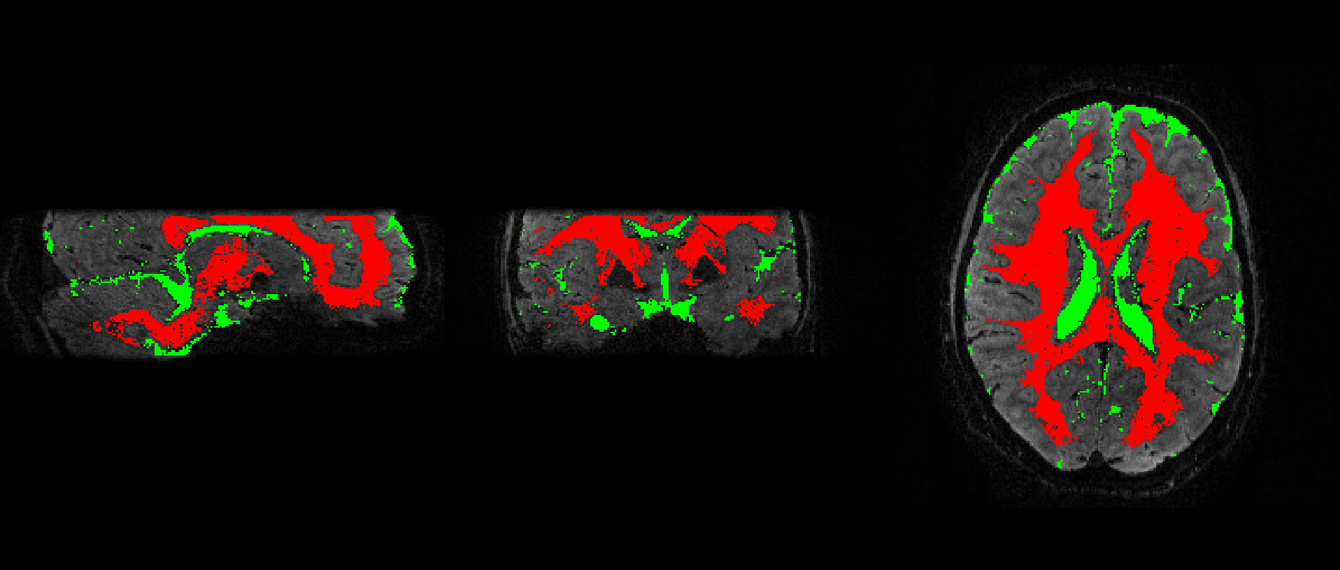

Fig 2. CSF (green) and WM (red) ROIs, transformed into the 3DEPI space

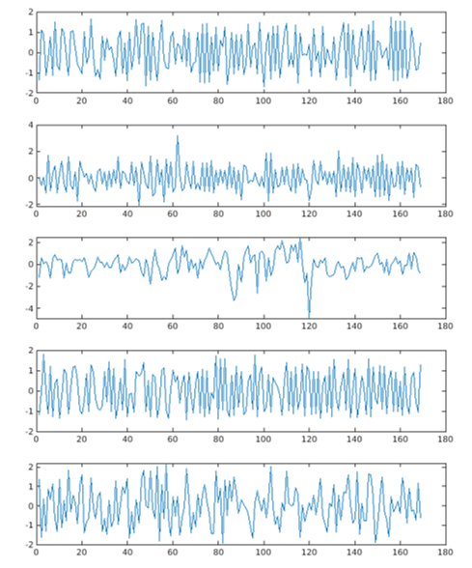

Fig 3. Examples for CSF regressors

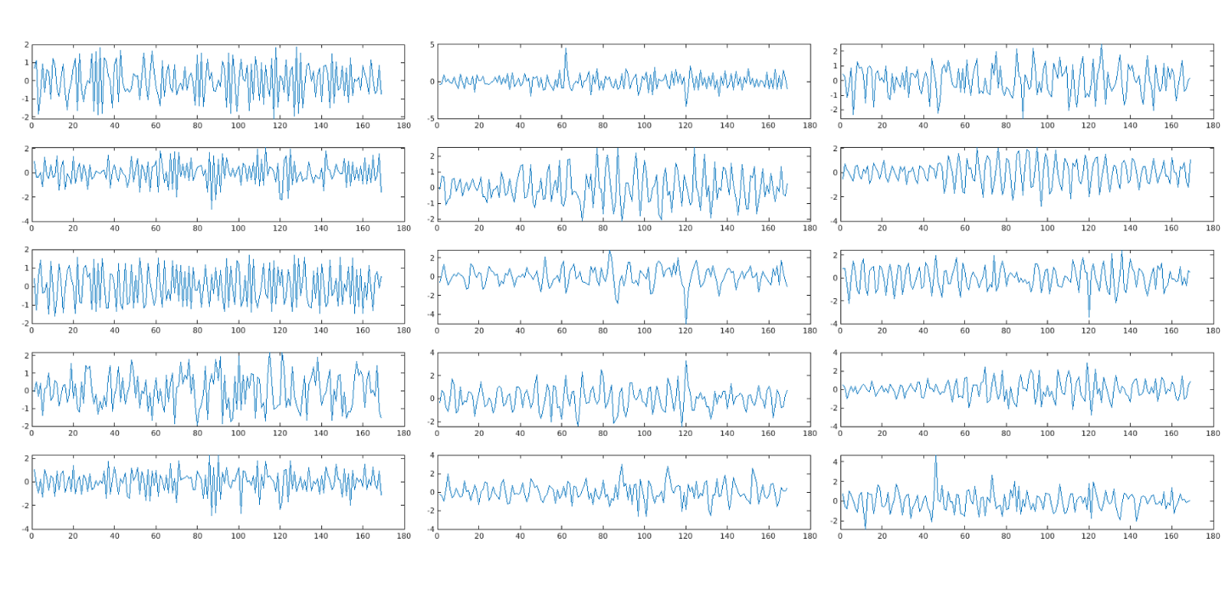

Fig 4. Examples for WM regressors

Fig 5. Couple of examples on effective tSNR maps of the 3DEPI fMRI data before and after correction

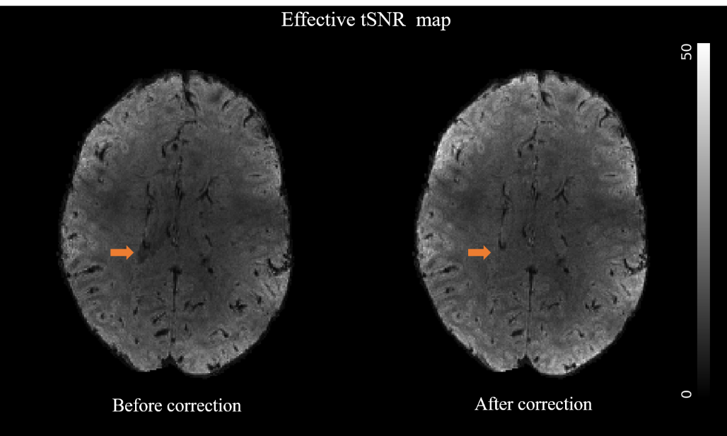

(1)

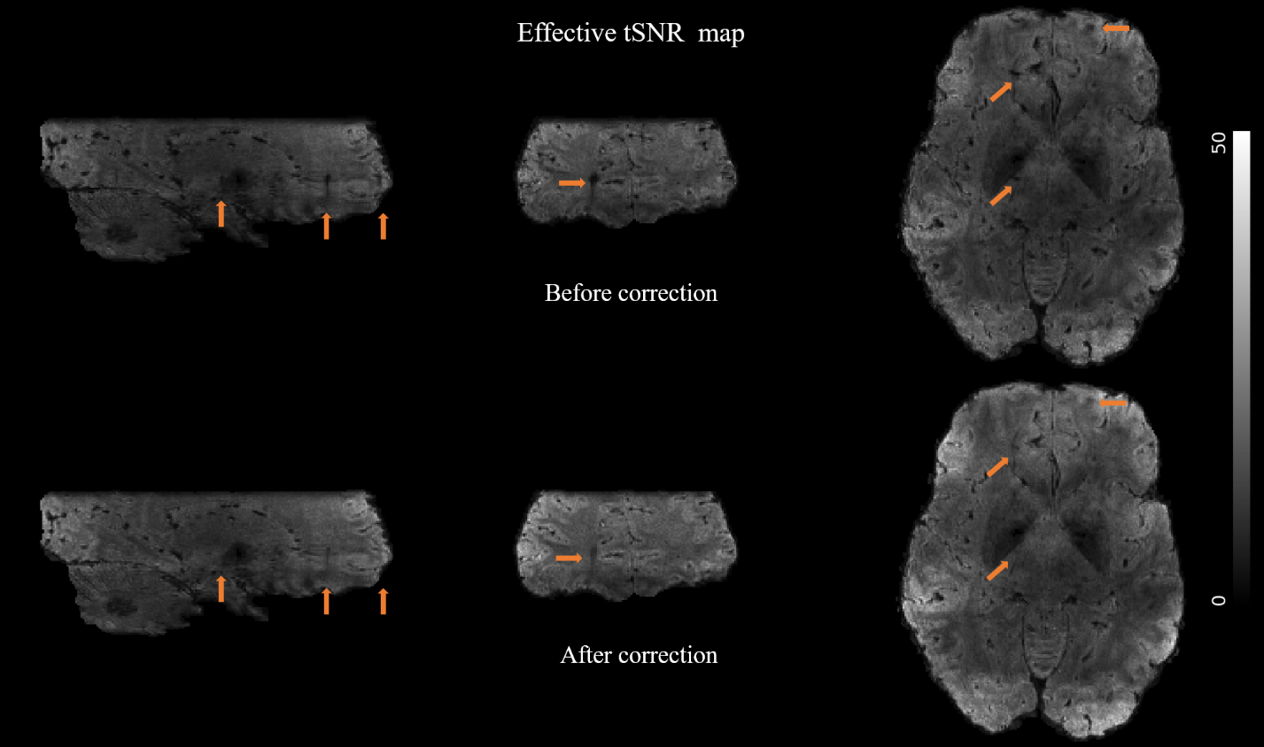(2)

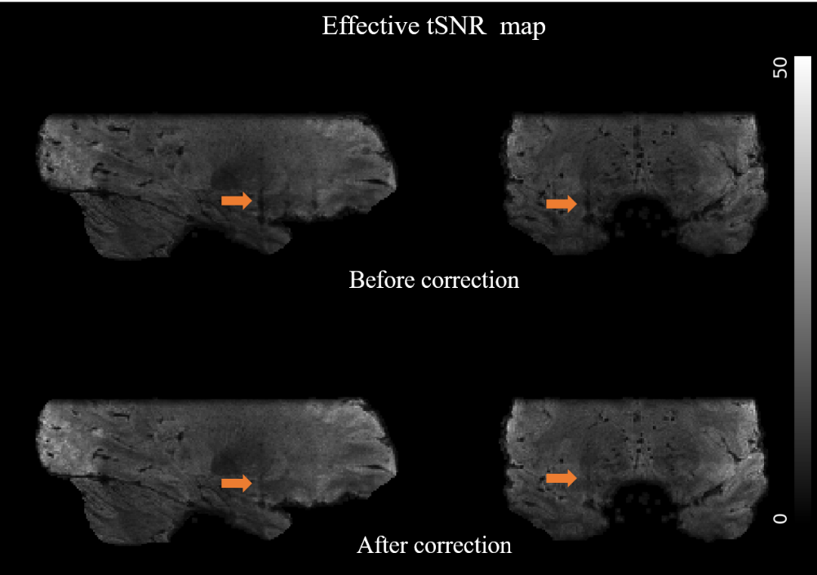

(3)

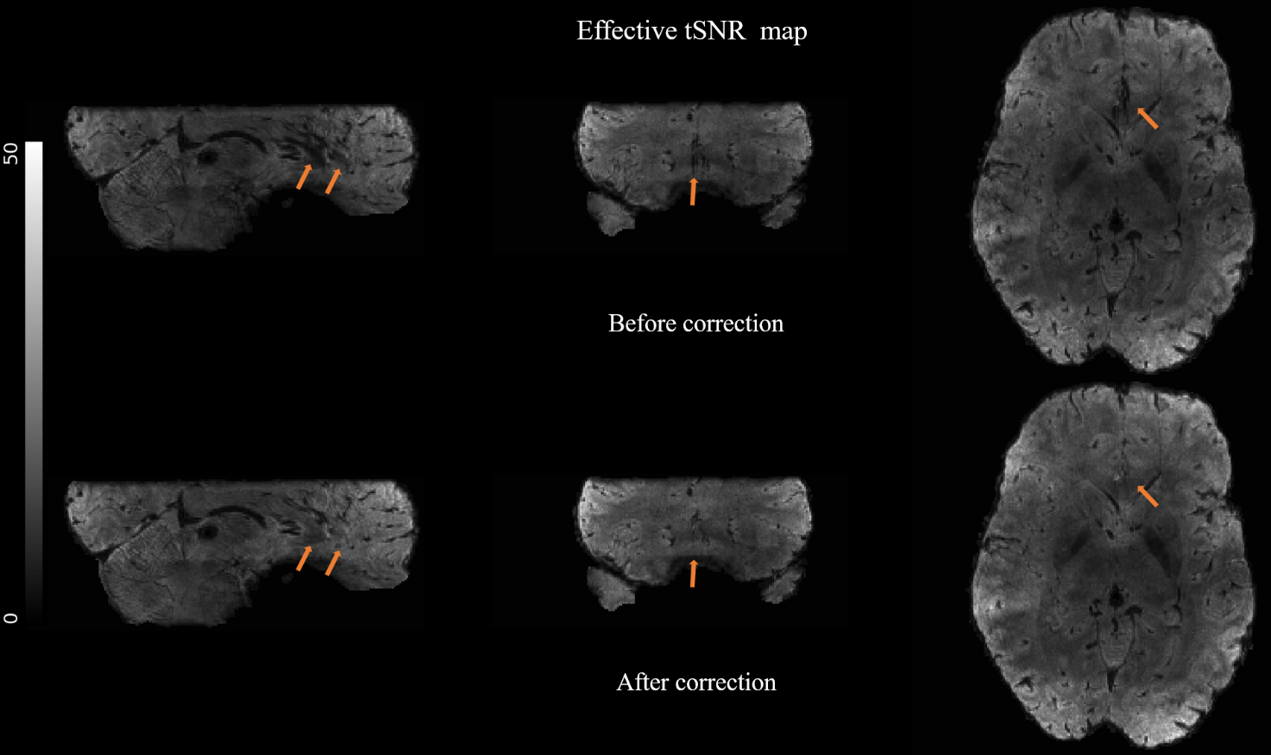(4)

1. Mascali, D., Moraschi, M., DiNuzzo, M., Tommasin, S., Fratini, M., Gili, T., Wise, R.G., Mangia, S., Macaluso, E. and Giove, F., 2021. Evaluation of denoising strategies for task‐based functional connectivity: Equalizing residual motion artifacts between rest and cognitively demanding tasks. Human Brain Mapping, 42(6), pp.1805-1828.
2. Chiew, M. and Miller, K.L., 2019. Improved statistical efficiency of simultaneous multi-slice fMRI by reconstruction with spatially adaptive temporal smoothing. Neuroimage, 203, p.116165.