INDUSTRIAL TRAINING REPORT



TITLE OF THE REPORT

# Domain and SSL

Prepared by

**Name :** Vaishnavi Ashok Patil

**Enrollment No. :** 1800100436

Submitted to Department of Computer Engineering

Government Polytechnic Karad

Year 2020-21

Department of Computer Engineering

Government Polytechnic Karad



This is to certify that **Miss Vaishnavi Ashok Patil** has partially completed Industrial Training during the period from **15-5-2020 to** **25-6-2020** in our Industry as a Partial Fulfillment of “**Diploma in Computer Engineering** ” From Government Polytechnic collage, Karad of MSBTE Mumbai during the academic year 2020-2021.

**Mr.Mirje A.M. Prof.Birnale M.A. Prof.Patil.S.B. Dr.Patil.R.K.**

(Training Manager) (Guide) (H.O.D) (Principal)

## **ACKNOWLEDGEMENT**

To become a professional in Information Technology industry, industrial training is the foundation for each undergraduate student. It helps students to improve their practical skills related to interpersonal, problems solving, research and reporting as well as soft skills. Also it helps the students get exposure to the industry, apply the gained knowledge throughout the academic program and learn new updated technologies. In addition, it helps students’ career development and to prepare for employment after graduation, by engaging in personal and professional development planning.

I hereby to extend my sincere appreciation and thankfulness to my helpful internship supervisor Prof. Birnale M.A., Further I would like to thankful the Prof.Patil.S.B, Head of computer department. The supervision and support that he gave truly help the progression and smoothness of the internship program. And also I would like to thank Mr. Amol Mirje, Owner of company ‘Happy Visitors Dot Com’ for their guidance and teaching me about the requirements of working in a industry as well as new technologies during the internship

Besides, this internship program makes me realized that the value of working together as a team and as a new experience in working environment. Not forget, great appreciation to other department staff that helps me from time to time during our internship. The whole program really brought us together to appreciate the true value of friendship and respect of each other.

## **ABSTRACT**

Industrial training is an important phase of a student life. A well planned, properly executed and evaluated industrial training helps a lot in developing a professional attitude. It develop an awareness of industrial approach to problem solving, based on a broad understanding of process and mode of operation of organization. The aim and motivation of this industrial training is to receive discipline, skills, teamwork and technical knowledge through a proper training environment, which will help me, as a student in the field of Information Technology, to develop a responsiveness of the self disciplinary nature of problems in information and communication technology. As a result I vital to achieve the minimum requirement of the company, it will help the company to maintaining the data on SQL server. Throughout this industrial training, I have been learned new programming language that required for the system, the process of the production lines and able to implement what I have learnt for the past year as a” Diploma in Computer Engineering”.

**Content**

|  |  |  |  |
| --- | --- | --- | --- |
| **Sr.no** | **Title** | | **Page no.** |
| 1 | Introduction to Industry | | 6 |
| 2 | Equipment and Software’s Used | | 7 |
| 3 | Domain  3.1 -  3.2 -  3.3 -  3.4 -  3.5 -  3.6 - | Introduction  Domain Name  Purpose  Domain name syntax  Use in web site hosting  Rules for Domain Names | 9 -13 |
| 4 | SSL  4.1 -  4.2 -  4.3 -  4.4 - | Introduction  What Is SSL  What is a certificate  Steps for SSL | 14 -19 |
| 5 | Projects |  | 20 |
| 6 | Bibliography/References | | 21 |

## **Introduction of Industry**

**Happy Visitors Dot Com - Website Design and Development Company**

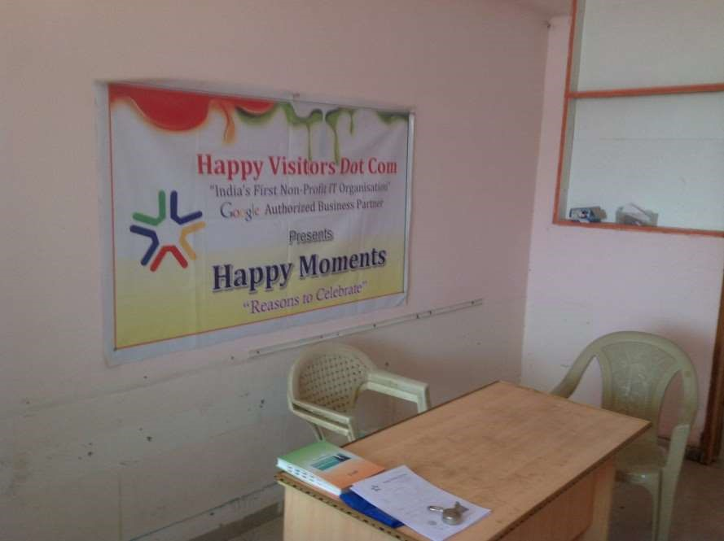

The company specializes in the website development in Kolhapur. In addition, the company provides services in affordable price.

The company is registered Non Profit IT Organization working for the up lift of Digital India concept. The company is in the Web Development Market since 2013. They have well documented Experience so that all clients get the best from their experience. Their advice based on the experience has helped many Customers to increase their business by 30%.

Company Address : Ayodhya Tower, 2nd Floor, Kolhapur, Maharashtra 416001

Training held : Lane no 16, MIRJE EMPIRE, Jaysingpur 416101 Hours : Open 24 hours

## **Company Profile**

Founder : Amol Mirje

Founded on : 1st Jan 2014

Website Clients : 160

SMS Clients : 350

### Number of staff : 13

Programmers : 5

Representatives : 3

Marketing and management : 5 Company’s Specialty :

* Top ranked company on Google Search Engine
* Lowest Cost
* Provides training for freshers
* Make dynamic websites
* Non Profit IT Organization
* Work Experience Since 2013
* 350+ Satisfied customers from all over Maharashtra.

**Equipment’s and Software’s Used**

### **Equipment’s**

* Laptop - Used for writing and executing programs
* Projector - Used for presentation

### **Software’s**

* Notepad, VS code - Used for coding
* Microsoft Expression Web - Used for Web Designing
* Visual Studio - ASP.net
* Xampp - Local Server

### **Technologies**

* HTML
* CSS
* ASP.net
* PHP
* Photoshop
* SEO
* json ld
* JQuary

## **Domain**

### **Introduction**

A web domain name is a sequence of letters and/or numbers/hyphens separated by one or more periods (".") that act as a pointer to a unique numerical address (IP) on a computer network such as the Internet. That address may host publicly available content (e.g a web site), or may be a private intranet. Domain names are formed by the rules and procedures of the Domain Name System (DNS). Any name registered in the DNS is a domain name. Domain names are organized in subdomains of the DNS root domain. The first-level set of domain names are the top-level domains (TLDs), such as com, info, net, edu, and org. Below these top-level domains in the DNS hierarchy are the second-level and third-level domain names that are typically open for reservation by end-users who wish to connect local area networks to the Internet, create other publicly accessible Internet resources or run web sites.

Registries and registrars usually charge an annual fee for the service of delegating a domain name to a user and providing a default set of name servers. Often, this transaction is termed a sale or lease of the domain name, and the registrant may sometimes be called an "owner", but no such legal relationship is actually associated with the transaction, only the exclusive right to use the domain name.

More correctly, authorized users are known as "registrants" or as "domain holders"

**How do domain names work?**

They operate under the Domain Name System (DNS), which is essentially the address book of the Internet that helps direct visitors to your website by translating the name into its related IP address number

### **Rules for Domain Names**

* Domain names can only use letters, numbers, and hyphens. No other characters are allowed.
* Hyphens cannot be used at the beginning or end of the domain name.
* You can't use a domain name that is already in use.
* Domain names are not case sensitive. e.g. www.mydomain.com is the same as www.MyDomain.com.
* You are strongly advised not to register a domain name that might be in breach of another company's trademark, unless you can prove that you have the right to do so.
* Minimum Length: Three characters plus the extension for all domain names.
* Maximum length: uk, com, org, net domains can be 64 Characters. All other domain extensions are limited to 63 characters (not including the extension).

**Types of Web Hosting :**

1. **Linux Hosting** - (All technologies except Microsoft Technologies) + Open Source

Linux hosting refers to shared hosting, the most popular hosting service in the industry. In fact, most of the websites are now hosted using Linux hosting due to its affordable price and flexibility. Linux hosting is compatible with PHP and MySQL, which supports scripts such as WordPress, Zen Cart, and phpBB.

1. **Windows Hosting** ( asp.net, c#, ms sql ) - Microsoft Technologies + Open Source

On the other hand, uses Windows as the servers' operating system and offers Windows-specific technologies such as ASP, .NET, Microsoft Access and Microsoft SQL server (MSSQL).

## **Domain Registration**

**• Definition :**

* Domain is a name of the website.
* Domain registration is the process of acquiring a domain name from a domain name registrar.

### **• List of domain extensions**

There are total 280 domain extensions. The two main groups are

the so-called gTLDs (generic top-level domains) and the ccTLDs (country code top-level domains).

|  |  |
| --- | --- |
| Domain  Extensions  .com  .in  .edu  .gov  .net    .org  .co  .co.in | Price  Rs. 730.00  Rs. 445.00  Rs. 1,500.00 Rs. 450.00  Rs. 1,039.00  Rs. 939.00  Rs. 799.00  Rs. 335.00 |

### **Popular Websites for Domain Registration**

* Domain.com
* GoDaddy
* GlobeHost
* Bigrock
* Bluehost
* Namecheap
* Hover
* Dreamhost

### **Rules for Domains**

* Make it memorable
* Be creative
* Don’t use domain name that already used
* Avoid names that are similar to competing brands
* Minimum Length : Three characters plus the extension for all domain names.
* Maximum length : uk, com, org, net domains can be 64 Characters. All other domain extensions are limited to 63 characters.

### **Steps for Registration of Domain**

* Select name of new Domain
* Visit any Domain Registrars, You’ll need to choose a registrar to host your new domain. As the authoritative registry for .com, .net, .in, .co.

Sign up and Sign in your account

* Choose your Web host ( Windows or Linux )
* From Domain select Register a New Domain , In search box enter your domain name and check availability and select extension
* It will open new Payment page verify details and price then select Checkout , Fill out the form with your details select payment getway pay via Net banking , Credit Card , UPI etc, Click Complete Order.
* You will redirect to payment page.

Note – Make sure that your network will not disconnect while doing these process

* Open Control panel by adding ‘ /cpanel ‘ , ex. – www.example.com/cpanel.
* Upload your index file using file manager.

**SSL - Secure Sockets Layer**

### **Introduction to SSL**

SSL and digital certificates are an essential building block of today’s information systems of all stripes. Without digital certificates we wouldn’t have e-commerce, online shopping, mobile devices, secure logins to our online accounts, SaaS applications, public cloud, or virtually any of the IT systems that businesses depend on today. Whether or not they’re visible to you, you depend on digital certificates for the communication, entertainment, and services you rely on every day.

Certificates are quite technically sophisticated, involving trust models, cryptography, industry standards, authentication requirements, and much more. So sometimes they can be hard for someone without a PhD in computer science to make sense of.

**What Is SSL ?**

SSL, or Secure Sockets Layer, is the common name for the security protocol used between systems across the open internet. The word can refer to the connections secured using this protocol or to the actual certificates that are issued and employed as the backbone of this system.

The SSL protocol exists to enable trusted communications between computers across a network. The most notable example of such a network is the open internet, but SSL is considered a best practice for infrastructure existing entirely inside a firewall as well. SSL enables trusted communications by instilling machine-to-machine communications with two main qualities:

When we say known authenticated identity, what we mean is that the SSL protocol enables the machine that is receiving information (which we’ll call the client) to confirm the identity of the machine that is providing that information (which we'll call the server). For many use cases the machines on both sides of the transaction, the client and the server, will have their identities confirmed by SSL this way.

Encrypted data flow refers to the ability to encrypt the data moving both ways in the SSL-secured connection. Encryption of data is a necessary part of maintaining private communications across the open internet, where otherwise it’s possible to spy on the content sent between machines.

SSL also known as TLS ( Transport Layer Security ).

This is cryptographic protocols designed to provide communications security over a computer network.

The connection is secure because symmetric cryptography is used to encrypt the data transmitted.

To create an SSL connection a web server requires an SSL Certificate. When you choose to activate SSL on your web server you will be prompted to complete a number of questions about the identity of your website and your company. Your web server then creates two cryptographic keys - a Private Key and a Public Key.

The complexities of the SSL protocol remain invisible to your customers. Instead their browsers provide them with a key indicator to let them know they are currently protected by an SSL encrypted session - the lock icon in the lower right-hand corner, clicking on the lock icon displays your SSL Certificate and the details about it.

**What is a certificate?**

SSL communications are enabled by certificates. A certificate is a file that is installed on a server. The certificate is specific to the URL or IP address for that server, and its presence on the machine enables the trust mechanisms and encryption that come with an SSL session.

We call it a certificate because it certifies the identity of the server to which is it assigned. The certificate contains information about the identity of the owner of a URL or IP address that can be detected and used by the client machine to confirm that identity.

Certificates are protected by hashing algorithms to ensure they are genuine and tamper proof. That means nobody can take an issued certificate and change it to claim to be another identity, and nobody can create a forgery of a certificate on a trusted public root. Any certificate that doesn’t contain the same information it had when when the Certificate Authority minted it will be easily detected as broken by systems interacting with it, and it will be distrusted.

The SSL protocol was originally developed by Netscape for Web browsers. SSL is a set of rules governing authentication and encrypted communication between clients and servers. SSL is widely used on the Internet by an increasing number of varied applications, especially for interactions that involve exchanging confidential information such as credit card numbers. SSL evolved into the Transport Layer Security (TLS) Version 1 standard.

SSL is positioned as a protocol layer between the Transmission Control Protocol (TCP) layer and the application to form a secure connection between clients and servers so that they can communicate in a secure manner over a network by providing :

* Privacy, where data messages are encrypted so that only the two application endpoints understand the data.
* Integrity, where message digests detect if any data was altered in flight.
* Authentication, which verifies the identity of the remote node, application, or user by using digital certificates.
* TCP/IP network using SSL

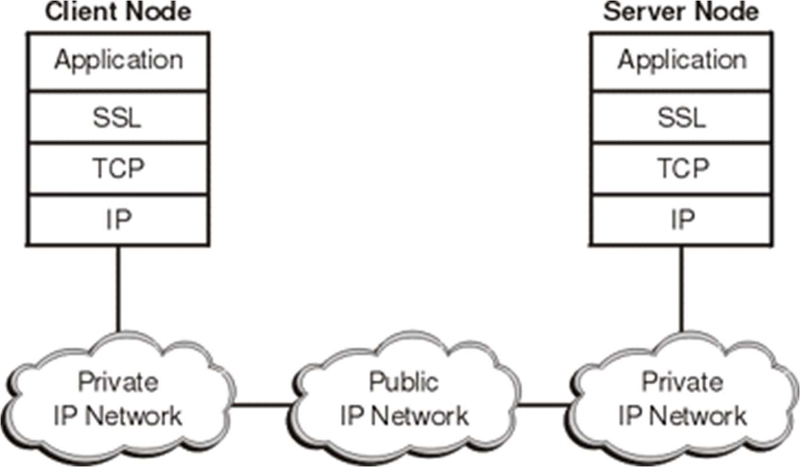

* This type of secure connection ensures that all data exchanged between clients and servers is encrypted, and is therefore not readable by a third party on the Internet. SSL has gained popularity in the Internet industry primarily because of its use of public-key certificates as a means of authenticating principles.
* To establish the connection, SSL requires, at a minimum, a server certificate. As part of the initial SSL handshake process, the server presents its certificate to the client to authenticate the server's identity. The authentication process uses public-key encryption and digital signatures to confirm that the server is, in fact, who the server claims to be (that is, the server's certificate is valid).

### Steps for SSL

* There are some free websites which provide free service of SSL certificate ex.

www.sslforfree.com

* Visit Website www.sslforfree.com/
* Register and login
* In search box enter your website address and click Create button.



* There are different methods for domain verification
* Automatic FTP Verification
* Manual Verification

### **Automatic FTP method**

* Enter your FTP ( File Transfer Protocol ) information and it will automatic verify your domain and make SSL certificate
* After downloading SSL certificate upload certificate to your domain using cpanel

### **Using Manual Method**

* Download the two verification files provided in page.
* Create a folder in your domain named ".well-known" if it does not already exist. If you use Windows you may have to add a dot at the end of the folder name in order to create a folder with a dot at the beginning.
* Create another folder in your domain under ".well-known" named "acmechallenge" if it does not already exist
* Upload the downloaded files to the "acme-challenge" folder.
* Verify successful upload by visiting the provided links in your browser .
* If the files do not show random alphanumeric characters or shows an error then recheck that you are uploading in the correct place. Also try viewing the page source (Right-click then click "view page source") of the above links to make sure nothing else shows up but the verification file contents.
* Click Download SSL Certificate.
* Then upload them to your website.
* After this it will show https instead of http.

## **Projects**

**Website** - www.SoundMagixStudio.com

Languages :

* HTML
* CSS
* JavaScript
* JQuary
* SQL server

The project is a copy of www.soundmagixstudio.com website which is company’s client’s website. The website is about music company.

In this projects there are following 6 pages given below -

* 1. Home
  2. Contact Us
  3. About Us iv. Services
  4. Gallery
  5. Voices

### **Features**

* Dynamic Website
* Slider and Animation
* Photo Gallery
* Video Gallery

## **Bibliography/References**

* https://en.wikipedia.org/wiki/SSL
* https://en.wikipedia.org/wiki/Domain
* https://www.techopedia.com/definition/1326/domain-networking
* https://techterms.com/definition/domain
* https://info.ssl.com/article.aspx?id=10241