**Final Year B. Tech., Sem VI 2021-22**

**High Performance Computing Lab**

**Assignment submission**

**PRN No: 2019BTECS00069**

**Full name: Vaishnavi Vilas Disale**

**Batch: B3**

**Assignment: 1**

**Q1.Hello World Program:**

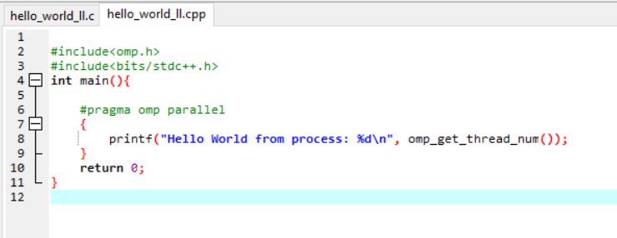

**Output:**

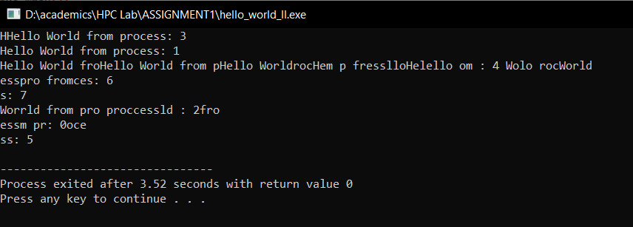

**Q2. To add squares of numbers Program:**

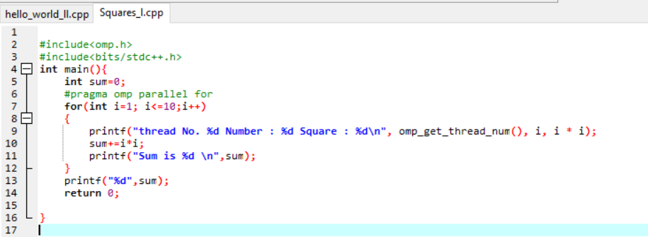

**Output:**

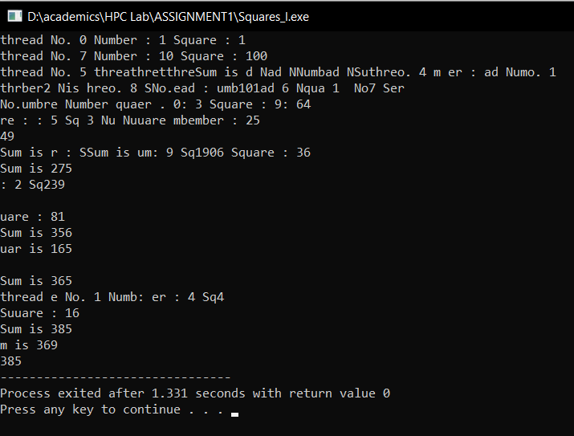

**GITHUB LINK:** [**https://github.com/vai69/HPC-LAB**](https://github.com/vai69/HPC-LAB)