**Final Year B. Tech., Sem VI 2021-22**

**High Performance Computing Lab**

**Assignment submission**

**PRN No: 2019BTECS00069**

**Full name: Vaishnavi Vilas Disale**

**Batch: B3**

**Assignment: 3**

**Study and Implementation of schedule, nowait, reduction, ordered and collapse clauses**

Q1: Analyse and implement a Parallel code for below program using OpenMP.

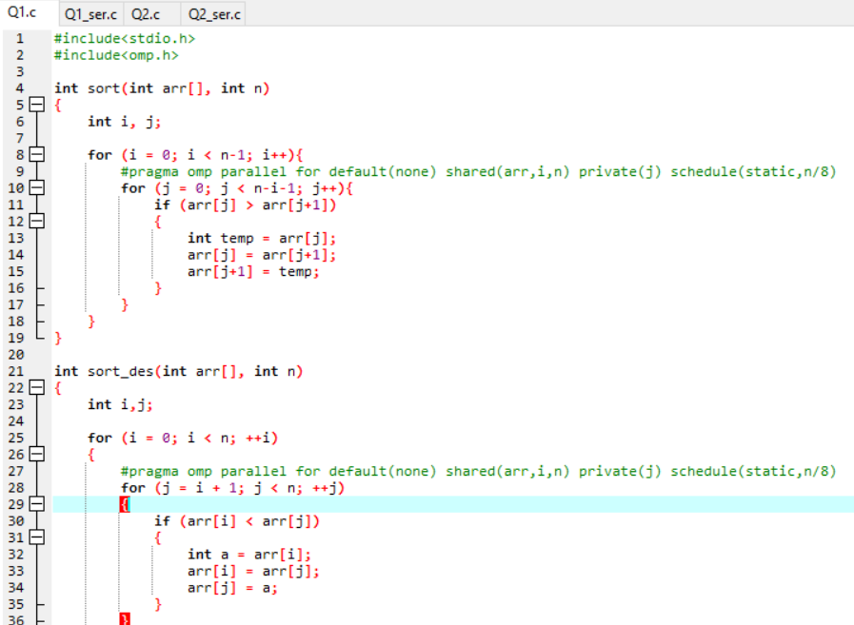

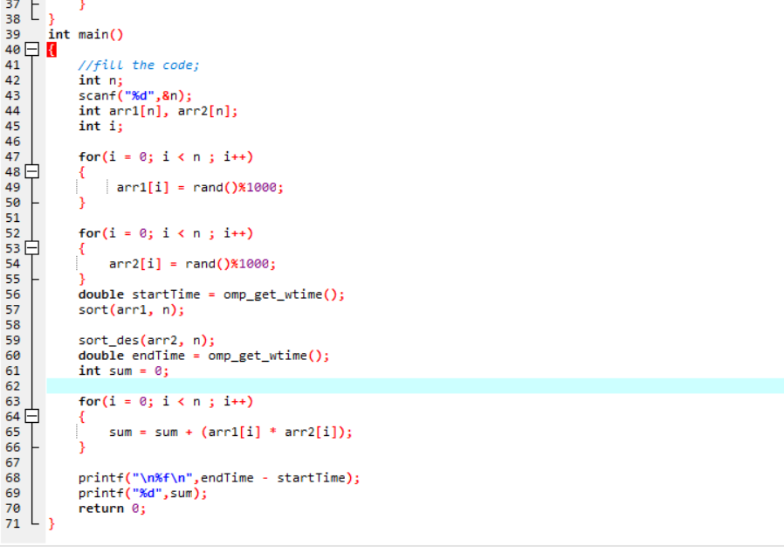

**Output Of Serial code:**

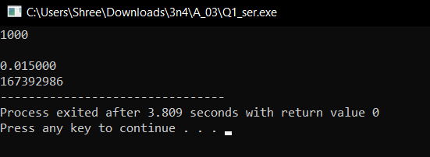

**Output of parallel code:**

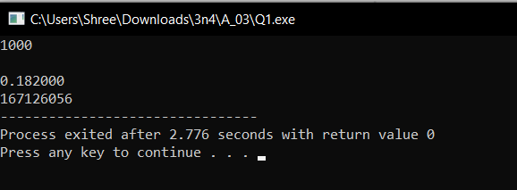

Q2: Write OpenMP code for two 2D Matrix addition, vary the size of your matrices from 250, 500, 750, 1000, and 2000 and measure the runtime with one thread (Use functions in C in calculate the execution time or use GPROF)

i. For each matrix size, change the number of threads from 2,4,8., and plot the speedup versus the number of threads.

ii. Explain whether or not the scaling behaviour is as expected.

