1. **Introduction**

**Purpose**

This documentation serves as a project proposal for an internship application. The goal is to outline the plan for developing a web-based banking system, which will demonstrate proficiency in full-stack development.

**Brief Overview**

The project involves building a banking system allowing users to create accounts, deposit and withdraw funds, and check account balances. Technologies include React for the front end, Flask for the back end, and MySQL for the database.

**Technologies Used**

* Front-End: React.js
* Back-End: Flask (Python)
* Database: MySQL

**2. Project Overview**

**Project Name:** Bank of Interns

**Objective:** The project aims to create a simple web-based banking system to manage customer accounts and transactions.

**Key Features:**

User account creation

Deposit and withdraw funds

Check account balance

**3. UML Diagram**

**Class Diagram**

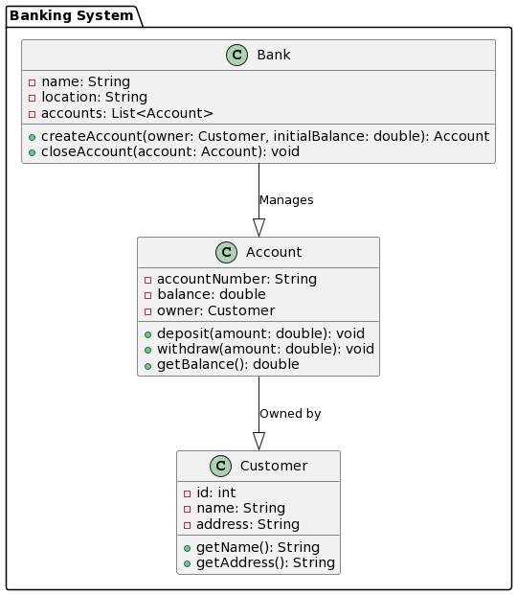

**Database Schema**

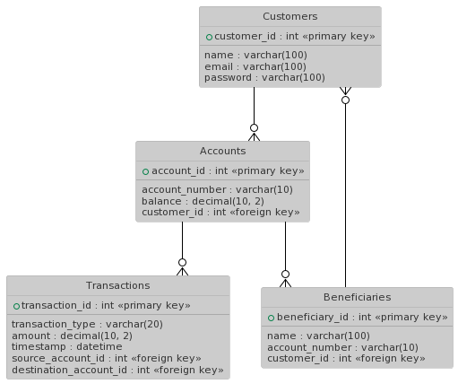

**Use Case Diagram**

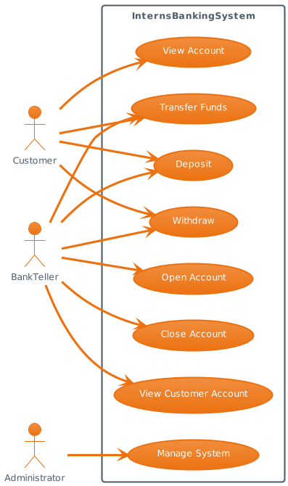

**Sequence Diagram (Deposit Transaction)**

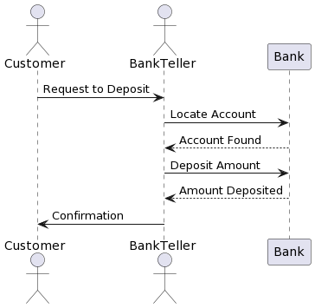

**4. Workflow**

**High-Level Workflow**

* User creates an account by providing name, email, and password.
* User deposits funds by specifying the account number and deposit amount.
* User withdraws funds by specifying the account number and withdrawal amount.
* User checks the account balance by entering the account number.

**Use Case Scenarios**

**Create Account Scenario:**

* User provides account details.
* System validates the input and creates a customer account.
* User receives a confirmation message.

**Deposit Scenario:**

* User specifies the account number and deposit amount.
* System checks the account's validity and updates the balance.
* User receives a deposit confirmation.

**Withdrawal Scenario:**

* User specifies the account number and withdrawal amount.
* System verifies the account's validity and available balance.
* Funds are deducted from the account, and the user receives a withdrawal confirmation.

**Balance Inquiry Scenario:**

* User enters the account number.
* System checks the account's validity and returns the account balance to the user.

**5. Requirements**

**User Stories**

* As a customer, I want to create a bank account to start using the banking system.
* As a customer, I want to deposit funds into my account.
* As a customer, I want to withdraw funds from my account.
* As a customer, I want to check my account balance.

**Functional Requirements**

* **Requirement 1: Account Creation**

Users can create a new customer account by providing their name, email, and password.

* **Requirement 2: Deposit**

Users can deposit funds into their account by specifying the account number and the deposit amount.

* **Requirement 3: Withdrawal**

Users can withdraw funds from their account by specifying the account number and the withdrawal amount.

* **Requirement 4: Balance Inquiry**

Users can check the balance of their account by providing the account number.

**Non-Functional Requirements**

* **Performance:** The application should provide a fast and responsive user experience.
* **Security:** User data should be encrypted and stored securely. Access to accounts should require authentication.
* **Scalability:** The application should be designed to handle an increasing number of users and transactions.
* **Usability:** The user interface should be intuitive and user-friendly.\

**6. Development Plan**

* **Milestone 1 (Day 1-2):** Project setup, database design, and initial back-end development.
* **Milestone 2 (Day 2-4):** Implement front-end components and connect them to the back end.
* **Milestone 3 (Day 4-5):** Testing and debugging.
* **Milestone 4 (Day 5-6):** Final testing, documentation, and project submission.

**7. Conclusion**

In conclusion, this documentation outlines the plan for developing a web-based banking system. The project aims to demonstrate proficiency in full-stack development using React for the front end and Flask for the back end. The provided UML diagram, workflow, and requirements offer a clear path for project implementation and will help in achieving the goals of the internship.