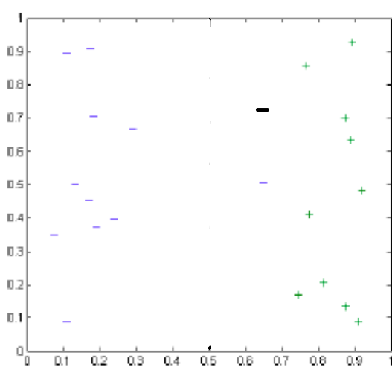

1. Kernel = linear

As the negative data point is on margin of linear boundary learnt it will not affect the linear separation line learnt.

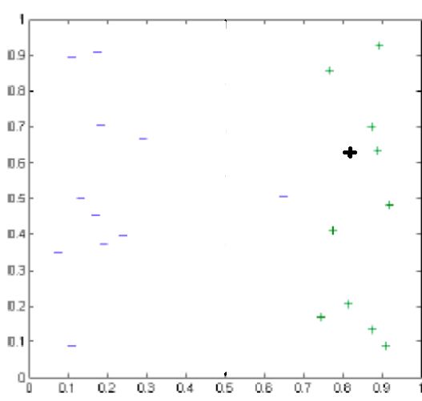

1. Kernel = quadratic

As the positive data point is way inside(right of the curve) the quadratic curve learnt will not affect support vectors of the margin of boundary and hence the boundary learnt will not change.

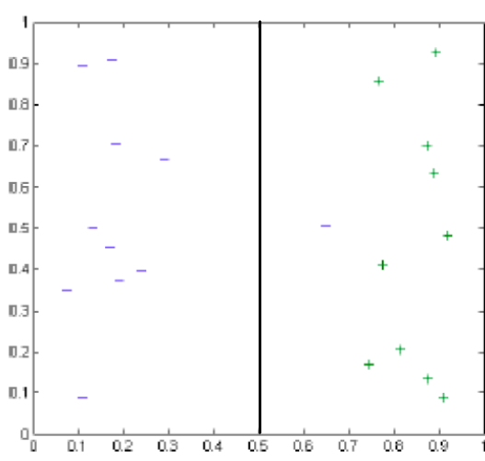

2) kernel = linear

As C is zero this means that the cost for making error is zero. So points can be misclassified to learn a decision boundary.

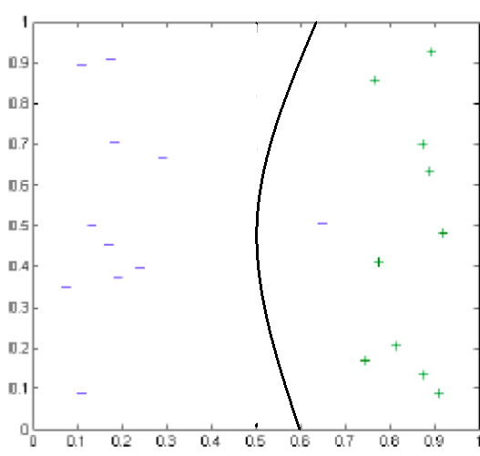

2) kernel = quadratic

As C is zero this means that the cost for making error is zero. So points can be misclassified to learn a decision boundary. Here negative point is misclassified.

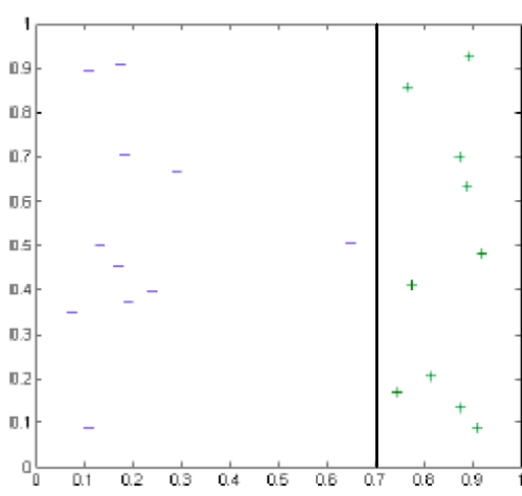

1. Kernel = linear

As cost for misclassification is very high there can not be any misclassified point.

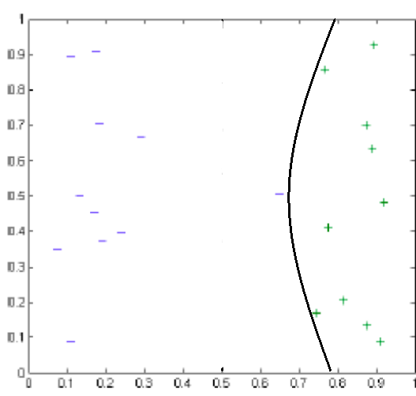

1. Kernel = quadratic

As cost for misclassification is very high there can not be any misclassified point.

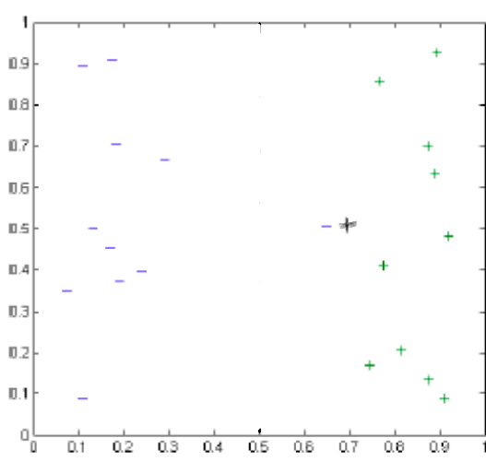

1. Kernel = linear

As the new data point is where the decision boundary was, the decision boundary has to be changed in order to have zero misclassified datapoints

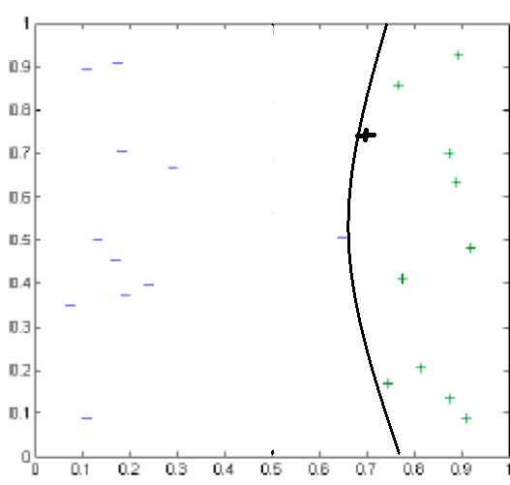

1. Kernel = quadratic

As the new data point is where the decision boundary was, the decision boundary has to be changed in order to have zero misclassified datapoint.

1. When C is zero for linear kernel the classification will be better. Because the line will generalize more on test dataset. If C is infinity the decision margin will try very hard to even correctly classify the outlier and will not generalize well.

When C is zero for quadratic kernel the classification will be better. Because the curve will generalize more on test dataset. If C is infinity the decision margin will try very hard to even correctly classify the outlier and will not generalize well.