***ORACLE ASSIGNMENT***

1)

1. Create the table as describe below

Table name : client_master

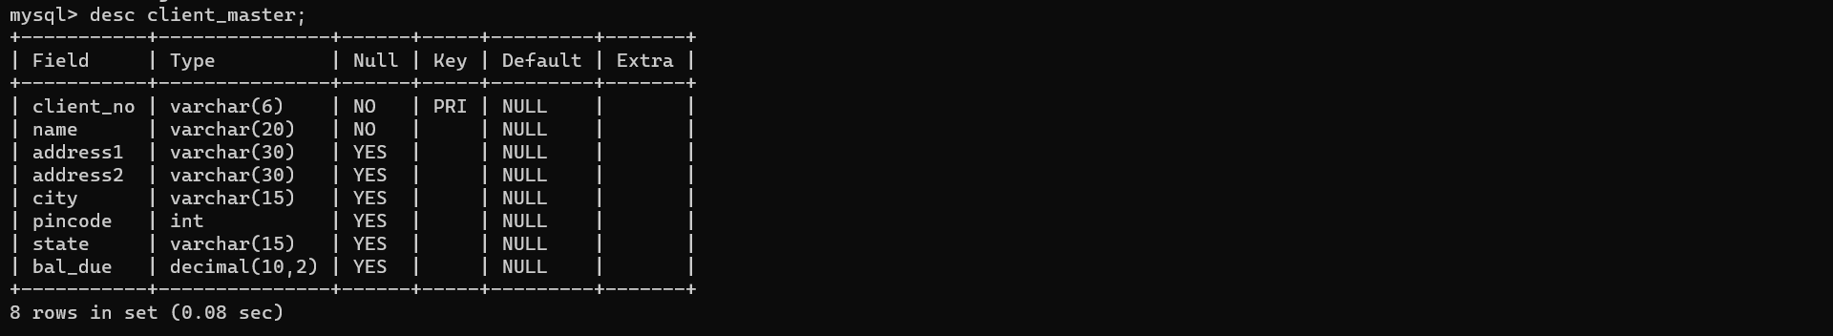

1. Create the table as describe below

Table name : product_master

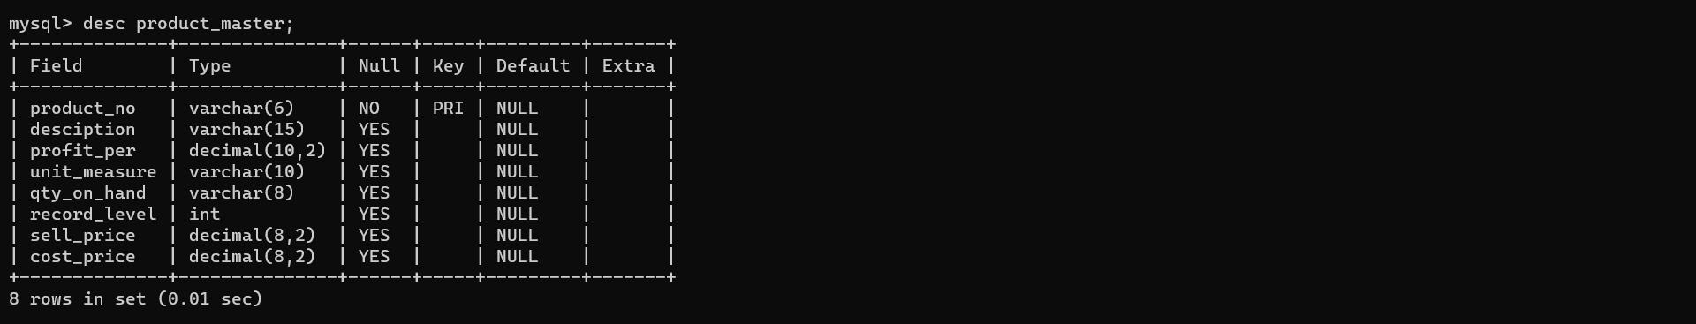

1. Create the table as describe below

Table name : salesman_master

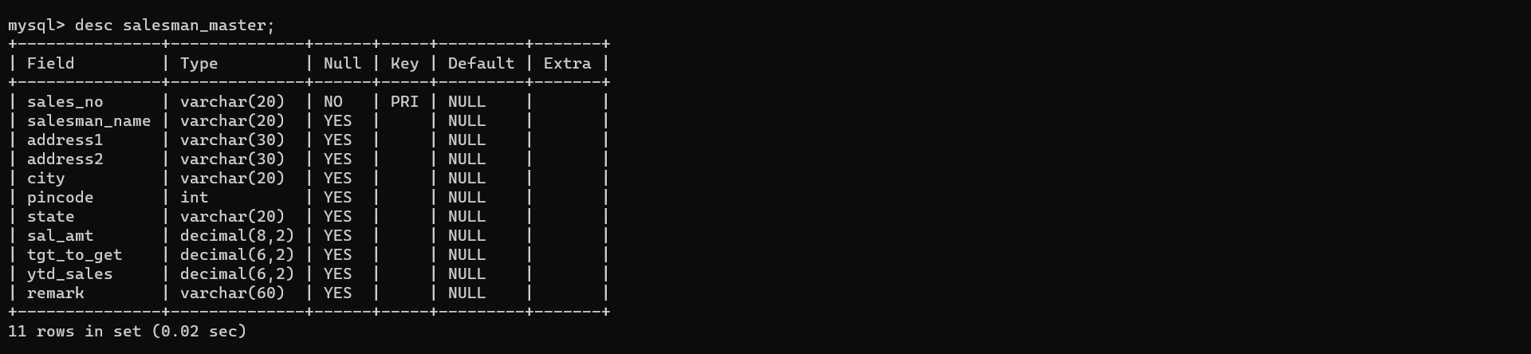

2)

A) select * from client_master

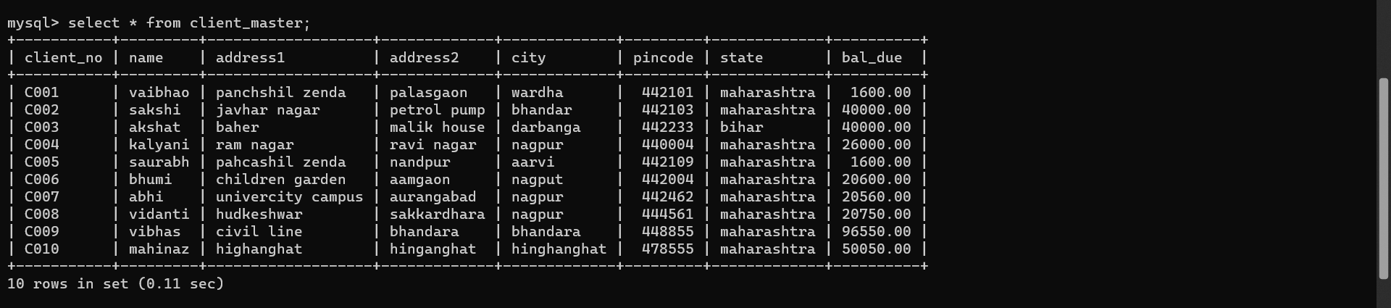

B) select * from product_master

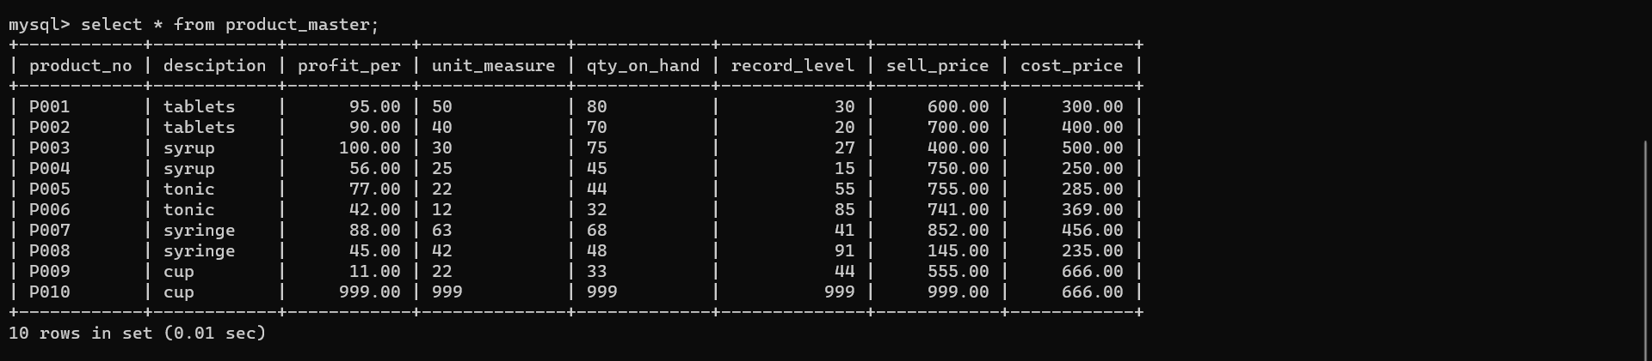

1. Select * from salesman_master

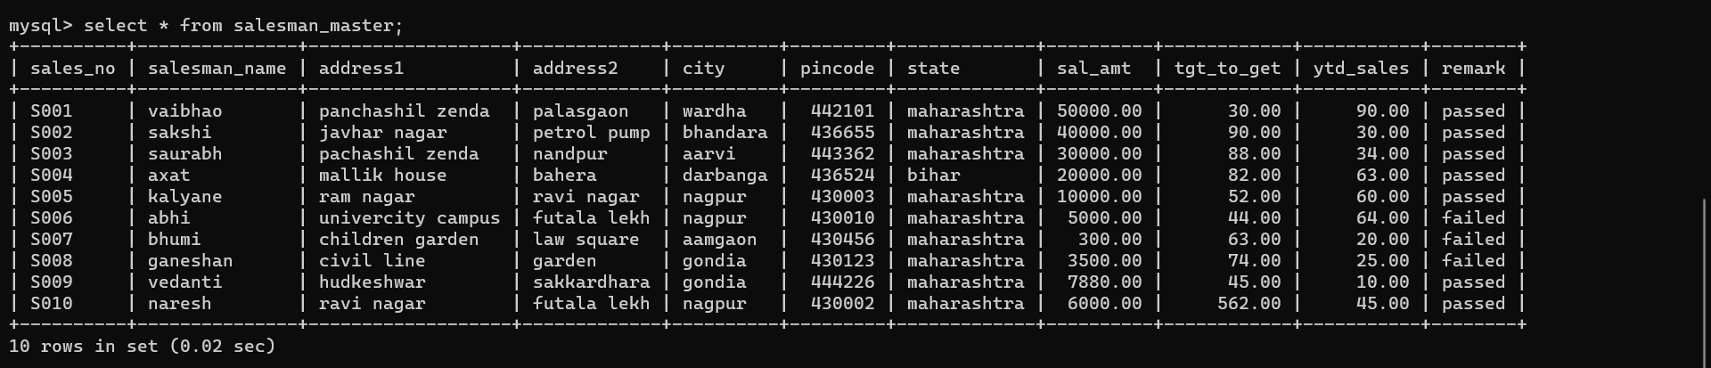

Read the question and write appropriate SQL statement as a answer

1. Exercise on retrieving record from the table
2. Find the name of all the client

select name from client_master;

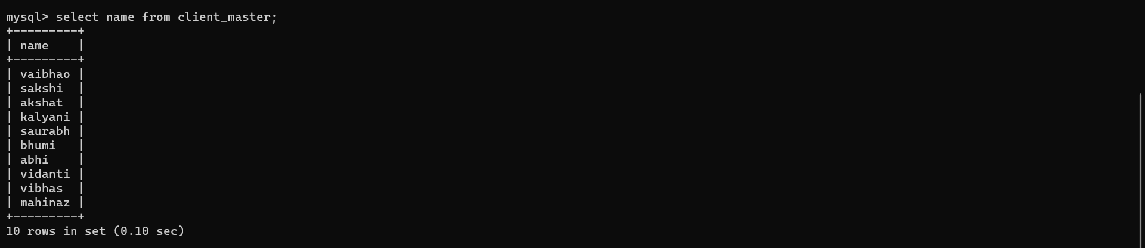

1. Retrieve the entire content of the client_master table

select * from client_master;

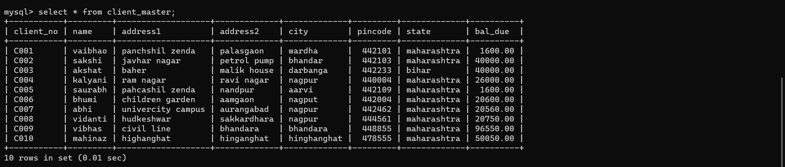

1. Retrieve the list of names and the cities of all the client

select name,city from client_master;

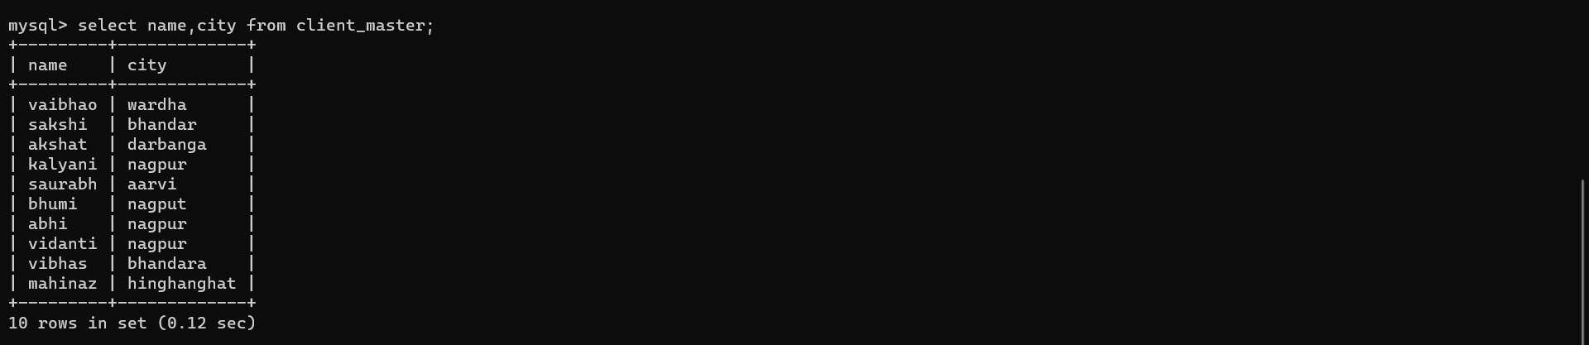

1. List the various product available from product_master

select * from product_master;

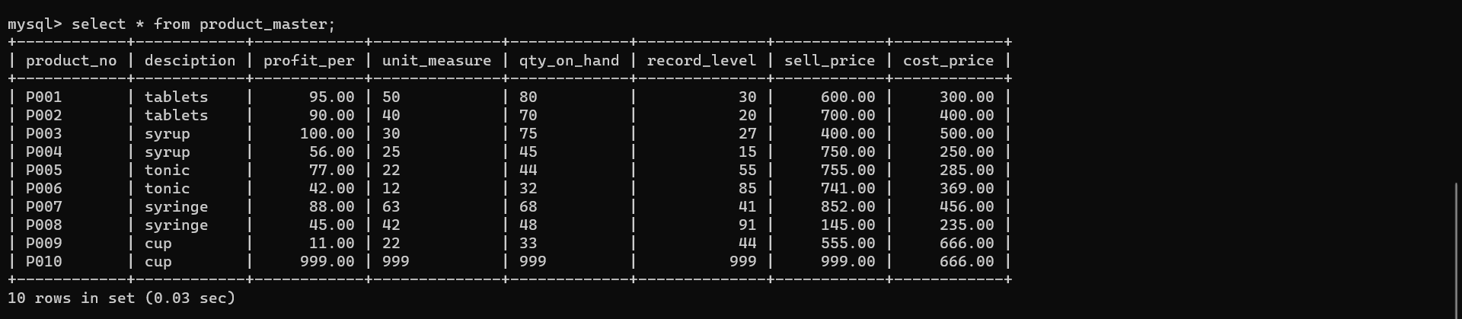

1. List all the client whose locate in Nagpur

select * from client_master where city='nagpur';

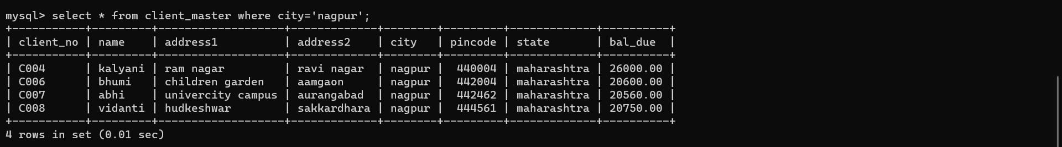

1. Find the name of the salesman who have the salary greater than RS.30000

select salesman_name , sal_amt from salesman_master where sal_amt > 30000;

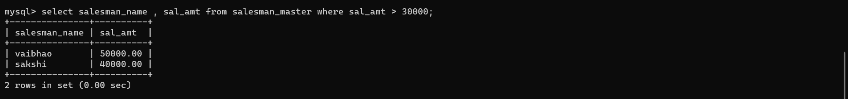

1. Exercise on update record in a table
2. Change the city of the name=bhumi to Nagpur

update client_master set city='nagpur' where name='bhumi';

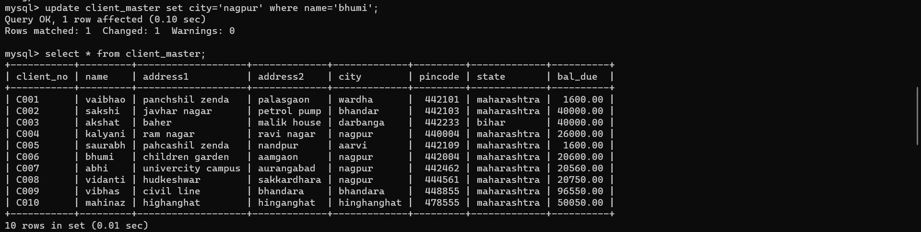

1. Change the bal_due of client no_C005 to RS10000

update client_master set bal_due=10000 where client_no='C005';

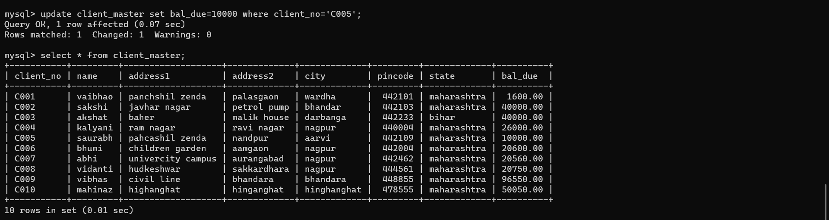

1. Change the cost_price of tablet to RS 2000

update product_master set cost_price='2000' where desciption='tablets'; 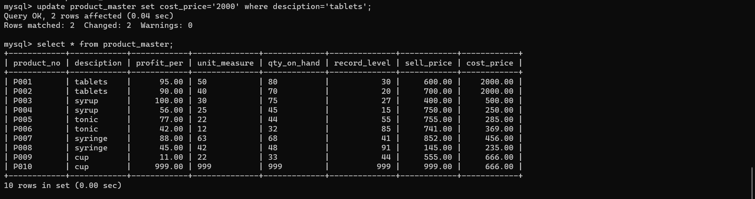

1. Change the city of the salesman to Nagpur salesman_no =S009

update salesman_master set city='nagpur' where sales_no='S009';

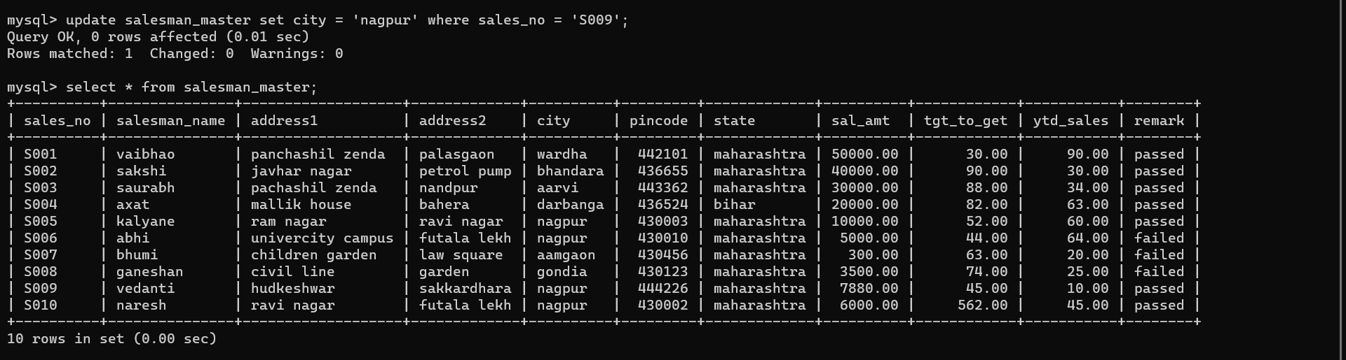

1. Exercise on deleting records in a table
2. Delete all the salesman from salesman_master whose salary are equal to RS6000

delete from salesman_master where sal_amt=6000;

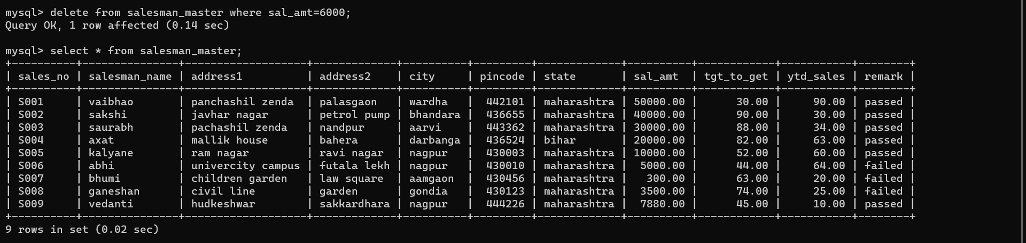

1. Delete all the product from the product_master where the quantity on hand is equal to 100

delete from product_master where qty_on_hand = '999';

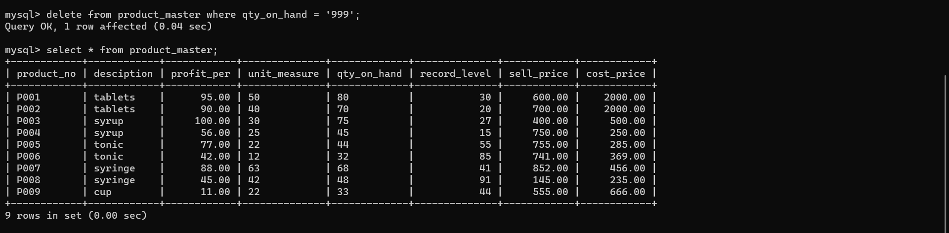

1. Delete all the client where state is west Bengal

delete from client_master where state = 'west bengal';

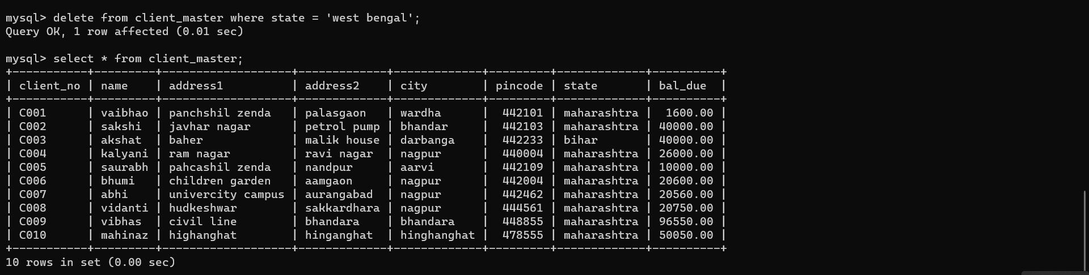

1. Exercise on altering the table structure
2. Add the column telephone of data type int and size=10

alter table client_master add telephone int(10);

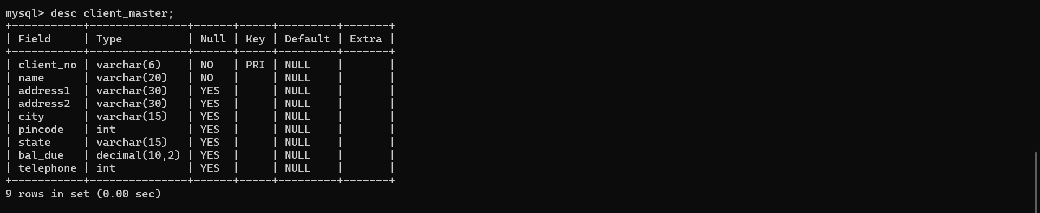

1. Change all size of sell_price column in product_master to 10,2

alter table product_master modify sell_price decimal(10,2);

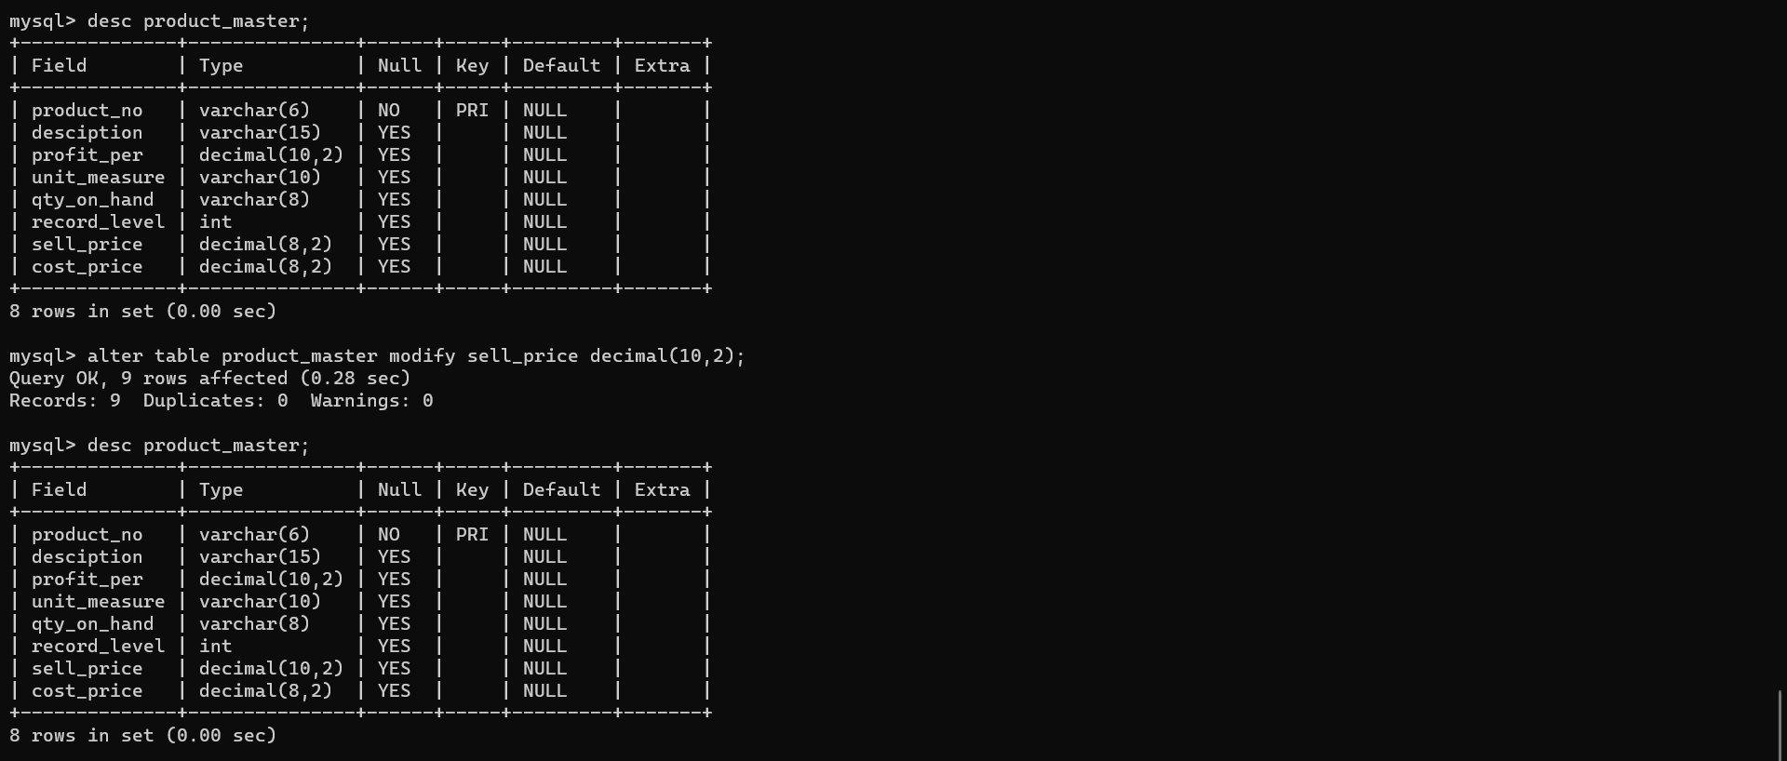

1. Destroy the table client_master long with its data

drop table client_master;



B)

2) Exercise on retrieving from a table after computing table data

a) Retrieve the contents of the column product_no,descriptiom and compute 10% of values content in the column sell_price and 110% of values contents in the column sell_price for each row from the table product master.

select product_no,sell_price*0.10 new_price from product_master;

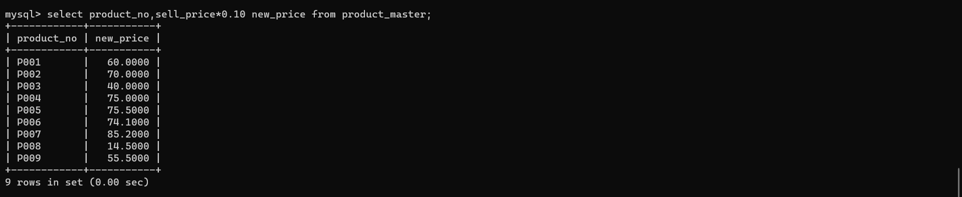

1. Execute the above command by just renaming the column name as increase price and new price respectively.

Select product_no,sell_price*0.10,sell_price*1.10 new_price from product_master

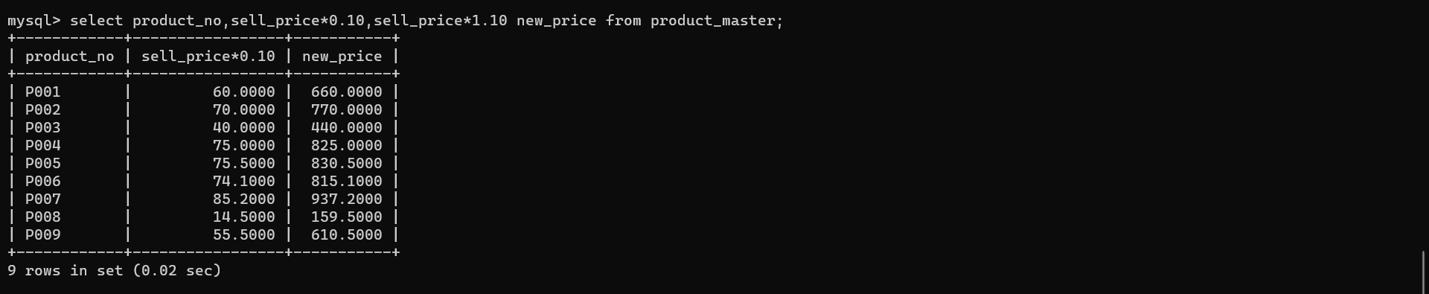

1. c) Retrieve the contents of the column product_no description profit_per,sell_price from the table product_master where the values contain in the field profit_per is between 25 and 56 both inclusive

select product_no,sell_price,profit_per from product_master where profit_per>=25 and profit_per<=56

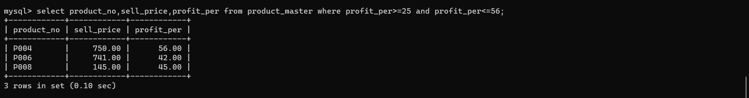

1. d) Retrieve the contents of the column product_no,description profit_per,sell_price from the table product_master where the values contained in the field profit_per is between 25 and 56 inclusive

select product_no,sell_price,profit_per from product_master where profit_per between 25 and 56;

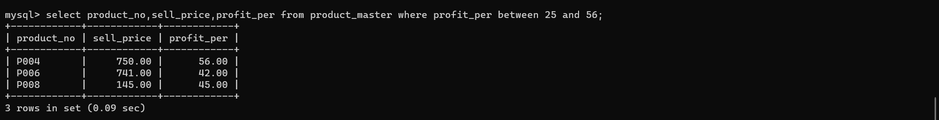

1. e) Retrieve the contents of the column product_no desctiption profit_per,sell_price from the table product_master where the values contained in the field profit_per is not between 25 and 56

select product_no,sell_price,profit_per from product_master where profit_per not between 25 and 56;

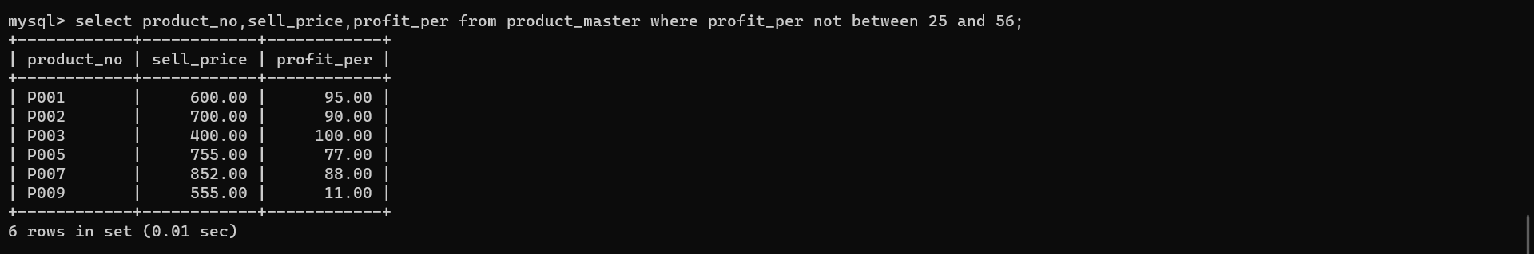

1. Retrieve the client information from the table client_master where the pin code values contain 442101 or 447788

Select * from client_master where pincode=442101 or pincode=442103;

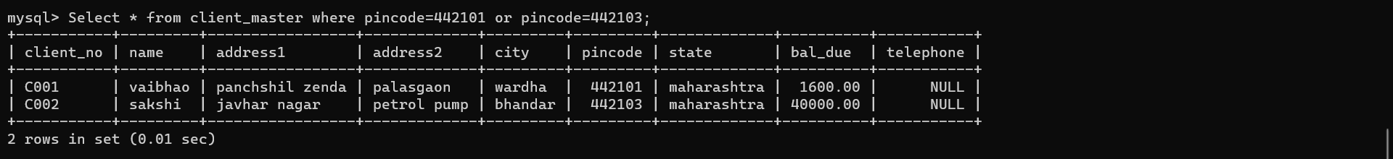

1. Retrieve the client information from the table client_master where the client those who are not in ‘nagpur’ or ‘bombay’

Select * from client_master where not(city=’nagpur’ OR city=’bombay’);

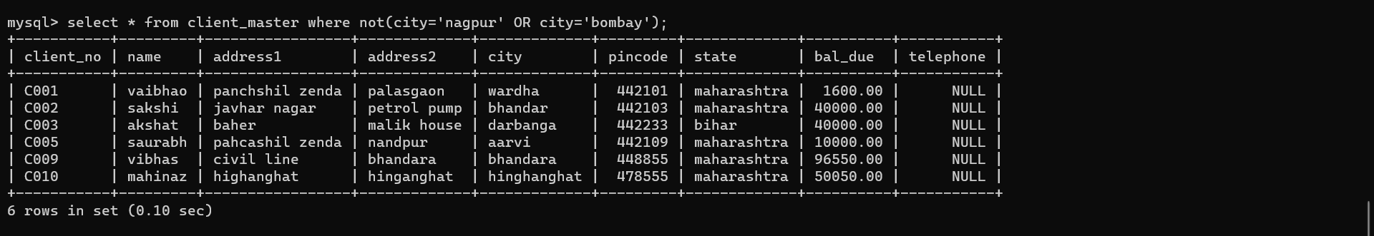

1. Retrieve the information of supplier whose name is being with the letter ‘ka’ from client_master

select * from client_master where name LIKE ‘ka%;

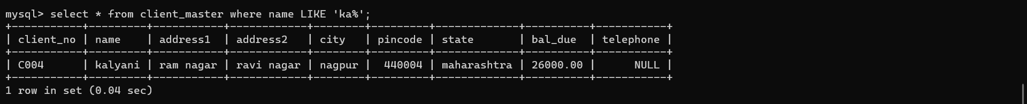

1. Retrieve the information of supplier whose name is where the second character of name are either ‘a’ or ‘h’ from the table supplier

select * from client_master where name LIKE '_h%';

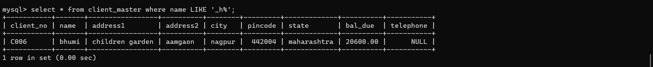

1. Retrieve the information of supplier whose name is begins with the letter ‘ab’ and length of name should be 3 char long from the table supplier master

select * from client_master where name LIKE 'ab%';

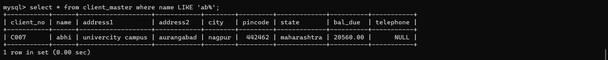

1. Retrieve the information of supplier where the supplier name is either ‘vaibhao’,’sakshi’,’kalyani’

select * from client_master where name IN('vaibhao','sakshi','kalyani');

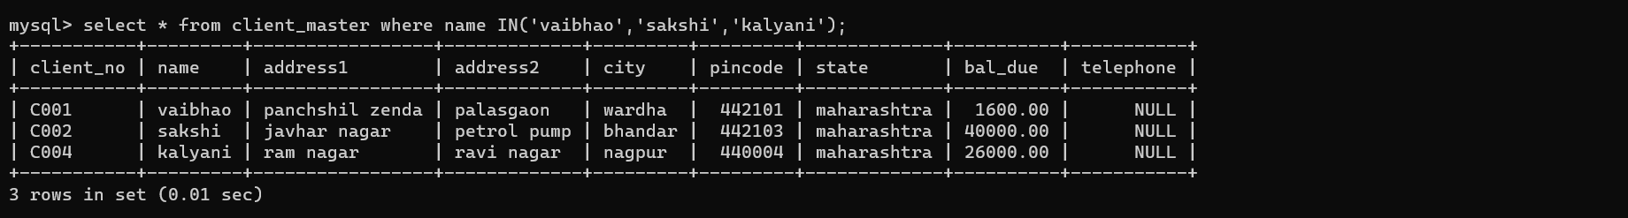

1. Retrieve the information of supplier where supplier name are other than ‘vaibhao’,’sakshi,’kalyani’

select * from client_master where name NOT IN('vaibhao','sakshi','kalyani');

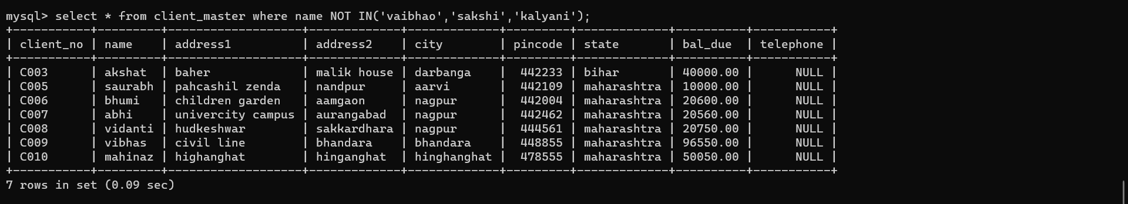

C)

1) Retrieve the product number and quality order for each quantity order for each product from sales_order_details table

a) Sales_order_details

i) order number

select order_no from sales_order_details;

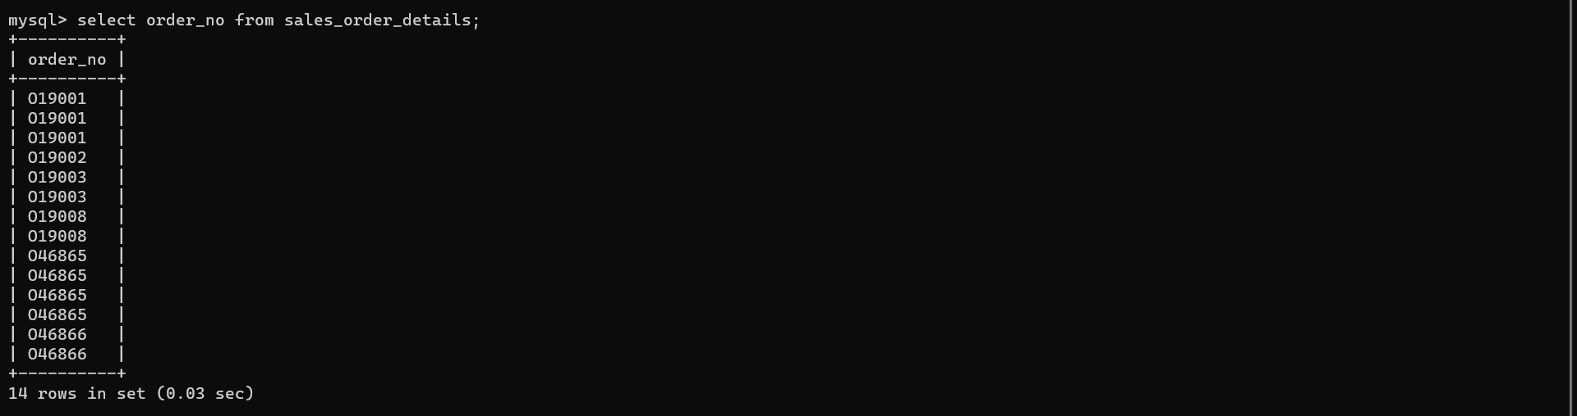

ii) product_no

select product_no from sales_order_details;

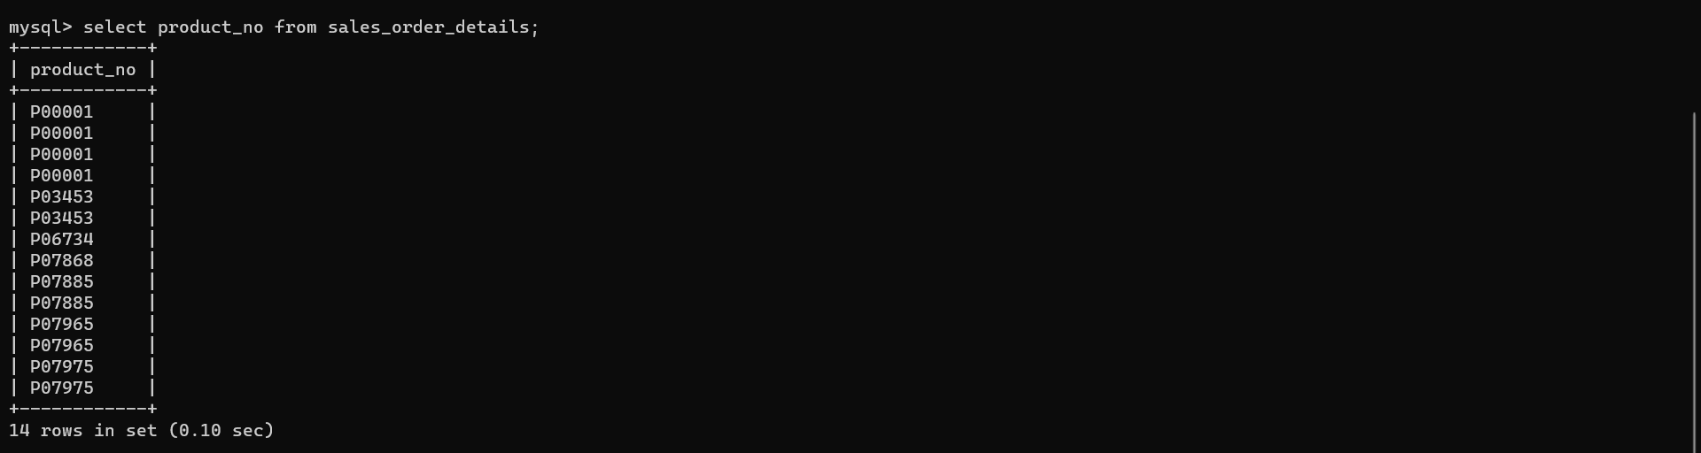

iii) qty_ordered

select qty_ordered from sales_order_details;

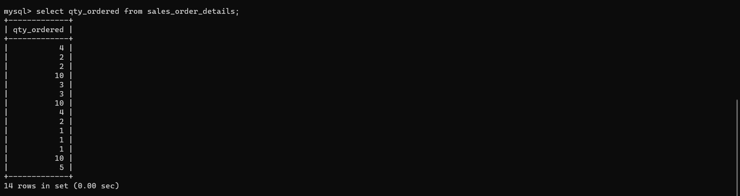

iv) qty_disp

select qty_disp from sales_order_details;

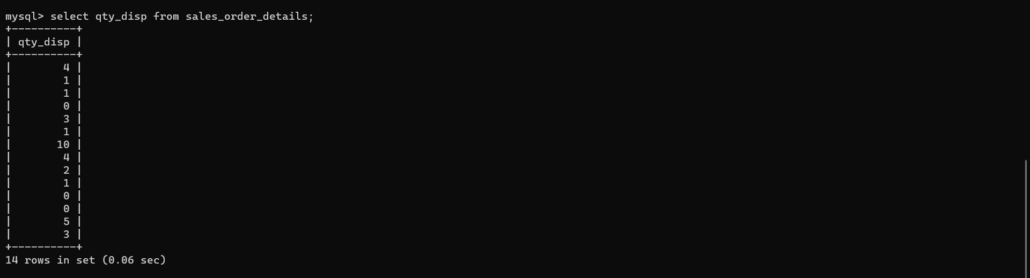

4) retrieve the product number and quantity ordered for product ‘P00001’ from sales_order_details

select product_no,qty_ordered from sales_order_details where product_no='P00001' ;

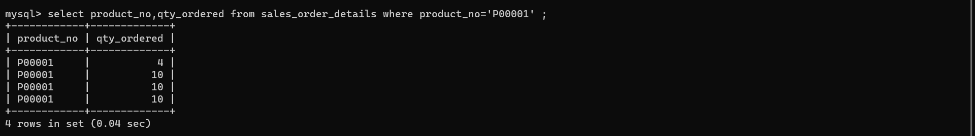

5) add the pk constrain on the coloum supply_no belong to the order_no

alter table sales_order_details add primary key (order_no)

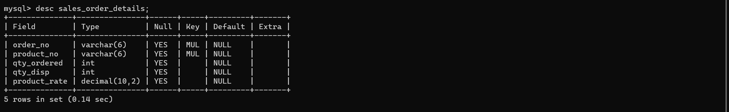

6) add fk constrain on the column order_no belong to the sales_order_details which reference the table sales_order.modify qty_ordered to include not null constrain

Alter table sales_order_details add constrain order_fkey foreign key(order_no) references sales_order modify (qty_ordered number(8) not null)

