1. Create table describe below.
2. Table Name : client_master1

create table client_master1(client_no varchar(10) primary key check(client_no like 'C%'),name varchar(20) not null, address1 varchar(30),address2 varchar(30),city varchar(15),pincode int(8),state varchar(15),bal_due decimal(10,2));

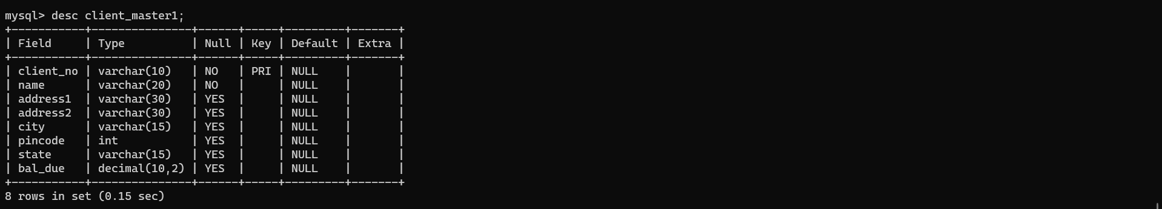

1. Table name : product_master1

create table product_master2(product_no varchar(10) primary key check(product_no like 'P%'), desciption varchar(15) not null,profit_percent decimal(4,2),unit_measure varchar(10) not null,qty_on_hand int(8) not null, record_lvl int(8) not null,sell_price decimal(8,2) not null,cost_price decimal(8,1) not null);

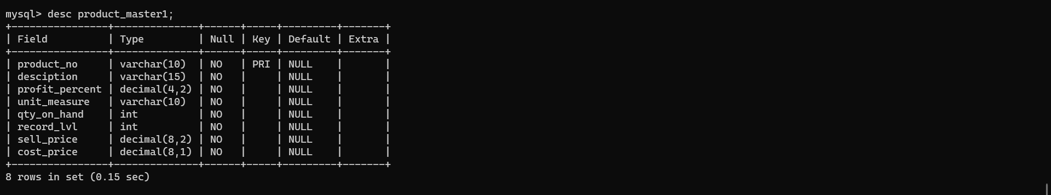

1. Table name : salesman_master1

create table salesman_master1(salesman_no varchar(10) primary key check(salesman_no like 'S%'),salesman_name varchar(20) not null,address1 varchar(30) not null,address2 varchar(30),city varchar(20),pincode int(8), state varchar(20),sal_amt decimal(8,2) not null,tgt_to_get decimal(6,2) not null, ytd_sales decimal(6,2) not null,remarks varchar(60));

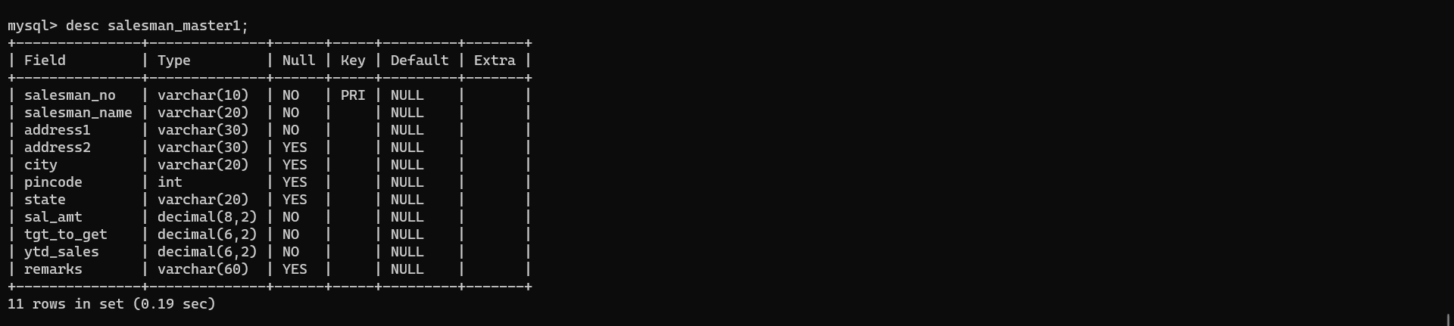

1. Table name : sales_order

create table salesman_master1(salesman_no varchar(10) primary key check(salesman_no like 'S%'),salesman_name varchar(20) not null,address1 varchar(30) not null,address2 varchar(30),city varchar(20),pincode int(8), state varchar(20),sal_amt decimal(8,2) not null,tgt_to_get decimal(6,2) not null, ytd_sales decimal(6,2) not null,remarks varchar(60));

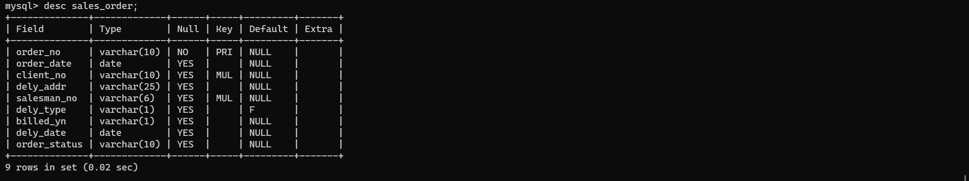

1. Table name : sales_order_details

create table sales_order_details(order_no varchar(6) ,foreign key(order_no) references sales_order(order_no),product_no varchar(6) , foreign key (product_no) references product_master1(product_no),qty_ordered int(8),qty_disp int (8),product_rate decimal(10,2));

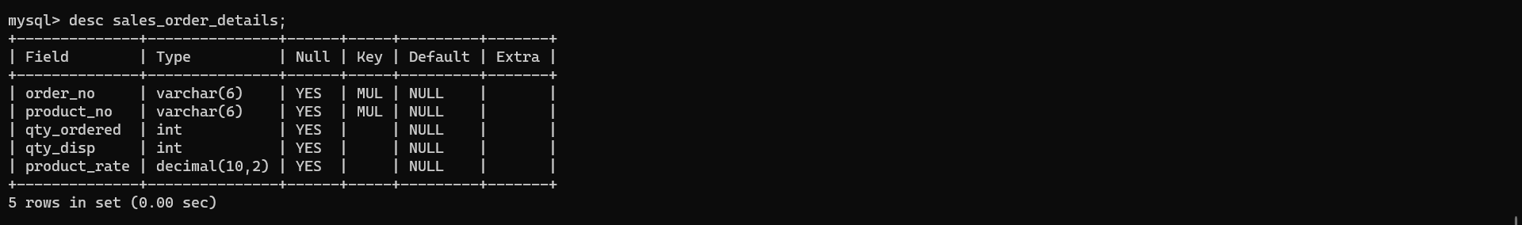

1. Insert the following data into their respective tables
2. Data for client_master1

mysql> insert into client_master1 values('C00001','ivan bayross','parel','worli','bombay',400054,'maharashtra',15000);

Query OK, 1 row affected (0.06 sec)

mysql> insert into client_master1 values('C00002','vandana saitwal','chennai','ashok nagar','madras',780001,'tamil nadu',0);

Query OK, 1 row affected (0.01 sec)

mysql> insert into client_master1 values('C00003','pramada jaguste','worli','parel','bombay',400057,'maharashtra',50000);

Query OK, 1 row affected (0.01 sec)

mysql> insert into client_master1 values('C00004','basu navindgi','worli','parel','bombay',400056,'maharashtra',0);

Query OK, 1 row affected (0.01 sec)

mysql> insert into client_master1 values('C00005','ravi sreedharan','jagatpur','majnu ka thela','delhi',100001,'delhi',2000);

Query OK, 1 row affected (0.00 sec)

mysql> insert into client_master1 values('C00006','rukhmini','majnu ka thela','jagatpur','bombay',400050,'maharashtra',0);

Query OK, 1 row affected (0.01 sec)

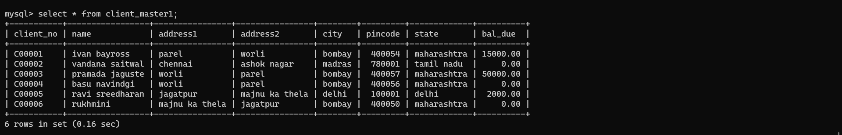

1. Data for product_master1

mysql> insert into product_master1 values('P00001','1.44 floppies',5,'piece',100,20,525,500);

Query OK, 1 row affected (0.00 sec)

mysql> insert into product_master1 values('P03453','monitors',6,'piece',10,3,12000,11280);

Query OK, 1 row affected (0.01 sec)

mysql> insert into product_master1 values('P06734','mouse',5,'piece',20,5,1050,1000);

Query OK, 1 row affected (0.01 sec)

mysql> insert into product_master1 values('P07865','1.22 floppies',5,'piece',100,20,525,500);

Query OK, 1 row affected (0.01 sec)

mysql> insert into product_master1 values('P07868','keyboards',2,'piece',10,3,3150,3050);

Query OK, 1 row affected (0.01 sec)

mysql> insert into product_master1 values('P07885','cd drive',2.5,'piece',10,3,5250,5100);

Query OK, 1 row affected (0.00 sec)

mysql> insert into product_master1 values('P07965','540 HDD',4,'piece',10,3,8400,8000);

Query OK, 1 row affected (0.01 sec)

mysql> insert into product_master1 values('P07975','1.44 drive',5,'piece',10,3,1050,1000);

Query OK, 1 row affected (0.00 sec)

mysql> insert into product_master1 values('P08865','1.22 drive',5,'piece',2,3,1050,1000);

Query OK, 1 row affected (0.01 sec)

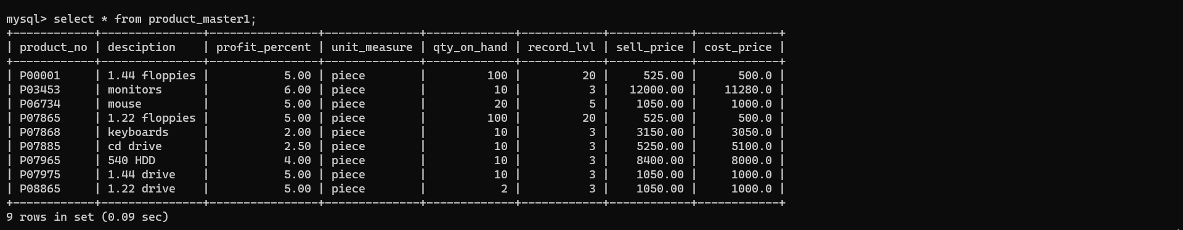

1. Data from salesman_master1

mysql> insert into salesman_master1 values('S00001','kiran','A/14','worli','bombay',400002,'maharashtra',3000,100,50,'good');

Query OK, 1 row affected (0.02 sec)

mysql> insert into salesman_master1 values('S00002','manish','65','nariman','bombay',400001,'maharashtra',3000,200,100,'good');

Query OK, 1 row affected (0.01 sec)

mysql> insert into salesman_master1 values('S00003','ravi','P-7','bandra','bombay',400032,'maharashtra',3000,200,100,'good');

Query OK, 1 row affected (0.19 sec)

mysql> insert into salesman_master1 values('S00004','ashish','A/5','juhu','bombay',400044,'maharashtra',3500,200,150,'good');

Query OK, 1 row affected (0.00 sec)

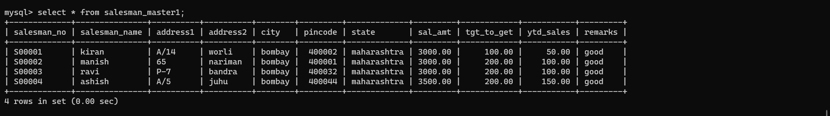

1. Data from sales_order

mysql> insert into sales_order values('O19001','1996-01-12','C00001','nagpur','S00001','F','N','1996-01-20','in process');

Query OK, 1 row affected (0.06 sec)

mysql> insert into sales_order values('O19002','1996-01-25','C00002','nagpur','S00002','P','N','1996-01-27','cancelled');

Query OK, 1 row affected (0.01 sec)

mysql> insert into sales_order values('O46865','1996-02-18','C00003','nagpur','S00003','F','Y','1996-02-20','fulfilled');

Query OK, 1 row affected (0.01 sec)

mysql> insert into sales_order values('O19003','1996-04-03','C00001','nagpur','S00001','F','Y','1996-04-07','fulfilled');

Query OK, 1 row affected (0.01 sec)

mysql> insert into sales_order values('O46866','1996-05-20','C00004','nagpur','S00002','P','Y','1996-05-22','cancelled');

Query OK, 1 row affected (0.01 sec)

mysql> insert into sales_order values('O19008','1996-05-24','C00005','nagpur','S00002','F','N','1996-05-26','in process');

Query OK, 1 row affected (0.01 sec)

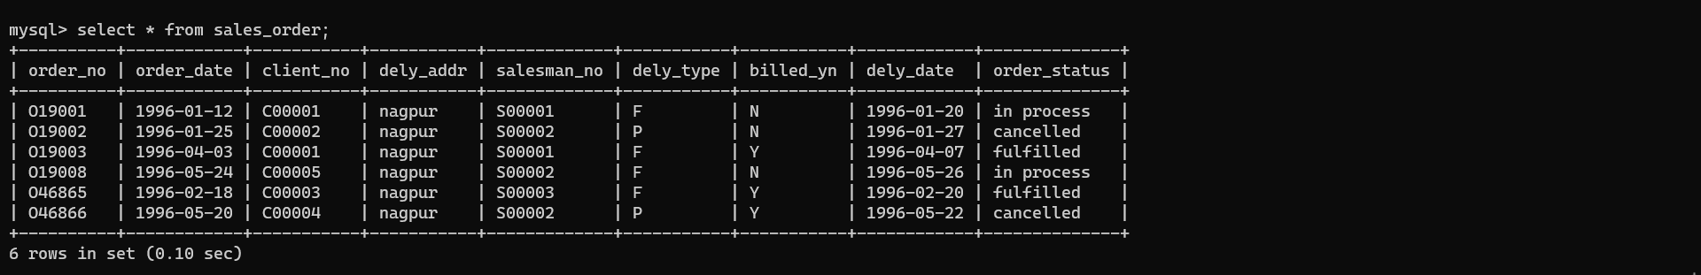

1. Data from sales_order_details

mysql> insert into sales_order_details values('O19001','P00001',4,4,525);

Query OK, 1 row affected (0.11 sec)

mysql> insert into sales_order_details values('O19001','P07965',2,1,8400);

Query OK, 1 row affected (0.01 sec)

mysql> insert into sales_order_details values('O19001','P07885',2,1,5250);

Query OK, 1 row affected (0.00 sec)

mysql> insert into sales_order_details values('O19002','P00001',10,0,525);

Query OK, 1 row affected (0.01 sec)

mysql> insert into sales_order_details values('O46865','P07868',3,3,3150);

Query OK, 1 row affected (0.01 sec)

mysql> insert into sales_order_details values('O46865','P07885',3,1,5250);

Query OK, 1 row affected (0.02 sec)

mysql> insert into sales_order_details values('O46865','P00001',10,10,525);

Query OK, 1 row affected (0.01 sec)

mysql> insert into sales_order_details values('O46865','P03453',4,4,1050);

Query OK, 1 row affected (0.00 sec)

mysql> insert into sales_order_details values('O19003','P03453',2,2,1050);

Query OK, 1 row affected (0.01 sec)

mysql> insert into sales_order_details values('O19003','P06734',1,1,12000);

Query OK, 1 row affected (0.01 sec)

mysql> insert into sales_order_details values('O46866','P07965',1,0,8400);

Query OK, 1 row affected (0.01 sec)

mysql> insert into sales_order_details values('O46866','P07975',1,0,1050);

Query OK, 1 row affected (0.01 sec)

mysql> insert into sales_order_details values('O19008','P00001',10,5,525);

Query OK, 1 row affected (0.01 sec)

mysql> insert into sales_order_details values('O19008','P07975',5,3,1050);

Query OK, 1 row affected (0.01 sec)

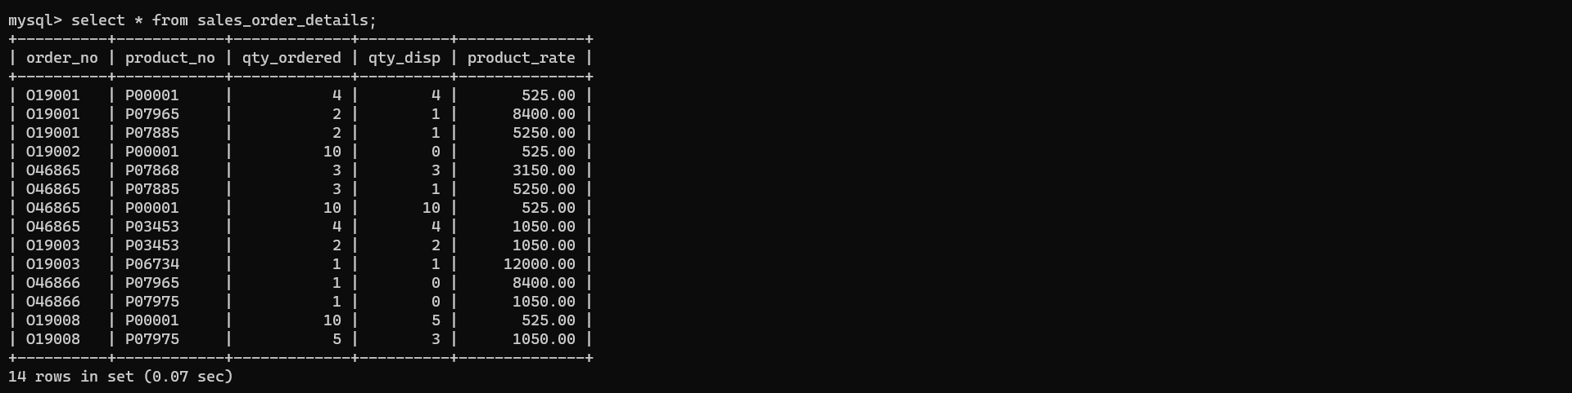

1. Exercises on computations on table data
2. Find the name of all client having ‘a’ as the second letters in their names.

Ans. select * from client_master1 where name like '_a%';

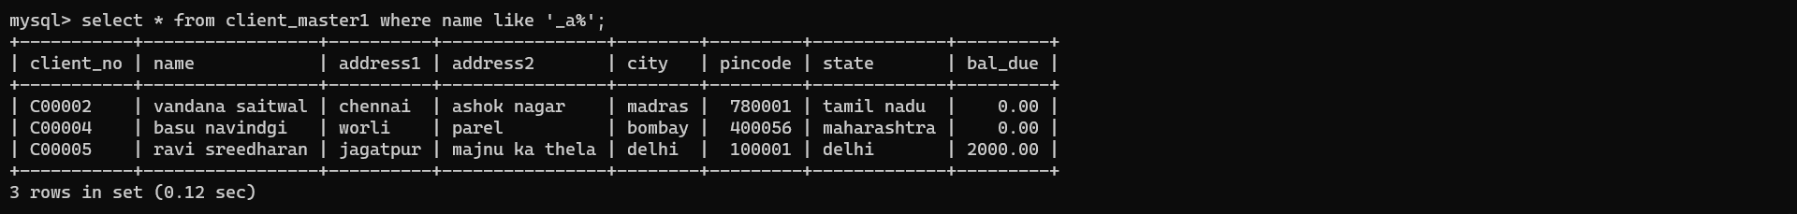

1. Find out the client who stay in city whose second letter is ‘a’

Ans. select * from client_master1 where city like '_a%';

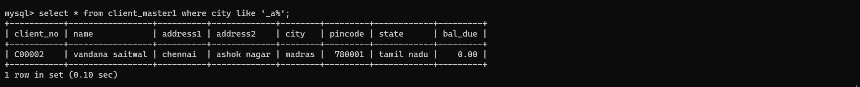

1. Find the list of all client who stay in ‘bombay’ or ‘delhi’

Ans. select * from client_master1 where city = 'bombay' OR 'delhi';

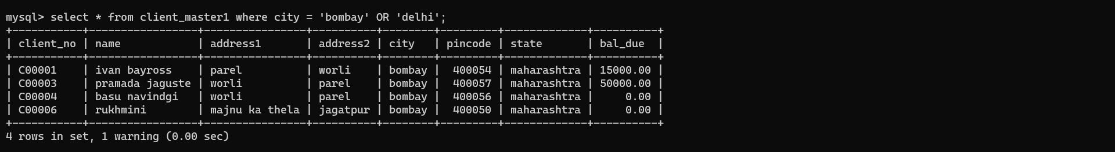

1. Print the list of client whose bal_due is greater than value 10000

Ans. select * from client_master1 where bal_due>10000;

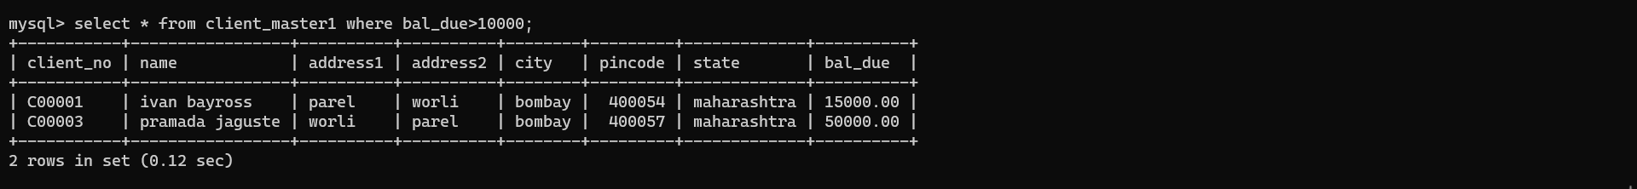

1. Print the information from sales_order table for order place in the '1996-01-25' '1996-01-12

Ans : select * from sales_order where order_date ='1996-01-25' or order_date='1996-01-12';

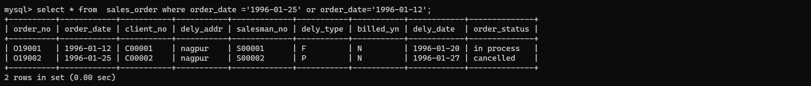

1. Display the order information for client_no’C00001’ and ‘C00002’

Ans : select * from client_master1 where client_no ='C00001' or client_no = 'C00002';

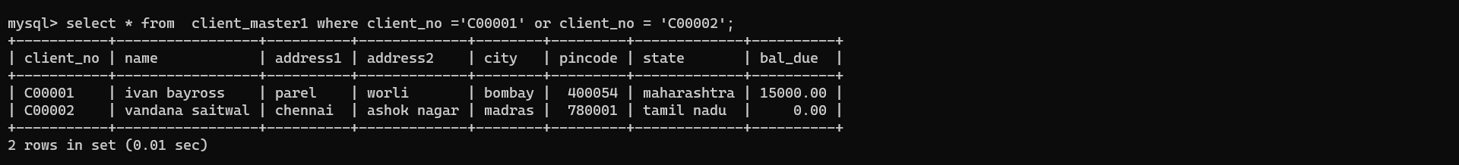

1. Find product whose selling_price is greater than 2000 and less than or equal to 5000

Ans : select * from product_master1 where sell_price >2000 and sell_price<5000;



1. Find product whose selling_price is more than 1500

Calculate a new selling_price as original selling price * 0.15.rename the new column in the above query new_price

Ans : select desciption,sell_price,sell_price * 0.15 "new_price" from product_master1 where sell_price>1500 ;

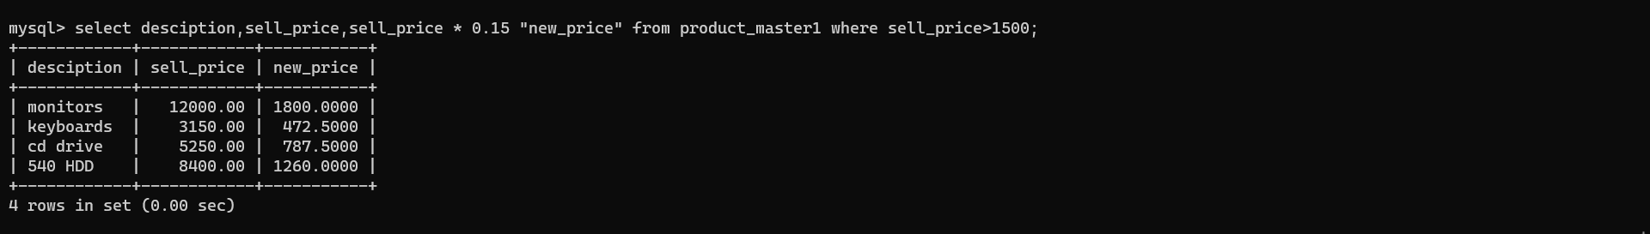

1. List the names ,city and state of client who are not in the state of Maharashtra

Ans : select name , city, state from client_master1 where not state='maharashtra';

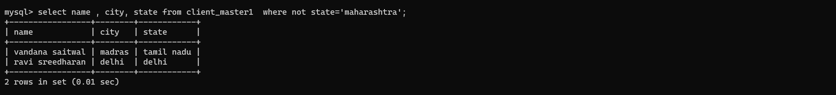

1. Count the total number of order

Ans : select order_no,count(*) from sales_order_details group by order_no;

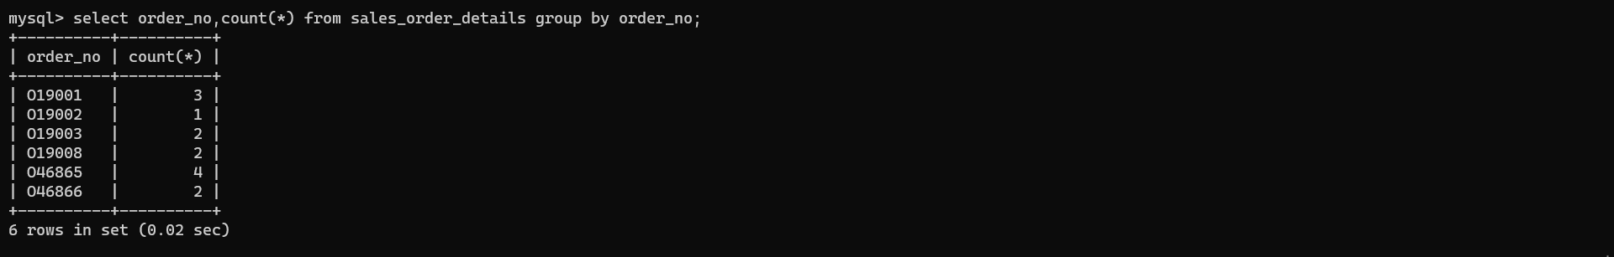

1. Calculate the average price of all the product

Ans : select avg(sell_price) from product_master;

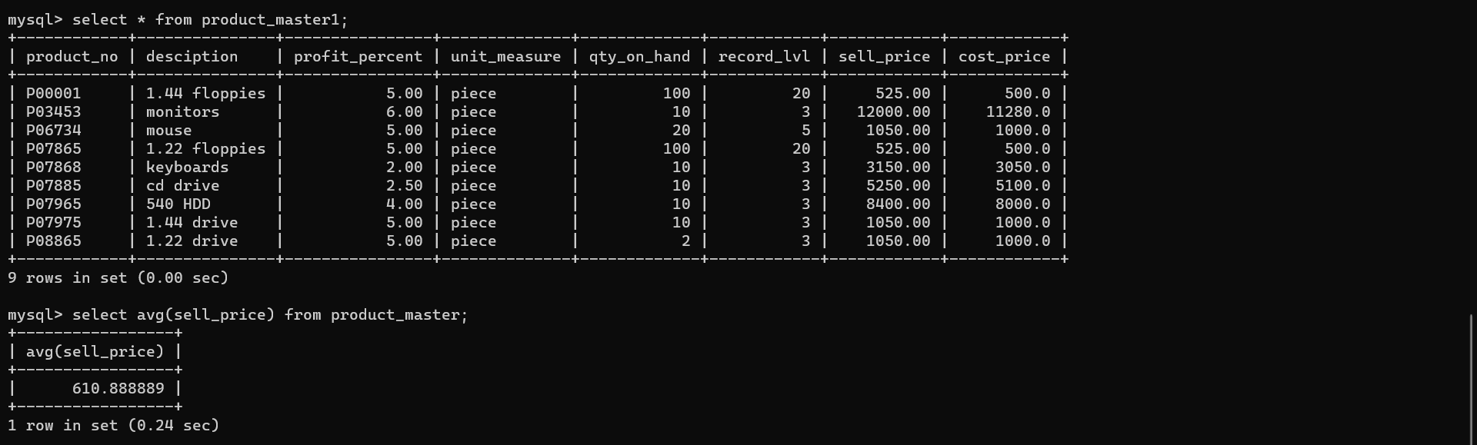

select avg(cost_price) from product_master;

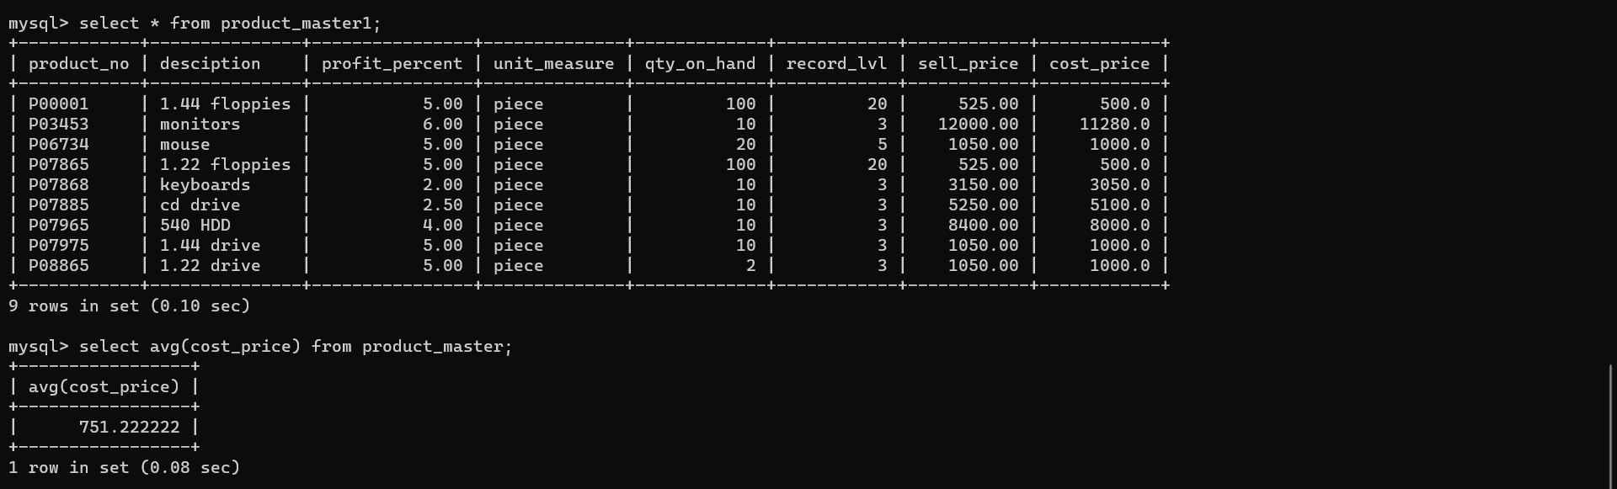

1. Determine the maximun and minimum product price rename the output as max_price and min_price respectively