Assignment – Set 1

1. Display the total number of records in the Emp table?

* select \* from employees;

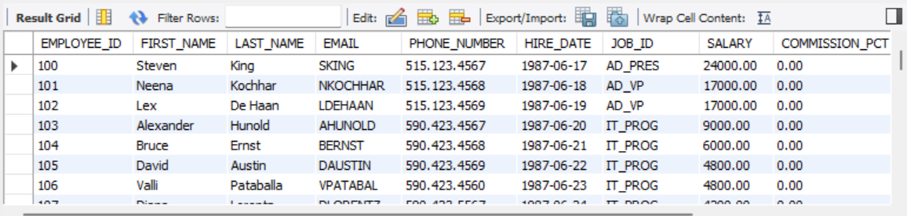

1. Display emp table with salary descending order?

* SELECT \* FROM employees ORDER BY salary DESC;

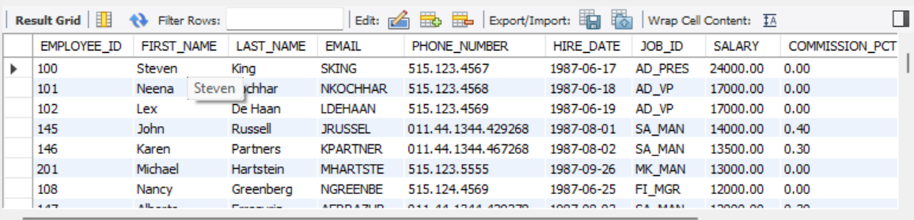

1. Display all the records in emp table order by ascending deptno, descending salary?