Cloud Computing Practical File
Submitted By –

Branch – ECE

Section – 1

Semester – 7

Subject Code – ITITE03


Department of Information Technology

NETAJI SUBHAS UNIVERSITY OF TECHNOLOGY NEW DELHI-110078

Nov. 2022
Index
S.No. | Topic | Signature
1. | Program to study and Install Cloudsim simulator and write the steps of  installation.
2. | Program to create a datacenter with one host and run one cloudlet on it.
3. | Program to create two datacenters with one host each and run cloudlets of  two users with network topology on them.
4. | Program to create two datacenters with one host each and run two  cloudlets on them.
5. | Program to create two datacenters with one host each and run cloudlets of  two users on them.
6. | Program to create a datacenter with two hosts and run two cloudlets on it.
7. | Program to create scalable simulations.
8. | Program to pause and resume the simulation, and create simulation  entities (a DatacenterBroker in this example) dynamically.
9. | Program to create simulation entities (a DatacenterBroker in this  example) in run-time using a global manager entity (GlobalBroker).

S.No. | Topic | Signature
10. | Execute a Python Program for the following in Google-Colab Platform:  a. Multiplication of 3 matrices of size  2 X 2.  b. Analyse boston house prices dataset  using Matplotlib/Seaborn Library.

Experiment – 1
Aim - Program to study and Install Cloudsim simulator and write the steps of installation.
Procedure –
Step 1: Before installing CloudSim following resources must be downloaded on the local system: a) Eclipse IDE for JAVA Developer. b) CloudSim Project code: CloudSim code can be downloaded from following project page https://code.google.com/p/cloudsim/, always download latest version to avoid any bug issues of previous packages. c) One external requirement of CloudSim i.e., common jar package of math related functions is to be downloaded.
Step 2: Unzip Eclipse and Cloudsim to some common folder.
Step 3: Open Eclipse.exe from Eclipse folder.
Step 4: Now in Eclipse go to menu File-> New -> Java Project.

Step 5:. Now a detailed new project window will be opened, here you provide project name and the path where you have unzipped the CloudSim project source code or you can put details as specified: a) Project Name: CloudSim b) Unselect the ‘Use default location’ option and then click on browse to open the path where you have unzipped the CloudSim project and finally click Next to set project settings.
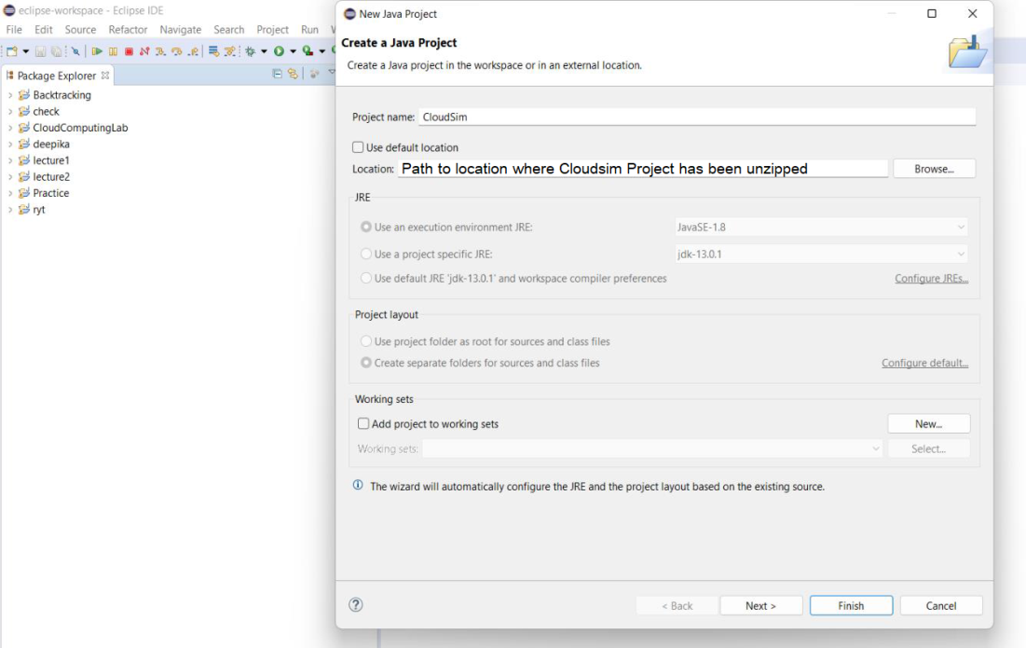
c) Now open ‘Libraries’ tab and click on add external jar (Math common jar will be included in project from this step). d) Open the path where you have unzipped the math common binaries and select ‘Common math 3.3.2.jar’ and click on open.
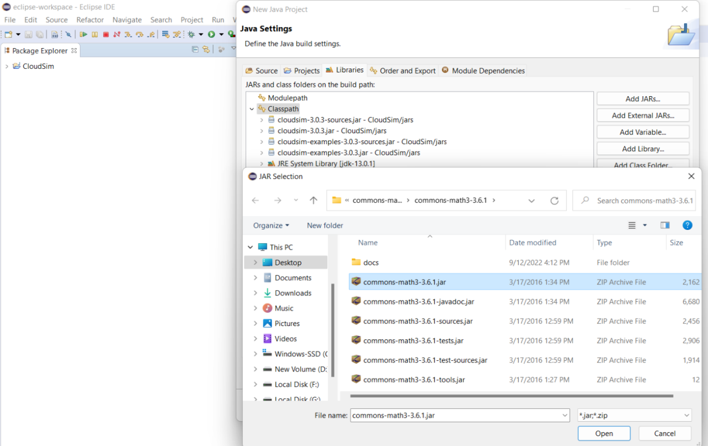
e) Ensure external jar that you opened in previous step is displayed in list and then click on ‘Finish’.
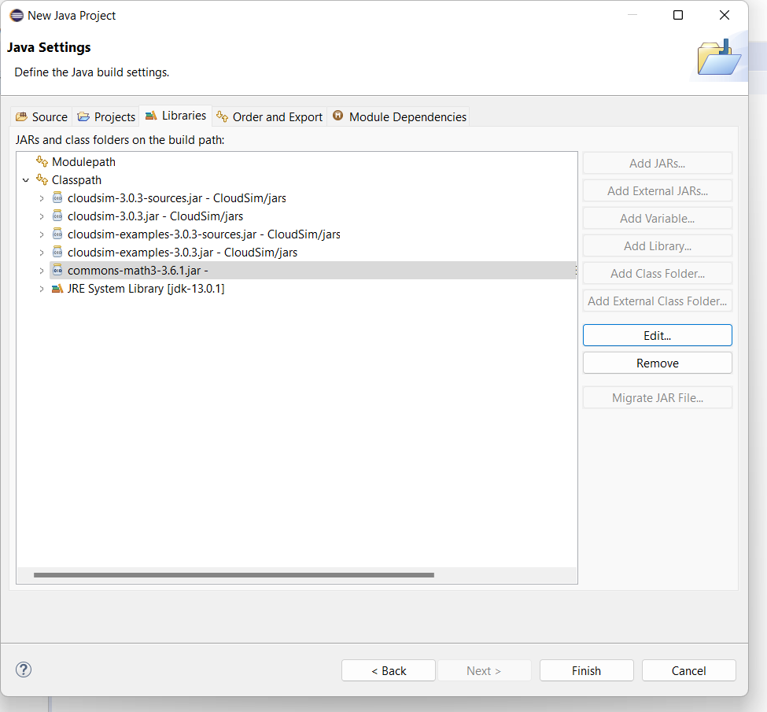
Step 6: Once the project is configured you can open the project explorer and start exploring the CloudSim project. In this manual we will be discussing all the examples that are provided under package ‘org.cloudbus.cloudsim.examples’ (as shown in figure below).
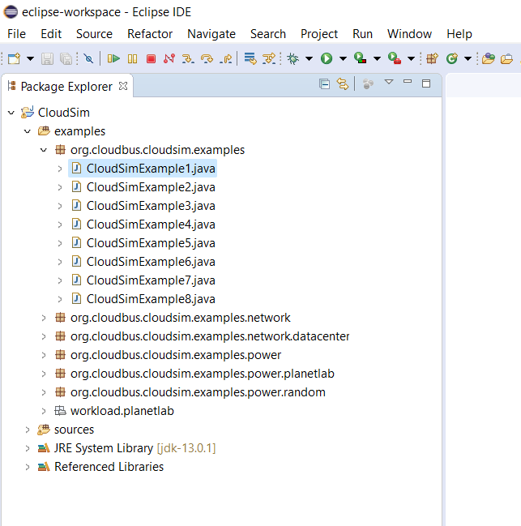

Experiment – 2
Aim - Program to create a datacenter with one host and run one cloudlet on it.
Software Used – Eclipse
Package Used – Cloudsim(Framework)
Code –
package org.cloudbus.cloudsim.examples;
/*
* Title: CloudSim Toolkit
* Description: CloudSim (Cloud Simulation) Toolkit for Modeling and Simulation
* of Clouds
* Licence: GPL - http://www.gnu.org/copyleft/gpl.html
*
* Copyright (c) 2009, The University of Melbourne, Australia
*/
import java.text.DecimalFormat;
import java.util.ArrayList;
import java.util.Calendar;
import java.util.LinkedList;
import java.util.List;
import org.cloudbus.cloudsim.Cloudlet;
import org.cloudbus.cloudsim.CloudletSchedulerTimeShared;
import org.cloudbus.cloudsim.Datacenter;
import org.cloudbus.cloudsim.DatacenterBroker;
import org.cloudbus.cloudsim.DatacenterCharacteristics;
import org.cloudbus.cloudsim.Host;
import org.cloudbus.cloudsim.Log;
import org.cloudbus.cloudsim.Pe;
import org.cloudbus.cloudsim.Storage;
import org.cloudbus.cloudsim.UtilizationModel;
import org.cloudbus.cloudsim.UtilizationModelFull;
import org.cloudbus.cloudsim.Vm;
import org.cloudbus.cloudsim.VmAllocationPolicySimple;
import org.cloudbus.cloudsim.VmSchedulerTimeShared;
import org.cloudbus.cloudsim.core.CloudSim;
import org.cloudbus.cloudsim.provisioners.BwProvisionerSimple;
import org.cloudbus.cloudsim.provisioners.PeProvisionerSimple;
import org.cloudbus.cloudsim.provisioners.RamProvisionerSimple;
/**
* A simple example showing how to create a datacenter with one host and run one
* cloudlet on it.
*/
public class CloudSimExample1 {
/** The cloudlet list. */
private static List<Cloudlet> cloudletList;
/** The vmlist. */
private static List<Vm> vmlist;
/**
* Creates main() to run this example.
*
* @param args the args
*/
@SuppressWarnings("unused")
public static void main(String[] args) {
Log.printLine("Starting CloudSimExample1...");
try {
// First step: Initialize the CloudSim package. It should be called
// before creating any entities.
int num_user = 1; // number of cloud users
Calendar calendar = Calendar.getInstance();
boolean trace_flag = false; // mean trace events
// Initialize the CloudSim library
CloudSim.init(num_user, calendar, trace_flag);
// Second step: Create Datacenters
// Datacenters are the resource providers in CloudSim. We need at
// list one of them to run a CloudSim simulation
Datacenter datacenter0 = createDatacenter("Datacenter_0");
// Third step: Create Broker
DatacenterBroker broker = createBroker();
int brokerId = broker.getId();
// Fourth step: Create one virtual machine
vmlist = new ArrayList<Vm>();
// VM description
int vmid = 0;
int mips = 1000;
long size = 10000; // image size (MB)
int ram = 512; // vm memory (MB)
long bw = 1000;
int pesNumber = 1; // number of cpus
String vmm = "Xen"; // VMM name
// create VM
Vm vm = new Vm(vmid, brokerId, mips, pesNumber, ram, bw, size, vmm, new CloudletSchedulerTimeShared());
// add the VM to the vmList
vmlist.add(vm);
// submit vm list to the broker
broker.submitVmList(vmlist);
// Fifth step: Create one Cloudlet
cloudletList = new ArrayList<Cloudlet>();
// Cloudlet properties
int id = 0;
long length = 400000;
long fileSize = 300;
long outputSize = 300;
UtilizationModel utilizationModel = new UtilizationModelFull();
Cloudlet cloudlet = new Cloudlet(id, length, pesNumber, fileSize, outputSize, utilizationModel, utilizationModel, utilizationModel);
cloudlet.setUserId(brokerId);
cloudlet.setVmId(vmid);
// add the cloudlet to the list
cloudletList.add(cloudlet);
// submit cloudlet list to the broker
broker.submitCloudletList(cloudletList);
// Sixth step: Starts the simulation
CloudSim.startSimulation();
CloudSim.stopSimulation();
//Final step: Print results when simulation is over
List<Cloudlet> newList = broker.getCloudletReceivedList();
printCloudletList(newList);
Log.printLine("CloudSimExample1 finished!");
} catch (Exception e) {
e.printStackTrace();
Log.printLine("Unwanted errors happen");
}
}
/**
* Creates the datacenter.
*
* @param name the name
*
* @return the datacenter
*/
private static Datacenter createDatacenter(String name) {
// Here are the steps needed to create a PowerDatacenter:
// 1. We need to create a list to store
// our machine
List<Host> hostList = new ArrayList<Host>();
// 2. A Machine contains one or more PEs or CPUs/Cores.
// In this example, it will have only one core.
List<Pe> peList = new ArrayList<Pe>();
int mips = 1000;
// 3. Create PEs and add these into a list.
peList.add(new Pe(0, new PeProvisionerSimple(mips))); // need to store Pe id and MIPS Rating
// 4. Create Host with its id and list of PEs and add them to the list
// of machines
int hostId = 0;
int ram = 2048; // host memory (MB)
long storage = 1000000; // host storage
int bw = 10000;
hostList.add(
new Host(
hostId,
new RamProvisionerSimple(ram),
new BwProvisionerSimple(bw),
storage,
peList,
new VmSchedulerTimeShared(peList)
)
); // This is our machine
// 5. Create a DatacenterCharacteristics object that stores the
// properties of a data center: architecture, OS, list of
// Machines, allocation policy: time- or space-shared, time zone
// and its price (G$/Pe time unit).
String arch = "x86"; // system architecture
String os = "Linux"; // operating system
String vmm = "Xen";
double time_zone = 10.0; // time zone this resource located
double cost = 3.0; // the cost of using processing in this resource
double costPerMem = 0.05; // the cost of using memory in this resource
double costPerStorage = 0.001; // the cost of using storage in this
// resource
double costPerBw = 0.0; // the cost of using bw in this resource
LinkedList<Storage> storageList = new LinkedList<Storage>(); // we are not adding SAN
// devices by now
DatacenterCharacteristics characteristics = new DatacenterCharacteristics(
arch, os, vmm, hostList, time_zone, cost, costPerMem,
costPerStorage, costPerBw);
// 6. Finally, we need to create a PowerDatacenter object.
Datacenter datacenter = null;
try {
datacenter = new Datacenter(name, characteristics, new VmAllocationPolicySimple(hostList), storageList, 0);
} catch (Exception e) {
e.printStackTrace();
}
return datacenter;
}
// We strongly encourage users to develop their own broker policies, to
// submit vms and cloudlets according
// to the specific rules of the simulated scenario
/**
* Creates the broker.
*
* @return the datacenter broker
*/
private static DatacenterBroker createBroker() {
DatacenterBroker broker = null;
try {
broker = new DatacenterBroker("Broker");
} catch (Exception e) {
e.printStackTrace();
return null;
}
return broker;
}
/**
* Prints the Cloudlet objects.
*
* @param list list of Cloudlets
*/
private static void printCloudletList(List<Cloudlet> list) {
int size = list.size();
Cloudlet cloudlet;
String indent = " ";
Log.printLine();
Log.printLine("========== OUTPUT ==========");
Log.printLine("Cloudlet ID" + indent + "STATUS" + indent
+ "Data center ID" + indent + "VM ID" + indent + "Time" + indent
+ "Start Time" + indent + "Finish Time");
DecimalFormat dft = new DecimalFormat("###.##");
for (int i = 0; i < size; i++) {
cloudlet = list.get(i);
Log.print(indent + cloudlet.getCloudletId() + indent + indent);
if (cloudlet.getCloudletStatus() == Cloudlet.SUCCESS) {
Log.print("SUCCESS");
Log.printLine(indent + indent + cloudlet.getResourceId()
+ indent + indent + indent + cloudlet.getVmId()
+ indent + indent
+ dft.format(cloudlet.getActualCPUTime()) + indent
+ indent + dft.format(cloudlet.getExecStartTime())
+ indent + indent
+ dft.format(cloudlet.getFinishTime()));
}
}
} }
Output –
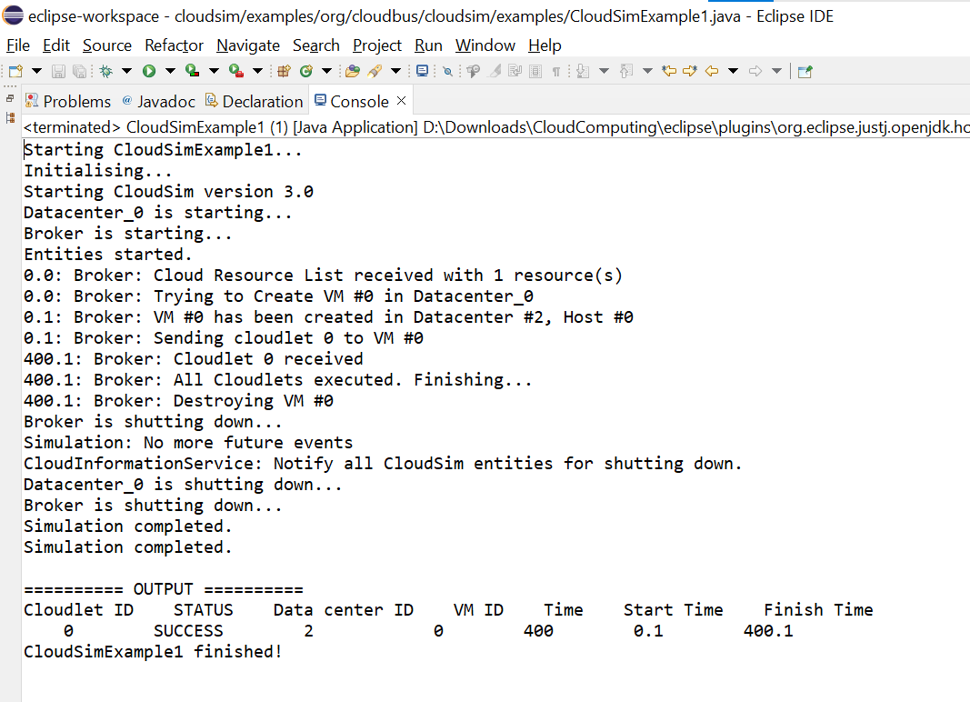

Experiment – 3
Aim - Program to create two datacenters with one host each and run cloudlets of
two users with network topology on them.
Software Used – Eclipse
Package Used – Cloudsim(Framework)
Code –
* Title: CloudSim Toolkit
* Description: CloudSim (Cloud Simulation) Toolkit for Modeling and Simulation
* of Clouds
* Licence: GPL - http://www.gnu.org/copyleft/gpl.html
*
* Copyright (c) 2009, The University of Melbourne, Australia
*/
package org.cloudbus.cloudsim.examples.network;
import java.text.DecimalFormat;
import java.util.ArrayList;
import java.util.Calendar;
import java.util.LinkedList;
import java.util.List;
import org.cloudbus.cloudsim.Cloudlet;
import org.cloudbus.cloudsim.CloudletSchedulerTimeShared;
import org.cloudbus.cloudsim.Datacenter;
import org.cloudbus.cloudsim.DatacenterBroker;
import org.cloudbus.cloudsim.DatacenterCharacteristics;
import org.cloudbus.cloudsim.Host;
import org.cloudbus.cloudsim.Log;
import org.cloudbus.cloudsim.NetworkTopology;
import org.cloudbus.cloudsim.Pe;
import org.cloudbus.cloudsim.Storage;
import org.cloudbus.cloudsim.UtilizationModel;
import org.cloudbus.cloudsim.UtilizationModelFull;
import org.cloudbus.cloudsim.Vm;
import org.cloudbus.cloudsim.VmAllocationPolicySimple;
import org.cloudbus.cloudsim.VmSchedulerSpaceShared;
import org.cloudbus.cloudsim.core.CloudSim;
import org.cloudbus.cloudsim.provisioners.BwProvisionerSimple;
import org.cloudbus.cloudsim.provisioners.PeProvisionerSimple;
import org.cloudbus.cloudsim.provisioners.RamProvisionerSimple;
/**
* A simple example showing how to create
* two datacenters with one host each and
* run cloudlets of two users with network
* topology on them.
*/
public class NetworkExample3 {
/** The cloudlet list. */
private static List<Cloudlet> cloudletList1;
private static List<Cloudlet> cloudletList2;
/** The vmlist. */
private static List<Vm> vmlist1;
private static List<Vm> vmlist2;
/**
* Creates main() to run this example
*/
public static void main(String[] args) {
Log.printLine("Starting NetworkExample3...");
try {
// First step: Initialize the CloudSim package. It should be called
// before creating any entities.
int num_user = 2; // number of cloud users
Calendar calendar = Calendar.getInstance();
boolean trace_flag = false; // mean trace events
// Initialize the CloudSim library
CloudSim.init(num_user, calendar, trace_flag);
// Second step: Create Datacenters
//Datacenters are the resource providers in CloudSim. We need at list one of them to run a CloudSim simulation
Datacenter datacenter0 = createDatacenter("Datacenter_0");
Datacenter datacenter1 = createDatacenter("Datacenter_1");
//Third step: Create Brokers
DatacenterBroker broker1 = createBroker(1);
int brokerId1 = broker1.getId();
DatacenterBroker broker2 = createBroker(2);
int brokerId2 = broker2.getId();
//Fourth step: Create one virtual machine for each broker/user
vmlist1 = new ArrayList<Vm>();
vmlist2 = new ArrayList<Vm>();
//VM description
int vmid = 0;
long size = 10000; //image size (MB)
int mips = 250;
int ram = 512; //vm memory (MB)
long bw = 1000;
int pesNumber = 1; //number of cpus
String vmm = "Xen"; //VMM name
//create two VMs: the first one belongs to user1
Vm vm1 = new Vm(vmid, brokerId1, mips, pesNumber, ram, bw, size, vmm, new CloudletSchedulerTimeShared());
//the second VM: this one belongs to user2
Vm vm2 = new Vm(vmid, brokerId2, mips, pesNumber, ram, bw, size, vmm, new CloudletSchedulerTimeShared());
//add the VMs to the vmlists
vmlist1.add(vm1);
vmlist2.add(vm2);
//submit vm list to the broker
broker1.submitVmList(vmlist1);
broker2.submitVmList(vmlist2);
//Fifth step: Create two Cloudlets
cloudletList1 = new ArrayList<Cloudlet>();
cloudletList2 = new ArrayList<Cloudlet>();
//Cloudlet properties
int id = 0;
long length = 40000;
long fileSize = 300;
long outputSize = 300;
UtilizationModel utilizationModel = new UtilizationModelFull();
Cloudlet cloudlet1 = new Cloudlet(id, length, pesNumber, fileSize, outputSize, utilizationModel, utilizationModel, utilizationModel);
cloudlet1.setUserId(brokerId1);
Cloudlet cloudlet2 = new Cloudlet(id, length, pesNumber, fileSize, outputSize, utilizationModel, utilizationModel, utilizationModel);
cloudlet2.setUserId(brokerId2);
//add the cloudlets to the lists: each cloudlet belongs to one user
cloudletList1.add(cloudlet1);
cloudletList2.add(cloudlet2);
//submit cloudlet list to the brokers
broker1.submitCloudletList(cloudletList1);
broker2.submitCloudletList(cloudletList2);
//Sixth step: configure network
//load the network topology file
String path = "D:\\Downloads\\CloudComputing\\cloudsim-3.0.3\\examples\\org\\cloudbus\\cloudsim\\examples\\network\\";
NetworkTopology.buildNetworkTopology(path + "topology.brite");
//maps CloudSim entities to BRITE entities
//Datacenter0 will correspond to BRITE node 0
int briteNode=0;
NetworkTopology.mapNode(datacenter0.getId(),briteNode);
//Datacenter1 will correspond to BRITE node 2
briteNode=2;
NetworkTopology.mapNode(datacenter1.getId(),briteNode);
//Broker1 will correspond to BRITE node 3
briteNode=3;
NetworkTopology.mapNode(broker1.getId(),briteNode);
//Broker2 will correspond to BRITE node 4
briteNode=4;
NetworkTopology.mapNode(broker2.getId(),briteNode);
// Sixth step: Starts the simulation
CloudSim.startSimulation();
// Final step: Print results when simulation is over
List<Cloudlet> newList1 = broker1.getCloudletReceivedList();
List<Cloudlet> newList2 = broker2.getCloudletReceivedList();
CloudSim.stopSimulation();
Log.print("=============> User "+brokerId1+" ");
printCloudletList(newList1);
Log.print("=============> User "+brokerId2+" ");
printCloudletList(newList2);
Log.printLine("NetworkExample3 finished!");
}
catch (Exception e) {
e.printStackTrace();
Log.printLine("The simulation has been terminated due to an unexpected error");
}
}
private static Datacenter createDatacenter(String name){
// Here are the steps needed to create a PowerDatacenter:
// 1. We need to create a list to store
// our machine
List<Host> hostList = new ArrayList<Host>();
// 2. A Machine contains one or more PEs or CPUs/Cores.
// In this example, it will have only one core.
List<Pe> peList = new ArrayList<Pe>();
int mips = 1000;
// 3. Create PEs and add these into a list.
peList.add(new Pe(0, new PeProvisionerSimple(mips))); // need to store Pe id and MIPS Rating
//4. Create Host with its id and list of PEs and add them to the list of machines
int hostId=0;
int ram = 2048; //host memory (MB)
long storage = 1000000; //host storage
int bw = 10000;
//in this example, the VMAllocatonPolicy in use is SpaceShared. It means that only one VM
//is allowed to run on each Pe. As each Host has only one Pe, only one VM can run on each Host.
hostList.add(
new Host(
hostId,
new RamProvisionerSimple(ram),
new BwProvisionerSimple(bw),
storage,
peList,
new VmSchedulerSpaceShared(peList)
)
); // This is our machine
// 5. Create a DatacenterCharacteristics object that stores the
// properties of a data center: architecture, OS, list of
// Machines, allocation policy: time- or space-shared, time zone
// and its price (G$/Pe time unit).
String arch = "x86"; // system architecture
String os = "Linux"; // operating system
String vmm = "Xen";
double time_zone = 10.0; // time zone this resource located
double cost = 3.0; // the cost of using processing in this resource
double costPerMem = 0.05; // the cost of using memory in this resource
double costPerStorage = 0.001; // the cost of using storage in this resource
double costPerBw = 0.0; // the cost of using bw in this resource
LinkedList<Storage> storageList = new LinkedList<Storage>(); //we are not adding SAN devices by now
DatacenterCharacteristics characteristics = new DatacenterCharacteristics(
arch, os, vmm, hostList, time_zone, cost, costPerMem,
costPerStorage, costPerBw);
// 6. Finally, we need to create a PowerDatacenter object.
Datacenter datacenter = null;
try {
datacenter = new Datacenter(name, characteristics, new VmAllocationPolicySimple(hostList), storageList, 0);
} catch (Exception e) {
e.printStackTrace();
}
return datacenter;
}
//We strongly encourage users to develop their own broker policies, to submit vms and cloudlets according
//to the specific rules of the simulated scenario
private static DatacenterBroker createBroker(int id){
DatacenterBroker broker = null;
try {
broker = new DatacenterBroker("Broker"+id);
} catch (Exception e) {
e.printStackTrace();
return null;
}
return broker;
}
/**
* Prints the Cloudlet objects
* @param list list of Cloudlets
*/
private static void printCloudletList(List<Cloudlet> list) {
int size = list.size();
Cloudlet cloudlet;
String indent = " ";
Log.printLine();
Log.printLine("========== OUTPUT ==========");
Log.printLine("Cloudlet ID" + indent + "STATUS" + indent +
"Data center ID" + indent + "VM ID" + indent + "Time" + indent + "Start Time" + indent + "Finish Time");
for (int i = 0; i < size; i++) {
cloudlet = list.get(i);
Log.print(indent + cloudlet.getCloudletId() + indent + indent);
if (cloudlet.getCloudletStatus() == Cloudlet.SUCCESS){
Log.print("SUCCESS");
DecimalFormat dft = new DecimalFormat("###.##");
Log.printLine( indent + indent + cloudlet.getResourceId() + indent + indent + indent + cloudlet.getVmId() +
indent + indent + dft.format(cloudlet.getActualCPUTime()) + indent + indent + dft.format(cloudlet.getExecStartTime())+
indent + indent + dft.format(cloudlet.getFinishTime()));
}
}
}
}

Output –
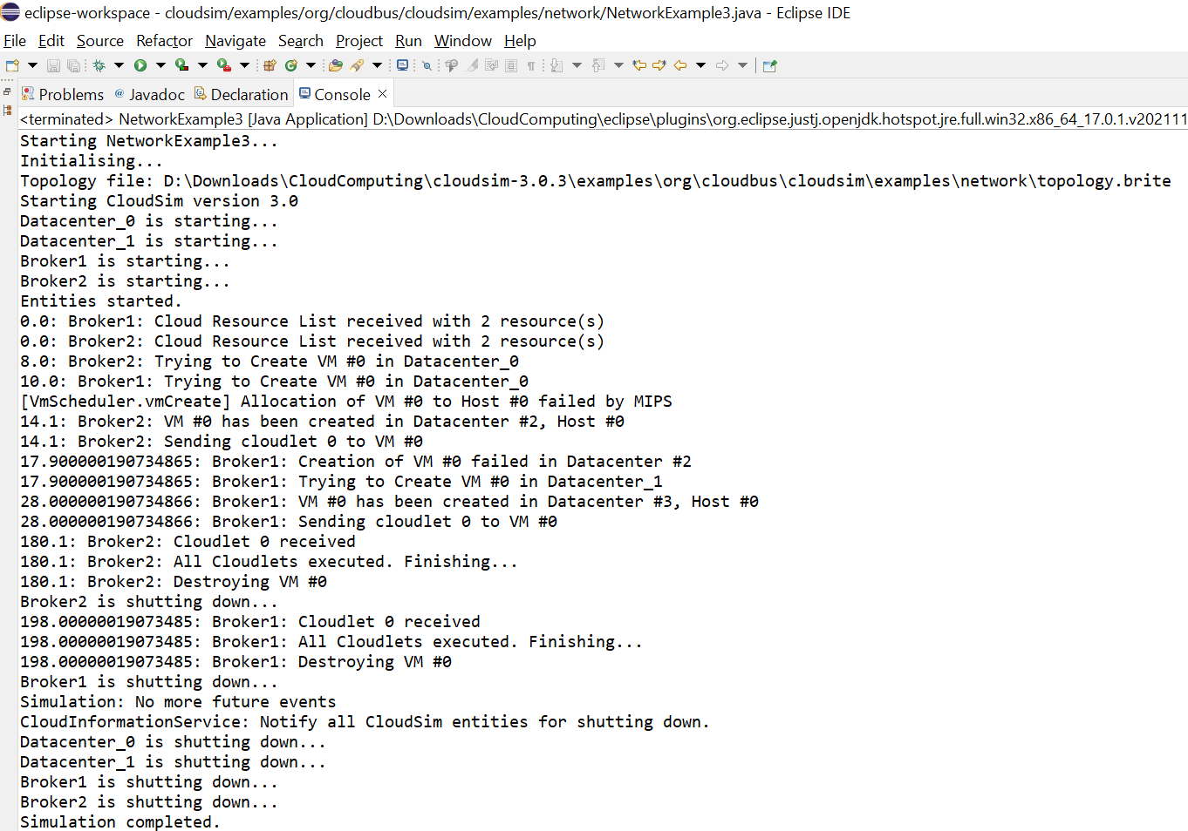

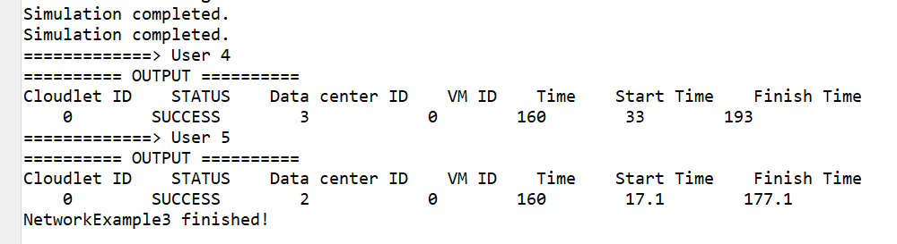

Experiment – 4
Aim - Program to create two datacenters with one host each and run two
cloudlets on them.two users with network topology on them.
Software Used – Eclipse
Package Used – Cloudsim(Framework)
Code –
* Title: CloudSim Toolkit
* Description: CloudSim (Cloud Simulation) Toolkit for Modeling and Simulation
* of Clouds
* Licence: GPL - http://www.gnu.org/copyleft/gpl.html
*
* Copyright (c) 2009, The University of Melbourne, Australia
*/
package org.cloudbus.cloudsim.examples;
import java.text.DecimalFormat;
import java.util.ArrayList;
import java.util.Calendar;
import java.util.LinkedList;
import java.util.List;
import org.cloudbus.cloudsim.Cloudlet;
import org.cloudbus.cloudsim.CloudletSchedulerTimeShared;
import org.cloudbus.cloudsim.Datacenter;
import org.cloudbus.cloudsim.DatacenterBroker;
import org.cloudbus.cloudsim.DatacenterCharacteristics;
import org.cloudbus.cloudsim.Host;
import org.cloudbus.cloudsim.Log;
import org.cloudbus.cloudsim.Pe;
import org.cloudbus.cloudsim.Storage;
import org.cloudbus.cloudsim.UtilizationModel;
import org.cloudbus.cloudsim.UtilizationModelFull;
import org.cloudbus.cloudsim.Vm;
import org.cloudbus.cloudsim.VmAllocationPolicySimple;
import org.cloudbus.cloudsim.VmSchedulerSpaceShared;
import org.cloudbus.cloudsim.core.CloudSim;
import org.cloudbus.cloudsim.provisioners.BwProvisionerSimple;
import org.cloudbus.cloudsim.provisioners.PeProvisionerSimple;
import org.cloudbus.cloudsim.provisioners.RamProvisionerSimple;
/**
* A simple example showing how to create
* two datacenters with one host each and
* run two cloudlets on them.
*/
public class CloudSimExample4 {
/** The cloudlet list. */
private static List<Cloudlet> cloudletList;
/** The vmlist. */
private static List<Vm> vmlist;
/**
* Creates main() to run this example
*/
public static void main(String[] args) {
Log.printLine("Starting CloudSimExample4...");
try {
// First step: Initialize the CloudSim package. It should be called
// before creating any entities.
int num_user = 1; // number of cloud users
Calendar calendar = Calendar.getInstance();
boolean trace_flag = false; // mean trace events
// Initialize the GridSim library
CloudSim.init(num_user, calendar, trace_flag);
// Second step: Create Datacenters
//Datacenters are the resource providers in CloudSim. We need at list one of them to run a CloudSim simulation
@SuppressWarnings("unused")
Datacenter datacenter0 = createDatacenter("Datacenter_0");
@SuppressWarnings("unused")
Datacenter datacenter1 = createDatacenter("Datacenter_1");
//Third step: Create Broker
DatacenterBroker broker = createBroker();
int brokerId = broker.getId();
//Fourth step: Create one virtual machine
vmlist = new ArrayList<Vm>();
//VM description
int vmid = 0;
int mips = 250;
long size = 10000; //image size (MB)
int ram = 512; //vm memory (MB)
long bw = 1000;
int pesNumber = 1; //number of cpus
String vmm = "Xen"; //VMM name
//create two VMs
Vm vm1 = new Vm(vmid, brokerId, mips, pesNumber, ram, bw, size, vmm, new CloudletSchedulerTimeShared());
vmid++;
Vm vm2 = new Vm(vmid, brokerId, mips, pesNumber, ram, bw, size, vmm, new CloudletSchedulerTimeShared());
//add the VMs to the vmList
vmlist.add(vm1);
vmlist.add(vm2);
//submit vm list to the broker
broker.submitVmList(vmlist);
//Fifth step: Create two Cloudlets
cloudletList = new ArrayList<Cloudlet>();
//Cloudlet properties
int id = 0;
long length = 40000;
long fileSize = 300;
long outputSize = 300;
UtilizationModel utilizationModel = new UtilizationModelFull();
Cloudlet cloudlet1 = new Cloudlet(id, length, pesNumber, fileSize, outputSize, utilizationModel, utilizationModel, utilizationModel);
cloudlet1.setUserId(brokerId);
id++;
Cloudlet cloudlet2 = new Cloudlet(id, length, pesNumber, fileSize, outputSize, utilizationModel, utilizationModel, utilizationModel);
cloudlet2.setUserId(brokerId);
//add the cloudlets to the list
cloudletList.add(cloudlet1);
cloudletList.add(cloudlet2);
//submit cloudlet list to the broker
broker.submitCloudletList(cloudletList);
//bind the cloudlets to the vms. This way, the broker
// will submit the bound cloudlets only to the specific VM
broker.bindCloudletToVm(cloudlet1.getCloudletId(),vm1.getId());
broker.bindCloudletToVm(cloudlet2.getCloudletId(),vm2.getId());
// Sixth step: Starts the simulation
CloudSim.startSimulation();
// Final step: Print results when simulation is over
List<Cloudlet> newList = broker.getCloudletReceivedList();
CloudSim.stopSimulation();
printCloudletList(newList);
Log.printLine("CloudSimExample4 finished!");
}
catch (Exception e) {
e.printStackTrace();
Log.printLine("The simulation has been terminated due to an unexpected error");
}
}
private static Datacenter createDatacenter(String name){
// Here are the steps needed to create a PowerDatacenter:
// 1. We need to create a list to store
// our machine
List<Host> hostList = new ArrayList<Host>();
// 2. A Machine contains one or more PEs or CPUs/Cores.
// In this example, it will have only one core.
List<Pe> peList = new ArrayList<Pe>();
int mips = 1000;
// 3. Create PEs and add these into a list.
peList.add(new Pe(0, new PeProvisionerSimple(mips))); // need to store Pe id and MIPS Rating
//4. Create Host with its id and list of PEs and add them to the list of machines
int hostId=0;
int ram = 2048; //host memory (MB)
long storage = 1000000; //host storage
int bw = 10000;
//in this example, the VMAllocatonPolicy in use is SpaceShared. It means that only one VM
//is allowed to run on each Pe. As each Host has only one Pe, only one VM can run on each Host.
hostList.add(
new Host(
hostId,
new RamProvisionerSimple(ram),
new BwProvisionerSimple(bw),
storage,
peList,
new VmSchedulerSpaceShared(peList)
)
); // This is our first machine
// 5. Create a DatacenterCharacteristics object that stores the
// properties of a data center: architecture, OS, list of
// Machines, allocation policy: time- or space-shared, time zone
// and its price (G$/Pe time unit).
String arch = "x86"; // system architecture
String os = "Linux"; // operating system
String vmm = "Xen";
double time_zone = 10.0; // time zone this resource located
double cost = 3.0; // the cost of using processing in this resource
double costPerMem = 0.05; // the cost of using memory in this resource
double costPerStorage = 0.001; // the cost of using storage in this resource
double costPerBw = 0.0; // the cost of using bw in this resource
LinkedList<Storage> storageList = new LinkedList<Storage>(); //we are not adding SAN devices by now
DatacenterCharacteristics characteristics = new DatacenterCharacteristics(
arch, os, vmm, hostList, time_zone, cost, costPerMem, costPerStorage, costPerBw);
// 6. Finally, we need to create a PowerDatacenter object.
Datacenter datacenter = null;
try {
datacenter = new Datacenter(name, characteristics, new VmAllocationPolicySimple(hostList), storageList, 0);
} catch (Exception e) {
e.printStackTrace();
}
return datacenter;
}
//We strongly encourage users to develop their own broker policies, to submit vms and cloudlets according
//to the specific rules of the simulated scenario
private static DatacenterBroker createBroker(){
DatacenterBroker broker = null;
try {
broker = new DatacenterBroker("Broker");
} catch (Exception e) {
e.printStackTrace();
return null;
}
return broker;
}
/**
* Prints the Cloudlet objects
* @param list list of Cloudlets
*/
private static void printCloudletList(List<Cloudlet> list) {
int size = list.size();
Cloudlet cloudlet;
String indent = " ";
Log.printLine();
Log.printLine("========== OUTPUT ==========");
Log.printLine("Cloudlet ID" + indent + "STATUS" + indent +
"Data center ID" + indent + "VM ID" + indent + "Time" + indent + "Start Time" + indent + "Finish Time");
DecimalFormat dft = new DecimalFormat("###.##");
for (int i = 0; i < size; i++) {
cloudlet = list.get(i);
Log.print(indent + cloudlet.getCloudletId() + indent + indent);
if (cloudlet.getCloudletStatus() == Cloudlet.SUCCESS){
Log.print("SUCCESS");
Log.printLine( indent + indent + cloudlet.getResourceId() + indent + indent + indent + cloudlet.getVmId() +
indent + indent + dft.format(cloudlet.getActualCPUTime()) + indent + indent + dft.format(cloudlet.getExecStartTime())+
indent + indent + dft.format(cloudlet.getFinishTime()));
}
}
}
}

Output –
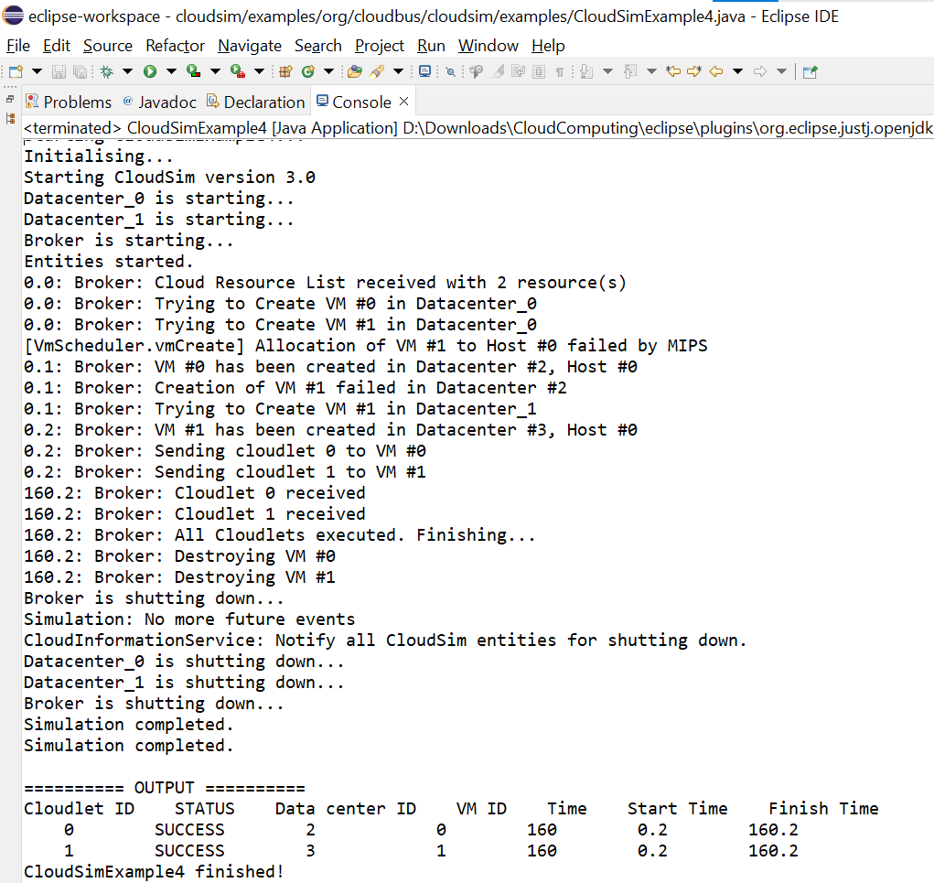

Experiment – 5
Aim - Program to create two datacenters with one host each and run cloudlets of two users on them.
Software Used – Eclipse
Package Used – Cloudsim(Framework)
Code –
* Title: CloudSim Toolkit
* Description: CloudSim (Cloud Simulation) Toolkit for Modeling and Simulation
* of Clouds
* Licence: GPL - http://www.gnu.org/copyleft/gpl.html
*
* Copyright (c) 2009, The University of Melbourne, Australia
*/
package org.cloudbus.cloudsim.examples;
import java.text.DecimalFormat;
import java.util.ArrayList;
import java.util.Calendar;
import java.util.LinkedList;
import java.util.List;
import org.cloudbus.cloudsim.Cloudlet;
import org.cloudbus.cloudsim.CloudletSchedulerTimeShared;
import org.cloudbus.cloudsim.Datacenter;
import org.cloudbus.cloudsim.DatacenterBroker;
import org.cloudbus.cloudsim.DatacenterCharacteristics;
import org.cloudbus.cloudsim.Host;
import org.cloudbus.cloudsim.Log;
import org.cloudbus.cloudsim.Pe;
import org.cloudbus.cloudsim.Storage;
import org.cloudbus.cloudsim.UtilizationModel;
import org.cloudbus.cloudsim.UtilizationModelFull;
import org.cloudbus.cloudsim.Vm;
import org.cloudbus.cloudsim.VmAllocationPolicySimple;
import org.cloudbus.cloudsim.VmSchedulerSpaceShared;
import org.cloudbus.cloudsim.core.CloudSim;
import org.cloudbus.cloudsim.provisioners.BwProvisionerSimple;
import org.cloudbus.cloudsim.provisioners.PeProvisionerSimple;
import org.cloudbus.cloudsim.provisioners.RamProvisionerSimple;
/**
* A simple example showing how to create
* two datacenters with one host each and
* run cloudlets of two users on them.
*/
public class CloudSimExample5 {
/** The cloudlet lists. */
private static List<Cloudlet> cloudletList1;
private static List<Cloudlet> cloudletList2;
/** The vmlists. */
private static List<Vm> vmlist1;
private static List<Vm> vmlist2;
/**
* Creates main() to run this example
*/
public static void main(String[] args) {
Log.printLine("Starting CloudSimExample5...");
try {
// First step: Initialize the CloudSim package. It should be called
// before creating any entities.
int num_user = 2; // number of cloud users
Calendar calendar = Calendar.getInstance();
boolean trace_flag = false; // mean trace events
// Initialize the CloudSim library
CloudSim.init(num_user, calendar, trace_flag);
// Second step: Create Datacenters
//Datacenters are the resource providers in CloudSim. We need at list one of them to run a CloudSim simulation
@SuppressWarnings("unused")
Datacenter datacenter0 = createDatacenter("Datacenter_0");
@SuppressWarnings("unused")
Datacenter datacenter1 = createDatacenter("Datacenter_1");
//Third step: Create Brokers
DatacenterBroker broker1 = createBroker(1);
int brokerId1 = broker1.getId();
DatacenterBroker broker2 = createBroker(2);
int brokerId2 = broker2.getId();
//Fourth step: Create one virtual machine for each broker/user
vmlist1 = new ArrayList<Vm>();
vmlist2 = new ArrayList<Vm>();
//VM description
int vmid = 0;
int mips = 250;
long size = 10000; //image size (MB)
int ram = 512; //vm memory (MB)
long bw = 1000;
int pesNumber = 1; //number of cpus
String vmm = "Xen"; //VMM name
//create two VMs: the first one belongs to user1
Vm vm1 = new Vm(vmid, brokerId1, mips, pesNumber, ram, bw, size, vmm, new CloudletSchedulerTimeShared());
//the second VM: this one belongs to user2
Vm vm2 = new Vm(vmid, brokerId2, mips, pesNumber, ram, bw, size, vmm, new CloudletSchedulerTimeShared());
//add the VMs to the vmlists
vmlist1.add(vm1);
vmlist2.add(vm2);
//submit vm list to the broker
broker1.submitVmList(vmlist1);
broker2.submitVmList(vmlist2);
//Fifth step: Create two Cloudlets
cloudletList1 = new ArrayList<Cloudlet>();
cloudletList2 = new ArrayList<Cloudlet>();
//Cloudlet properties
int id = 0;
long length = 40000;
long fileSize = 300;
long outputSize = 300;
UtilizationModel utilizationModel = new UtilizationModelFull();
Cloudlet cloudlet1 = new Cloudlet(id, length, pesNumber, fileSize, outputSize, utilizationModel, utilizationModel, utilizationModel);
cloudlet1.setUserId(brokerId1);
Cloudlet cloudlet2 = new Cloudlet(id, length, pesNumber, fileSize, outputSize, utilizationModel, utilizationModel, utilizationModel);
cloudlet2.setUserId(brokerId2);
//add the cloudlets to the lists: each cloudlet belongs to one user
cloudletList1.add(cloudlet1);
cloudletList2.add(cloudlet2);
//submit cloudlet list to the brokers
broker1.submitCloudletList(cloudletList1);
broker2.submitCloudletList(cloudletList2);
// Sixth step: Starts the simulation
CloudSim.startSimulation();
// Final step: Print results when simulation is over
List<Cloudlet> newList1 = broker1.getCloudletReceivedList();
List<Cloudlet> newList2 = broker2.getCloudletReceivedList();
CloudSim.stopSimulation();
Log.print("=============> User "+brokerId1+" ");
printCloudletList(newList1);
Log.print("=============> User "+brokerId2+" ");
printCloudletList(newList2);
Log.printLine("CloudSimExample5 finished!");
}
catch (Exception e) {
e.printStackTrace();
Log.printLine("The simulation has been terminated due to an unexpected error");
}
}
private static Datacenter createDatacenter(String name){
// Here are the steps needed to create a PowerDatacenter:
// 1. We need to create a list to store
// our machine
List<Host> hostList = new ArrayList<Host>();
// 2. A Machine contains one or more PEs or CPUs/Cores.
// In this example, it will have only one core.
List<Pe> peList = new ArrayList<Pe>();
int mips=1000;
// 3. Create PEs and add these into a list.
peList.add(new Pe(0, new PeProvisionerSimple(mips))); // need to store Pe id and MIPS Rating
//4. Create Host with its id and list of PEs and add them to the list of machines
int hostId=0;
int ram = 2048; //host memory (MB)
long storage = 1000000; //host storage
int bw = 10000;
//in this example, the VMAllocatonPolicy in use is SpaceShared. It means that only one VM
//is allowed to run on each Pe. As each Host has only one Pe, only one VM can run on each Host.
hostList.add(
new Host(
hostId,
new RamProvisionerSimple(ram),
new BwProvisionerSimple(bw),
storage,
peList,
new VmSchedulerSpaceShared(peList)
)
); // This is our first machine
// 5. Create a DatacenterCharacteristics object that stores the
// properties of a data center: architecture, OS, list of
// Machines, allocation policy: time- or space-shared, time zone
// and its price (G$/Pe time unit).
String arch = "x86"; // system architecture
String os = "Linux"; // operating system
String vmm = "Xen";
double time_zone = 10.0; // time zone this resource located
double cost = 3.0; // the cost of using processing in this resource
double costPerMem = 0.05; // the cost of using memory in this resource
double costPerStorage = 0.001; // the cost of using storage in this resource
double costPerBw = 0.0; // the cost of using bw in this resource
LinkedList<Storage> storageList = new LinkedList<Storage>(); //we are not adding SAN devices by now
DatacenterCharacteristics characteristics = new DatacenterCharacteristics(
arch, os, vmm, hostList, time_zone, cost, costPerMem, costPerStorage, costPerBw);
// 6. Finally, we need to create a PowerDatacenter object.
Datacenter datacenter = null;
try {
datacenter = new Datacenter(name, characteristics, new VmAllocationPolicySimple(hostList), storageList, 0);
} catch (Exception e) {
e.printStackTrace();
}
return datacenter;
}
//We strongly encourage users to develop their own broker policies, to submit vms and cloudlets according
//to the specific rules of the simulated scenario
private static DatacenterBroker createBroker(int id){
DatacenterBroker broker = null;
try {
broker = new DatacenterBroker("Broker"+id);
} catch (Exception e) {
e.printStackTrace();
return null;
}
return broker;
}
/**
* Prints the Cloudlet objects
* @param list list of Cloudlets
*/
private static void printCloudletList(List<Cloudlet> list) {
int size = list.size();
Cloudlet cloudlet;
String indent = " ";
Log.printLine();
Log.printLine("========== OUTPUT ==========");
Log.printLine("Cloudlet ID" + indent + "STATUS" + indent +
"Data center ID" + indent + "VM ID" + indent + "Time" + indent + "Start Time" + indent + "Finish Time");
DecimalFormat dft = new DecimalFormat("###.##");
for (int i = 0; i < size; i++) {
cloudlet = list.get(i);
Log.print(indent + cloudlet.getCloudletId() + indent + indent);
if (cloudlet.getCloudletStatus() == Cloudlet.SUCCESS){
Log.print("SUCCESS");
Log.printLine( indent + indent + cloudlet.getResourceId() + indent + indent + indent + cloudlet.getVmId() +
indent + indent + dft.format(cloudlet.getActualCPUTime()) + indent + indent + dft.format(cloudlet.getExecStartTime())+
indent + indent + dft.format(cloudlet.getFinishTime()));
}
}
} }

Output –
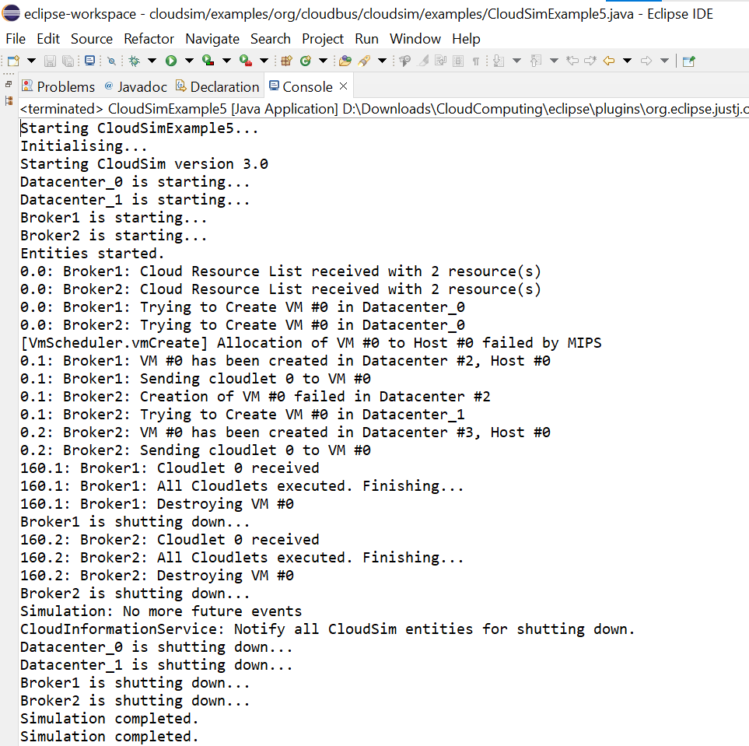
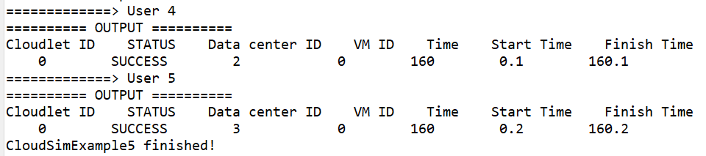
Experiment – 6
Aim - Program to create a datacenter with two hosts and run two cloudlets on it.
Software Used – Eclipse
Package Used – Cloudsim(Framework)
Code –
* Title: CloudSim Toolkit
* Description: CloudSim (Cloud Simulation) Toolkit for Modeling and Simulation
* of Clouds
* Licence: GPL - http://www.gnu.org/copyleft/gpl.html
*
* Copyright (c) 2009, The University of Melbourne, Australia
*/
package org.cloudbus.cloudsim.examples;
import java.text.DecimalFormat;
import java.util.ArrayList;
import java.util.Calendar;
import java.util.LinkedList;
import java.util.List;
import org.cloudbus.cloudsim.Cloudlet;
import org.cloudbus.cloudsim.CloudletSchedulerTimeShared;
import org.cloudbus.cloudsim.Datacenter;
import org.cloudbus.cloudsim.DatacenterBroker;
import org.cloudbus.cloudsim.DatacenterCharacteristics;
import org.cloudbus.cloudsim.Host;
import org.cloudbus.cloudsim.Log;
import org.cloudbus.cloudsim.Pe;
import org.cloudbus.cloudsim.Storage;
import org.cloudbus.cloudsim.UtilizationModel;
import org.cloudbus.cloudsim.UtilizationModelFull;
import org.cloudbus.cloudsim.Vm;
import org.cloudbus.cloudsim.VmAllocationPolicySimple;
import org.cloudbus.cloudsim.VmSchedulerTimeShared;
import org.cloudbus.cloudsim.core.CloudSim;
import org.cloudbus.cloudsim.provisioners.BwProvisionerSimple;
import org.cloudbus.cloudsim.provisioners.PeProvisionerSimple;
import org.cloudbus.cloudsim.provisioners.RamProvisionerSimple;
/**
* A simple example showing how to create
* a datacenter with two hosts and run two
* cloudlets on it. The cloudlets run in
* VMs with different MIPS requirements.
* The cloudlets will take different time
* to complete the execution depending on
* the requested VM performance.
*/
public class CloudSimExample3 {
/** The cloudlet list. */
private static List<Cloudlet> cloudletList;
/** The vmlist. */
private static List<Vm> vmlist;
/**
* Creates main() to run this example
*/
public static void main(String[] args) {
Log.printLine("Starting CloudSimExample3...");
try {
// First step: Initialize the CloudSim package. It should be called
// before creating any entities.
int num_user = 1; // number of cloud users
Calendar calendar = Calendar.getInstance();
boolean trace_flag = false; // mean trace events
// Initialize the CloudSim library
CloudSim.init(num_user, calendar, trace_flag);
// Second step: Create Datacenters
//Datacenters are the resource providers in CloudSim. We need at list one of them to run a CloudSim simulation
@SuppressWarnings("unused")
Datacenter datacenter0 = createDatacenter("Datacenter_0");
//Third step: Create Broker
DatacenterBroker broker = createBroker();
int brokerId = broker.getId();
//Fourth step: Create one virtual machine
vmlist = new ArrayList<Vm>();
//VM description
int vmid = 0;
int mips = 250;
long size = 10000; //image size (MB)
int ram = 2048; //vm memory (MB)
long bw = 1000;
int pesNumber = 1; //number of cpus
String vmm = "Xen"; //VMM name
//create two VMs
Vm vm1 = new Vm(vmid, brokerId, mips, pesNumber, ram, bw, size, vmm, new CloudletSchedulerTimeShared());
//the second VM will have twice the priority of VM1 and so will receive twice CPU time
vmid++;
Vm vm2 = new Vm(vmid, brokerId, mips * 2, pesNumber, ram, bw, size, vmm, new CloudletSchedulerTimeShared());
//add the VMs to the vmList
vmlist.add(vm1);
vmlist.add(vm2);
//submit vm list to the broker
broker.submitVmList(vmlist);
//Fifth step: Create two Cloudlets
cloudletList = new ArrayList<Cloudlet>();
//Cloudlet properties
int id = 0;
long length = 40000;
long fileSize = 300;
long outputSize = 300;
UtilizationModel utilizationModel = new UtilizationModelFull();
Cloudlet cloudlet1 = new Cloudlet(id, length, pesNumber, fileSize, outputSize, utilizationModel, utilizationModel, utilizationModel);
cloudlet1.setUserId(brokerId);
id++;
Cloudlet cloudlet2 = new Cloudlet(id, length, pesNumber, fileSize, outputSize, utilizationModel, utilizationModel, utilizationModel);
cloudlet2.setUserId(brokerId);
//add the cloudlets to the list
cloudletList.add(cloudlet1);
cloudletList.add(cloudlet2);
//submit cloudlet list to the broker
broker.submitCloudletList(cloudletList);
//bind the cloudlets to the vms. This way, the broker
// will submit the bound cloudlets only to the specific VM
broker.bindCloudletToVm(cloudlet1.getCloudletId(),vm1.getId());
broker.bindCloudletToVm(cloudlet2.getCloudletId(),vm2.getId());
// Sixth step: Starts the simulation
CloudSim.startSimulation();
// Final step: Print results when simulation is over
List<Cloudlet> newList = broker.getCloudletReceivedList();
CloudSim.stopSimulation();
printCloudletList(newList);
Log.printLine("CloudSimExample3 finished!");
}
catch (Exception e) {
e.printStackTrace();
Log.printLine("The simulation has been terminated due to an unexpected error");
}
}
private static Datacenter createDatacenter(String name){
// Here are the steps needed to create a PowerDatacenter:
// 1. We need to create a list to store
// our machine
List<Host> hostList = new ArrayList<Host>();
// 2. A Machine contains one or more PEs or CPUs/Cores.
// In this example, it will have only one core.
List<Pe> peList = new ArrayList<Pe>();
int mips = 1000;
// 3. Create PEs and add these into a list.
peList.add(new Pe(0, new PeProvisionerSimple(mips))); // need to store Pe id and MIPS Rating
//4. Create Hosts with its id and list of PEs and add them to the list of machines
int hostId=0;
int ram = 2048; //host memory (MB)
long storage = 1000000; //host storage
int bw = 10000;
hostList.add(
new Host(
hostId,
new RamProvisionerSimple(ram),
new BwProvisionerSimple(bw),
storage,
peList,
new VmSchedulerTimeShared(peList)
)
); // This is our first machine
//create another machine in the Data center
List<Pe> peList2 = new ArrayList<Pe>();
peList2.add(new Pe(0, new PeProvisionerSimple(mips)));
hostId++;
hostList.add(
new Host(
hostId,
new RamProvisionerSimple(ram),
new BwProvisionerSimple(bw),
storage,
peList2,
new VmSchedulerTimeShared(peList2)
)
); // This is our second machine
// 5. Create a DatacenterCharacteristics object that stores the
// properties of a data center: architecture, OS, list of
// Machines, allocation policy: time- or space-shared, time zone
// and its price (G$/Pe time unit).
String arch = "x86"; // system architecture
String os = "Linux"; // operating system
String vmm = "Xen";
double time_zone = 10.0; // time zone this resource located
double cost = 3.0; // the cost of using processing in this resource
double costPerMem = 0.05; // the cost of using memory in this resource
double costPerStorage = 0.001; // the cost of using storage in this resource
double costPerBw = 0.0; // the cost of using bw in this resource
LinkedList<Storage> storageList = new LinkedList<Storage>(); //we are not adding SAN devices by now
DatacenterCharacteristics characteristics = new DatacenterCharacteristics(
arch, os, vmm, hostList, time_zone, cost, costPerMem, costPerStorage, costPerBw);
// 6. Finally, we need to create a PowerDatacenter object.
Datacenter datacenter = null;
try {
datacenter = new Datacenter(name, characteristics, new VmAllocationPolicySimple(hostList), storageList, 0);
} catch (Exception e) {
e.printStackTrace();
}
return datacenter;
}
//We strongly encourage users to develop their own broker policies, to submit vms and cloudlets according
//to the specific rules of the simulated scenario
private static DatacenterBroker createBroker(){
DatacenterBroker broker = null;
try {
broker = new DatacenterBroker("Broker");
} catch (Exception e) {
e.printStackTrace();
return null;
}
return broker;
}
/**
* Prints the Cloudlet objects
* @param list list of Cloudlets
*/
private static void printCloudletList(List<Cloudlet> list) {
int size = list.size();
Cloudlet cloudlet;
String indent = " ";
Log.printLine();
Log.printLine("========== OUTPUT ==========");
Log.printLine("Cloudlet ID" + indent + "STATUS" + indent +
"Data center ID" + indent + "VM ID" + indent + "Time" + indent + "Start Time" + indent + "Finish Time");
DecimalFormat dft = new DecimalFormat("###.##");
for (int i = 0; i < size; i++) {
cloudlet = list.get(i);
Log.print(indent + cloudlet.getCloudletId() + indent + indent);
if (cloudlet.getCloudletStatus() == Cloudlet.SUCCESS){
Log.print("SUCCESS");
Log.printLine( indent + indent + cloudlet.getResourceId() + indent + indent + indent + cloudlet.getVmId() +
indent + indent + dft.format(cloudlet.getActualCPUTime()) + indent + indent + dft.format(cloudlet.getExecStartTime())+
indent + indent + dft.format(cloudlet.getFinishTime()));
}
}
}
}

Output –
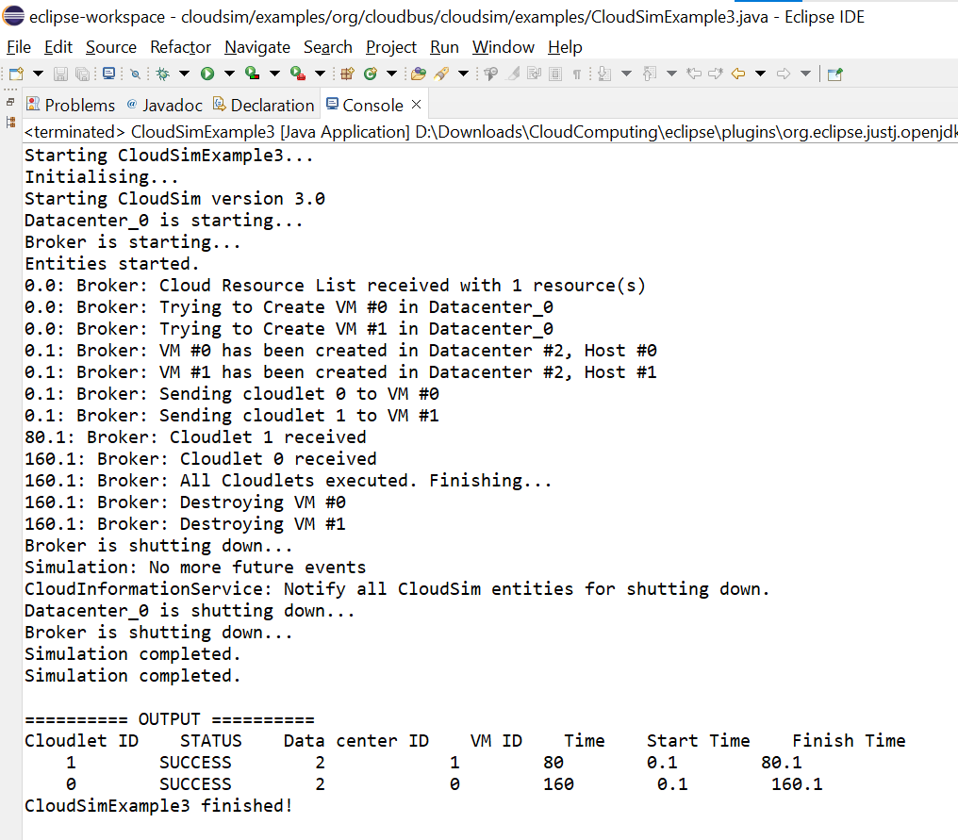

Experiment – 7
Aim - Program to create scalable simulations.
Software Used – Eclipse
Package Used – Cloudsim(Framework)
Code –
* Title: CloudSim Toolkit
* Description: CloudSim (Cloud Simulation) Toolkit for Modeling and Simulation
* of Clouds
* Licence: GPL - http://www.gnu.org/copyleft/gpl.html
*
* Copyright (c) 2009, The University of Melbourne, Australia
*/
package org.cloudbus.cloudsim.examples;
import java.text.DecimalFormat;
import java.util.ArrayList;
import java.util.Calendar;
import java.util.LinkedList;
import java.util.List;
import org.cloudbus.cloudsim.Cloudlet;
import org.cloudbus.cloudsim.CloudletSchedulerTimeShared;
import org.cloudbus.cloudsim.Datacenter;
import org.cloudbus.cloudsim.DatacenterBroker;
import org.cloudbus.cloudsim.DatacenterCharacteristics;
import org.cloudbus.cloudsim.Host;
import org.cloudbus.cloudsim.Log;
import org.cloudbus.cloudsim.Pe;
import org.cloudbus.cloudsim.Storage;
import org.cloudbus.cloudsim.UtilizationModel;
import org.cloudbus.cloudsim.UtilizationModelFull;
import org.cloudbus.cloudsim.Vm;
import org.cloudbus.cloudsim.VmAllocationPolicySimple;
import org.cloudbus.cloudsim.VmSchedulerTimeShared;
import org.cloudbus.cloudsim.core.CloudSim;
import org.cloudbus.cloudsim.provisioners.BwProvisionerSimple;
import org.cloudbus.cloudsim.provisioners.PeProvisionerSimple;
import org.cloudbus.cloudsim.provisioners.RamProvisionerSimple;
/**
* An example showing how to create
* scalable simulations.
*/
public class CloudSimExample6 {
/** The cloudlet list. */
private static List<Cloudlet> cloudletList;
/** The vmlist. */
private static List<Vm> vmlist;
private static List<Vm> createVM(int userId, int vms) {
//Creates a container to store VMs. This list is passed to the broker later
LinkedList<Vm> list = new LinkedList<Vm>();
//VM Parameters
long size = 10000; //image size (MB)
int ram = 512; //vm memory (MB)
int mips = 1000;
long bw = 1000;
int pesNumber = 1; //number of cpus
String vmm = "Xen"; //VMM name
//create VMs
Vm[] vm = new Vm[vms];
for(int i=0;i<vms;i++){
vm[i] = new Vm(i, userId, mips, pesNumber, ram, bw, size, vmm, new CloudletSchedulerTimeShared());
//for creating a VM with a space shared scheduling policy for cloudlets:
//vm[i] = Vm(i, userId, mips, pesNumber, ram, bw, size, priority, vmm, new CloudletSchedulerSpaceShared());
list.add(vm[i]);
}
return list;
}
private static List<Cloudlet> createCloudlet(int userId, int cloudlets){
// Creates a container to store Cloudlets
LinkedList<Cloudlet> list = new LinkedList<Cloudlet>();
//cloudlet parameters
long length = 1000;
long fileSize = 300;
long outputSize = 300;
int pesNumber = 1;
UtilizationModel utilizationModel = new UtilizationModelFull();
Cloudlet[] cloudlet = new Cloudlet[cloudlets];
for(int i=0;i<cloudlets;i++){
cloudlet[i] = new Cloudlet(i, length, pesNumber, fileSize, outputSize, utilizationModel, utilizationModel, utilizationModel);
// setting the owner of these Cloudlets
cloudlet[i].setUserId(userId);
list.add(cloudlet[i]);
}
return list;
}
////////////////////////// STATIC METHODS ///////////////////////
/**
* Creates main() to run this example
*/
public static void main(String[] args) {
Log.printLine("Starting CloudSimExample6...");
try {
// First step: Initialize the CloudSim package. It should be called
// before creating any entities.
int num_user = 1; // number of grid users
Calendar calendar = Calendar.getInstance();
boolean trace_flag = false; // mean trace events
// Initialize the CloudSim library
CloudSim.init(num_user, calendar, trace_flag);
// Second step: Create Datacenters
//Datacenters are the resource providers in CloudSim. We need at list one of them to run a CloudSim simulation
@SuppressWarnings("unused")
Datacenter datacenter0 = createDatacenter("Datacenter_0");
@SuppressWarnings("unused")
Datacenter datacenter1 = createDatacenter("Datacenter_1");
//Third step: Create Broker
DatacenterBroker broker = createBroker();
int brokerId = broker.getId();
//Fourth step: Create VMs and Cloudlets and send them to broker
vmlist = createVM(brokerId,20); //creating 20 vms
cloudletList = createCloudlet(brokerId,40); // creating 40 cloudlets
broker.submitVmList(vmlist);
broker.submitCloudletList(cloudletList);
// Fifth step: Starts the simulation
CloudSim.startSimulation();
// Final step: Print results when simulation is over
List<Cloudlet> newList = broker.getCloudletReceivedList();
CloudSim.stopSimulation();
printCloudletList(newList);
Log.printLine("CloudSimExample6 finished!");
}
catch (Exception e)
{
e.printStackTrace();
Log.printLine("The simulation has been terminated due to an unexpected error");
}
}
private static Datacenter createDatacenter(String name){
// Here are the steps needed to create a PowerDatacenter:
// 1. We need to create a list to store one or more
// Machines
List<Host> hostList = new ArrayList<Host>();
// 2. A Machine contains one or more PEs or CPUs/Cores. Therefore, should
// create a list to store these PEs before creating
// a Machine.
List<Pe> peList1 = new ArrayList<Pe>();
int mips = 1000;
// 3. Create PEs and add these into the list.
//for a quad-core machine, a list of 4 PEs is required:
peList1.add(new Pe(0, new PeProvisionerSimple(mips))); // need to store Pe id and MIPS Rating
peList1.add(new Pe(1, new PeProvisionerSimple(mips)));
peList1.add(new Pe(2, new PeProvisionerSimple(mips)));
peList1.add(new Pe(3, new PeProvisionerSimple(mips)));
//Another list, for a dual-core machine
List<Pe> peList2 = new ArrayList<Pe>();
peList2.add(new Pe(0, new PeProvisionerSimple(mips)));
peList2.add(new Pe(1, new PeProvisionerSimple(mips)));
//4. Create Hosts with its id and list of PEs and add them to the list of machines
int hostId=0;
int ram = 2048; //host memory (MB)
long storage = 1000000; //host storage
int bw = 10000;
hostList.add(
new Host(
hostId,
new RamProvisionerSimple(ram),
new BwProvisionerSimple(bw),
storage,
peList1,
new VmSchedulerTimeShared(peList1)
)
); // This is our first machine
hostId++;
hostList.add(
new Host(
hostId,
new RamProvisionerSimple(ram),
new BwProvisionerSimple(bw),
storage,
peList2,
new VmSchedulerTimeShared(peList2)
)
); // Second machine
//To create a host with a space-shared allocation policy for PEs to VMs:
//hostList.add(
// new Host(
// hostId,
// new CpuProvisionerSimple(peList1),
// new RamProvisionerSimple(ram),
// new BwProvisionerSimple(bw),
// storage,
// new VmSchedulerSpaceShared(peList1)
// )
// );
//To create a host with a oportunistic space-shared allocation policy for PEs to VMs:
//hostList.add(
// new Host(
// hostId,
// new CpuProvisionerSimple(peList1),
// new RamProvisionerSimple(ram),
// new BwProvisionerSimple(bw),
// storage,
// new VmSchedulerOportunisticSpaceShared(peList1)
// )
// );
// 5. Create a DatacenterCharacteristics object that stores the
// properties of a data center: architecture, OS, list of
// Machines, allocation policy: time- or space-shared, time zone
// and its price (G$/Pe time unit).
String arch = "x86"; // system architecture
String os = "Linux"; // operating system
String vmm = "Xen";
double time_zone = 10.0; // time zone this resource located
double cost = 3.0; // the cost of using processing in this resource
double costPerMem = 0.05; // the cost of using memory in this resource
double costPerStorage = 0.1; // the cost of using storage in this resource
double costPerBw = 0.1; // the cost of using bw in this resource
LinkedList<Storage> storageList = new LinkedList<Storage>(); //we are not adding SAN devices by now
DatacenterCharacteristics characteristics = new DatacenterCharacteristics(
arch, os, vmm, hostList, time_zone, cost, costPerMem, costPerStorage, costPerBw);
// 6. Finally, we need to create a PowerDatacenter object.
Datacenter datacenter = null;
try {
datacenter = new Datacenter(name, characteristics, new VmAllocationPolicySimple(hostList), storageList, 0);
} catch (Exception e) {
e.printStackTrace();
}
return datacenter;
}
//We strongly encourage users to develop their own broker policies, to submit vms and cloudlets according
//to the specific rules of the simulated scenario
private static DatacenterBroker createBroker(){
DatacenterBroker broker = null;
try {
broker = new DatacenterBroker("Broker");
} catch (Exception e) {
e.printStackTrace();
return null;
}
return broker;
}
/**
* Prints the Cloudlet objects
* @param list list of Cloudlets
*/
private static void printCloudletList(List<Cloudlet> list) {
int size = list.size();
Cloudlet cloudlet;
String indent = " ";
Log.printLine();
Log.printLine("========== OUTPUT ==========");
Log.printLine("Cloudlet ID" + indent + "STATUS" + indent +
"Data center ID" + indent + "VM ID" + indent + indent + "Time" + indent + "Start Time" + indent + "Finish Time");
DecimalFormat dft = new DecimalFormat("###.##");
for (int i = 0; i < size; i++) {
cloudlet = list.get(i);
Log.print(indent + cloudlet.getCloudletId() + indent + indent);
if (cloudlet.getCloudletStatus() == Cloudlet.SUCCESS){
Log.print("SUCCESS");
Log.printLine( indent + indent + cloudlet.getResourceId() + indent + indent + indent + cloudlet.getVmId() +
indent + indent + indent + dft.format(cloudlet.getActualCPUTime()) +
indent + indent + dft.format(cloudlet.getExecStartTime())+ indent + indent + indent + dft.format(cloudlet.getFinishTime()));
}
}
}
}

Output –
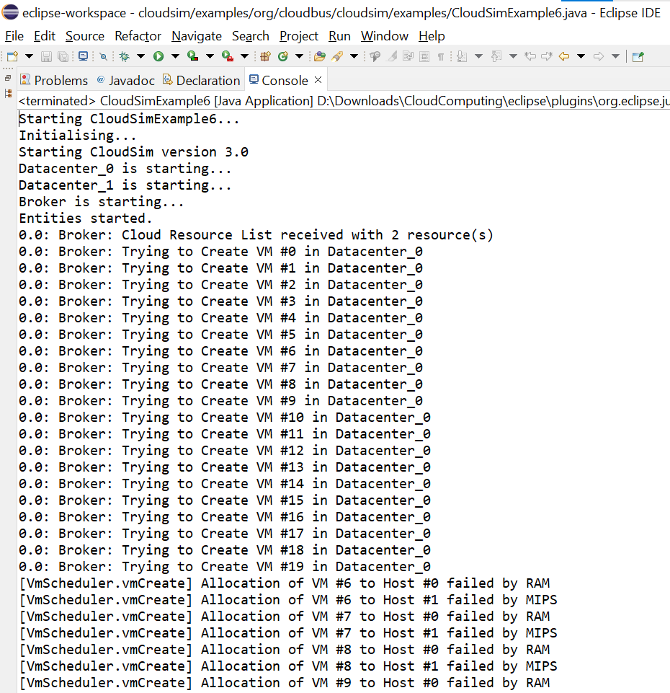
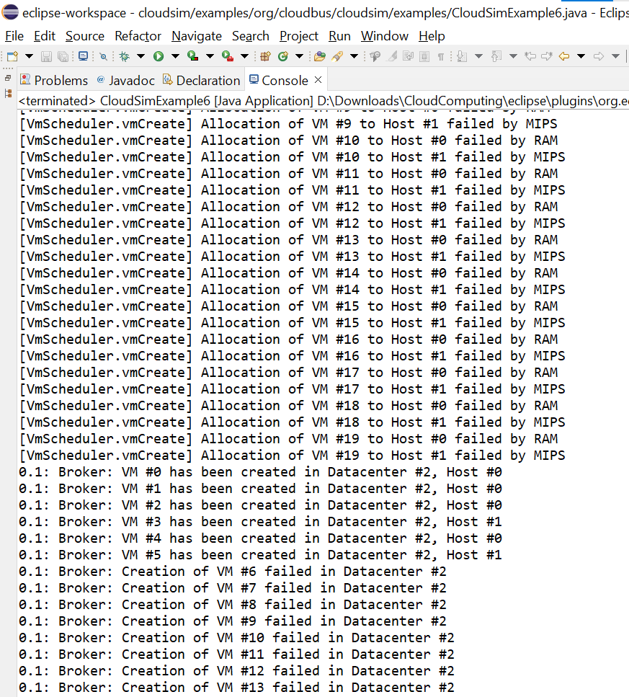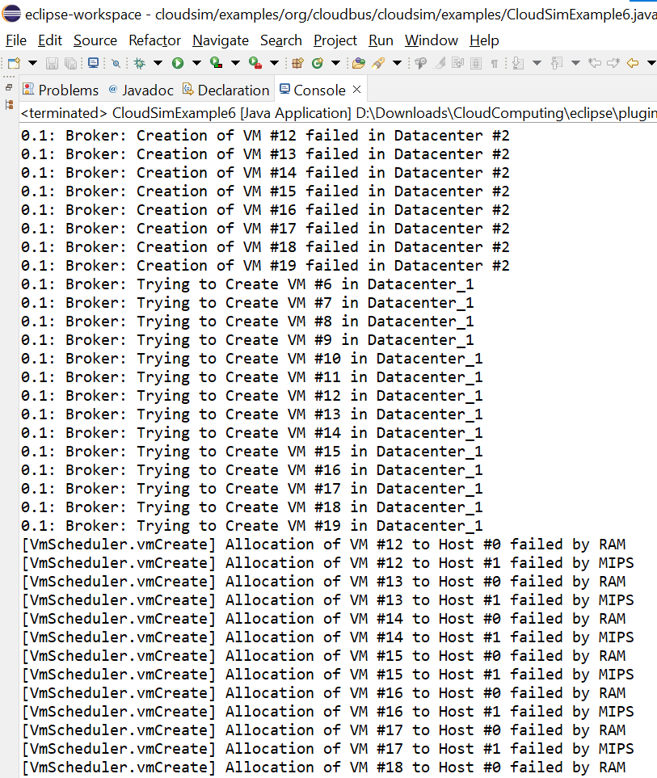
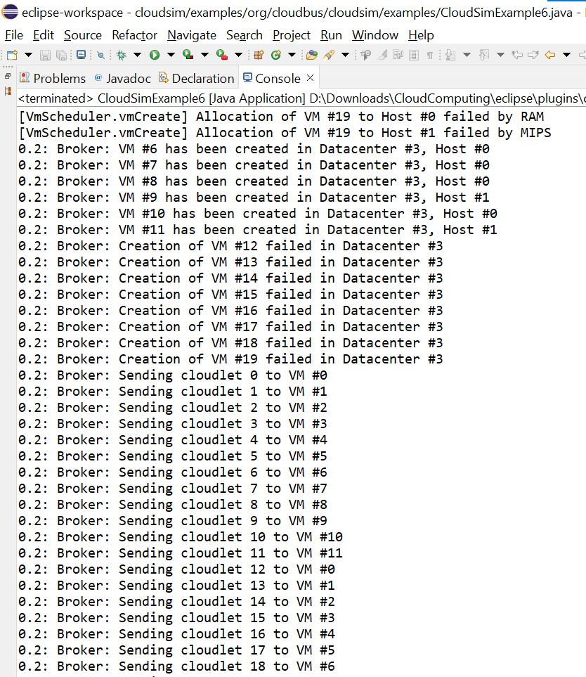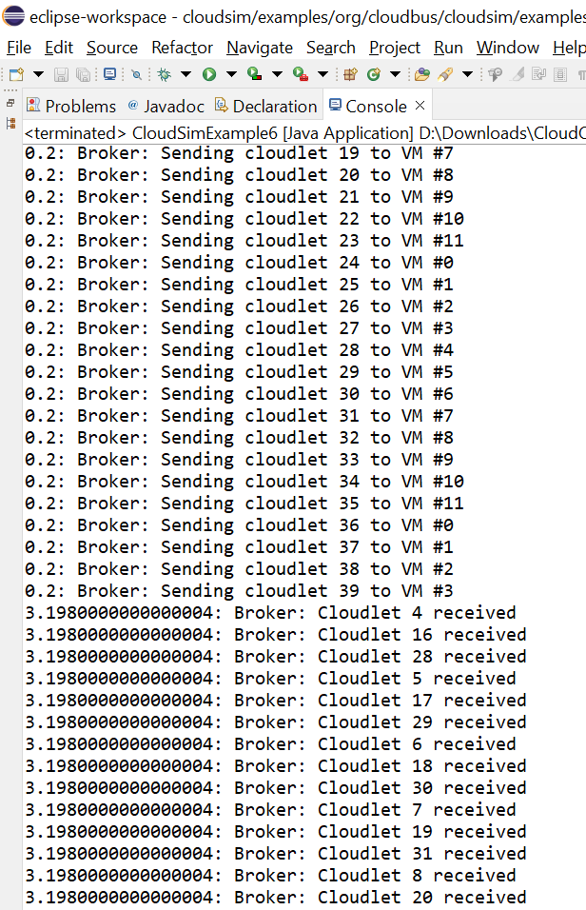
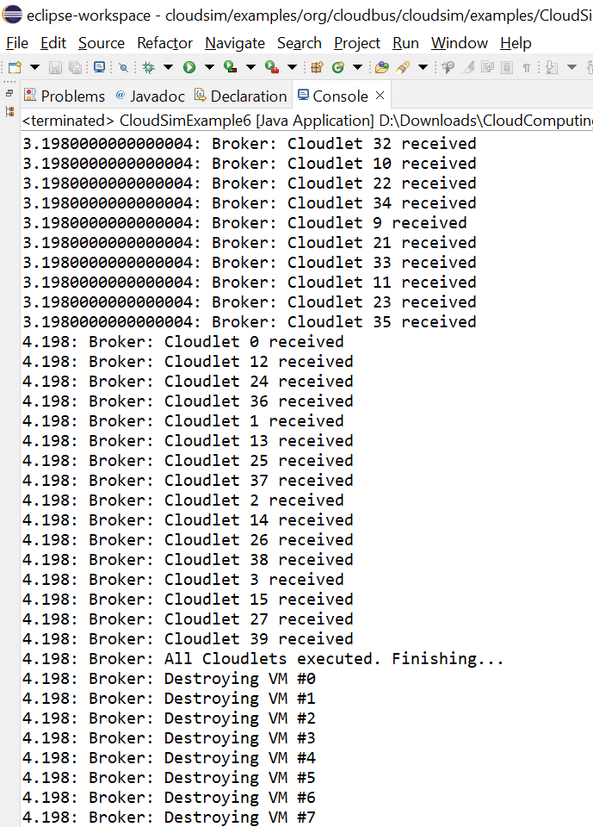
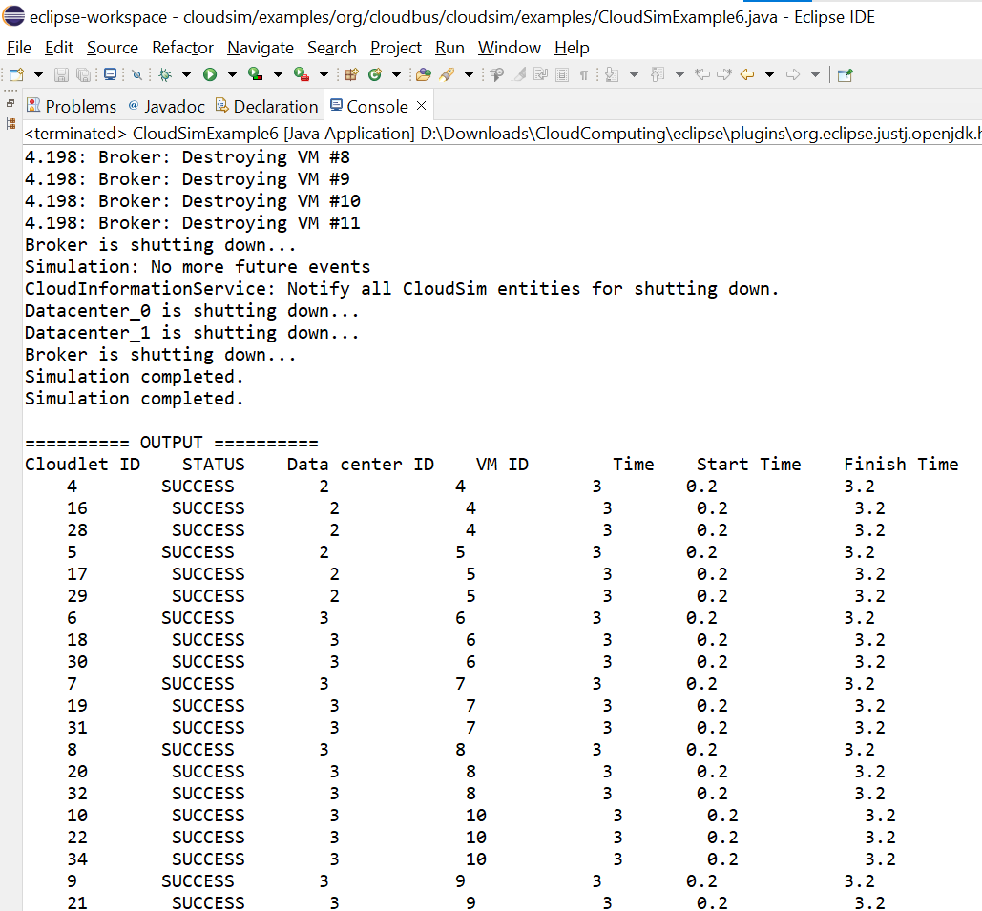
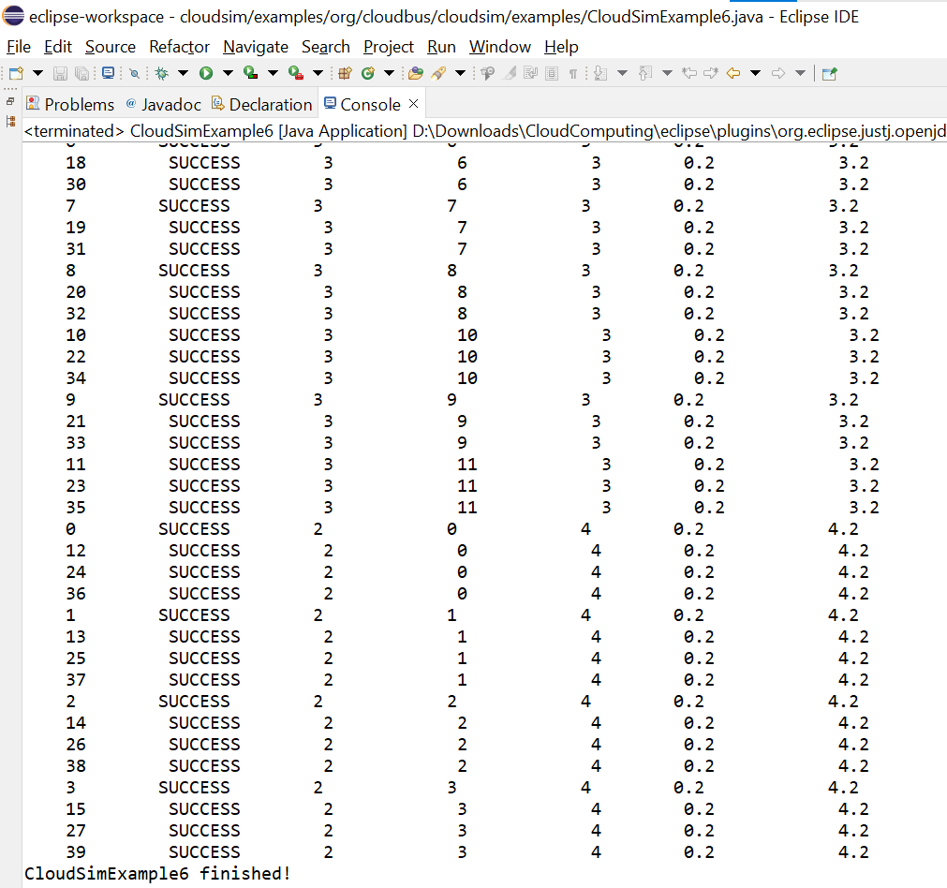

Experiment – 8
Aim - Program to pause and resume the simulation, and create simulation entities (a DatacenterBroker in this example) dynamically.
Software Used – Eclipse
Package Used – Cloudsim(Framework)
Code –
* Title: CloudSim Toolkit
* Description: CloudSim (Cloud Simulation) Toolkit for Modeling and Simulation
* of Clouds
* Licence: GPL - http://www.gnu.org/copyleft/gpl.html
*
* Copyright (c) 2009, The University of Melbourne, Australia
*/
package org.cloudbus.cloudsim.examples;
import java.text.DecimalFormat;
import java.util.ArrayList;
import java.util.Calendar;
import java.util.LinkedList;
import java.util.List;
import org.cloudbus.cloudsim.Cloudlet;
import org.cloudbus.cloudsim.CloudletSchedulerTimeShared;
import org.cloudbus.cloudsim.Datacenter;
import org.cloudbus.cloudsim.DatacenterBroker;
import org.cloudbus.cloudsim.DatacenterCharacteristics;
import org.cloudbus.cloudsim.Host;
import org.cloudbus.cloudsim.Log;
import org.cloudbus.cloudsim.Pe;
import org.cloudbus.cloudsim.Storage;
import org.cloudbus.cloudsim.UtilizationModel;
import org.cloudbus.cloudsim.UtilizationModelFull;
import org.cloudbus.cloudsim.Vm;
import org.cloudbus.cloudsim.VmAllocationPolicySimple;
import org.cloudbus.cloudsim.VmSchedulerTimeShared;
import org.cloudbus.cloudsim.core.CloudSim;
import org.cloudbus.cloudsim.provisioners.BwProvisionerSimple;
import org.cloudbus.cloudsim.provisioners.PeProvisionerSimple;
import org.cloudbus.cloudsim.provisioners.RamProvisionerSimple;
/**
* An example showing how to pause and resume the simulation,
* and create simulation entities (a DatacenterBroker in this example)
* dynamically.
*/
public class CloudSimExample7 {
/** The cloudlet list. */
private static List<Cloudlet> cloudletList;
/** The vmlist. */
private static List<Vm> vmlist;
private static List<Vm> createVM(int userId, int vms, int idShift) {
//Creates a container to store VMs. This list is passed to the broker later
LinkedList<Vm> list = new LinkedList<Vm>();
//VM Parameters
long size = 10000; //image size (MB)
int ram = 512; //vm memory (MB)
int mips = 250;
long bw = 1000;
int pesNumber = 1; //number of cpus
String vmm = "Xen"; //VMM name
//create VMs
Vm[] vm = new Vm[vms];
for(int i=0;i<vms;i++){
vm[i] = new Vm(idShift + i, userId, mips, pesNumber, ram, bw, size, vmm, new CloudletSchedulerTimeShared());
list.add(vm[i]);
}
return list;
}
private static List<Cloudlet> createCloudlet(int userId, int cloudlets, int idShift){
// Creates a container to store Cloudlets
LinkedList<Cloudlet> list = new LinkedList<Cloudlet>();
//cloudlet parameters
long length = 40000;
long fileSize = 300;
long outputSize = 300;
int pesNumber = 1;
UtilizationModel utilizationModel = new UtilizationModelFull();
Cloudlet[] cloudlet = new Cloudlet[cloudlets];
for(int i=0;i<cloudlets;i++){
cloudlet[i] = new Cloudlet(idShift + i, length, pesNumber, fileSize, outputSize, utilizationModel, utilizationModel, utilizationModel);
// setting the owner of these Cloudlets
cloudlet[i].setUserId(userId);
list.add(cloudlet[i]);
}
return list;
}
////////////////////////// STATIC METHODS ///////////////////////
/**
* Creates main() to run this example
*/
public static void main(String[] args) {
Log.printLine("Starting CloudSimExample7...");
try {
// First step: Initialize the CloudSim package. It should be called
// before creating any entities.
int num_user = 2; // number of grid users
Calendar calendar = Calendar.getInstance();
boolean trace_flag = false; // mean trace events
// Initialize the CloudSim library
CloudSim.init(num_user, calendar, trace_flag);
// Second step: Create Datacenters
//Datacenters are the resource providers in CloudSim. We need at list one of them to run a CloudSim simulation
@SuppressWarnings("unused")
Datacenter datacenter0 = createDatacenter("Datacenter_0");
@SuppressWarnings("unused")
Datacenter datacenter1 = createDatacenter("Datacenter_1");
//Third step: Create Broker
DatacenterBroker broker = createBroker("Broker_0");
int brokerId = broker.getId();
//Fourth step: Create VMs and Cloudlets and send them to broker
vmlist = createVM(brokerId, 5, 0); //creating 5 vms
cloudletList = createCloudlet(brokerId, 10, 0); // creating 10 cloudlets
broker.submitVmList(vmlist);
broker.submitCloudletList(cloudletList);
// A thread that will create a new broker at 200 clock time
Runnable monitor = new Runnable() {
@Override
public void run() {
CloudSim.pauseSimulation(200);
while (true) {
if (CloudSim.isPaused()) {
break;
}
try {
Thread.sleep(100);
} catch (InterruptedException e) {
e.printStackTrace();
}
}
Log.printLine("\n\n\n" + CloudSim.clock() + ": The simulation is paused for 5 sec \n\n");
try {
Thread.sleep(5000);
} catch (InterruptedException e) {
e.printStackTrace();
}
DatacenterBroker broker = createBroker("Broker_1");
int brokerId = broker.getId();
//Create VMs and Cloudlets and send them to broker
vmlist = createVM(brokerId, 5, 100); //creating 5 vms
cloudletList = createCloudlet(brokerId, 10, 100); // creating 10 cloudlets
broker.submitVmList(vmlist);
broker.submitCloudletList(cloudletList);
CloudSim.resumeSimulation();
}
};
new Thread(monitor).start();
Thread.sleep(1000);
// Fifth step: Starts the simulation
CloudSim.startSimulation();
// Final step: Print results when simulation is over
List<Cloudlet> newList = broker.getCloudletReceivedList();
CloudSim.stopSimulation();
printCloudletList(newList);
Log.printLine("CloudSimExample7 finished!");
}
catch (Exception e)
{
e.printStackTrace();
Log.printLine("The simulation has been terminated due to an unexpected error");
}
}
private static Datacenter createDatacenter(String name){
// Here are the steps needed to create a PowerDatacenter:
// 1. We need to create a list to store one or more
// Machines
List<Host> hostList = new ArrayList<Host>();
// 2. A Machine contains one or more PEs or CPUs/Cores. Therefore, should
// create a list to store these PEs before creating
// a Machine.
List<Pe> peList1 = new ArrayList<Pe>();
int mips = 1000;
// 3. Create PEs and add these into the list.
//for a quad-core machine, a list of 4 PEs is required:
peList1.add(new Pe(0, new PeProvisionerSimple(mips))); // need to store Pe id and MIPS Rating
peList1.add(new Pe(1, new PeProvisionerSimple(mips)));
peList1.add(new Pe(2, new PeProvisionerSimple(mips)));
peList1.add(new Pe(3, new PeProvisionerSimple(mips)));
//Another list, for a dual-core machine
List<Pe> peList2 = new ArrayList<Pe>();
peList2.add(new Pe(0, new PeProvisionerSimple(mips)));
peList2.add(new Pe(1, new PeProvisionerSimple(mips)));
//4. Create Hosts with its id and list of PEs and add them to the list of machines
int hostId=0;
int ram = 16384; //host memory (MB)
long storage = 1000000; //host storage
int bw = 10000;
hostList.add(
new Host(
hostId,
new RamProvisionerSimple(ram),
new BwProvisionerSimple(bw),
storage,
peList1,
new VmSchedulerTimeShared(peList1)
)
); // This is our first machine
hostId++;
hostList.add(
new Host(
hostId,
new RamProvisionerSimple(ram),
new BwProvisionerSimple(bw),
storage,
peList2,
new VmSchedulerTimeShared(peList2)
)
); // Second machine
// 5. Create a DatacenterCharacteristics object that stores the
// properties of a data center: architecture, OS, list of
// Machines, allocation policy: time- or space-shared, time zone
// and its price (G$/Pe time unit).
String arch = "x86"; // system architecture
String os = "Linux"; // operating system
String vmm = "Xen";
double time_zone = 10.0; // time zone this resource located
double cost = 3.0; // the cost of using processing in this resource
double costPerMem = 0.05; // the cost of using memory in this resource
double costPerStorage = 0.1; // the cost of using storage in this resource
double costPerBw = 0.1; // the cost of using bw in this resource
LinkedList<Storage> storageList = new LinkedList<Storage>(); //we are not adding SAN devices by now
DatacenterCharacteristics characteristics = new DatacenterCharacteristics(
arch, os, vmm, hostList, time_zone, cost, costPerMem, costPerStorage, costPerBw);
// 6. Finally, we need to create a PowerDatacenter object.
Datacenter datacenter = null;
try {
datacenter = new Datacenter(name, characteristics, new VmAllocationPolicySimple(hostList), storageList, 0);
} catch (Exception e) {
e.printStackTrace();
}
return datacenter;
}
//We strongly encourage users to develop their own broker policies, to submit vms and cloudlets according
//to the specific rules of the simulated scenario
private static DatacenterBroker createBroker(String name){
DatacenterBroker broker = null;
try {
broker = new DatacenterBroker(name);
} catch (Exception e) {
e.printStackTrace();
return null;
}
return broker;
}
/**
* Prints the Cloudlet objects
* @param list list of Cloudlets
*/
private static void printCloudletList(List<Cloudlet> list) {
int size = list.size();
Cloudlet cloudlet;
String indent = " ";
Log.printLine();
Log.printLine("========== OUTPUT ==========");
Log.printLine("Cloudlet ID" + indent + "STATUS" + indent +
"Data center ID" + indent + "VM ID" + indent + indent + "Time" + indent + "Start Time" + indent + "Finish Time");
DecimalFormat dft = new DecimalFormat("###.##");
for (int i = 0; i < size; i++) {
cloudlet = list.get(i);
Log.print(indent + cloudlet.getCloudletId() + indent + indent);
if (cloudlet.getCloudletStatus() == Cloudlet.SUCCESS){
Log.print("SUCCESS");
Log.printLine( indent + indent + cloudlet.getResourceId() + indent + indent + indent + cloudlet.getVmId() +
indent + indent + indent + dft.format(cloudlet.getActualCPUTime()) +
indent + indent + dft.format(cloudlet.getExecStartTime())+ indent + indent + indent + dft.format(cloudlet.getFinishTime()));
}
}
}
}

Output –
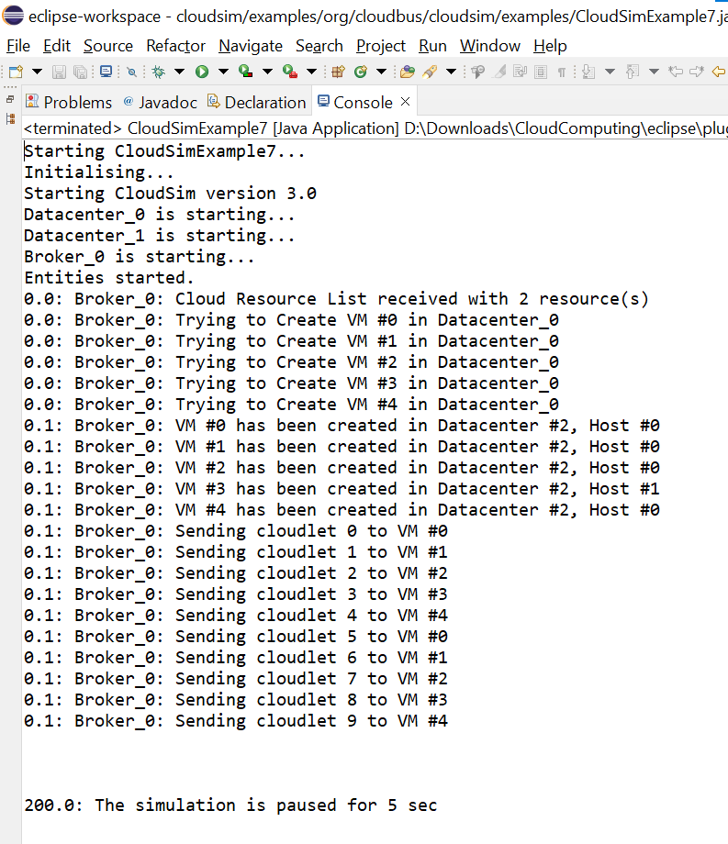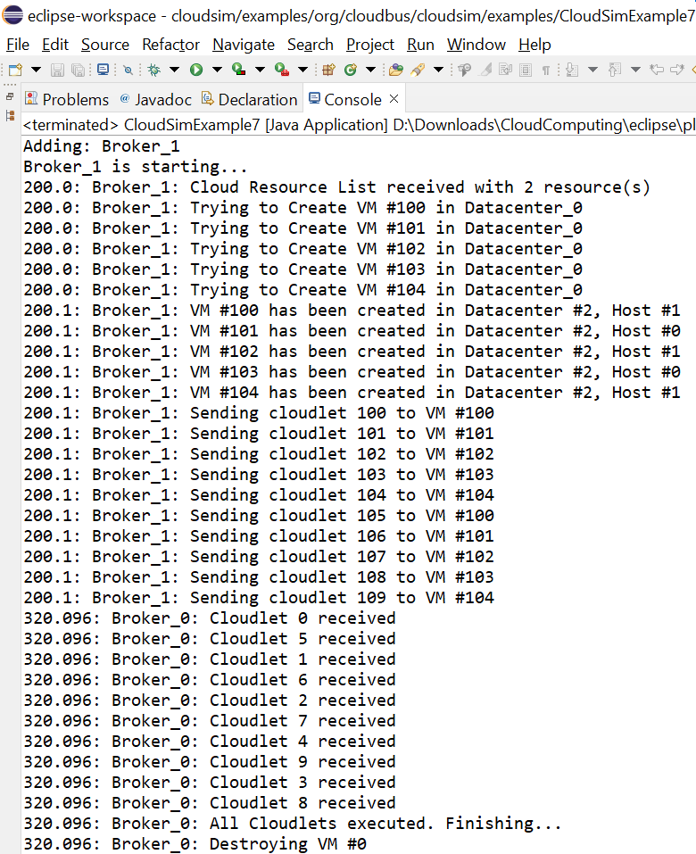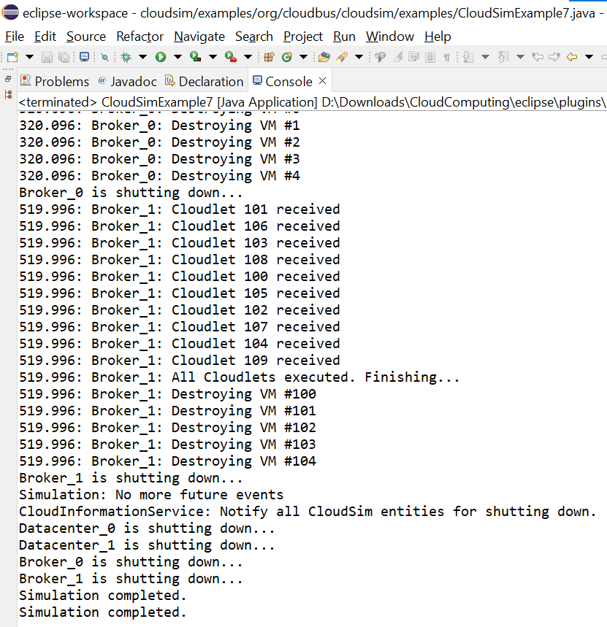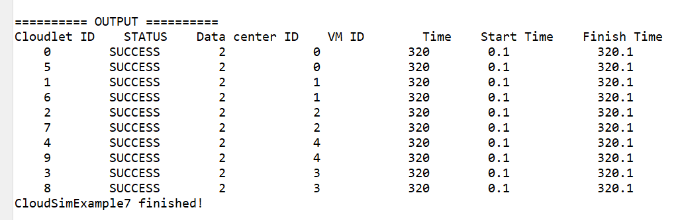
Experiment – 9
Aim - Program to create simulation entities (a DatacenterBroker in this example) in run-time using a global manager entity (GlobalBroker).entities (a DatacenterBroker in this example) dynamically.
Software Used – Eclipse
Package Used – Cloudsim(Framework)
Code –
* Title: CloudSim Toolkit
* Description: CloudSim (Cloud Simulation) Toolkit for Modeling and Simulation
* of Clouds
* Licence: GPL - http://www.gnu.org/copyleft/gpl.html
*
* Copyright (c) 2009, The University of Melbourne, Australia
*/
package org.cloudbus.cloudsim.examples;
import java.text.DecimalFormat;
import java.util.ArrayList;
import java.util.Calendar;
import java.util.LinkedList;
import java.util.List;
import org.cloudbus.cloudsim.Cloudlet;
import org.cloudbus.cloudsim.CloudletSchedulerTimeShared;
import org.cloudbus.cloudsim.Datacenter;
import org.cloudbus.cloudsim.DatacenterBroker;
import org.cloudbus.cloudsim.DatacenterCharacteristics;
import org.cloudbus.cloudsim.Host;
import org.cloudbus.cloudsim.Log;
import org.cloudbus.cloudsim.Pe;
import org.cloudbus.cloudsim.Storage;
import org.cloudbus.cloudsim.UtilizationModel;
import org.cloudbus.cloudsim.UtilizationModelFull;
import org.cloudbus.cloudsim.Vm;
import org.cloudbus.cloudsim.VmAllocationPolicySimple;
import org.cloudbus.cloudsim.VmSchedulerTimeShared;
import org.cloudbus.cloudsim.core.CloudSim;
import org.cloudbus.cloudsim.core.SimEntity;
import org.cloudbus.cloudsim.core.SimEvent;
import org.cloudbus.cloudsim.provisioners.BwProvisionerSimple;
import org.cloudbus.cloudsim.provisioners.PeProvisionerSimple;
import org.cloudbus.cloudsim.provisioners.RamProvisionerSimple;
/**
* An example showing how to create simulation entities
* (a DatacenterBroker in this example) in run-time using
* a globar manager entity (GlobalBroker).
*/
public class CloudSimExample8 {
/** The cloudlet list. */
private static List<Cloudlet> cloudletList;
/** The vmList. */
private static List<Vm> vmList;
private static List<Vm> createVM(int userId, int vms, int idShift) {
//Creates a container to store VMs. This list is passed to the broker later
LinkedList<Vm> list = new LinkedList<Vm>();
//VM Parameters
long size = 10000; //image size (MB)
int ram = 512; //vm memory (MB)
int mips = 250;
long bw = 1000;
int pesNumber = 1; //number of cpus
String vmm = "Xen"; //VMM name
//create VMs
Vm[] vm = new Vm[vms];
for(int i=0;i<vms;i++){
vm[i] = new Vm(idShift + i, userId, mips, pesNumber, ram, bw, size, vmm, new CloudletSchedulerTimeShared());
list.add(vm[i]);
}
return list;
}
private static List<Cloudlet> createCloudlet(int userId, int cloudlets, int idShift){
// Creates a container to store Cloudlets
LinkedList<Cloudlet> list = new LinkedList<Cloudlet>();
//cloudlet parameters
long length = 40000;
long fileSize = 300;
long outputSize = 300;
int pesNumber = 1;
UtilizationModel utilizationModel = new UtilizationModelFull();
Cloudlet[] cloudlet = new Cloudlet[cloudlets];
for(int i=0;i<cloudlets;i++){
cloudlet[i] = new Cloudlet(idShift + i, length, pesNumber, fileSize, outputSize, utilizationModel, utilizationModel, utilizationModel);
// setting the owner of these Cloudlets
cloudlet[i].setUserId(userId);
list.add(cloudlet[i]);
}
return list;
}
////////////////////////// STATIC METHODS ///////////////////////
/**
* Creates main() to run this example
*/
public static void main(String[] args) {
Log.printLine("Starting CloudSimExample8...");
try {
// First step: Initialize the CloudSim package. It should be called
// before creating any entities.
int num_user = 2; // number of grid users
Calendar calendar = Calendar.getInstance();
boolean trace_flag = false; // mean trace events
// Initialize the CloudSim library
CloudSim.init(num_user, calendar, trace_flag);
GlobalBroker globalBroker = new GlobalBroker("GlobalBroker");
// Second step: Create Datacenters
//Datacenters are the resource providers in CloudSim. We need at list one of them to run a CloudSim simulation
@SuppressWarnings("unused")
Datacenter datacenter0 = createDatacenter("Datacenter_0");
@SuppressWarnings("unused")
Datacenter datacenter1 = createDatacenter("Datacenter_1");
//Third step: Create Broker
DatacenterBroker broker = createBroker("Broker_0");
int brokerId = broker.getId();
//Fourth step: Create VMs and Cloudlets and send them to broker
vmList = createVM(brokerId, 5, 0); //creating 5 vms
cloudletList = createCloudlet(brokerId, 10, 0); // creating 10 cloudlets
broker.submitVmList(vmList);
broker.submitCloudletList(cloudletList);
// Fifth step: Starts the simulation
CloudSim.startSimulation();
// Final step: Print results when simulation is over
List<Cloudlet> newList = broker.getCloudletReceivedList();
newList.addAll(globalBroker.getBroker().getCloudletReceivedList());
CloudSim.stopSimulation();
printCloudletList(newList);
Log.printLine("CloudSimExample8 finished!");
}
catch (Exception e)
{
e.printStackTrace();
Log.printLine("The simulation has been terminated due to an unexpected error");
}
}
private static Datacenter createDatacenter(String name){
// Here are the steps needed to create a PowerDatacenter:
// 1. We need to create a list to store one or more
// Machines
List<Host> hostList = new ArrayList<Host>();
// 2. A Machine contains one or more PEs or CPUs/Cores. Therefore, should
// create a list to store these PEs before creating
// a Machine.
List<Pe> peList1 = new ArrayList<Pe>();
int mips = 1000;
// 3. Create PEs and add these into the list.
//for a quad-core machine, a list of 4 PEs is required:
peList1.add(new Pe(0, new PeProvisionerSimple(mips))); // need to store Pe id and MIPS Rating
peList1.add(new Pe(1, new PeProvisionerSimple(mips)));
peList1.add(new Pe(2, new PeProvisionerSimple(mips)));
peList1.add(new Pe(3, new PeProvisionerSimple(mips)));
//Another list, for a dual-core machine
List<Pe> peList2 = new ArrayList<Pe>();
peList2.add(new Pe(0, new PeProvisionerSimple(mips)));
peList2.add(new Pe(1, new PeProvisionerSimple(mips)));
//4. Create Hosts with its id and list of PEs and add them to the list of machines
int hostId=0;
int ram = 16384; //host memory (MB)
long storage = 1000000; //host storage
int bw = 10000;
hostList.add(
new Host(
hostId,
new RamProvisionerSimple(ram),
new BwProvisionerSimple(bw),
storage,
peList1,
new VmSchedulerTimeShared(peList1)
)
); // This is our first machine
hostId++;
hostList.add(
new Host(
hostId,
new RamProvisionerSimple(ram),
new BwProvisionerSimple(bw),
storage,
peList2,
new VmSchedulerTimeShared(peList2)
)
); // Second machine
// 5. Create a DatacenterCharacteristics object that stores the
// properties of a data center: architecture, OS, list of
// Machines, allocation policy: time- or space-shared, time zone
// and its price (G$/Pe time unit).
String arch = "x86"; // system architecture
String os = "Linux"; // operating system
String vmm = "Xen";
double time_zone = 10.0; // time zone this resource located
double cost = 3.0; // the cost of using processing in this resource
double costPerMem = 0.05; // the cost of using memory in this resource
double costPerStorage = 0.1; // the cost of using storage in this resource
double costPerBw = 0.1; // the cost of using bw in this resource
LinkedList<Storage> storageList = new LinkedList<Storage>(); //we are not adding SAN devices by now
DatacenterCharacteristics characteristics = new DatacenterCharacteristics(
arch, os, vmm, hostList, time_zone, cost, costPerMem, costPerStorage, costPerBw);
// 6. Finally, we need to create a PowerDatacenter object.
Datacenter datacenter = null;
try {
datacenter = new Datacenter(name, characteristics, new VmAllocationPolicySimple(hostList), storageList, 0);
} catch (Exception e) {
e.printStackTrace();
}
return datacenter;
}
//We strongly encourage users to develop their own broker policies, to submit vms and cloudlets according
//to the specific rules of the simulated scenario
private static DatacenterBroker createBroker(String name){
DatacenterBroker broker = null;
try {
broker = new DatacenterBroker(name);
} catch (Exception e) {
e.printStackTrace();
return null;
}
return broker;
}
/**
* Prints the Cloudlet objects
* @param list list of Cloudlets
*/
private static void printCloudletList(List<Cloudlet> list) {
int size = list.size();
Cloudlet cloudlet;
String indent = " ";
Log.printLine();
Log.printLine("========== OUTPUT ==========");
Log.printLine("Cloudlet ID" + indent + "STATUS" + indent +
"Data center ID" + indent + "VM ID" + indent + indent + "Time" + indent + "Start Time" + indent + "Finish Time");
DecimalFormat dft = new DecimalFormat("###.##");
for (int i = 0; i < size; i++) {
cloudlet = list.get(i);
Log.print(indent + cloudlet.getCloudletId() + indent + indent);
if (cloudlet.getCloudletStatus() == Cloudlet.SUCCESS){
Log.print("SUCCESS");
Log.printLine( indent + indent + cloudlet.getResourceId() + indent + indent + indent + cloudlet.getVmId() +
indent + indent + indent + dft.format(cloudlet.getActualCPUTime()) +
indent + indent + dft.format(cloudlet.getExecStartTime())+ indent + indent + indent + dft.format(cloudlet.getFinishTime()));
}
}
}
public static class GlobalBroker extends SimEntity {
private static final int CREATE_BROKER = 0;
private List<Vm> vmList;
private List<Cloudlet> cloudletList;
private DatacenterBroker broker;
public GlobalBroker(String name) {
super(name);
}
@Override
public void processEvent(SimEvent ev) {
switch (ev.getTag()) {
case CREATE_BROKER:
setBroker(createBroker(super.getName()+"_"));
//Create VMs and Cloudlets and send them to broker
setVmList(createVM(getBroker().getId(), 5, 100)); //creating 5 vms
setCloudletList(createCloudlet(getBroker().getId(), 10, 100)); // creating 10 cloudlets
broker.submitVmList(getVmList());
broker.submitCloudletList(getCloudletList());
CloudSim.resumeSimulation();
break;
default:
Log.printLine(getName() + ": unknown event type");
break;
}
}
@Override
public void startEntity() {
Log.printLine(super.getName()+" is starting...");
schedule(getId(), 200, CREATE_BROKER);
}
@Override
public void shutdownEntity() {
}
public List<Vm> getVmList() {
return vmList;
}
protected void setVmList(List<Vm> vmList) {
this.vmList = vmList;
}
public List<Cloudlet> getCloudletList() {
return cloudletList;
}
protected void setCloudletList(List<Cloudlet> cloudletList) {
this.cloudletList = cloudletList;
}
public DatacenterBroker getBroker() {
return broker;
}
protected void setBroker(DatacenterBroker broker) {
this.broker = broker;
}
}
}

Output –
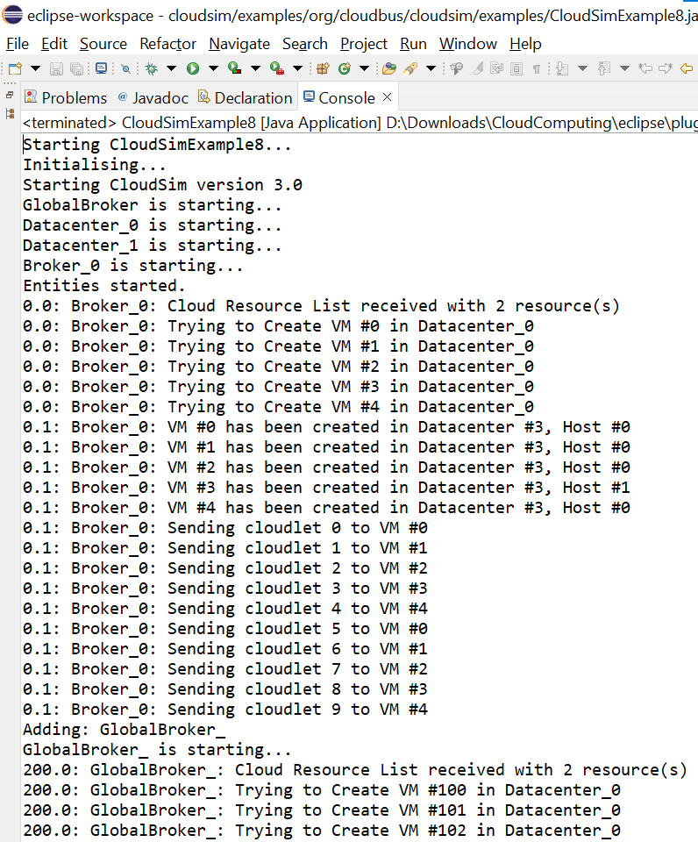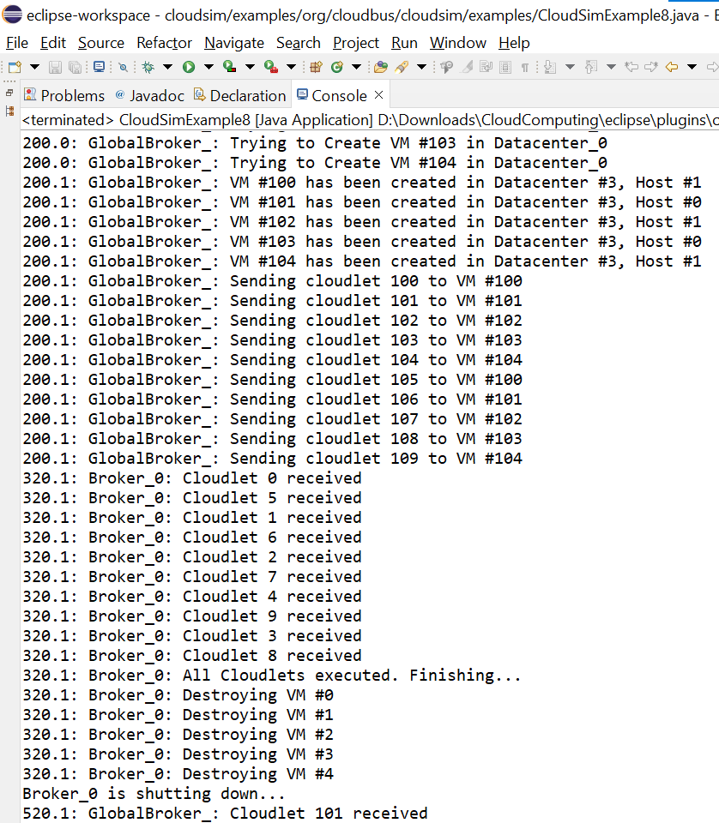
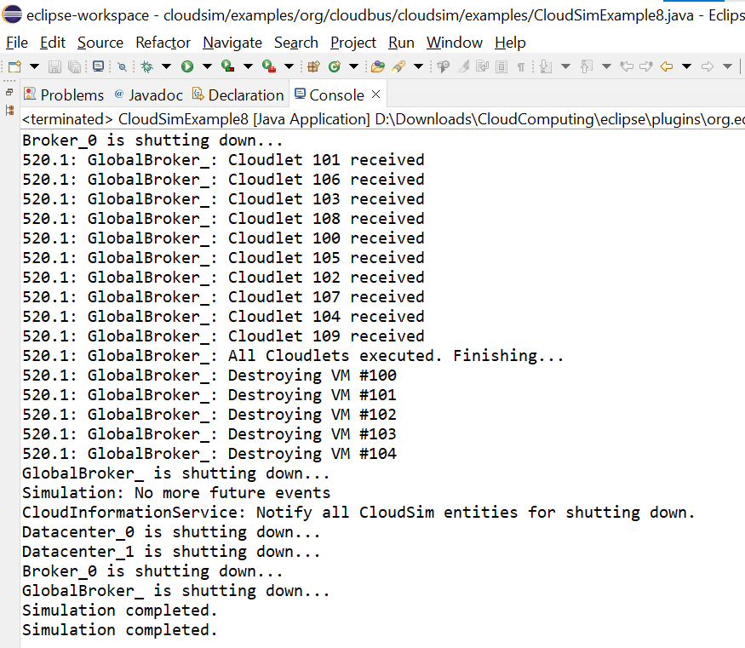
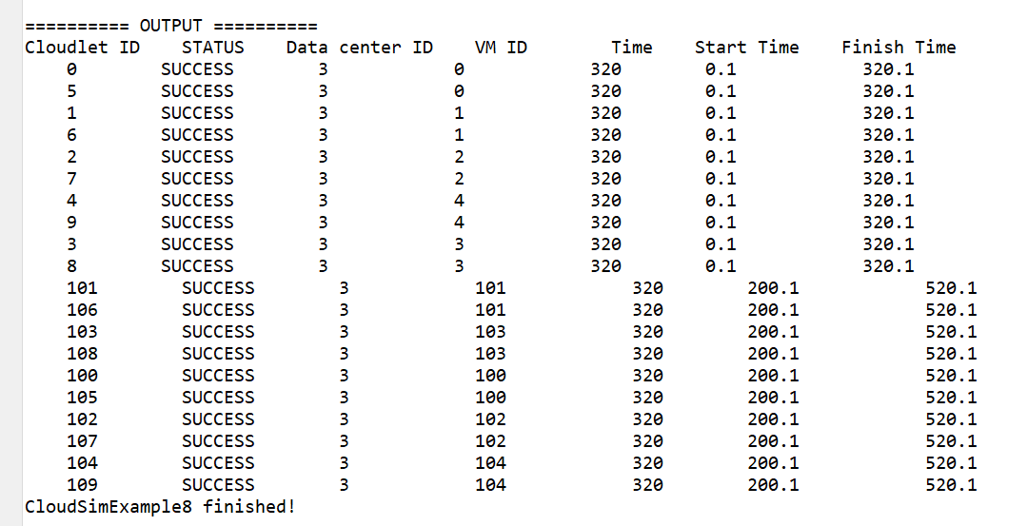

Experiment – 10
Aim - Execute a Python Program for the following in Google-Colab Platform:
a. Multiplication of 3 matrices of size 2 X 2.
b. Analyse boston house prices dataset using Matplotlib/Seaborn Library
Software Used – Google Colab
Language Used – Python
- Multiplication of 3 matrices of size 2 X 2.
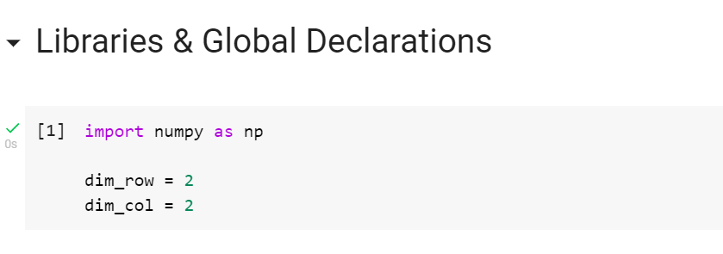
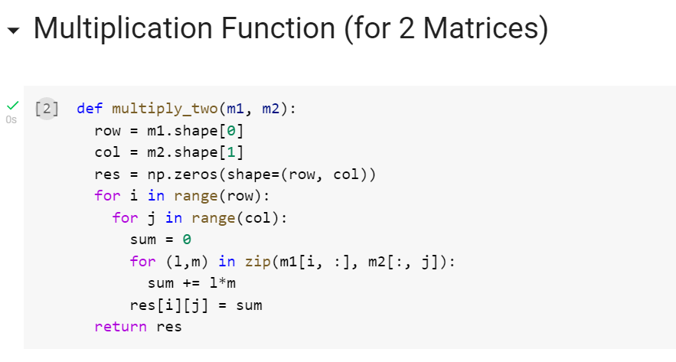
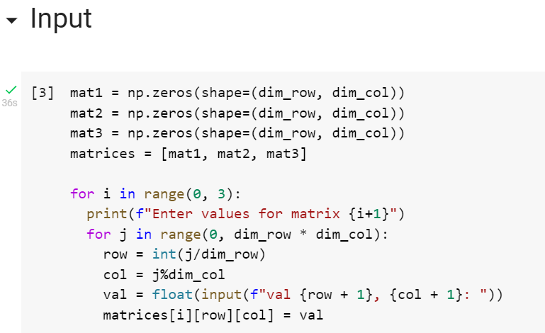
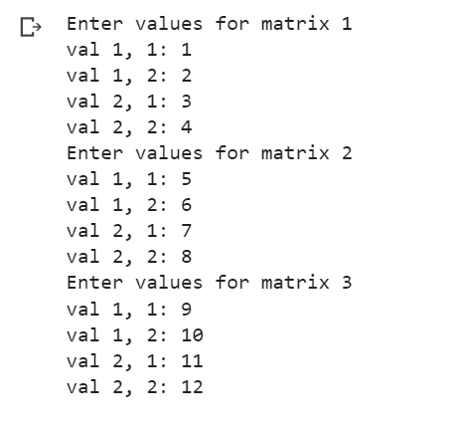
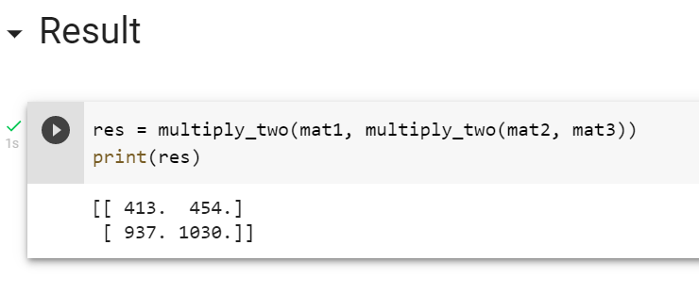

- Analyse boston house prices dataset using Matplotlib/Seaborn Library
