DIGITAL ELECTRONICS CIRCUIT DESIGNER
& SIMULATOR
C++17 Object-Oriented Project Report
Submission package: implementation + UML/class diagrams + documentation
Project scope
NAND/NOR-based logic gates, composite digital circuits, simulation, CSV output, and circuit storage.

1. Executive Summary
This project implements the Digital Electronics Circuit Designer idea as a C++17 console-based simulator. The design begins with primitive NAND and NOR gates and builds higher-level gates and circuits by composing reusable objects. The current implementation includes basic gates, Half Adder, Full Adder, 4-Bit Ripple Carry Adder, 4-Bit Counter, 2:1 MUX, 4:2 Encoder, and 2:4 Decoder. Simulation results are represented by the SimulationResult class and can be displayed in the terminal or persisted using CSV-related classes.
The most practical submission strategy is to keep the existing working implementation, organize it around the assignment requirements, add clear UML diagrams, and submit a concise technical report explaining the architecture, OOP concepts, circuit equations, workflow, build instructions, test evidence, and future improvements. A full rewrite is unnecessary because the supplied code already covers the core project idea.

2. Requirement-to-Implementation Mapping
Assignment expectation | Implemented class / feature | Status
Gates: NAND, NOR | NAND, NOR | Implemented
Build other gates from NAND/NOR | NOT, AND, OR, XOR | Implemented
Complex digital circuits | HalfAdder, FullAdder, FourBitAdder, FourBitCounter | Implemented
Additional circuit examples | MUX, Encoder, Decoder | Implemented
Circuit class | Abstract Circuit + derived circuit classes | Implemented
Simulation result | SimulationResult | Implemented
Separate output class | Output + CSVOutput | Implemented
Wiring objects | Wire class in composite circuits | Implemented
CSV output | CSVOutput / CircuitStorage | Implemented
Multi-threaded stretch goal | Not fully implemented | Future extension

3. System Architecture
The code follows a layered object-oriented structure. Component provides a common name-bearing base class. Gate and Circuit derive from Component and represent two main families: individual logic gates and complete digital circuits. Output provides an output abstraction and CSVOutput provides a concrete CSV implementation. Wire stores a signal and source/destination references for circuit-level signal flow. SimulationResult is a simple data object used to move inputs and outputs from a circuit to a display or file writer.
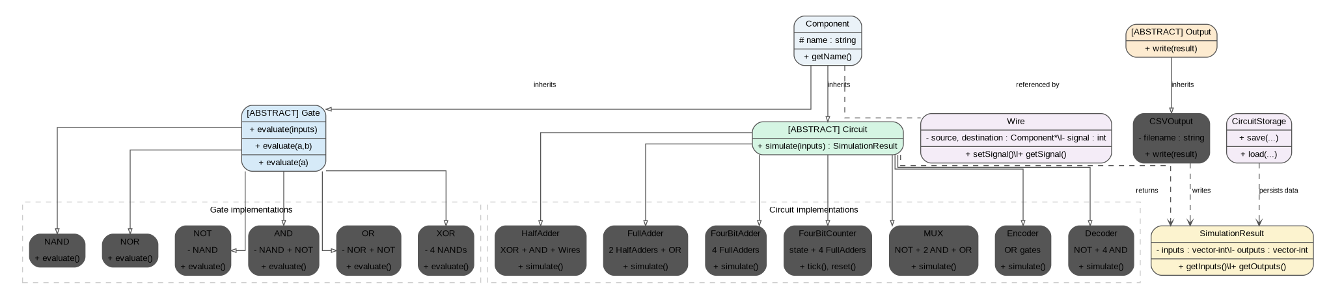
Figure 1. UML-style core class diagram of the project architecture.
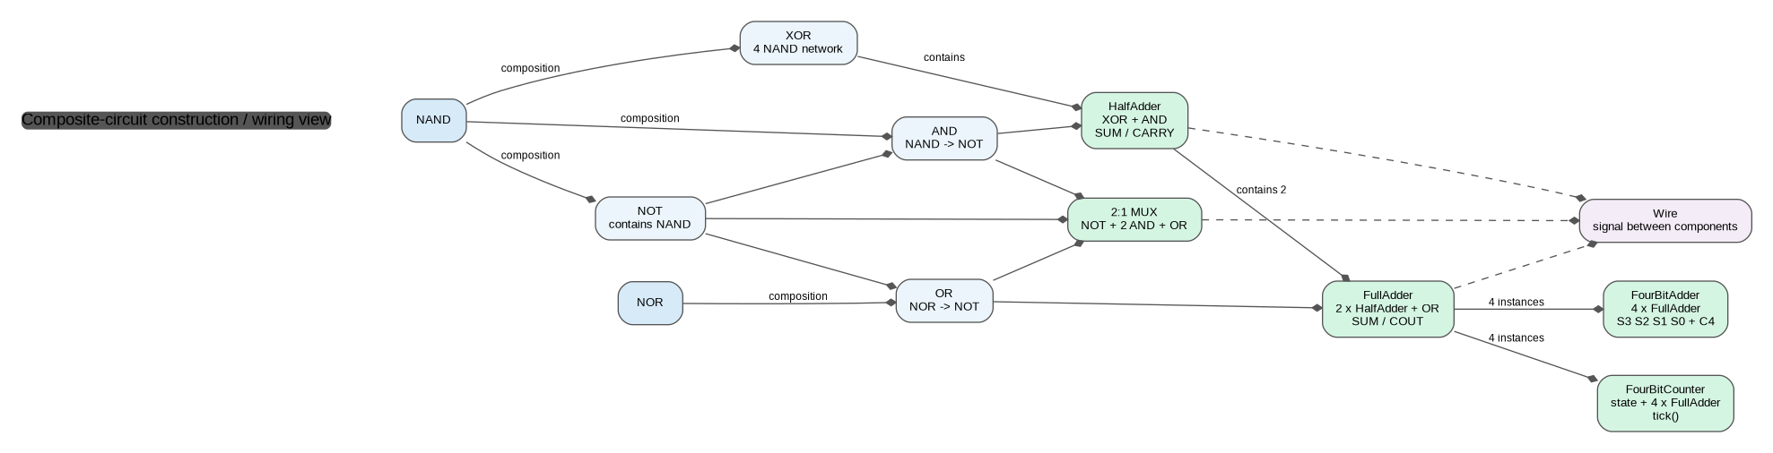
Figure 2. UML-style composition view showing how gates and larger circuits are built from reusable components.
The composition view is important for explaining the assignment requirement that larger digital elements be assembled from smaller elements. For example, a FullAdder is assembled from two HalfAdder objects and one OR gate; a 4-Bit Adder contains four FullAdder objects; and the 4-Bit Counter reuses four FullAdder objects for the increment operation.

4. Object-Oriented Design
OOP principle | Where it appears | Explanation
Abstraction | Gate, Circuit, Output | Interfaces define the operation while concrete classes provide the implementation.
Inheritance | Component -> Gate/Circuit; Gate -> specific gates; Circuit -> specific circuits | Common behavior is shared across related types.
Polymorphism | evaluate(...) and simulate(...) | Code can work with the common interface while concrete implementations perform the operation.
Encapsulation | Private member gates, wires, counter state | Internal circuit details are kept inside classes and exposed through methods.
Composition | AND, OR, XOR, HalfAdder, FullAdder, 4-Bit Adder | Complex objects are constructed from simpler component objects.

5. Basic Workflow
The normal execution path starts in main.cpp, where the menu is shown and user input is validated. A selected circuit is then created. The circuit receives binary input values, evaluates its internal gates/circuits, builds a SimulationResult, and displays or saves the result.
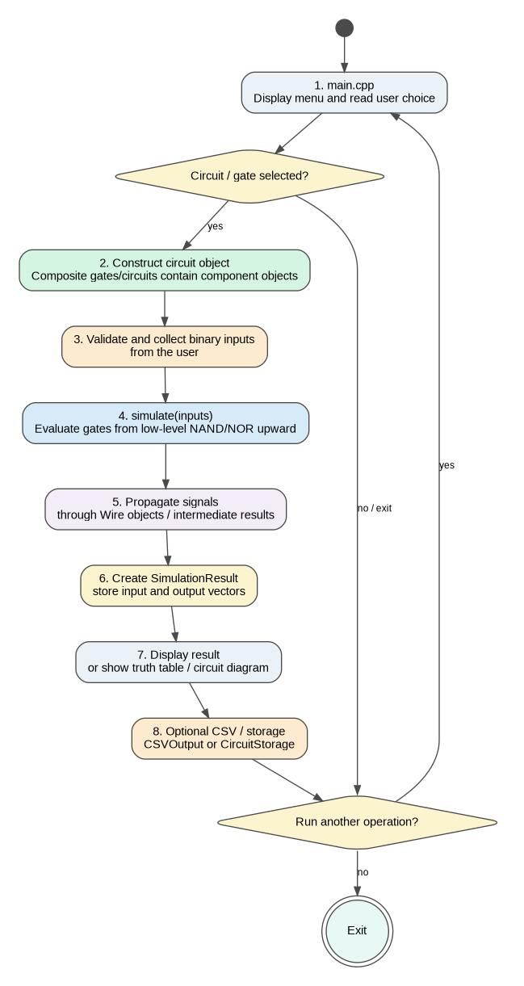
Figure 3. Project workflow from menu selection to simulation and optional CSV/storage output.

6. Gate Implementation
NAND and NOR act as the primitive gates. The higher-level gates are derived from them rather than treating AND, OR, and XOR as independent primitives.
Gate | Construction / Boolean idea
NAND | Y = NOT(A AND B)
NOR | Y = NOT(A OR B)
NOT | Implemented as NAND(A, A)
AND | NAND output followed by NOT
OR | NOR output followed by NOT
XOR | Standard 4-NAND XOR network

int x = nand1.evaluate(a, b);
int y = nand2.evaluate(a, x);
int z = nand3.evaluate(b, x);
return nand4.evaluate(y, z);
This is a strong point to demonstrate during the viva: the project does not simply call a built-in XOR operation; it constructs XOR from NAND gates.

7. Composite Circuit Implementation

7.1 Half Adder
Inputs: A, B. Outputs: SUM and CARRY.
SUM = A XOR B
CARRY = A AND B

7.2 Full Adder
The Full Adder is constructed from two HalfAdder objects and one OR gate.
SUM = A XOR B XOR Cin
COUT = AB + Cin(A XOR B)

7.3 4-Bit Ripple Carry Adder
The FourBitAdder contains four FullAdder objects. Carry from one stage becomes the carry-in to the next stage, beginning at the least-significant bit.

7.4 4-Bit Counter
The counter maintains a four-bit state. Each tick adds one to the state by reusing the FullAdder objects. The main program introduces a one-second delay to simulate a visible clock.

7.5 Additional Combinational Circuits
Circuit | Inputs | Outputs / behavior
2:1 MUX | I0, I1, S | Y = I0.S' + I1.S
4:2 Encoder | D0-D3 (one-hot) | Y1 = D2 + D3; Y0 = D1 + D3
2:4 Decoder | A, B | Exactly one output Y0-Y3 is active for a valid input

8. Wiring and Signal Flow
The Wire class contains source and destination Component pointers together with a signal value. Composite circuits create Wire members in their constructors, then set the signals produced by intermediate components during simulate(). This provides an explicit representation of signal movement between circuit elements.
A useful viva clarification is that the current project combines object composition with explicit Wire objects, but evaluation itself is still orchestrated inside each circuit's simulate() method. A future fully generic circuit editor could store a graph of components and connections and evaluate that graph automatically.

9. Simulation Results, Output, and Storage
SimulationResult stores the inputs and outputs of one simulation operation. The Output abstraction separates computation from presentation.
Class | Responsibility
SimulationResult | Stores input and output vectors and provides accessors.
Output | Abstract output interface.
CSVOutput | Writes SimulationResult data to a CSV file.
CircuitStorage | Saves and loads circuit type, input/output bits, and counter state using a simple CSV format.

10. Build and Run Instructions
The project targets C++17 and can be compiled directly with g++. Run the following commands from the project folder:
g++ -std=c++17 *.cpp -o simulator
./simulator
On Windows with MinGW, the second command can be replaced by simulator.exe. The program presents a menu for logic gates, adders, counter, MUX, encoder, decoder, and CSV save/load operations.

11. Testing and Verification
The supplied code was compiled successfully with g++ using the C++17 standard. An automated functional test program was also run against the implementation.
Area tested | Coverage | Result
Basic gates | NAND, NOR, NOT, AND, OR, XOR truth tables | PASS
Half Adder | All 4 input combinations | PASS
Full Adder | All 8 input combinations | PASS
4-Bit Adder | All A=0..15 and B=0..15 cases with Cin=0 | PASS
4-Bit Counter | Increment, wraparound, reset | PASS
MUX | All 8 input combinations | PASS
Encoder | Four valid one-hot inputs | PASS
Decoder | All 4 input combinations | PASS
CSV/storage | Save/load and CSV file creation | PASS

Overall automated test result: ALL FUNCTIONAL TESTS PASSED.

12. Limitations and Future Improvements
- The current application is console based; a graphical circuit editor is not included.
- Most simulate() functions assume correctly sized binary input vectors; the menu layer performs user-facing validation.
- Wire objects exist, but circuit evaluation is not yet a generic graph engine. A future version could model arbitrary component-to-component connections and automatically traverse the graph.
- The multi-threaded stretch goal from the assignment is not fully implemented. The counter uses std::thread only for the one-second clock delay; separate circuits are not currently simulated concurrently.
- CSVOutput currently writes one SimulationResult record. A next version could add column names for every input/output and export complete truth tables for plotting.

13. Recommended Demonstration Sequence
For a short project demonstration, the clearest order is:
- Show the class structure: Component -> Gate/Circuit and Output -> CSVOutput.
- Run NAND and XOR to show that composite gates are constructed from primitive NAND/NOR gates.
- Run Half Adder and Full Adder to show hierarchical circuit composition.
- Run the 4-Bit Adder with a visible example and show the carry chain.
- Run the 4-Bit Counter and explain state + tick().
- Save a circuit to CSV and open the file in Excel to demonstrate the output requirement.

14. Submission File Structure
A clean submission should separate source code, diagrams, tests, and documentation:
Digital_Circuit_Designer_Simulator/
|-- *.h / *.cpp
|-- README.txt
|-- tests/functional_tests.cpp
|
|-- docs/
|-- Project_Report.docx
|-- UML_Class_Diagram.puml
|-- UML_Circuit_Composition_Diagram.puml
|-- UML_Workflow_Diagram.puml
|-- UML_Core_Class_Diagram.png
|-- UML_Circuit_Composition_Diagram.png
|-- UML_Workflow_Diagram.png

15. Conclusion
The supplied code already provides a substantial implementation of the Digital Electronics Circuit Designer idea. The recommended submission approach is therefore refinement and presentation rather than a rewrite: keep the working C++ implementation, make the architecture explicit with UML/class diagrams, and use this report to connect the code to the assignment requirements. The result is a coherent OOP project that demonstrates reusable components, inheritance, composition, simulation, signal flow, and CSV-based output.

