Chapter 1
Introduction to Computer Graphics

OBJECTIVE OF THE CHAPTER
Students will able to:
- Understand the overview of the computer graphics field.
- Understand the features of computer graphic.
- Define the differences between computer graphics and manual drafting.

A picture is worth a thousand words" is the standard saying. With the introduction of computers we may as well revise the saying to "A computer is worth a million pictures!" Early man used drawings to communicate even before he learnt to talk, write, or count. Incidentally these ancient hieroglyphics (picture-writings) communicate as well today, as they must have done thousands of years ago.
Later, with the development of language, science and mathematics, drawing got reduced to a secondary means of communication, to supplement and to illustrate, and soon became a specialty of draftsmen and a skill of artists.
Now with the advances in computer hardware and software graphics has come a full circle and more and more people are teaching and learning, communicating and sharing their ideas through the medium of graphics, replacing words.
Before we go any further, the author would like to make it clear that in this book, frequent mention of the computer user will necessarily have to be made, and any and all references to man the male of the species will automatically represent both genders.
After all, the computer is the Great Equalizer, one of the few things in the world where not only the sex, but also the age, status, health, wealth, race, nationality, religion, formal education, language, and almost every other distinguishing characteristic of humans, won't make a bit of a difference.
So finally, all of us all over the world are truly equal, in the eyes of the Almighty, and in front of a computer!

NATURE AND TYPES OF COMPUTER GRAPHICS
Before we can understand computer graphics, we need to understand how a computer works. A computer by itself can do only three things: Arithmetic calculations, logical comparisons, and storage-retrieval of programs and data from its memory. That was all that was asked of a computer in the beginning.
But today's computer is a much more versatile machine, invading and influencing almost every activity of its users. The computer's full versatility is being exploited through the input, output, and special processing hardware attached to and driven by it-printers and plotters, modems (i.e. Modulator-Demodulators, or Digital/Analog converters), music synthesizers, numeric-controlled machines and robots, -as well as through sophisticated software used to operate the hardware. Today a computer can handle numbers, words, pictures, sound, still pictures and animations including movies, all in black and white or color. It can understand the spoken word and talk back. It can create dinosaurs and beat chess grandmasters.
It does all these with just zeros and ones, or to be more precise, with just the recognition of the absence or presence of a voltage signal! Its power lies simply in its speed and its infallibility for carrying out instructions.
By graphics we will refer to any sketch, drawing, special artwork or other material to pictorially depict an object or a process or otherwise conveys information, as a supplement to or instead of written descriptions.
The sketch may be of a building or bridge or other construction. It may be of a machine part or of the human anatomy. It may be a scientific plot, electrical network, or process flowchart. It may also be a cartoon or landscape created by an artist. It may be just a few regular lines, or a two-dimensional (2D) drawing, or a representation of a three-dimensional (3D) object as a picture. The graphics may also include text ((hat is, words, letters and other type able or printable symbols) in various sizes and shapes.
Traditionally, graphics bas referred to engineering drawings of buildings, bridges, machine parts etc. and scientific drawings such as x-v curves, network and process flowcharts. In recent decades, graphics has ventured into industrial design, advertising and other artistic endeavors. During the last few years, even newspapers and periodicals aimed at the common man have begun to utilize graphics to present quantitative news such as election results and production statistics.
Computer graphics can do all this and more. In fact, the power and easy availability of computer graphics have increased the use of pictures to replace and augment words to describe, educate, or inform a wide variety of audiences, on a wide variety of subjects.

Computer graphics can be broadly divided into the following classes:
- Business Graphics or the broader category of Presentation Graphics, which refers to graphics, such as bar-charts (also called histograms), pie-charts. pictograms (i.e. scaled symbols). x-y charts, etc. Used to present quantitative information to inform and convince the audience
- Scientific Graphics, such as x-v plots, curve-fitting, contour plots, system or program flowcharts etc.
- Scaled Drawings, such as architectural representations, drawings of buildings, bridges, and machines
- Cartoons and artwork, including advertisements
- Graphical User Interfaces (GUIs) which are the images which appear on almost all computer screens these days. designed to help the user utilize the software without having to refer to manuals or read a lot of text on till monitor

WHAT IS COMPUTER GRAPHICS?

Good question! People use the term "computer graphics" to mean different things in different contexts. Most simply, computer graphics are pictures that are generated by a computer. Everywhere you look today, there are examples to he found, especially in magazines and on television. This book was typeset using a computer: Every character (even this one: G) was "drawn" from a library of character shapes stored in computer memory. Books and magazines abound with pictures created on a computer. Some look so natural, you can't distinguish them from photographs of a "real" scene. Others have an artificial or surreal feeling, intentionally fashioned to achieve some visual effect. And movies today often show scenes that never existed. but were carefully crafted by computer, mixing the real and the imagined.
"Computer graphics" also refers to the tools used to make such pictures. The purpose of this hook is to show what the tools are and ho" to apply them. There are both hardware and software tools. I Hardware tools include video monitors and printers that display graphics, as well as input devices, like a mouse or trackball. that let a user point to items and draw figures. The computer itself, of course, is a hardware tool, along with its special circuitry to facilitate graphical display and capture images.
As for software tools, you are already familiar with the usual ones: the computer's operating system, editor, compiler, and debugger, found in any programming environment. For graphics, there must also he a collection of "graphics routines" that produce the pictures themselves. For example, all graphics libraries have functions to draw a simple line or circle (or characters such as G). Sonic go well beyond this, containing functions to draw and manage windows with pull-down menus and dialog boxes or to set up a "camera" in a three-dimensional coordinate system and to make "snapshots" of objects stored in some data base.
In this book, we show how to write programs that utilize graphics libraries and how to add functionality to those programs. Not too long ago, programmers were compelled to use highly "device-dependent" libraries, designed for use on one specific computer system with one specific type of display device. This made it very difficult to "port" a program to another

MANUAL DRAFTING VERSUS COMPUTER GRAPHICS
We may compare and contrast manual drafting and computer graphics, as follows:
- Manual drafting can be started right away because the tools are commonly and readily available. It is usually completed in a predictable time frame because progress depends on the volume of the work and the number of personnel working.
On the other band, computer graphics needs considerable lead time, i.e. preparation time, such as for the writing of the program and its debugging (in the case where a standard package is not used), and for preparation of data and its correction. Subsequent progress will be incredibly fast and efficient, with the right hardware and software and properly trained personnel.
- Corrections in manual drafting will he time-consuming and the result will not be quite neat. Each manipulation would involve extensive erasure and re-drawing. or more commonly, a fresh drawing. With computer graphics, corrections will he fast and the result will be another original.
- Special effects such as color and shading in manual drafting will require specialists and enormous amounts of time, but in computer work all such enhancements are again a function of the software and hardware, requiring very little additional time and effort on the part of the user.
- Certain graphics processes such as (a) assembly from components, (h) animation (i.e. display of movement as in a cartoon), and (c) enhancements (such as highlighting, shading, and digitizing), are very tedious to develop manually, but are exceedingly simple with a computer.
- In manual drafting each different view, resulting from every modification of viewpoint, scale or other parameter, will have to be redrawn as if it is a fresh drawing. When computerized, however, all modifications can be done through a few commands, with no additional manual input, graphic or otherwise.
- In sharp contrast to the lines drawn and areas shaded continuously in manual drawing, any and every point, line or area depicted on a computer is composed of dots of finite size, because of the very nature of the hardware used to display them. In general. a point shown on the monitor corresponds to a pixel, abbreviation for `picture element', which is the smallest unit of the screen addressable by the computer.

The adverse effects of the display, which will be discussed in a subsequent chapter, are being minimized by improved technology but still the fact remains that computer graphics display, and to a minor extent even its printing, will he subject to this practical limitation of resolution, namely the fineness of the finite unit of the underlying computation and process of depiction.

The fact is that in modern packages even text, referring to alphabets, numbers and standard symbols, is printed as pixels, to permit the use of multiple fonts and type sizes and to allow their mixing with drawings and pictures on the same page.

- Manual drafting involves relatively low investment compared to the enormous amounts of money required for computer graphics. Further, while computer graphics does not need the back-breaking drudgery of manual drafting, it still needs a rather specialized kind of training, concentration, and effort.

The enormous advantages of computer graphics over manual drafting will not be in economy in the long-term, but in terms of speed and staff and customer satisfaction in the long-term. The speed and efficiency of computer graphics soon translates to more, bigger, and faster jobs.

FEATURES OF COMPUTER GRAPHICS
- Functions of Computer Graphics
The computer assists in the development and reproduction of graphics at every stage, from conception to completion. Modern graphics packages enable the following tasks:
- The creation of an object (which actually refers to the image of an object or concept) with data from one or more of the following:
(a) Input coordinates and calculated values
(h) Freehand or specific input from keyboard, mouse, light pen etc.
(c) Scanning from an existing drawing
- Its manipulation, i.e. correction, modification (such as shift, flip, shear, scale, or rotate)
- Its production, namely printing and plotting
- Characteristics of Computer Graphics
It is no exaggeration to say that digital computers have changed the way we think about and create pictures. Most of the exciting images we see on TV while news and other items are being introduced, most of the cute pictures that accompany sports commentaries, documentaries and almost all the computer games presentations are made possible through the magic of computer graphics packages. Some of the major characteristics of computer graphics may he listed as follows:

- The interactive nature and the preview capability of computer processing. These features are extremely useful in computer graphics. One can create a drawing without resorting to drawing instruments and without back-breaking physical effort, modify it as one goes along, look at it from various angles and in different styles, and arrive at a satisfactory final version quickly and pleasantly. This is the most efficient characteristic of modern computer usage but is often taken completely for granted.

- Computer graphics is not only pretty and impressive to look at but also very user-friendly, making its operation a joy and an adventure. Modern computer packages have made it very easy for anyone with some computer training and experience to use these packages for quickly and neatly producing complicated drawings that would have taken draftsmen many days and weeks of drudgery. Some of the things that these packages can do almost instantaneously, at the touch of a button, such as coloring, hatching, shading etc. would take veteran artist hours if done by hand.

- But the ease of production of these high quality graphics does not cone cheap. For,
  - Many man-years would have gone into the development of a graphics package, and thus a good graphics package will cost a fortune.
  - The hardware to run the package will also he quite expensive, involving large storage, very high resolution monitors, and fast machines with math co-processors to speed up the countless calculations involved.
  - Likewise, even to use a package efficiently, it would need proper and formal training from experienced staff.

- Finally, as with most other computer applications, it must be remembered that invariably it is not the computer that makes mistakes, it is the person entering the data or using the command. In computer graphics this truth is often the most difficult to accept, because, unlike in computations, data processing, or word-processing, the logic of a mistake in computer graphics is not at all obvious!

WHERE COMPUTER-GENERATED PICTURES ARE USED
Computer graphics can draw pictures of actual objects with dazzling realism. But it can also draw things that never existed or could never exist. The programmer describes an object of interest through some algorithm in a program, and the program generates a picture from this model.
In this section, we look briefly at some applications that use computer graphics, to demonstrate the range of situations that can benefit from graphics. Later we shall describe several of these applications in detail as case studies.
- Art, Entertainment, and Publishing
Computer graphics is widely used in the production of movies, television programs, hooks, and magazines. The cost of graphics systems has decreased markedly in recent years, and powerful software tools have been developed to utilize such systems. Talented designers can now routinely use computers to create special effects, animation, and high-quality publications.

Movie Production, Animation, and Special Effects
Computer-animated commercials are seen regularly on television, and some very impressive animations are being integrated into feature movies.
Animations are created by writing a sequence of images onto film or videotape, each image being only slightly different from the one before. When the film or videotape is played back at 20 to 30 frames a second, the human eye blends the images and sees smooth motion.
Computer Games
The player moves joysticks and pulls triggers, and the computer-generated image responds instantly. Special hardware is often used to speed up the generation of successive images. Arcade games provide some of the greatest challenges to graphics programmers, as the action must be realistic and at the same time very fast.

Browsing on the World Wide Web
We live in a networked world, and many people regularly "surf "the World Wide Web. Plate 4 shows a sample image from a browser. The user moves the mouse to a spot on the screen and clicks to choose the next Web site to visit, whereupon a page of information is sent over the Internet. The browser must rapidly interpret the data on the page and draw it on the screen as high-quality text and graphics.

Slide, Book, and Magazine Design
Another form of publishing is sometimes called "presentation graphics." In a business setting, high-quality slides are designed to be shown to a group of customers or management. Often, slides contain bar charts or pie charts that summarize complex information in a readily understandable form. These graphics must he of high quality and have visual appeal in order to make a particular point.

A paint system is another tool for generating images by computer. The user fashions the image by sketching- often using a tablet or light pen -and by selecting colors and patterns to create the desired effects. The system provides an assortment of tools: Previously rendered images can he retrieved from mass storage and merged with new images, "palettes" of different colors can he accessed and displayed, and many different textures can be created by means of simple commands. These systems are often used to create pages you encounter on the World Wide Web.

Mapmaking is another form of publishing. Mapmaking is an exacting activity because a huge amount of information and detail must he integrated together with great accuracy.

- Computer Graphics and Image Processing
The fields of computer graphics and image processing are blending together more each year, so that it is becoming harder (and less important) to know where the boundary between them lies. In this hook we focus on computer graphics. but also describe a number of techniques that historically would have been confined to the image-processing field.

The main task in computer graphics is to create pictures and images-to synthesize them on the basis of sonic description, or model, in a computer. The main task in image processing, on the other hand, is to improve or alter images that were created elsewhere, perhaps digitized from photographs or captured by a video recorder. Processing can remove "specks" of noise from an image, enhance the contrast of the image, sharpen its edges, and fix its colors. Software routines can he used to search for certain features in an image and highlight them to make them more noticeable or understand able.

- Monitoring a Process
Highly complex systems like factories, power plants, and air traffic control systems must be carefully monitored, often, there must he a "human in the loop" to watch out for impending trouble. The operator must be given information, on a status display, that is current and that can be interpreted instantly. Measurements arc made of the system every second or so, and the data are transmitted to the monitoring station, to be converted to graphical information and presented to the operator.
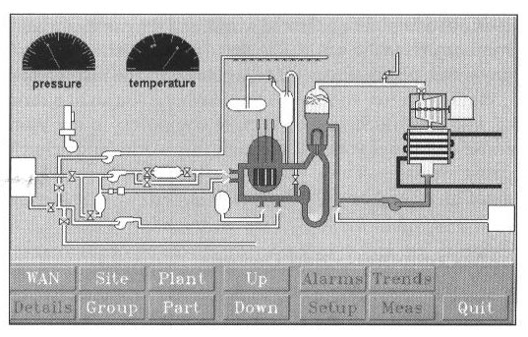
For example, Figure shows a display from a manufacturing process. The user sees a schematic representation of the process, giving the whole picture at a glance. Various icons can flash or change color to alert the user to changes that need attention.

- Displaying Simulations
Some systems, that are displayed graphically actually exist and can be measured in real lime. Others have never been built, perhaps could never he built, and exist only as equations and algorithms in a computer. But they can still he tested and "run through their paces" as if they existed, and valuable information can be obtained. Computer graphics has the ability to display objects as if they already physically exist, when in actuality they are only models inside a computer.

A variety of systems can he profitably simulated: the movement of a robot as it shuffles down the slope of an active volcano, the response of the human body to the introduction of a foreign substance, and the effect of global warming due to an increase in hydrocarbons. The classic example is a flight simulator. The system is an airplane with a certain shape and flying characteristics, along with a "world" consisting of a landing field, mountains, other planes, and of course, "air," all modeled appropriately. In a flight simulator, the dynamics of the airplane's motion are modeled on a computer. During a simulated flight, as the pilot moves the controls, the program calculates new positions and speeds for the simulated plane. The pilot sees a simulated view outside the cockpit. Flight simulator programs are among the most demanding and difficult graphics applications to write, because they must respond so rapidly.

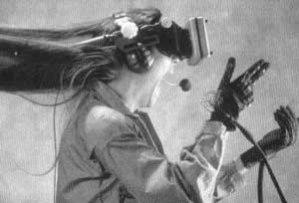

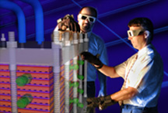

Another form of simulation has recently become popular: the simulation of "virtual worlds". Figure shows a woman interacting with a virtual world using a head-mounted display and data gloves. As she turns her head the graphical display shows different views of a computer-generated world, and she can move her “virtual hands” to touch different objects in the world. She sees a picture of her "hands" in the world, and when she "grasps" an object she sees it being clutched and responding to her hand movements.

Another example where you sit at a terminal viewing and interacting with a world stored on remote computers in the World Wide Web. You use the mouse to propel yourself through this world, and "chat" with people you meet by typing messages. These people are graphical representations of other users representation of you, and chatting back at you.

- Computer-aided Design
A number of disciplines make heavy use of interactive computer graphics to facilitate the design of some system or product. For example shows the process of designing the casing of an electric soldering iron. The computer holds a model of the device in memory, and a picture based on the model is displayed for the user to examine. The designer can rotate the object and zoom in for a closer look, perhaps using a trackball or "data glove" to carry out the manipulation. To speed up the rendering, a wire-frame drawing is used, whereby the shape of the object is suggested by a grid of connected lines.

Presumably, the designer would scrutinize the current model and then indicate certain changes in its shape, whereupon the model would be updated and rendered again. When the shape seems about right, the user requests a more realistic view, as in Plate 12h. This view might take longer to produce, because the algorithms that produce full-color renderings with shadows, glossy highlights, and fine detail can be very complex.

Analysis and simulation can be used here, too. The shape of the soldering iron might have the right visual appeal, but the casing might be too weak or too heavy or might be uncomfortable to grip. Algorithms can be applied to the model to analyze its weight and heft, and to test whether the inner workings of the soldering iron will fit properly inside the casing. Further algorithms can test whether the particular shape is too expensive to produce in steel or aluminum and even whether the internal parts can be assembled conveniently in the final manufacturing process! The computer can be a powerful ally throughout design and manufacturing. Our principal interest in this book is in producing images of an object that provide the designer with the right information.

- Computer-aided Architectural Design
Computer graphics can also help architects design buildings. Here the model might be a floor plan of a house. An architect can make adjustments to the floor plan, moving a wall here or adjusting a window there (with the mouse, of course), and then see a fully rendered version showing how the house. Different textures, such as brick or stucco, can be tried out. Using interactive controls, the architect can even "walk through" the house and show a client how he or she will experience the house when it finally is built.

- Electrical Circuit Design
Computer-aided design offers enormous benefits. Here the model is a symbolic description of an electronic circuit that might form part of a new computer. The designer can add new circuit elements (called "gates") by selecting from a menu of icons (small pictures that represent the elements) and "dragging" the icon to tile desired position in the circuit. By means of simple pointing actions, the designer can add, delete, and connect gates. Then, simulation software can test how a real version of the circuit would perform. On the basis of the results of the simulation, the designer adjusts the circuit and tests it again.

- Scientific Analysis and Visualization
Scientific data are often complex, and relationships among the variables of an experiment can be difficult to visualize. Graphics provides a superb tool for presenting scientific information in a way that can be easily grasped. When data are displayed in the right way, you often have new insights into the underlying process you are investigating. By displaying data properly, you can also communicate ideas better to colleagues.

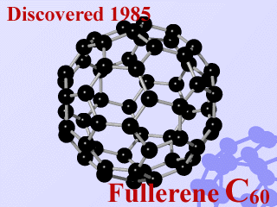

Figure shows an example of the graphical display of complex scientific data. In the figure, a surface is seen to undulate in a fashion the eye can grasp immediately. The height of the surface represents one quantity (such as temperature or viscosity) that is displayed against two other quantities to produce a three-dimensional plot. By contract, if these data were presented as just a table of numbers, one would have to study the table laboriously in order to obtain the same information.

CG shows the structure of a complex molecule of "fullerine", named after Buckminster Fuller. It consists of 60 carbon atoms arranged in a particular geometric pattern and provides a third stable form of carbon (along with graphite and diamond). The geometric arrangement is made immediately apparent using computer graphics. This particular rendition of the molecule was created to be not only clear and revealing but also beautiful.
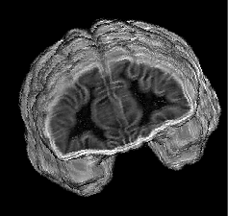
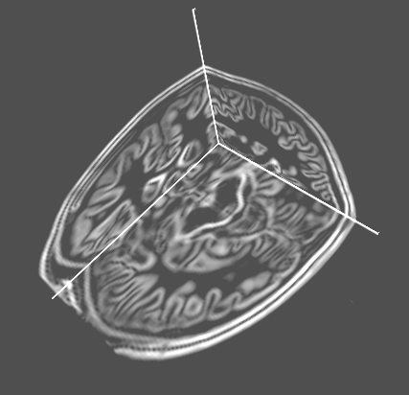

Figure shows a complex image built up by scanning a human head. Areas of different colors immediately inform a physician about the state of health of each part of the brain.

In Figure, graphics are used to present a huge amount of weather data in a form that can be readily recognized and analyzed, to assist in predicting future weather.

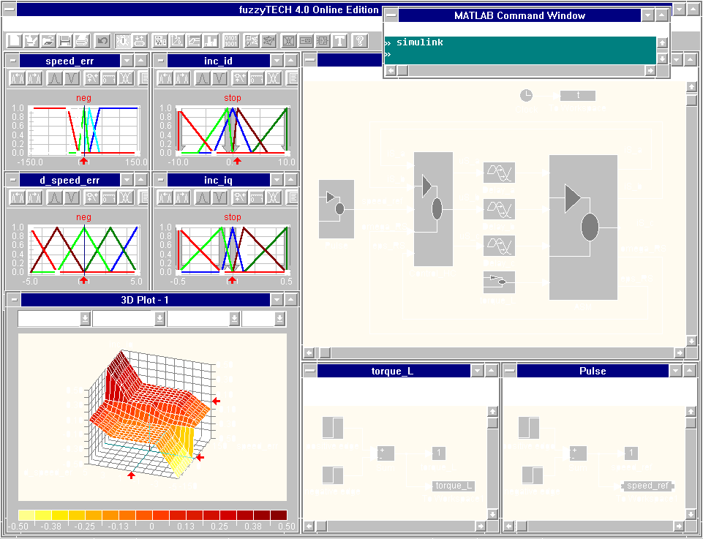

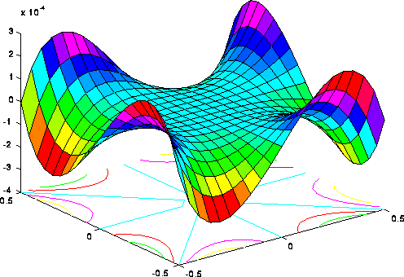

In addition to assisting humans in understanding measured data, computer graphics is well suited for providing insight into complex mathematical ideas. Several powerful programs (Mathernatica, MatLab, MathCad, etc.) have been developed recently that allow a user to enter equations and "rules" pertaining to various quantities and then to see the resulting objects displayed in some fashion. For instance, Figure a shows a surface generated by a mathematical formula. The surface is displayed using Mathermatica by typing the single instruction.

References
- Krishnamurthy, N. (2002), Introduction to Computer Graphics, Singapore, Mc Graw-Hill.
- Hill, F. S. (2001), Computer Graphics using Open GL, New Jersey, Prentice Hall.

