Q1. What is Flask Framework? What are the advantages of Flask Framework?

Flask is a web framework of python. It allows you to quickly build web application. Simplicity, flexibility , minimalism are some of its advantage.

Create a simple Flask application to display ‘Hello World!!’. Attach the screenshot of the output in

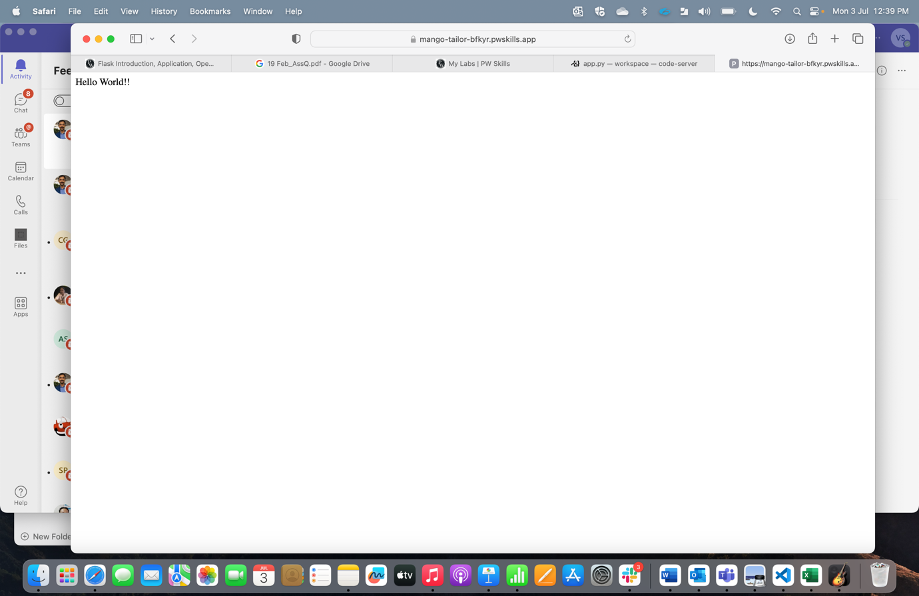

What is App routing in Flask? Why do we use app routes?

App routing is mapping url to the specific function. App route is used to define which function needs to get executed for each url.

Q4. Create a “/welcome” route to display the welcome message “Welcome to ABC Corporation” and a “/”

route to show the following details:

Company Name: ABC Corporation

Location: India

Contact Detail: 999-999-9999

Attach the screenshot of the output

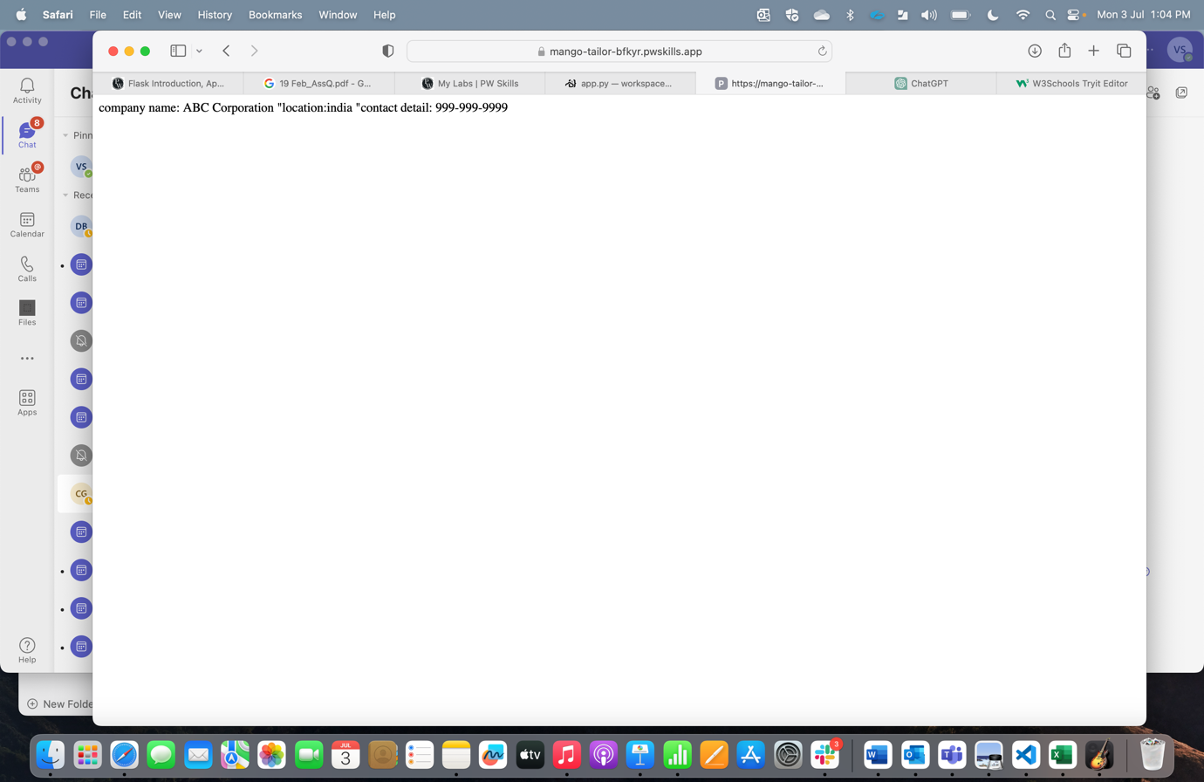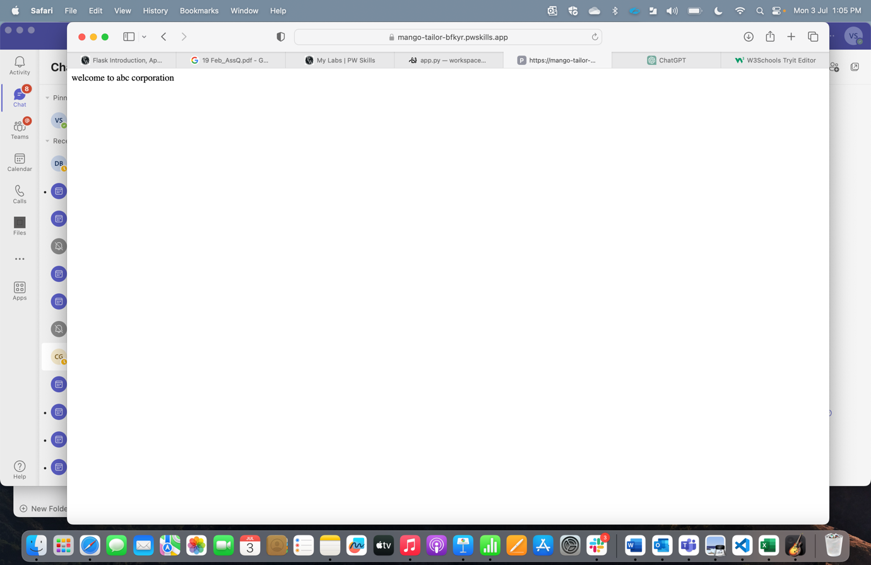

What function is used in Flask for URL Building? Write a Python code to demonstrate the working of the

url_for() function.

url_for

