 

# INSTITUTE FOR ADVANCED COMPUTING ANDSOFTWARE DEVELOPMENT (IACSD), AKURDI, PUNE

Documentation On

Digital Wallet

PG-DAC September 2023

**Submitted By:**

**Group No: 63**

**Roll No. Name:**

**239109 Vaibhav Deshmane**

**239227 Vinit Sarode**

**Mrs. Geeta Darunte Mr. Rohit Puranik**

**Project Guide Centre Coordinator**

## ABSTRACT

This project is a web-based digital wallet system for transacting the digital currency. The project objective is to deliver the online transactions across internet through a web platform.

The service is designed to be secure and convenient. Users' personal credentials and financial data are encrypted and stored in secure database. The service is expected to benefit both businesses and consumers. Businesses will be able to transact easily and increase their sales. Consumers will be able to shop more conveniently and securely.

The service is still under development, but it has the potential to revolutionize the way we transact digital currency. The "Digital Wallet" project is modeled after popular platforms like Paytm. This digital wallet solution aims to provide users with a convenient and secure way to manage their financial transactions. Users can effortlessly load funds into their digital wallets, send money to other users, and withdraw funds as needed. The project's core features are designed to replicate the ease and accessibility of existing digital wallet services, offering a user-friendly solution for modern financial needs.

## ACKNOWLEDGEMENT

I take this occasion to thank God, almighty for blessing us with his grace and taking our endeavor to a successful culmination. I extend my sincere and heartfelt thanks to our esteemed guide, **Mrs. Geeta Garunte** for providing me with the right guidance and advice at the crucial juncture sand for showing me the right way. I extend my sincere thanks to our respected **Centre Co-Ordinator Mr. Rohit Puranik Sir**, for allowing us to use the facilities available. I would like to thank the other faculty members also, at this occasion. Last but not the least, I would like to thank my friends and family for the support and encouragement they have given me during the course of our work.

**Vaibhav Deshmane (239109)**

**Vinit Sarode (239227)**

**Table of Contents**

ABSTRACT 1

ACKNOWLEDGEMENT 2

INTRODUCTION 6

FEATURES 6

* 1. PROJECT OBJECTIVE 7
  2. PROJECT OVERVIEW 7
  3. PROJECT SCOPE 8
  4. STUDY OF THE SYSTEM 8
     1. MODULES 8

SYSTEM ANALYSIS 16

* 1. EXISTING SYSTEM 16
  2. PROPOSED SYSTEM 16
  3. SYSTEM REQUIREMENT SPECIFICATION 16
     1. GENERAL DESCRIPTION 16
     2. SYSTEM OBJECTIVES 17
     3. SYSTEM REQUIREMENTS 17

SYSTEM DESIGN 19

* 1. INPUT AND OUTPUT DESIGN 19
     1. INPUT DESIGN 19
     2. OUTPUT DESIGN 19

DATABASE DESIGN 21

* 1. DATABASE 21
  2. SYSTEM TOOLS 21
     1. FRONT END 21
     2. BACKEND 21

1. LEVEL DFD 22
2. LEVEL DFD FOR SECRETARY 23
3. LEVEL DFD FOR FLAT OWNER 24
4. LEVEL DFD FOR SECURITY GUARD 25

E-R DIAGRAM 26

CLASS DIAGRAM 27

TABLE STRUCTURE 28

PROJECT DIAGRAMS 29

CONCLUSION 50

REFERENCES 51

## LIST OF FIGURES

**FIGURE 1: CUSTOMER ACTIVITY DIAGRAM 11**

**FIGURE 2: ADMIN ACTIVITY DIAGRAM 13**

**FIGURE 4: 0 LEVEL DFD 23**

**FIGURE 5: CUSTOMER DATA FLOW DIAGRAM 24**

**FIGURE 6: ADMIN DATA FLOW DIAGRAM 25**

**FIGURE 8: E-R DIAGRAM 27**

**FIGURE 9: CLASS DIAGRAM 28**

**FIGURE 10: TABLE STRUCTURE 29**

**FIGURE 11: PROJECT DIAGRAMS 32**

## INTRODUCTION

This Software Requirements Specification (SRS) aims to provide a comprehensive and well-documented outline of the requirements for the “Digital Wallet” payment service. This document serves as a guiding resource to articulate the fundamental aspects of the digital wallet ecosystem. “Digital Wallet” constitutes a dynamic platform encompassing multiple functionalities, catering to both users and sellers. The digital wallet system comprises two integral subsystems: the User Wallet subsystem and the Merchant Services subsystem. Generally, in society all the work is decided in meetings and maintenance bills, contact no of members are noted on the papers. There is no automated system for doing all the things that generally happen in society, so that members can come to know what is happening in society.

The “Digital Wallet” digital wallet payment service is engineered to revolutionize the realm of online financial transactions, allowing users to manage their funds with unparalleled convenience and security. By amalgamating cutting-edge technology with a user-centric approach, the system facilitates secure and efficient transactions within an extensive network of users and merchants. This digital wallet service is a reflection of the modern age's transformational shift towards digital finance, ensuring seamless financial interactions and enhancing financial inclusion.

#### Features: -

1. Separate login for Customer and Admin.
2. Easy to add or update the customer information by admin.
3. Easy to do online transactions by customer.
4. Admin can manage all customers’ accounts and transactions done by customers.
5. Customers can check their account transaction history, also can get statement on email.
6. Easy to do update profile and to do transactions.
7. Customer can apply for FD or Loan as per their requirement.

### PROJECT OBJECTIVE

The objective of the project is to create a secure and user-friendly digital wallet platform that enables easy fund management, peer-to-peer transactions, and seamless interactions with online merchants. Prioritize security, accessibility, affordability, and financial inclusivity, while offering a convenient interface and expanding global seller services.

### PROJECT OVERVIEW

The “Digital Wallet” digital wallet payment service presents a streamlined solution for users to manage their finances seamlessly, eliminating the need for physical payment methods. Likewise, the service benefits sellers by extending their reach to a global audience. This system is designed to be accessible to users of various backgrounds, requiring only basic computer and smartphone operation skills for efficient use.

The “Digital Wallet” platform offers user-friendly interfaces for both buyers and sellers. Users can effortlessly top up their digital wallets, make peer-to-peer transactions, and conduct hassle-free online purchases from a diverse range of merchants. The project emphasizes accessibility and inclusivity, allowing individuals without technical expertise to participate effectively.

➢



Product Perspective

The “Digital Wallet” service addresses the needs of individuals who seek efficient and secure financial transactions without the need to visit physical locations. It streamlines the process of managing funds, making payments, and conducting transactions online.

* Product Function Adding funds to digital wallets

Facilitating peer-to-peer money transfers

Enabling online purchases from a variety of merchantsE-Commerce “Digital Wallet” should support this use case:

* ​



User Characteristics

Users should have a basic understanding of terms like account login, wallet balance, transactions, and security features to effectively utilize the “Digital Wallet” service.

* ​



Principle Actors

Users (both customers and sellers)

Admin for system management and oversight



General Constraints & Dependencies

The “Digital Wallet” service is reliant on users having access to a computer or smartphone with a stable internet connection. This infrastructure is essential for the seamless operation of the system and its core functionalities.

### PROJECT SCOPE

The “Digital Wallet” payment service serves as a comprehensive platform for secure and seamless financial transactions. It enables users to effortlessly manage their funds, engage in peer-to-peer money transfers, and conduct transactions with various online merchants. By creating a secure and user-friendly ecosystem, the project enhances financial inclusivity and empowers users with a digital wallet solution that adapts to modern finance trends.

The “Digital Wallet” project is designed to facilitate interactions between users and sellers on a global scale. Users can easily add funds to their digital wallets, make swift money transfers, and engage in online transactions

with confidence. The service stands out for its ability to offer users a convenient way to manage their financial activities from a remote location, eliminating the need for physical presence.

Key features, such as recommendation models and detailed transaction histories, provide users with personalized insights and help in discovering suitable products. These features, accompanied by secure money transactions and reliable delivery services, contribute to customer satisfaction and build a sense of trust within the user community.

The “Digital Wallet” project is dedicated to increasing sales and customer loyalty. Corporate goals involve optimizing management costs, ensuring customer satisfaction, and fostering long-term relationships. Embracing technology, innovative marketing strategies, and adaptive research and development efforts form the cornerstone of the project's growth strategy. The vision for “Digital Wallet” is to establish itself as a user-centric, efficient platform that caters to the evolving financial needs of both customers and sellers, creating a robust digital finance ecosystem.

### STUDY OF THE SYSTEM

### MODULES:

The system after careful analysis has been identified to be presented with the following modules and roles.

The modules involved are:

* + - * Administrator
      * Users
* Administrator

The administrator is the super user of this application. Only admin have access into this admin page. Admin may be the owner of the platform. The administrator has all the information about the users and about all transactions. This module is divided into different sub modules.

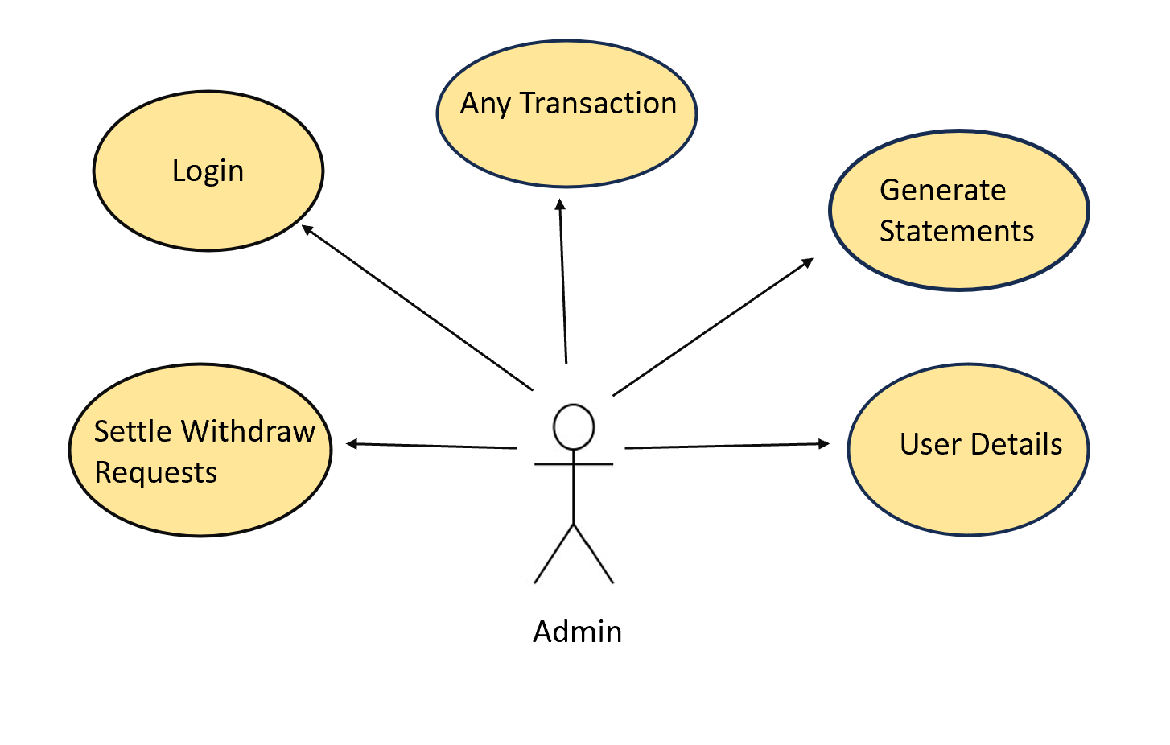

figure 1: Admin Activity Diagram

IACSD

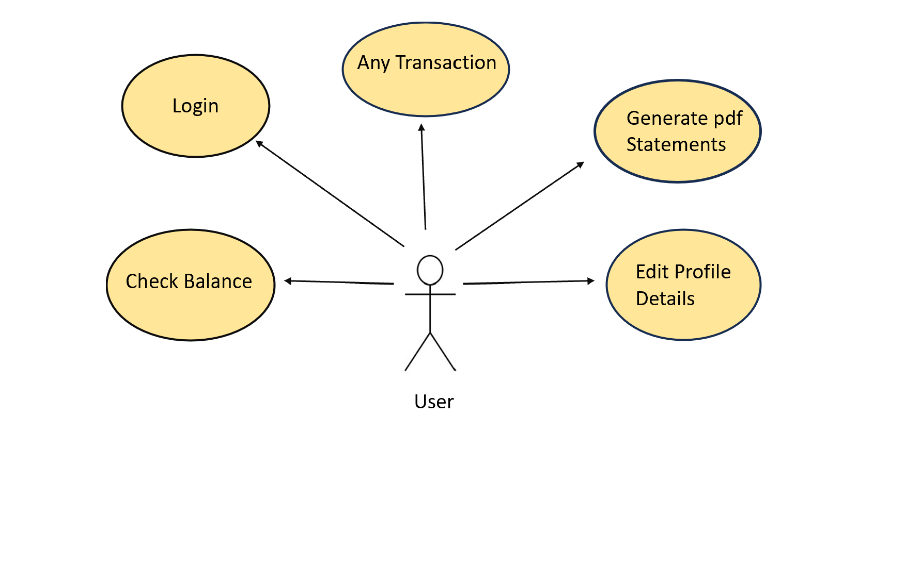

Figure 2: User Activity Diagram

[11]

## SYSTEM ANALYSIS

System analysis is the process of gathering and interpreting facts, diagnosing problems, and using the information to recommend improvements on the system. System analysis is a problem-solving activity that requires intensive communication between the system users and system developers.

System analysis or study is an important phase of any system development process. The system is viewed as a whole, the inputs are identified, and the system is subjected to close study to identify the problem areas. The solutions are given as a proposal. The proposal is reviewed on user request and suitable changes are made. This loop ends as soon as the user is satisfied with the proposal.

### EXISTING SYSTEM

The current system for payments is to visit the shop manually and produce the currency cash for of the

price of the item.

* It is less user-friendly.
* User must go to shop and en cash the products.
* It is difficult to count currency for large the required product.
* It is a time-consuming process
* Not in reach of distant users.

### PROPOSED SYSTEM

**The "digital Wallet" payment service radically transforms the existing shopping paradigm. Unlike the manual process of visiting physical stores, the project brings convenience and efficiency to users' fingertips.**

### SYSTEM REQUIREMENT SPECIFICATION

**A Software Requirements Specification (SRS) document for a digital wallet system outlines the functional and non-functional requirements of the system, as well as its scope, architecture, user interfaces**

* + 1. **SYSTEM OBJECTIVES**
* To provide a Web application for online payments across globe.
* To provide an online payments web site for business and individual users.
  + 1. **SYSTEM REQUIREMENTS**

**NON-FUNCTIONAL REQUIREMENTS**

Modularity:

* Digital Wallet would be complex application due to its functionality expected.
* Digital Wallet would be composed using set of reusable modules.

Portability:

* Digital Wallet could be accessed from any personal device.
* Digital Wallet will provide portable user interface using standard web technologies while building portal.
* Digital Wallet could be deployed to any server Operating Environment.
* Digital Wallet could be deployed to any Cloud such as Microsoft Azure or Amazon Web Service(AWS) or GCP
* Digital Wallet could have been deployed to any other physical server or Virtualized server.

Security:

* Digital Wallet will implement Role based security to access content from Remote place.
* Digital Wallet will provide secure communication between payment gateway applications (SSL)
* Digital Wallet will expire session maintained for each user after 15 minutes.
* Digital Wallet will not keep any sensitive data on user’s device.
* Users’ information would be protected.
* All servers where Digital Wallet deployed would have been protected using firewall.

Safe:

* Digital Wallet will keep regular back up of data in incremental way.
* Digital Wallet will be protected against malicious attack with proper cybersecurity rules.
* Digital Wallet hosted servers would have been protected within restricted environment.

Reliability:

* Digital Wallet will always be available 99.999%
* Digital Wallet should have low downtime
* Digital Wallet server would keep their availability using failover server

Scalability:

* Digital Wallet will provide consistent user experience irrespective of number users grow on particular events such as festival season as transactions increase. (Load balancing).

Compatibility:

* Digital Wallet could be installed on Windows server, Linux server.
* Digital Wallet will provide chrome browser compatible user interface.

**FUNCTIONAL REQUIREMENTS**

USER

* + USER LOGIN

**Description of feature**

This feature used by the user to login into system. A user must login with his username and password to the system after registration. If they are invalid, the user not allowed to enter the system.

Functional Requirement

* Username and password will be provided after user registration is confirmed.
* Password should be hidden from others while typing it in the field.
  + REGISTER NEW USER

Description of feature

A new user will have to register in the system by providing essential details in order to transact in the system. The admin must approve new transaction.

Functional Requirement

* System must be able to verify and validate information.
* The system must encrypt the password of the customer to provide security.

Functional Requirement

* + System must ensure that, only a registered customer can carry transactions.
  + Admin account should be secured so that only owner can access that account
* Users can create accounts with valid email addresses and passwords.
* User authentication will be required for accessing wallet functionalities.
* Users can view their wallet balances.
* Users must be able to add funds to their digital wallets using various payment methods such as credit/debit cards, net banking, and UPI.
* The system should provide real-time updates of wallet balances after successful top-up transactions.
* Users should be able to send money to other users within the platform using recipient's wallet ID or Bank Account ID.
* Users should be able to withdraw funds from their digital wallets to their linked bank accounts.
* Withdrawal requests should be processed securely and efficiently.
* Maintain a detailed transaction history for each user, including top-ups, transfers, withdrawals, and purchases.
* Users should be able to view their transaction history within the application.
* PDF statements download facility.
* Admins should have access to a secure panel for managing user accounts, verifying sellers, and monitoring transactions.
* Design the system architecture to handle a high volume of concurrent transactions without performance degradation.
* Provide a platform for users to contact customer support for assistance with transactions, account issues, and inquiries.

*ADMIN*

* + MANAGE USER

Description of features

The administrator can add user, delete user, view user and block user.

* + VIEW TRANSACTION

Description of features

The administrator can view transactions and details of customers.

* + - Functional Requirements:
* The system must identify the login of the admin.
* Admin account should be secured so that only owner of the shop can access that account.

## SYSTEM DESIGN

System design is the solution for the creation of a new system. This phase focuses on the detailed implementation of the feasible system. Its emphasis on translating design.

Specifications to performance specification. System design has two phases of development.

* Logical Design
* Physical Design

During logical design phase the analyst describes inputs (sources), outputs(destinations), databases (data sores) and procedures (data flows) all in a format that meets the user requirements. The analyst also specifies the needs of the user at a level that virtually determines the information flow in and out of the system and the data resources. Here the logical design is done through data flow diagrams and database design. The physical design is followed by physical design or coding. Physical design produces the working system by defining the design specifications, which specify exactly what the candidate system must do. The programmers write the necessary programs that accept input from the user, perform necessary processing on accepted data and produce the required report on a hard copy or display it on the screen.

### INPUT AND OUTPUT DESIGN

* + 1. INPUT DESIGN:

Input design is the link that ties the information system into the world of its users. The input design involves determining the inputs, validating the data, minimizing the data entry and provides a multi-user facility. Inaccurate inputs are the most common cause of errors in data processing. Errors entered by the data entry operators can be controlled by input design. The user-originated inputs are converted to a computer-based format in the input design. Input data are collected and organized into groups of similar data. Once identified, the appropriate input media are selected for processing. All the input data are validated and if any data violates any conditions, the user is warned by a message. If the data satisfies all the conditions, it is transferred to the appropriate tables in the database. In this project the student details are to be entered at the time of registration. A page is designed for this purpose which is user friendly and easy to use. The design is done such that users get appropriate messages when exceptions occur.

* + 1. OUTPUT DESIGN:

Computer output is the most important and direct source of information to the user. Output design is a very important phase since the output needs to be in an efficient manner. Efficient and intelligible output design improves the system relationship with the user and helps in decision making. Allowing the user to view the sample screen is important because the user is the ultimate judge of the quality of output. The output module of this system is the selected notifications.

## DATABASE DESIGN

* 1. **DATABASE**

Databases are the storehouses of data used in the software systems. The data is stored in tables inside the database. Several tables are created for the manipulation of the data for the system. Two essential settings for a database are -

* Primary key - the field that is unique for all the record occurrences
* Foreign key - the field used to set relation between tables Normalization is a technique to avoid redundancy in the tables.
  1. **SYSTEM TOOLS**

The various system tools that have been used in developing both the front end and the back end of the project are being discussed in this chapter.

IACSD coinbank.com

* + 1. **FRONT END:**

**React is a library (version 17.0)which is developed by Facebook are utilized to implement the frontend. React (also known as React.js or ReactJS) is a free and open-source front-end JavaScript library for building user interfaces or UI components. It is maintained by Facebook and a community of individual developers and companies. React can be used as a base in the development of single page or mobile applications. However, React is only concerned with state management and rendering that state to the DOM, so creating React applications usually requires the use of additional libraries for routing, as well as certain client-side functionality.**

* + 1. **BACKEND:**

**The back end is implemented using MySQL(8.0) which is used to design databases.**

**MySQL:**

**MySQL is the world's second most widely used open-source relational database management system (RDBMS). The SQL phrase stands for Structured Query Language.**

**Spring-Boot(v 3.1.3):**

**This is used to connect MYSQL and fetch data from database and store the data in database. The Spring Framework is an application framework and inversion of control container for the Java platform. The framework's core features can be used by any Java application, but there are extensions for building web applications on top of the Java EE (Enterprise Edition) platform.**

**Although the framework does not impose any specific programming model, it has become popular in the Java community as an addition to the Enterprise JavaBeans (EJB) model. The Spring Framework is Open-source Framework.**

[18]

**Customer Data Flow Diagram**

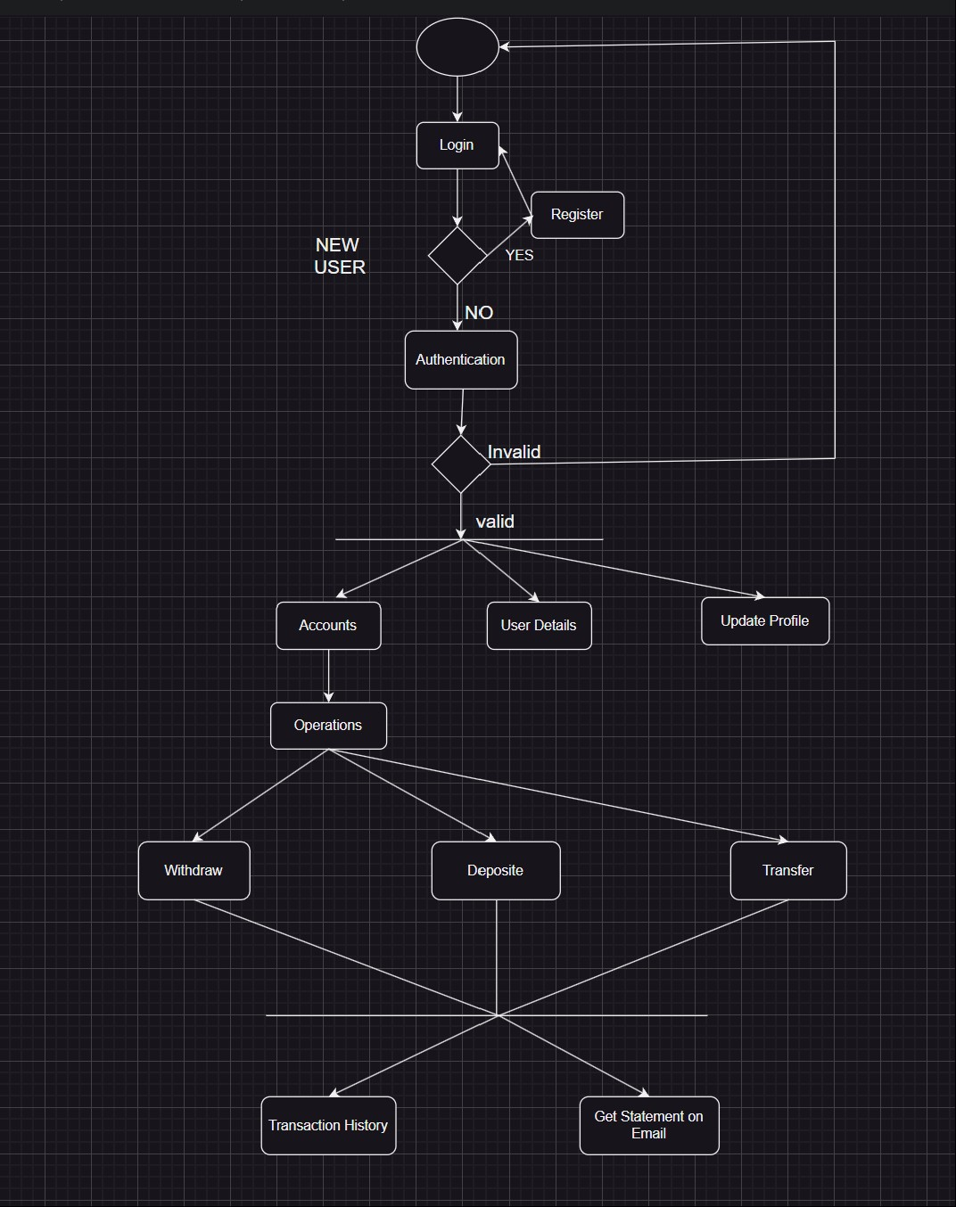

Figure 5: Customer Data Flow Diagram

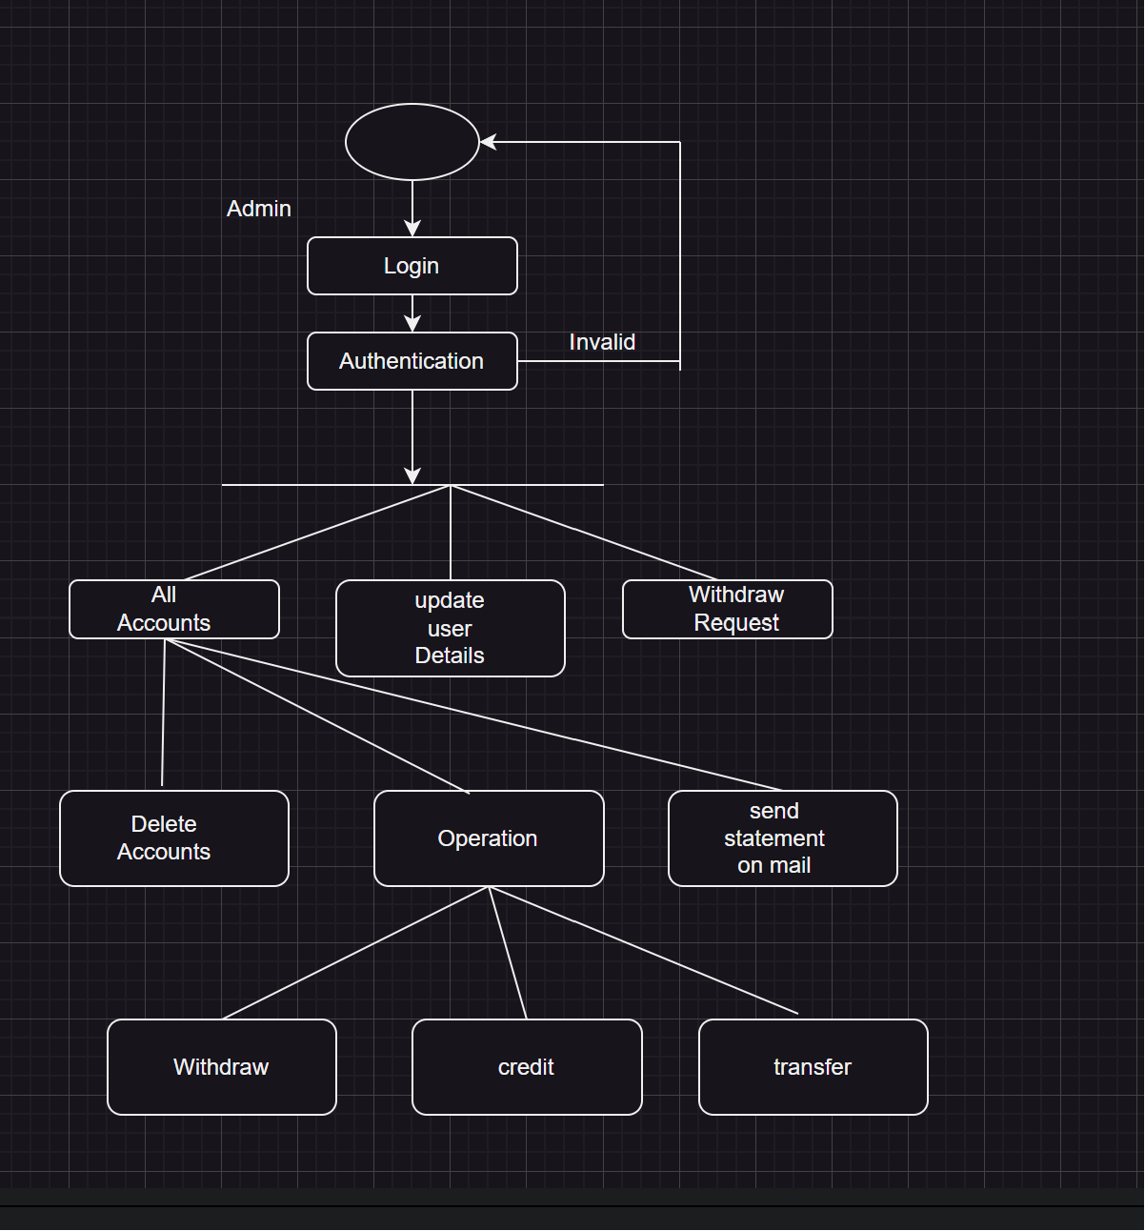

Figure 5.1: Admin Data Flow Diagram

#### Class Diagram

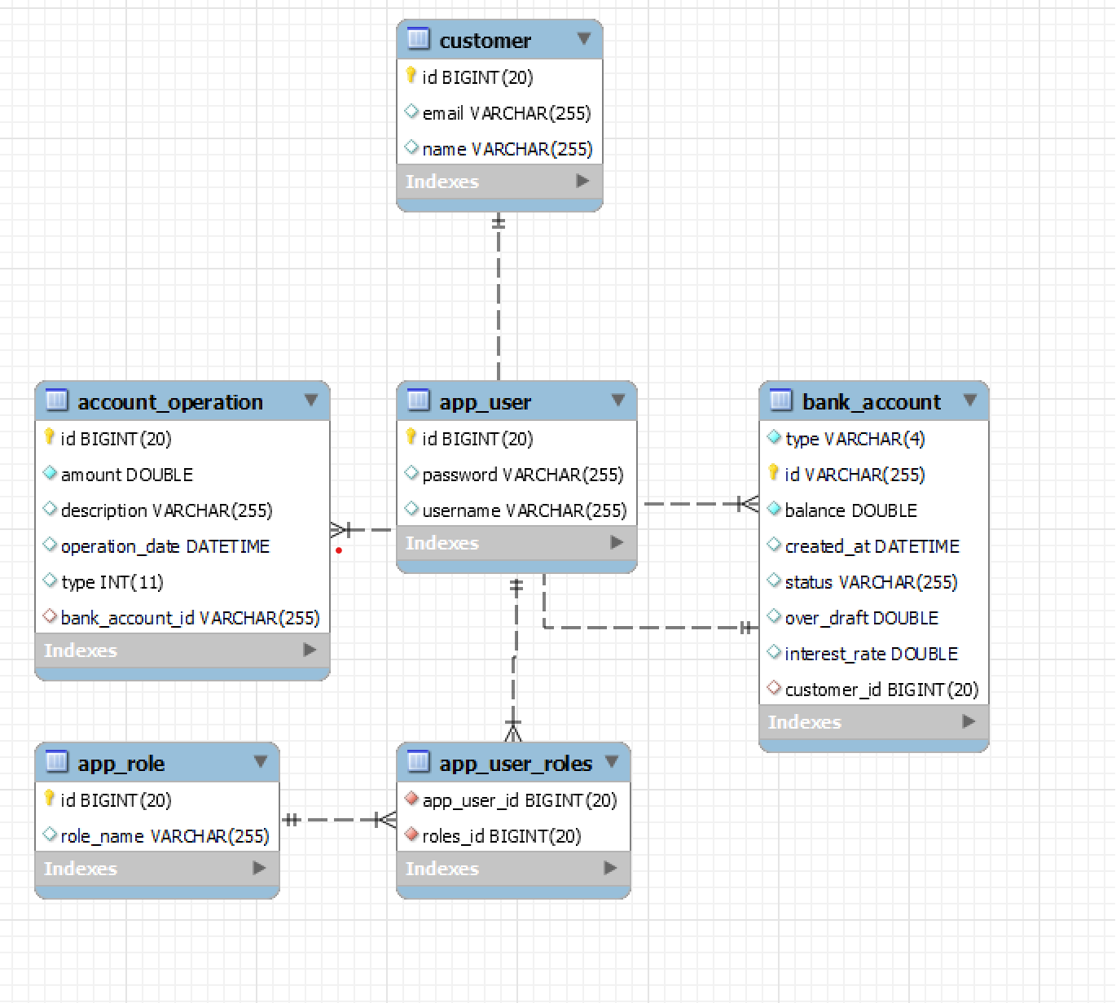

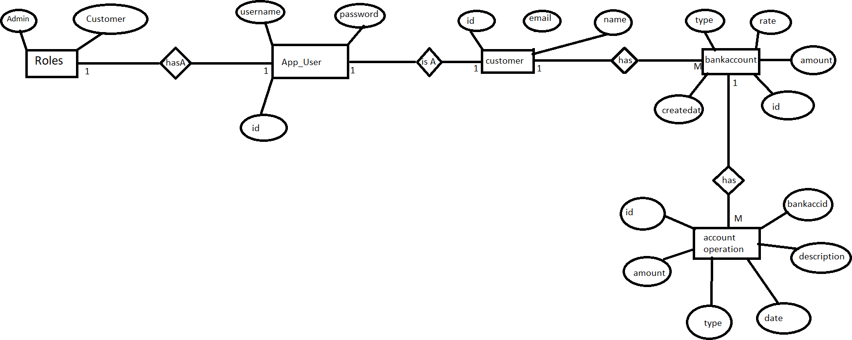

Figure 6: E-R Diagram

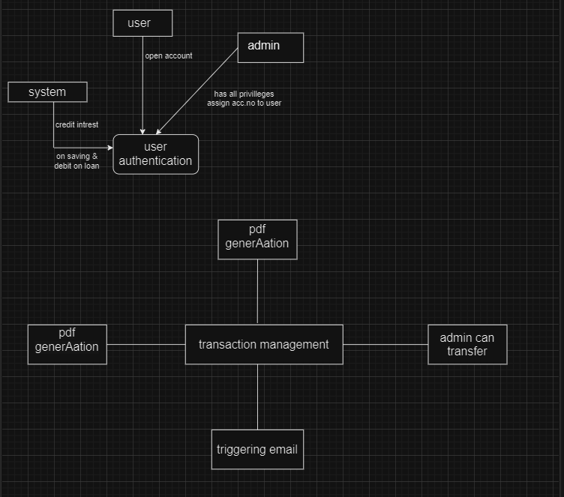

Level 0 DFD

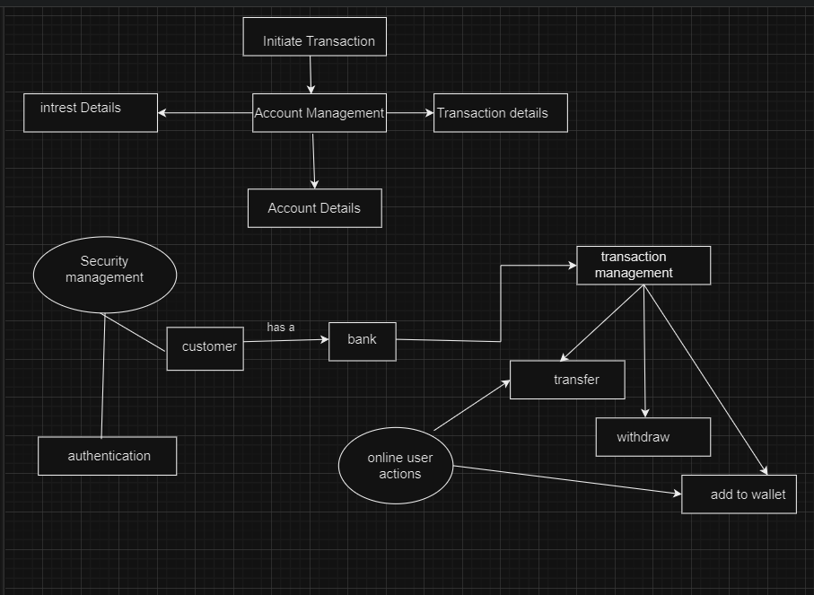

Level 1

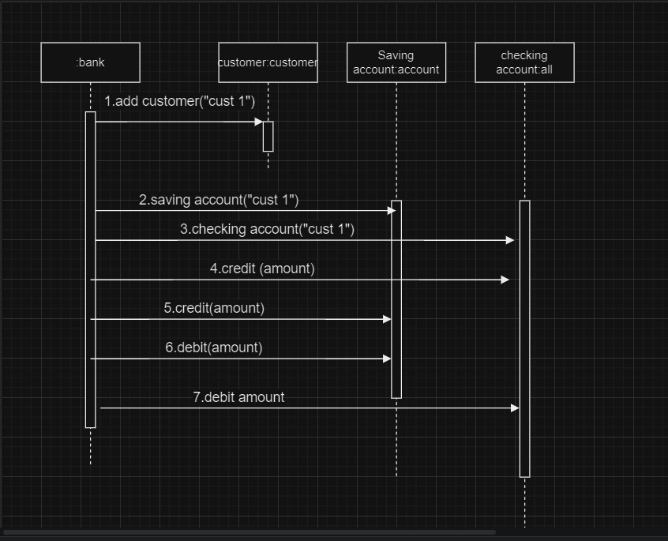

**Sequence Diagram**

*Table Structure*

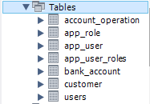**Tables :**

#### BankAccount :

[25]

**Account Operation:**

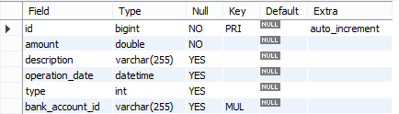

#### Customer :

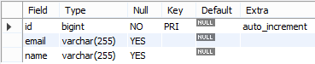

**AppRole :**



#### AppUser :

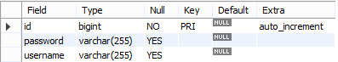

**AppUserRoles :**



IACSD coinbank.com

## Use Case Diagram:

## 

## PROJECT DIAGRAMS

## 

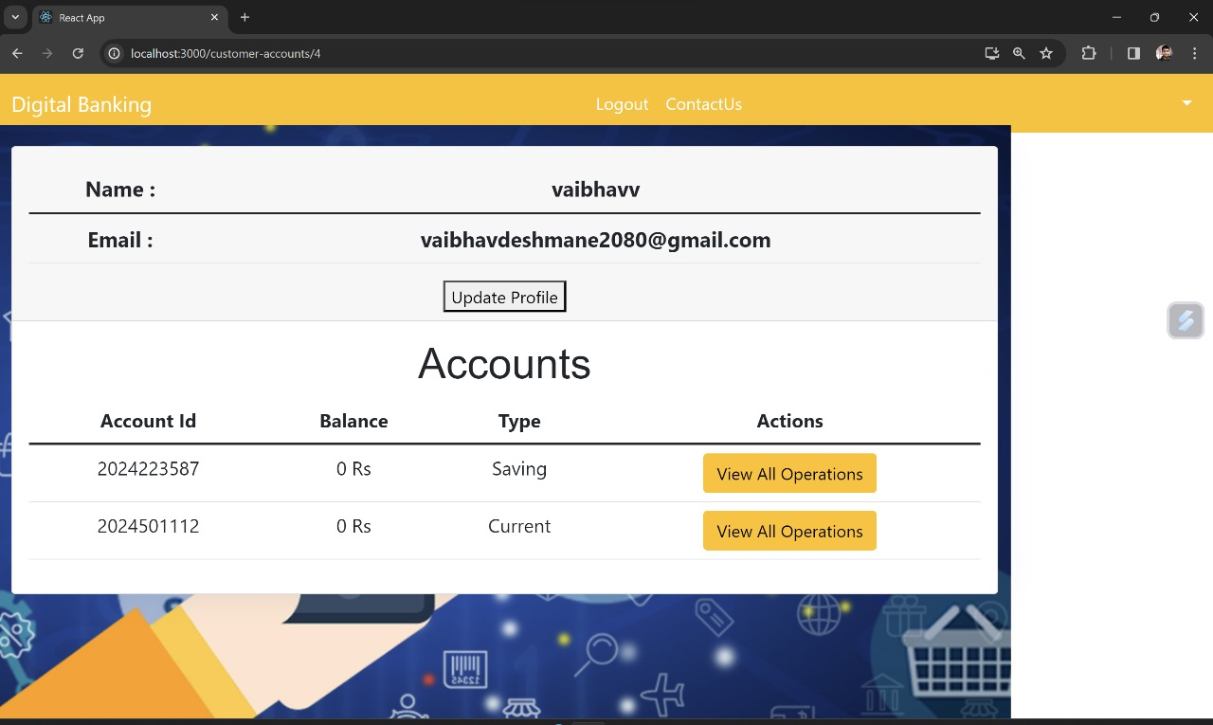

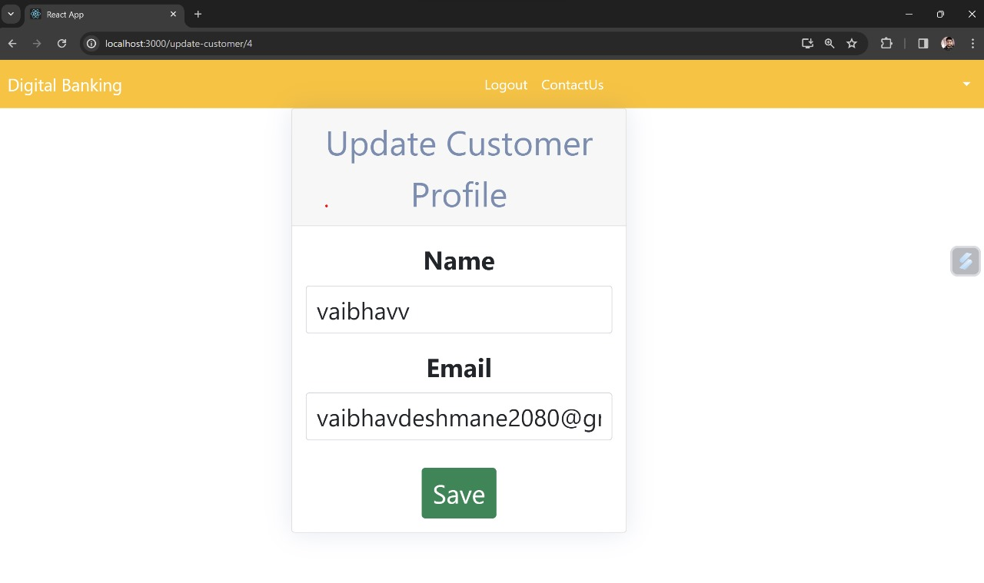

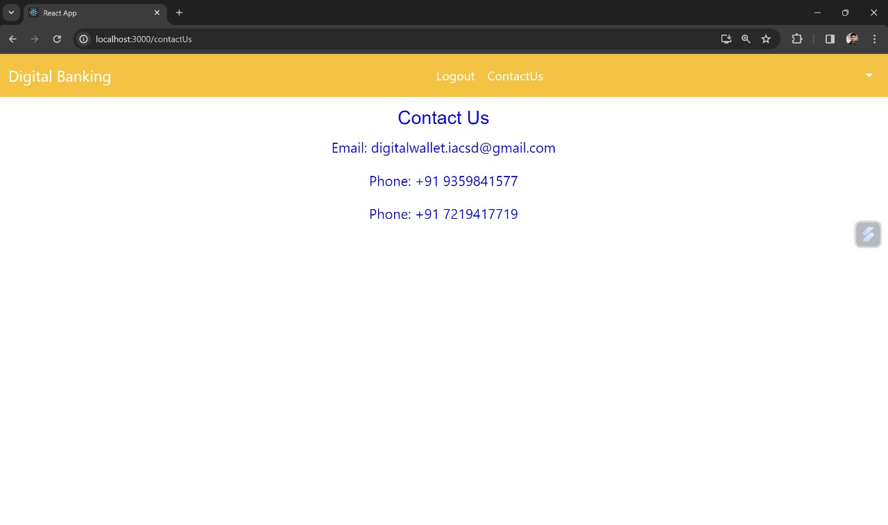

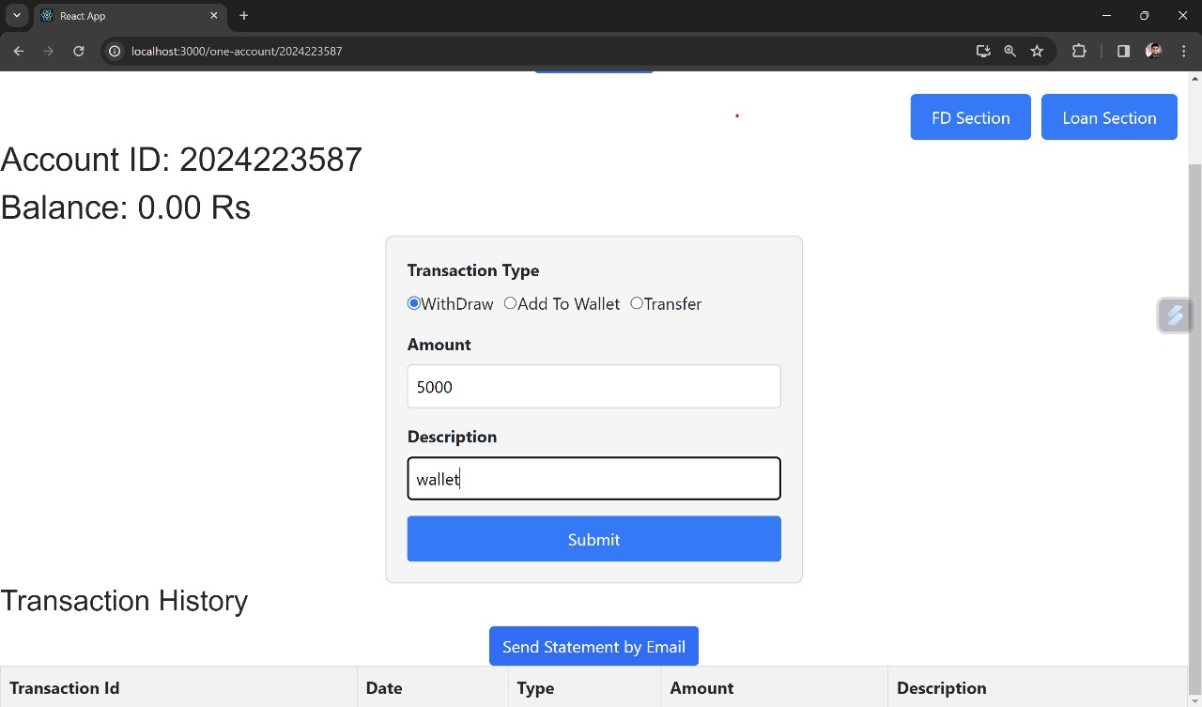

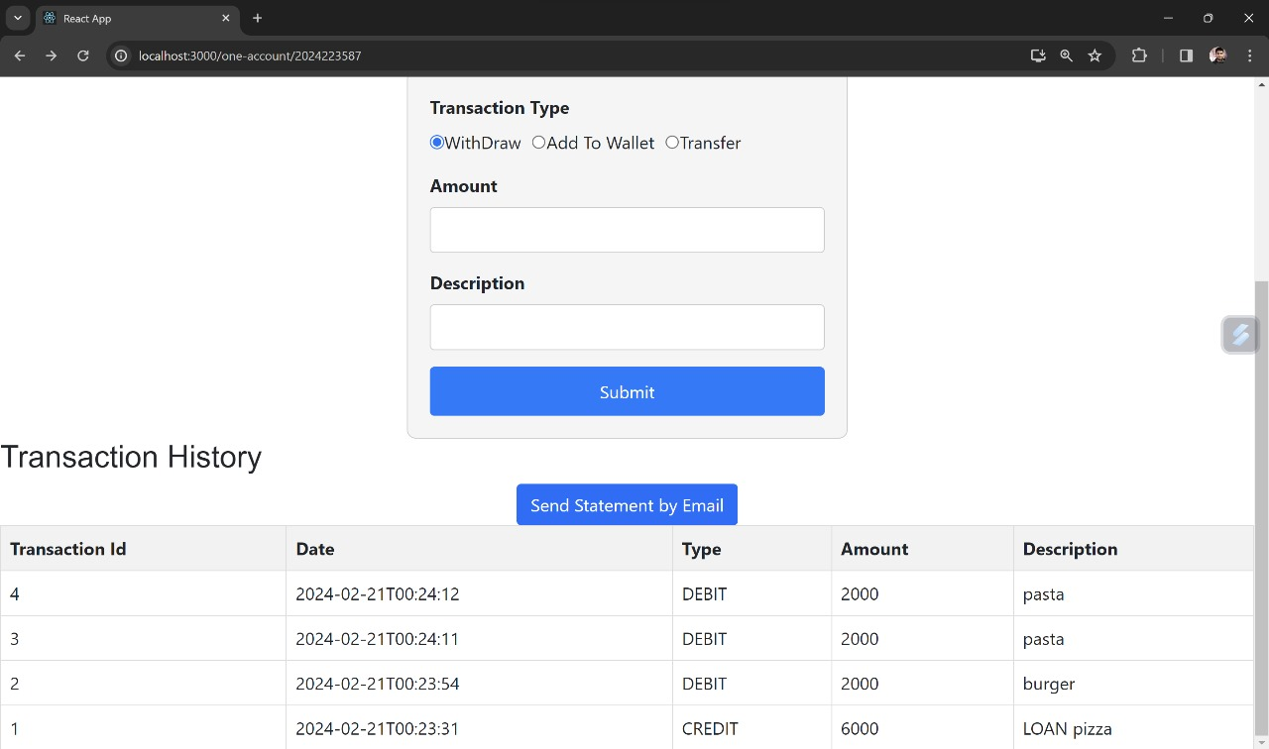

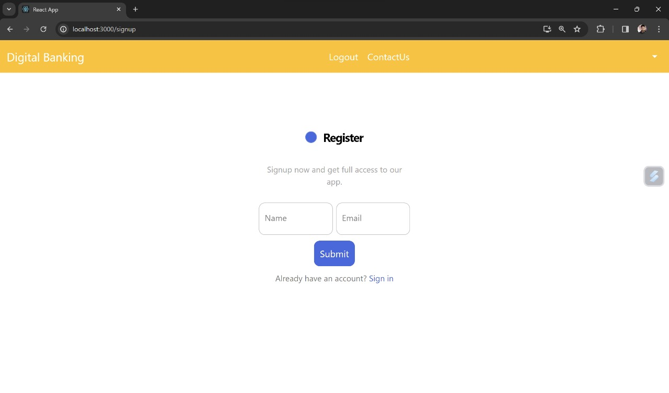

# 

# 

# Future Scope

Cross-Border Payments: The scope of digital payment wallets can expand to facilitate seamless cross-border payments. IoT and Wearables Integration: With the rise of Internet of Things (IoT) devices and wearable technology, payment wallets could extend their functionality to allow for convenient and secure payments through these devices .Contactless and NFC Payments: As contactless payments gain popularity, payment wallet systems could expand their support for near-field communication (NFC) technology. This enables users to make payments simply by tapping their smartphones or cards on compatible terminals. Personal Finance Management: Future payment wallet systems could evolve into comprehensive personal finance management platforms, providing users with insights into their spending patterns, budgeting tools, and investment recommendations.

# CONCLUSION

The “DigitalWallet" digital wallet payment service project has been brought to a successful culmination, fulfilling its intended objectives and purposes. The endeavor to create a secure, efficient, and user- centric digital wallet ecosystem has been achieved with diligence, resulting in a system that empowers users and facilitates seamless financial interactions.

Throughout the course of this project, significant strides have been made in the domain of modern digital finance. The project's success is attributed to its error-free development, efficiency, and time- saving capabilities. The core aim of developing a digital wallet service to streamline financial activities and online transactions has been realized effectively.

The project's implementation journey was both educational and enlightening. The utilization of cutting-edge technologies like React.js, responsive templates, REST APIs, and MySQL database management enriched our practical knowledge. The development process further deepened our understanding of software development life cycles and project management phases. Rigorous testing methodologies were employed to ensure the system's robustness and reliability.

In the context of future prospects, the “DigitalWallet" digital wallet payment service holds immense potential for expansion and enhancement. Possibilities for integrating features such as detailed product descriptions, user feedback mechanisms, and online payment methods exist. As the digital finance landscape evolves, the “DigitalWallet" project is well-positioned to adapt and grow, contributing to the continued evolution of online financial platforms.

In conclusion, the completion of the “DigitalWallet" digital wallet payment service project signifies a successful endeavor in crafting an application that redefines how financial transactions are conducted. This project not only serves as an achievement in itself but also sets the stage for ongoing innovation and refinement in the realm of digital wallet solutions.

IACSD coinbank.com

# REFERENCES

1. <https://aws.amazon.com/solutions/case-studies/paytm/>
2. <https://www.storegrowers.com/google-gpay-case-studies>
3. Mc Graw Hill’s, Java: The complete reference 7thEdition, Herbert Scheldt
4. <https://www.geeksforgeeks.org/web-development-projects/>

**ONLINE REFERENCE**

1. [www.w3school.com](http://www.w3school.com/)

[2] [www.javatpoint.com](http://www.javatpoint.com/)

[51]